**Timer**

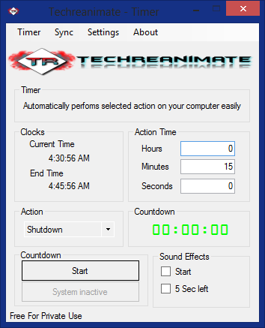

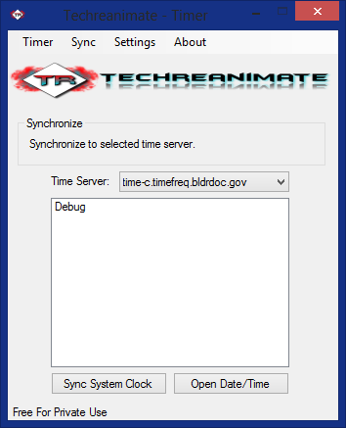

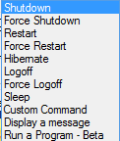

A VB.net Program I had part in developing, made to keep your computer from staying on or to remind you of a self-set alert when you are playing a game. Mostly used by ourselves when watching movies at night. Timer helped us put our computers to sleep or power down if we happened to fall asleep while watching movies. It also keeps your system clock up to date with a long list of Global time servers.