Four most important types of graph models:

* Undirected graphs have simple connections

* di-graphs where the direction of each connection is significant

* edge-weighted graphs where each connection has an associated weight

* edge-weighted di-graphs where each connection has both a direction and a weight.

A graph is a set of vertices (points) and a collection of edges (lines) that each connect a pair of vertices.

UNDIRECTED GRAPHS:

We use names 0 to V-1 as names for our vertices in a V-vertex graph. (V nr of vertices), this is so that we can use array indexing to access information corresponding to each vertex.

Can use symbol table to establish a 1-1 mapping to associate V arbitrary vertex names with the V integers between 0 and V-1.

v-w regers to an edge that connects v and w, w-v refers to the same edge.

Two simple anomalies:

* A self-loop is an edge that connects a vertex to itself

* Two edges that connect the same pair of vertices are parallel.

These are allowed but not included in the examples.

Glossary

When there is an edge connecting two vertices, we say the vertices are adjacent to one another and that the edge is incident to (touches) both vertices.

The degree of a vertex is the number of edges incident to it.

A subgraph is a subset of a graph’s edges (and associated vertices) that constitutes a graph.

A path in a graph is a sequence of vertices connected by edges.

A simple path is one with no repeated vertices.

A cycle is a path with at least one edge whose first and last vertices are the same

A simple cycle is a cycle with no repeated edges or vertices (except first/last vertices).

The length of a path or a cycle is its number of edges.

A vertex is connected to another if there exists a path that contains both of them.

A graph is connected if there is a path from every vertex to every other vertex in the graph. It’s not connected if it consists of a set of connected components which are maximal connected subgraphs. (the largest possible subgraph, no other node in the graph can be added to the subgraph while still being connected)
An acyclic graph is a graph with no cycles. Several of the algorithms we consider are concerned with finding acyclic subgraphs of a given graph that satisfy certain properties.

A tree is an acyclic connected graph. A disjoint set of trees is called a forest.

A spanning tree of a connected graph is a subgraph that contains all of that graph’s vertices and is a sinlgle tree.

A spanning forest of a graph is the union of spanning trees of its connected components.

A graph (G) with (V) vertices is a tree if and only if it satisfies any of the following five conditions:

* G has V-1 edges and no cycles.

* G has V-1 edges and is connected.

* G is connected, but removing any edge disconnects it.

* G is acyclic. But adding any edge creates a cycle.

* Exactly one simple path connects each pair of vertices in G.

A bipartite graph is a graph whose vertices we can divide into two sets such that all edges connect a vertex in one set with a vertex in the other set.

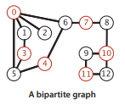
Figure: One set of vertices is
colored red and the other set
is colored black

Undirected graph data type

API for an undirected graph:

public class Graph
Graph(int V) *Constructor1 Creates a V-vertex graph with no edges
Graph(In in) *Constructor2 Reads graph from input stream(Scanner instead if In?)
int V() Returns number of vertices
ine E() Returns number of edges
void addEdge(int v, int w) Adds edge v-w to graph
Iterable<Integer> adj(int v) Allows u to iterate through adj vertices to v
String toString() String representation to use in print

Constructor2 assumes an input format consisting of 2E+2 integer values:
(+1) V, (+1) then E, (+2E) then E pairs of values between V and V-1, each pair denoting an edge.

Typical graph-processing code implementation:

//Computes the degree of v.
int degree(Graph G, int v)
{
//First set it to 0, no edges have been found yet.
int degree = 0;
//Call our iterator to get all adj vertices to v, for each vertex w adj to v
//add an edge (degree) to it.
for(int w : G.adj(v))
degree++;
return degree;
}
//Computes max degree in graph
int maxDegree(Graph G)
{
//Set max to 0, no degrees have been found yet
int max = 0;
//Initialize w to be a comparison variable to v
int w;
//For all vertices in the graph
for(int v = 0; v < G.V(); v++)
{
//Compute the degree of the current vertex
w = degree(G, v);
//If it’s degree is greater than max update max to w.
if(w > max)
max = w;
}
return max;
}
//Computes average degree in graph
int avgDegree(Graph G)
{
//Two times the number of edges in the graph divided by the number of vertices.
return 2 * G.E() / G.V();
}

//Counts the number of self-loops
int nrOfSelfLoops(Graph G)
{
//Set count to 0, no self loops have been found yet
int count = 0;
//For all vertices in the graph
for(int v = 0; v < G.V(); v++)
//Call our iterator to get all adj vertices to v, for each vertex w adj to v
for(int w : G.adj(v))
//If adjacent to itself its a self loop, count it.
if(v == w)
count++;
//Each edge is counted twice so we return our count / 2.
return count / 2;
}
//Returns a string representation of the graph’s adjacency lists (its an instance
//method in graph)
String toString()
{
//Initialize the string
String s = V + “ vertices “ + E + “ edges\n”;
//For all vertices in the graph
for(int v = 0; v < V; v++)
{
//Append the vertex into the string
s += v + “ “;
//Call our iterator to get all adj vertices to v, for each vertex w adj to v
for(int w : this.adj(v))
//Append the vertex into the string
s += w + “ “;
//Append new line to have space between the adjacency lists
s += “\n”;
}
return s;
}

Representation alternatives

Requirements when we decide which datastructure to use to implement the API:

* We must have the space to accommodate the types of graphs that we are likely to encounter in applications.

* We want to develop time-efficient implementations of Graph instance methods.

An adjacency matrix maintains a V-by-V boolean array, with the entry in row v and column w defined to be true if there is an edge adjacent to both vertex v and w in the graph, and false otherwise. This representation fails on the first requirement.

An array of edges uses an Edge class with two instance variables of type int. This representation is simple but fails the second requirement.

An array of adjacency lists maintains a vertex-indexed array of lists of the vertices adjacent to each vertex. This representation satisfies both requirements for typical applications.

Adjacency-lists data structure

Keeps track of all the vertices adjacent to each vertex on a linked list that is associated with that vertex.

To implement lists we use the Bag ADT with a linked-list implementation so we can add new edges in constant time and iterate through adjacent vertices in constant time per adjacent vertex.

To add an edge connecting v and w, we add w to v’s adjacency list and v to w’s adjacency list, thus each edge appears twice.

Space usage proportional to V + E.
Constant time to add an edge.
Time proportional to the degree of v to iterate through vertices adjacent to v.

The order in which edges are added to the graph determines the order in which vertices appear in the array of adjacency lists built by Graph.

When using the constructor that reads edges from an input stream, the input format and the order in which edges are specified in the file determine the order in which vertices appear in the array of adjacency lists built by Graph.

We assume Graph has a test client that reads a graph from the input stream named as command-line argument and then prints it to show the order in which vertices appear in adjacency lists.

Implementation of Graph data type using adjacency list

public class Graph
{
//Instance variable to determine the number of vertices, can’t be updated
private final int V;
//Instance variable to determine the number of edges in the graph
private int E;
//List implementation using Bag ADT
private Bag<Integer>[] adj;

//Constuctor 1. Default
public Graph(int V)
{
//Set nr of vertices to the given integer and set edges to 0.
this.V = V;
this.E = 0;
//Create the array of lists with size V.
adj = (Bag<Integer>[]) new Bag[V];
//For each vertex in the array, initialize their lists to empty
for(int v = 0; v < V; v++)
adj[v] = new Bag<Integer>();
}
//Constructor 2. Reads graph from an input stream in the format V followed by E
//followed by a list of pairs of in values between 0 and V-1.
Public Graph(Scanner in)
{
//Reads V and calls constructor 1 with it.
this(in.readInt());
//Reads E.
int E = in.readInt();
//For all edges
for(int i = 0; i < E; i++)
{
//Add an edge by reading two vertices and connecting them
int v = in.readInt();
int w = in.readInt();
addEdge(v, w);
}
}
//Getters for vertices and edges
public int V() { return V; }
purlic int E() { return E; }

//Adds an edge to the graph
public void addEdge(int v, int w)
{
//Add w to v’s list and v to w’s list
adj[v].add(w);
adj[w].add(v);
//Tally nr of edges
E++;
}
//Allows iteration through vertices adjacent to v,returns bag at index v in list
public Iterable<Integer> adj(int v)
{
return adj[v];
}

Design pattern for graph processing

Develop for each given task, a task-specific class so that clients can create objects to perform the task.

A typical client program builds a graph, passes that graph to an agorithm implementation class (as argument to a constructor) and then calls client query methods to learn various properties of the graph.

We use source s to distinguish the vertex provided as argument to the contructor from the other vertices in the graph (v, w, etc).

Depth-first search

Many graph properties are related to paths, so a natural way to learn them is to move from vertex to vertex along the graph’s edges. Nearly all of the graph-processing algorithms use this same basic abstract model, with different strategies.

Searching in a maze

Say maze instead of graph, passage instead of edge and intersection instead of vertex.

One trick for exploring a maze without getting lost is known as Tremaux exploration. To explore all passages in a maze:

* Take any unmarked passage, unrolling a string behind you.

* Mark all intersections and passages when you first visit them.

* Retrace steps (using the string) when approaching a marked intersection.

* Retrace steps when no unvisited options remain at an intersection encountered while retracing steps.

The string guarantees that you can always find a way out and the mark guarantee you avoid visiting any passage or intersection twice.

Tremaux exploration differs in subtle ways from exploring a graph.

_

The classic recursive method for searching in a connected graph (visiting all of its vertices and edges) mimics Tremaux maze exploration.

To search a graph invoke a recursive method that visits vertices. To visit a vertex

* Mark it as having been visited

* Visit (recursively) all the vertices that are adjacent to it and that have not yet been marked.

This method is depth-first search. It maintains an array of boolean values to mark all of the vertices that are connected to the source. The recursive method marks the given vertex and calls itself for any unmarked vertices on its adjacencty list, If graph is connected every adjacency-list entry is checked

One way passages

The call-return mechanism in the program corresponds to the string in the maze. When we have processed all the edges incident to a vertex (explored all the passages leaving an intersection) we “return”.

In the same way that we encounter each passage in the maze twice (once in each direction) we encounter each edge in the graph twice (once at each of its vertices).

In Tremaux exploraton, we either explore a passage for the first time or return along it from a marked vertex. In DFS of an undirected graph, we either do a recursive call when we encounter an edge v-w (if w is not marked) or skip the edge (if w is marked). The second time we encounter the edge, in the opposite orientation w-v we always ignore it, because destination vertex v has already been visited.

Tracing DFS

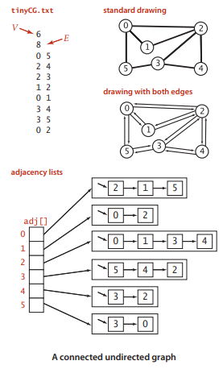
The order in which edges are examined and vertices visited depends upon the representation, not jus the graph or the algorithm. Since DFS only examines vertices connected to the source, we use a small connected graph for traces.

In the input example on the right,
vertex 2 is the first vertex visited
after 0 because it happens to be first
on 0’s adjacency list.

DFS traverses each edge in the graph twice, always finding a marked vertex the second time.

This example has eight edges but we need to trace the action of the algorithm on the 16 entries on the adjacency lists.

Detailed trace of depth-first search

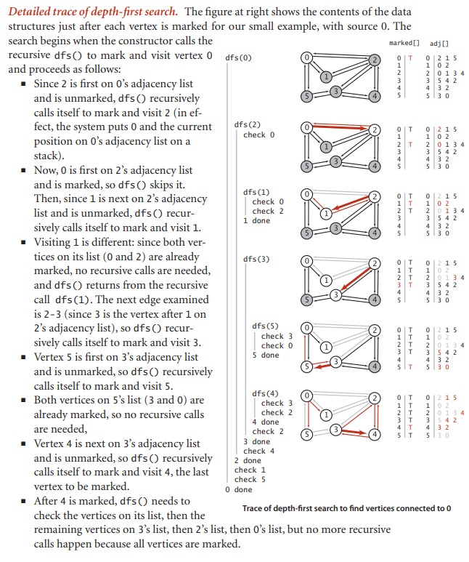
DFS can be used to address problems such as:
Connectivity, Are two given vertices connected?, How many connected components does the graph have?
Single-source paths, is there a path from s to a given target vertex v? If so, find such a path.
Finding paths

API:

public class Paths
Paths(Graph G, int s) //Finds paths in G from source s
boolean hasPathTo(int v) //Returns true if there is a path from s to v
Iterable<Integer> pathTo(int v)//Path from s to v, null if no such path

The constructor takes a source vertex s as argument and computes paths from s to each vertex connected to s.

After creating a Paths object for a source s, the client can use the instance method pathTo() to iterate through the vertices on a path from s to any vertex connected to s.

We can later develop implementations that find paths having certain properties.

Implementation

An instance variable array edgeTo[] of int values that serves the purpose of giving a way to find a path back to s for every vertex connected to s. Instead of just keeping track of the path from the current vertex back to the start, we remember a path from each vertex to the start.
To accomplish this, we remember the edge v-w that takes us to each vertex w for the first time, by setting edgeTo[w] = v. In other words, v-w is the last edge on the known path from s to w.
The result of the search is a tree rooted at the source. EdgeTo[] is a parent-link representation of that tree.

Public class DFP
{
//Has this vertex been visited?
private boolean[] marked;
//Last vertex on known path from s to w
private int[] edgeTo;
//Source
private final int s;
//Takes a source vertex s as argument and computes paths from s to each vertex
//connected to s.
public DFP(Graph G, int s)
{
marked = new boolean[G.V()];
edgeTo = new int[G.V()];
this.s = s;
dfs(G, s);
}

private void dfs(Graph G, int v)
{
marked[v] = true;
for(int w : G.adj(v))
if(!marked[w])
{
edgeTo[w] = v;
dfs(G, w);
}
}
//Returns true if there is a path from s to v
public boolean hasPathTo(int v)
{
return marked[v];
}
//Iterate through the vertices on a path from s to any vertex connected to s.
public Iterable<Integer> pathTo(int v)
{
//If no path from s to v, return null
if(!hasPathTo(v))
return null;
//Create a stack of vertices?
Stack<Integer> path = new Stack<Integer>();
//Add all vertices on the known path from s to w, to stack
for(int x = v; x != s; x = edgeTo[x])
path.push(x);
path.push(s); //Add source
return path;
}
To recover the path from s to any vertex v, the pathTo() method uses a variable x to travel up the tree, setting x to edgeTo[x], putting each vertex onto a stack until reaching s.

Breadth-first search

The paths discovered by depth-fist search depend not just on the graph, but also on the representation and the nature of the recursion. This does not help much with solving problems such as Is there a path from s to a given vertex v and if so, find the shortest such path (the one with least amount of edges). Breadth-first search solves this.

To find a shortest path from s to v, we start at s and check for v among all the vertices that we can reach by following one edge, then we check for v among all the vertices that we can reach from s by following two edges, and so forth.

Where DFS is like one person exploring a maze, BFS is like a group of searchers exploring by fanning out in all directions, each unrolling his or her own ball of string.
When more than one passage needs to be explored, the searcgers split up to explore all of them, when two groups meet up, they join forces (using the ball of string held by the one getting there first).

In a program, when we come to a point during a graph search where we have more than one edge to traverse, we choose one and save the others to be explored later. In BFS we want to explore the vertices in order of their distance from the source. This order is easily arranged with a FIFO queue. We choose, of the passages yet to be explored, the one that was least recently encountered.

Implementation

It’s based on maintaining a queue of all vertices that have been marked but whose adjacency lists have not been checked. We put the source vertex on the queue, then perform the following steps until the queue is empty:

* Take the next vertex v from the queue and mark it.

* Put onto the queue all unmarked vertices that are adjacent to v.

The bfs() method is not recursive. Instead of the implicit stack provided by recursion, it uses an explicit queue. The paths can be constructed using the same pathTo() implementation used for DFS.

We can use BFS to implement the search API that we implemented with DFS.

We put the source vertex on the data structure, then perform the folling steps
until the data structure is empty:

* Take the next vertex v from the data structure and mark it.

* Put onto the data structure all unmarked vertices that are adjacent to v.

Difference between DFS and BFS is that BFS takes the least recently added vertex
and DFS takes the most recently added.

Public class BFS
{
//Is the shortest path to this vertex known?
Private boolean[] marked;
//Last vertex on known path to this vertex from source
private int[] edgeTo;
//Source
private final int s;

public BFS(Graph G, int s)
{
marked = new boolean[G.V()];
edgeTo = new int[G.V()];
this.s = s;
bfs(G, s);
}
//Marks all vertices connected to s
private void bfs(Graph G, int s)
{
Queue<Integer> q = new Queue<Integer>();
//Mark the source as known
marked[s] = true;
//Put source in the queue
q.enQ(s);
while(!q.isEmpty())
{
//Remove next vertex from the queue
int v = q.deQ();
//For every unmarked adjacent vertex
for(int w : G.adj(v))
if(!marked[w])
{
//Save last adge on a shortest path, mark it(now its known),add to q
edgeTo[w] = v;
marked[w] = true;
q.enQ(w);
}
}
}
//Returns true if there is a path from s to v
public boolean hasPathTo(int v)
{
return marked[v];
}
//Iterate through the vertices on a path from s to any vertex connected to s.
public Iterable<Integer> pathTo(int v)
{
//If no path from s to v, return null
if(!hasPathTo(v))
return null;
//Create a stack of vertices?
Stack<Integer> path = new Stack<Integer>();
//Add all vertices on the known path from s to w, to stack
for(int x = v; x != s; x = edgeTo[x])
path.push(x);
path.push(s); //Add source
return path;
}
}
Connected components

Symbol graphs

Used to process graphs defined using strings instead of integers to define and refer to vertices. To accommodate this we define an input format with the following properties:
* Vertex names are strings.
* A specified delimiter separates vertex names (to allow for the possibility of spaces in names)
* Each line represents a set of edges, connecting the first vertex name on the
line to each of the other vertices named on the line.
* The number of vertices V and the number of edges E are both implicitly defined.

It is a bipartite graph

API:

public class SymbolGraph
SymbolGraph(String filename, String delim) Builds graph specified in filename using delim to separate vertex names
boolean contains(String key) Returns true if key is a vertex in graph
int index(String key) Returns index associated with key
String name(int v) Returns key associated with index v
Graph G() Underlaying graph

This API provides a constructor to read and build the graph and client methods name() and index() for translating vertex names between the strings on the input stream and the integer indices used by our graph processing methods.

Any client can use index() when it wants to convert a vertex name to an index for use in graph processing and name() when it wants to convert an index from graph processing into a name for use in the context of the application.

Implementation

It builds on three data structures:
* A symbol table st with String keys (vertex names) and int values (indices).
* An array keys[] that serves as an inverted index, giving the vertex name
associated with each integer index.
* A Graph G built using the indices to refer to vertices.

SymbolGraph uses two passes through the data to build these data strucures, primarily because the number of vertices V is needed to build the (normal) Graph.

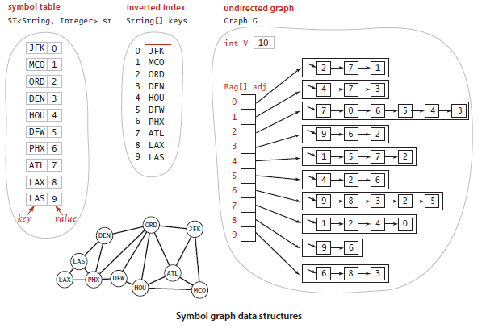
SymbolGraph
is a
Data type!

Public class SymbolGraph
{
//Unordered symbol table with keys as string and value as integer
private ST<String, Integer> st;
//The indices of the strings
private String[] keys;
//The graph
private Graph G;

public SymbolGraph(String text, String delim)
{
st = new ST<String, Integer>();
//First pass
Scanner in = new Scanner(text);
/*Builds the index by reading strings to associate each distinct string with
**an index*/
while(in.hasNextLine())
{
String[] a = in.readLine().split(delim);
for(int I = 0; I < a.length; i++)
if(!delim.contains(a[i]))
delim.put(a[i], st.size());
}
//Inverted index to get string keys to array
keys = new String[st.size()];
for(String name : st.keys())
keys[st.get(name)] = name;
//Second pass, builds the graph by connecting the first vertex on each line
//to all the others
G = new Graph(st.size());
in = new Scanner(text);
while(in.hasNextLine())
{
String[] a = in.readLine().split(delim);
int v = st.get(a[0]);
for(int I = 1; I < a.length; i++)
G.addEdge(v, st.get(a[i]));
}
}
public boolean contains(String s)
{
return st.contains(s);
}
public int index(String s)
{
return st.get(s);
}
public String name(int v)
{
return keys[v];
}
public Graph G()
{
return G;
}

Summary

