DAY-1:

PROGRAM:  
name =input()  
rollnumber =input()  
age= (input())  
mobilenumber = (input())

 print("Name :"+ name)  
print("Age :" + age)  
print("Roll Number :" + rollnumber)  
print("Mobile Number :" + mobilenumber)

OUTPUT:

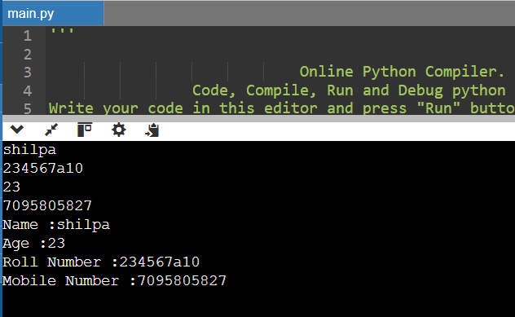

ARITHEMETIC OPERATORS:

PROGRAM:

a=(15//3);

print(a)

OUTPUT:

5

PROGRAM:  
a=(14%5);

Print(a)

OUTPUT:

4

PROGRAM:  
a=20;

b=30;

print(a>b)

print(a>=b)

print(a<=b)

print(a!=b)

print(a==b)

OUTPUT:

False

False

True

True

False

PROGRAM:

num1 = float(input("Enter first number: "))  
num2 = float(input("Enter second number: "))

addition = num1 + num2  
subtraction = num1 - num2  
multiplication = num1 * num2  
division = num1 / num2 if num2 != 0 else "Undefined (division by zero)"  
modulus = num1 % num2 if num2 != 0 else "Undefined (modulus by zero)"  
exponentiation = num1 ** num2  
floor_division = num1 // num2 if num2 != 0 else "Undefined (floor division by zero)"

print("\nArithmetic Operations:")  
print(f"{num1} + {num2} = {addition}")  
print(f"{num1} - {num2} = {subtraction}")  
print(f"{num1} * {num2} = {multiplication}")  
print(f"{num1} / {num2} = {division}")  
print(f"{num1} % {num2} = {modulus}")  
print(f"{num1} ** {num2} = {exponentiation}")  
print(f"{num1} // {num2} = {floor_division}")

OUTPUT:

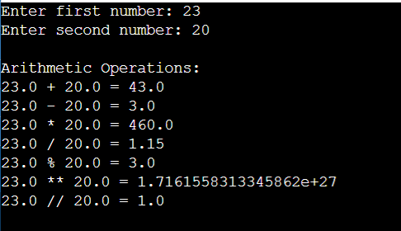

PROGRAM:

LOGICAL:

a = input("Enter first boolean value (True/False): ").strip().capitalize()  
b = input("Enter second boolean value (True/False): ").strip().capitalize()

 if a not in ["True", "False"] or b not in ["True", "False"]:  
    print("Invalid input. Please enter 'True' or 'False'.")  
else:  
    a = a == "True"  
    b = b == "True"  
    and_result = a and b  
    or_result = a or b  
    not_a = not a  
    not_b = not b  
    print("\nLogical Operations:")  
    print(f"{a} AND {b} = {and_result}")  
    print(f"{a} OR {b} = {or_result}")  
    print(f"NOT {a} = {not_a}")  
    print(f"NOT {b} = {not_b}")

OUTPUT:

