DAY-2:

BANKING SYSTEM:

PROGRAM:

balance = 1000.0  # Initial balance

print("Welcome to Simple Bank")  
print("1. Check Balance")  
print("2. Deposit Money")  
print("3. Withdraw Money")  
choice = int(input("Enter your choice (1/2/3): "))

 if choice == 1:  
    print(f"Your current balance is: ₹{balance:.2f}")

 elif choice == 2:  
    amount = float(input("Enter amount to deposit: ₹"))  
    if amount > 0:  
        balance += amount  
        print(f"₹{amount:.2f} deposited successfully.")  
        print(f"Updated balance: ₹{balance:.2f}")  
    else:  
        print("Invalid deposit amount!")

 elif choice == 3:  
    amount = float(input("Enter amount to withdraw: ₹"))  
    if 0 < amount <= balance:  
        balance -= amount  
        print(f"₹{amount:.2f} withdrawn successfully.")  
        print(f"Updated balance: ₹{balance:.2f}")  
    elif amount > balance:  
        print("Insufficient funds!")  
    else:  
        print("Invalid withdrawal amount!")

 else:  
    print("Invalid choice. Please select 1, 2, or 3.")

OUTPUT:

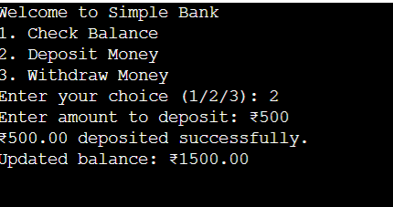

LOOPS:  
PROGRAM:

print("Odd numbers using for loop:")  
for i in range(1, 11):  
    if i % 2 != 0:  
        print(i)

print("Odd numbers using while loop:")  
i = 1  
while i <= 10:  
    if i % 2 != 0:  
        print(i)  
    i += 1

OUTPUT:

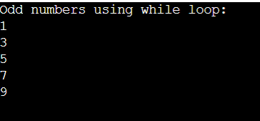

PROGRAMS:

print("Even numbers using for loop:")  
for i in range(0, 11):  
    if i % 2 == 0:  
        print(i)

print("Even numbers using while loop:")  
i = 0  
while i <= 10:  
    if i % 2 == 0:  
        print(i)  
    i += 1

OUTPUT:  
