**Source code:**

Calculator.java

package Arithmetic;

interface operations

{

void add(float a, float b);

void sub(float a, float b);

void mul(float a, float b);

void div(float a, float b);

}

public class Calculator implements operations

{

//public float a,b,c,d,m,s;

public float c,d,m,s;

public void add(float a, float b)

{ c=a+b;

System.out.println("Sum is "+c);

}

public void sub(float a, float b)

{ s=a-b;

System.out.println("Difference is "+s);

}

public void mul(float a, float b)

{ m=a*b;

System.out.println("Product is "+m);

}

public void div(float a, float b)

{ d=a/b;

System.out.println("Quotient is "+d);

}

public static void main(String args[])

{

}

}

Operations.java

import Arithmetic.Calculator;

import java.util.*;

public class Operations

{

public static void main(String args[])

{

float a,b;

Scanner sc = new Scanner(System.in);

System.out.print(“Enter a value “);

a = sc.nextFloat();

System.out.print(“Enter another value “);

b = sc.nextFloat();

Calculator cal = new Claculator();

cal.add(a,b);

cal.sub(a,b);

cal.mul(a,b);

cal.div(a,b);

}

}

**Output:**

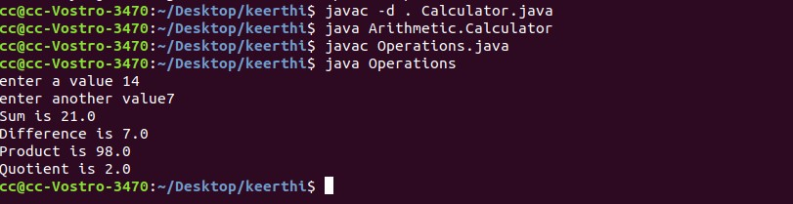

**Source code:**

import java.util.*;

class Userexception extends Exception {

public Userexception(String msg) {

super(msg);

}

}

class Passwdexception extends Exception {

public Passwdexception(String msg) {

super(msg);

}

}

class Exception_prgrm{

public static void main(String[] args) {

Scanner s = new Scanner(System.in);

System.out.print("Enter username: ");

String username = s.nextLine();

System.out.print("Enter password :: ");

String password = s.nextLine();

int length = username.length();

try {

if(length < 6)

throw new Userexception("Username must be greater than 6 characters");

else if(!password.equals("abc@123"))

throw new Passwdexception("Incorrect password");

else

System.out.println("Login Successful !!!");

}

catch (Userexception e) {

System.out.println(e);

}

catch (Passwdexception p) {

System.out.println(p);

}

}

}

**Output:**

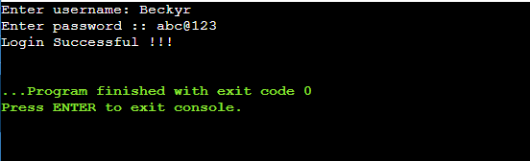

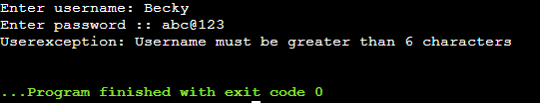

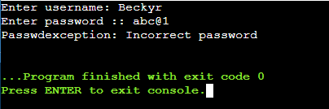

**Source code:**

import java.util.*;

class Multiplication extends Thread{

public void run(){

System.out.println("\n\nMultiplication Table of 5\n");

for(int i=1;i<=10;i++)

{

System.out.println("5*"+i+"="+(5*i));

}

}

}

class Prime extends Thread{

public void run(){

int count=0,i=1,j,n,no=0;

Scanner sc=new Scanner(System.in);

System.out.println("\n\nEnter value for N (count of prime no:):");

n=sc.nextInt();

System.out.println("Prime Numbers are:");

while(no!=n){

count=0;

for(j=2;j<=i/2;j++)

{

if(i%j==0){

count++;

break;

}

}

if(count==0&&i!=1)

{

System.out.print(i+" ");

no++;

}

i++;

}

}

}

class threadmulti{

public static void main(String args[]){

Multiplication m=new Multiplication();

m.run();

Prime p=new Prime();

p.run();

}

}

**Output:**

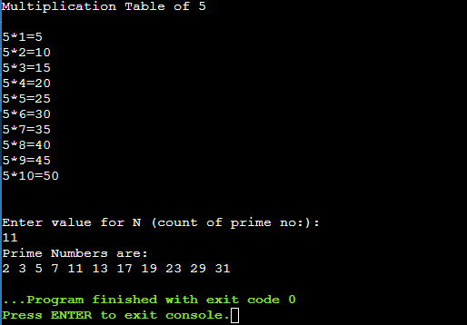

**Source code:**

import java.awt.*;

import java.awt.event.*;

import java.awt.event.WindowEvent;

import java.awt.event.WindowListener;

public class EventHandling extends Frame implements MouseListener,WindowListener{

Frame f1;

Label l;

EventHandling()

{

f1=new Frame("Event Handling ");

f1.setLayout(new GridLayout(2,1));

f1.setSize(500,400);

f1.setVisible(true);

f1.addMouseListener(this);

f1.addWindowListener(this);

l=new Label();

l.setBounds(20,50,100,20);

f1.add(l);

f1.setLayout(null);

f1.setVisible(true);

}

String msg ="";

int xpos=0,ypos=0;

public void mouseClicked(MouseEvent e) {

l.setText("Mouse Clicked");

}

public void mouseEntered(MouseEvent e) {

l.setText("Mouse Entered");

}

public void mouseExited(MouseEvent e) {

l.setText("Mouse Exited");

}

public void mousePressed(MouseEvent e) {

l.setText("Mouse Pressed");

}

public void mouseReleased(MouseEvent e) {

l.setText("Mouse Released");

}

public static void main(String args[])

{

EventHandling f1 = new EventHandling();

new EventHandling();

}

@Override

public void windowActivated (WindowEvent arg0)

{

System.out.println("activated");

}

@Override

public void windowClosed (WindowEvent arg0)

{

System.out.println("closed");

}

@Override

public void windowClosing (WindowEvent arg0)

{

System.out.println("closing");

System.exit(0);

}

@Override

public void windowDeactivated (WindowEvent arg0)

{

System.out.println("deactivated");

}

@Override

public void windowDeiconified (WindowEvent arg0)

{

System.out.println("deiconified");

}

@Override

public void windowIconified(WindowEvent arg0)

{

System.out.println("iconified");

}

@Override

public void windowOpened(WindowEvent arg0)

{

System.out.println("opened");

}

}

**Output:**

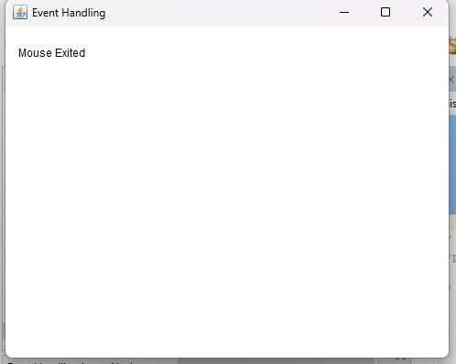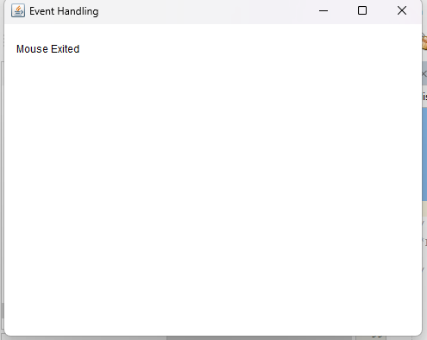

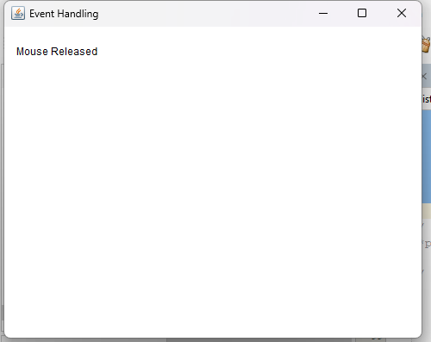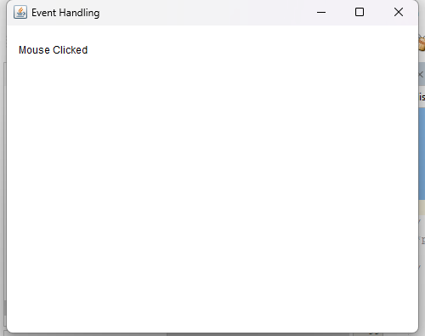

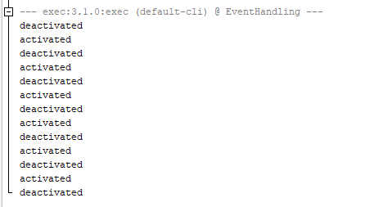

**Source code:**

import java.io.*;

import java.util.Scanner;

public class Readfile {

public static void main(String[] args) {

String fileName = "sample.txt"; // Change this to the desired file name

Scanner sc = new Scanner(System.in);

// Write to the file

try (FileWriter fileWriter = new FileWriter(fileName);

BufferedWriter bufferedWriter = new BufferedWriter(fileWriter)) {

System.out.println("Enter the text ");

String textToWrite =sc.nextLine();

bufferedWriter.write(textToWrite);

} catch (IOException e) {

e.printStackTrace();

}

// Read from the file and display on the console

try (FileReader fileReader = new FileReader(fileName);

BufferedReader bufferedReader = new BufferedReader(fileReader)) {

String line;

System.out.println("Reading from the file:");

while ((line = bufferedReader.readLine()) != null) {

System.out.println(line);

}

}

catch (IOException e) {

e.printStackTrace();

}

}

}

**Output:**

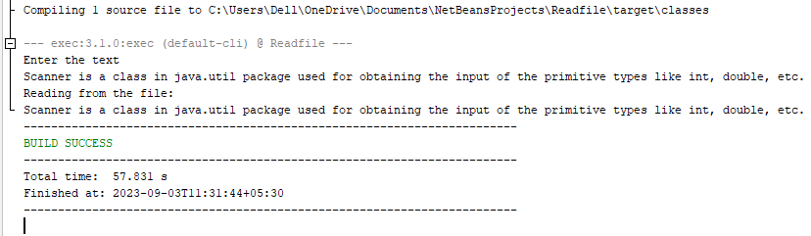

**Source code:**

import java.io.BufferedReader;

import java.io.BufferedWriter;

import java.io.FileReader;

import java.io.FileWriter;

import java.io.IOException;

import java.util.Scanner;

public class Copyfile {

public static void main(String[] args) {

Scanner sc = new Scanner(System.in);

System.out.print("Provide source file name :");

String sfile = sc.next();

System.out.print("Provide destination file name :");

String dfile = sc.next();

try {

// Create a FileReader and FileWriter

FileReader fileReader = new FileReader(sfile);

FileWriter fileWriter = new FileWriter(dfile);

// Create BufferedReader and BufferedWriter for reading and writing

BufferedReader bufferedReader = new BufferedReader(fileReader);

BufferedWriter bufferedWriter = new BufferedWriter(fileWriter);

// Read and write the contents line by line

String line;

while ((line = bufferedReader.readLine()) != null) {

bufferedWriter.write(line);

bufferedWriter.newLine(); // Add newline character

}

// Close the file streams

bufferedReader.close();

bufferedWriter.close();

System.out.println("File copied successfully!");

// Display the contents of the copied file

FileReader copiedFileReader = new FileReader(dfile);

BufferedReader copiedBufferedReader = new BufferedReader(copiedFileReader);

System.out.println("Contents of the copied file:");

while ((line = copiedBufferedReader.readLine()) != null) {

System.out.println(line);

}

copiedBufferedReader.close();

} catch (IOException e) {

System.err.println("An error occurred: " + e.getMessage());

}

}

}

**Output:**

