**Source code:**

class Welcome

{

public static void main(String args[])

{

System.out.println("Welcome Java");

}

}

**Output:**

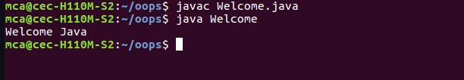

**Source code:**

class Rectangle

{

double length, breadth;

void setdata(double l,double b)

{

length = l;

breadth = b;

}

double getArea()

{

return length*breadth;

}

}

class findArea

{ public static void main(String args[])

{

Rectangle r = new Rectangle();

r.setdata(12.48,13);

System.out.println("Area of Rectangle: "+ r.getArea());

}

}

**Output:**

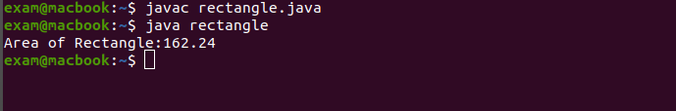

**Source Code:**

import java.util.Scanner;

class OddEven

{

public static void main(String args[])

{

Scanner sc=new Scanner(System.in);

System.out.println("Enter the number:");

int num = sc.nextInt();

if(num%2==0)

{

System.out.println(num + " is an Even number");

}

else

{

System.out.println( num + " is an Odd number ");

}

}

}

**Output:**

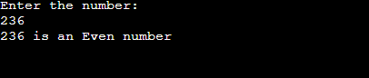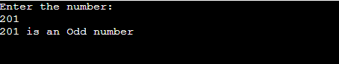

**Source Code:**

import java.util.Scanner;

class Product

{String pcode, pname;

int price;

Product(String pcode_get, String pname_get, int price_get)

{

pcode = pcode_get; pname = pname_get; this.price = price_get;

}

void compare(Product b,Product c)

{

if(price<=b.price && price<=c.price)

System.out.println("Lowest price of product is "+pname+" and price is "+price);

if(b.price<=c.price && b.price<=price)

System.out.println("Lowest price of product is "+b.pname+" and price is "+b.price);

if(c.price<=price && c.price<=price)

System.out.println("Lowest price of product is "+c.pname+" and price is "+c.price);

}

}

class Productdet

{

public static void main(String args[])

{

Product p_1=new Product("A123","Radio",887);

Product p_2=new Product("B123","Cooler",587);

Product p_3=new Product("C123","TV",1000);

p_1.compare(p_2,p_3);

}

}

**Output:**

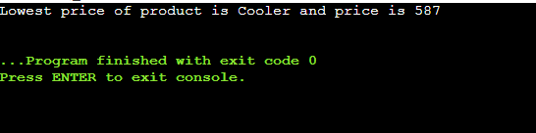

**Source Code:**

import java.util.Scanner;

class MatrixAdd

{

public static void main(String args[])

{

int i,j,rows,cols;

Scanner n=new Scanner(System.in);

System.out.println("Enter the no of rows: ");

rows=n.nextInt();

System.out.println("Enter the no of cols: ");

cols=n.nextInt();

int A[][]= new int[rows][cols];

int B[][]=new int[rows][cols];

System.out.println("Enter the elements of Matrix A: ");

for(i=0;i<rows;i++)

{

for(j=0;j<cols;j++)

{

A[i][j]=n.nextInt();

}

}

System.out.println("Enter the elements of Matrix B: ");

for(i=0;i<rows;i++)

{

for(j=0;j<cols;j++)

{

B[i][j]=n.nextInt();

}

}

int C[][]=new int[rows][cols];

System.out.println(" The sum of Matrix A and B: ");

for(i=0;i<rows;i++)

{

for(j=0;j<cols;j++)

{

C[i][j]=A[i][j]+B[i][j];

System.out.print(C[i][j]+" ");

}

System.out.println();

}

}

}

**Output:**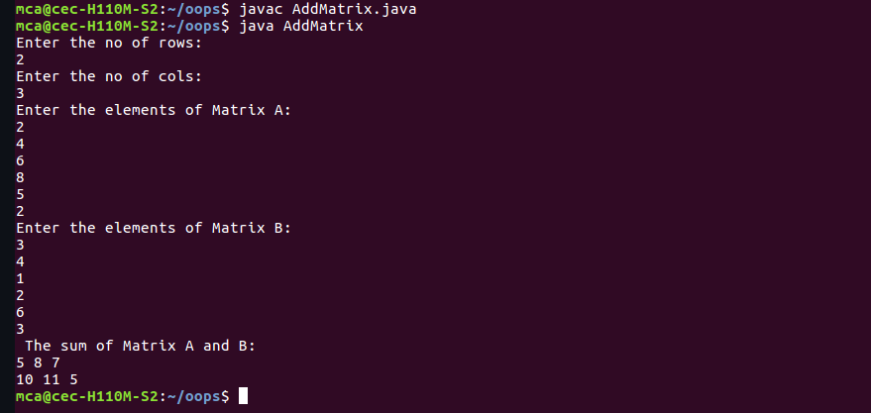

**Source Code:**

import java.util.Scanner;

public class Complex {

double real;

double imag;

public Complex(double real, double imag) {

this.real = real;

this.imag = imag;

}

public static void main(String[] args) {

Scanner s = new Scanner(System.in);

System.out.println("Enter the 1st complex no: ");

double a1 = s.nextDouble();

double b1 = s.nextDouble();

System.out.println("Enter the 2nd complex no: ");

double a2 = s.nextDouble();

double b2 = s.nextDouble();

Complex n1 = new Complex(a1, b1),

n2 = new Complex(a2, b2),

temp;

temp = add(n1, n2);

System.out.printf("Sum = "+temp.real+" + "+temp.imag+"i ");

}

public static Complex add(Complex n1, Complex n2)

{

Complex temp = new Complex(0.0, 0.0);

temp.real = n1.real + n2.real;

temp.imag = n1.imag + n2.imag;

return(temp);

}

}

**Output:**

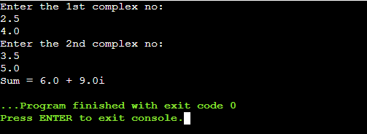

**Source Code:**

import java.util.Scanner;

class Matrix

{

public static void main(String args[])

{

int i,j,rows,cols,f=0;

Scanner n=new Scanner(System.in);

System.out.println("Enter the no of rows: ");

rows=n.nextInt();

System.out.println("Enter the no of cols: ");

cols=n.nextInt();

if(rows!=cols)

System.out.print(" Not symmetric");

else

{

int num[][]= new int[rows][cols];

System.out.println("Enter the elements of Matrix: ");

for(i=0;i<rows;i++)

{

for(j=0;j<cols;j++)

{

num[i][j]=n.nextInt();

}

}

for(i=0;i<rows;i++)

{

for(j=0;j<cols;j++)

{

if(num[i][j]!=num[j][i])

{

f=1;

break;

}

}

}

if(f==1)

System.out.println("Not Symmetric");

else

System.out.print(" Symmetric");

}

}

}

**Output:**

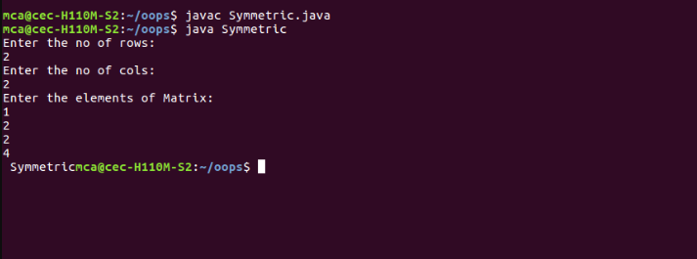

**Source Code:**

import java.util.Scanner;

class Leapyr

{

public static void main(String args[])

{

Scanner sc=new Scanner(System.in);

int start,end;

System.out.println("Enter the begining year: ");

start = sc.nextInt();

System.out.println("Enter the end year: ");

end = sc.nextInt();

System.out.println("Leap years: ");

for(int i=start;i<=end;i++)

{

if(i%4==0||(i%100!=0)&&(i%400==0))

System.out.println(i);

}

}

}

**Output:**

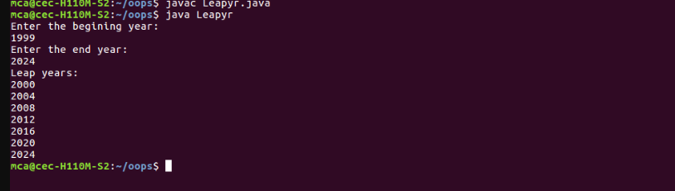

**Source Code:**

import java.util.Scanner;

class Test

{

public static void main(String args[])

{

CPU o1 = new CPU();

o1.display1();

CPU.RAM o3 = new CPU.RAM();

o3.set();

o3.display();

}

}

class CPU

{ int price;

Scanner kb = new Scanner(System.in);

void display1()

{

Processor o2 =new Processor();

o2.read();

o2.display2();

}

class Processor

{ int ncores;

String manft;

void read()

{System.out.println("Enter the price of CPU ");

price = kb.nextInt();

System.out.println("Enter the no: of cores ");

ncores = kb.nextInt();

System.out.println("Enter the name of CPU manufacturer ");

manft = kb.next();

}

void display2()

{

System.out.println("Manufacturer: " +manft);

System.out.println("Number of cores: " +ncores);

System.out.println("Price: " +price);

}

}

public static class RAM

{

Scanner kb = new Scanner(System.in);

String manf;

int mm;

void set()

{

System.out.println("Enter the memory size ");

mm = kb.nextInt();

System.out.println("Enter the name of manufacturer ");

manf = kb.next();

}

void display()

{ System.out.println("Memory Size " +mm+"GB");

System.out.println("Memory manufacturer " +manf);

}

}

}

**Output:**

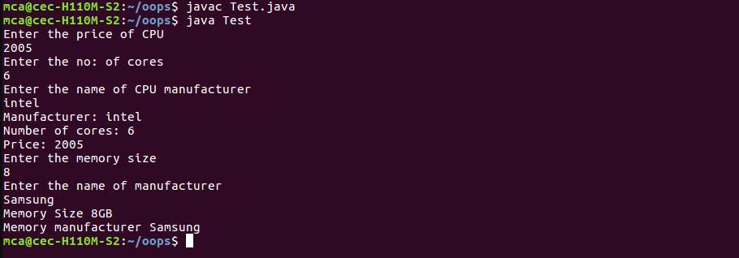

**Source Code:**

import java.util.Scanner;

public class Stdmarks

{ public static void main(String args[])

{

float per, total=0,t;

int n,i,max;

Scanner s = new Scanner(System.in);

System.out.println("Enter the number of subjects ");

n=s.nextInt();

int mark[]=new int[n];

System.out.println("Enter the maximum marks of each subject ");

max=s.nextInt();

System.out.println("Enter the mark ");

for(i=0;i<n;i++)

{

System.out.println("Enter the mark "+(i+1));

mark[i]=s.nextInt();

if(mark[i]>max)

{

System.out.println("Enter the mark less than or equal to : "+max);

i--;

}

}

for(i=0;i<n;i++)

{

total=total+mark[i];

}

t=n*max;

per=(total/t)*100;

System.out.println("Total :" +total);

System.out.println("Percentage :"+per+"%");

}

}

**Output:**

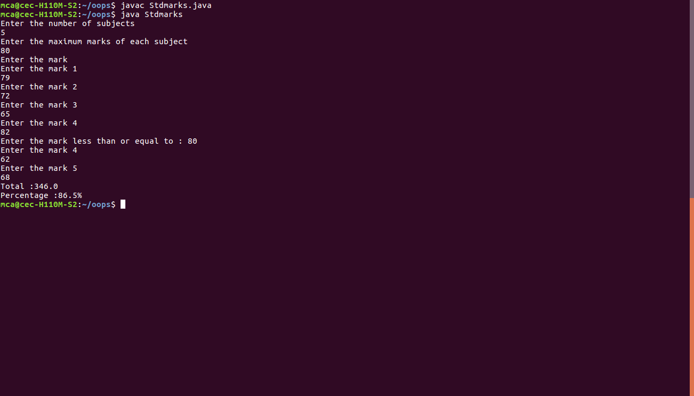

**Source Code:**

import java.util.Scanner;

class Sortstr

{

public static void main(String args[])

{

int i,j, n;

String temp;

Scanner sc=new Scanner(System.in);

System.out.println("Enter the no:of strings ");

n= sc.nextInt();

String str[]= new String[n];

Scanner s=new Scanner(System.in);

System.out.println("Enter the strings ");

for(i=0;i<n;i++)

{

str[i]=s.nextLine();

}

for(i=0;i<n;i++)

{

for(j=i+1;j<n;j++)

{ if(str[i].compareTo(str[j])>0)

{

temp=str[i];

str[i]=str[j];

str[j]=temp;

}

}

}

System.out.println("String sorted order ");

for(i=0;i<n;i++)

{

System.out.println(str[i]+" ");

}

}

}

**Output:**

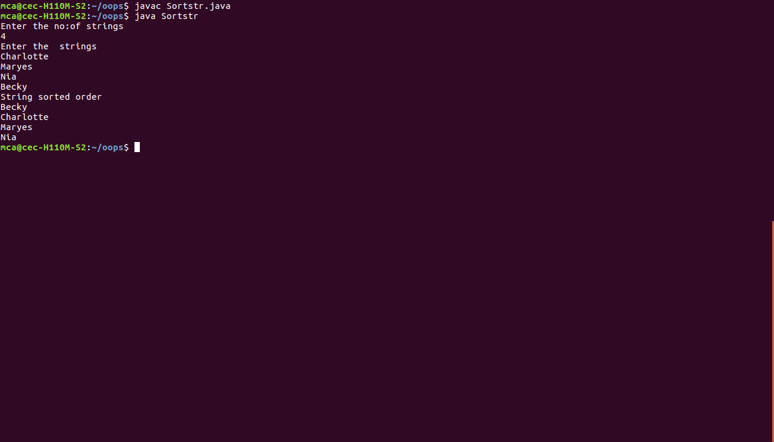

**Source Code:**

import java.util.*;

class Sort{

public static void main(String args[]){

String temp;

Scanner sc=new Scanner(System.in);

System.out.println("Enter the string");

temp=sc.nextLine();

char str_arr[]=temp.toCharArray();

Arrays.sort(str_arr);

String sorted="";

sorted=sorted.valueOf(str_arr);

System.out.println("Sorted string is \n" +sorted);

}

}

**Output:**

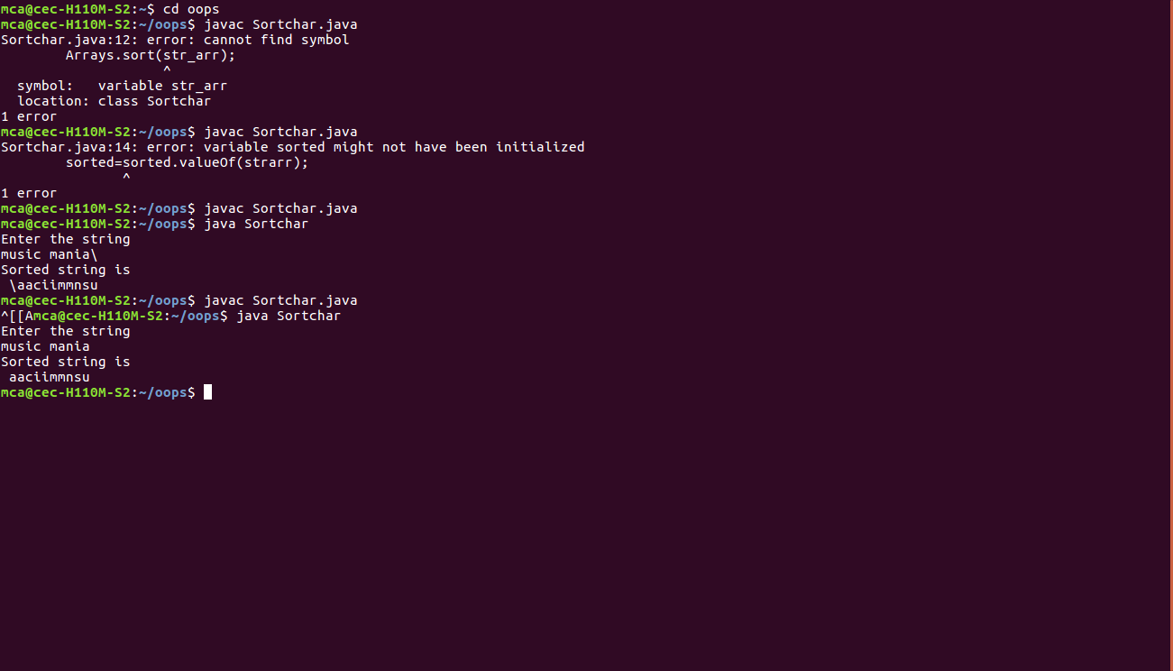

**Source Code:**

import java.util.Scanner;

class Searchele

{

public static void main(String args[])

{

int i,n,f=0;

Scanner sc=new Scanner(System.in);

System.out.println("Enter the size of array");

n=sc.nextInt();

int arr[]= new int[n];

System.out.println("Enter the elements of array");

for(i=0;i<n;i++)

arr[i]=sc.nextInt();

System.out.println("Enter the element to be searched");

int a=sc.nextInt();

for(i=0;i<n;i++)

{

if(arr[i]==a)

{

f=1;

break;

}

}

if(f==1)

System.out.println(a+" is found at position "+(i+1));

else

System.out.println("not found");

}

}

**Output:**

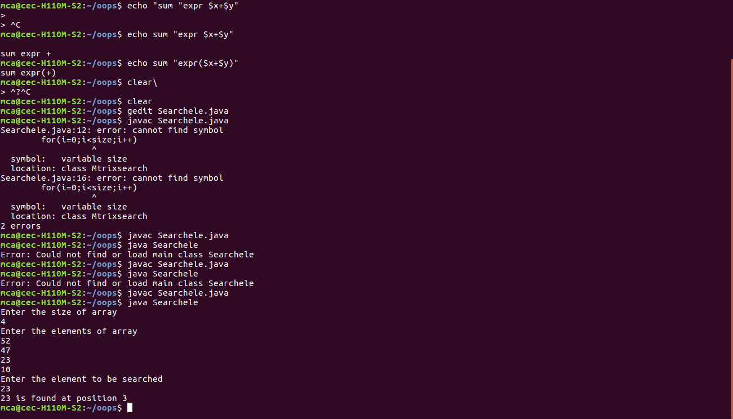

**Source Code:**

import java.util.*;

class Strman

{

public static void main(String args[])

{

Scanner sc =new Scanner(System.in);

System.out.println("String MANIPULATION METHODS");

System.out.println("enter a string: ");

String str1=sc.nextLine();

System.out.println("enter another string: ");

String str2=sc.nextLine();

String str3=str1.concat(str2);

System.out.println("After String concatenation: " + str3);

System.out.println("Length of concatnated string is : "+ str3.length());

System.out.println(str3+" converted to uppercase : "+ str3.toUpperCase());

System.out.println(str3+" after replacing all occurence of e to a : "+str3.replace('e','a'));

char ch[]=str3.toCharArray();

for(int i=0;i<ch.length;i++)

{ System.out.println("character at "+(i+1)+" is "+ch[i]);

}

System.out.println("Index position of the substring "+str2+" is "+str3.indexOf(str2));

System.out.println("\n StringBuffer CLASS METHODS");

System.out.println("enter a string: ");

String temp=sc.nextLine();

StringBuffer str=new StringBuffer(temp);

System.out.println("enter another string: ");

String temp1=sc.nextLine();

str.append(temp1);

System.out.println(temp+" after String concatenation: " + str);

System.out.println("Length of string :"+str1+" is "+str1.length());

System.out.println("enter a substring: ");

String temp2=sc.nextLine();

System.out.println("enter a position where the substring has to be inserted: ");

int pos =sc.nextInt();

str.insert(pos,temp2);

System.out.println("changed string : "+str);

}

}

**Output:**

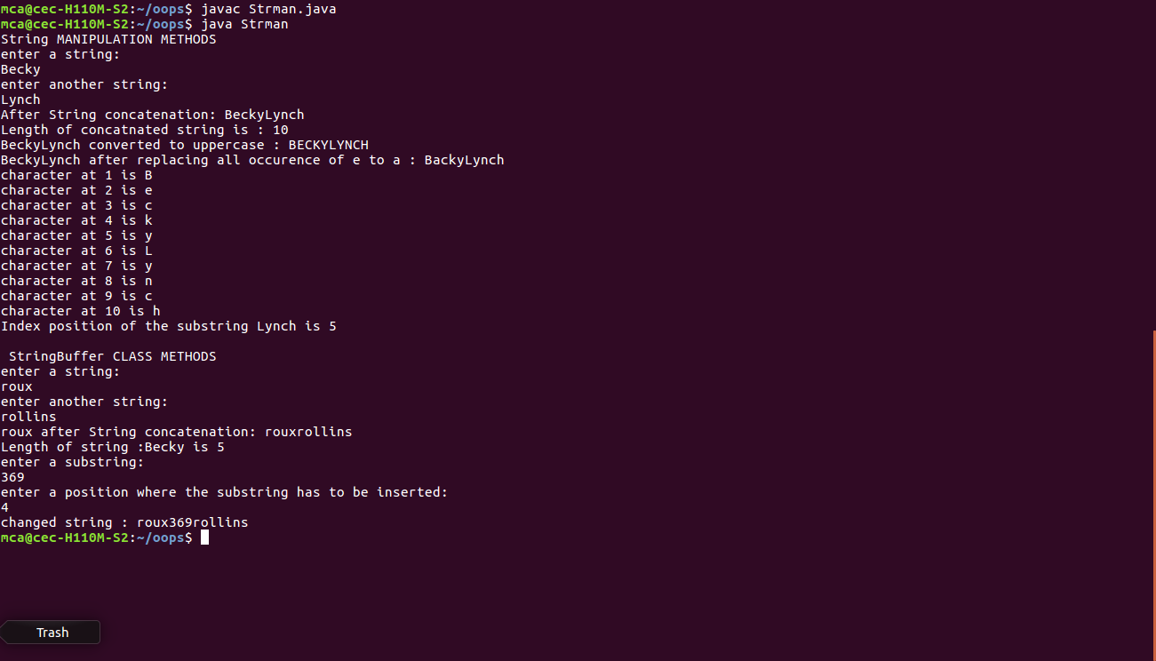

**Source Code:**

import java.util.*;

class Employee

{

int e_no;

String e_name;

float e_salary;

Employee(int id,String name,float sal)

{

e_no=id;

e_name=name;

e_salary=sal;

}

}

class Main

{

public static void main(String args[])

{

Scanner sc = new Scanner(System.in);

Scanner s = new Scanner(System.in);

int id,i,flag=0;

String name;

float sal;

System.out.println("Enter the no.of employees: ");

int n=sc.nextInt();

Employee[] obj=new Employee[n];

for(i=0;i<n;i++)

{

System.out.println("Enter the details of employee: " + (i+1));

System.out.println("Employee no: ");

id=sc.nextInt();

System.out.println("Employee name: ");

name=s.nextLine();

System.out.println("Employee salary: ");

sal=sc.nextFloat();

obj[i]=new Employee(id,name,sal);

}

System.out.println("Enter the employee id to be searched: ");

int temp=sc.nextInt();

for(i=0;i<n;i++)

{

if(obj[i].e_no==temp)

{

System.out.println("Result found!");

flag=1;

break;

}

}

if(flag==1)

System.out.println("Employee name: "+ obj[i].e_name);

else

System.out.println("Not found" );

}

}

**Output:**

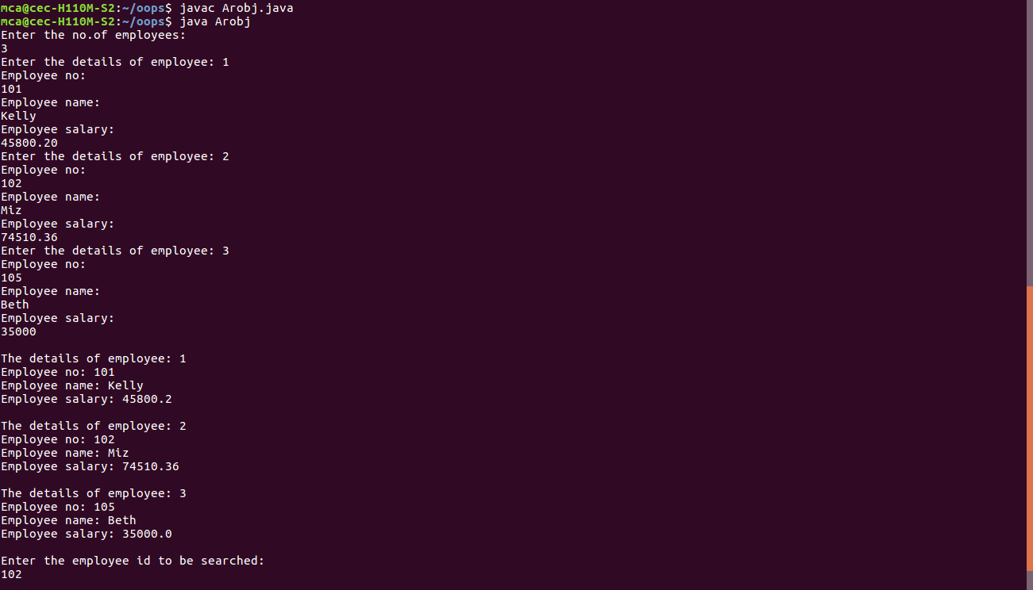

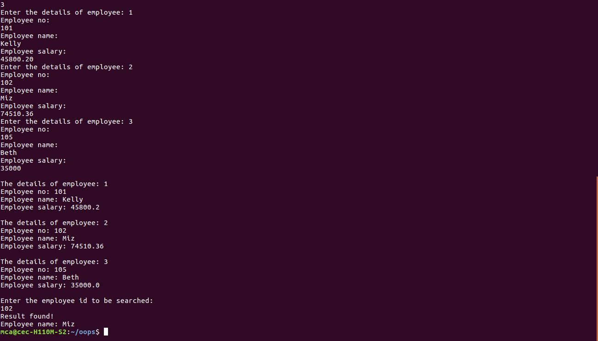

**Source Code:**

import java.util.*;

class Area

{

void area(int l, int b)

{

int r=l*b;

System.out.println("Area of rectangle: "+r);

}

void area(double r)

{

double a=3.14*r*r;

System.out.println("Area of circle: "+a);

}

void area(int side)

{

int ar=side*side;

System.out.println("Area of square: "+ar);

}

}

class mthold

{

public static void main(String args[])

{

Scanner s = new Scanner(System.in);

System.out.println("Enter the length and breadth of rectangle ");

int l=s.nextInt();

int b=s.nextInt();

System.out.println("Enter the radius of circle ");

double r=s.nextDouble();

System.out.println("Enter the side of square ");

int side=s.nextInt();

Area o = new Area();

o.area(l,b);

o.area(r);

o.area(side);

}

}

**Output:**

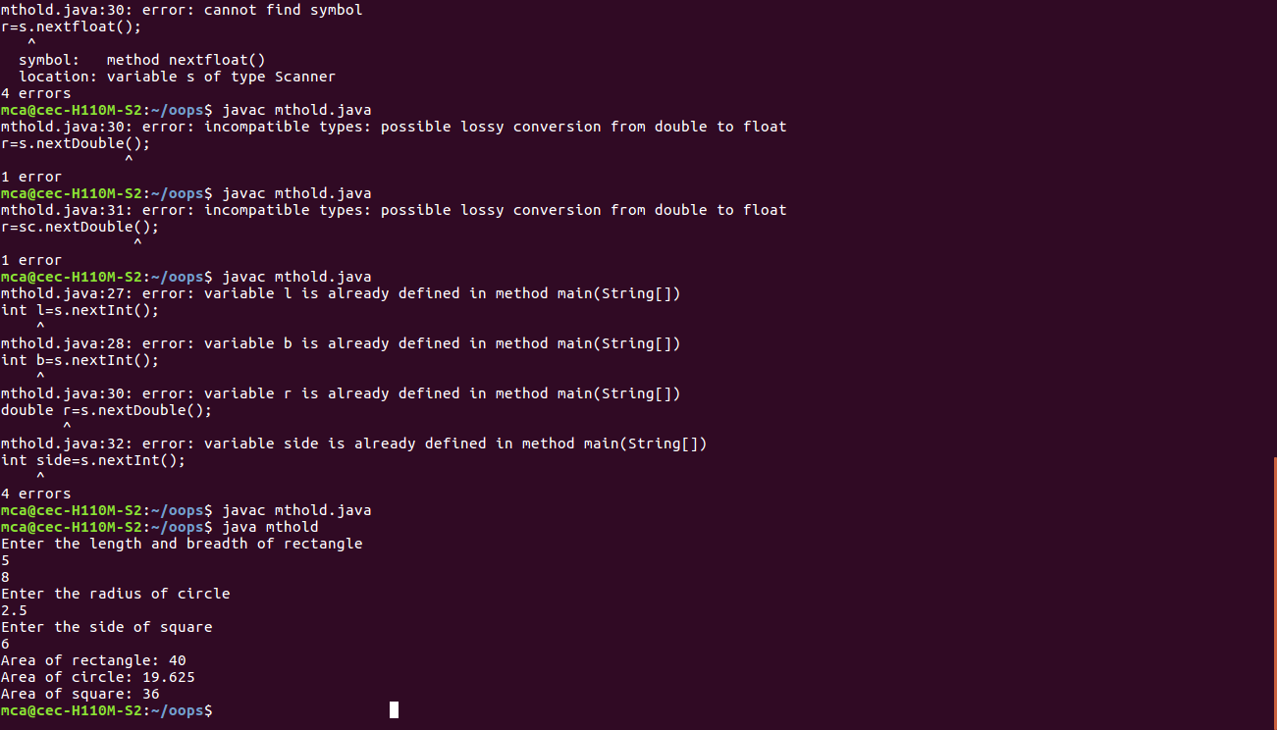

**Source code:**

import java.util.*;

class Employee

{

public int empid;

public String ename, addr;

public float sal;

Employee(int id, String name, String eaddr,float saly)

{empid=id;

ename=name;

addr=eaddr;

sal=saly;

}

}

class Teacher extends Employee

{

public String subj,dept;

Teacher(int id, String name, String eaddr,float saly,String dep,String sub)

{super(id,name,eaddr,saly);

subj=sub;

dept=dep;

}

public void display()

{

System.out.println("Employee id : "+empid);

System.out.println("Employee name : "+ename);

System.out.println("Employee Address : "+addr);

System.out.println("Employee Salary : "+sal);

System.out.println("Department : "+dept);

System.out.println("subjects taught by teacher: "+subj);

System.out.println("----------------------------------------------");

}

}

class Simplein

{

public static void main(String args[]){

int i;

Scanner sc =new Scanner(System.in);

System.out.println("Enter the no of employee");

int n=sc.nextInt();

Teacher[] t=new Teacher[n];

for(i=0;i<n;i++)

{

System.out.println("enter the details of Employee "+(i+1));

System.out.println("Employee id:");

int empid=sc.nextInt();

System.out.println("Employee Salary:");

float sal=sc.nextFloat();

sc.nextLine();

System.out.println("Employee name:");

String name=sc.nextLine();

System.out.println("Employee Address:");

String addr=sc.nextLine();

System.out.println("Teacher Department:");

String dept=sc.nextLine();

System.out.println("Subject taught by teacher:");

String subj=sc.nextLine();

t[i] = new Teacher(empid,name,addr,sal,dept,subj);

}

for(i=0;i<n;i++)

t[i].display();

}

}

**Output:**

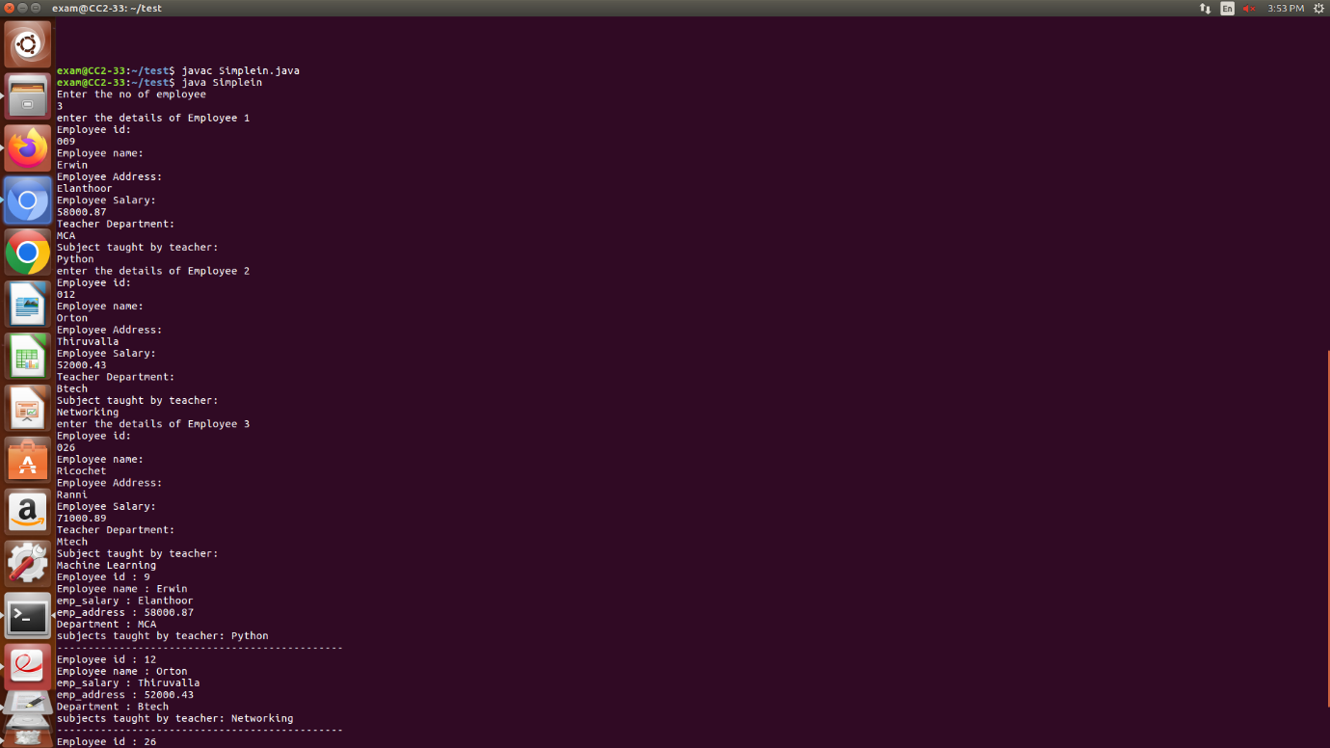

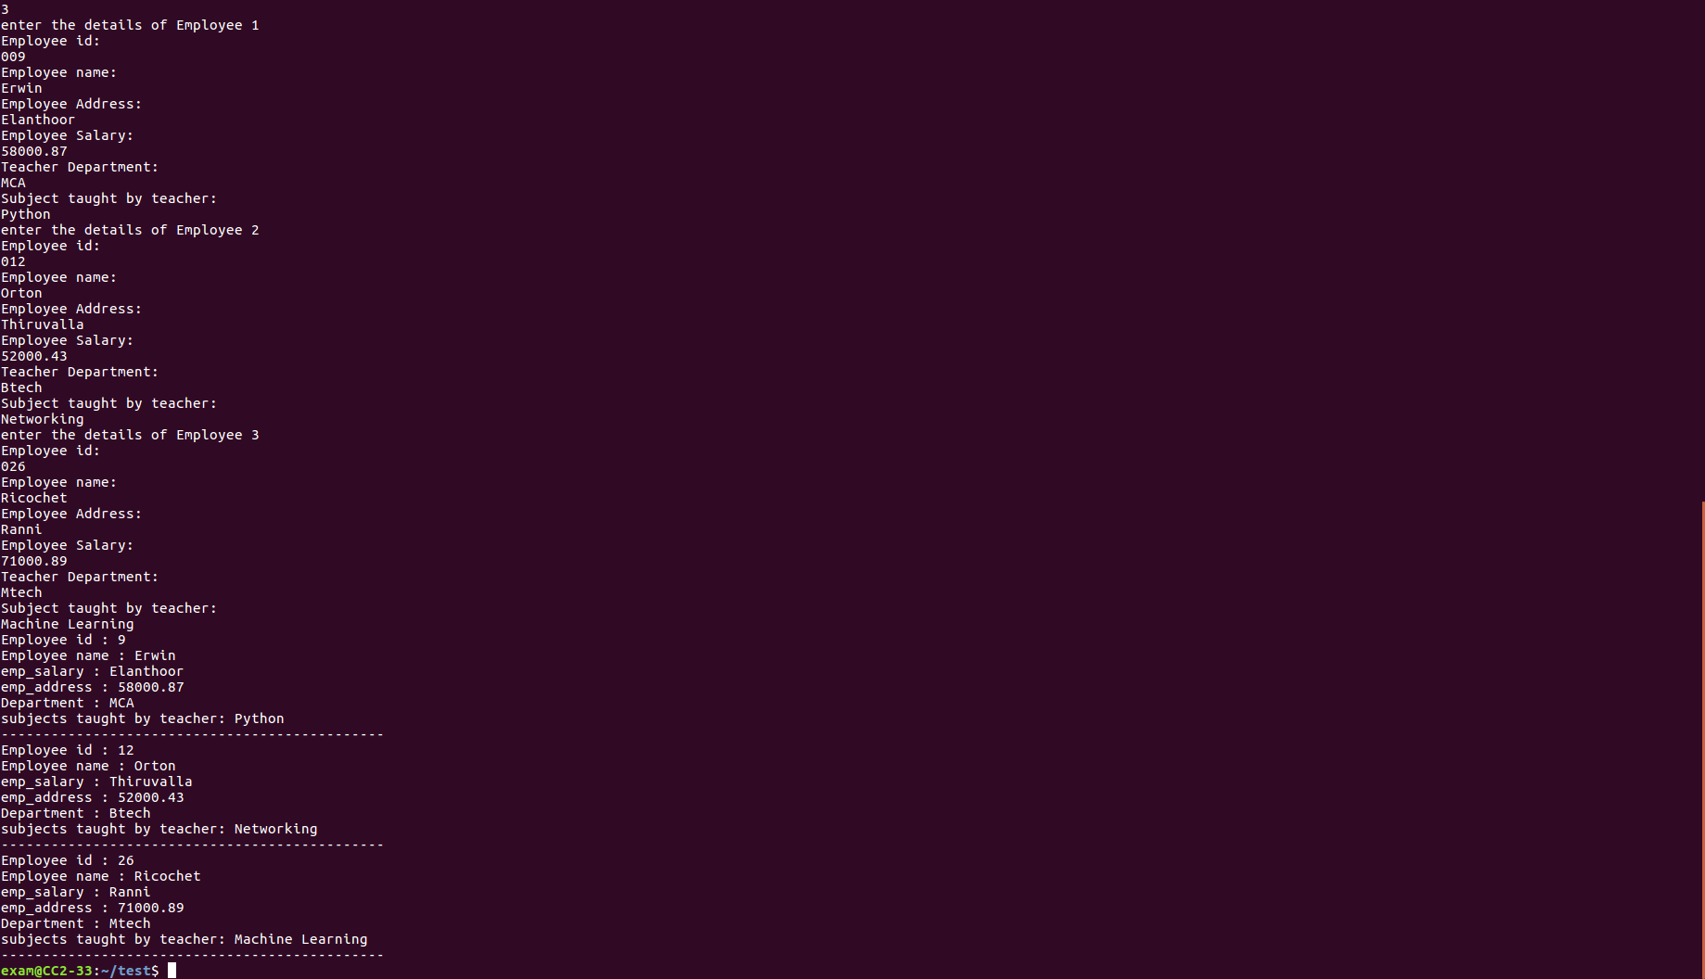

**Source code:**

import java.util.*;

class Person

{

public int age;

public String pname,gender,address;

Person(String name,String sex,String add,int age)

{

pname=name;

this.age=age;

gender=sex;

address=add;

}

}

class Employee extends Person

{

public int empid;

public String cpname,qual;

public float salary;

Employee(int id,String cname,float sal,String quali,String name,String sex,String add,int age)

{

super(name,sex,add,age);

empid=id;

cpname=cname;

salary=sal;

qual=quali;

}

}

class Teacher extends Employee

{

public int tchid;

public String dept,sub;

Teacher(int id,String cname,float sal,String quali,String name,String sex,String add,int age,String dep,String subj,int tid)

{

super(id,cname,sal,quali,name,sex,add,age);

tchid=tid;

dept = dep;

sub = subj;

}

public void display(){

System.out.println();

System.out.println("Person Name : "+pname);

System.out.println("Person Age : "+age);

System.out.println("Person Gender :"+gender);

System.out.println("Person Address :" +address);

System.out.println("emp_id :"+empid);

System.out.println("Cname :"+cpname);

System.out.println("Emp Salary :"+salary);

System.out.println("emp_Qualificatio :"+qual);

System.out.println("Teacher id :"+tchid);

System.out.println("Employee Department :"+dept);

System.out.println("Teacher subjects taught :"+sub);

System.out.println("----------------------------------------------");

}

}

class Mulin{

public static void main(String args[]){

int i;

Scanner sc =new Scanner(System.in);

System.out.println("enter the no of Persons");

int n=sc.nextInt();

Teacher[] t=new Teacher[n];

for(i=0;i<n;i++)

{

System.out.println("enter the details of Persons"+(i+1));

System.out.println("Employee id:");

int id=sc.nextInt();

System.out.println("Employee Salary:");

float sal=sc.nextFloat();

System.out.println("Teacher id:");

int tid=sc.nextInt();

System.out.println("Person age:");

int age=sc.nextInt();

sc.nextLine();

System.out.println("Person name:");

String name=sc.nextLine();

System.out.println("Person Gender:");

String sex=sc.nextLine();

System.out.println("Person Address:");

String add=sc.nextLine();

System.out.println("Company name:");

String cname=sc.nextLine();

System.out.println("Employee Qualification:");

String quali=sc.nextLine();

System.out.println("Teacher Department:");

String dep=sc.nextLine();

System.out.println("Subject taught by teacher:");

String subj=sc.nextLine();

t[i] = new Teacher(id,cname,sal,quali,name,sex,add,age,dep,subj,tid);

}

for(i=0;i<n;i++)

t[i].display();

}

}

**Output:**

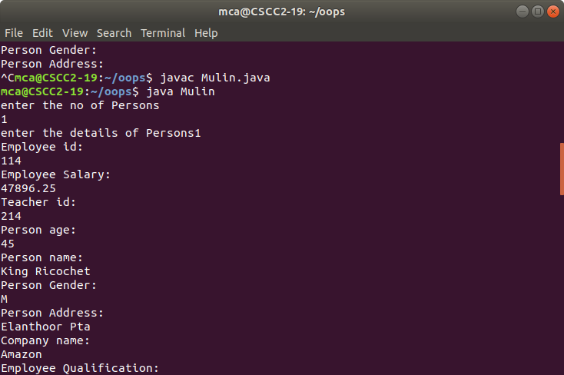

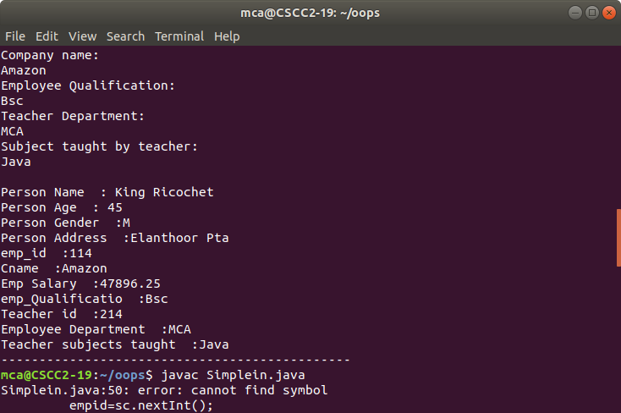

**Source code:**

import java.util.Scanner;

class Publisher

{

String pub_name;

Publisher(String name)

{

pub_name=name;

}

}

class Book extends Publisher

{

String nbook,author;

float price;

Book(String pname,String aname,String bname,float price)

{

super(pname);

nbook=bname;

author=aname;

this.price=price;

}

}

class Literature extends Book

{

Literature(String bname,String aname,String pname,float p1)

{

super(pname,aname,bname,p1);

}

void display1()

{

System.out.println("Publisher name: " + pub_name);

System.out.println("Name of the book: : " + nbook);

System.out.println("Author name: " + author);

System.out.println("Price of book: " + price);

}

}

class Fiction extends Book

{

Fiction(String bname,String aname,String pname,float p2)

{

super(pname,aname,bname,p2);

}

void display2()

{

System.out.println("Publisher name: " + pub_name);

System.out.println("Name of the book: " + nbook);

System.out.println("Author name: " + author);

System.out.println("Price of book: " + price);

}

}

class Hierin

{

public static void main(String args[])

{

Scanner sc=new Scanner(System.in);

System.out.println("Enter details of the book(literature): ");

System.out.println("Name of book: ");

String b1name=sc.nextLine();

System.out.println("Name of author: ");

String a1name=sc.nextLine();

System.out.println("Publisher name: ");

String p1name=sc.nextLine();

System.out.println("Price: ");

float p1=sc.nextFloat();

Scanner s=new Scanner(System.in);

System.out.println("Enter details of the book(fiction): ");

System.out.println("Name of book: ");

String b2name=s.nextLine();

System.out.println("Name of author: ");

String a2name=s.nextLine();

System.out.println("Publisher name: ");

String p2name=s.nextLine();

System.out.println("Price: ");

float p2=s.nextFloat();

System.out.println(" ");

System.out.println("Book Details : ");

Literature l=new Literature(b1name,a1name,p1name,p1);

l.display1();

System.out.println(" ");

System.out.println("Book Details : ");

Fiction f=new Fiction(b2name,a2name,p2name,p2);

f.display2();

}

}

**Output:**

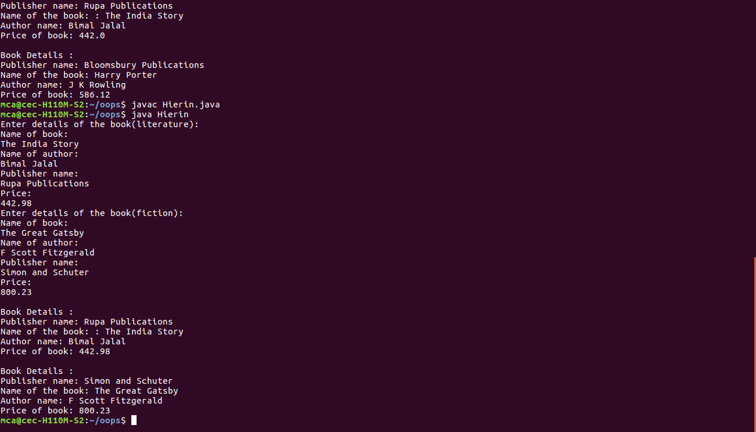

**Source Code:**

import java.util.*;

interface Student

{

void read1(String sname,float s,String admsn);

}

interface Sports

{

void read2(float p);

}

class Result implements Student, Sports

{

public String name,admsn;

public float total;

public float point;

public void read1(String sname,float s,String regno)

{

name=sname;

total=s;

admsn=regno;

}

public void read2(float pt)

{

point=pt;

}

public void display()

{

System.out.println("Register number: "+admsn);

System.out.println("Name: " +name);

System.out.println("Academic CGPA: "+total);

System.out.println("Score obtained in sports: "+point);

}

}

class interfaceSS

{

public static void main(String args[])

{

Scanner sc=new Scanner(System.in);

Scanner s=new Scanner(System.in);

float pt,total;

System.out.print("Enter the admission number: ");

String admsn=sc.nextLine();

System.out.print("Name of the student: ");

String name=sc.nextLine();

System.out.println("Enter the academic and sports details of a student: ");

System.out.print("Enter the total CGPA obtained: ");

total=s.nextFloat();

System.out.print("Enter the overall score point obtained in sports(out of 10): ");

pt=s.nextFloat();

Result o =new Result();

o.read1(name,total,admsn);

o.read2(pt);

o.display();

}

}

**Output:**

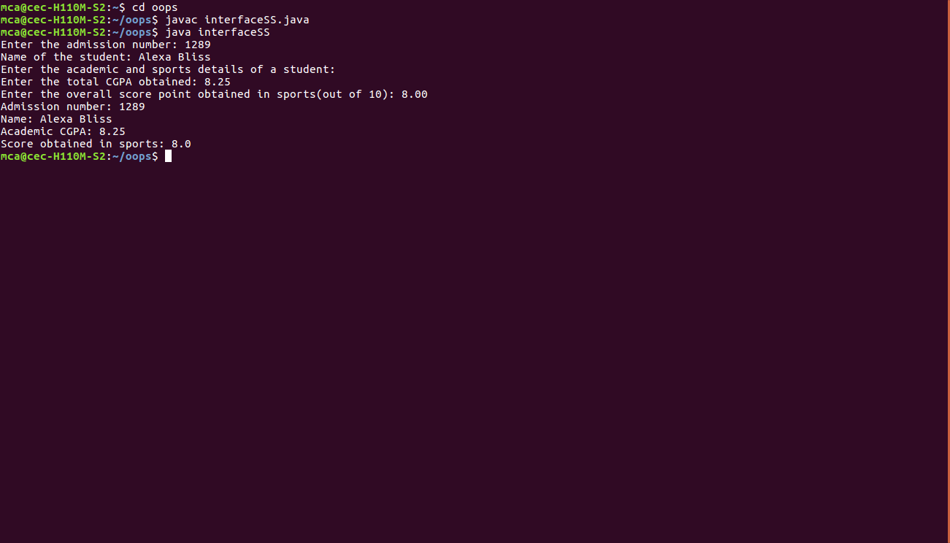

**Source code:**

import java.util.*;

interface interface1

{

void area();

void perimeter();

}

class Circle implements interface1

{

public float r;

Circle(float rad)

{

r=rad;

}

public void area()

{

System.out.println("Area of the circle is: " + (3.14*r*r));

}

public void perimeter()

{

System.out.println("Perimeter of the circle is: " + (2*3.14*r));

}

}

class Rectangle implements interface1

{

public float len,bdth;

Rectangle(Float l, Float b)

{

len=l;

bdth=b;

}

public void area()

{

System.out.println("Area of the rectangle is: " + (len*bdth));

}

public void perimeter()

{

System.out.println("Perimeter of the rectangle is: " + (2*(len+bdth)));

}

}

class AreaPeri

{

public static void main(String[]args)

{

int ch=1;

while(ch == 1)

{

Scanner sc=new Scanner(System.in);

System.out.println("\n 1.Circle 2. Rectangle ");

System.out.print("Enter your choice: ");

int choice=sc.nextInt();

switch(choice)

{

case 1:

System.out.print("Enter the radius of the circle: ");

float r=sc.nextFloat();

Circle c=new Circle(r);

c.area();

c.perimeter();

break;

case 2:

System.out.print("Enter the length of the rectangle:");

float l=sc.nextFloat();

System.out.print("Enter the breadth of the rectangle: ");

float b=sc.nextFloat();

Rectangle rec=new Rectangle(l,b);

rec.area();

rec.perimeter();

break;

}

System.out.print("Want to continue?(1(yes) or 0(no)) ");

ch=sc.nextInt();

}

}

}

**Output:**

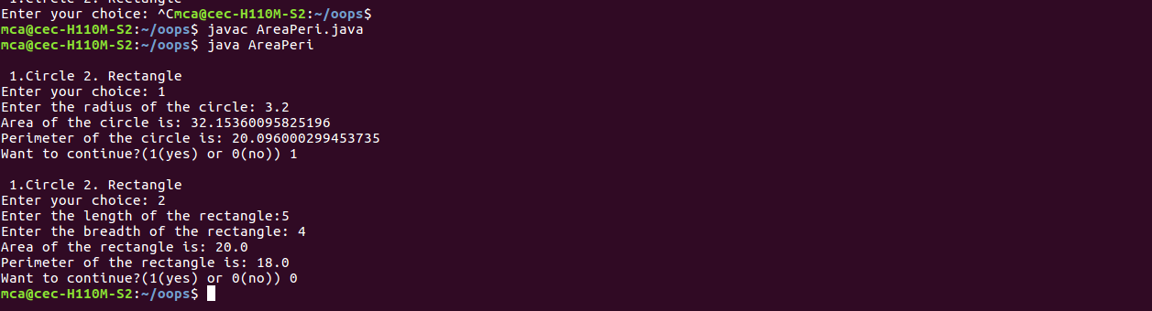

**Source code:**

import java.util.*;

import java.text.SimpleDateFormat;

interface bill

{

void method();

}

class Product implements bill

{

String p_name;

int p_id,p_qty,order_no;

float p_price,total_price;

Product()

{

}

Product(String name,int id,int qty,float price,float total)

{

p_name=name;

p_id=id;

p_qty=qty;

p_price=price;

total_price=total;

}

void display()

{

Date date = new Date();

SimpleDateFormat formatter = new SimpleDateFormat("dd/MM/yy");

String str = formatter.format(date);

Random rand = new Random();

int upperbound = 25;

int int_random = rand.nextInt(upperbound);

System.out.println("\n");

System.out.println("Order no:"+ int_random);

System.out.println("Date: " + str);

System.out.println("-------------------------------

--------------------------------------------------");

System.out.println("\nProduct Id\tName\t Quantity\tUnit price\tTotal");

}

public void method()

{

System.out.println(p_id+"\t\t" +p_name+"\t\t" +p_qty+"\t" +p_price+"\t\t" +total_price);

}

}

class Bill

{

public static void main(String args[])

{

Scanner sc=new Scanner(System.in);

Scanner s=new Scanner(System.in);

float net_amt=0,total;

System.out.print("Enter the total number of items: ");

int n=sc.nextInt();

Product [] obj=new Product[n];

for(int i=0;i<n;i++)

{

System.out.println("Enter product" + " " +(i+1) + " " + "details:");

System.out.print("Name: ");

String name = s.nextLine();

System.out.print("ID: ");

int id= sc.nextInt();

System.out.print("Quantity: ");

int qty = sc.nextInt();

System.out.print("Price (per item): ");

float price = sc.nextFloat();

total = price * qty;

net_amt+=total;

obj[i]=new Product(name,id,qty,price,total);

}

Product prdct=new Product();

prdct.display();

for(int i=0;i<n;i++)

obj[i].method();

System.out.println("---------------------------------------------------------------------------------");

String temp="Net Amount";

System.out.println("\t\t\t\t\t\t"+temp+" "+net_amt);

System.out.println();

}

}

**Output:**

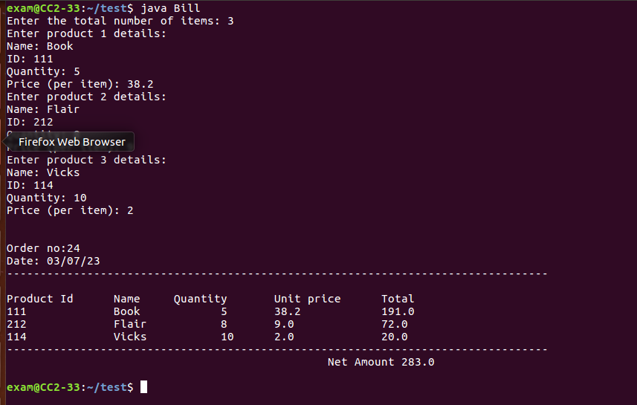

**Source code:**

import java.util.*;

class Dimen

{

public float a,b;

Dimen()

{

}

Dimen(float side)

{

a=side;

}

Dimen(float len,float bdth)

{

a=len;

b=bdth;

}

void area()

{

System.out.println("Area of different shapes ");

}

}

class Square extends Dimen

{

Square(float a)

{

super(a);

}

void area()

{

System.out.println("Area of square: "+a*a);

}

}

class Rectangle extends Dimen

{

Rectangle(float a,float b)

{

super(a,b);

}

void area()

{

System.out.println("Area of rectangle: "+a*b);

}

}

class Circle extends Dimen

{

Circle(float a)

{

super(a);

}

void area()

{

System.out.println("Area of circle: "+3.14*a*a);

}

}

class Overriding

{

public static void main(String args[])

{

Scanner sc =new Scanner(System.in);

Dimen d=new Dimen();

d.area();

System.out.println("Enter the side of square ");

float a=sc.nextFloat();

Square sq=new Square(a);

sq.area();

System.out.println("Enter the length of rectangle ");

float l=sc.nextFloat();

System.out.println("Enter the breadth of rectangle ");

float b=sc.nextFloat();

Rectangle rec=new Rectangle(l,b);

rec.area();

System.out.println("Enter the radius of circle ");

float r=sc.nextFloat();

Circle c=new Circle(r);

c.area();

}

}

**Output:**

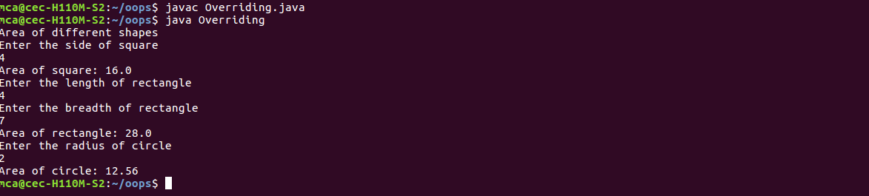

**Source code:**

import java.util.*;

abstract class Shape

{

abstract void calculate_area();

}

class Rectangle extends Shape

{

float len,bdth;

Rectangle(float l,float b)

{

len=l;bdth=b;

}

void calculate_area()

{

System.out.println("Area of rectangle is " + " " + (len*bdth));

}

}

class Circle extends Shape

{

float radius;

Circle(float r)

{

radius=r;

}

void calculate_area()

{

System.out.println("Area of circle is " + " " + (3.14*radius*radius));

}

}

class Square extends Shape

{

float side;

Square(float a)

{

side=a;

}

void calculate_area()

{

System.out.println("Area of square is " + " " + (side*side));

}

}

class Abstract

{

public static void main(String args[]){

Scanner sc=new Scanner(System.in);

System.out.print("Enter the length of the rectangle: ");

float l=sc.nextFloat();

System.out.print("Enter the breadth of the rectangle: ");

float b=sc.nextFloat();

Shape obj1=new Rectangle(l,b);

obj1.calculate_area(); System.out.print("Enter the radius of the circle: ");

float r=sc.nextFloat();

Shape obj2=new Circle(r);

obj2.calculate_area();

System.out.print("Enter the side length of the square: ");

float a=sc.nextFloat();

Shape obj3=new Square(a);

obj3.calculate_area();

}

}

**Output:**

