LABCYCLE 2

EXPERIMENT NO:1

FACTORIAL

Date: 12/12/2022

AIM: Program to find the factorial of a number.

ALGORITHM:

Step 1: Start.

Step 2: Input an integer number from the user.

Step 3: Initialize fact=1.

Step 4: Use for loop to multiply “fact” with all the numbers less than and equal to the number given by the user.

Step 5: Now, print the factorial of that number.

Step 6: Stop.

PROGRAM CODE:

def fact(num):

f=1

if num==0:

print("Factorial is : ",f)

elif num<0:

print("Can't find the factorial ")

else:

for i in range(1,num+1):

f=f*i

print("Factorial of ", num," is ",f)

num=int(input("Enter the number to find Factorial "))

fact(num)

OUTPUT:

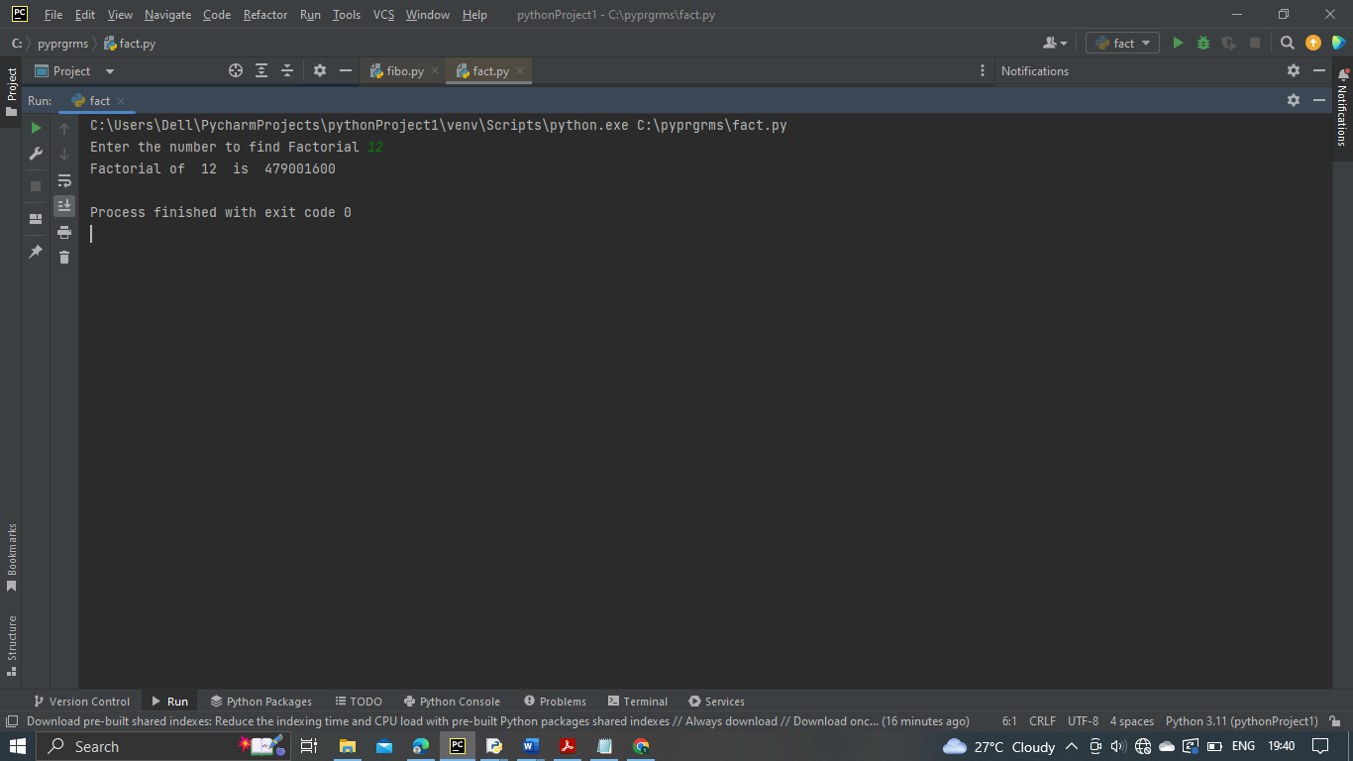

RESULT:

Program to find factorial has been executed successfully and output is verified.

LABCYCLE 2

EXPERIMENT NO:2

FIBONACCI SERIES

Date: 12/12/2022

AIM: Generate Fibonacci series of N terms.

ALGORITHM:

Step 1: Take the first two numbers of the series and the number of terms to be printed from the user.

Step 2: Print the first two numbers.

Step 3: Use a for loop to find the sum of the first two numbers and then proceed the fibonacci series.

Step 4: Print the fibonacci series till n-+1.

Step 5: Stop.

PROGRAM CODE:

a=int(input("enter the 1st no in the series "))

b=int(input("enter the 2nd no in the series "))

n=int(input("enter the no: of terms needed "))

print("Fibonacci series ")

print(a,b, end=" ")

for i in range(2,n+1):

f=a+b

a=b

b=f

print(f, end=" ")

OUTPUT:

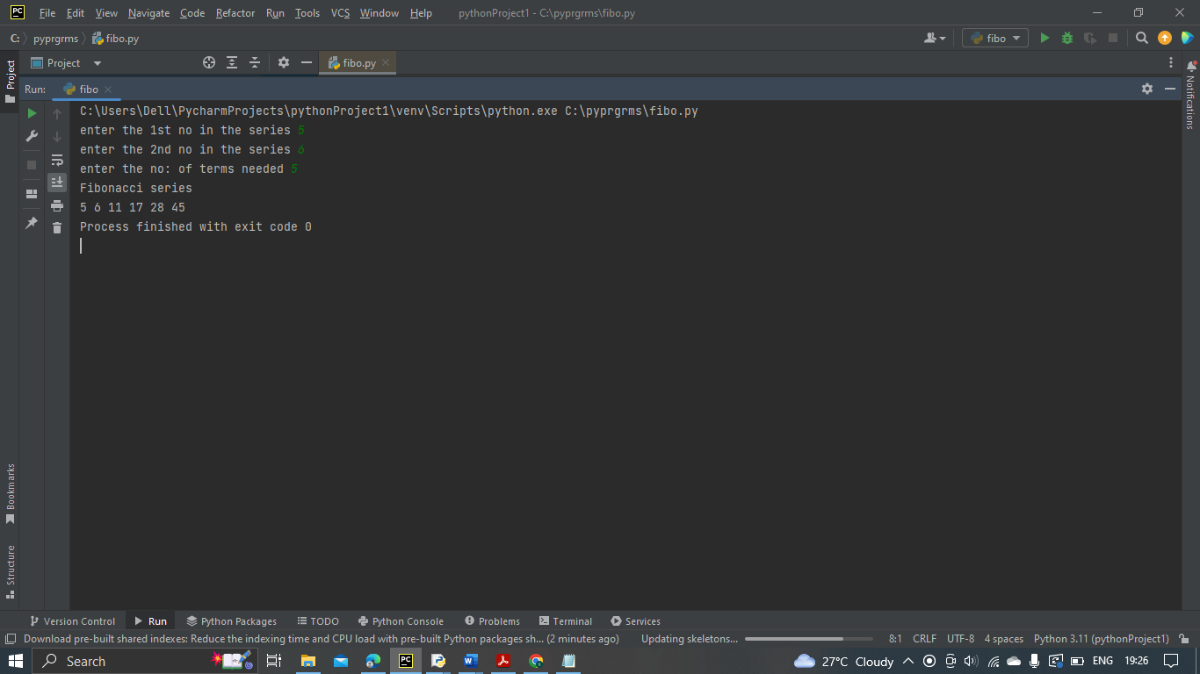

RESULT:

Program to display fibonacci has been executed successfully and output is verified.

LABCYCLE 2

EXPERIMENT NO:3

SUM OF ITEMS IN A LIST

Date: 12/12/2022

AIM: Find the sum of all items in a list.

ALGORITHM:

Step 1: Start.

Step 2: Take the number of elements in the list and store it in a variable.

Step 3: Accept the values into the list using for loop and insert into the list.

Step 4: Initialize a variable s=0 to store the sum.

Step 5: Access each element in list using for loop and take sum.

Step 6: Print s.

Step 7: Stop.

PROGRAM CODE:

list1=[]

len1=int(input("Enter the number of elements you want to add on list "))

for i in range(0,len1):

print("Enter the element ",i+1)

inp=int(input())

list1.append(inp)

s=0

for i in list1:

s=s+i

print("Sum of elements in list are ",s)

OUTPUT:

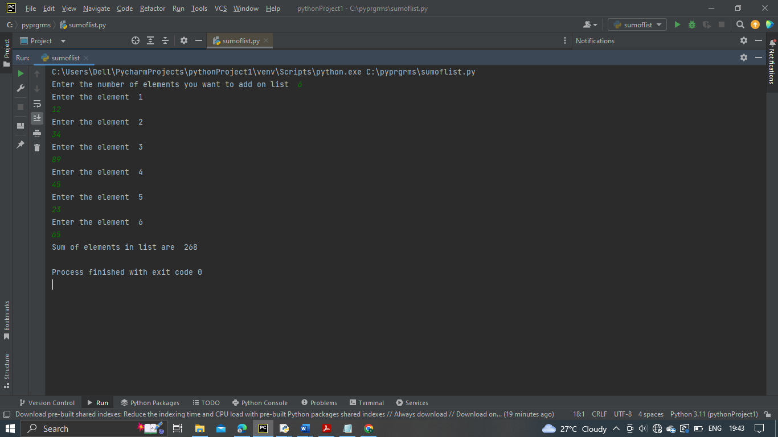

RESULT:

Program to find sum of elements in a list has been executed successfully and output is verified.

LABCYCLE 2

EXPERIMENT NO:4

EVEN FOUR DIGIT IS A PERFECT SQUARE

Date: 14/12/2022

AIM: Generate a list of four digit numbers in a given range with all their digits even and the

number is a perfect square.

ALGORITHM:

Step 1: Start.

Step 2: Set the lower and upper range for four-digit number.

Step 3: Set the lower and upper range for the square number which result four-digit.

Step 4: Check for each digit is even or not.

Step 5: Print the number.

Step 6: Stop.

PROGRAM CODE:

print("Four digit even perfect square ")

for i in range(1000,10000,1):

for j in range(32,100,1):

if i==j*j:

string=str(i)

if int(string[0])%2==0 and int(string[1])%2==0 and

int(string[2])%2==0 and int(string[3])%2==0:

print(i)

OUTPUT:

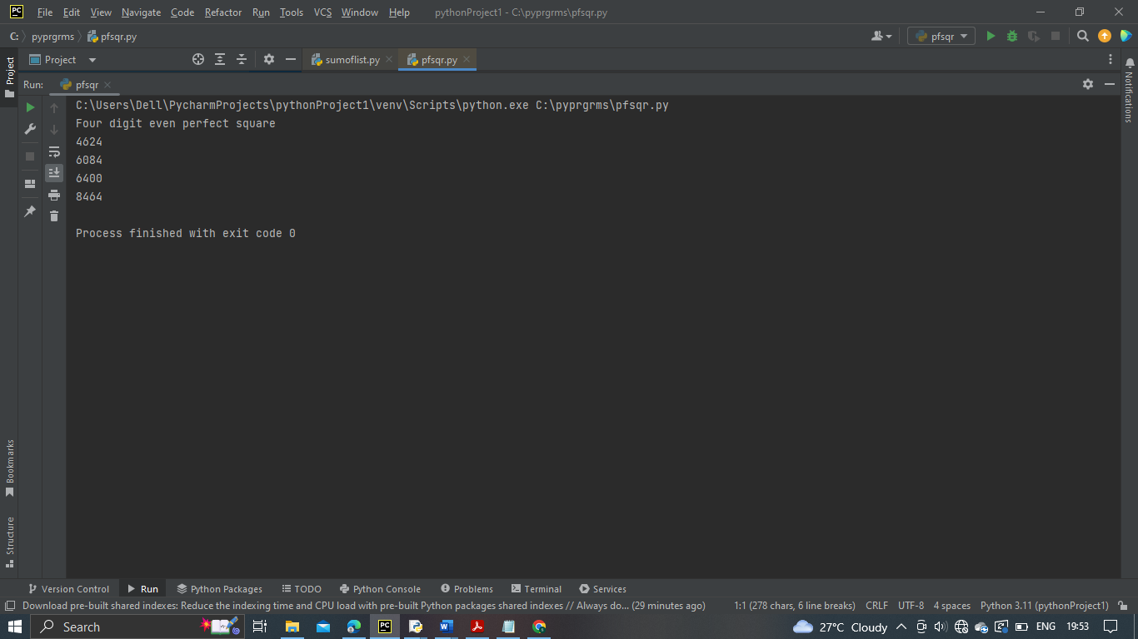

RESULT:

Program to find even four digit perfect square has been executed successfully and output is verified.

LABCYCLE 2

EXPERIMENT NO:5

NUMBER PYRAMID

Date: 19/12/2022

AIM: Display the given pyramid with step number accepted from user.

1

2 4

3 6 9

4 8 12 16

ALGORITHM:

Step 1: Start.

Step 2: Set the limit.

Step 3: Set the range of values.

Step 4: Print product.

Step 5: Stop.

PROGRAM CODE:

rows=int(input("Enter the number of rows: "))

step=int(input("Enter the step number: "))

for i in range(1,rows+1,step):

for j in range(1,i+1,step):

print(i*j,end=" ")

print("\n")

OUTPUT:

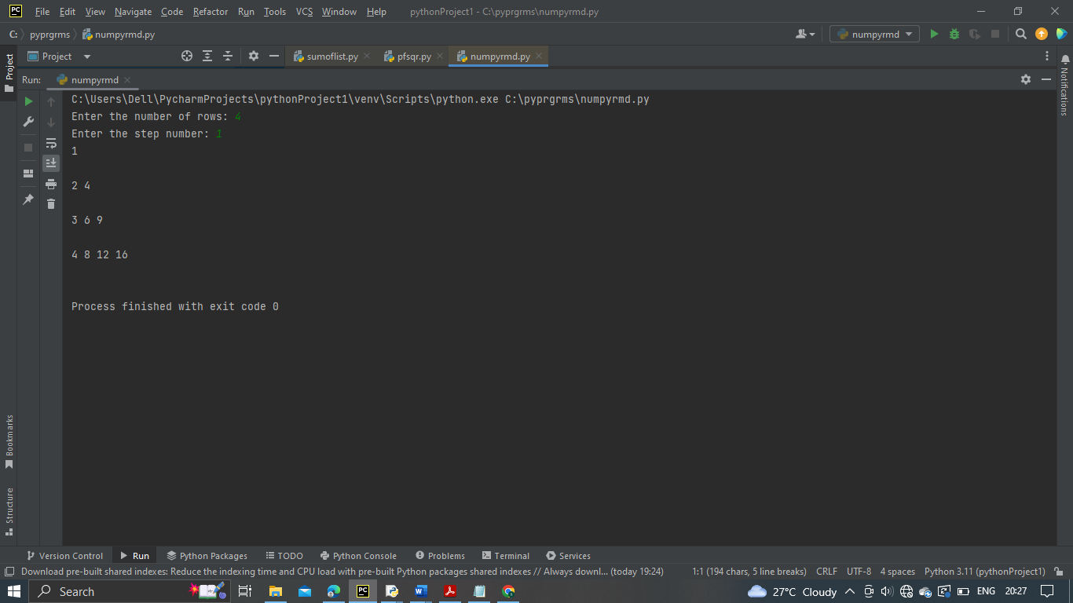

RESULT:

Program to display number pyramid has been executed successfully and output is verified.

LABCYCLE 2

EXPERIMENT NO:6

CHARACTER FREQUENCY

Date: 14/12/2022

AIM: Count the number of characters (character frequency) in a string.

ALGORITHM:

Step 1: Start.

Step 2: Define a string.

Step 3: Define an array freq with same size of the string.

Step 4: Two loops will be used to count the frequency of each character. Outer loop will be used to select a character and initialize element at corresponding index in array freq with 1.

Step 5: Inner loop will compare the selected character with rest of the character present in the string.

Step 6: If a match found ,increment element in freq by 1 and set the duplicated of selected character by ‘0’ to mark them as visited.

Step 7: Finally, display the character and their corresponding frequencies by iterating through the array freq.

Step 8: Stop.

PROGRAM CODE:

string = input("Enter a string ")

freq=[None]*len(string)

for i in range(0,len(string)):

freq[i]=1

for j in range(i+1,len(string)):

if(string[i]==string[j]):

freq[i]=freq[i]+1

string=string[:j]+'0'+string[j+1:]

print("Characters and their corresponding frequencies")

for i in range(0,len(freq)):

if(string[i]!='' and string[i]!='0'):

print(string[i]+"-"+str(freq[i]))

OUTPUT:

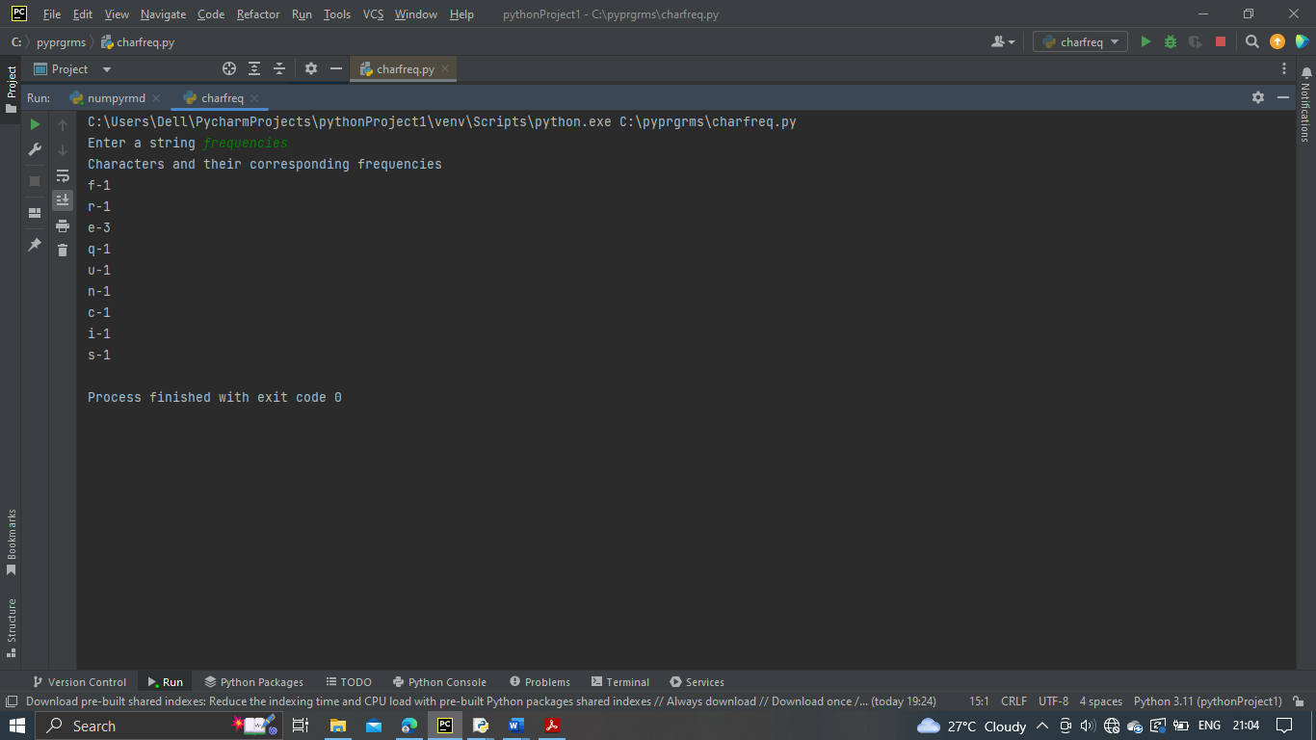

RESULT:

Program to print character frequency has been executed successfully and output is verified.

LABCYCLE 2

EXPERIMENT NO:7

ADDING “ly” AND “ing” TO A STRING

Date: 14/12/2022

AIM: Add ‘ing’ at the end of a given string. If it already ends with ‘ing’, then add ‘ly’.

ALGORITHM:

Step 1: Start.

Step 2: Input a string and find the length of string.

Step 3: Check if length greater than 0:

If ing present in string , str+=”ly”.

Else:

str+=”ing”

Step 4: Print string.

Step 5: Stop.

PROGRAM CODE:

def addstr(str):

l=len(str)

if l>0:

if str[-3:]=="ing":

str+="ly"

else:

str+="ing"

print(str)

str=input("Enter the string ")

addstr(str)

OUTPUT:

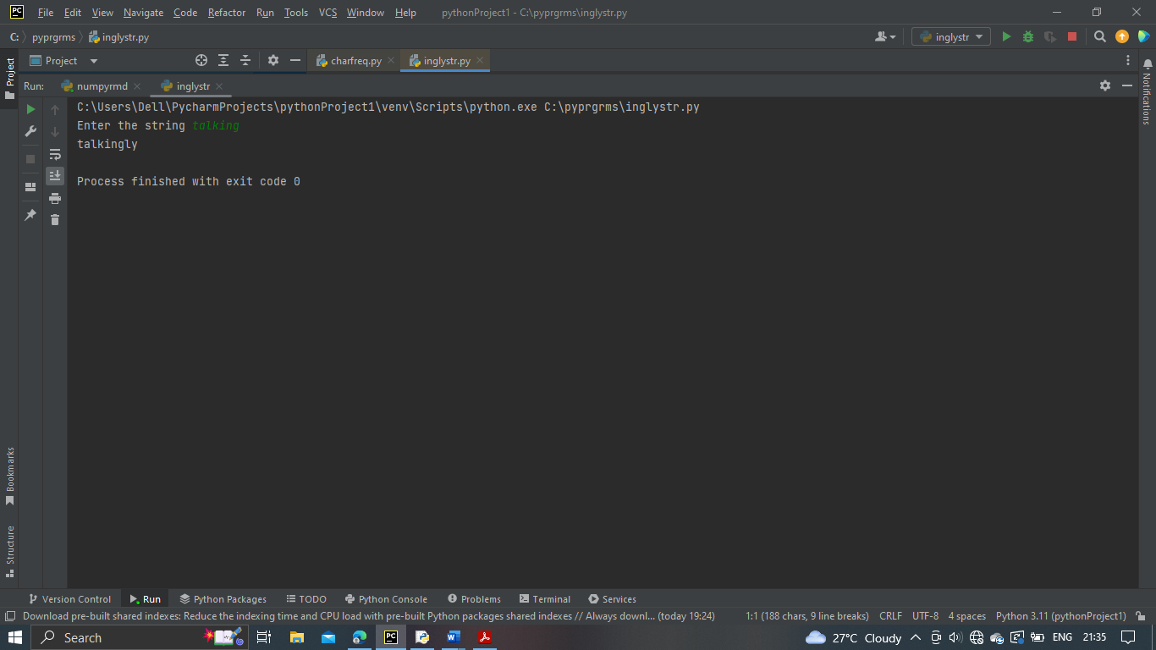

RESULT:

Program to add “ly” and “ing” to a string has been executed successfully and output is verified.

LABCYCLE 2

EXPERIMENT NO:8

LONGEST WORD

Date: 14/12/2022

AIM: Accept a list of words and return length of longest word.

ALGORITHM:

Step 1: Start.

Step 2: Initialize an empty list and size of list.

Step 3: Using for loop access each element and add to list.

Step 4: Check the length of each element and compare with first element in list. If it is greater than first element then store in temp variable.

Step 5: Print the word.

Step 6: Stop.

PROGRAM CODE:

a=[]

n=int(input("Enter the size of the list "))

for i in range(1,n+1):

print("Enter the ",i," element ")

inp=input()

a.append(inp)

max1=len(a[0])

temp=a[0]

for i in a:

if len(i)>max1:

max1=len(i)

temp=i

print("The word with longest length is ",temp," with ",max1)

OUTPUT:

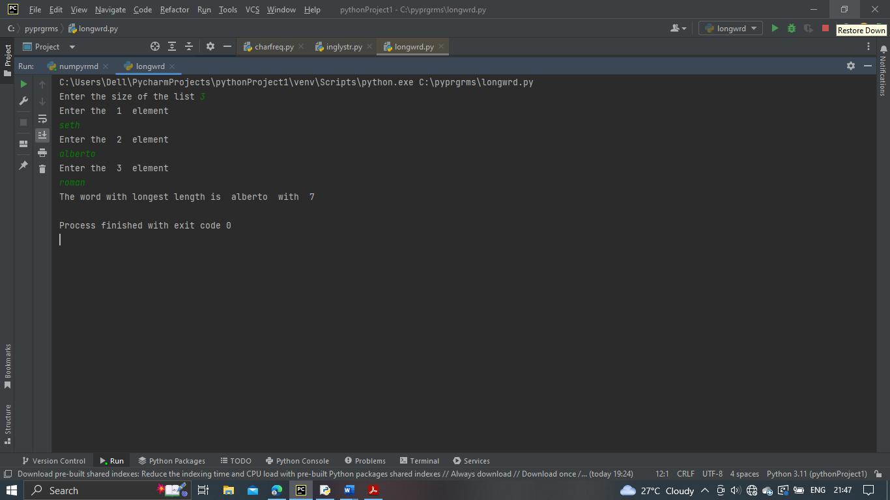

RESULT:

Program to get longest word in a list has been executed successfully and output is verified.

LABCYCLE 2

EXPERIMENT NO:9

PRINT PATTERN

Date: 12/12/2022

AIM: Construct following pattern using nested loop.

*

* *

* * *

* * * *

* * * * *

* * * *

* * *

* *

*

ALGORITHM:

Step 1: Start.

Step 2: Input the maximum range of pattern.

Step 3: Use outer for loop and inner for loop and print the pattern till the range.

Step 4: Then reverse the range in step 4 and print the pattern.

Step 5: Stop.

PROGRAM CODE:

n=5

for i in range (0,n):

for j in range(0,i):

print("*",end=" ")

print(" ")

for i in range (n,0,-1):

for j in range(0,i):

print("*", end=" ")

print(" ")

OUTPUT:

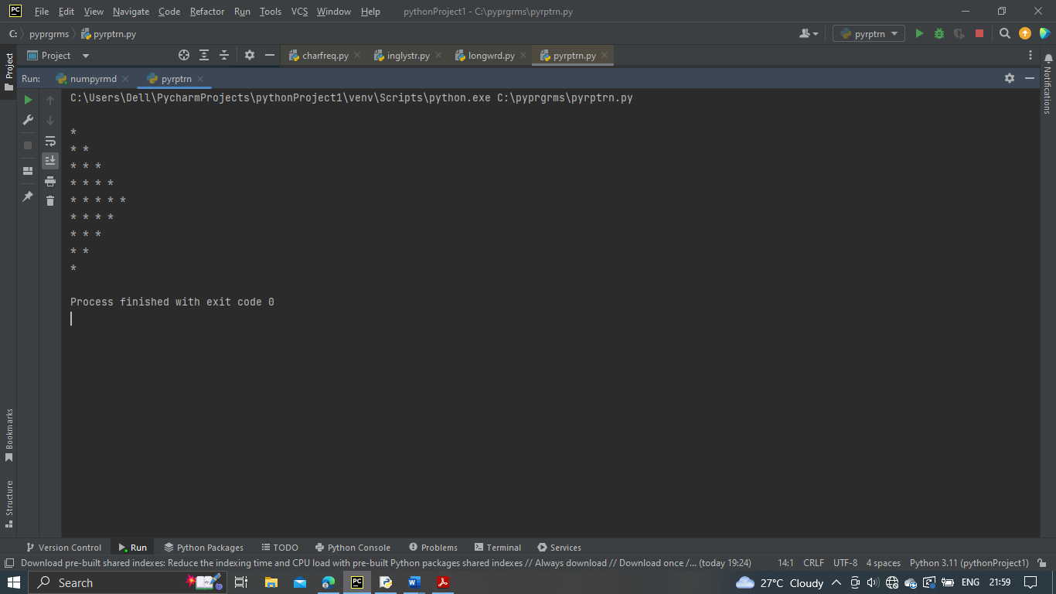

RESULT:

Program to print pattern has been executed successfully and output is verified.

LABCYCLE 2

EXPERIMENT NO:10

FACTORS

Date: 19/12/2022

AIM: Generate all factors of a number.

ALGORITHM:

Step 1: Start.

Step 2: Input a number to find the factor.

Step 3: Check the divisibility of number in range 1 till number.

Step 4: Print if number divisible by i.

Step 5: Stop.

PROGRAM CODE:

num=int(input("Enter the number to find factor "))

print("Factors of ",num," are\n")

for i in range(1,num+1):

if num%i==0:

print(i)

OUTPUT:

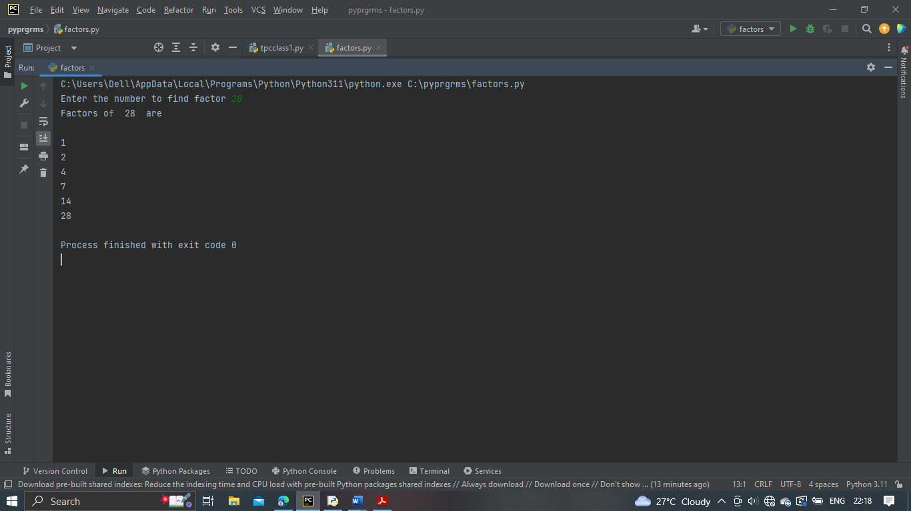

RESULT:

Program to find factors has been executed successfully and output is verified.

LABCYCLE 2

EXPERIMENT NO:11

LAMBDA FUNCTIONS

Date: 19/12/2022

AIM: Write lambda functions to find area of square, rectangle and triangle.

ALGORITHM:

Step 1: Start.

Step 2: Initialize a function with lambda function with arguments for square, rectangle and triangle.

Step 3: Input the dimensions for square, rectangle and triangle.

Step 4: Call each 3 three functions and print values.

Step 5: Stop.

PROGRAM CODE:

area_s=lambda a : a*a

area_rect=lambda l,b : l*b

area_triangle=lambda b1,h :0.5*b1*h

a=int(input("Enter the side of the square "))

print("Area of square ",area_s(a))

l=int(input("Enter the length of rectangle "))

b=int(input("Enter the breadth of rectangle "))

print("Area of rectangle ",area_rect(l,b))

b1=int(input("Enter the base of triangle "))

h=int(input("Enter the base of triangle "))

print("Area of triangle ",area_triangle(b1,h))

OUTPUT:

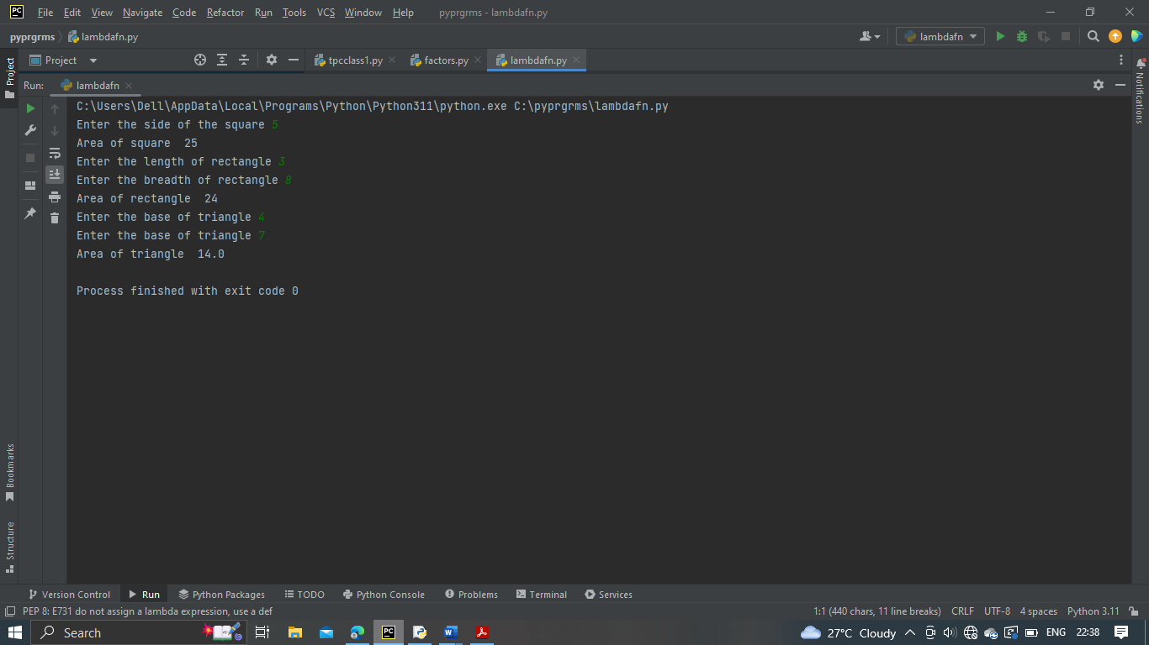

RESULT:

Program to perform lambda function has been executed successfully and output is verified.