Lab Cycle 3
Experiment No:4
Date: 11/04/2023
Aim: Familiarization of Stored Procedure, Function, Cursor and Triggers.

1. Create a procedure which will receive account_id and amount to withdraw. If the account does not exist, it will display a message. Otherwise, if the account exists, it will allow the withdrawal only if the new balance after the withdrawal is at least 1000.

SQL> CREATE TABLE ACCOUNT (
account_id INT PRIMARY KEY,
balance DECIMAL(10, 2)
);

SQL>INSERT INTO ACCOUNT (account_id, balance)
VALUES(1, 1500.00), (2, 2200.50), (3, 1800.75), (4, 1300.25), (5, 2500.00);

SQL> DELIMITER //
CREATE PROCEDURE WithdrawMoney (
IN acID INT,
IN withdraw_amount DECIMAL(10, 2)
)

BEGIN
DECLARE current_balance DECIMAL(10, 2);
DECLARE updatedBalance DECIMAL(10, 2);
i

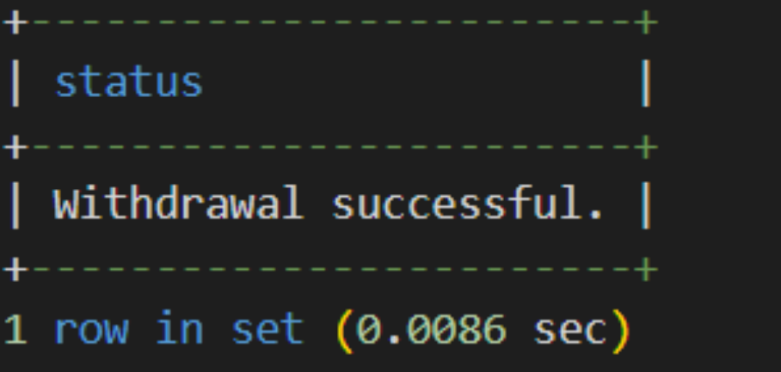

ii.

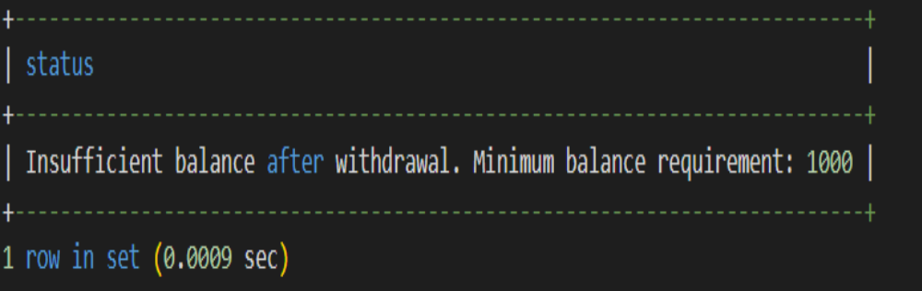

IF EXISTS (SELECT 1 FROM account WHERE account_id = acID) THEN
SELECT balance INTO current_balance FROM account WHERE account_id = acID;
IF current_balance - withdraw_amount >= 1000 THEN
SET updatedBalance = current_balance - withdraw_amount;
UPDATE account SET balance = updatedBalance WHERE account_id = acID;
SELECT 'Withdrawal successful.' as status;
ELSE
SELECT 'Insufficient balance after withdrawal. Minimum balance requirement: 1000' as status;
END IF;
ELSE
SELECT 'Account does not exist.';
END IF;
END;
//
DELIMITER ;

i. SQL> call WithdrawMoney(5,500);
ii. SQL> call WithdrawMoney(1,600);

2. Create a ‘Customer’ table with attributes customer id, name, city and credits. Write a stored procedure to display the details of a particular customer from the customer table, where name is passed as a parameter.

SQL> SQL> CREATE TABLE Customer (
customer_id INT PRIMARY KEY,
name VARCHAR(50),
city VARCHAR(50),
credits DECIMAL(10, 2)
);
SQL> INSERT INTO Customer (customer_id, name, city, credits)
VALUES
(1, 'John Doe', 'New York', 1500.00),
(2, 'Jane Smith', 'Los Angeles', 2000.50),
(3, 'Michael Johnson', 'Chicago', 1800.75),
(4, 'Emily Brown', 'Houston', 1200.25),
(5, 'William Wilson', 'Miami', 2500.00);
SQL> DELIMITER //
CREATE PROCEDURE GetCustomerDetailsByName ( IN customer_name VARCHAR(50))
BEGIN
IF EXISTS (SELECT 1 FROM CUSTOMER WHERE name = customer_name) THEN
SELECT * FROM Customer WHERE name = customer_name;
ELSE
SELECT 'Customer not found.';
END IF;
i.

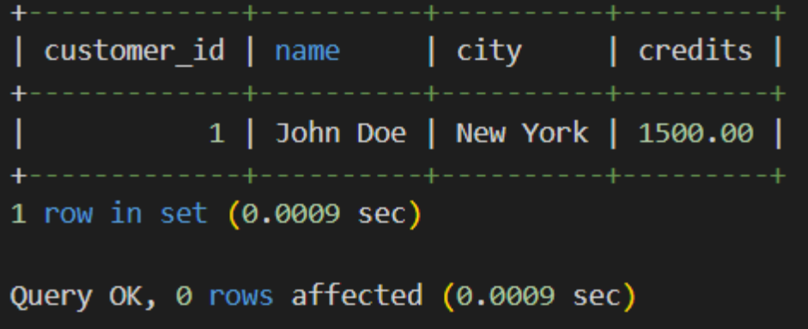

ii.

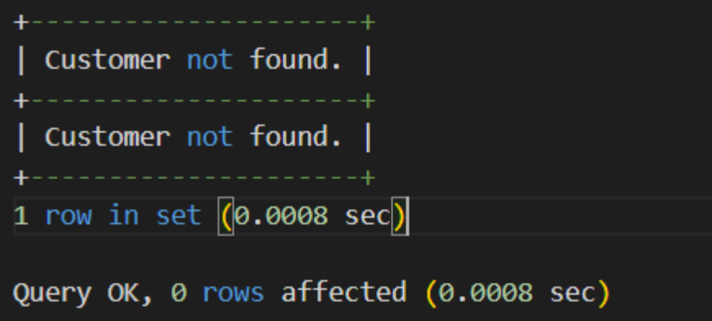

END;
//
DELIMITER ;
i. CALL GetCustomerDetailsByName('John Doe');
ii. CALL GetCustomerDetailsByName('Johny');

3. Create a stored procedure to determine membership of a particular customer based on the following credits:
Above 5000 = Membership Platinum
1000 to 5000 = Gold
< 1000 = silver
[Use IN and OUT Parameters]

SQL>DELIMITER //
CREATE PROCEDURE DetermineMembership (
IN customer_credits DECIMAL(10, 2),
OUT membership_level VARCHAR(50)
)
BEGIN
DECLARE local_membership_level VARCHAR(50);
IF customer_credits > 5000 THEN
SET local_membership_level = 'Membership Platinum';
ELSEIF customer_credits >= 1000 AND customer_credits <= 5000 THEN
SET local_membership_level = 'Gold';
ELSE
SET local_membership_level = 'Silver';
END IF;
SET membership_level = local_membership_level;
END;
//
DELIMITER ;
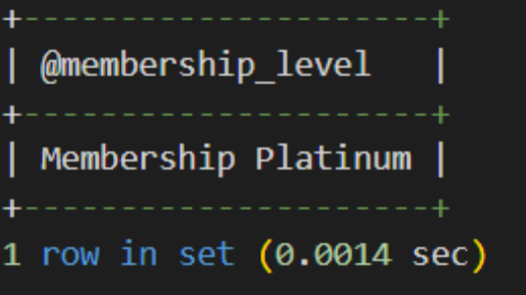
SQL> SET @membership_level = '';
SQL> CALL DetermineMembership(7000, @membership_level);
SQL> SELECT @membership_level;

4. Write a function that takes employee name as parameter and returns the number of employeeswith this name. Use the function to update details of employees with unique names. For othercases, the program (not the function) should display error messages - “No Employee” or “Multiple employees”.

SQL> CREATE TABLE employees (
id INT PRIMARY KEY,
name VARCHAR(100),
salary DECIMAL(10, 2)
);
SQL> INSERT INTO employees (id, name, salary) VALUES
(1, 'John', 10000),
(2, 'James', 10000),
(3, 'James', 12000);
Function
DELIMITER //
CREATE FUNCTION UpdateEmployeeSalaryByName (employee_name VARCHAR(100), new_salary DECIMAL(10, 2)) RETURNS INT
BEGIN
DECLARE employee_count INT;
SELECT COUNT(*) INTO employee_count
FROM employees WHERE name = employee_name;
IF employee_count = 1 THEN
UPDATE employees SET salary = new_salary WHERE name = employee_name;
END IF;
RETURN employee_count;
i.

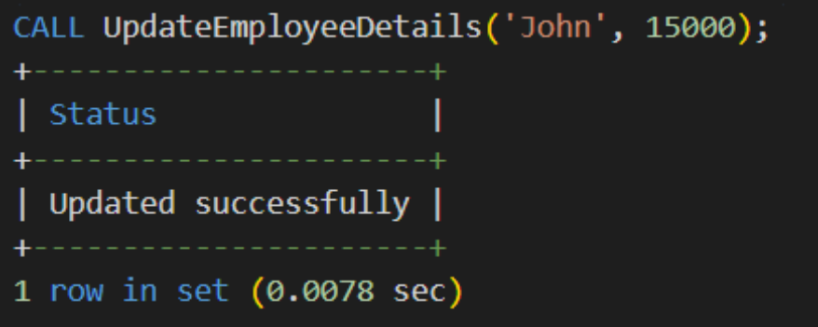

ii.

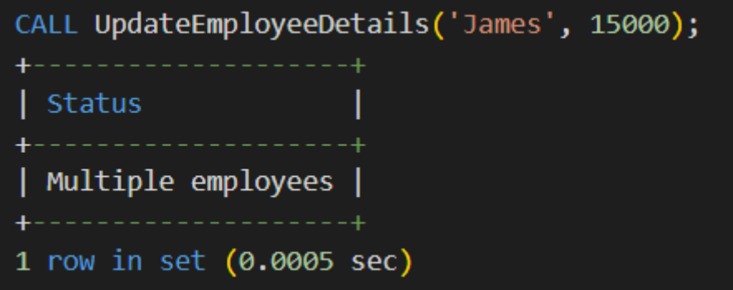

iii.

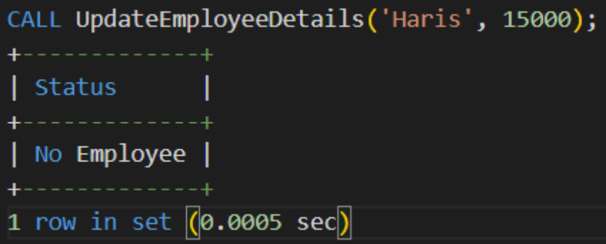
END;
//
DELIMITER ;

Procedure
DELIMITER //
CREATE PROCEDURE UpdateEmployeeDetails (
IN employee_name VARCHAR(100),
IN new_salary DECIMAL(10, 2)
)
BEGIN
DECLARE employee_count INT;
SET employee_count = UpdateEmployeeSalaryByName(employee_name,new_salary);
IF employee_count = 0 THEN
SELECT 'No Employee' AS Status;
ELSEIF employee_count = 1 THEN
SELECT 'Updated successfully' AS Status;
ELSE
SELECT 'Multiple employees' AS Status;
END IF;
END;
//
DELIMITER ;
i. CALL UpdateEmployeeDetails('John', 15000);
ii. CALL UpdateEmployeeDetails('James', 15000);
iii. CALL UpdateEmployeeDetails('Haris', 15000);

5. Write a stored procedure using cursor to calculate salary of each employee. Consider an Emp_salary table have the following attributes emp_id, emp_name, no_of_working_days, designation and salary.

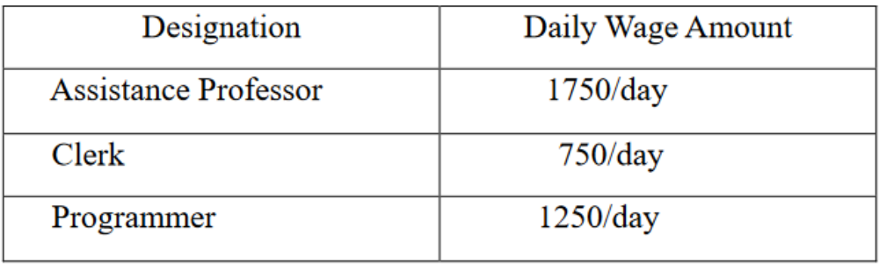

SQL> CREATE TABLE Emp_salary (
emp_id INT PRIMARY KEY,
emp_name VARCHAR(100),
no_of_working_days INT,
designation VARCHAR(50),
salary DECIMAL(10, 2)
);
SQL> INSERT INTO Emp_salary (emp_id, emp_name, no_of_working_days, designation)
VALUES
(1, 'Employee1', 20, 'Assistance Professor'),
(2, 'Employee2', 25, 'Clerk'),
(3, 'Employee3', 22, 'Programmer'),
(4, 'Employee4', 18, 'Assistance Professor'),
(5, 'Employee5', 23, 'Clerk');

Procedure
SQL> DELIMITER //
CREATE PROCEDURE CalculateEmployeeSalary()
BEGIN
DECLARE done INT DEFAULT FALSE;
DECLARE empId INT;
DECLARE workingDays INT;
DECLARE position VARCHAR(100);
DECLARE sal DECIMAL(10, 2);
DECLARE employeeCursor CURSOR FOR
SELECT emp_id, no_of_working_days, designation, salary FROM Emp_salary;
DECLARE CONTINUE HANDLER FOR NOT FOUND SET done = TRUE;
OPEN employeeCursor;
read_loop: LOOP
FETCH employeeCursor INTO empId, workingDays, position, sal;
IF done THEN
LEAVE read_loop;
END IF;
IF position = 'Assistance Professor' THEN
SET sal = workingDays * 1750;
ELSEIF position = 'Clerk' THEN
SET sal = workingDays * 750;
ELSE
SET sal = workingDays * 1250;
END IF;
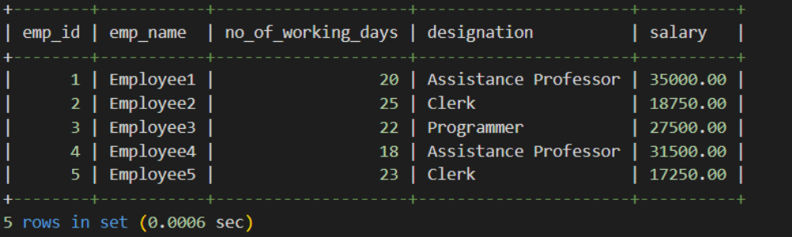
UPDATE Emp_salary SET salary = sal WHERE emp_id = empId;
END LOOP;
CLOSE employeeCursor;
END //
DELIMITER ;
SQL> CALL CalculateEmployeeSalary();
SQL> select * from emp_salary;

6. Write a procedure to calculate the electricity bill of all customers. Electricity board charges the following rates to domestic uses to find the consumption of energy.

a) For first 100 units Rs:2 per unit.
b) 101 to 200 units Rs:2.5 per unit.
c) 201 to 300 units Rs: 3 per unit.
d) Above 300 units Rs: 4 per unit
Consider the table ‘Bill’ with fields customer_id, name, pre_reading, cur_reading, unit, and amount.
CREATE TABLE Bill (
customer_id INT AUTO_INCREMENT PRIMARY KEY,
name VARCHAR(100),
pre_reading INT,
cur_reading INT,
unit INT,
amount DECIMAL(10, 2)
);
INSERT INTO Bill (customer_id, name, pre_reading, cur_reading, unit, amount)
VALUES
(1, 'Customer1', 100, 200, 0, 0),
(2, 'Customer2', 150, 350, 0, 0),
(3, 'Customer3', 100, 400, 0, 0),
(4, 'Customer4', 150, 600, 0, 0);

Procedure

SQL> DELIMITER //
CREATE PROCEDURE CalculateElectricityBill()
BEGIN
DECLARE cust_id INT;
DECLARE pre_read INT;
DECLARE cur_read INT;
DECLARE consumed_units INT;
DECLARE bill_rate DECIMAL(10, 2);
DECLARE customer_cursor CURSOR FOR
SELECT customer_id, pre_reading, cur_reading, (cur_reading - pre_reading) AS units_consumed
FROM Bill;
OPEN customer_cursor;
read_loop: LOOP
FETCH customer_cursor INTO cust_id, pre_read, cur_read, consumed_units;
IF cust_id IS NULL THEN
LEAVE read_loop;
END IF;
IF consumed_units <= 100 THEN
SET bill_rate = consumed_units * 2.00;
ELSEIF consumed_units <= 200 THEN
SET bill_rate = (100 * 2.00) + ((consumed_units - 100) * 2.50);
ELSEIF consumed_units <= 300 THEN
SET bill_rate = (100 * 2.00) + (100 * 2.50) + ((consumed_units - 200) * 3.00);
ELSE
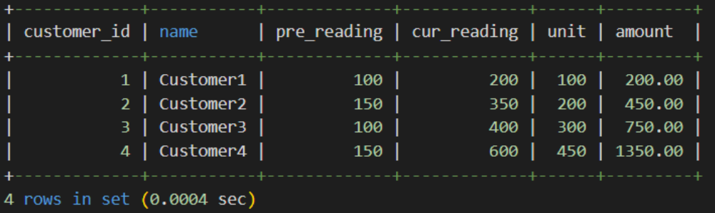
SET bill_rate = (100 * 2.00) + (100 * 2.50) + (100 * 3.00) + ((consumed_units - 300) * 4.00);
END IF;
UPDATE Bill SET amount = bill_rate, unit = (cur_read - pre_read) WHERE customer_id = cust_id;
END LOOP;
CLOSE customer_cursor;
END;
//
DELIMITER ;
SQL> call CalculateElectricityBill();
SQL> select * from bill;

7. Create a trigger on employee table such that whenever a row is deleted, it is moved to history table named ‘Emp_history’ with the same structure as employee table. ‘Emp_history’ will contain an additional column “Date_of_deletion” to store the date on which the row is removed.[ After Delete Trigger]

SQL> CREATE TABLE Emp_table (
emp_id INT AUTO_INCREMENT PRIMARY KEY,
emp_name VARCHAR(100) NOT NULL
);
SQL> CREATE TABLE Emp_history (
emp_id INT PRIMARY KEY,
emp_name VARCHAR(100) NOT NULL,
Date_of_deletion DATE NOT NULL
);
SQL> INSERT INTO Emp_table (emp_name)
VALUES
('John Doe'),
('Jane Smith'),
('Mike Johnson'),
('Emily Davis'),
('Robert Brown')
Procedure
DELIMITER //
CREATE TRIGGER MoveToEmpHistory
i.

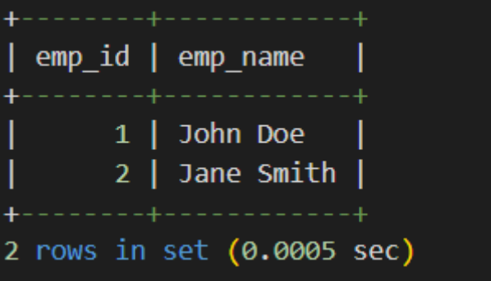

ii.

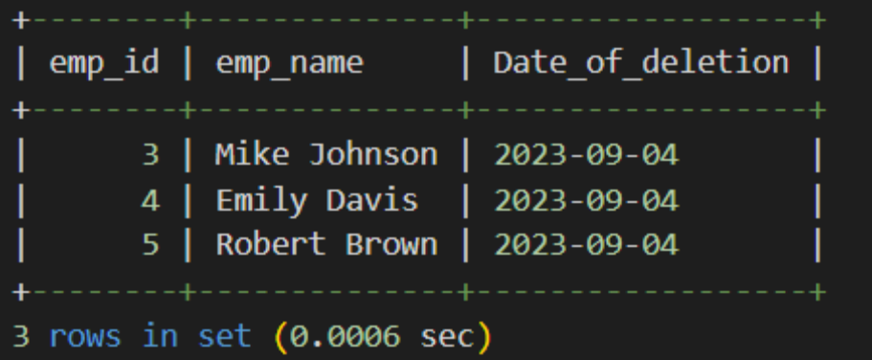

AFTER DELETE ON Emp_table
FOR EACH ROW
BEGIN
INSERT INTO Emp_history (emp_id, emp_name, Date_of_deletion)
VALUES (OLD.emp_id, OLD.emp_name, NOW());
END;
//
DELIMITER ;
i. SQL> select * from emp_table;
ii.SQL> select * from emp_history;
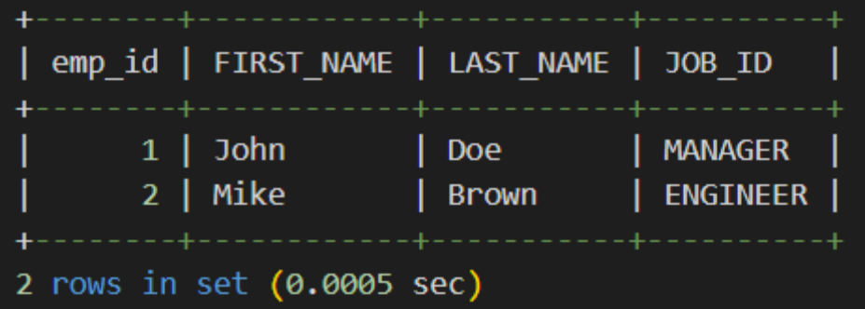
8. Before insert a new record in emp_details table, create a trigger that check the column value of FIRST_NAME, LAST_NAME, JOB_ID and if there are any space(s) before or after the FIRST_NAME, LAST_NAME, TRIM () function will remove those. The value of the JOB_ID will be converted to upper cases by UPPER () function. [Before Insert Trigger].

SQL> CREATE TABLE emp_details (
emp_id INT AUTO_INCREMENT PRIMARY KEY,
FIRST_NAME VARCHAR(255),
LAST_NAME VARCHAR(255),
JOB_ID VARCHAR(255)
);
DELIMITER //
SQL> CREATE TRIGGER BeforeInsert_emp_details
BEFORE INSERT ON emp_details
FOR EACH ROW
BEGIN
SET NEW.FIRST_NAME = TRIM(NEW.FIRST_NAME);
SET NEW.LAST_NAME = TRIM(NEW.LAST_NAME);
SET NEW.JOB_ID = UPPER(NEW.JOB_ID);
END;
//
DELIMITER ;
SQL> INSERT INTO emp_details (FIRST_NAME, LAST_NAME, JOB_ID)
VALUES (' John ', ' Doe ', 'manager');
select * from emp_details;

9. Consider the following table with sample data. Create a trigger to calculate total marks, percentage and grade of the students, when marks of the subjects are updated. [After Update Trigger]

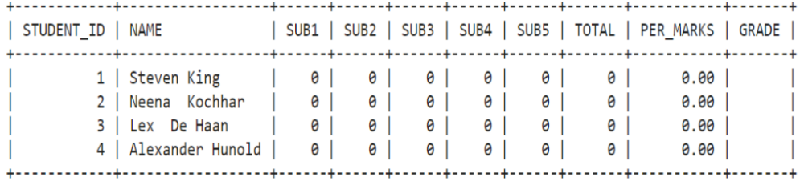
For this sample calculation, the following conditions are assumed:
Total Marks (will be stored in TOTAL column) : TOTAL = SUB1 + SUB2 + SUB3 + SUB4 +
SUB5.
Percentage of Marks (will be stored in PER_MARKS column): PER_MARKS = (TOTAL)/5
Grade (will be stored in GRADE column):
- If PER_MARKS>=90 -> 'EXCELLENT'
- If PER_MARKS>=75 AND PER_MARKS<90 -> 'VERY GOOD'
- If PER_MARKS>=60 AND PER_MARKS<75 -> 'GOOD'
- If PER_MARKS>=40 AND PER_MARKS<60 -> 'AVERAGE'
- If PER_MARKS<40-> 'NOT PROMOTED'

SQL> CREATE TABLE students (
student_id INT AUTO_INCREMENT PRIMARY KEY,
name VARCHAR(50),
sub1 INT,
sub2 INT,
sub3 INT,
sub4 INT,
sub5 INT,

total INT,
per_marks DECIMAL(5, 2),
grade VARCHAR(20)
);
SQL> INSERT INTO students (name, sub1, sub2, sub3, sub4, sub5)
VALUES
('John Doe', 50, 60, 70, 80, 0),
('Mike Brown', 0, 0, 0, 0, 0);
SQL> DELIMITER //
CREATE TRIGGER calculate_marks_and_grade
BEFORE UPDATE ON students
FOR EACH ROW
BEGIN
DECLARE total_marks INT;
DECLARE percentage DECIMAL(5, 2);
DECLARE student_grade VARCHAR(20);
SET total_marks = NEW.sub1 + NEW.sub2 + NEW.sub3 + NEW.sub4 + NEW.sub5;
SET percentage = total_marks / 5;
IF percentage >= 90 THEN
SET student_grade = 'EXCELLENT';
ELSEIF percentage >= 75 AND percentage < 90 THEN
SET student_grade = 'VERY GOOD';
ELSEIF percentage >= 60 AND percentage < 75 THEN
SET student_grade = 'GOOD';
ELSEIF percentage >= 40 AND percentage < 60 THEN
SET student_grade = 'AVERAGE';
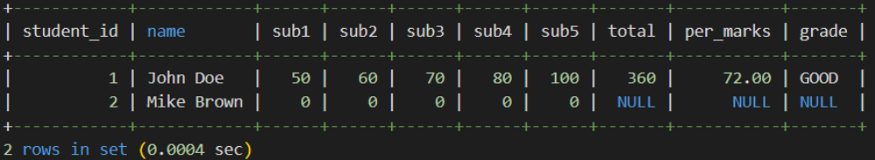
ELSE
SET student_grade = 'NOT PROMOTED';
END IF;
SET NEW.total = total_marks;
SET NEW.per_marks = percentage;
SET NEW.grade = student_grade;
END;
//
DELIMITER ;
SQL> update students set sub5 = 100 where student_id = 1;
SQL> select * from students;

Result:
SQL query executed successfully and output is verified.

Lab Cycle 4
Experiment No:5
Date: 18/04/2023
Aim:
1: Create a Table ‘Order_Details’ with the given data and perform the following operations
mysql->CREATE TABLE Order_Details (Order_ID INT,Product_Name
VARCHAR(100),Order_Num INT,Order_Date DATE);
INSERT INTO Order_Details (Order_ID, Product_Name, Order_Num, Order_Date)
VALUES (1, 'Laptop', 5544, '2020-02-01'),
(2, 'Mouse', 3322, '2020-02-11'),
(3, 'Desktop', 2135, '2020-01-05'),
(4, 'Mobile', 3432, '2020-02-22'),
(5, 'Anti-Virus', 5648, '2020-03-10');
a) Start a new transaction and insert 2 rows into the table Order_Details.
mysql->START TRANSACTION;
INSERT INTO Order_Details (Order_ID, Product_Name, Order_Num, Order _Date) VALUES (6, 'FireWall', 1006, '2023-07-22'), (7, 'Keyboard', 1007, '2023-07 22');
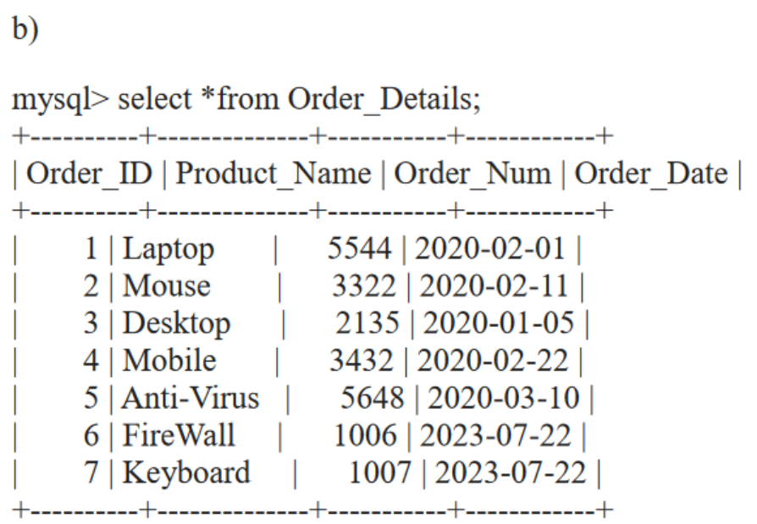
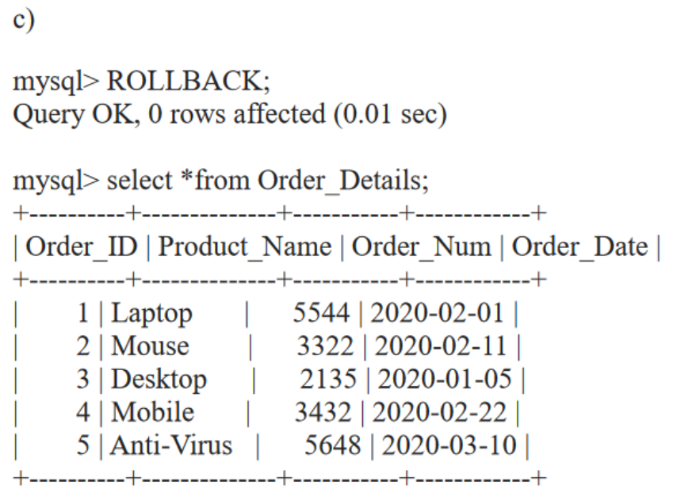
b) Display the details of Order_Details.

mysql-> select * from Order_Details;

c) Rollback the current transaction and check the contents of the table Order_Details.

mysql-> ROLLBACK;
select*from Order_Details;
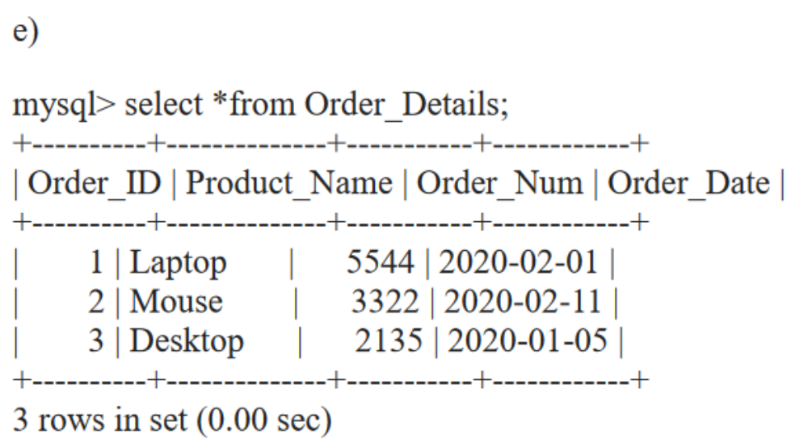

f)
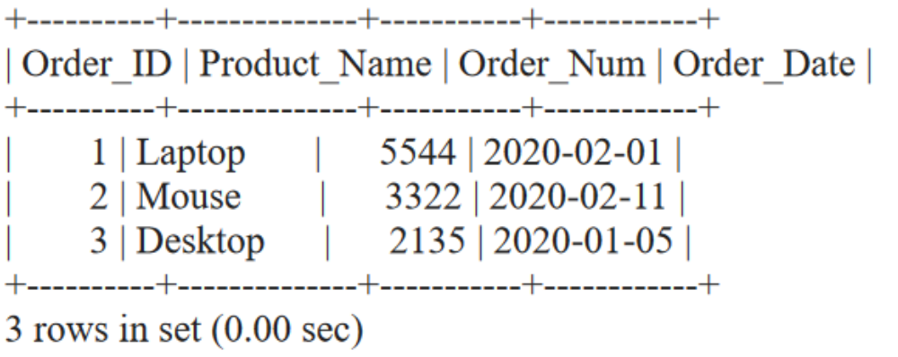

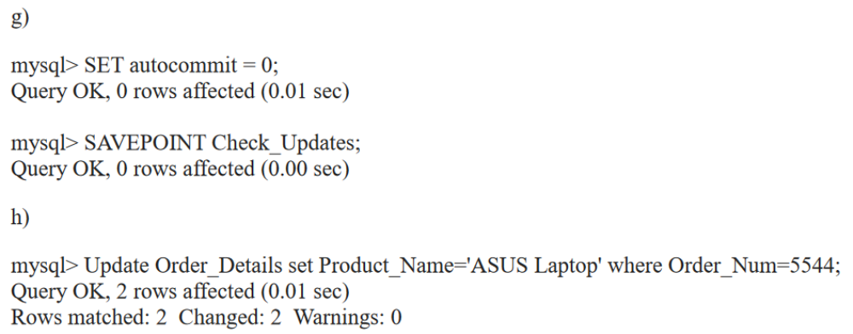
d) Start a new transaction and delete 2 rows from the table Order_Details.

mysql-> START TRANSACTION;
delete from Order_Details where Order_ID in(4,5);

e) Display the details of Order_Details.

mysql->select * from Order_Details;

f) Commit the current transaction and check the details of the table Order_Details.

mysql->COMMIT;
select * from Order_Details;

g) Disable autocommit and create a savepoint named ‘Check_Updates’.

mysql->SET autocommit = 0;
SAVEPOINT Check_Updates;

h) Update details of the order with Order_Num 5544.

mysql->update Order_Details set Product_Name='ASUS Laptop' where
Order_Num=5544;

i) Insert 2 more rows into the table.

mysql->INSERT INTO Order_Details (Order_ID, Product_Name, Order_Num, Order_Date) VALUES(6, 'FireWall', 1006, '2023-07-22'),(7, 'Laptop', 1007, '2023-07-22');

j) Create a savepoint named ‘Check_delete’

mysql-> SAVEPOINT
Check_delete;

k) Delete order details of a product named ‘Laptop’.

mysql->delete from Order_Details where Product_Name='Laptop';
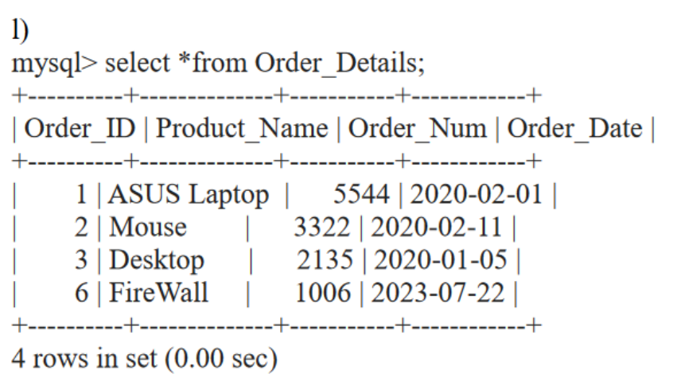

m)
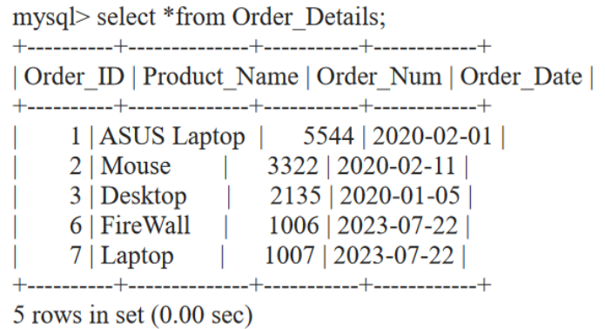
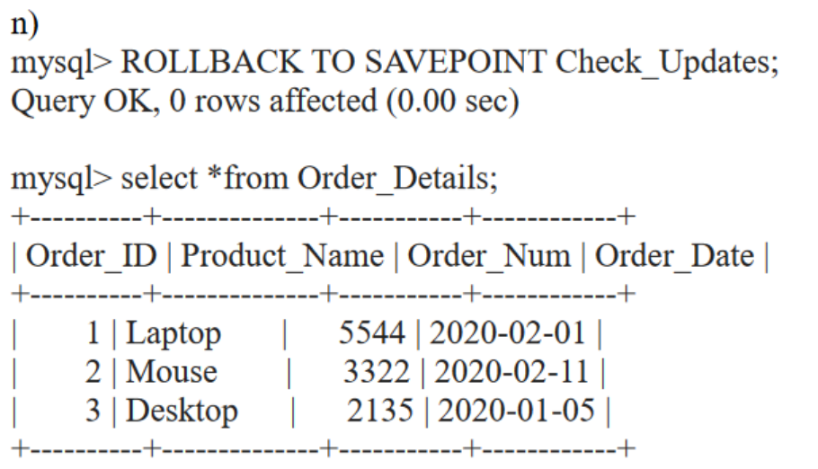
l) Display the current details of the table Order_Details.

mysql-> select * from Order_Details;

m) Rollback to savepoint ‘Check_delete’ and check the details of the table Order_Details.

mysql->ROLLBACK TO SAVEPOINT Check_delete;

select*from Order_Details;

n) Rollback to savepoint ‘Check_Updates’ and check the details of the table Order_Details.

mysql->ROLLBACK TO SAVEPOINT Check_Updates;
select*from Order_Details;
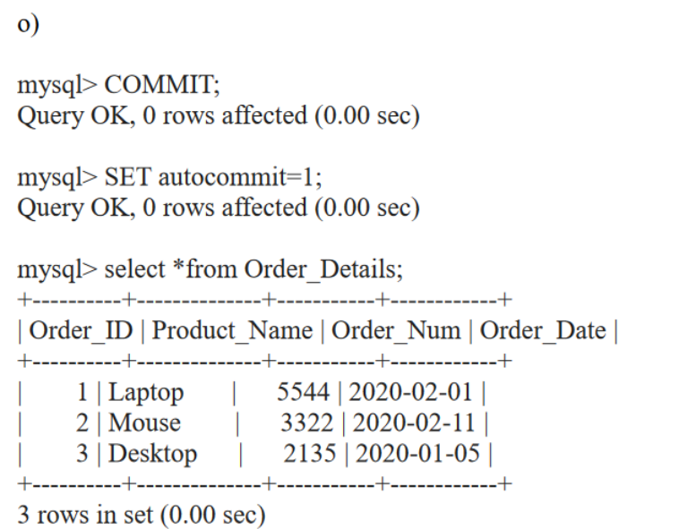

o) Commit the changes and enable autocommit.

mysql-> COMMIT;
SET autocommit=1;

Result:
SQL query executed successfully and output is verified.

Lab Cycle 5
Experiment No:6
Date: 18/04/2023
Aim:

1. Build sample collections/documents to perform query operation.

i.Create a database (Eg : MyCev)
test> use MyCev

ii.Create a collection (Eg: db_mca)
MyCev> db.createCollection("db_mca")

iii.Create a collection (Eg: db_cs)
MyCev> db.createCollection("db_cs")

iv.Insert 10 data to the collection
MyCev> db.db_mca.insertMany([ { name: "ram", rollno: 15,branch
:"mca",mark:70 } , {name: "rani", rollno: 16,branch :"mca",mark:72
},{name: "mahi", rollno: 17,branch :"mca",mark:65} ,{name: "anandhan",
rollno: 05,branch :"mca",mark:75 },{name: "sreekutty", rollno: 18,branch
:"mca",mark:76},{name: "devika", rollno: 10,branch :"mca",mark:78
},{name: "adithya", rollno: 03,branch :"mca",mark:80 },{name: "maya",
rollno: 20,branch :"mca",mark:82 },{name: "nidhi", rollno: 22,branch
:"mca",mark:84},{name: "arathy", rollno: 07,branch :"mca",mark:88 }]);
MyCec> db.db_cs.insertMany([{name: "John", rollno: 101, branch: "CS", mark: 70},{name: "Alice", rollno: 102, branch: "CS", mark: 72},{name: "Bob", rollno: 103, branch: "CS", mark: 65},{name: "Eva", rollno: 104, branch: "CS", mark:
v) MyCev> db.db_mca.find().limit(5);
[
{
_id: ObjectId("64ede662964e5f10ee8afc61"),
name: 'ram',
rollno: 15
branch:’cs’
},
{
_id: ObjectId("64ede684964e5f10ee8afc62"),
name: 'maya',
rollno: 25,
branch: 'mca',mark: 70},
{
_id: ObjectId("64ede9df964e5f10ee8afc6b"),
name: 'anandhan',
rollno: 5,
branch: 'mca',
mark: 75
},
{
_id: ObjectId("64ede9df964e5f10ee8afc6c"),
name: 'sreekutty',
rollno: 18,
branch: 'mca',
mark: 76
},
{
_id: ObjectId("64ede9df964e5f10ee8afc6d"),
name: 'devika',
rollno: 10,
branch: 'mca',
mark: 78
}]
vi) MyCev> db.db_mca.find().skip(2)
[
{
_id: ObjectId("64ede9df964e5f10ee8afc6a"),
name: 'mahi',
rollno: 17,
branch: 'mca',
mark: 65
},
{
_id: ObjectId("64ede9df964e5f10ee8afc6b"),
name: 'anandhan',
rollno: 5,
branch: 'mca',
mark: 75
75},{name: "David", rollno: 105, branch: "CS", mark: 76},{name: "Sarah", rollno: 106, branch: "CS", mark: 78},{name: "Michael", rollno: 107, branch: "CS", mark: 80},{name: "Emily", rollno: 108, branch: "CS", mark: 82},{name: "James", rollno: 109, branch: "CS", mark: 84},{name: "Olivia", rollno: 110, branch: "CS", mark: 88}]);
v.List the first 5 data from the collection (limit)
MyCev> db. db_mca.find().limit(5);
vi.List the entire data except first 2 data (skip)
MyCev> db.db_mca.find().skip(2
{
_id: ObjectId("64ede9df964e5f10ee8afc6c"),
name: 'sreekutty',
rollno: 18,
branch: 'mca',
mark: 76
},
{
_id: ObjectId("64ede9df964e5f10ee8afc6d"),
name: 'devika',
rollno: 10,
branch: 'mca',
mark: 78
},
{
_id: ObjectId("64ede9df964e5f10ee8afc6e"),
name: 'adithya',
rollno: 3,
branch: 'mca',
mark: 80
},
{
_id: ObjectId("64ede9df964e5f10ee8afc70"),
name: 'nidhi',
rollno: 22,
branch: 'mca',
mark: 84
},
{
_id: ObjectId("64ede9df964e5f10ee8afc71"),
name: 'arathy',
rollno: 7,
branch: 'mca',
mark: 88
}]
vii)
MyCev> db.db_mca.find().sort({ field_name: 1 });
[
{
_id: ObjectId("64ede7a1964e5f10ee8afc63"),
name: 'ram',
rollno: 15,
branch: 'mca',
mark: 70
},
{
_id: ObjectId("64ede7a1964e5f10ee8afc64"),
name: 'rani',
rollno: 16,
branch: 'mca',
mark: 72
},
{
vii.Sort the data by choosing any field in the collection

MyCev> db. db_mca.find().sort({ field_name: 1 });

viii.Delete data from the collection

MyCev> db. db_cs.deleteMany({ key:1 });
id: ObjectId("64ede808964e5f10ee8afc67"),
name: 'mahi',
rollno: 17,
branch: 'mca',
mark: 65
},
{ id: ObjectId("64ede9df964e5f10ee8afc6b"),
name: 'anandhan',
rollno: 5,
branch: 'mca',
mark: 75
},
{ id: ObjectId("64ede9df964e5f10ee8afc6c"),
name: 'sreekutty',
rollno: 18,
branch: 'mca',
mark: 76
},
{ id: ObjectId("64ede9df964e5f10ee8afc6d"),
name: 'devika',
rollno: 10,
branch: 'mca',
mark: 78
},
{ _id: ObjectId("64ede9df964e5f10ee8afc6e"),
name: 'adithya',
rollno: 3,
branch: 'mca',
mark: 80
},
{ _id: ObjectId("64ede9df964e5f10ee8afc6f"),
name: 'maya',
rollno: 20,
branch: 'mca',
mark: 82
},
{ _id: ObjectId("64ede9df964e5f10ee8afc70"),
name: 'nidhi',
rollno: 22,
branch: 'mca',
mark: 84
},
{ id: ObjectId("64ede9df964e5f10ee8afc71"),
name: 'arathy',
rollno: 7,
branch: 'mca',
mark: 88
}]
ix.Drop the collection (db_cs)
MyCev> db. db_cs.drop();

x.Drop Database
MyCev> db.dropDatabase()
iv. [
{ "_id": ObjectId("64f2c64864b3ab60751038b1"), "name": "maya", "rollno": 15, "subject": "english", "mark": 70 },
{ "_id": ObjectId("64f2c64864b3ab60751038b2"), "name": "ardra", "rollno": 16, "subject": "maths", "mark": 75 },
{ "_id": ObjectId("64f2c64864b3ab60751038b3"), "name": "mahima", "rollno": 17, "subject": "botany", "mark": 65 },
{ "_id": ObjectId("64f2c64864b3ab60751038b4"), "name": "anandhan", "rollno": 5, "subject": "zoology", "mark": 75 },
{ "_id": ObjectId("64f2c64864b3ab60751038b5"), "name": "sreekutty", "rollno": 18, "subject": "commerce", "mark": 76 },
{ "_id": ObjectId("64f2c64864b3ab60751038b6"), "name": "devika", "rollno": 10, "subject": "geography", "mark": 78 },
{ "_id": ObjectId("64f2c64864b3ab60751038b7"), "name": "adithya", "rollno": 3, "subject": "history", "mark": 80 },
{ "_id": ObjectId("64f2c64864b3ab60751038b8"), "name": "maya", "rollno": 20, "subject": "malayalam", "mark": 82 },
{ "_id": ObjectId("64f2c64864b3ab60751038b9"), "name": "theertha", "rollno": 22, "subject": "maths", "mark": 84 },
{ "_id": ObjectId("64f2c64864b3ab60751038ba"), "name": "akshaya", "rollno": 7, "subject": "english", "mark": 88 }
]
2. Design Databases using MongoDB and perform CRUD operations.
i.Create a database Myclass.
test> use Myclass
ii.Create a collection named “db_students” Should contain this fields : {
student_name, student_rollno, mark[subject, mark] }
Nb: Mark should be stored as array
Myclass> db.createCollection("db_students")
iii.Insert details of 10 students in a class
Myclass>db.students.insertMany([{name:"maya",rollno:15,subject:"engli
sh",mark:70},{name:"ardra",rollno: 16,subject :"maths",mark:75 },{name:
"mahima",rollno:17,subject:"botany",mark:65},{name:"anandhan",rollno:
05,subject:"zoology",mark:75},{name:"sreekutty",rollno:18,subject:"com
merce",mark:76},{name:"devika",rollno: 10,subject:"geography",mark:78
},{name: "adithya", rollno: 03,subject:"history",mark:80 },{name: "maya",
rollno:20,subject:"malayalam",mark:82},{name:"theertha",rollno:22,subje
ct:"maths",mark:84},{name:"akshaya",rollno:07,subject:"english",mark:8
8 }]);
iv.List the entire students in the class
Myclass> db.students.find();
v.Update mark of any students in the collection “db_students”
Myclass> db.students.updateOne({name: "theertha"},{ $set:{
v)
Myclass> db.students.updateOne({name: "theertha"},{ $set:{ mark:90}})
{
acknowledged: true,
insertedId: null,
matchedCount: 1,
modifiedCount: 1,
upsertedCount: 0
}
vi)
Myclass> db.students.deleteOne({})
{ acknowledged: true, deletedCount: 1 }
mark:90}})
vi.Delete the data of first student in the collection
Myclass> db.students.deleteOne({})
[
{
_id: ObjectId("64f303cdbf0c07e03ec2aaad"),
emp_name: 'Abraham',
designation: 'superwiser',
salary: 35000
},
{
_id: ObjectId("64f303cdbf0c07e03ec2aab1"),
emp_name: 'Samuel',
designation: 'superwiser',
salary: 35000
}
]
v)
Employee> db.employee.find({designation:"sales"});
[
{
_id: ObjectId("64f303cdbf0c07e03ec2aaab"),
emp_name: 'Sharath',
designation: 'sales',
salary: 15000
},
{
_id: ObjectId("64f303cdbf0c07e03ec2aaae"),
emp_name: 'Muhammed',
designation: 'sales',
salary: 15000
},
{
_id: ObjectId("64f303cdbf0c07e03ec2aaaf"),
emp_name: 'Rohith',
designation: 'sales',
salary: 20000
},
{
_id: ObjectId("64f303cdbf0c07e03ec2aab2"),
emp_name: 'Johns',
designation: 'sales',
salary: 15000
}
]
3.{emp_name : “Sharath”, designation: “sales”, salary: 15000}
{emp_name : “Shyam”, designation: “manager”, salary: 50000}
{emp_name : “Abraham”, designation: “superwiser”, salary: 35000}
{emp_name : “Muhammed”, designation: “sales”, salary: 15000}
{emp_name : “Rohith”, designation: “sales”, salary: 20000}
{emp_name : “Nirmal”, designation: “driver”, salary: 20000}
{emp_name : “Samuel”, designation: “superwiser”, salary: 35000}
{emp_name : “Johns”, designation: “sales”, salary: 15000}
i. Create a database Employee
test> use Employee
ii. Create a collection “db_employee”
MyCev> db.createCollection("db_employee")
iii. Insert the above employee details to the collection
called“db_employee”
Employee> db.employee.insertMany([ {emp_name : "Sharath",
designation:"sales",salary:15000},{emp_name :"Shyam",
designation: "manager", salary: 50000},{emp_name :
"Abraham",designation:"superwiser",salary:
35000},{emp_name : "Muhammed", designation: "sales",
salary: 15000},{emp_name : "Rohith", designation: "sales",
salary: 20000},{emp_name : "Nirmal", designation: "driver",
salary: 20000},{emp_name : "Samuel", designation:
"superwiser", salary: 35000},{emp_name : "Johns",
designation: "sales", salary: 15000}]);
iv. List the details of employee having ‘salary > 15000’ AND designation
= “supervisor”
vi)
{
acknowledged: true,
insertedId: null,
matchedCount: 0,
modifiedCount: 0,
upsertedCount: 0
}
vii)
[ { _id: null, totalSalary: 65000 } ]
Employee>db.employee.find({salary:{$gt:15000},designation:"superwiser"});
v.List the details of employee who working in ‘sales’ department
Employee> db.employee.find({designation:"sales"});
vi. Update the emp_name :’’Sharath” to Abhijith
Employee>db.db_employee.updateOne({emp_name:"Sharath"},{
$set:{emp_name:"Abhijith"}});
vii. Find the total sum of salary of employees under the sales department
Employee>db.employee.aggregate([{$match:{designation:"sales" }},
{$group: { _id: null,totalSalary:{$sum:"$salary" } }}]);

Result:
Program query executed successfully and output is verified.

