1.

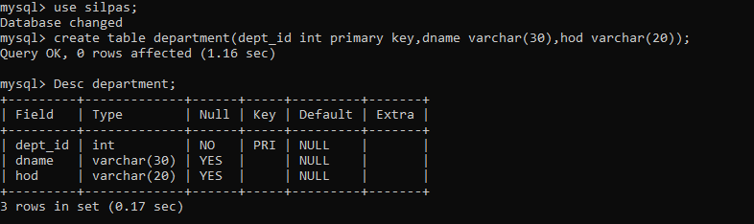

2.

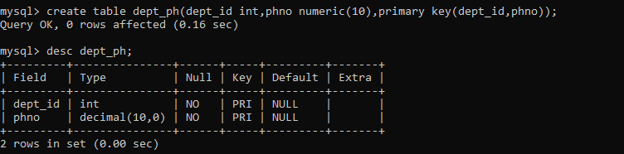

3.

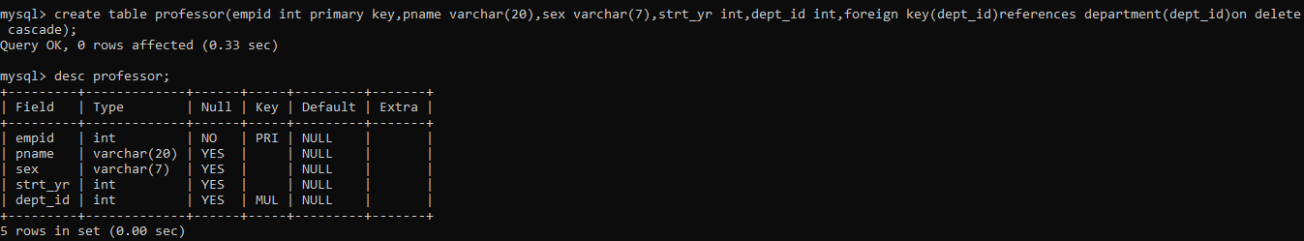4.

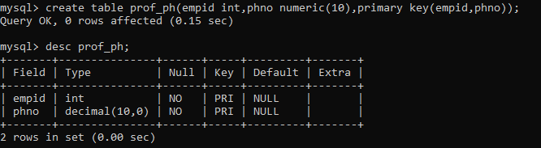

5.

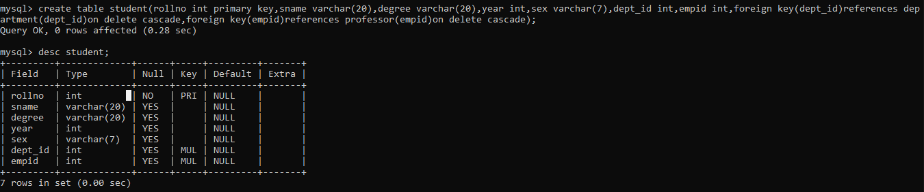

6.

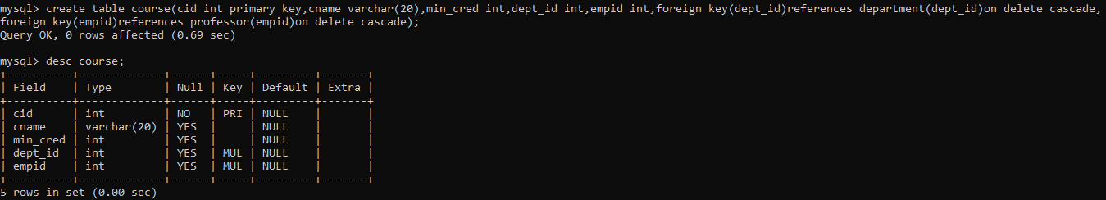

7.

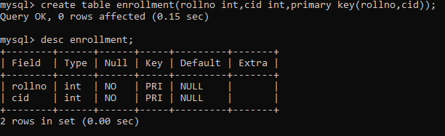

8.

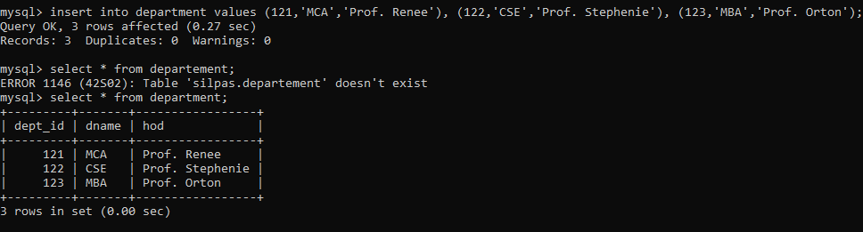

9.

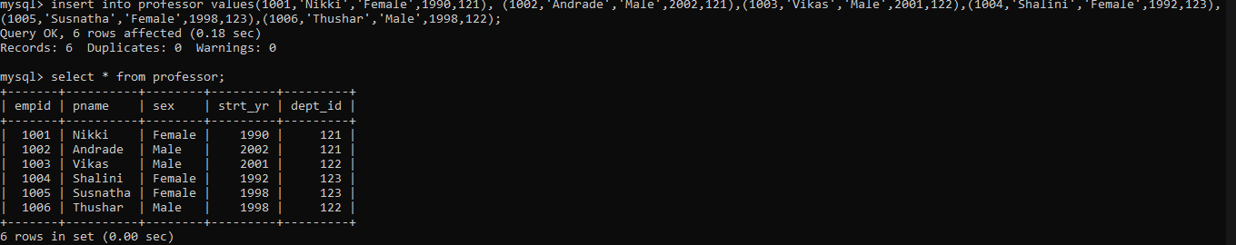

10.

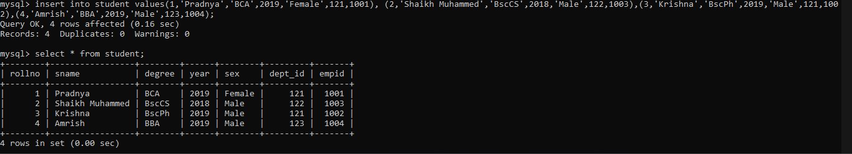

11.

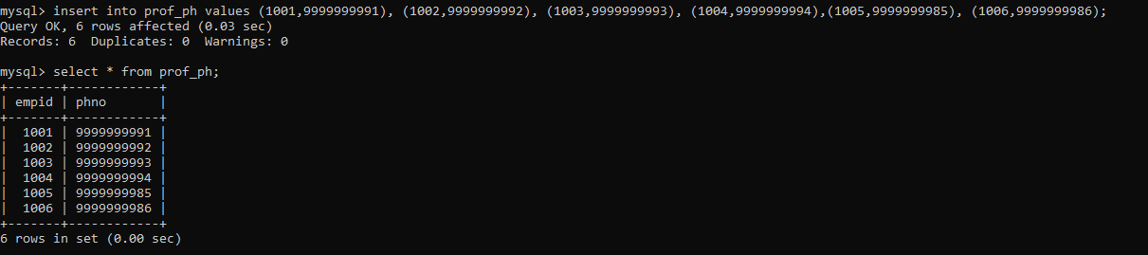

12.

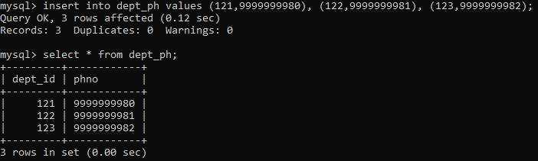

13.

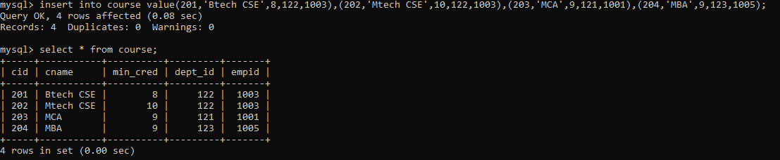

14.

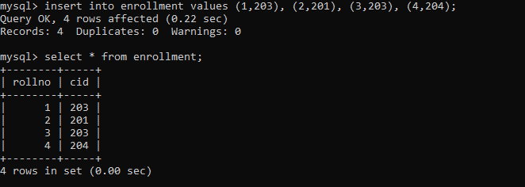

a.

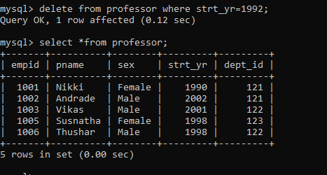

b.

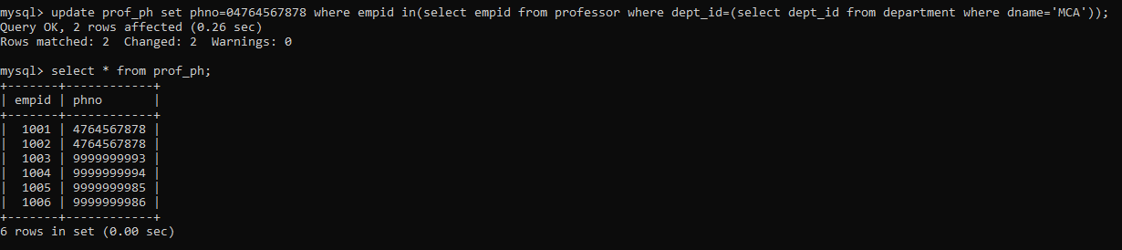

c.

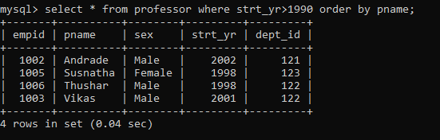

d.

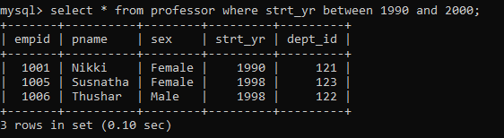

e.

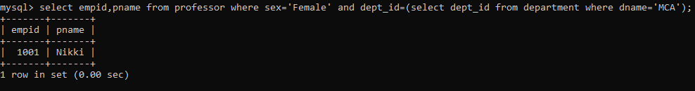

f.

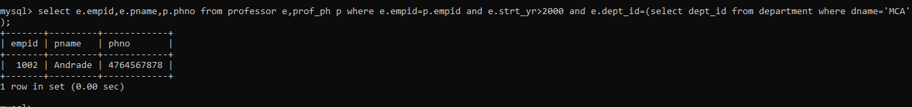

g.

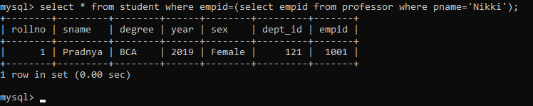

h.

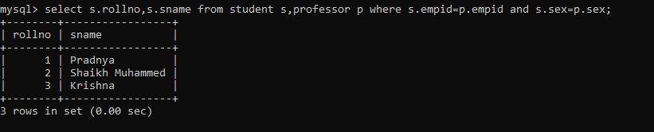

I.

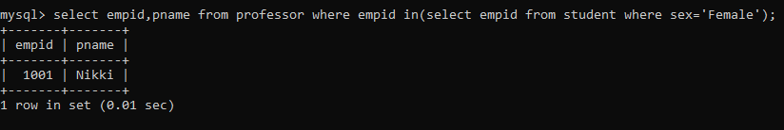

j.

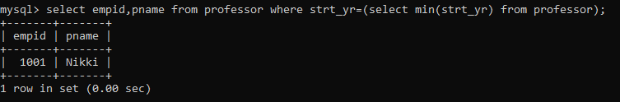

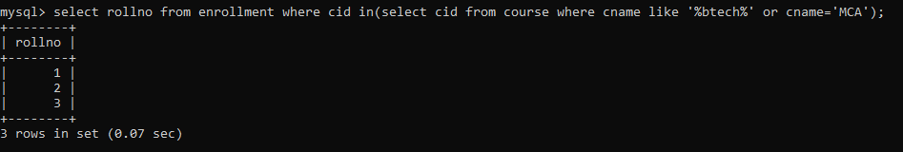

k.

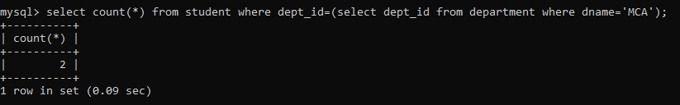

l.

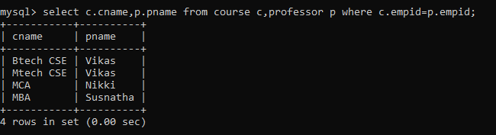

m.

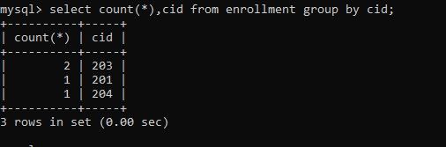

n.

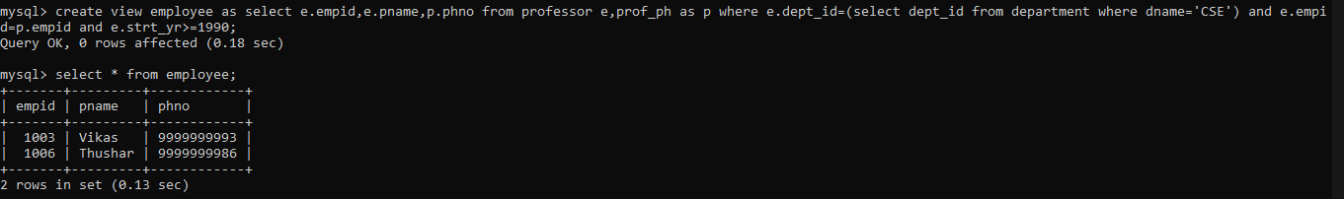

o.



p.

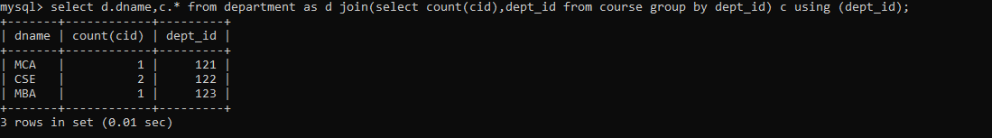

q.

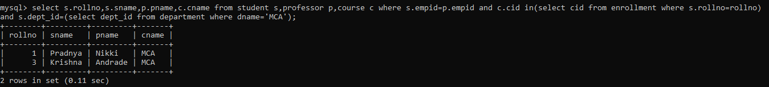

Q2.

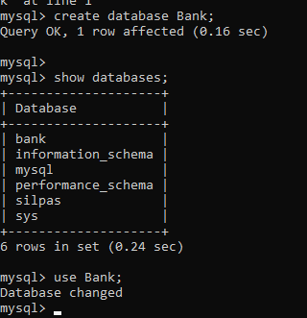

2. 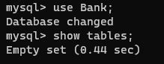

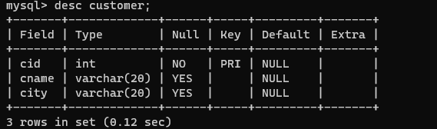



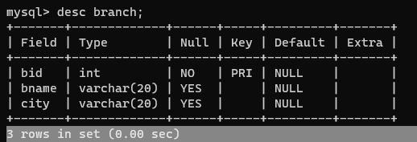

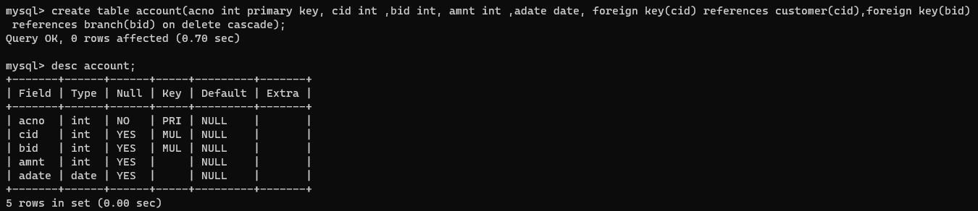

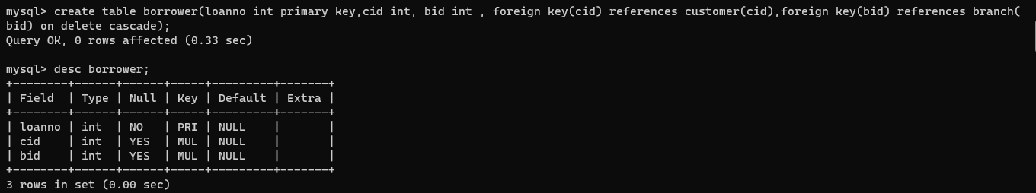

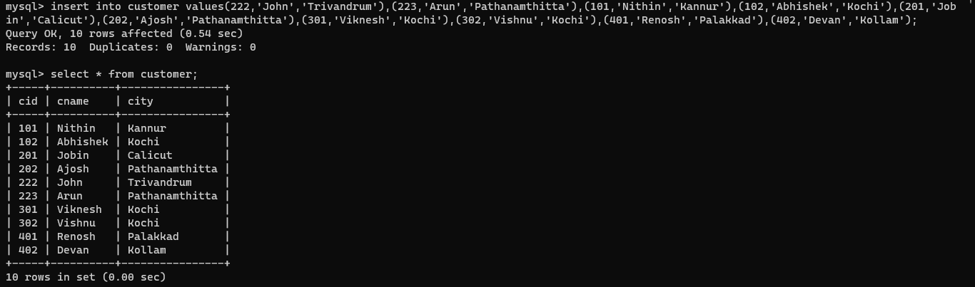

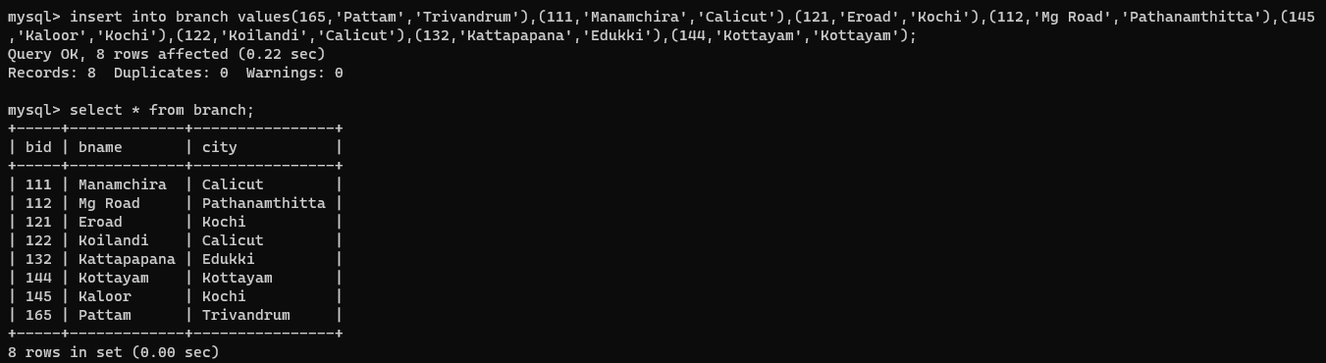

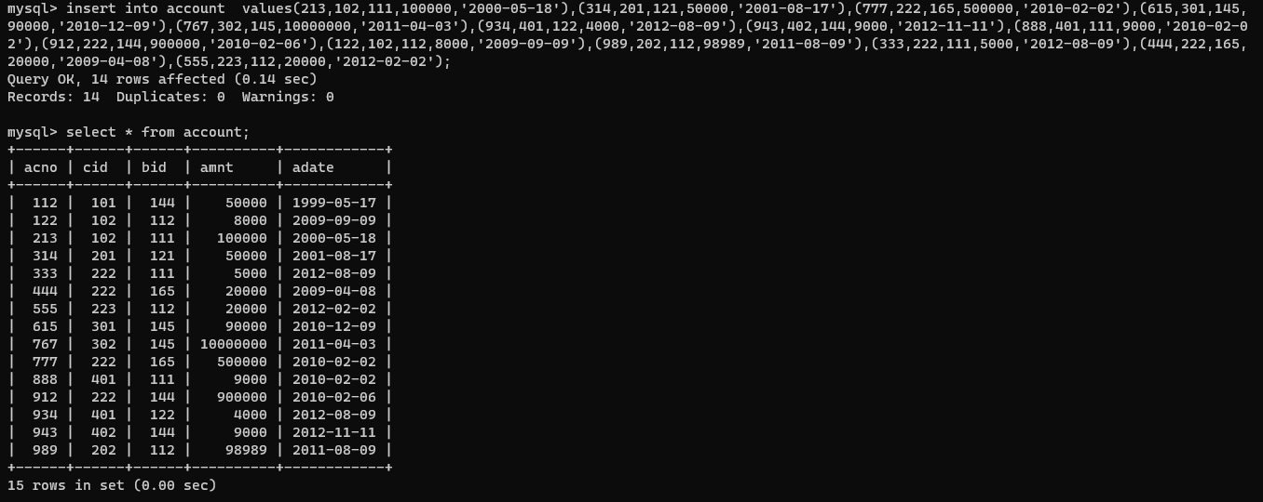

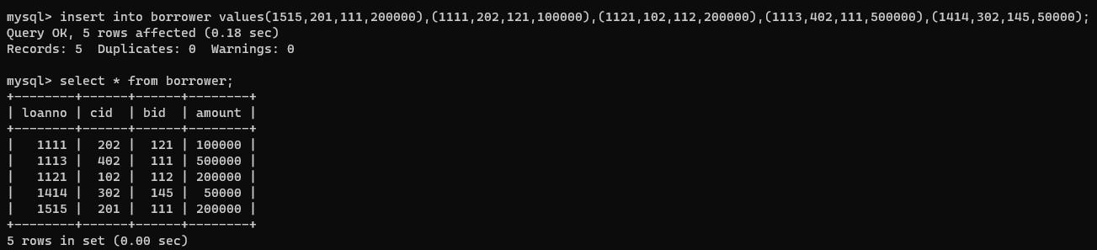

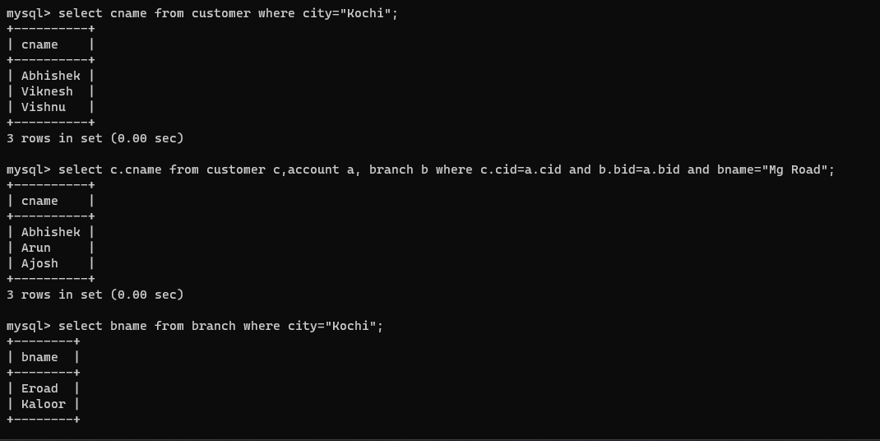

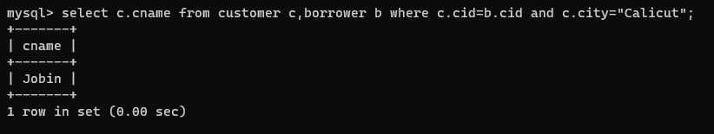

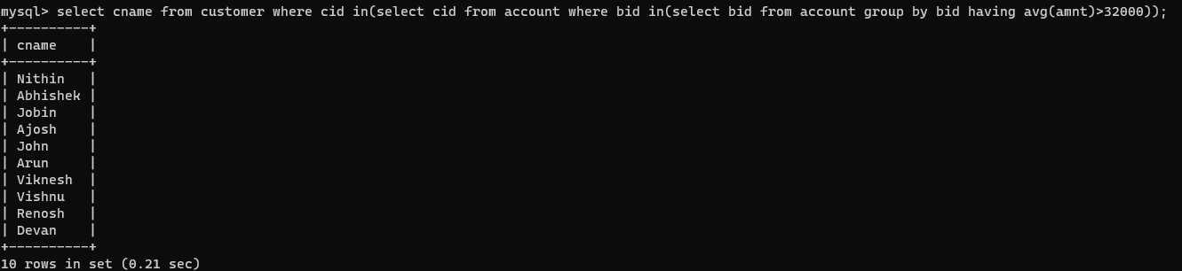

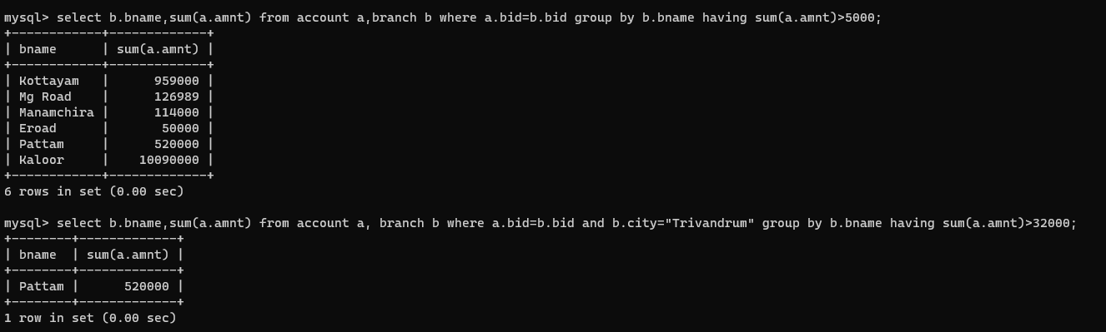

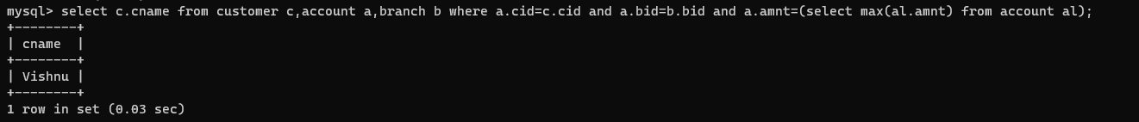

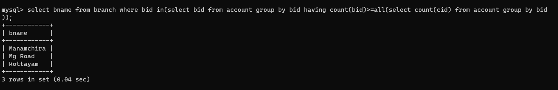

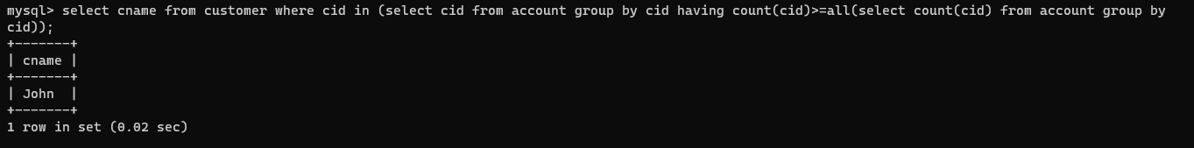

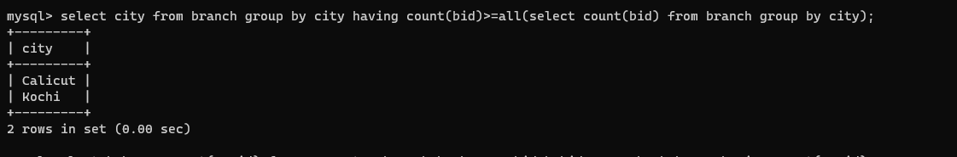

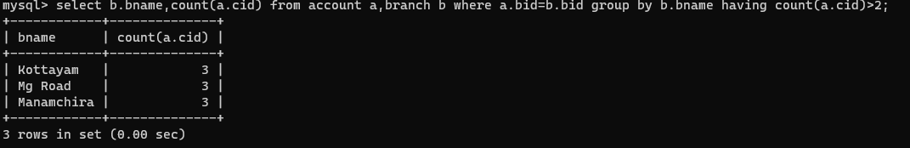

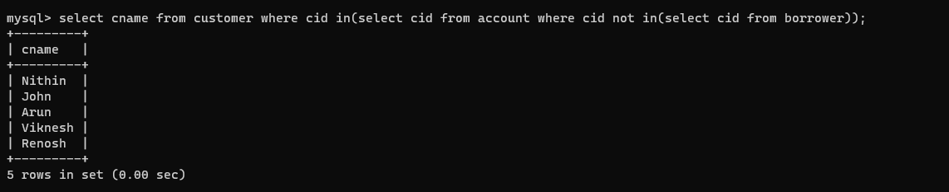

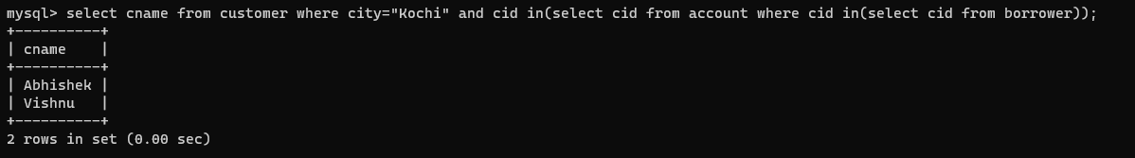

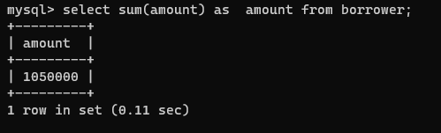

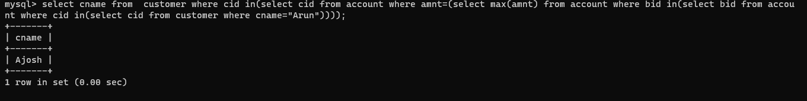

Employees table

1. mysql> select e.fname,e.lname from employees e join departments l on e.deptid=l.deptid where l.locid=1700;

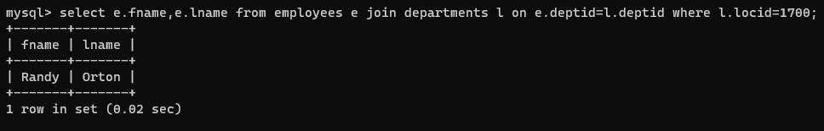

2. mysql> select e.fname,e.lname from employees e join departments l on e.deptid=l.deptid where l.locid not in(1700);

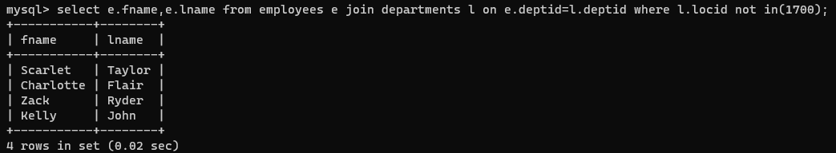

3. mysql> select fname,lname,salary from employees where salary=(select max(salary) from employees);

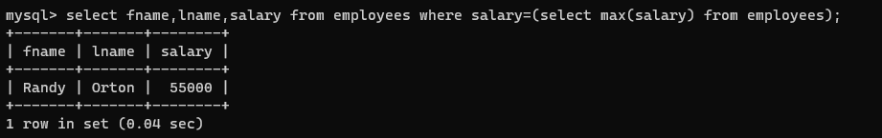

4. mysql> select fname,lname,salary from employees where salary>all(select avg(salary) from employees);

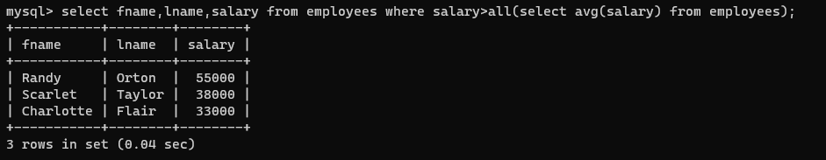

5. mysql> select departments.deptid,depname,employees.fname,employees.lname from departments,employees where departments.deptid=employees.deptid and employees.salary>10000; 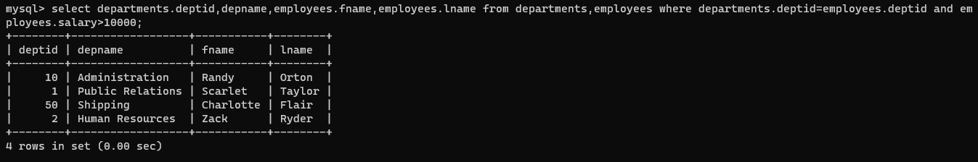

6. mysql> select departments.deptid,depname,employees.fname,employees.lname from departments,employees where departments.deptid=employees.deptid and employees.salary<10000;

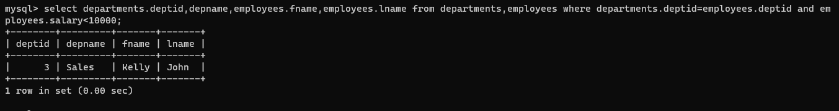

10.

select emp_id,fname,salary,(select avg(salary) from employees) as avg_salary,salary-(select avg(salary) from employees) as salary_diff from employees;

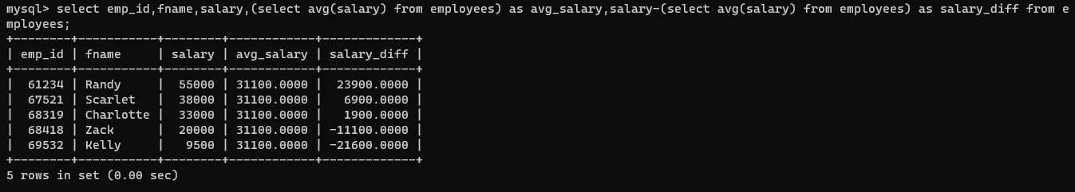

11.

mysql> select emp_id,fname,lname,salary,depname from employees,departments where employees.deptid=departments.deptid and salary>(select avg(salary) from employees);

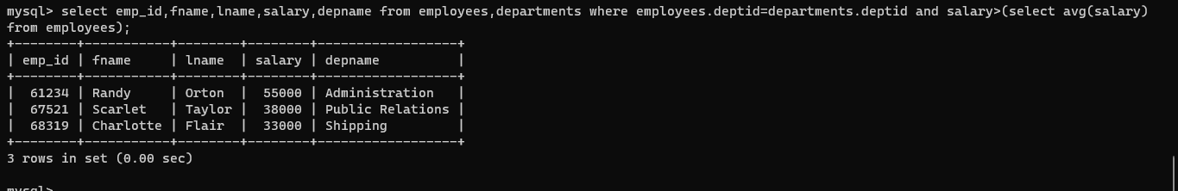

12. select fname,lname from dependents where relation is NULL;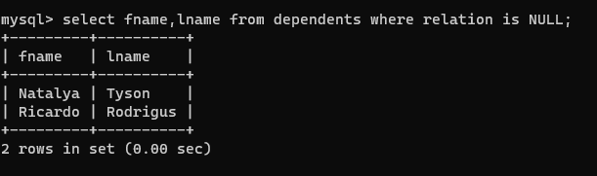

13. mysql> select fname,lname,depname,e.deptid from employees e join departments d on d.deptid=e.deptid where d.deptid in(1,2,3);

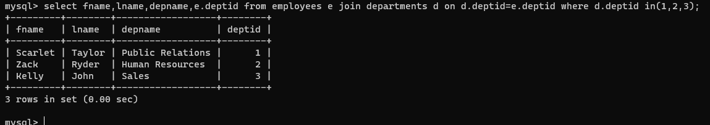

14. select fname,lname,depname,e.deptid,j.job_title from employees e join jobs j on j.jobid=e.jobid join departments d on d.deptid=e.deptid where d.deptid in(1,2,3) and salary>10000;

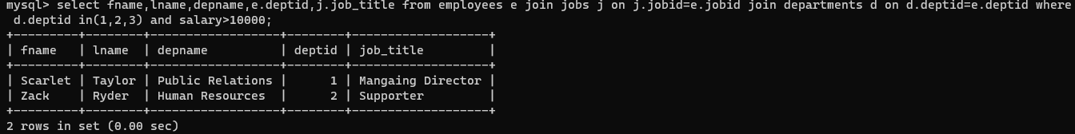

15. select depname,saddress,pcode,c.cname,r.rname from departments d join locations l on l.locid=d.locid join countries c on l.cid=c.cid join regions r on c.regionid=r.regionid;

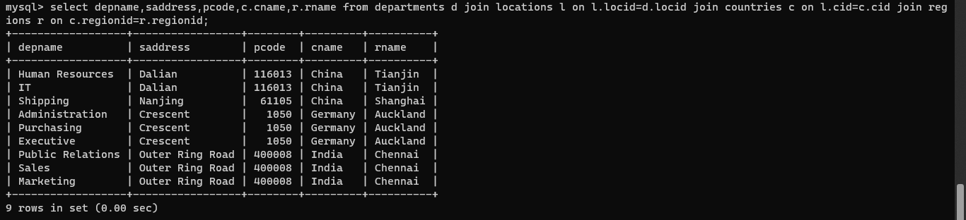16.

17. select e.fname, e.lname, d.depname, l.city, l.sprovince from employees e join departments d on e.deptid = d.deptid join locations l on d.locid = l.locid where e.fname like 'Z%';

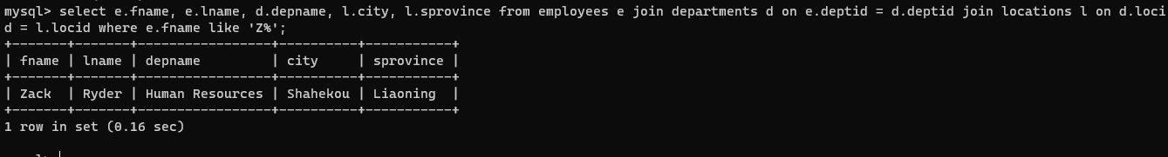

23. create view delhi_employees as select ej.name,ej.employee_id,ej.phone_number,ej.job_title,d.department_name,ej.manager_name from ( select concat(e.first_name,' ',e.last_name) as name,e.employee_id,e.department_id,e.phone_number,j.job_title,(select concat(first_name, ' ' ,last_name) as fullname from employees where employee_id=e.manager_id) as manager_name from employees e join jobs j on j.job_id=e.job_id) ej join department d on d.department_id=ej.department_id ;

24. select name from delhi_employees where job_title like 'manager' and department_name like 'finance';

25. update delhi_employees set phone_number=121121121 where name like 'Smith%';

26. select e.employee_id,e.first_name,e.last_name,e.email,e.phone_number,e.hire_date,e.job_id,e.salary,e.manager_id,e.department_id,d.dependent_id from employees e left join dependents d on d.employee_id=e.employee_id where dependent_id is null;

27. select employee_id,first_name,last_name,email,phone_number,manager_id from employees where manager_id=101 union select employee_id,first_name,last_name,email,phone_number,manager_id from employees where manager_id=201;

28. select ed.employee_id,ed.first_name,ed.last_name,count(ed.employee_id) as No_of_Dependents from (select e.employee_id,e.first_name,e.last_name,d.dependent_id from employees e join dependents d on e.employee_id=d.employee_id) ed group by e.employee_id having No_of_Dependents>=1;