Trace a Web/API Request Using DevTools, DNS, and curl
Objective: To demonstrate how one API request can be traced from DNS resolution to browser inspection and command-line response validation.
Tools required: Google Chrome with DevTools, Terminal, nslookup, curl, Internet access

Steps to be followed:
1. Resolve the API hostname using DNS
2. Open the API endpoint in Chrome
3. Capture the request in Chrome DevTools
4. Inspect the request method, URL, and status
5. Inspect request and response headers
6. Inspect the JSON response body
7. Send the same request using curl and verify the result
Step 1: Resolve the API hostname using DNS
Use nslookup to resolve the public API hostname. The returned IP address may change over time.
nslookup jsonplaceholder.typicode.com
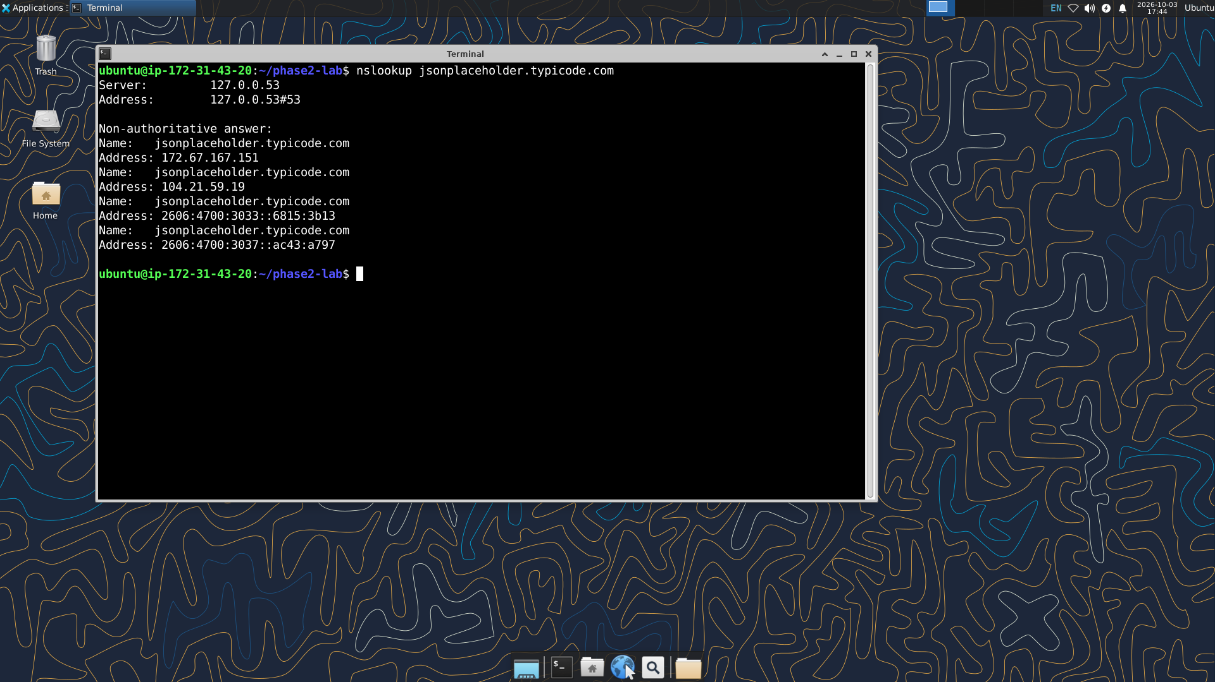
DNS lookup for jsonplaceholder.typicode.com

Step 2: Open the API endpoint in Chrome
Open the following endpoint and confirm that the browser displays a JSON response.
https://jsonplaceholder.typicode.com/posts/1
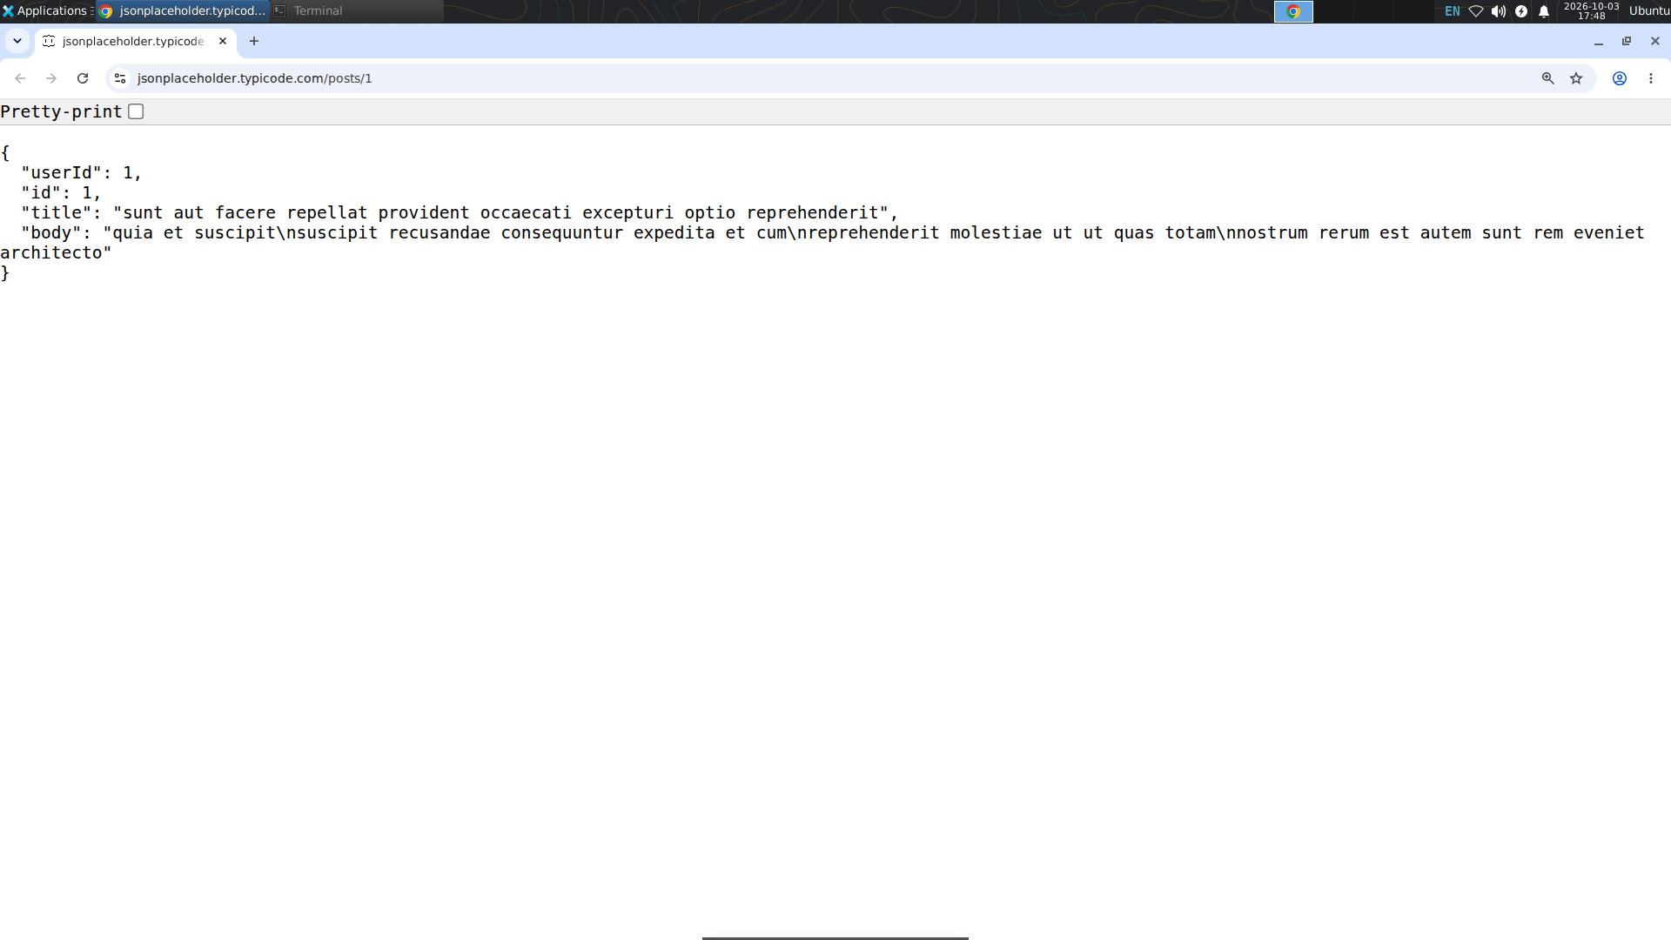
API endpoint opened in Chrome
Step 3: Capture the request in Chrome DevTools
Open Developer Tools, select the Network tab, and reload the page so the API request is captured.
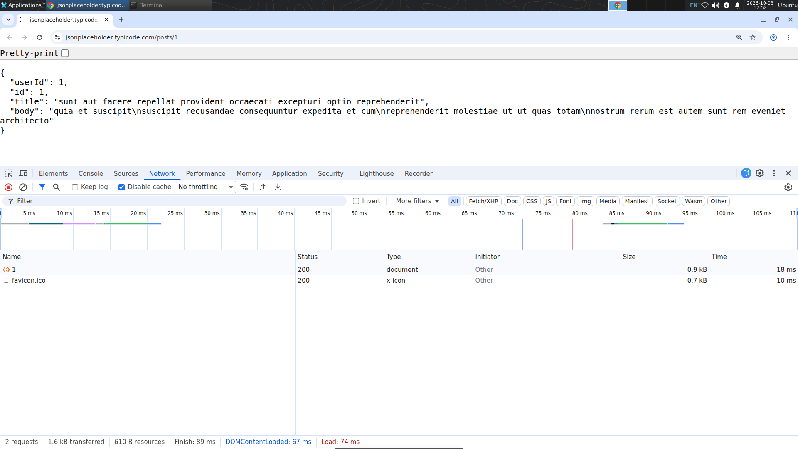
API request captured in the Chrome DevTools Network panel
Step 4: Inspect the request method, URL, and status
Select the /posts/1 request. Verify that the request uses GET and returns a successful HTTP status.
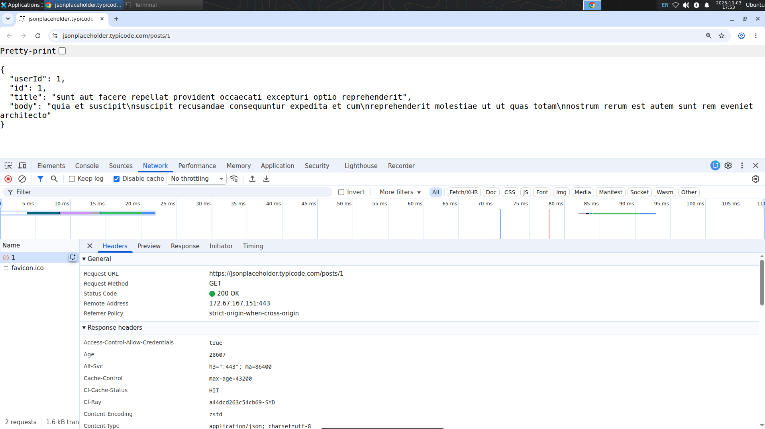
Request details showing URL, GET method, and successful status
Step 5: Inspect request and response headers
Review the Headers area and identify the request URL, method, status, and response content type.
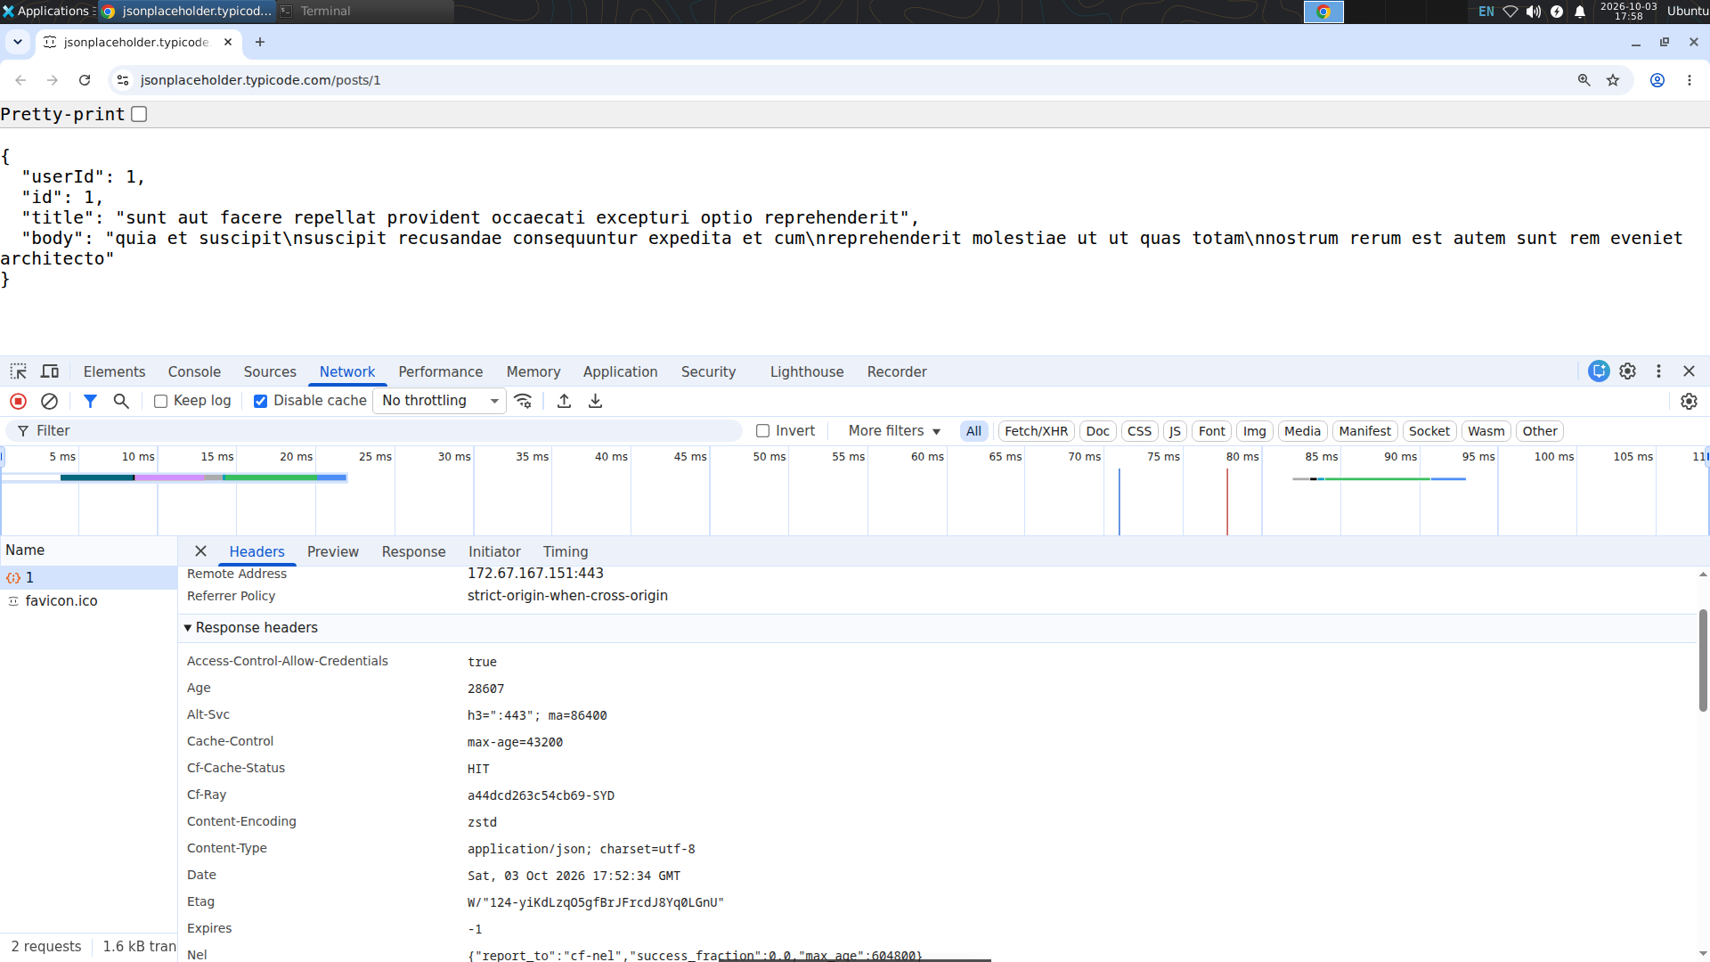
Request and response headers in Chrome DevTools

Step 6: Inspect the JSON response body
Open the Response or Preview tab and connect the GET request to the returned JSON data.
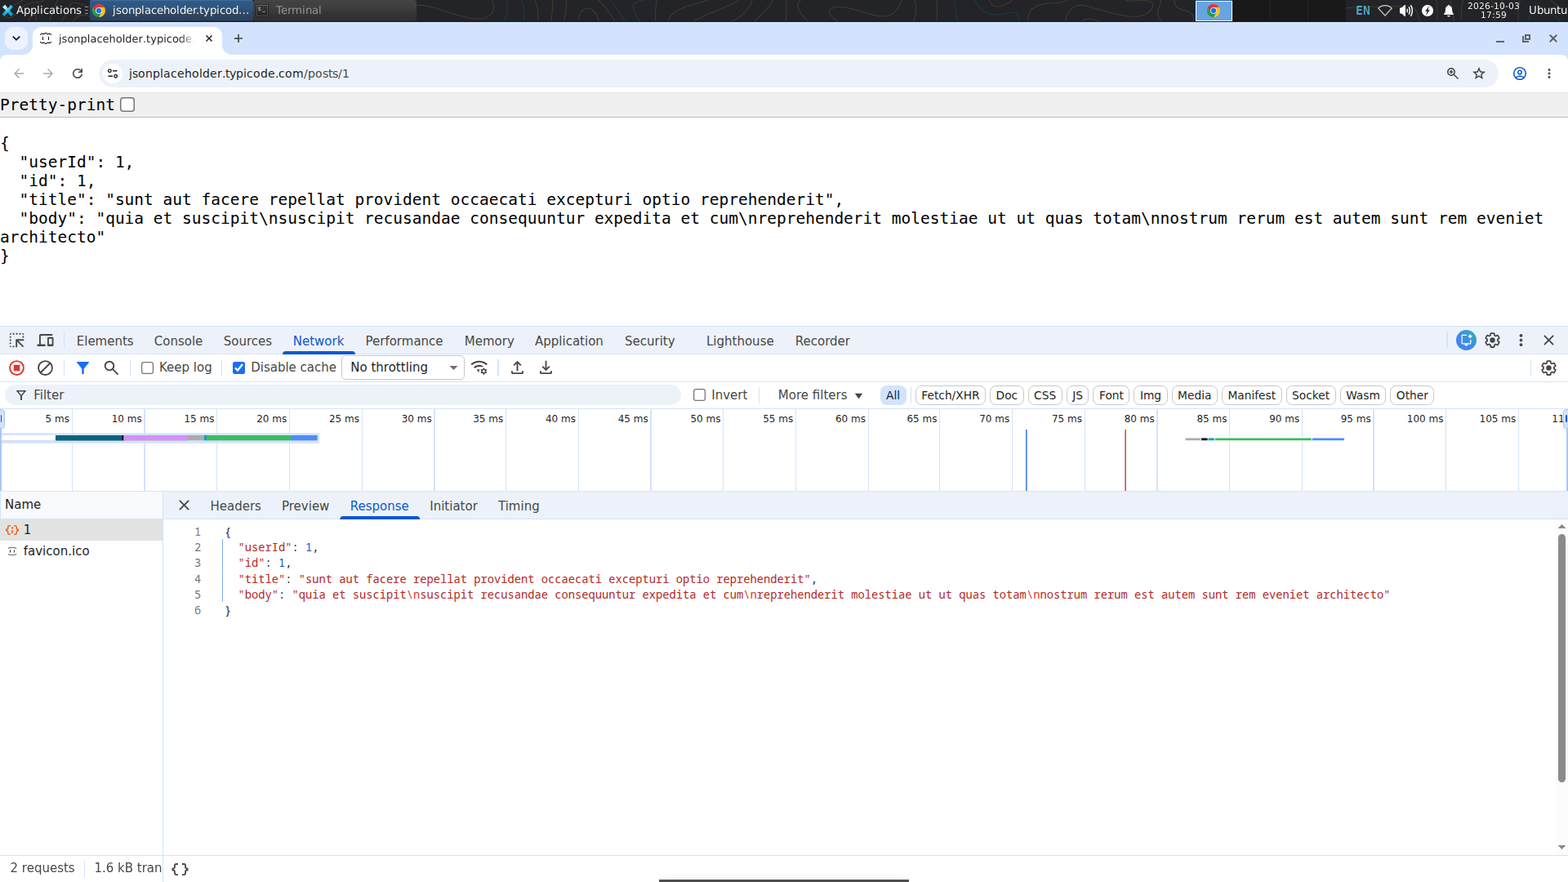
JSON response body returned by the API
Step 7: Send the same request using curl
Use curl with the -i option to display the HTTP response headers and JSON body together.
curl -i https://jsonplaceholder.typicode.com/posts/1
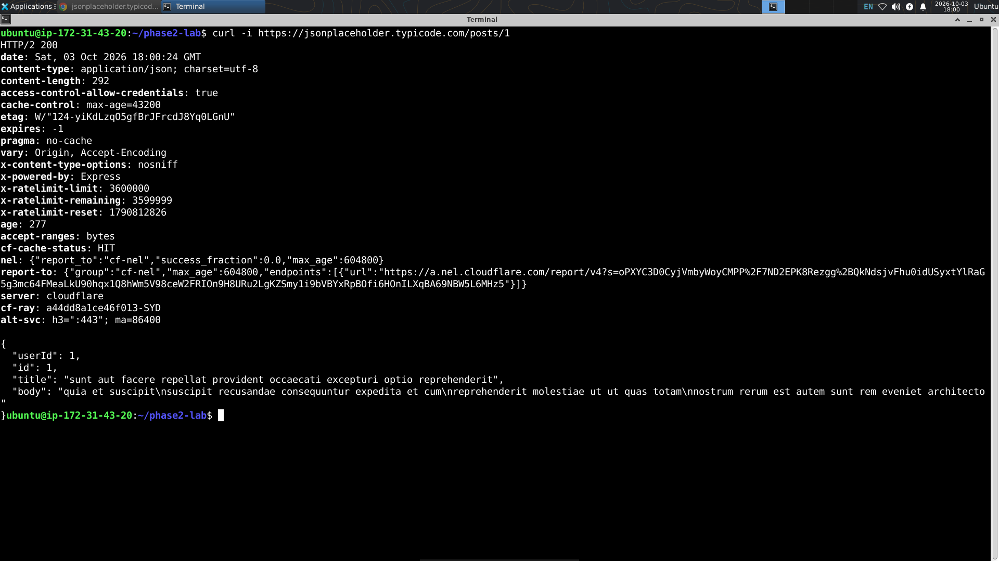
Successful API response using curl
Step 8: Verify the request journey
Compare the browser, DevTools, DNS, and curl evidence. The same API interaction can be observed from different viewpoints.
Verification
• The API hostname resolves successfully using DNS.
• The API endpoint opens in Chrome and returns JSON.
• Chrome DevTools captures the /posts/1 request.
• The request method is GET and the response status is successful.
• Request/response headers and the JSON response body can be inspected.
• curl sends the same request and displays the HTTP response and JSON body.
Activity complete when all verification points are satisfied.
Optional reference: JSON-only curl output
curl -s https://jsonplaceholder.typicode.com/posts/1
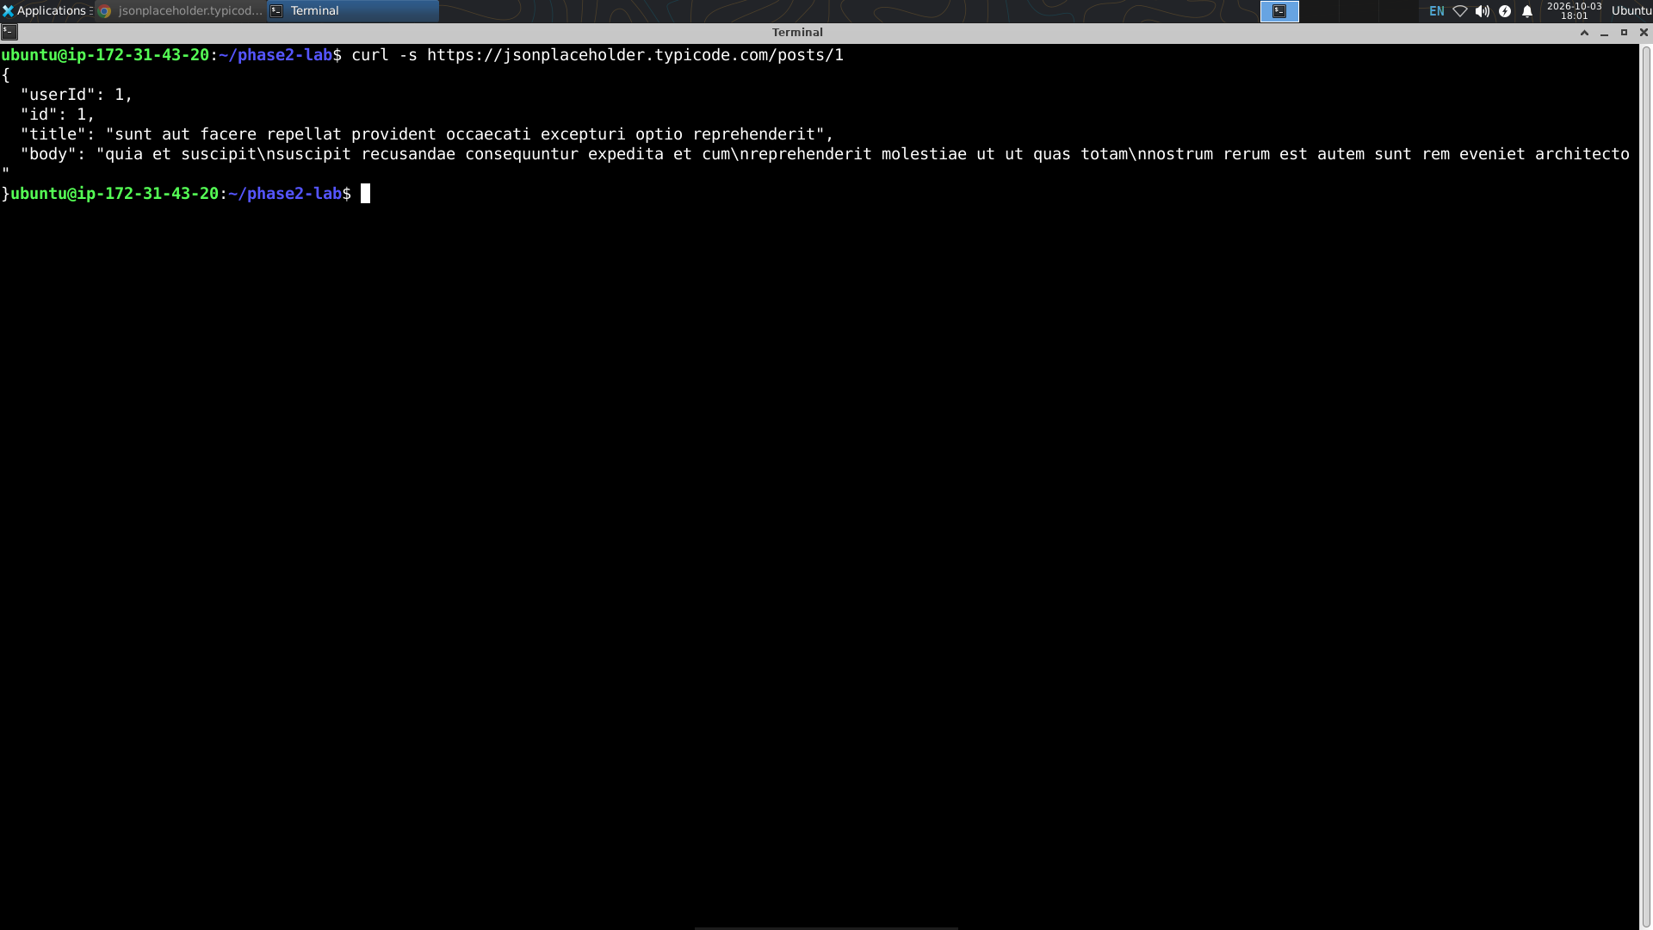
Optional clean JSON-only response using curl

