Grow Castle Autobot manual 06.10.2026 (1.51.5)
Requirements 5
Installation 5
Help 5
Setup 6
PC 6
Task bar 6
LDPlayer 6
Resolution 6
Settings description 7
Settings tab 7
Version 7
Save/Load 7
Open in explorer 7
Open log file 7
Open in Github 7
Open guide 7
Control buttons 8
Window name 8
Set pos 8
Build to play 8
Dungeon farm settings 9
Farm dungeon 9
Open dungeon_statistics.txt 9
Mat, get click delay 9
Make replays if dungeon doesn’t load 9
Missclick on dungeons 9
Include diagonal missclicks 10
Autobattle mode settings 10
AB mode 10
Time between skips, Battles with skips 11
Notification’s settings 11
Notification on 30 crystals 11
Play audio on 30 crystals 11
Notification only mode 12
Log 30 crystals collection time 12
Skips settings 12
Skip waves 12
Skip with oranges 13
Background mode 13
Solve captcha settings 13
Solve captcha 13
Open captcha.log 13
Upgrades for crystals 13
Upgrade castle 13
Upgrade hero for crystals 14
Ad watching settings 15
Ad for speed 15
Ad for coins 15
Ad during X3 15
Ad after skip only 15
Altars 15
Heal altar 15
Death altar 15
Replay last wave 15
Screenshot settings 16
Items / Runes 16
Popups 16
Solved captchas 16
Failed captchas 17
Captcha errors 17
On esc 17
Long load 17
Long wave 17
After 10 esc 17
AB errors 17
On freezing 18
LDPlayer load fail 18
Save screenshots cache on error 18
Build tabs 19
Example of a customized build 19
Pw 19
Smith 19
Orc band, Military F 19
Chrono 19
Single click 19
Clickable 20
Scoped heroes 20
Test tab 20
Mouse tests 20
Clicks test 20
Test mouse movement 20
Get crystals count 21
Restart, Reset, Cleanup 21
Restart 21
Reset 21
Cleanup 21
Upgrade hero, Upgrade castle 21
Show game status 21
Solve captcha 22
Screenshots tests 22
Save window screen 22
Save screenshot 22
Save screenshot jpg 23
Getscreen benchmark 23
Online actions tests 23
Advanced tab 24
Hotkeys 24
Mouse behavior 24
Simulate mouse movement 24
Press fixed point on dungeon enter 24
Click waits 25
Randomize cast sequence 25
Press all heroes on cast 25
Press fixed point on hero 26
Waits and online actions between battles 26
Ignore waits on AB mode 26
Ignore waits during X3 from ad 27
Trigger time min, max 27
Wait time min, max 27
Online actions 28
Online actions delay 29
Guild actions 29
Top actions 29
Press Deck 30
Craft stones 30
Do save 30
Before/After wait 30
Monitor freezing 31
Max battle length 31
Cleanup interval 31
Save before cleanup 31
Do restarts 31
Max restarts for reset 32
Gc loading limit 32
Fixed ad wait 32
Pw on boss 32
Orc band and Military on skip only 33
Collect mimic 33
Other 33
Manual waving 33
Changing parameters in runtime 33
Red background 33
Output files 34
gc.log 34
dungeon_statistics.txt 34
captcha.log 34
timerx3spd.txt 35
30crystalsTime.log 35
Hint detection 36
Problems solving 37
Error while calling gca_captcha_solver.dll 37
Lags 37
Cannot watch ad until the end 37
Problem with starting autobattle 37

Requirements
- 64-bit Windows OS
- 1920x1080 monitor. The script can still run on smaller monitors, but it wasn’t tested. There may be problems with smaller monitors.
- LDPlayer 9 android emulator installed. The script was tested with LDPlayer 9.5.37.0.
- Good computer performance. Grow castle should run at least 30 fps stable with required window size.
- Experience in game (reach 30k waves yourself at least).

Installation
- Go to releases list, and download latest one. Do not download source code – it’s wrong archive.
- Unzip it to folder dedicated for script.
- Open App folder, and find gca.exe. Create desktop shortcut for it, and run. Do not remove it from its folder, and do not remove any other file from there.

Help
If you have questions or troubles with setup or anything else – open a new Discussion or Issue on github page. You can also ask me directly, but it’s better to allow other people to know about issue and how to solve it.

Setup

PC

Task bar
The task bar should be at the bottom of the screen.

LDPlayer
The side bar should remain open:
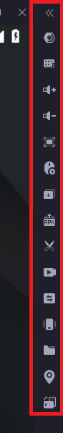

Resolution
Set resolution to 1600x900:
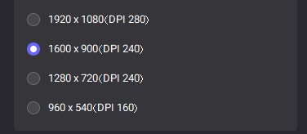

Settings description

Settings tab
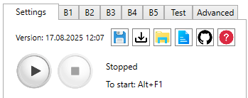

Version
First that you see is Version, which is date and time when I built this exact version. This version is logged every time you start script.

Save/Load

Settings are stored as json file. When you save – your current settings are written to file, and you can load them. Load works even if you have saved settings from previous versions, where some settings are missing (default value is set in this case).
Your current settings are stored in “.\App\clickerSettings.json” file. It is rewritten every time you change anything in settings.
You cannot save and load settings when script is running.

Open in explorer
This button will open explorer at script’s location, and select App folder, where script’s executable file is.

Open log file
This button will open gc.log file with your default editor for *.log files. If it doesn’t exist – it will be created.

Open in Github
This button will open Grow Castle Autobot repository in Github with your default browser.

Open guide
This button will open .\gca_guide.pdf with your default *.pdf app. If it doesn’t exist – you will see error about it.

Control buttons
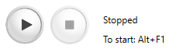
Next are Start and Stop buttons. You can use them, but it’s better to use hotkeys that are also indicated there. You can change hotkeys in Advanced tab.
You can pause script by pressing Start button while it’s running, or by Start hotkey. However, it might not work properly sometimes, because script uses stopwatches inside that are not stopped when you hit pause.

Window name
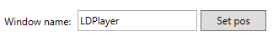
Here you have to write your LDPlayer window name, without the version.
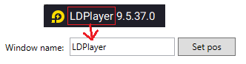

Set pos
After pressing Set pos button, the window should take the size and position which script needs to work properly. The LDPlayer window should not be maximized.
If you write wrong name – you will see error. Window name is case sensitive.
It is important to make sure that there are no windows with the same name as emulator, as it can grab the wrong window, because of this there may be problems.

Build to play

The number of the build that the script will play. The button on the right will open selected build.
All 5 builds are configured in Build tabs:

Dungeon farm settings
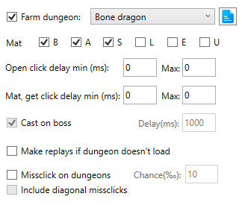

Farm dungeon
From the drop-down list you select a dungeon, if there is a checkmark, it will play there.
For dragons: whether to mat items of different grades.
For dungeons: whether to start cast heroes only when the boss came out with given delay.
Note: All runes will be collected from dungeons.
When farming dragons – will count item grades from dragons in dungeon_statistics.txt file.
Will disable Skip waves, AB mode, Replay last wave.

Open dungeon_statistics.txt
This button will open dungeon_statistics.txt with your default *.txt editor. Will create this file, if it doesn’t exist.

Mat, get click delay
The script identifies item very fast, and if you set 0 there – it will get or mat item as fast as possible. This setting sets delay.

Make replays if dungeon doesn’t load
If the internet is gone, and script cannot open dungeons, then if it’s checked, then until next captcha the script will play replays. Then will switch back to dungeons.
If it’s not checked, then if dungeon panel doesn’t open due to internet issues, the script will wait for random time between 10 and 20 seconds, and will try again and will keep trying to open it infinitely.
If dungeons panel opens, but script is stuck right on “BATTLE” button, then it can indicate that inventory is full, or you are out of contracts. In this case script will make 3 attempts to start dungeon, and if it will fail 3 times in row, then will either start making replays (if checked), or will stop right there otherwise.

Missclick on dungeons
This setting is made just to simulate human behaviour. If you think that developer can see all clicks timings and coordinates (this is probably not the case here), then you can check this. Then set chance of missclick (chance is measured in per mille (‰).
$$1 ‰ = 0.1\%$$
For example, if you farm bone dragon, then if it decides to make missclick, then will click Red, Legendary, or Expert dungeon:
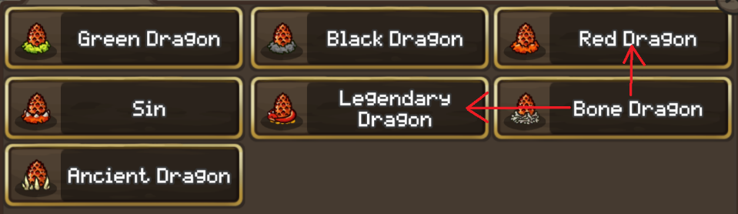

Include diagonal missclicks
If checked, then will also missclick to Black dragon, or Intermediate dungeon:
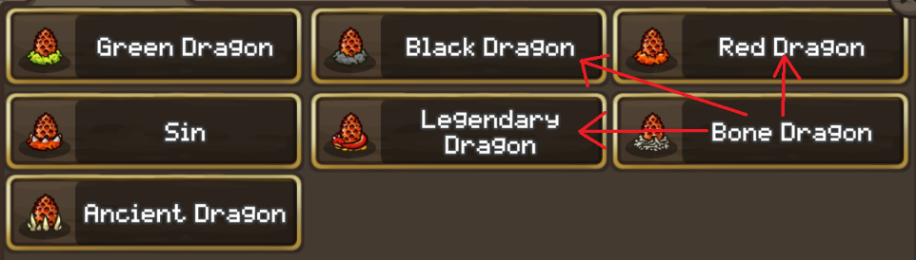
Under Include diagonal missclicks there is little extra space – This is space for kill time and kills per hour label. It will update every time when script entered dungeon successfully.

Autobattle mode settings
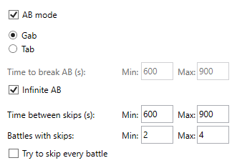

AB mode
If enabled, the script will start auto battle, and watch for game. If game crashes, or you lost on AB, or emulator freezed, then it will restart autobattle.
Then you can set time for autobattle. This is needed if you want to upgrade hero or tower between AB sessions.
Otherwise, if you don’t want script to do anything between battles, then set Infinite AB checkbox.
To exit from autobattle, script will pause game, and click “Exit after battle” button. It will do it only if you are not in very end of wave to avoid bugs. If you are at the end of wave, then will wait for next one, and press this button there.

Time between skips, Battles with skips
Starting from 1.50.0 you can skip waves without stopping autobattle. After starting autobattle, the script will wait for random number of seconds between min and max, and will try to skip random number of times from Battles with skips range. Will decide to skip based on your skip settings (with/without oranges).
If Try to skip every battle is checked, then will not have any timer between skips. It is better to use when you want to skip with oranges. Otherwise – better to make it once in a while.
The script will stop if you are out of gold or time, but it’s still very desirable to control it yourself.
You can set delays between clicks on AB button, switching to gab and start buttons to make it slower or faster in additional settings in Advanced tab.
Warn: Of course, you need to enable Solve captcha, otherwise it will just stop, and these functions will be useless.
Note: If ab loses constantly, the script will constantly restart autobattle.

Notification’s settings
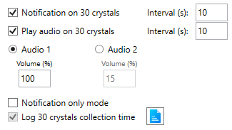
This section is made to notify user that game has collected 30 white crystals.

Notification on 30 crystals
This option is available only if you have AB mode or Notification only mode enabled. If enabled – the script will send desktop notification (toast) when you have 30 crystals collected.
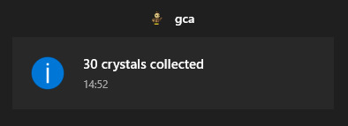
Since crystals calculation happened 2 times per second, we have Interval that specifies time between notifications. If you have AB mode enabled – then current white crystals calculation will only happen while in battle. If there is Victory animation or wait between autobattles panel or something else – the background will be dimmed, and script will not count crystals then.

Play audio on 30 crystals
This option is available only if you have AB mode or Notification only mode enabled. If enabled – the script will invoke one of audio files when 30 crystals are collected. In .\App folder, you will see Audio1.mp3 and Audio2.mp3 files. By default, first is small notification sound, and second one is alarm sound, downloaded from internet. You can replace these files with another audios, but you need to make sure that they are placed inside of .\App\ folder, and have file name exactly “Audio1.*” and “Audio2.*”. The type of file doesn’t matter, but it must be one of supported formats by Windows Media Player. If you put video there – it will still run, but only video’s sound will be there.
You select which audio to play when 30 crystals are collected. Again, script checks number of crystals often so that it can catch exact moment of collecting 30 crystals, and you can’t run audio for every detection, so you specify interval between playing this audio.
There are also settings for volume. This is additional volume multiplier so that you don’t need to change whole computer sound volume when you want to make it quieter.
Note: if audio file is missing – nothing will be played.
You can expand app horizontally, and there you can test notifications and audio playing:
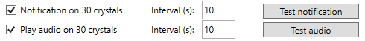

Notification only mode
This will enable separate script mode that won’t do anything in game. Everything that script can do in this mode:
- Resizing LDPlayer window if you modified its size while it was watching
- Send notifications, play audios, make logs
- Calculating amount of white crystals
No clicks, no other checks are made by script in this mode. The purpose of this mode is to notify user that 30 crystals are collected. It will calculate number of white crystals always, even when you have animation of victory, or another thing that overlaps crystals amount and makes it dimmed.

Log 30 crystals collection time
This works only with Notification only mode. If enabled, the script will write time of when 30 crystals were collected to 30crystalsTime.log, compare it to previous time of collecting 30 crystals and write the difference between them to file. You can open this file with button next to it.
The script only writes first detection of 30 crystals, and there must be at least 5 detections of lower amount in row before to trigger it, which means that there must be <30 crystals for at least 5 seconds to make script write it to file.
Note: when you start script and you already have 30 crystals – the time will be logged in file.

Skips settings
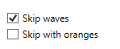

Skip waves
Skip the waves or not. If you are not skipping with oranges, the script will look on the white number of crystals to see if there are 30 crystals.
Will disable Upgrade castle, Upgrade hero, Farm dungeon, Replay last wave.
Note: The script doesn’t identify exact number of white crystals you have, but correct results are these:
Actual amount | Script’s output
0 - 9 | 0
10 - 29 | 10
30 - 119 | 30
This is enough to do all actions that script can do. You can test correctness of these calculations in Test tab.

Skip with oranges
If enabled, will ignore number of crystals. It will always skip. If the oranges are over, the store will open once and script will disable skipping with oranges automatically.

Background mode
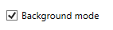
With it the script will not steal the cursor and you can overlap the LDPlayer with another window, but you can’t minimize LDPlayer. Minimized windows are not rendered, and script will see nothing. The script will try to fix LDPlayer size in case you changed it, but it’s better to avoid it.
It’s better to have this enabled, because LDPlayer has ads popups that will block the view if script captures whole screen. With background mode script will not see ads.
Note: without background mode, Monitor freezing function won’t work, even if it’s enabled.

Solve captcha settings

Solve captcha

If enabled – the script will solve captcha that appears right after starting battle. After starting script – it will check if “.\App\gca_captcha_solver.dll” is present and returns correct values.
You can test how captcha solving works by expanding app horizontally, there will be Solve captcha test. For it, you have to wait for captcha and start it with captcha on screen. The same test is in Test tab.
Note: The script will stop if it failed captcha 4 times in a row. It is practically impossible to make it fail 4 times in a row. All fails that happened to me were related to the lag during captcha animation and it was not possible to determine where crystal went, which happens rare.

Open captcha.log
This button next to Solve captcha will open your current captcha.log file.

Upgrades for crystals

Upgrade castle

Upgrade castle parts for crystals. For correct work, the upgrading parts must be on the floor specified in the Floor dropdown:
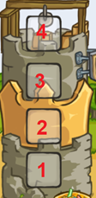
Will disable Upgrade hero for crystals, Skip waves.
You can test how tower upgrading works by expanding app horizontally, there will be Upgrade castle test button next to it, or in Test tab.
Info: After click on floor, the tower that stands on that floor opens and it is upgraded while you have 10 or more white crystals, or until it has been upgraded 90 times in a row (if the tower has reached the maximum level). Tower upgrade is called every 10 battles.
Info: Script will stop when you reach 9999 level, and then will disable upgrading.

Upgrade hero for crystals
If enabled, will upgrade hero on selected Slot:
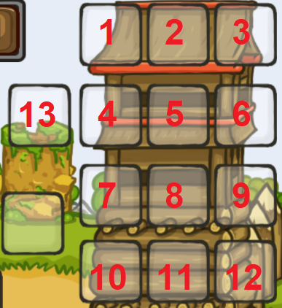
The hero that is upgrading should be in your build and at correct slot, because when you click on it – it will automatically open, and that’s how script works.
The script will upgrade until you have random amount of crystals between 0 and 9. After reaching 10 crystals – it just randomly chooses how many to upgrade more.
Will disable: Upgrade castle, Skip waves.
You can test how hero upgrading works by expanding app horizontally, there will be Upgrade hero test button, or in Test tab.
Info: Script will stop when you reach 9999 level, and then will disable upgrading.

Ad watching settings
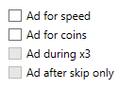

Ad for speed
Watch ads for X3. It is called in the main menu of gc through store. Viewing ads is a separate algorithm. If the ad completed successfully, then the last time the ad was viewed will be written to the file timerx3spd.txt - this is necessary to save the last time the ad was viewed after you stop script. Next hour the advertisement will not be checked. If the ad ends, it will not start and the script will automatically turn off viewing it.

Ad for coins
After the wave, there is a delay of 0.4 seconds, after which it is checked whether the advertisement popped up, and will watch it if it sees ad button.

Ad during X3
Whether to watch ads for coins during X3 with ads. You can turn it off to make the most of X3 from ads, or enable it if you need to watch ads for coins as quickly as possible.

Ad after skip only
Watch ads for coins only after skip 30 waves. There is more bonus gold, so there will be more gold from advertising. Cannot be activated without Skip waves.
Info: After the start of the ad, the script waits for a couple of seconds, and simply presses the right click once a second until it sees one of the options for the pause button that I entered into its algorithm, or until the game opens. If the advertisement has not closed in 2 minutes, then a restart is made. I met only 3 options for pauses in advertising - and I entered them into the script. In fact, this is just checking the color of the pixels at the given coordinates, where the continue button usually always appears - always the same color. If you have another ads UI, you can set Fixed ad wait in Advanced tab to add constant wait after ad opening. Its also important to exit from ad by pressing “Back” button, because if the only way to exit it is click “X” button on screen, then script will not able to do it.

Altars
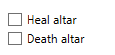

Heal altar
It will hit the altar when there is low hp, and Smith is either not in the build, or is pressed already, if there is Smith, then it will press him first.

Death altar
Presses the altar on the dragon and dungeon - when the boss appears. Works only there.

Replay last wave
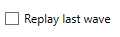
Make replays of the last wave. Will disable Farm dungeon, Skip waves, AB mode.

Screenshot settings
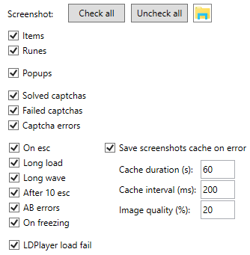
The script will save screenshot of some situations. By pressing button with folder image, it will open location where screenshots are saved.

Items / Runes
Before clicking “GET” script will save screenshot of item on screen. Only items that go to inventory are screenshotted. This is done so that you can safely show the screenhot to someone, and not be suspected of as script. The same is for runes. Screenshots are saved to folder “.\screens\Items\”.

Popups
Popups are messages that appear on left down part of screen:
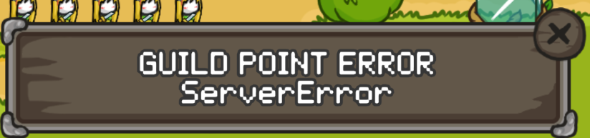
They all will be saved to “.\screens\Popups\”. Mostly you will see reward from captcha or another useless things, but sometimes there may be something useful.

Solved captchas
If enabled, all captchas that are solved will be saved to “.\screens\Captchas\” folder. There you will see 24 original frames of captcha, and results, where it determined the most likely paths of all cups like this:
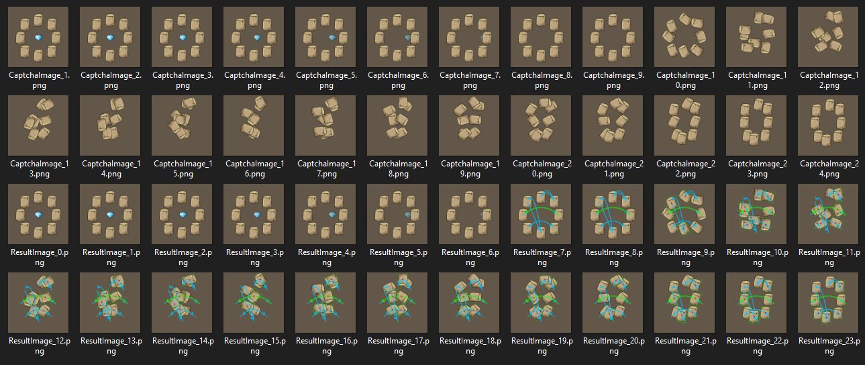
Keep in mind that average size of one captcha record is 4 MB. It is used to identify potentiall errors.

Failed captchas
If enabled, failed captchas will be saved to “.\screens\Failed captchas\” folder. It is better to enable it to have ability to identify error cause.

Captcha errors
If captcha started, and script didn’t find crystal, then “.\screens\Captchas\Errors\Error_N.png” screenshot will be saved. It can happen when you start script with already scrambled captcha, or you are running after future update, where captcha is changed.

On esc
If some unexpected panel is opened in game and doesn’t go away for 4 seconds in row, this situation is non-standard and the script starts pressing the right click to close it. At this point, a “.\screens\Errors\OnEsc_N.png” screenshot will be saved.
Right click is pressed until the sky opens, or 10 times - if after 10 right clicks did not open the sky - a screenshot is saved from the checkbox After 10 esc.

Long load
After opening gc when restarting the game, a stopwatch starts. If the gc menu has not opened in gc loading limit amount of time, a “.\screens\Errors\LongGCLoad_N.png” screenshot will be saved.

Long wave
When battle (any) is going for longer than Max battle length amount of time, a “.\screens\Errors\LongWave_N.png” screenshot will be saved.
If it’s AB mode, then it’s AB errors checkbox instead.

After 10 esc
If some unextected panel pops up, and script couldn’t close it after 10 “back” clicks, a “.\screens\Errors\unknown_N.png” screenshot will be saved.

AB errors
When you run AB mode, and switching to the next wave is going more than 10 seconds (Victory animation + 2 seconds timer before next wave), then “.\screens\Errors\AB_Error_N.png” will be saved.
If wave is going more than Max battle length amount of time, then “.\screens\Errors\AB_Error2_N.png” will be saved.

On freezing
If Monitor freezing is enabled together with Background mode, and script detects freezing, then “.\screens\Erorrs\Freezing_N.png” will be saved before making reset. This is useful to identify wrong freezing detections.

LDPlayer load fail
If after the reset LDPlayer didn’t start in 5 minutes, a “.\screens\Errors\LDPlayerLoadFail_N.png” screenshot will be saved before script will be stopped.

Save screenshots cache on error
The script is constantly taking screen of game while playing to decide what to do next. When it does it, it will save screenshots for some amount of time in memory (cache). If any of previous error happens, it will save current screenshots cache to “.\screens\Errors\Screen_caches\Screen_cache_N\” folder.
Sometimes it is very important to know what happened before this error.
You can set parameters of caching:
- Cache duration (seconds amount) is how many time screenshots are saved before deleting from memory. For example, if you set 60, then cache will contain screenshots from previous 60 seconds, and delete screenshots that were taken more than 60 seconds ago.
- Cache interval (milliseconds amount) is how frequently screenshots will be saved. Script takes screenshot of game very frequently (sometimes 100+ screenshots per second), and you don’t need to save them all. For example, if you set 200 there, then screenshots will be saved with 0.2 second gap.
- Image quality (percent amount) is quality of images in cache. Screenshot of game window has size of 1 MB on average, and cache can have a lot of images, so images are compressed to jpg format before saving them. If you set 100, then quality will be high, and screenshots will take more memory. 0 means maximal compression. Optimal value is 20%, which doesn’t corrupt image, and saves 90% of memory. You can test different image quality values in Test tab.
If you disable it, screenshots cache will still be working with this settings: Cache duration = 120 seconds, Cache interval = 300 milliseconds, Image quality = 10%. Screenshots cache will always be saved in case of hint detection, regardless of this setting.

Build tabs
There are 5 tabs where you can customize build. When activating heroes, script will make different actions on different heroes.

Example of a customized build
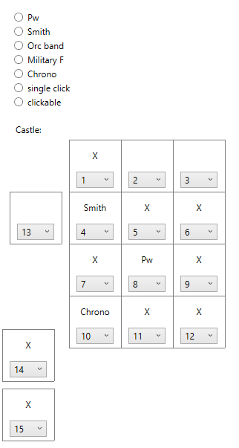

Pw
Pure wizard. It should be on the center vertical. It is pressed last after all heroes.

Smith
It is pressed when you have low hp. It may not have time to press when the damage is too fast. There can be problem when the HP number is very big (has 11 digits hp value), and the checked pixel is overlapped with that number.

Orc band, Military F
if you specify them, they will be pressed once at the beginning of the wave on manual battle start. It’s not recommended to play waves manually.
You can set them to be pressed on skip only in Advanced tab.

Chrono
Will be pressed first at the beginning of the battle.

Single click
Will be pressed once per battle. This is useful when you have summons that require single cast.
Tip: You can also use it in farming dungeons. If you kill boss by single cast – set all heroes to Single click, and you will not have problem with accidental hero opening when battle ends.

Clickable
Other heroes that should be clicked. They are pressed if they have a blue line above. Marked as “X”.

Scoped heroes
It doesn't work on heroes that need a scope, such as Ice Mage. This is just waste of time and potential bugs source, so it would be better to remove all such heroes from build when using script to cast heroes.
The number in the dropdown list is order in the cast sequence.

Test tab
Here you can test script’s functions without having to start it and wait for specific moment.

Mouse tests

Clicks test
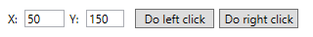
First test is to do left or right click at given coordinates. This will send message to LDPlayer window about click at these coordinates, and you have to set Window name correctly for it to work. Right click should do the same as “Back” button or Escape button press.
Default (50, 150) left click should click at “<Town” button if you have gc opened and have correct window position and size.

Test mouse movement
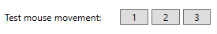
Test if mouse is moving properly. If you want to see it, you have to disable Background mode.
1 | Move mouse in circle.
2 | Move mouse in rectangle around heroes’ slots (if window has correct size).
3 | Move mouse in square spiral.
The script will run initialization code before test, so you have to setup everything correctly to make it work, even though it is not needed during test, otherwise you will get initialization error.
The next is test mouse movement from point to point:
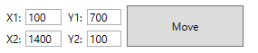
This will move mouse from (X1, Y1) to (X2, Y2), using the settings that you have and algorithm that will work when you start script. That is, if you disable Simulate mouse movement setting – you won’t see mouse movement, because it will be ignored. Also, if you enable Background mode, you won’t see the movement, but it still will send messages about mouse movement to LDPlayer window (the game will not see it).

Get crystals count

This will call function that calculates current number of white crystals. It also shows if you have oranges or not.
Dark mode is used when script upgrades hero or castle for crystals (because crystals number is dimmed).
It doesn’t return the actual number of crystals. These are correct results:
Actual amount | Script’s output
0 - 9 | 0
10 - 29 | 10
30 - 119 | 30

Restart, Reset, Cleanup
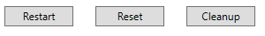

Restart
Will close gc and open it. You need to test it before first run, because there are many situations when restart is made.

Reset
Will press Reset button, then wait up to 5 minutes for LDPlayer to load, and then open gc.

Cleanup
Will invoke same code as will be invoked when Cleanup interval is elapsed. Will close gc, and will either make reset and start gc.

Upgrade hero, Upgrade castle
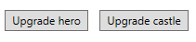
Will invoke same function as will be invoked when Upgrade hero for crystals or Upgrade castle is enabled.

Show game status
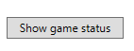
This will show where in game you are right now (if this position is defined in script). Positions that should be identified:
- Gc menu
  - Empty game (game resets)
  - Ad for coins panel
  - Hell buttons
  - Replay buttons
- In town
  - Forge position
- In battle
  - Skip panel
- Paused
  - “Exit after battle” button
- In forge
  - Whether is on top of forge list
- Start AB panel
- Lost on AB panel
- Captcha panel
- Hero panel
  - Choose class panel
- Dungeon list
  - Dungeon panel
- In shop
- Item panel, item’s grade (dropped after dragon, not in inventory)
  - Rune panel (dropped after dungeon, not in inventory)
- In top
  - Section in top
  - Global or local top
- In guild
- Save panel
- Player profile panel
- Popup

Solve captcha
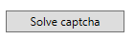
Will solve captcha. For this, you have to first open captcha. Instead of clicking on the right thing – it will more cursor to it, so you can see if it solved it correctly.

Screenshots tests

Save window screen

This will capture LDPlayer window, and save “.\screens\Test\WindowScreenshot_N.png” screenshot. Button with folder icon will open “.\screens\Test\” folder, and select created screenshot.

Save screenshot

This will capture complete screen, and save “.\screens\Test\CompleteScreenshot_N.png” screenshot. Button with folder icon will open “.\screens\Test\” folder, and select created screenshot.

Save screenshot jpg

This will capture LDPlayer window, then compress image to jpg format with given image Quality, and save “.\screens\Test\JpgScreenshot_N.png”.
The Quality is percent value. 0 means that image quality will be the worst, but image size will be minimized. 100 means simple jpg conversion.
The screenshots cache makes images compression with same algorithm before saving images to memory, and you can test how different images quality looks like and how many space single screenshot takes here.

Getscreen benchmark
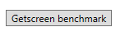
This will capture LDPlayer screen 100 times in row, and show average time of capturing screenshot. It should take not more than 50ms. on average (with correct window size), but it’s still stable even if it is slow.

Online actions tests
Online actions are done before or after waiting between battles in order to simulate human behavior. Here you can test them.
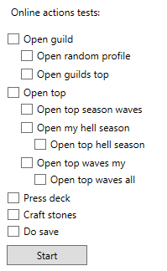
The logic that should happen for each action is described in Online actions. Here order of Open guild -> Open top -> Craft stones -> Do save is not randomized, but in runtime it will be randomized. Order of sub-actions will be randomized always.
Here the chance of each action is 100%.

Advanced tab
Here you have settings that are rarely changed.

Hotkeys
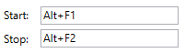
You have Start and Stop hotkeys that you can change. The hotkey can have zero or more modifier keys (Ctrl, Shift or Alt), and must end with non-modifier key (any other key on keyboard). The hotkeys are registered globally, and will work when app is not focused. It might not work if selected hotkey is already registered by another app. Default Alt + F1 and Alt + F2 are normally not taken by anything in Windows by default.
You cannot set same hotkey for start and stop.

Mouse behavior

Simulate mouse movement
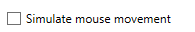
If enabled, then script will simulate mouse movement to the point where it has to click. This will not be visible when you have Background mode enabled, but it still will send messages to LDPlayer window about mouse movement. The game doesn’t see it anyways.
The generated mouse path is quartic Bezier curve with intermediate points that are randomly positioned within a padded rectangle formed by starting and finishing points, where padding is 5% of distance between starting and finishing points. Thus, the path can have 0, 1 or 2 inflection points, depending on how intermediate points were placed.
The speed of movement also varies within a path randomly, but you cannot change mouse speed in settings.
Note: There may be bugs due to time taken by script to move mouse to click position.
You can test mouse movement from point to point in Test tab.

Press fixed point on dungeon enter
This was made to simulate key bindings. If you expand the app horizontally – you will see fixed point coordinates settings:
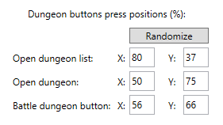
The lower X value is, the closer to the left will be the point.
The lower Y value is, the closer to top will be the point.
Each button has it’s bounds, and here you set percentage (0-100) inside these bounds, where the script will press it. When you haven’t set it and run for the first time – the values will be randomized automatically. The same for heroes here.

Click waits
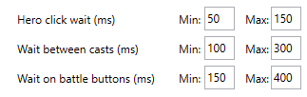
All click waits are milliseconds amount of time that is chosen randomly between Min and Max every time.
- Hero click wait is wait after clicking hero in battle. Do not put very small value there, because the game might not respond if clicks are very quick. The default settings should be ok.
- Wait between casts is wait after clicking all heroes, before starting checking cycle again. Here you can set zeros if you want, and have no delay after making casts.
- Wait on battle buttons is waits after pressing “Battle”, opening Autobattle panel, switching to gab, and before pressing Start. Fast clicks can ruin starting autobattle, so it’s better to have some delays there. The default settings should be ok.

Randomize cast sequence
If disabled, then script will cast clickable heroes from left to right, then top to bottom.
If enabled, then script will start from random clickable hero, and select random neighbor hero as next to click. If there is no neighbor, then will check heroes on distance of 2 cells. This way the script will press all heroes randomly and choose one of the closest heroes to previous one.

Press all heroes on cast
If enabled – will press heroes on cast, even when there is a red line above it.

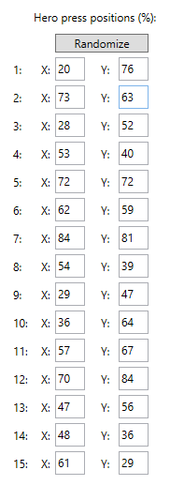
Press fixed point on hero
This was made to simulate key bindings. If you expand the app horizontally – you will see fixed point coordinates settings →
The lower X value is, the closer to the left will be the point.
The lower Y value is, the closer to top will be the point.
Each hero has it’s bounds, and here you set percentage (0-100) inside these bounds, where the script will press it. When you haven’t set it and run for the first time – the values will be randomized automatically. The same for dungeon enter here.

Waits and online actions between battles
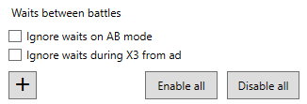
This was only made to reduce script’s efficiency and simulate human behavior by adding random waits and some online actions between battles.
This is very important to add this to your setup to reduce probability of being banned (hopefully).
Click “+” button, and you will see a new slot:
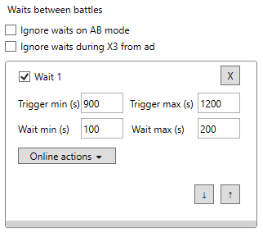
The checkbox “Wait N” specifies whether this slot is enabled. If you uncheck it, it will be ignored.
“X” button will remove it from list.
Up and down arrows will swap current slot with slot above or below.

Ignore waits on AB mode
If you have AB mode enabled, then waiting between battles is meaningless, because running autobattle is essentially afk mode, where it is assumed that you are not playing, so we don’t need to simulate human behaviour here. Only waiting part will be ignored in this case, online actions are still done. Read about them first.

Ignore waits during X3 from ad
If you have Ad for speed enabled, then when you have x3 from ad – script will ignore waits, even when time is elapsed. When 20 minutes after watching last ad for speed are passed – will continue making waits.
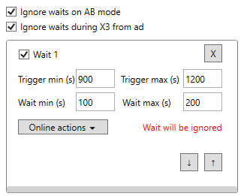

Trigger time min, max
Seconds value. When script will start first battle, it will initiate timer that will be elapsed after random amount of time between min and max values. Every time before starting next battle script will check if this slot is elapsed. It doesn’t affect how script behaves while it is in “Running” state. It is just a timer.
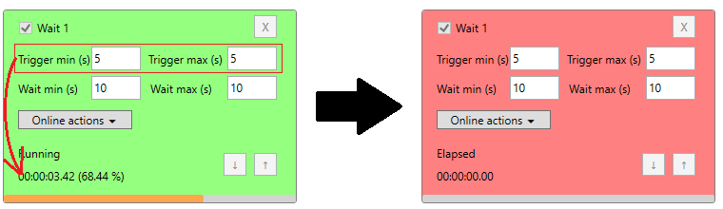

Wait time min, max
Seconds value. Before starting next battle, script checks all timers that you have there. If a slot is elapsed, it will take random time between min and max, and will just wait before starting next battle.
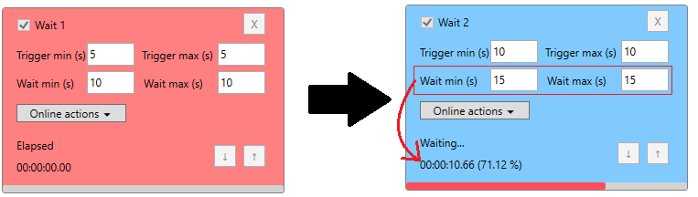
All other non-elapsed slots will be suspended while waiting for it:
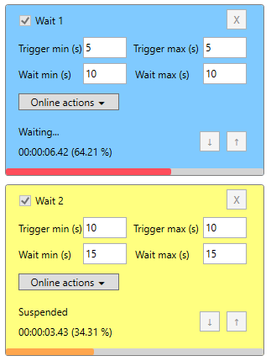
If multiple timers are elapsed together, then script will choose the bottom one to wait for, and all elapsed timers above will be ignored, and will be reset after waiting:
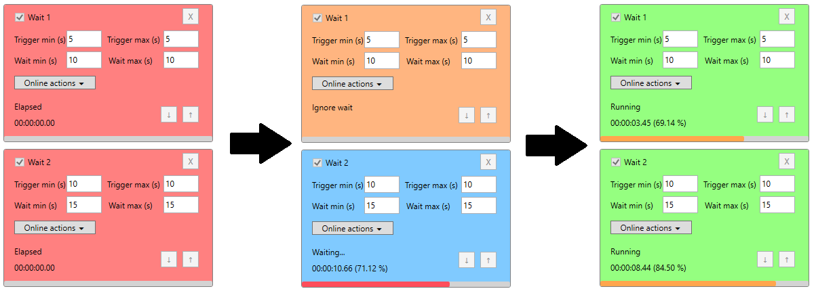
This means that when slot is triggered less frequently – it’s better to put it lower on list.
Note: When running script with waits between battles enabled – better not leaving it on Advanced tab, because timers are updated constantly, and it will increase CPU load.

Online actions
Online actions are done before and/or after waiting between battles in order to simulate human behavior. You can test online actions in Test tab.
For each action you can set chance of making it. It is made to randomize actions and not to do same things every time.
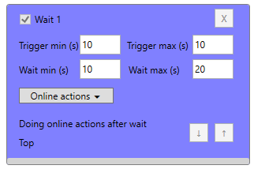
The order of actions is randomized.
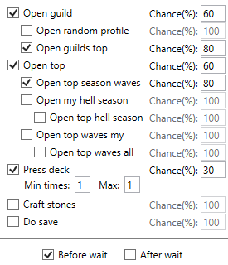

Online actions delay
When making action – every time it will make random delay between 3 and 6 seconds.

Guild actions
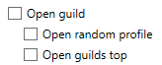
When Open guild is not checked or was filtered out by chance – will not enter guild and will do nothing there, even if nested checkboxes are checked.
If it’s checked – will enter guild, then wait. Then will do other selected actions there:
- Open random profile: script will click in random place, and will open one of 6 player profile in guild. If there was player and profile opened – will wait, and close it. If profile was not opened – will do nothing and go further.
- Open guilds top: will open guilds top, wait, and go further.
Note: guild actions order is randomized. It’s not necessary that order will be same as checkboxes.
After these actions script will close guild.

Top actions
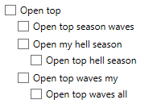
When Open top is not checked or was filtered out by chance – will not enter top and will do nothing, even if nested checkboxes are checked.
If it’s checked – will open top:

and if current open section is not top season waves (your places, not top 100), then will switch to it.
Then it will wait, and do other selected actions there:
- Open top season waves: will switch to top 100 in season waves and wait.
- Open my hell season: will switch to hell season and wait. The game will automatically open your places there.
  - Open top hell season: will switch to top 100 in hell season and wait.
- Open top waves my: will switch to overall waves top and wait. The game will automatically open your places there.
  - Open top waves all: will switch to top 100 in overall waves top and wait.
Note: top actions order is randomized. It’s not necessary that order will be same as checkboxes.

Press Deck
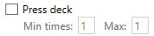
Will open deck list with this button:

The game sends some network request when you open this list, so it’s decided to add it here.

Craft stones
To craft stones, script will check where it currently is. If it’s in gc menu – will switch to town. When it’s invoked in runtime – it is guaranteed that it’s invoked in gc menu.
Then script will automatically find where forge is. If you don’t have forge there – will do nothing and will go back to gc menu.
Then will open forge, and if it’s scrolled down – will scroll up. It’s better to make it already scrolled up, because sometimes it can’t scroll to top (probably because of weak scroll, or something else). It will not press any buttons without making sure that it is not on top on buttons list in forge.
Then will craft A stones, then wait random time between 1 and 4 seconds, and click craft S stones.
Then will close forge and go back to gc menu.

Do save
When in gc menu – will open save panel and do save. If there is popup or ad for coins – will close it.

Before/After wait
Specify whether to do these actions before or/and after waiting. At least one checkbox must be selected, and app will ensure this by not letting you to disable both.

Monitor freezing
If you play for long time without resetting emulator, it can start freezing. This will ruin script’s work.
If enabled, then every time when script makes screenshot, it will store it in memory for 2 seconds. If it finds that there are same screenshots taken, then it will be considered as freezing, and reset will be done immediately, without closing gc. This is not desirable to do like this, but script cannot close gc properly when emulator is freezing. After such reset in the middle of the game, gc can reset your progress, and you will have to make load. If script detects empty add, it will stop immediately. If you want to prevent emulator freezing, you can make Cleanup more often. This will reset emulator properly with closing gc.
Freezing detection will be automatically disabled when script starts watching ad, closes gc, enters dungeons, solves captcha.
This works only when Background mode is enabled. Disabling Background mode won’t automatically disable this checkbox, but you have to know that it won’t work without it.

Max battle length

This is milliseconds value. If battle goes longer than this amount of time, the script will restart the game. This works in Dungeon farming, AB mode, Replays, manual battles.

Cleanup interval
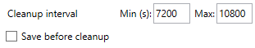
This is seconds value. After starting script, next cleanup time will be chosen by adding random number of seconds between min and max to current time.
The time of next cleanup will be indicated below min and max textboxes:
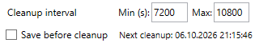
Cleanup will be made between battles only.
You can test how cleanup is made by expanding app horizontally, there will be Cleanup test button, or in Test tab.

Save before cleanup
This will try to save game before cleanup (To prevent losing progress in case of game resets). However, if you have troubles with internet at the moment of save, the script will not make save.

Do restarts

Sometimes ad disappears, and you have to restart game to make it appear again, or there are other reasons to restart gc. After starting script, next restart time will be chosen by adding random number of seconds between min and max to current time.
Note: when you mat item, and do restart, the item will be back (the dust that you got for it will also be removed). Because of this, if you are farming dragon, and mat item of specific grade (for example, mat A items on Legendary dragon), you will see that you still get A items in inventory. That’s because of this game’s feature.
Next restart time will be indicated under Do restarts checkbox.
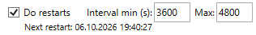
You can test how restart is made by expanding app horizontally, there will be Restart test button, or in Test tab.

Max restarts for reset
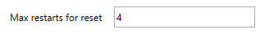
When script restarts game, it might encounter some problems. If it tries to restart 4 times in row, and cannot do it, then script will make reset. You can test how reset happens by expanding app horizontally, there will be Reset test button, or in Test tab.

Gc loading limit
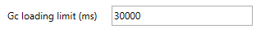
This is milliseconds value. After opening gc script will wait until gc menu opens. If it takes longer than this amount of time, restart will be made. You can test how restart is made in Test tab.

Fixed ad wait

This is milliseconds value. If script cannot close ad after starting it because of pausing it, you can set fixed ad wait after opening it. After this wait, script will start trying to close it.

Pw on boss

This is milliseconds value. The script will press pw on boss.
It works like this: when the wave reaches this point:

script stops activating pw, and when boss hp bar appears, it will be pressed after specified number of milliseconds. Then there will be higher chance to press all heroes at once on the bosses, and the wave will end faster.
Note: this will work only when script plays waves manually, or makes replays.

Orc band and Military on skip only
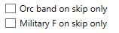
If checked, then script will press Orc band or military F only when script does skip 30 waves. It may be useful because if you press them and they give bonus wave, you won’t get crystal in the end of the wave, and you also don’t get crystals after skipping 30 waves.

Collect mimic

Mimic is collected when making replays, or playing manually.

Other

Manual waving
If you disable Farm dungeon, AB mode, Replay last wave, then script will play waves manually. This is the most dangerous way to play, because it’s easily detectable from developer side.

Changing parameters in runtime
The script cannot change its parameters when its running. You have to restart it. In this case, you will see that modified settings are marked with orange color:
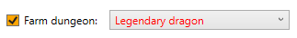

Red background
If you see that app has red background like this:
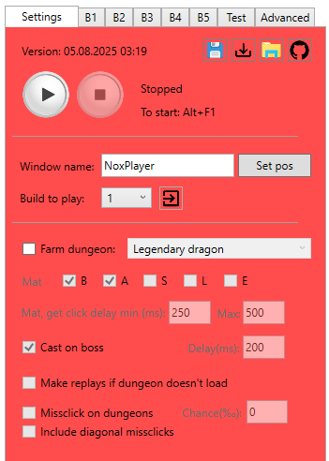
Then it means that script encountered some error while it was playing. Usually it’s simple errors like internet disappeared and script couldn’t open dungeons. But it also could be more serious problems.
Go and check “.\screens\Errors\” folder or gc.log file, and sort screenshots by creation time, and see what happened there.
To reset background, you have to restart app. It was made to make you notice this.

Output files

gc.log
This is log file where each action done by script is written.
The line from log typically has this structure:
[dd.MM.yyyy HH:mm:ss.fff <caller line number>] [<log type>] message…
Log types that exists:
Letter | Type | Description
I | Info | Regular message that appears most time
W | Warn | Unexpected, but fixable situation
E | Error | Needs inspection, it could be some bug
F | Fatal | Something that script cannot solve, and it will be stopped
U | User | User actions (start script, stop script etc.)
Q | Question | May be error, may be normal situation (like dungeons did not load)
O | Change settings | When script changes settings by itself (disable ad for x3, disable skip with oranges, switch to replays instead of dungeons)
N | Expected something, but didn’t happen | For example, script waits for ad for coins to appear, but it doesn’t
K | Expected and fixable | For example, game is overlapped by Victory animation
R | Restart, Reset | When restarting gc, resetting emulator
X | Fix something | Fix wrong window size (if you change in runtime), or close hero panel
M | Mistake | When about to do missclick in dungeon, or ignore mimic chest
S | Screenshot | When making screenshot
H | Hint | Hint on top of game detected
P | Popup | When popup detected
C | Captcha | While solving captcha
L | Online actions | When making online actions
- | Unreachable code | Somehow got into situation that should have been impossible to reach

dungeon_statistics.txt
The number of items of different grades from each dragon. The numbers must be on their strings, otherwise the script will not be able to read them. If there will be error while reading number from file – it will be replaced with its default content.

captcha.log
Each attempt to solve captcha is recorded there.
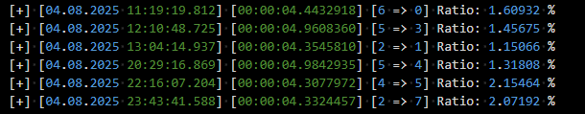
Log line in there looks like this:
[+/-] [<Date and time of attempt>] [<time solving>] [<start pos> => <finish pos>] [Ratio: <calculated chance of fail>] (Restarts: <amount of restarts to solve >)(if >0)
Position numeration:
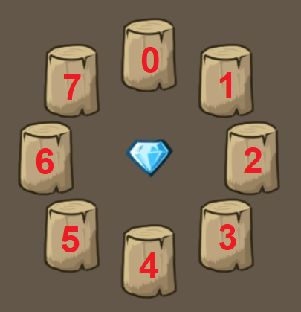

timerx3spd.txt
Here script will save last time of watching ad for x3 speed. If you want to erase information from there and make script check it even if it watched it recently, you can delete this file, and it will be created automatically with default value.

30crystalsTime.log
This file is created in Notification only mode if Log 30 crystals collection time is enabled. In it you can see time of 30 crystals detection, with difference between current and previous detection time:
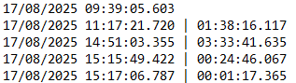

Hint detection
Once such a message popped up. At this time, the script was playing and saved the image. It restarted the game, but account was banned after this. We don’t have any information about what happened before this in game, or after restart.
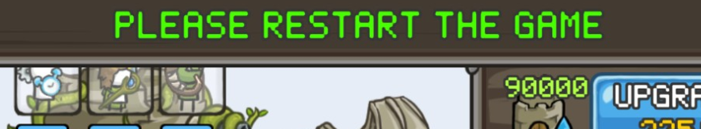
And this is more recent version (same situation as before: restarted game, but acc was banned, and we know almost nothing):
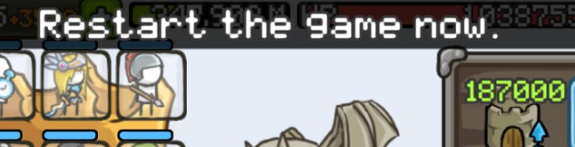
The script was improved to catch such hints, and if script detects it – it will save screen cache, even if it’s disabled, and will save screenshots from what will happen next, even if all screenshot options are disabled.
The script will check these pixels:
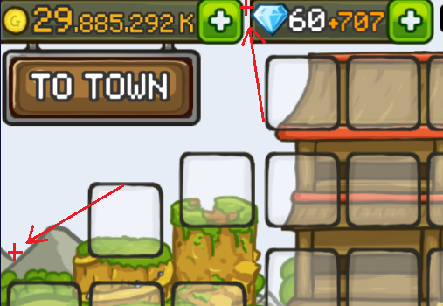
if the top pixel is blocked by something, and the bottom one is free (has regular sky color), the script will consider it as a hint, and will restart the game after 7 seconds. Then, it will keep making screenshots for some time (maybe something will happen then). After it, the script will continue playing.
There was a moment when there was a warning about server maintenance that also appeared on top of game in the middle of playing. If this will happen again, then script will probably be not usable for some time.
Note: You can also trigger this by pulling status bar in LDPlayer (where you have time, battery charge, wifi…)

Problems solving

Error while calling gca_captcha_solver.dll
If you start script with Solve captcha enabled and see error like “Error while calling gca_captcha_solver.dll: file or one of its dependencies was not found”, that means that you don’t have gca_captcha_solver.dll or opencv_world490.dll in “.\App\” folder. There are bunch of dlls that app needs to work. Some of them (maybe most) are not used, but deleting them can result in errors in runtime. Do not delete it.
If you are completely sure that everything is fine, and all files are at correct places, then you have to check if you have Microsoft Visual C++ 2015-2022 Redistributable (64x) on your computer. Press Win+R, then type “appwiz.cpl”. It will open Programs and components window in control panel. Then try to find “Microsoft Visual C++ 2015-2022 Redistributable (64x)” there. If you don’t have it, then download it from microsoft website.
Otherwise, I don’t know where exactly the problem could be.

Lags
If you have significant lags that prevent script to run correctly, then check if you have CPU virtualization enabled by expanding the app horizontally in Settings tab next to Set pos button.
Don’t forget to set more ram and cores for LDPlayer in its settings.
If it’s still lagging when running script – then it’s because of script takes screenshots of game window every time, and it causes emulator to redraw it, and it causes bigger load. Need to have more powerful pc then.

Cannot watch ad until the end
If script stops ads and cannot watch it to the end because of trying to exit it, it is probably because you have different ads UI that I didn’t add to sctipt. To fix this, try to set Fixed ad wait parameter to 30 or more seconds, to make script try to close ad after 30 seconds after starting it.
It’s also important to exit from ad by pressing “Back” button, because if the only way to exit it is click “X” button on screen, then script will not able to do it.

Problem with starting autobattle
If script cannot start autobattle correctly, try to increase Waits on battle buttons min and max values.

