Grow Castle autobot manual 05.08.2025 (1.40.10)

Requirements 5

Installation 5

Help 5

Setup 6

PC 6

Task bar 6

Nox 6

Theme 6

Grow castle position 7

Reset, Cleanup buttons positions 7

In case you have troubles with reset or cleanup buttons check 8

Resolution 9

FPS 9

Right click to move back 9

Recent apps 10

Notifications 10

Fix nox problems 11

Google Play services keeps stopping 11

Remove Discord overlay popup 12

Settings description 14

Settings tab 14

Version 14

Save/Load 14

Open in explorer 14

Open in Github 14

Control buttons 14

Window name 15

Set pos 15

Build to play 16

Dungeon farm settings 16

Farm dungeon 16

Mat, get click delay 16

Make replays if dungeon doesn’t load 16

Do missclicks 17

Include diagonal missclicks 17

Autobattle mode settings 17

AB mode 17

Break AB on 30 crystals 18

Skips between AB sessions 18

AB (wave canceling) 18

Skips settings 19

Skip waves 19

Skip with oranges 19

Background mode 19

Solve captcha settings 19

Solve captcha 19

Restart on captcha 19

Upgrades for crystals 20

Upgrade castle 20

Upgrade hero for crystals 20

Ad watching settings 21

Ad for speed 21

Ad for coins 21

Ad during X3 21

Ad after skip only 21

Altars 21

Heal altar 21

Death altar 21

Replay last wave 22

Screenshot settings 22

Items / Runes 22

Popups 22

Solved captchas 22

Failed captchas 23

Captcha errors 23

On esc 23

Long load 23

Long wave 23

After 10 esc 23

AB errors 23

On freezing 24

Nox load fail 24

Nox main menu load fail 24

Clear all fail 24

Save screenshots cache on error 24

Build tabs 25

Example of a customized build 25

Pw 25

Smith 25

Orc band, Military F 25

Chrono 25

Single click 25

Clickable 25

Scoped heroes 26

Test tab 26

Mouse tests 26

Clicks test 26

Test mouse movement 26

Get crystals count 27

Restart, Reset, Cleanup 27

Restart 27

Reset 27

Cleanup 27

Upgrade hero, Upgrade castle 27

Show game status 27

Solve captcha 28

Screenshots tests 28

Save window screen 28

Save screenshot 28

Save screenshot jpg 28

Getscreen benchmark 29

Online actions tests 29

Advanced tab 30

Hotkeys 30

Mouse behaviour 30

Simulate mouse movement 30

Randomize cast sequence 30

Click waits 30

Waits and online actions between battles 31

Ignore waits on AB mode 31

Trigger time min, max 32

Wait time min, max 32

Online actions 33

Online actions delay 33

Guild actions 34

Top actions 34

Craft stones 34

Do save 35

Before/After wait 35

Monitor freezing 35

Speedup on item drop 35

I have x3 35

Speedup on item drop 36

Max battle length 36

Cleanup interval 36

Cleanup or Reset 36

Do save before cleanup 36

Do restarts 36

Max restarts for reset 37

Gc loading limit 37

Fixed ad wait 37

Pw on boss 37

Orc band and Military on skip only 37

Collect mimic 37

Other 38

Manual waving 38

Changing parameters in runtime 38

Red background 38

Output files 39

.\gc.log 39

.\dungeon_statistics.txt 39

.\captcha.log 39

.\timerx3spd.txt 40

Hint detection 41

Problems solving 42

Error while calling gca_captcha_solver.dll 42

Cannot start script because of reset and cleanup buttons check 42

Cannot watch ad till the end 42

Cannot exit pause or hero window 42

Problem with starting battle 42

Problem with starting autobattle 42

# Requirements

* 64-bit Windows OS
* 1920x1080 monitor. The script can still run on smaller monitors, but it wasn’t tested. There may be problems with smaller monitors.
* [Nox](https://www.bignox.com/) android emulator installed. The script was tested with **NoxPlayer 7.0.6.2**.
* Good computer performance. Grow castle should run at least 30 fps stable with required window size.
* Experience in game (reach 30k waves yourself at least).

# Installation

* Go to [releases list](https://github.com/Silpux/GrowCastleAutobot/releases), and download latest one. Do not download source code – it’s wrong archive.
* Unzip it to folder dedicated for script.
* Open **App** folder, and find **gca_clicker.exe**. Create desktop shortcut for it, and run. Do not remove it from its folder, and do not remove any other file from there.

# Help

If you have questions or troubles with setup or anything else – open a new [Discussion](https://github.com/Silpux/GrowCastleAutobot/discussions/new/choose) or [Issue](https://github.com/Silpux/GrowCastleAutobot/issues/new) on github page. You can also ask me directly, but it’s better to allow other people to know about issue and how to solve it.

# Setup

## PC

### Task bar

The task bar should be at the bottom of the screen.

## Nox

### Theme

You have to set nox default theme:

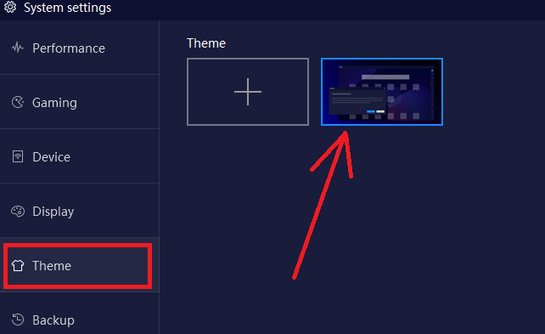

### Grow castle position

Grow castle must be here. When script restarts the game, it will click here:

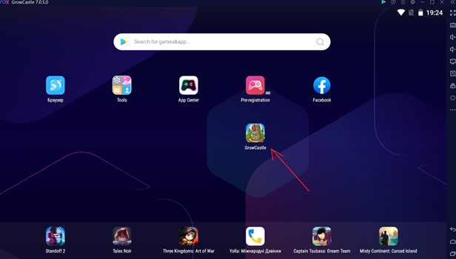

### Reset, Cleanup buttons positions

Move Cleanup button and Reset button here:

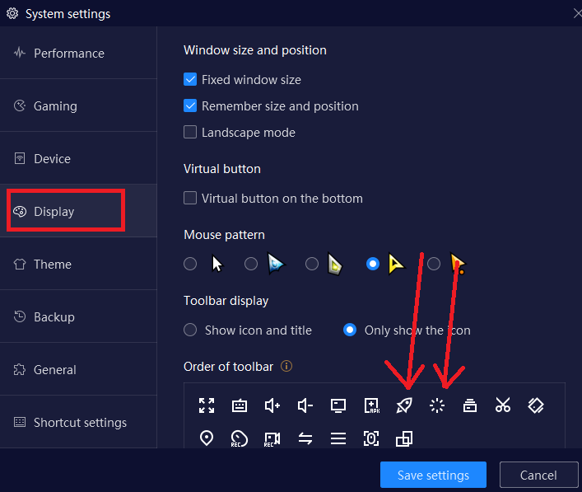

These buttons must be here (keep the side bar open always):



The script will check if these buttons are in right place when you start it.

#### In case you have troubles with reset or cleanup buttons check

If for some reason the script doesn’t allow you to run because of this error:

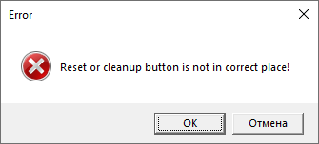

and you have them in correct places, then check if you have default nox theme. If everything is fine, and you still have this error, then you can disable this check. For this you have to expand the app horizontally, and next to Window name setting you will see **Disable reset and cleanup buttons check:**

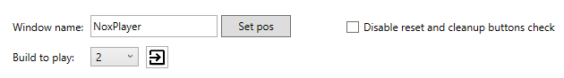

Do this only if you have troubles with this check while these buttons are in correct place. After disabling it, run reset and cleanup tests and ensure that they work correctly.

### Resolution

Set resolution to 1920x1080

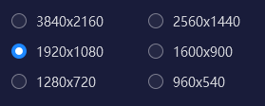

### FPS

Set 60 fps



### Right click to move back

Check this checkbox to right-click to move backward (make sure that right click makes same thing as Esc button)

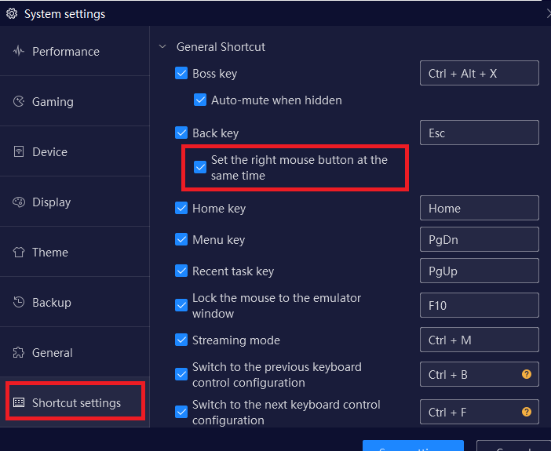

### Recent apps

Only grow castle must be in recent apps, otherwise script will not see clear all button when it restarts the game

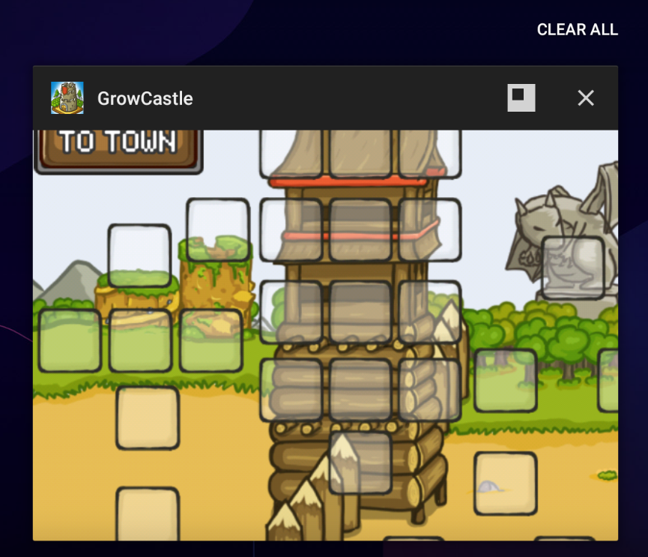

### Notifications

Block notifications from all apps, because it can ruin script’s work

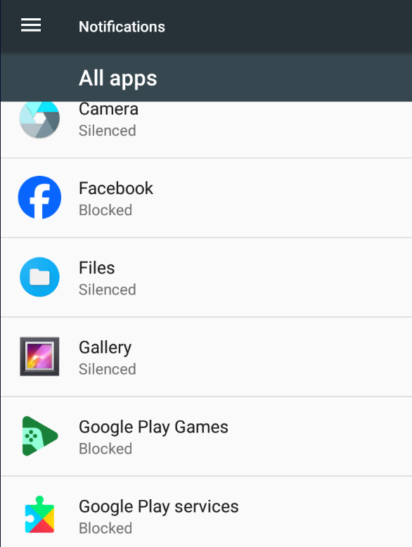

## Fix nox problems

### Google Play services keeps stopping

If you have problem where you have “**Google Play services has stopped**” and it keeps stopping – it will be huge problem for script.

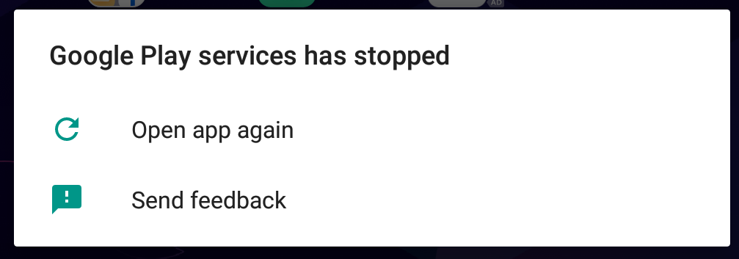

You will have to disable it:

1. Go to **Settings** -> **Security**  
   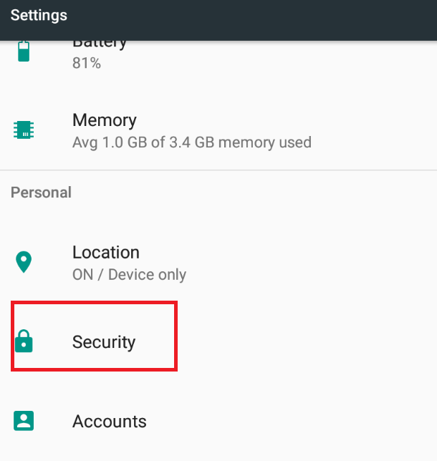
2. Open **Device administrators**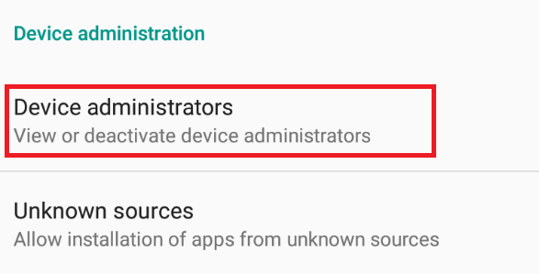
3. Disable everything you have there  
   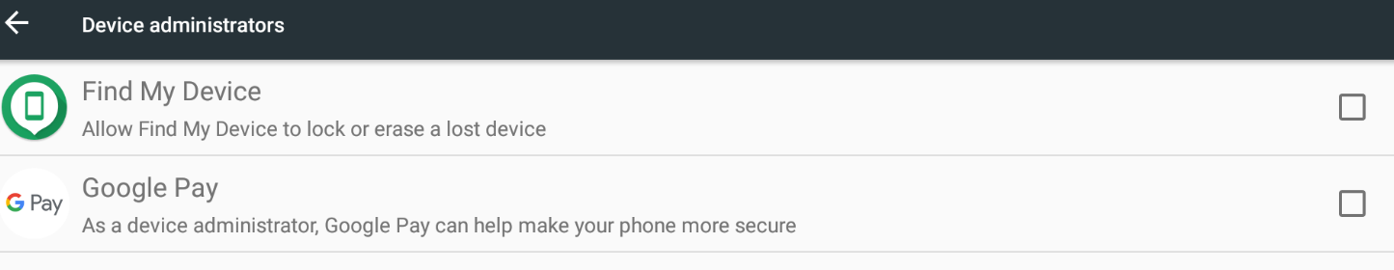
4. Now go back to Settings, and open **Apps**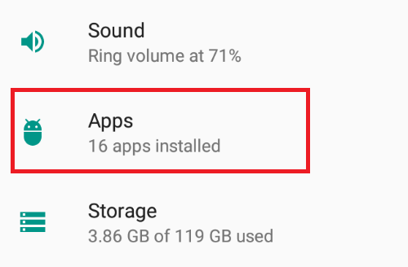
5. Find **Google Play services**, and disable it  
   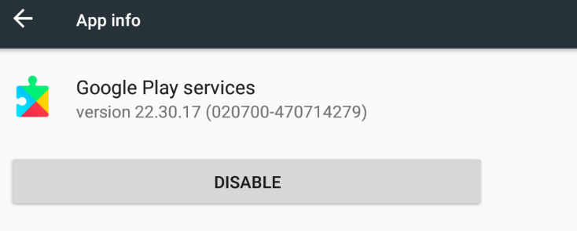

This will stop it from crashing. However, you won’t be able to use “**Load**” function in grow castle, because Google Play services are involved there, and grow castle will crash.

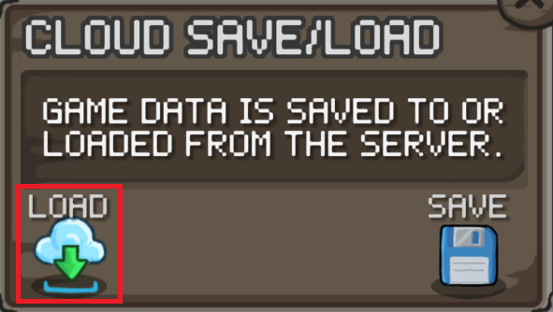

You can just enable Google Play services temporarily for that.

### Remove Discord overlay popup

It doesn’t block script from running, but can be annoying if you don’t use it.

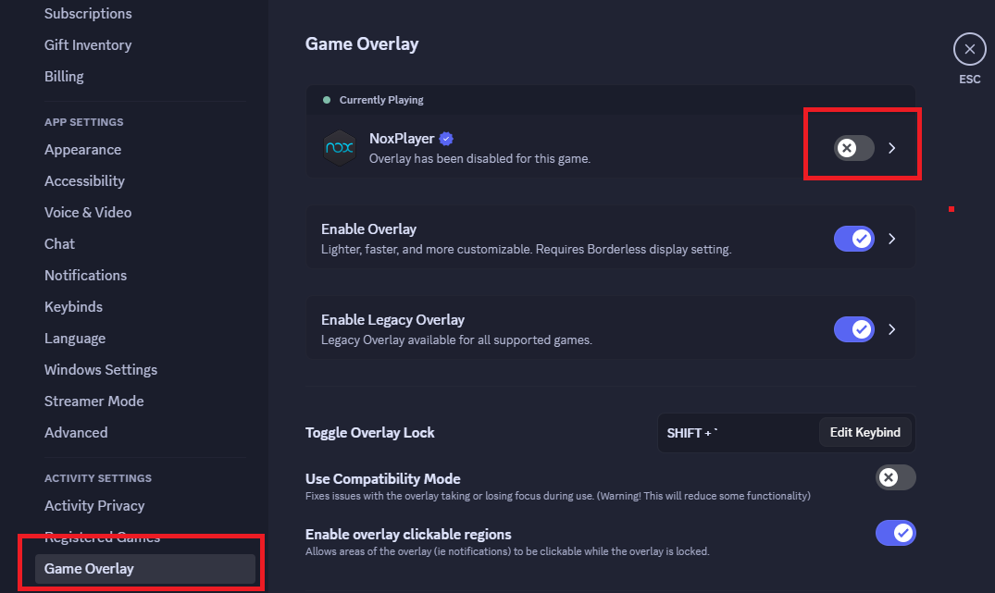

# Settings description

## Settings tab

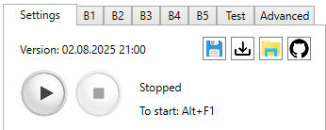

#### Version

First that you see is **Version**, which is date and time when I built this exact version. This version is logged every time you start script.

#### Save/Load



Settings are stored as json file. When you save – your current settings are written to file, and you can load them. Load works even if you have saved settings from previous versions, where some settings are missing (default value is set in this case).

Your current settings are stored in “.**\App\clickerSettings.json”** file. It is rewritten every time you change anything in settings.

You cannot save and load settings when script is running.

#### Open in explorer



This button will open explorer at script’s location, and select **App** folder, where script’s executable file is.

#### Open in Github



This button will open Grow Castle Autobot repository in Github with your default browser.

#### Control buttons

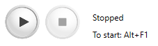

Next are **Start** and **Stop** buttons. You can use them, but it’s better to use hotkeys that are also indicated there. You can change hotkeys in Advanced tab.

You can pause script by pressing **Start** button while it’s running, or by **Start** hotkey. However, it might not work properly sometimes, because script uses stopwatches inside that are not stopped when you hit pause.

#### Window name



Here you have to write your Nox window name, without the version.

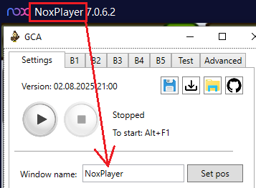

#### Set pos

After pressing **Set pos** button, the window should take the size and position which script needs to work properly.

If you write wrong name – you will see error.

It is important to make sure that there are no windows with the same name as nox, as it can grab the wrong window, because of this there may be problems.

When you try to move nox window after pressing **Set pos**, the window can be bugged slightly, and display like this:

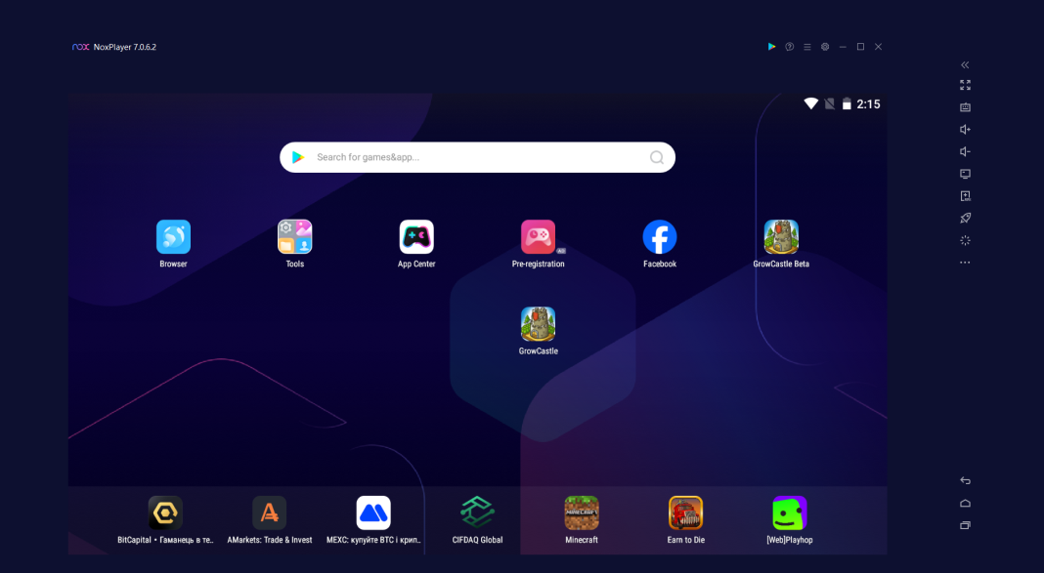

This is just how nox reacts after resizing with commands. To fix it you can just maximize it, and restore back, or just don’t move it after pressing **Set pos**.

Don’t press **Set pos** when nox window is maximized, because inner window won’t be resized with it.

#### Build to play



The number of the build that the script will play. The button on the right will open selected build.

All 5 builds are configured in Build tabs: 

### Dungeon farm settings

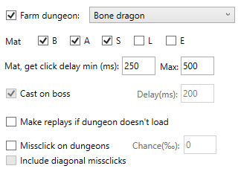

#### Farm dungeon

From the drop-down list you select a dungeon, if there is a checkmark, it will play there.

**For dragons**: whether to mat items of different grades.

**For dungeons**: whether to start cast heroes only when the boss came out with given delay.

**Note**: All runes will be collected from dungeons.

When farming dragons – will count item grades from dragons in “.\dungeon_statistics.txt” file.

Mutually exclusive with: Skip waves, AB mode, [AB (wave canceling)](#_AB_(wave_canceling)), Replay last wave.

#### Mat, get click delay

The script identifies item very fast, faster than you can read what stats item has, and if you set 0 there – it will get or mat item as fast as possible, which is not recommended. Set delay, the default one should be ok.

#### Make replays if dungeon doesn’t load

If the internet is gone, and script cannot open dungeons, then if it’s checked, then **until next captcha** the script will play replays. Then will switch back to dungeons.

If it’s not checked, then **if dungeon panel doesn’t open** due to internet issues, the script will wait for random time between 10 and 20 seconds, and will try again and will keep trying to open it infinitely.

If dungeons panel opens, but script is stuck right on **“BATTLE”** button, then it can indicate that inventory is full, or you are out of contracts. In this case script will make 3 attempts to start dungeon, and if it will fail 3 times in row, then will either start making replays (if checked), or will stop right there otherwise.

#### Do missclicks

This settings is made just to simulate human behaviour. If you think that developer can see all clicks timings and coordinates (that could possibly be true), then you can check this. Then set chance of missclick (**chance is measured in** per mille **(‰)**.

For example, if you farm bone dragon, then if it decides to make missclick, then will click Red, Legendary, or Expert dungeon:

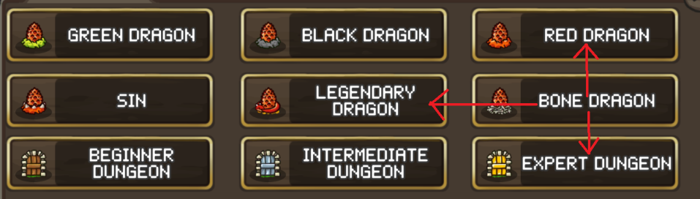

##### Include diagonal missclicks

If checked, then will also missclick to Black dragon, or Intermediate dungeon:

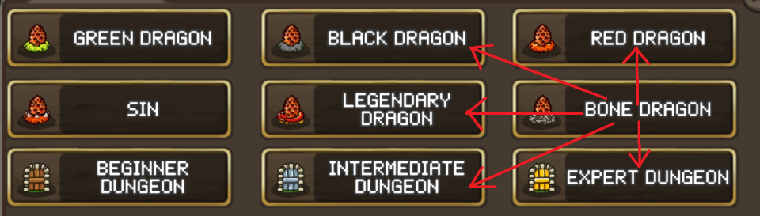

You don’t need to worry about if you don’t have contracts while farming dragon. If it couldn’t start dungeon – missclick is canceled, and next try it will definitely open dragon.

Under **Include diagonal missclicks** there is little extra space – This is space for kill time and kills per hour label. It will update every time when script entered dungeon successfully.

### Autobattle mode settings

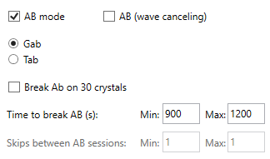

#### AB mode

If enabled, the script will start auto battle, then wait random amount of seconds between **Time to break AB** min and max, then will wait for first cancel AB button, stop AB, then will make something between AB sessions, and start again. All the time the script will watch the game, and if the wave goes on for more than max battle length, or something blocks it, then a restart is made, and the timer is reset, as if this time has passed. Then it will pass the captcha, if it comes out (and Solve captcha is enabled), and start AB again.

This is useful, because:

* You can add waves skipping: if you enable Skip waves, then script will skip every time when it’s possible (based on skip settings)
* You can add upgrading hero/castle in between AB sessions
* Script will restart AB after you lost during AB
* Script can watch ad for speed between AB sessions
* Script will detect nox freezing, and will reset nox when needed

It can be combined with Upgrade castle, and Upgrade hero for crystals. In this case, will upgrade them in between AB sessions.

The script will stop if you are out of gold or time, but it’s still very desirable to control it yourself.

#### Break AB on 30 crystals

If enabled, script will look on crystals count while AB is running. Once it sees that there is 30 crystals, it will drop the timer and wait for first cancel AB button, and stop AB. This is made so you can skip as many as possible. But you can disable Skip waves, and it will just stop and do what settings tell.

#### Skips between AB sessions

When **AB mode** and Skip waves are enabled – you can set **Skips between AB sessions**. This is amount of battles that script will start and wait for them to finish, then cancel, and start again. The purpose of these battles is to skip waves. If you set **1** to both min and max, then after each AB session script will start one battle, then finish it, and start next AB session, which results in exactly 2 battle starts with skips (60 crystals). If you set **0** on both min and max, then after AB session script will start next AB session, which results in 1 battle start with skip.

**Note**: When I say “with skips”, it is not necessarily skip with oranges. It will decide to skip based on your Skip waves settings.

#### AB (wave canceling)

If enabled, then script will start wave, start AB, then wait for cancel AB button that appears between waves during AB, cancel AB and start next wave with AB. It will save time between waves in AB mode. Can be combined with Skip waves, Upgrade castle, Upgrade hero for crystals.

You can set delays between clicks on AB button, switching to gab and start buttons to make it slower or faster in additional settings in Advanced tab.

**Tip**: you can enable **AB mode**, set 999999 to **Time between skips** min and max, and disable Skip waves, Upgrade castle, Upgrade hero for crystals. In this case, the script will just look for the game, and if game crashes, or you got defeats and AB stopped automatically, it will start AB again.

**Warn**: Of course, you need to enable Solve captcha, otherwise it will just stop, and this functions will be useless.

**Note**: If ab loses constantly, the script will constantly restart autobattle.

### Skips settings



#### Skip waves

Skip the waves or not. If you are not skipping with oranges, the script will look on the white number of crystals to see if there are 30 crystals.

Mutually exclusive with: Upgrade castle, Upgrade hero, Farm dungeon, Replay last wave.

**Note**: The script doesn’t identify exact number of white crystals you have, but correct results are these:

|  |  |
| --- | --- |
| Actual amount | Script’s output |
| 0 - 9 | 0 |
| 10 - 19 | 10 |
| 20 - 29 | 20 |
| 30 - 99 | 30 |

This is more than enough to do all actions that script can do. You can test correctness of these calculations in Test tab.

#### Skip with oranges

If enabled, will ignore amount of crystals. It will always skip. If the oranges are over, the store will open once and script will disable skipping with oranges automatically.

### Background mode



With it the script will not steal the cursor and you can overlap the nox with another window, but you can’t minimize the nox. Minimized windows are not rendered, and script will see nothing. Also do not try to move nox window across screen while it is playing. The script will try to fix nox positions in case you changed it, but it’s better to avoid it.

**Warn**: with background mode, Monitor freezing function won’t work, even if it’s enabled.

### Solve captcha settings

#### Solve captcha



If enabled – the script will solve captcha that appears right after starting battle. After starting script – it will check if **“.\App\gca_captcha_solver.dll”** is present and returns correct values.

#### Restart on captcha

If enabled, then in case if script failed on captcha 4 times in row or solving captcha is disabled – it will restart game, and then stop.

If disabled, then will stop without restarting.

The captcha solver works very good, and solves 99+% captchas. The only captchas where it failed had animation lags which caused script to detect tracking cup wrongly. Otherwise, it will solve every single captcha.

### Upgrades for crystals

#### Upgrade castle



Upgrade castle parts for crystals. For correct work, the upgrading parts must be on the floor specified in the **Floor** dropdown:

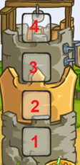

Mutually exclusive with: Upgrade hero for crystals, Skip waves.

You can test how tower upgrading works in Test tab.

**Info:** After click on floor, the tower that stands on that floor opens and it is upgraded while you have 10 or more white crystals, or until it has been upgraded 90 times in a row (if the tower has reached the maximum level). Tower upgrade is called every 10 battles.

**Info:** Script will stop when you reach 9999 level, and then will disable upgrading.

#### Upgrade hero for crystals



If enabled, will upgrade hero on selected **Slot**:

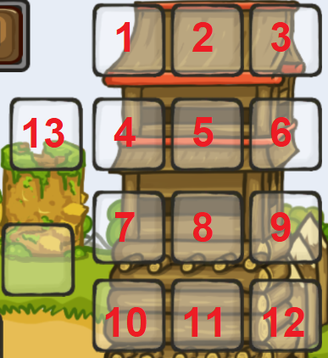

The hero that is upgrading should be in your build and at correct slot, because when you click on it – it will automatically open, and that’s how script works.

The script will upgrade until you have random amount of crystals between 0 and 9. After reaching 10 crystals – it just randomly chooses how many to upgrade more.

Mutually exclusive with: Upgrade castle, Skip waves.

You can test how hero upgrading works in Test tab.

**Info:** Script will stop when you reach 9999 level, and then will disable upgrading.

### Ad watching settings

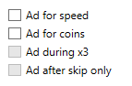

#### Ad for speed

Watch ads for X3. It is called in the main menu of gc through store. Viewing ads is a separate algorithm. If the ad completed successfully, then the last time the ad was viewed will be written to the file “.\timerx3spd.txt” - this is necessary to save the last time the ad was viewed after you stop script. Next hour the advertisement will not be checked. If the ad ends, it will not start and the script will automatically turn off viewing it.

#### Ad for coins

After the wave, there is a delay of 0.4 seconds, after which it is checked whether the advertisement popped up, and will watch it if it sees ad button.

#### Ad during X3

Whether to watch ads for coins during X3 with ads. You can turn it off to make the most of X3 from ads, or enable it if you need to watch ads for coins as quickly as possible.

#### Ad after skip only

Watch ads for coins only after skip 30 waves. There is more bonus gold, so there will be more gold from advertising. Cannot be activated without Skip waves.

**Info**: After the start of the ad, the script waits for a couple of seconds, and simply presses the right click once a second until it sees one of the options for the pause button that I entered into its algorithm, or until the game opens. If the advertisement has not closed in 2 minutes, then a restart is made. I met only 3 options for pauses in advertising - and I entered them into the script. In fact, this is just checking the color of the pixels at the given coordinates, where the continue button usually always appears - always the same color. If you have another ads UI, you can set Fixed ad wait in Advanced tab to add constant wait after ad opening. Its also important to exit from ad by pressing “Back” button, because if the only way to exit it is click “X” button on screen, then script will not able to do it.

### Altars



#### Heal altar

It will hit the altar when there is low hp, and Smith is either not in the build, or is pressed already, if there is Smith, then it will press him first.

#### Death altar

Presses the altar on the dragon and dungeon - when the boss appears. Works only there.

### Replay last wave



Make replays of the last wave. Mutually exclusive with Farm dungeon, Skip waves, AB mode, [AB (wave canceling)](#_AB_(wave_canceling)).

### Screenshot settings

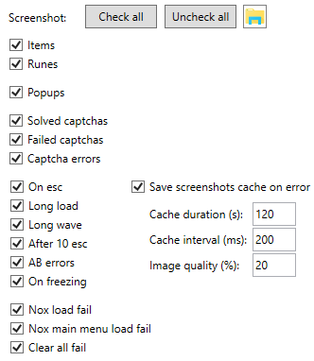

The script will save screenshot of some situations. By pressing button with folder image, it will open location where screenshots are saved.

#### Items / Runes

Before clicking **“GET”** script will save screenshot of item on screen. Only items that go to inventory are screenshotted. This is done so that you can safely show the screenhot to someone, and not be suspected of as script. The same is for runes. Screenshots are saved to folder **“.\screens\Items\”**.

#### Popups

Popups are messages that appear on left down part of screen:

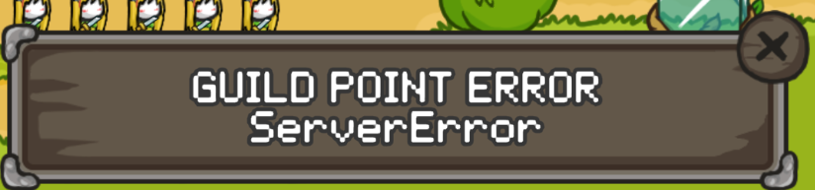

They all will be saved to **“.\screens\Popups\”**. Mostly you will see reward from captcha or another useless things, but sometimes there may be something useful.

#### Solved captchas

If enabled, all captchas that are solved will be saved to **“.\screens\Captchas\”** folder. There you will see 24 original frames of captcha, and results, where it determined the most likely paths of all cups like this:

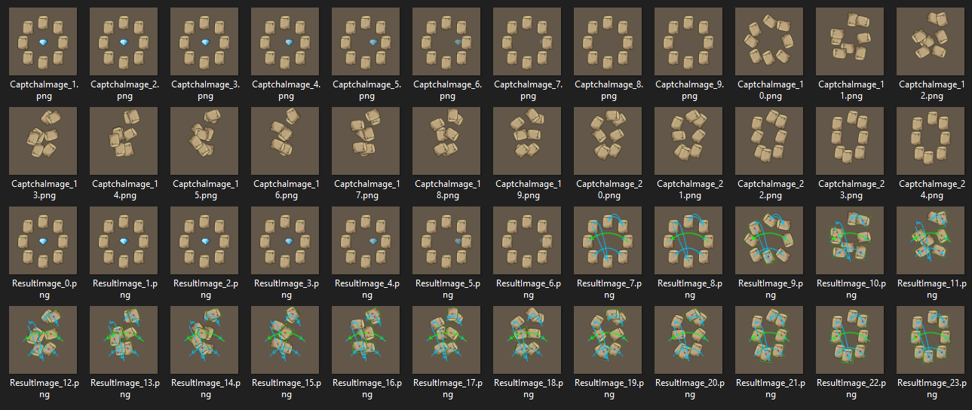

Keep in mind that average size of one captcha record is 4 MB. It is used to identify potentiall errors.

#### Failed captchas

If enabled, failed captchas will be saved to **“.\screens\Failed captchas\”** folder. It is better to enable it to have ability to identify error cause.

#### Captcha errors

If captcha started, and script didn’t find crystal, then **“.\screens\Captchas\Errors\Error_N.png”** screenshot will be saved. It can happen when you start script with already scrambled captcha, or you are running after future update, where captcha is changed.

#### On esc

If some unexpected panel is opened in game and doesn’t go away for 4 seconds in row, this situation is non-standard and the script starts pressing the right click to close it. At this point, a **“.\screens\Erorrs\OnEsc_N.png”** screenshot will be saved.

Right click is pressed until the sky opens, or 10 times - if after 10 right clicks did not open the sky - a screenshot is saved from the checkbox After 10 esc.

#### Long load

After clicking on gc from the nox menu when restarting the game, a stopwatch starts. If the gc menu has not opened in Gc loading limit amount of time, a **“.\screens\Erorrs\LongGCLoad_N.png”** screenshot will be saved.

#### Long wave

When battle (any) is going for longer than Max battle length amount of time, a **“.\screens\Erorrs\LongWave_N.png”** screenshot will be saved.

If it’s AB mode, then it’s AB errors checkbox instead.

#### After 10 esc

If some unextected panel pops up, and script couldn’t close it after 10 “back” clicks, a **“.\screens\Erorrs\unknown_N.png”** screenshot will be saved.

#### AB errors

When you run AB mode, and switching to the next wave is going more than 10 seconds (Victory animation + 2 seconds timer before next wave), then **“.\screens\Erorrs\AB_Error_N.png”** will be saved.

If wave is going more than Max battle length amount of time, then **“.\screens\Erorrs\AB_Error2_N.png”** will be saved.

#### On freezing

If Monitor freezing is enabled together with Background mode, and script detects freezing, then **“.\screens\Erorrs\Freezing_N.png”** will be saved before making reset. This is useful to identify wrong freezing detections.

#### Nox load fail

If after the reset nox didn’t start in 5 minutes, a **“.\screens\Erorrs\NoxLoadFail_N.png”** screenshot will be saved before script will be stopeed.

#### Nox main menu load fail

Main menu is opened when closing game. If for some reason script couldn’t close game. **“.\screens\Erorrs\NoxMainMenuLoadFail_N.png”** screenshot will be saved.

#### Clear all fail

If script could not find “Clear all” button when closing game. This happens when you have multiple apps in recent apps. The game should be closed completely, so it is important to press “Clear all”. If it couldn’t press it, a **“.\screens\Erorrs\ClearAllFail_N.png”** screenshot will be saved.

#### Save screenshots cache on error

The script is constantly taking screen of game while playing to decide what to do next. When it does it, it will save screenshots for some amount of time in memory (cache). If any of previous error (except of Clear all fail and Nox main menu load fail) happens, it will save current screenshots cache to **“.\screens\Erorrs\Screen_caches\Screen_cache_N\”** folder.

Sometimes it is very important to know what happened before this error.

You can set parameters of caching:

* **Cache duration** (seconds amount) is how many time screenshots are saved before deleting from memory. For example, if you set 60, then cache will contain screenshots from previous 60 seconds, and delete screenshots that were taken more than 60 seconds ago.
* **Cache interval** (milliseconds amount) is how frequently screenshots will be saved. Script takes screenshot of game very frequently (sometimes 100+ screenshots per second), and you don’t need to save them all. For example, if you set 200 there, then screenshots will be saved with 0.2 second gap.
* **Image quality** (percent amount) is quality of images in cache. Screenshot of game window has size of 1 MB on average, and cache can have a lot of images, so images are compressed to jpg format before saving them. If you set 100, then quality will be high, and screenshots will take more memory. 0 means maximal compression. Optimal value is 20%, which doesn’t corrupt image, and saves 90% of memory. You can test different image quality values in Test tab.

If you disable it, screenshots cache will still be working with this settings: **Cache duration** = 120 seconds,  **Cache interval** = 300 milliseconds, **Image quality** = 10%. Screenshots cache will always be saved in case of hint detection, regardless of this setting.

## Build tabs



There are 5 tabs where you can customize build. When activating heroes, script will make different actions on different heroes.

### **Example of a customized build**

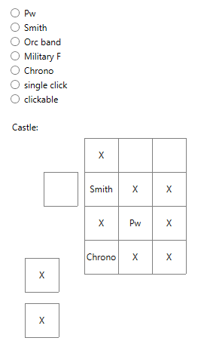

#### Pw

Pure wizard. It should be on the center vertical. It is pressed last after all heroes.

#### Smith

It is pressed when you have low hp. It may not have time to press when the damage is too fast. There can be problem when the HP number is very big (has 11 digits hp value), and the checked pixel is overlapped with that number.

#### Orc band, Military F

if you specify them, they will be pressed once at the beginning of the wave (when AB mode, [AB (wave canceling)](#_AB_(wave_canceling)), or manual battle start is enabled).

You can set them to be pressed on skip only in Advanced tab.

#### Chrono

Will be pressed first at the beginning of the battle.

#### Single click

Will be pressed once per battle. This is useful when you have summons that require single cast.

**Tip**: You can also use it in farming dungeons. If you kill boss by single cast – set all heroes to **Single click**, and you will not have problem with accidental hero opening when battle ends.

#### Clickable

Other heroes that should be clicked. They are pressed if they have a blue line above. Marked as “X”.

#### Scoped heroes

It doesn't work on heroes that need a scope, such as Ice Mage. This is just waste of time and potential bugs source, so it would be better to remove all such heroes from build when using script to cast heroes.

## Test tab

Here you can test script’s functions without having to start it and wait for specific moment.

### Mouse tests

#### Clicks test



First test is to do left or right click at given coordinates. This will send message to nox window about click at this coordinates, and you have to set Window name correctly for it to work. Right click should do the same as “Back” button or Escape button press.

Default (50, 150) left click should click at **“To town”** button if you have gc opened and have correct window position and size.

#### Test mouse movement



Test if mouse is moving properly. If you want to see it, you have to disable Background mode.

|  |  |
| --- | --- |
| 1 | Move mouse in circle. |
| 2 | Move mouse in rectangle around heroes slots (if window has correct size). |
| 3 | Move mouse in square spiral. |

The script will run initialization code before test, so you have to setup everything correctly to make it work, even though it is not needed during test, otherwise you will get initialization error.

The next is test mouse movement from point to point:



This will move mouse from (X1, Y1) to (X2, Y2), using the settings that you have and algorithm that will work when you start script. That is, if you disable Simulate mouse movement setting – you won’t see mouse movement, because it will be ignored. Also, if you enable Background mode, you won’t see the movement, but it still will send messages about mouse movement to nox window.

### Get crystals count



This will call function that calculates current amount of white crystals. It also shows if you have oranges or not.

**Dark mode** is used when script upgrades hero or castle for crystals (because crystals number is dimmed).

It doesn’t return the actual amount of crystals. These are correct results:

|  |  |
| --- | --- |
| Actual amount | Script’s output |
| 0 - 9 | 0 |
| 10 - 19 | 10 |
| 20 - 29 | 20 |
| 30 - 99 | 30 |

### Restart, Reset, Cleanup



#### Restart

Will close gc and open it. You need to test it before first run, because there are many situations when restart is made.

#### Reset

Will press **Reset** button, then wait up to 5 minutes for nox to load, and then open gc. You need to set correct positions for **Reset** and **Cleanup** buttons (here).

#### Cleanup

Will invoke same code as will be invoked when Cleanup interval is elapsed. Will close gc, and will either make reset, or press **Cleanup** button, then wait 7 seconds, and start gc.

### Upgrade hero, Upgrade castle



Will invoke same function as will be invoked when Upgrade hero for crystals or Upgrade castle is enabled.

### Show game status



This will show where in game you are right now (if this position is defined in script). Positions that should be identified:

* Gc menu
  + Empty game
  + Ad for coins panel
  + Hell buttons
  + Replay buttons
* In town
  + Forge position
* In battle
  + Skip panel
* Paused
* Exit panel
* In forge
  + Whether is on top of forge list
* Lost on AB panel
* Captcha panel
* Hero panel
  + Choose class panel
* In shop
* Item panel
  + Rune panel
* In top
* In guild
* Save panel
* Player profile panel
* Nox main menu
* Popup

### Solve captcha



Will solve captcha. For this, you have to first open captcha.

### Screenshots tests

#### Save window screen



This will capture nox window, and save **“.\screens\Test\WindowScreenshot_N.png”** screenshot. Button with folder icon will open **“.\screens\Test\”** folder, and select created screenshot.

#### Save screenshot



This will capture complete screen, and save **“.\screens\Test\CompleteScreenshot_N.png”** screenshot. Button with folder icon will open **“.\screens\Test\”** folder, and select created screenshot.

#### Save screenshot jpg



This will capture nox window, then compress image to jpg format with given image **Quality**, and save “”.

The **Quality** is percent value. 0 means that image quality will be the worst, but image size will be minimized. 100 or more means simple jpg conversion.

The screenshots cache makes images compression with same algorithm before saving images to memory, and you can test how different images quality looks like and how many space single screenshot takes here.

#### Getscreen benchmark



This will capture nox screen 100 times in row, and show average time of capturing screenshot. It should take not more than 50 ms on average (with correct window size), but it still stable even if it is slow.

### Online actions tests

Online actions are done before or after waiting between battles in order to simulate human behaviour. Here you can test them.

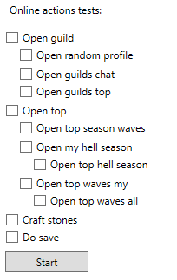

The logic that should happen for each action is described in Online actions. Here order of **Open guild -> Open top -> Craft stones -> Do save** is not randomized, but in runtime it will be randomized. Order of subactions will be randomized always.

Here the chance of each action is 100%.

## Advanced tab

Here you have settings that are rarely changed.

### Hotkeys



You have **Start** and **Stop** hotkeys that you can change. The hotkey can have zero or more modifier keys (**Ctrl**, **Shift** or **Alt**), and must end with non-modifier key (almost any key on keyboard). The hotkeys are registered globally, and will work when app is not focused. It might not work if selected hotkey is already registered by another app, but default **Alt + F1** and **Alt + F2** are not taken by anything in Windows by default.

You cannot set same hotkey for start and stop.

### Mouse behaviour

#### Simulate mouse movement



If enabled, then script will simulate mouse movement to the point where it has to click. This will not be visible when you have Background mode enabled, but it still will send messages to nox window about mouse movement.

The generated mouse path is quartic bezier curve with intermediate points that are randomly positioned within a padded rectangle formed by starting and finishing points, where padding is 5% of distance between starting and finishing points. Thus, the path can have 0, 1 or 2 inflection points, depending on how intermediate points were placed.

The speed of movement also varies within a path randomly, but you cannot change mouse speed in settings.

There may be bugs due to time taken by script to move mouse to click position.

You can test mouse movement from point to point in Test tab.

#### Randomize cast sequence



If disabled, then script will cast clickable heroes from left to right, then top to bottom.

If enabled, then script will start from random clickable hero, and select random neighbour hero as next to click. If there is no neighbour, then will check heroes on distance of 2 cells. This way the script will press all heroes randomly and choose one of the closest hero to previous one.

#### Click waits

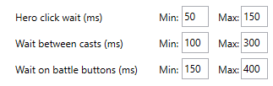

All click waits are milliseconds amount of time that is chosen randomly between **Min** and **Max** every time.

* **Hero click wait** is wait after clicking hero in battle. Do not put very small value there, because the game might not respond if clicks are very quick. The default settings should be ok.
* **Wait between casts** is wait after clicking all heroes, before starting checking cycle again. Here you can set zeros if you want, and have no delay after making casts.
* **Wait on battle buttons** is waits after pressing **“Battle”**, opening Autobattle panel, switching to gab, and before pressing **Start**. Fast clicks can ruin starting autobattle, so it’s better to have some delays there. The default settings should be ok.

### Waits and online actions between battles

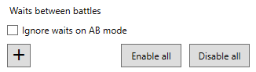

This was only made to reduce script’s efficiency and simulate human behaviour by adding random waits and some online actions between battles.

This is very important to add this to your setup to reduce probability of being banned (hopefully).

Click **“+”** button, and you will see a new slot:

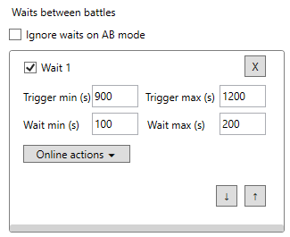

The checkbox **“Wait N”** specifies whether this slot is enabled. If you uncheck it, it will be ignored.

**“X”** button will remove it from list.

Up and down arrows will swap current slot with slot above or below.

#### Ignore waits on AB mode

If you have AB mode enabled, then waiting between battles is meaningless, because running autobattle is essentially afk mode, where it is assumed that you are not playing, so we don’t need to simulate human behaviour here. Only waiting part will be ignored in this case, online actions are still done. Read about them first.

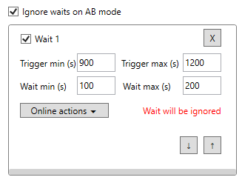

#### Trigger time min, max

Seconds value. When script will start first battle, it will initiate timer that will be elapsed after random amount of time between min and max values. Every time before starting next battle script will check if this slot is elapsed. It doesn’t affect how script behaves while it is in **“Running”** state. It is just a timer.

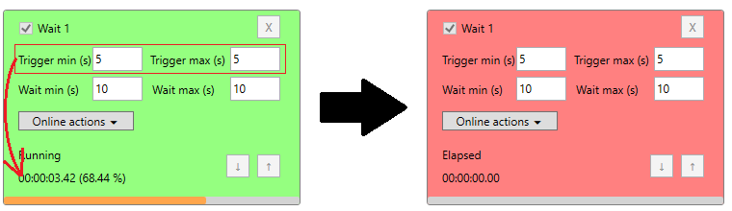

#### Wait time min, max

Seconds value. Before starting next battle, script checks all timers that you have there. If a slot is elapsed, it will take random time between min and max, and will just wait before starting next battle.

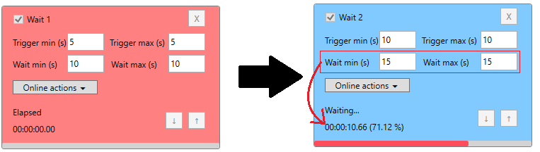

All other non-elapsed slots will be suspended while waiting for it:

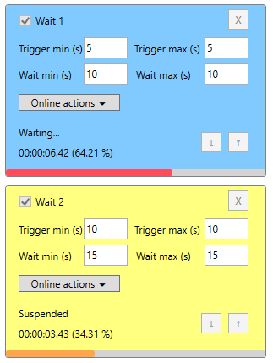

If multiple timers are elapsed together, then script will choose the bottom one to wait for, and all elapsed timers above will be ignored, and will be reset after waiting:

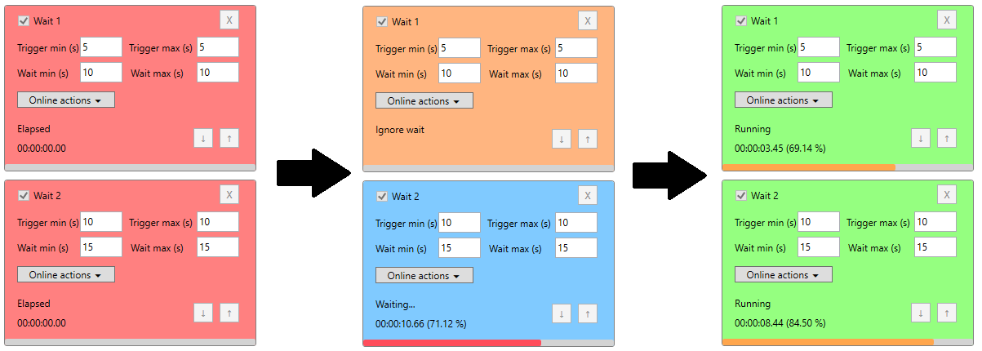

This means that when slot is triggered less frequently – it’s better to put it lower on list.

#### Online actions

Online actions are done before and/or after waiting between battles in order to simulate human behaviour. You can test online actions in Test tab.

For each action you can set chance of making it. It is made to randomize actions and not to do same things every time.

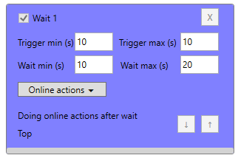

The order of actions is randomized.

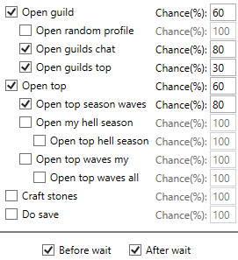

##### Online actions delay

When making action – every time it will make random delay between 3 and 6 seconds.

##### Guild actions

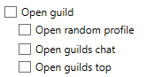

When **Open guild** is not checked or was filtered out by chance – will not enter guild and will do nothing there, even if nested checkboxes are checked.

If it’s checked – will enter guild, then wait. Then will do other selected actions there:

* Open random profile: for it script will scroll up guild members, and click in random place, and will open one of 6 player profile in there. If there was player and profile opened – will wait, and close it. If profile was not opened – will do nothing and go further.
* Open guilds chat: will open chat, wait, and go further.
* Open guilds top: will open guilds top, wait, and go further.

**Note**: guild actions order is randomized. It’s not necessary that order will be same as checkboxes.

After these actions script will close guild.

##### Top actions

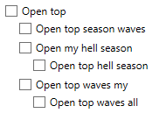

When **Open top** is not checked or was filtered out by chance – will not enter top and will do nothing, even if nested checkboxes are checked.

If it’s checked – will open top:



and if current open section is not top season waves (your places, not top 100), then will switch to it.

Then it will wait, and do other selected actions there:

* Open top season waves: will switch to top 100 in season waves and wait.
* Open my hell season: will switch to hell season and wait. The game will automatically open your places there.
  + Open top hell season: will switch to top 100 in hell season and wait.
* Open top waves my: will switch to overall waves top and wait. The game will automatically open your places there.
  + Open top waves all: will switch to top 100 in overall waves top and wait.

**Note**: top actions order is randomized. It’s not necessary that order will be same as checkboxes.

##### Craft stones



To craft stones, script will check where it currently is. If it’s in gc menu – will switch to town. If it’s not in town and not in gc menu – will do nothing. When it’s invoked in runtime – it is guaranteed that it’s invoked in gc menu.

Then script will automatically find where forge is. If you don’t have forge there – will do nothing and will go back to gc menu.

Then will open forge, and if it’s scrolled down – will scroll up.

Then will craft A stones, then wait random time between 1 and 4 seconds, and click craft S stones.

Then will close forge and go back to gc menu.

##### Do save



When in gc menu – will open save panel and do save. If there is popup or ad for coins – will close it.

##### Before/After wait



Specify whether to do these actions before or/and after waiting. At least one checkbox must be selected, and app will ensure this by not letting you to disable both.

### Monitor freezing



If you play for long time without resetting nox, it can start freezing. This will ruin script’s work.

If enabled, then every time when script makes screenshot, it will store it in memory for 2 seconds. If it finds that there are same screenshots taken, then it will be considered as freezing, and reset will be done immediately, without closing gc. This is not desirable to do like this, but script cannot close gc properly when nox is freezing. After such reset in the middle of the game, gc can reset your progress, and you will have to make load. If script detects empty add, it will stop immediately. If you want to prevent nox freezing, you can make Cleanup more often and set to make reset instead of cleanup. This will reset nox properly with closing gc.

Freezing detection will be automatically disabled when script starts watching ad, closes gc, enters dungeons, solves captcha.

This works only when Background mode is enabled. Disabling Background mode won’t automatically disable this checkbox, but you have to know that it won’t work without it.

### Speedup on item drop



#### I have x3

If you have bought x3 speed, then if you want to speedup on item drop, you will have to click on speed 3 times instead of 2. With it, you cannot start script with Ad for speed enabled.

#### Speedup on item drop

If enabled, then after beating dragon and waiting for chest to drop item, will make double (or triple) click on speed to speedup item drop animation.

### Max battle length



This is milliseconds value. If battle goes longer than this amount of time, the script will restart gc. This works in Dungeon farming, AB mode, Replays, manual battles.

### Cleanup interval

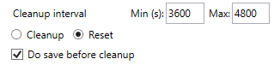

This is seconds value. After starting script, next cleanup time will be chosen by adding random amount of seconds between min and max to current time.

The time of next cleanup will be indicated below min and max textboxes:

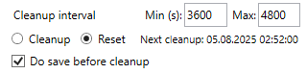

Cleanup will be made between battles only.

You can test how cleanup is made in Test tab.

#### Cleanup or Reset

Sometimes cleanup doesn’t free memory taken by nox. Reset always frees memory.

You have to remember that sometimes gc can reset your game when you do reset, so you have to keep this in mind when enabling this. Script will close gc and wait for some time before clicking reset, so it should be fine on average.

#### Do save before cleanup

This will try to save game before cleanup (To prevent losing progress in case of game resets). However, if you have troubles with internet at the moment of save, the script will not make save.

### Do restarts



Sometimes ad disappears, and you have to restart game to make it appear again, or there are another reasons to restart gc. After starting script, next restart time will be chosen by adding random amount of seconds between min and max to current time. Next restart time will be indicated under **Do restarts** checkbox.



You can test how restart is made in Test tab.

### Max restarts for reset



When script restarts game, it might encounter some problems. For example, multiple apps in recent apps, or troubles with opening nox main menu. If it tries to restart 4 times in row, and cannot do it, then script will make reset. You can test how reset happens in Test tab.

### Gc loading limit



This is milliseconds value. After opening gc script will wait until gc menu opens. If it takes longer than this amount of time, restart will be made. You can test how restart is made in Test tab.

### Fixed ad wait



This is milliseconds value. If script cannot close ad after starting it because of pausing it, you can set fixed ad wait after opening it. After this wait, script will start trying to close it.

### Pw on boss



This is milliseconds value. The script will press pw on boss.

It works like this: when the wave reaches this point:



script stops activating pw, and when boss hp bar appears, it will be pressed after specified amount of milliseconds. Then there will be higher chance to press all heroes at once on the bosses, and the wave will end faster.

**Note:** this will work only when script plays waves manually, or makes replays.

### Orc band and Military on skip only



If checked, then script will press Orc band or military F only when script does skip 30 waves. It may be useful because if you press them and they give bonus wave, you won’t get crystal in the end of the wave, and you also don’t get crystals after skipping 30 waves.

### Collect mimic



Mimic is collected when making replays, or playing manually.

## Other

### Manual waving

If you disable Farm dungeon, AB mode, [AB (wave canceling)](#_AB_(wave_canceling)), Replay last wave, then script will play waves manually. This is the most dangerous way to play, because it’s easily detectable from developer side.

### Changing parameters in runtime

The script cannot change its parameters when its running. You have to restart it. In this case, you will see that modified settings are marked with orange color:



### Red background

If you see that app has red background like this:

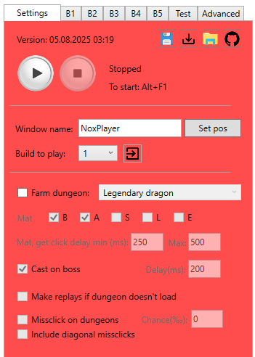

Then it means that script encountered some error while it was playing. Usually it’s simple erorrs like error while restarting game or resetting nox. But it also could be serious problems like hint detection, and you might be banned already.

Go and check **“.\screens\Errors\”** folder, and sort screenshots by creation time, and see what happened there.

To reset background, you have to restart app. It was made to make you notice this.

# Output files

## .\gc.log

This is log file where each action done by script is written.

The line from log typically has this structure:

[dd.MM.yyyy HH:mm:ss.fff <caller line number>] [<log type>] message…

Log types that exists:

|  |  |  |
| --- | --- | --- |
| Letter | Type | Description |
| I | Info | Regular message that appears most time |
| W | Warn | Unexpected, but fixable situation |
| E | Error | Needs inspection, it could be some bug |
| F | Fatal | Something that script cannot solve, and it will be stopped |
| U | User | User actions (start script, stop script etc.) |
| Q | Question | May be error, may be normal situation (like dungeons did not load) |
| O | Change settings | When script changes settings by itself (disable ad for x3, disable skip with oranges, switch to replays instead of dungeons) |
| N | Expected something, but didn’t happen | For example, script waits for ad for coins to appear, but it doesn’t |
| K | Expected and fixable | For example, game is overlapped by Victory animation |
| R | Restart, Reset | When restarting gc, resetting nox |
| X | Fix something | Fix wrong window size (if you change in runtime), or close hero panel |
| M | Mistake | When about to do missclick in dungeon, or ignore mimic chest |
| S | Screenshot | When making screenshot |
| H | Hint | Hint on top of game detected |
| P | Popup | When popup detected |
| C | Captcha | While solving captcha |
| L | Online actions | When making online actions |
| - | Unreachable code | Somehow got into situation that should have been impossible to reach |

## .\dungeon_statistics.txt

The number of items of different grades from each dragon. The numbers must be on their strings, otherwise the script will not be able to read them. If there will be error while reading number from file – it will be replaced with it’s default content.

## .\captcha.log

Each attempt to solve captcha is recorded there.

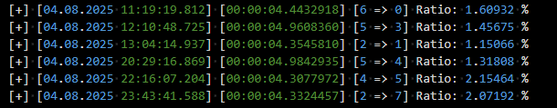

Log line in there looks like this:

[+/-] [<Date and time of attempt>] [<time solving>] [<start pos> => <finish pos>] [Ratio: <calculated chance of fail>] (Restarts: <amount of restarts to solve >)(if >0)

Position numeration:

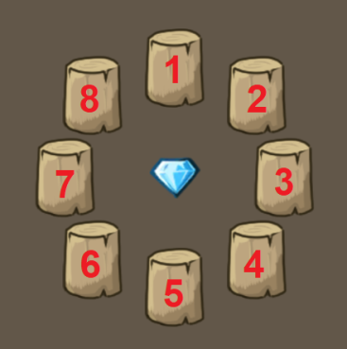

## .\timerx3spd.txt

Here script will save last time of watching ad for x3 speed. If you want to erase information from there and make script check it even if it watched it recently, then you can delete this file, and it will be created automatically with default value.

# Hint detection

Once such a message popped up. At this time, the script was playing and saved the image. It restarted the game, but account was banned after this. We don’t have any information about what happened before this in game, or after restart.

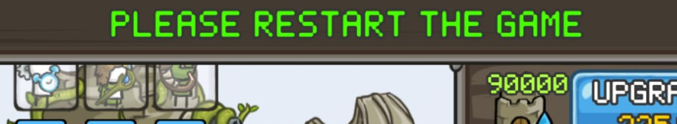

And this is more recent version (same situation as before: restarted game, but acc was banned, and we know almost nothing):

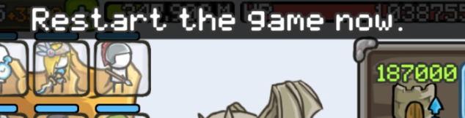

The script was improved to catch such hints, and if script detects it – it will save screen cache, even if it’s disabled, and will save screenshots from what will happen next, even if all sceeenshot options are disabled.

The script will check this pixels:

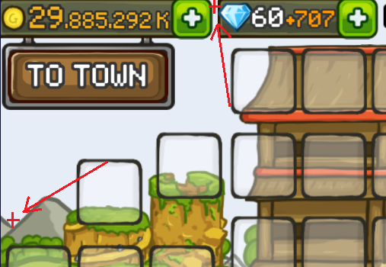

if the top pixel is blocked by something, and the bottom one is free (has regular sky color), the script will consider it as a hint, and will restart the game after 7 seconds. Then, it will keep making screenshots for some time (maybe something will happen then). After it, the script will continue playing.

There was a moment when there was a warning about server maintenance that also appearen on top of game in the middle of playing. If this will happen again, then script will probably be not usable for some time.

**Note**: You can also trigger this by pulling status bar in nox (where you have time, battery charge, wifi…)

# Problems solving

### Error while calling gca_captcha_solver.dll

If you start script with Solve captcha enabled and see error like “Error while calling gca_captcha_solver.dll: file or one of its dependencies was not found”, that means that you either don’t have **gca_captcha_solver.dll** or **opencv_world490.dll** in “**.\App\”** folder. There are bunch of dlls that app needs to work. Some of them (maybe most) are not used, but deleting them can result in errors in runtime. Do not delete it.

If you are completely sure that everything is fine, and all files are at correct places, then you probably have 32-bit Windows. I did not try to run this on 32-bit OS, but **gca_captcha_solver.dll** was built for 64-bit Windows, so it probably wouldn’t run.

Otherwise, I don’t know where exactly the problem could be.

### Cannot start script because of reset and cleanup buttons check

If you see this error when trying to start script

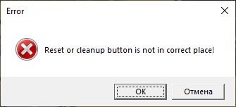

Then follow instructions for this case.

### Cannot watch ad until the end

If script stops ads and cannot watch it to the end because of trying to exit it, it is probably because you have different ads UI that I didn’t add to sctipt. To fix this, try to set Fixed ad wait parameter to 30 or more seconds, to make script try to close ad after 30 seconds after starting it.

Its also important to exit from ad by pressing “Back” button, because if the only way to exit it is click “X” button on screen, then script will not able to do it.

### Cannot exit pause or hero window

If script cannot exit pause window or hero window, and clicks in some random place on screen, check if you have right click to move backwards enabled.

### Problem with starting battle

If script keeps open exit window before start wave, or doesn’t close skip window after starting wave, try to increase Waits on battle buttons min and max values.

### Problem with starting autobattle

If script cannot start autobattle correctly, try to increase Waits on battle buttons min and max values.