Software Requirements Specification
for
Pro-Shine



Version 1.0
Prepared by Gewrgios Malachias
14/1/2020

Content Table
1. Introduction 1
1.1 Purpose 1
1.2 Document Conventions 1
1.3 Intended Audience and Reading Suggestions 1
1.4 Project Scope 1
1.5 References 1
2. Overall Description 2
2.1 Product Functions 2
2.2 User Classes and Characteristics 2
2.3 Operating Environment 2
2.4 Design and Implementation Constraints 2
3. External Interface Requirements 3
3.1 User Interfaces 3
4. System Features 4
4.1 Automation of most actions needed to play the game 4
4.2 Evade Staff Members 4
4.3 Auto – Reconnect 4
4.4 Add Graphical User Interface (GUI) 4

Revision History
Name | Date | Reason For Changes | Version
Gewrgios Malachias | 10/01/19 | Initial Software Requirements Specification draft | 1.0

Introduction

Purpose
This Document intends to describe and analyze, the potential and the requirements of the PRO – Shine open source software.

Document Conventions
Everything underlined is a website. Use control + click to move to the website.

Intended Audience and Reading Suggestions

The Document is intended for every programmer/developer that wants to learn more about the open source project and the client/user that needs more information about the project.

Project Scope
Pro - Shine is a free, open source and advanced bot for Pokemon Revolution Online. It’s main purpose is to automate some activities in Pokemon Revolution Online. Pro – Shine supports only Windows for the moment, but Linux and MacOS might be supported in the future, using Mono or .Net Core.

References
https://proshine-bot.com/

https://github.com/DubsCheckum/proshine

Overall Description

Product Functions
Write down your own scripts, or even use some that someone else has written and automate every action in Pokemon Revolution Online. All you need to do is to know how to write Lua scripts.

User Classes and Characteristics
Most of the people use this program, because Pokemon Revolution Online is pretty time consuming, and requires to spend many hours in order to finish it.

Operating Environment
The program is available only in Windows
Here are the supported versions:
- Windows Vista ( Service Pack 2)
- Windows 7 ( Service Pack 1 )
- Windows 8.1
- Windows 10

Design and Implementation Constraints
Pro – Shine consumes about 30MB memory. It’s written in C# language. It requires following library to build and run:

.NET Framework 4.5.2.

External Interface Requirements

User Interfaces
Windows GUI:

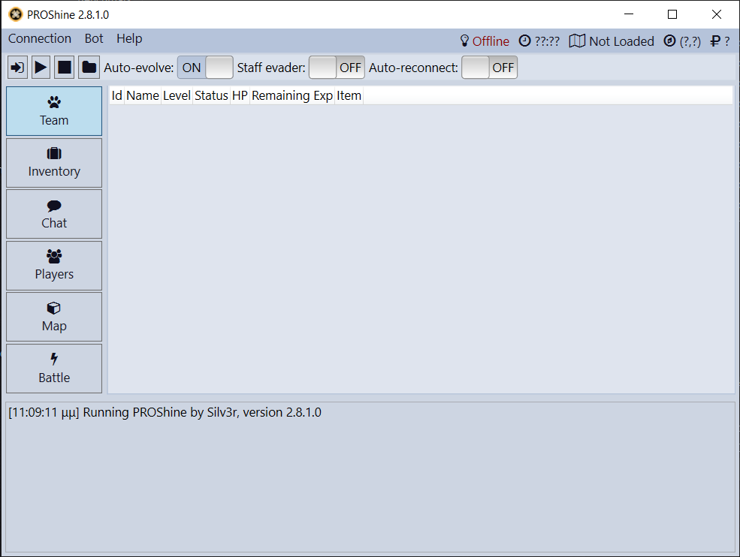

Windows GUI gives the user many options that we list below:
- Auto - evolve Pokemon
- Auto – reconnect
- Viewing and adjusting your team
- Looking in your inventory and giving items
- Spectating the chat
- Spectating the players nearby
- An image of the map
- Which Pokemon you are against.

System Features

Automation of most actions needed to play the game
Pro - Shine gives you the potential to write scipts that will allow you to do everything inside the game automatically.This means that you can catch pokemon, level up your team, fight npc trainers, fish to catch pokemon and whatever else you are able to script.

Evade Staff Members
You can turn-on the option to evade the staff members and by doing so, whenever a Game Master comes nearby your
account will be logged out of the game.

Auto – Reconnect
Also there is the option to auto – reconnect in that case whenever you get kicked out by the game, you automatically reconnect into it.

Add Graphical User Interface (GUI)
It is also possible for someone to add GUI to the original program just by adding some lines inside the lua script someone is using.

Original GUI:
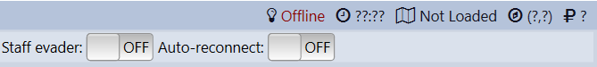


GUI with lua Script:

