

CONTENTS

**About this guide3**

**Guest guide**

Adopting a dog4

Volunteering

Register as a volunteer6

Participate in an event8

Edit Volunteer Profile9

**Employee guide**

Inserting a new dog10

Creating a new event12

Accepting adoption requests14

Editing dog’s profile15

**Administrator**

Consultation16

Inserting new employee17

About this guide

This guide describes how to use Dog Shelter Manager, a platform that manipulates shelter’s databases and simplifies adoption processes, volunteering and other relations between employee and people looking for a dog to adopt, including internal tools for easy shelter management and data that can be used to increase the flow of adoption and help.

Guest

Adopting a dog

To adopt a dog, first the guest needs to look up for all the dogs, so he can find the perfect fit.

First step is to click in Animals button to access the dog’s list, where he will see all dogs from the database

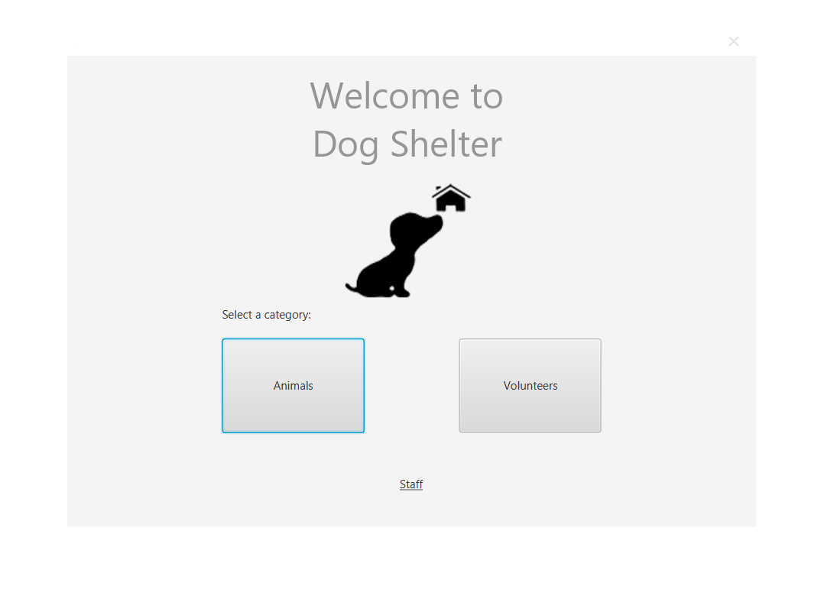

Animals button.

Here the guest can search for the dog he is most interested, there is a search bard where he can type what kind of breed, gender, age or even name.

To access the dog’s profile, the guest just needs to click one of the results on the table

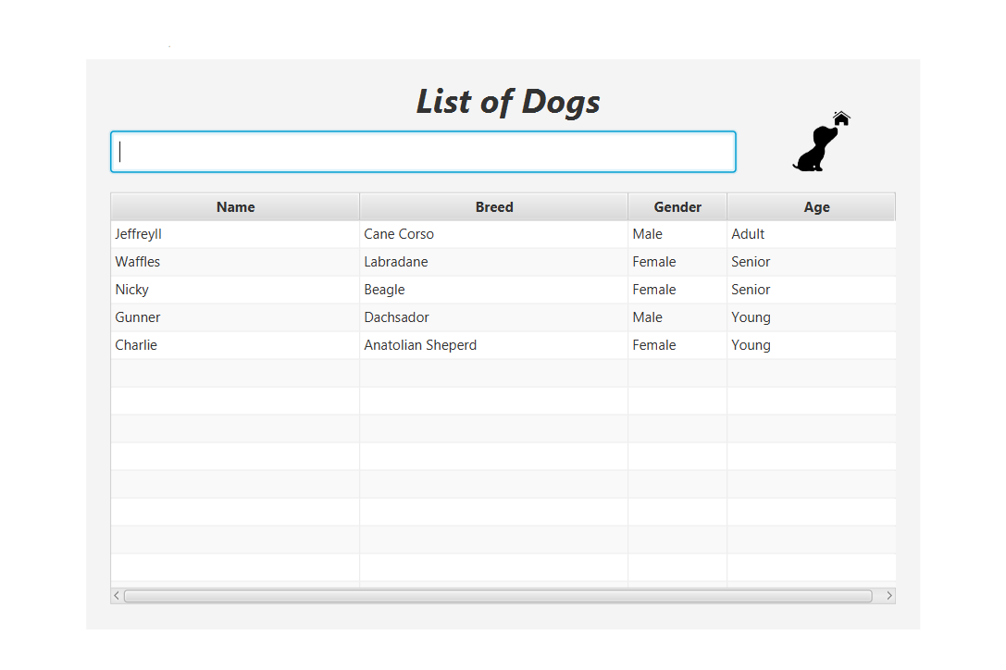

Search bar.

Home button, returns

to Landing Page.

Selecting a dog, opens

the dog’s profile.

This is the dog’s profile, here the guest will see the dog’s information including the photo.

To send a adoption request, the guest clicks in “Adopt Me!” button to open the pop-up, where he will fill a adoption request form with his information.

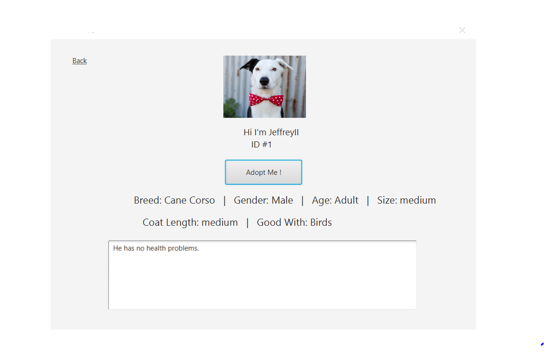

“Adopt Me !” button

brings a pop-up.

Back button, returns

to the dog list.

This is the pop-up for the adoption request, where the guest can fill the form and submit his request,

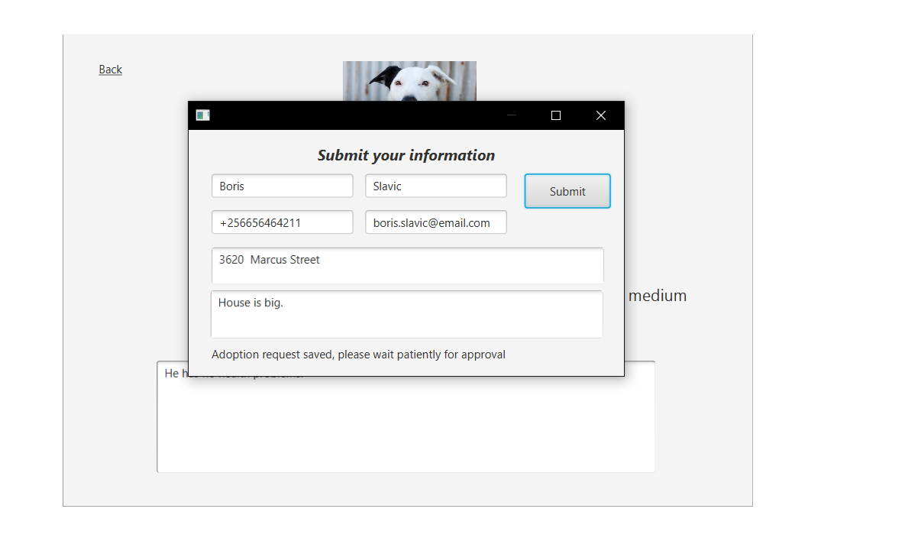after filling just click submit and wait patiently for the guest’s answer.

Submit button.

Guest

Volunteering

Register as a volunteer

To volunteer in any event of the shelter, first the guest needs to register as a volunteer, where he will give his information and receive a volunteer id and set his password of access.

First thing is to click in the Volunteer button to register or login.



Volunteers button.

In case the guest doesn’t have an account in the system, he has to click the Register button to access the form of registration.

In case he already has an account, he just needs to login with his volunteer Id, given by the program when he registered, and it will bring him to the volunteer’s page.

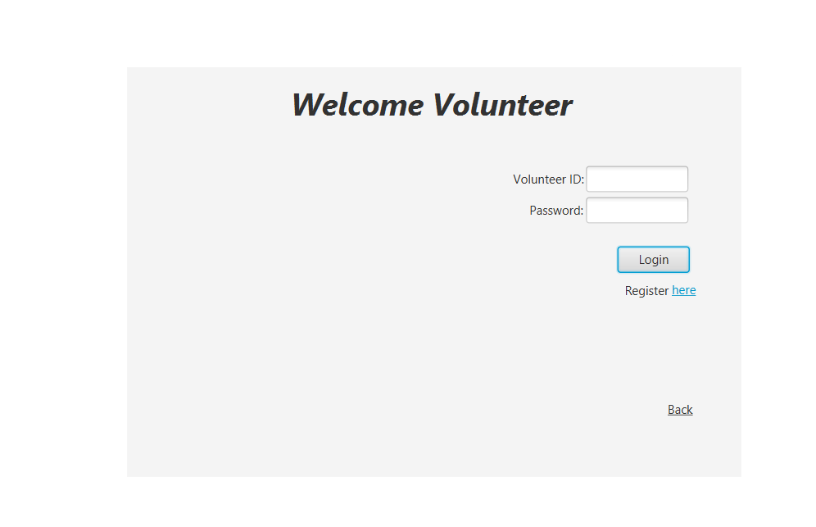

Register button, opens

registration form.

Back button, returns

to Landing Page.

Login button, in case

the guest has already registered,

this will open volunteer’s page.

This is where the guest can register as a volunteer to get access to the volunteer`s page, he will get an id after filling the form and submitting by clicking on Register button.

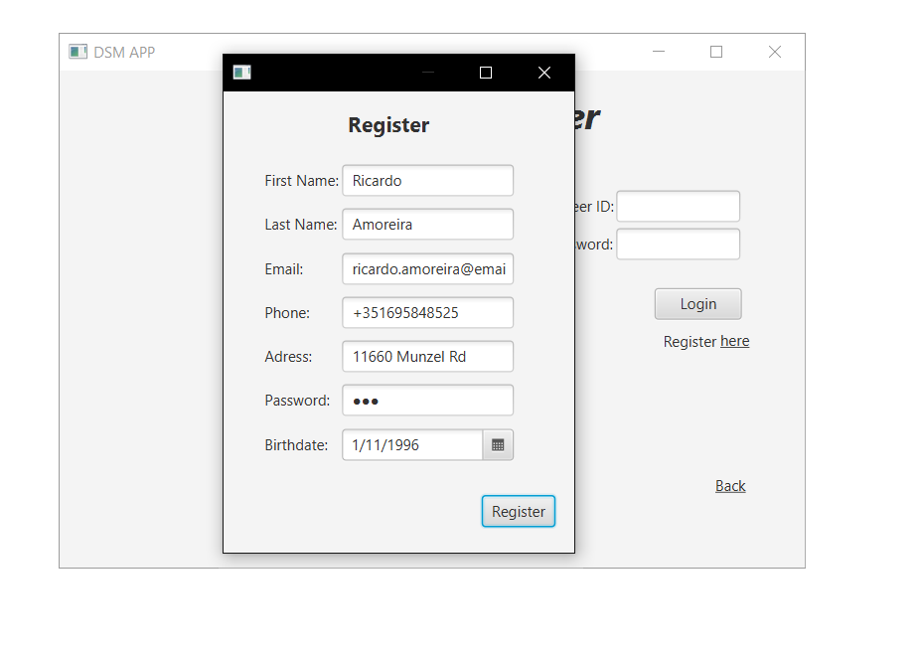

Register button.

The guest has to save this ID to access his account, or he will have to register again, but with other email and phone number. Now he can login Volunteer Page.

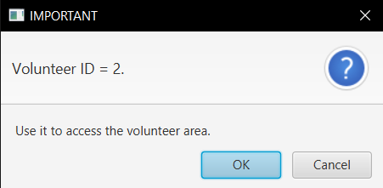

Volunteering

Participate in an event

This is the Volunteer Page, the guest can see his personal information, a calendar to select a date, a table with events of the day, that he selected, a table with information about the day that was selected and a table with the events he already registered to participate.

Starting with the main function, first thing to participate in a event is to select a date.

After that consult the table to see what events the shelter has for that day, then he selects the event he wants, when selected, the table at the right side will show information about that event.

Now he just needs to click the button Participate, after confirmation, the event appears in his table of events on the top left.

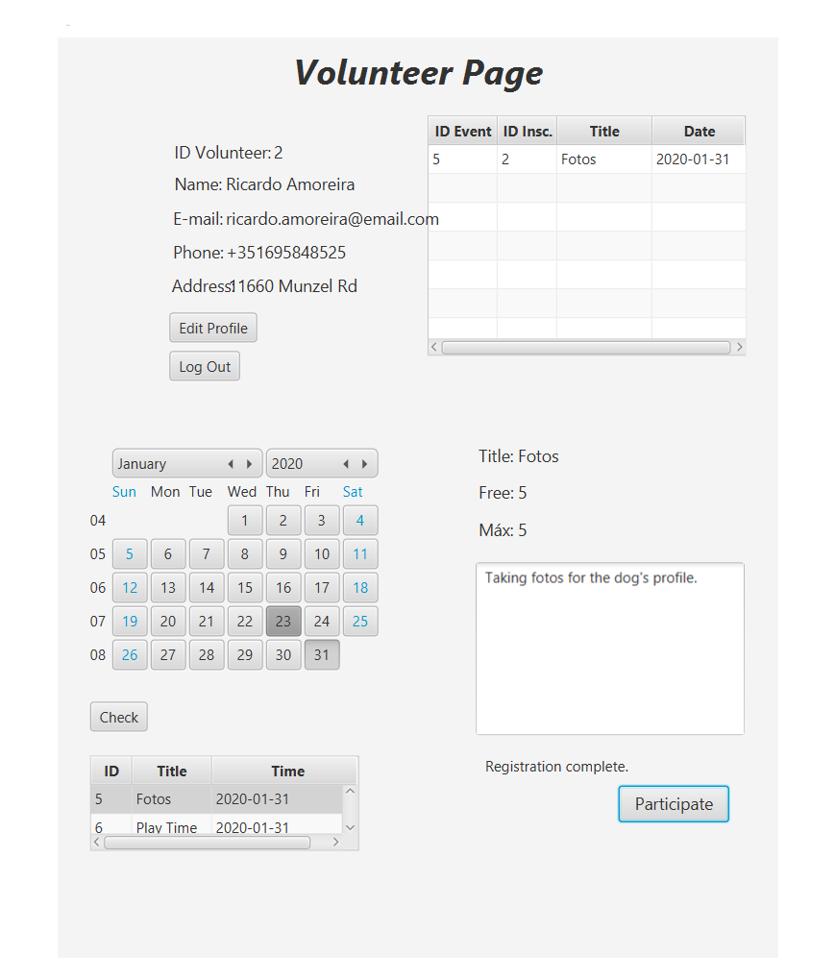

Personal Information area,

has information about the volunteer and an Edit Profile button, that opens a form to change any information he wants and a Log Out button, to return to the Landing Page.

Calendar, where you select date and by clicking on the Check button, if there is an event on that day, it will show on the next table below.

Events of the selected date.

Information about the event.

Registered events of the volunteer.

Participate on the event.

Volunteering

Edit volunteer profile

As a volunteer, you can make changes in your page, for example, changing email or contact information.

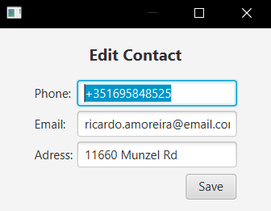First select button Edit Profile in the personal information area. A pop-up will appear, and the volunteer will be able to change information.

Save changes.

Employee

Inserting a dog

To create a new dog, the employee must first login with his username and password and click in the button Insert Dog. First, the way to access employee and administrator pages is by selecting Staff label on the bottom of the Landing Page. After that login.



Staff button opens login page.

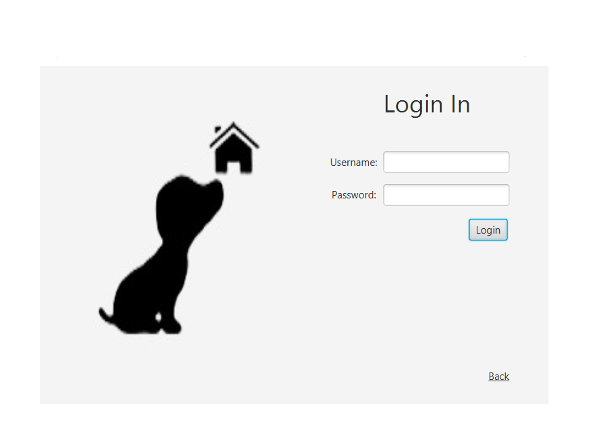This is the login page where employees and administrators can access their pages.

In this case will be an employee registering with a username and password, then click Login.

Login button.

This is the employee’s page where he can consult information about adoption, dogs and events. The employee has the responsibility of creating dog profiles and events, managing adoption requests and dog profiles.

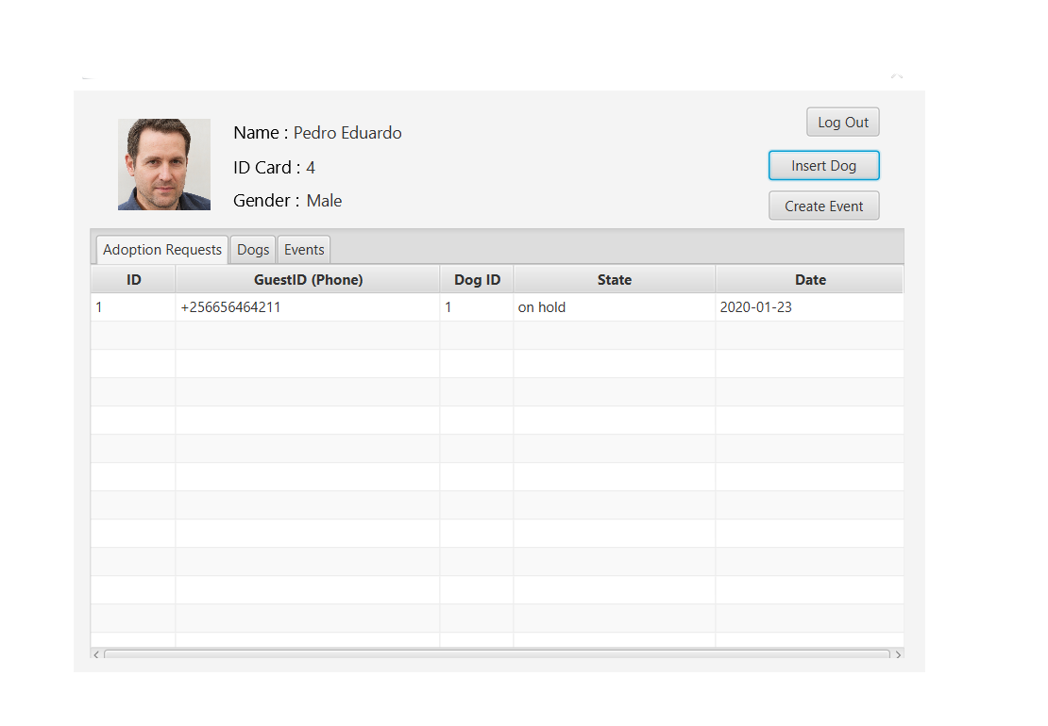In this case we want to select Insert Dog, this will open a new page.

Inserting Dog button.

Log out button, returns to

Landing Page.

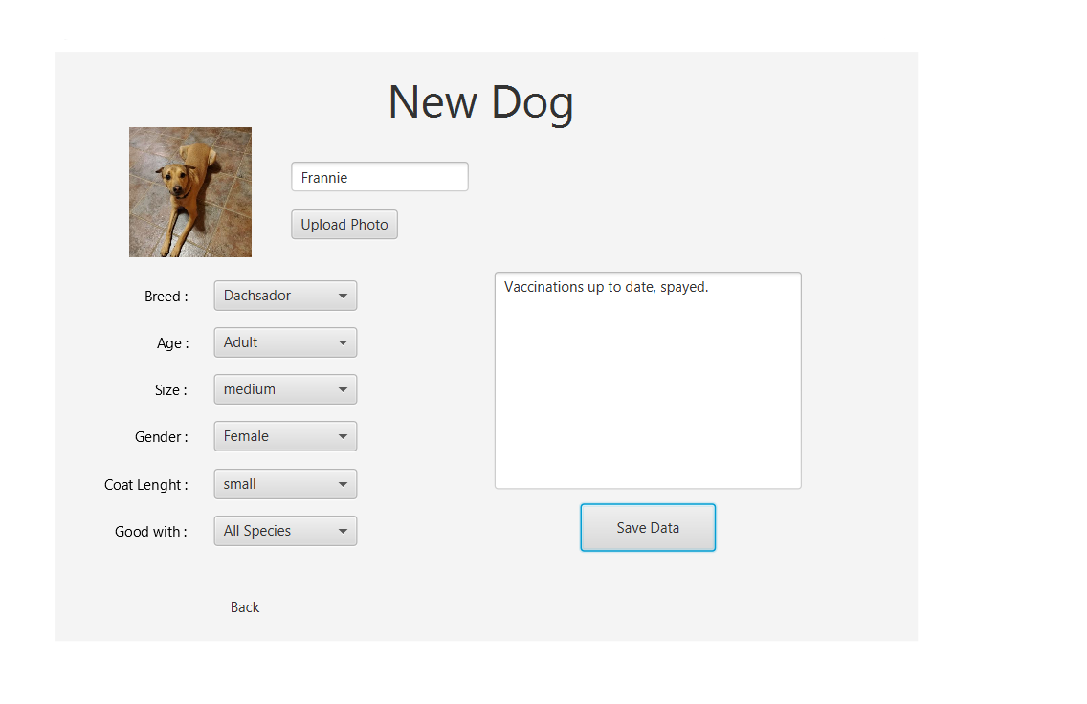In this page, the employee can insert the dog’s name, attributes, conditions, photo and observations about the dog.

Submits the dog’s information.

Upload Photo opens the browser of windows files to select an image.

Creating a new event

The employee creates events for the volunteers to participate. To do so they must select the Create Event button on their page.

Create Event button.

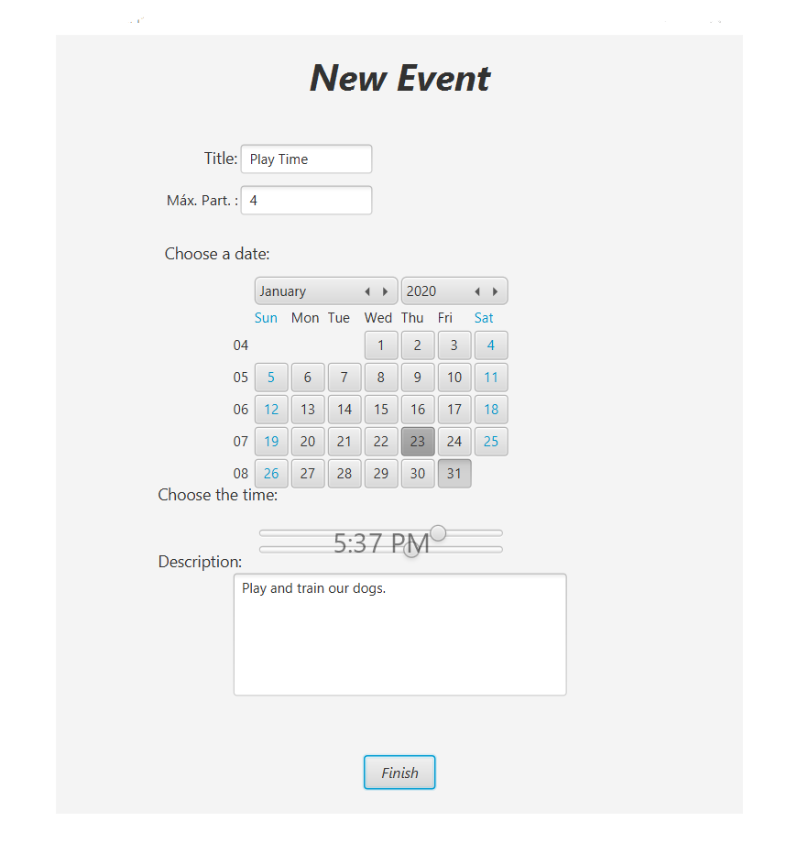This is the page where the employee can create a new event. The employee has the option of giving it a title, a maximum of participants for the event, choosing the date and the hour of the event.

Title and maximum number of volunteers.

Interactive calendar, where the employee selects a day for the event.

Interactive slider, where the employee chooses the time.

Information about the event.

Submits the new event.

Accepting adoption requests

After a guest has submitted an adoption request, it will then show in the employee’s page table of Adoption Requests. Here the employee can select one of the requests, this will open a pop-up where he can review the information about the person adopting the dog and the dog’s profile. After reviewing the information, he can decide by selecting an option of a choice box containing “accept” and “reject”. By selecting both, the result will disappear from the Adoption Requests table, but will be visible by the administrator’s table of Adoptions.

Select one of the adoption requests from the table.

This is the pop-up that appears when the employee selects a adoption request.

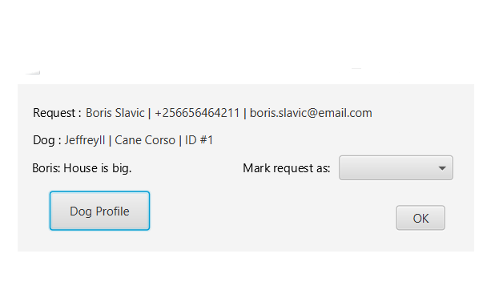Here we have the information about the guest that requested the dog, a button to see the profile of the dog, in this case to check if it’s a good adoption, and a choice box where he can accept or reject the request.

Dog Profile.

Choice box, where there is the option of accept and reject.

Dog Profile.

Editing dog’s profile

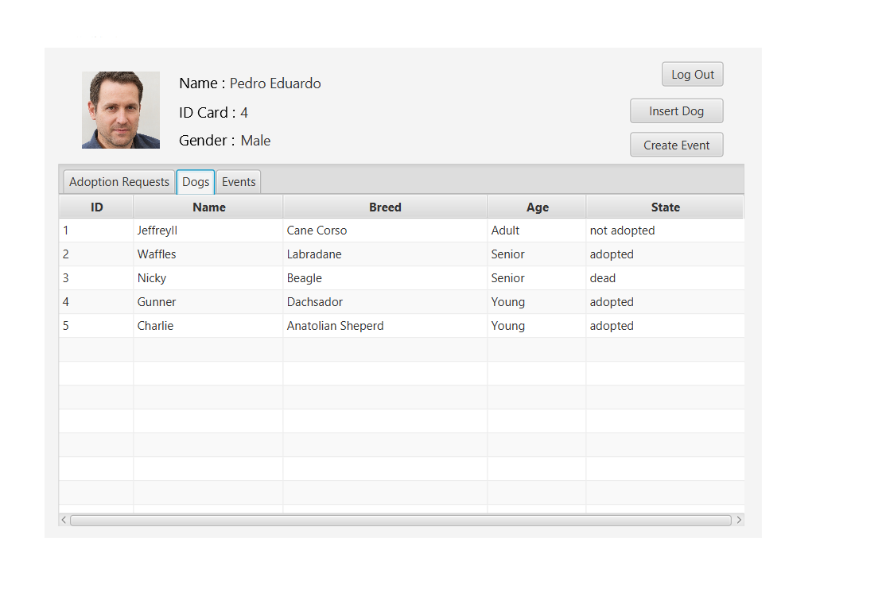The employee can edit the dog’s profile, important functionality because the dog may grow more or have changes in his health. To access this, the employee must select a dog from the table Dog they have in their page. The results of the Dog table are all the dogs that have passed and that still are in the shelter.

Select a dog row to open the Edit Dog page.

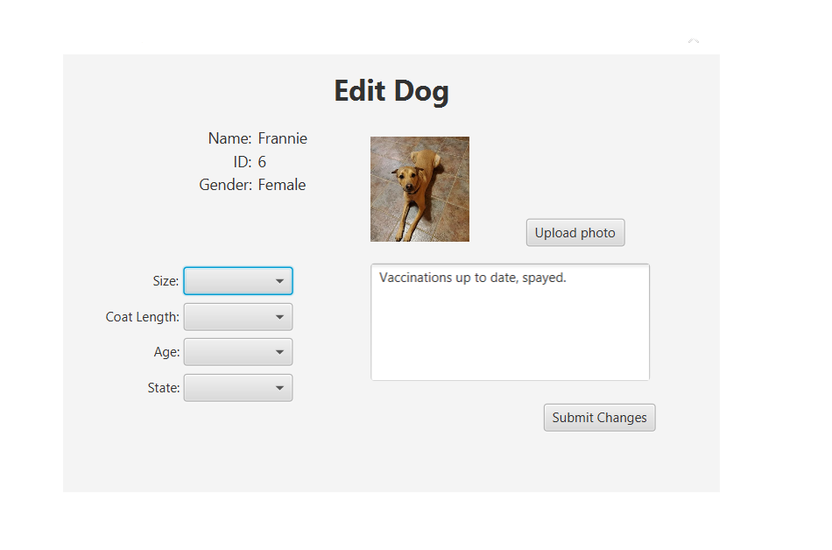This is where the employee can edit the dog’s information, here he can change the dog’s size, coat length, age and state. The state is the most important because it tells the us if the dog was returned or dead.

Submit changes.

Upload Photo opens the browser of windows files to select an image.

Administrator

Consultation

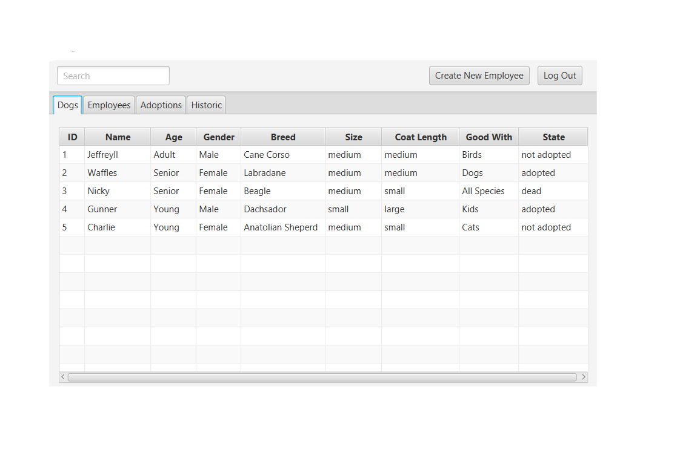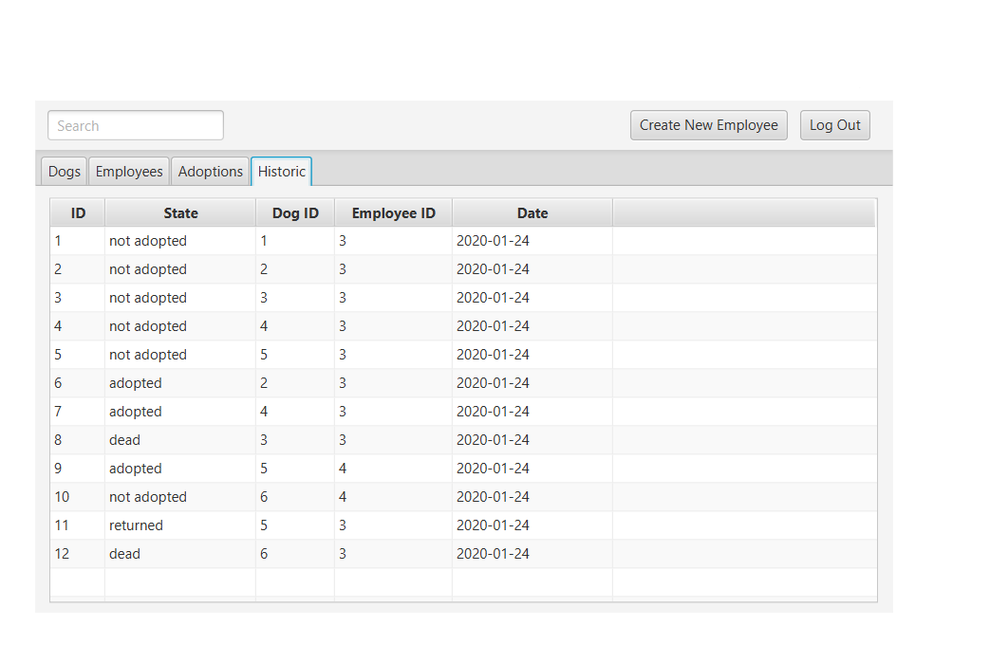As the administrator, you have access to all information of all that happens in the shelter. The administrator has a table of all dogs, employees, adoptions and state changes to of the dog.

Log Out, returns to the Landing Page.

Table of Information only.

The Historic table has all the state changes of the dog, since the day they were inserted in the database, even when they are adopted or returned.

Historic table, where all the registrations of state changes of the dog appear.

Inserting new employee

As the administrator, you can insert new employees into the system. To access this functionality, click the button on the administrator’s page Create New Employee, this will open a new page where you can insert a new employee.

Create New Employee button.

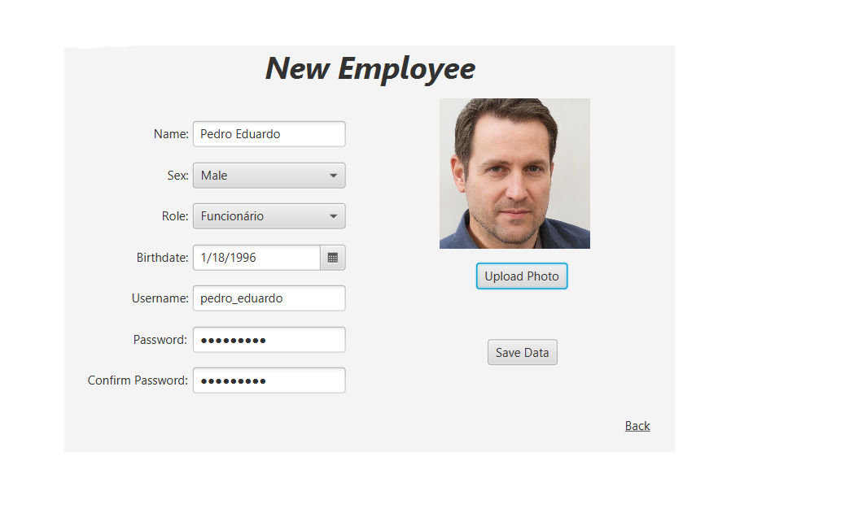In here, the administrator must insert the information of the new employee, this includes the username and password, so the employee can access their page.

Save Data button, submit new employee.

Upload Image button.

Back button returns to administrator page.