PiTray: Assembly Instructions  
Provided by ACROBOTIC

Part 1: Material list

* 1 PiTray Top
* 1 PiTray Base
* 8 4-40 Hex Nut
* 2 Spacer
* 2 4-40 Screws at ¾”
* 2 4-40 screws at ½”

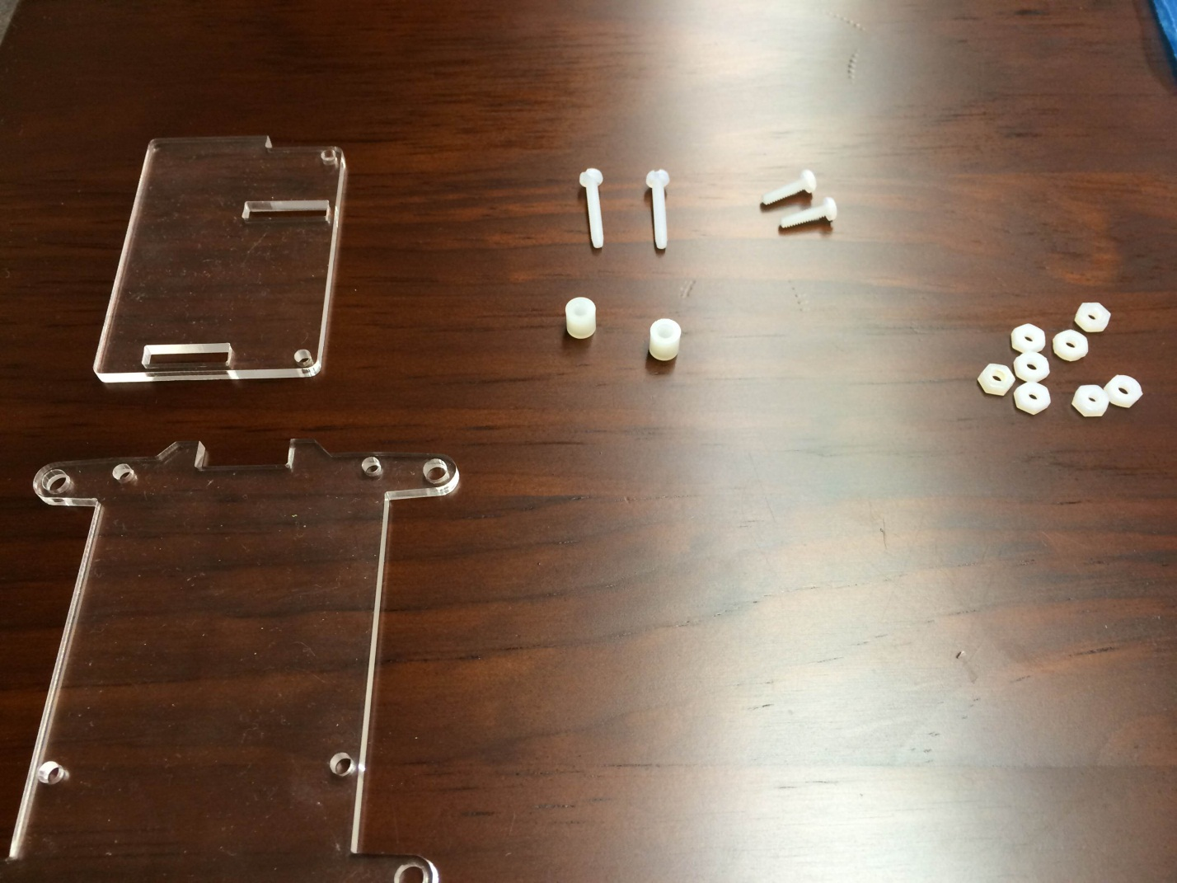

Part 2: Assembly

Step 1: place the two ½” screws through the PiTray Base and seal it with two hex nuts. The screws should be placed on the side where the opening in the middle is closest to the mounting holes. This side should be your right side if the opening is facing away from you.

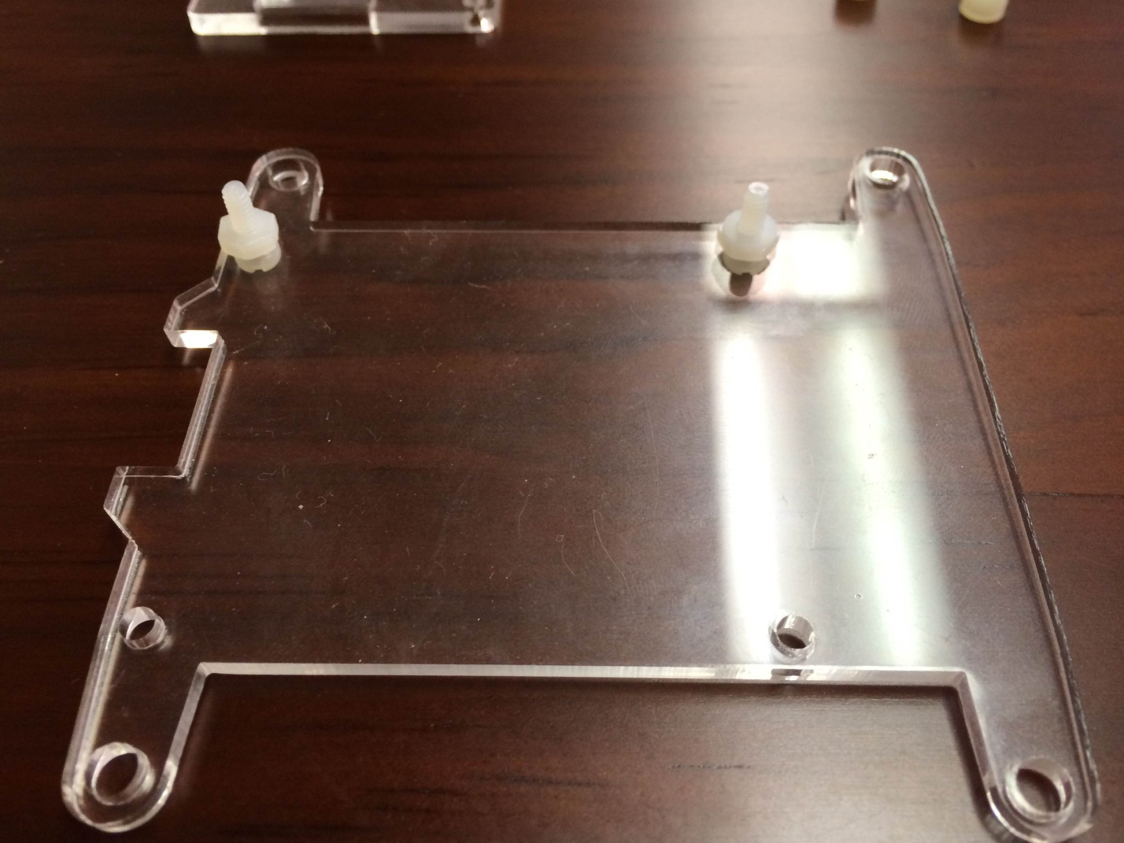

Step 2: Put the two ¾” screws into the other two mounting holes and seal it with another two hex nut.

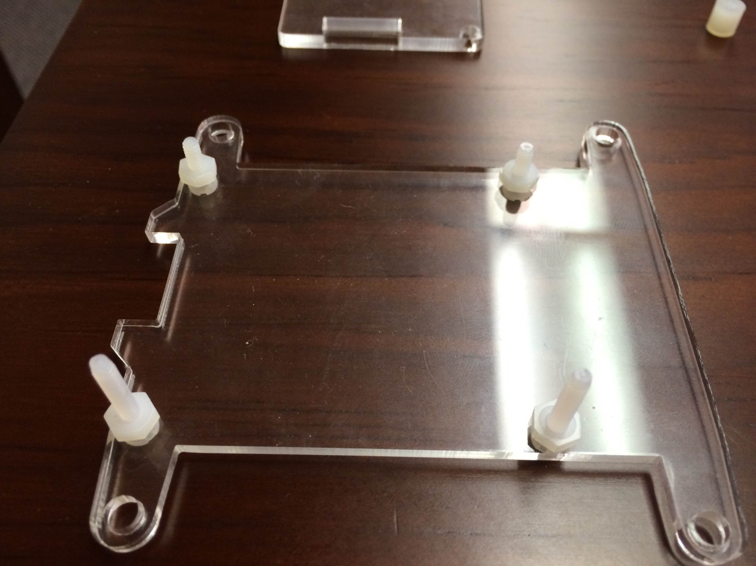

Step 3: place your Raspberry Pi\* on the base plate. If done properly, the two ½” screws should emerge from the side with the pins. And the SD card should be centered in the opening in the back of the PiTray.

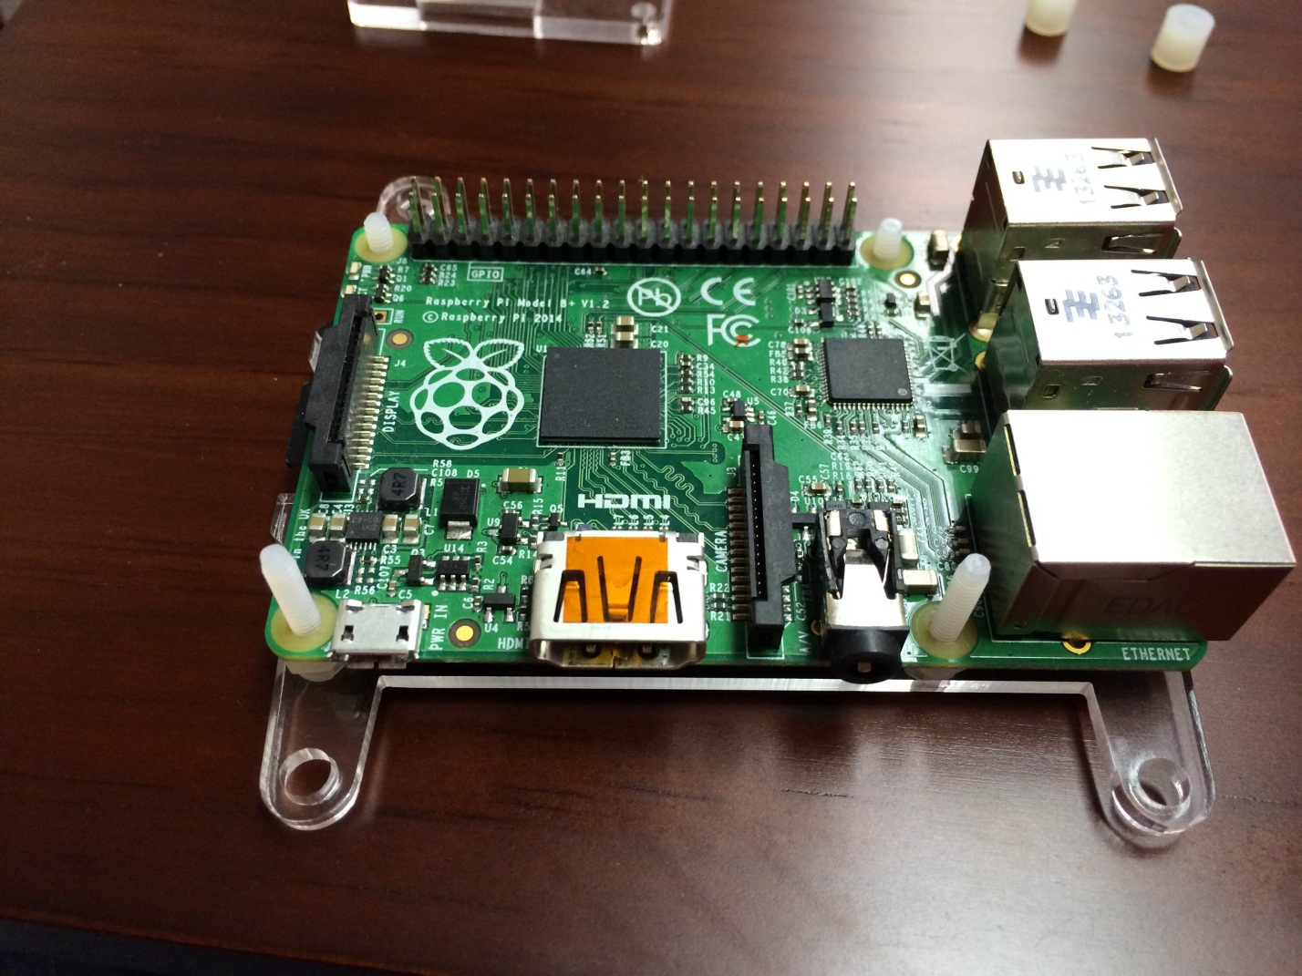

\*Raspberry Pi not included in this kit\*

Step 4: Put the Spacer on the 3/4” screw.

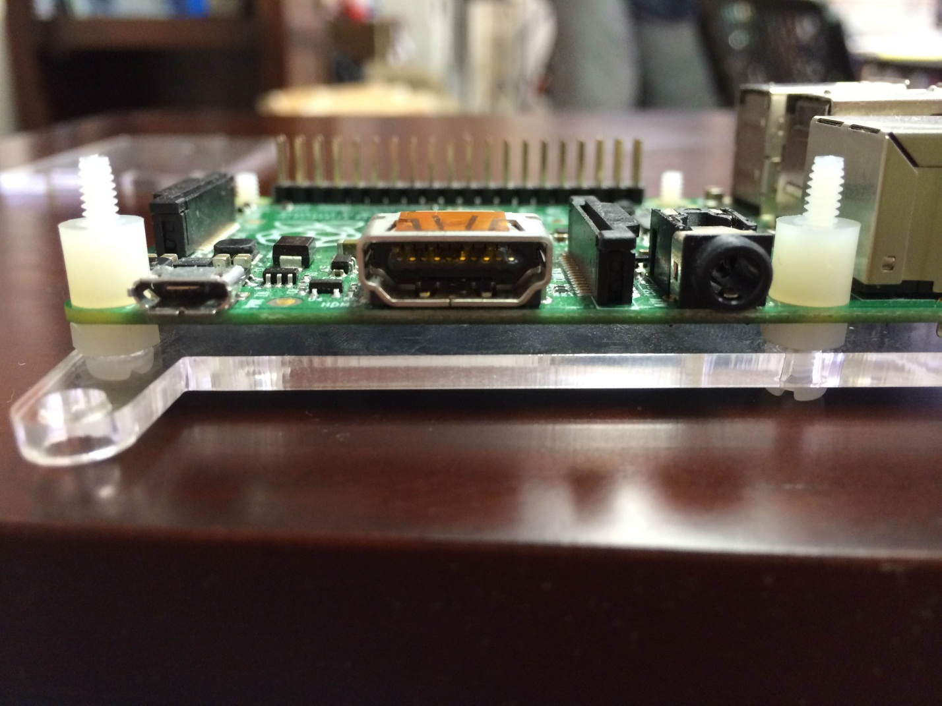

Step 5: Seal the hex nut into the ½” screw. This should hold Raspberry Pi to the base plate.

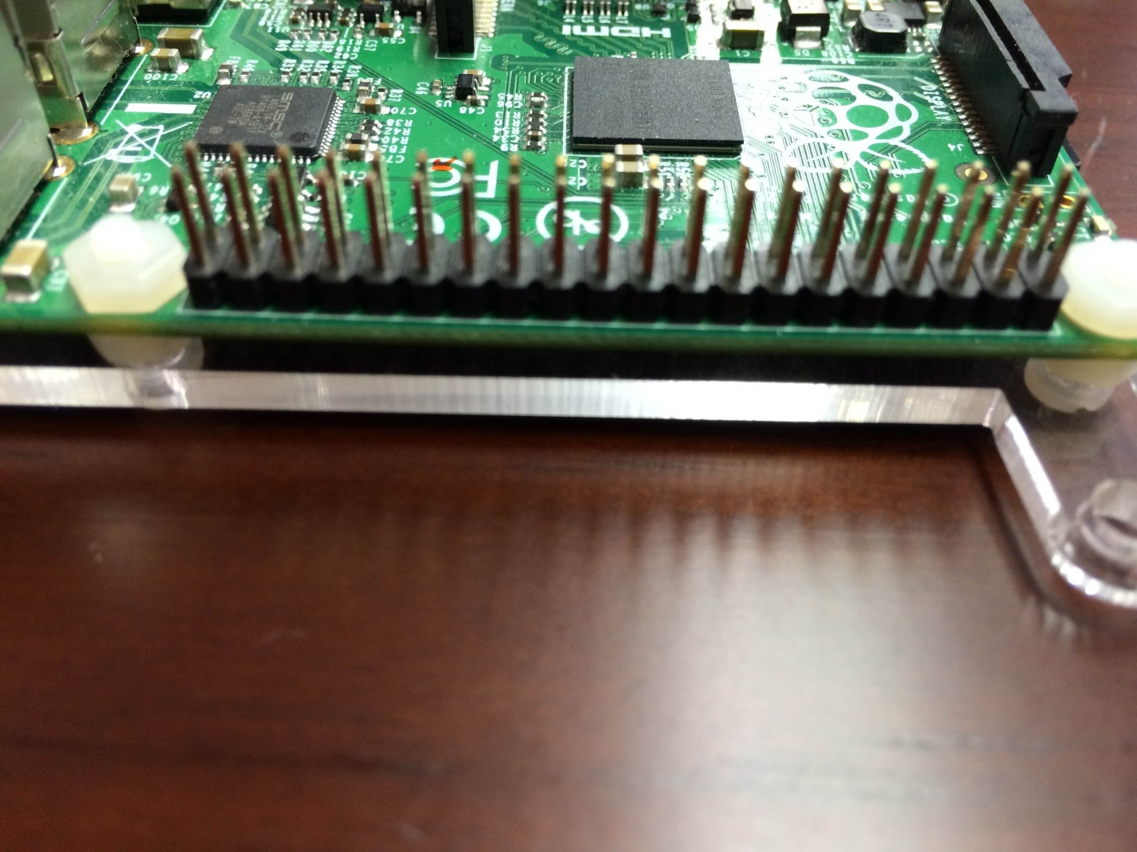

Step 6: Place the top plate on top the raspberry Pi. The holes should align. Then seal it with the hex nut. Now that your Raspberry Pi is successfully placed onto the PiTray, it’s now ready to be served and enjoyed.

