LLM-Based Multi-Agent Audit Support System
ELEC5620 — Stage 1 Design Report

Member | SID | Contribution
Chen Li | 540308998 | 33.3%
Yunpeng Tao | 540998342 | 33.3%
Yuanhao Wang | 540356287 | 33.3%

Contents
1. Introduction and scope 2
1.1 Problem and the One-Person AI Company 2
1.2 Stakeholders and boundary 2
1.3 Assumptions and exclusions 2
2. Requirements specification 3
2.1 Requirement classification 3
2.2 Non-functional requirements 5
2.3 Individual ad hoc requirements 5
2.4 Feature model 6
3. Use cases 7
3.1 Overall use case diagram 7
3.2 Use case specifications 8
UC-01. Accept engagement — Chen Li 8
UC-02. Plan audit and assess risks — Chen Li 8
UC-05. Reassess audit risks — Chen Li 9
UC-03. Execute procedures and test journals — Yunpeng Tao 10
UC-04. Review exceptions and judgments — Yunpeng Tao 10
UC-06. Complete audit and approve report — Yuanhao Wang 11
UC-07. Archive and switch engagements — Yuanhao Wang 12
UC-09. Handle notifications and withdrawal — Yuanhao Wang 12
4. Architecture and LLM design 13
4.1 Layers and packages 13
4.2 Agents and support components 14
4.3 Role of LLMs 15
4.4 Key design decisions 17
4.5 Extension points 17
5. Elementary structure modelling 17
5.1 Domain model 18
5.2 Agents, services and interfaces 23
6. Complex structure modelling 27
6.1 Orchestrator structured class 27
6.2 Runtime object snapshot 28
6.3 Communication and collaboration 29
7. Behaviour modelling 30
7.1 Engagement lifecycle 30
7.2 Activity diagrams 33
7.3 Interaction diagrams 38
7.4 State machine diagrams 42
8. Traceability and contributions 45
8.1 Traceability and change assessment 45
8.2 Contributions 46
References 47

1. Introduction and scope

1.1 Problem and the One-Person AI Company
In Australia, the financial report of a company that must be audited is audited by a Registered Company Auditor, an individual registered with ASIC who forms the opinion and personally signs the auditor’s report. A sole practitioner must accept the engagement, assess risks, perform procedures, evaluate misstatements and report: work that a firm would normally share among a team. The proposed One-Person AI Company assigns that support work to ten agents (Table 4.1) that mirror a small audit firm: A1 as engagement manager, parallel A6 instances as field staff, A7 as independent reviewer and A10 as the practitioner’s single point of contact. The RCA approves reserved decisions, resolves disputes and signs the report. An engagement passes through five phases: P0 acceptance, P1 planning, P2 execution, P3 completion and P4 reporting.

1.2 Stakeholders and boundary
Table 1.1. Stakeholder responsibilities
Stakeholder | Interaction and responsibility
RCA | Primary operator; decides acceptance, risks, materiality, review outcomes, opinion, notifications and signature.
Client: management and governance | Supplies accounting records, documents and responses; receives communications; prepares corrections and representations.
External data source | Provides registry, accounting, banking and confirmation information through adapters; receives authorised submissions, including lodgements with ASIC.
External EQR reviewer | Performs the engagement quality review (EQR) outside the system; findings and completion are recorded for the signature gate.
LLM provider | Processes de-identified prompts under a data-processing agreement with no training use; its outputs are untrusted until validated.

1.3 Assumptions and exclusions
Design assumptions are recorded as agreements AG-01–AG-06 (Table 2.1). Out of scope: forming or signing the opinion, physical procedures and management interviews (results are recorded), substantive EQR work (ASQM 2; performed by the external reviewer) and human-readable workpaper export. The RCA performs the ASA 402, 620 and 720 evaluations outside the system; each outcome is recorded in a register that must be complete before signature.

2. Requirements specification

2.1 Requirement classification
Table 2.1. Agreements and design assumptions
ID | Premise or boundary
AG-01 | Audit support; the RCA makes and owns statutory judgments.
AG-02 | Australian framework: Australian Auditing Standards (ASA), Corporations Act 2001 and APES 110.
AG-03 | Registered RCA; independent external EQR before signature when required.
AG-04 | Authorised accounting API access; synthetic demonstration data.
AG-05 | SME single reporting entities subject to statutory audit; listed entities, IPOs and group audits (ASA 600) excluded.
AG-06 | Human opinion and signature; physical procedures performed externally.

Table 2.2. Mandatory requirements
ID | Required capability
M-01 | Scan the complete journal population; do not replace this scan with sampling.
M-02 | Every judgment adopted in an audit conclusion is traceable through valid evidence pointers to original evidence.
M-03 | Reserved decision points require explicit human confirmation before progression.
M-04 | Block reporting if objective coverage is incomplete or a required procedure is unsettled.
M-05 | Present an inspectable reasoning record for every AI judgment.
M-06 | A human override requires the replacement conclusion and a recorded reason.
M-07 | Log model calls, prompts, inputs, parameters, human actions, transitions, rules, external actions, failures and retries.
M-08 | An approved risk revision reopens affected completed procedures.
M-09 | Acceptance includes ASIC registration and ABN validity checks.
M-10 | Execution requires an approved audit plan; revisions retain versions and reasons.
M-11 | Provide one human entry point that transfers decisions verbatim, with equivalent fallback forms.
M-12 | Persist notification deadlines from awareness dates; escalate unresolved items and block signature.
M-13 | Enforce independence, representations, reconciliation and all pre-signature prerequisites.
M-14 | Permit human-authorised withdrawal at any phase and seal the engagement records.
Optional requirements. O-01 multiple concurrent engagements; O-02 additional external sources (litigation, adverse media); O-03 mobile review; O-04 multilingual reports; O-05 cross-year client profile reuse; O-06 rule improvement proposals from human overrides.
Figure 2.1. User requirement diagram: requirement classification and derivation
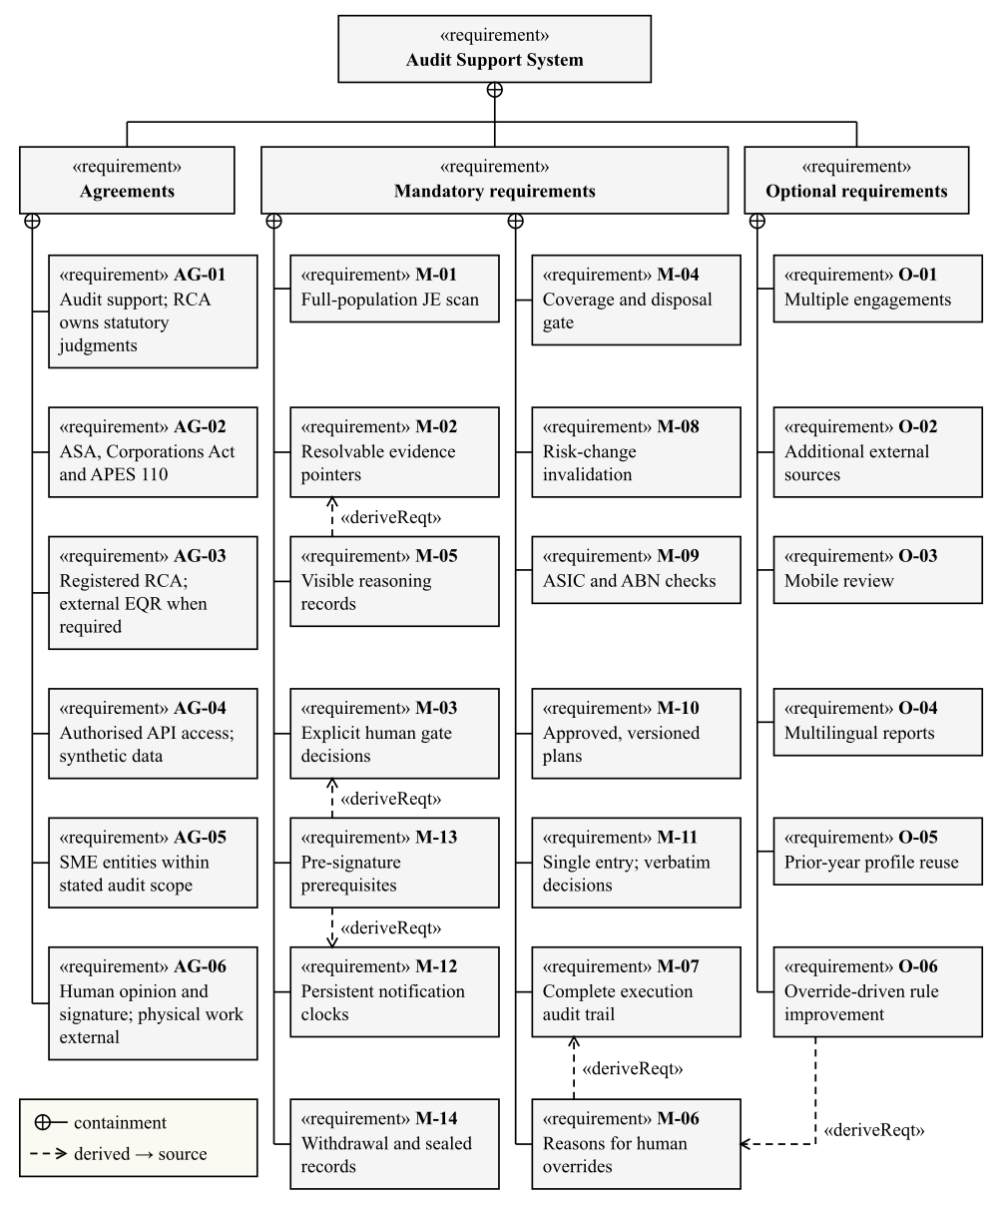

2.2 Non-functional requirements
Table 2.3. Non-functional requirements and evaluation conditions
Quality | Design target and planned evidence
Performance | 100,000 journal entries scanned in <30 s and 3,000 in <3 s; a single LLM judgment in <10 s. Record scale, hardware, concurrency and latency percentiles.
Traceability | 100% of adopted judgments resolve to original evidence; invalid generated outputs remain visible as failures.
Reconstruction | Recompute deterministic rules, assembly, scheduling and confidence; replay cached LLM results from versioned inputs.
Isolation and privacy | Server-side engagement authorisation, encrypted storage and access logging; only de-identified, procedure-declared fields go to approved providers and regions, with names, tax file numbers and bank accounts replaced by locally mapped placeholders (Privacy Act 1988, APP 8); uploaded and returned content cannot change tools or permissions.
Availability | Interrupt and resume an engagement without losing decisions or duplicating external actions; A10 failure switches to forms within 30 s.
Archive integrity | Prototype: hashes and enforced read-only records. Production: WORM retention, recovery and controlled amendments.

2.3 Individual ad hoc requirements
AH-A — Chen Li (acceptance and planning). As the RCA, before I accept a client I need the registry, ABN, independence and background checks in one place, with the evidence behind each finding. During planning I need the system to propose materiality, risks and audit objectives with reasons, let me change any of them with my own reasons, and only then build a plan that covers every objective. I approve one exact plan version, and nothing is executed until I do. If new facts appear during fieldwork, I need to see which risks and procedures they affect, decide whether to revise the plan, and keep the earlier assessment on file. Derived requirements: M-03, M-04, M-08–M-10.
AH-B — Yunpeng Tao (execution and review). As the RCA, I cannot read every journal entry myself, so I need every entry tested by rules and every exception linked to the original entries and documents. When the AI explains an exception, I need to see its evidence, reasoning and counterargument, and an independent check before anything closes without me. Failed, unsupported or disputed work must stay visible until I decide it, and my decision and original reason must reach the system exactly as I gave them, through one reliable entry point even when the conversation interface is down. Derived requirements: M-01, M-02, M-05–M-07, M-11.
AH-C — Yuanhao Wang (completion, reporting and statutory matters). As the RCA, at completion I need corrected and uncorrected misstatements evaluated against materiality, and every report draft kept as a version I can annotate. I must not be able to sign until every prerequisite has passed: independence, reconciliation, any required EQR and valid written representations; if management refuses the representations or I cannot rely on them, the only report I may sign is a disclaimer of opinion. When I become aware of a reportable matter, the system must hold the statutory deadline from my awareness date and escalate it; if I withdraw from the engagement, those deadlines must survive and the records must be sealed. Derived requirements: M-03, M-04, M-12–M-14.

2.4 Feature model
Figure 2.2. Complete feature model
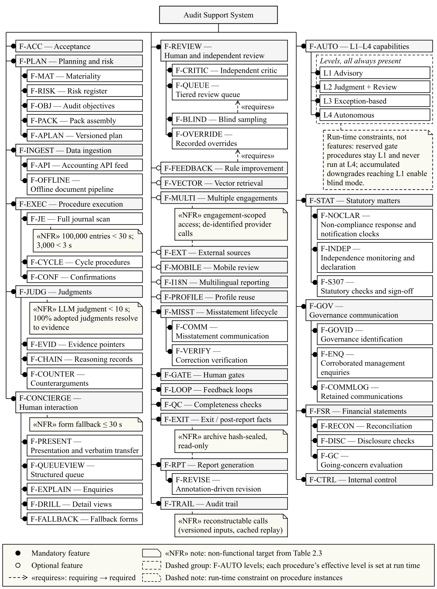

3. Use cases
These requirements lead to nine stakeholder goals. Human decisions use the concierge interface or equivalent fallback forms. Phase progression between use cases follows the lifecycle in Figure 7.1 rather than «include» relations.

3.1 Overall use case diagram
Figure 3.1. System boundary, actors and nine use cases
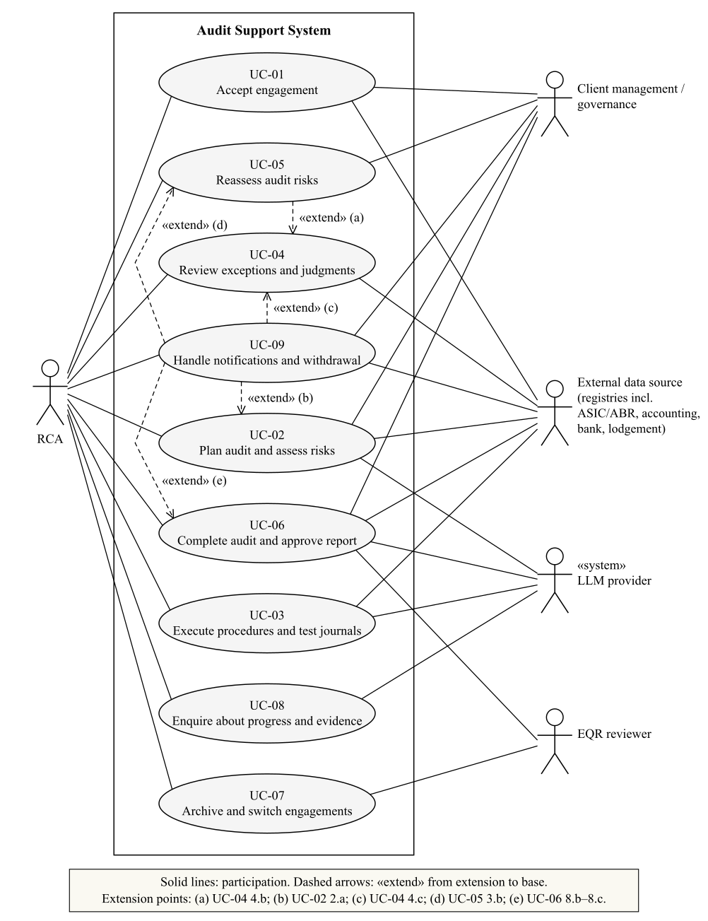
The RCA participates in every use case; the LLM provider is a secondary actor for the use cases whose agents call a model.

3.2 Use case specifications
Members specified these use cases: Chen Li UC-01, UC-02 and UC-05; Yunpeng Tao UC-03 and UC-04; Yuanhao Wang UC-06, UC-07 and UC-09. UC-08 appears only in Figure 3.1. All use cases are at user-goal level.

UC-01. Accept engagement — Chen Li
Primary actor: RCA. Supporting actors: Client management / governance; registry sources. Phase: P0. Related requirements: M-03, M-09; O-02; AG-01–AG-06.
Goal | Precondition | Success Condition | Failure Condition | Trigger
Decide whether to accept an eligible client and establish the engagement. | The RCA is authenticated and the client is within scope. | Acceptance, terms and appointment are confirmed; planning may begin. | The engagement remains blocked or is declined with its reason. | The RCA creates an engagement and supplies client identifiers.

Main Success Scenario
- The RCA enters the client name and ABN and requests acceptance assessment.
- The system checks registration, ABN validity, background and independence, and presents the findings with evidence.
- The RCA reviews the findings and decides whether to accept the engagement.
- The system presents the engagement terms, responsibilities, access commitments and appointment evidence.
- The RCA confirms the terms and appointment prerequisites.
- The system records the decisions and governance recipients and opens planning.

Extension Scenarios
- 2.a {An optional external source is configured} Litigation and adverse-media results are added to the findings with their source labelled; an unavailable source is reported as a gap, not as a clean result.
- 3.a {Information is insufficient} The system requests supplementary information and returns to step 2; acceptance remains unapproved.
- 3.b {The RCA rejects acceptance} The system records the reason and ends the use case with the engagement declined.
- 5.a {Terms, appointment or the presented version are invalid} The system blocks progression, presents current material and returns to step 4.

UC-02. Plan audit and assess risks — Chen Li
Primary actor: RCA. Supporting actors: Client; accounting and document sources. Phase: P1. Related requirements: M-03, M-04, M-10; O-05.
Goal | Precondition | Success Condition | Failure Condition | Trigger
Approve a complete plan based on current risks and materiality. | Acceptance is approved and data access is authorised. | The current plan is approved and passes coverage checks; execution may begin. | Missing data, coverage gaps or absent approval keep execution blocked. | The RCA opens planning for the accepted engagement.

Main Success Scenario
- The RCA requests planning and supplies access to accounting records, statements and documents.
- The system reconciles the journal population, checks data quality, generates the baseline of material objectives from the trial balance and disclosure checklist, and proposes risk ratings with reasons; revenue occurrence and cut-off start as significant fraud risks.
- The RCA reviews and confirms materiality, objectives and risks, recording reasons for any changes, including any rebuttal of the revenue fraud presumption.
- The system assembles risk-scaled procedures for every objective, closes dependencies and checks coverage.
- The system presents the resulting plan version and explanatory narrative.
- The RCA approves the displayed version and confirms whether EQR is required; the system records approval and starts execution.

Extension Scenarios
- 2.a {Data reconciliation or quality checks fail} The system requests replacement or missing data and returns to step 2. After three unsuccessful resubmissions, the RCA assesses continuance through UC-09.
- 4.a {Coverage is incomplete} The system adds suitable procedures and repeats step 4; objective changes first return to step 3. A scope limitation needs an explicit RCA decision before rechecking.
- 6.a {The RCA rejects the plan} The system retains comments, revises the plan and returns to step 4 for coverage checks.
- 6.b {The submitted approval targets an outdated version} The system rejects it and returns to step 5 with the current version.

UC-05. Reassess audit risks — Chen Li
Primary actor: RCA. Supporting actors: Client governance when communication is required. Phase: P2 or P3; approved revision returns to P1 assembly. Related requirements: M-03, M-08, M-10, M-14.
Goal | Precondition | Success Condition | Failure Condition | Trigger
Approve or reject a risk revision without losing prior work. | An existing risk assessment and plan are identifiable. | An approved revision creates a new plan; rejection restores the suspended phase. | Unapproved revisions cannot replace risks or restart blocked work. | The RCA opens a blocking reassessment request or accepts an advisory proposal.

Main Success Scenario
- The system records the suspended phase and, for a blocking trigger, stops dispatch at safe points while retaining completed work.
- The system presents proposed risk changes, evidence, reasons and affected procedures.
- The RCA approves the proposed revision.
- The system versions the changed assessment and reopens affected completed work while preserving unrelated results.
- The system reassembles the plan without re-ingesting data and continues with UC-02 steps 4–6 for approval.
- The system executes the approved affected work and returns it to completion review when settled.

Extension Scenarios
- 1.a {The trigger is advisory} Work continues until the RCA chooses reassessment; the system then follows step 2.
- 3.a {The RCA rejects reassessment} The system records the reason, clears the flag and resumes the recorded phase, P2 or P3, without revising the assessment.
- 3.b {The RCA chooses withdrawal} UC-09 seals the engagement.
- 4.a {The approved revision concerns fraud or another reportable matter} The RCA completes the required governance discussion and notification assessment.

UC-03. Execute procedures and test journals — Yunpeng Tao
Primary actor: RCA. Supporting actors: Accounting and confirmation sources. Phase: P2. Related requirements: M-01, M-02, M-05, M-07.
Goal | Precondition | Success Condition | Failure Condition | Trigger
Execute approved work and retain traceable results for review. | The current plan is approved; required inputs and dependencies are available. | Results are retained; eligible work is settled and outstanding review tasks are visible. | Failed, unsupported or disputed work remains unresolved and visible. | Approval recorded in UC-02 releases the current plan for execution.

Main Success Scenario
- The RCA receives the execution schedule and manual assignments for the approved plan.
- The system runs ready independent procedures in parallel and initiates required external confirmations.
- The system tests every supplied journal entry and retains exceptions linked to the original entries.
- The system explains selected exceptions using evidence, validates the results and obtains independent review where required.
- The RCA completes assigned manual work and returns the results with evidence; the system presents matters requiring human review through UC-04.
- The system retains outcomes and updates procedure status while continuing unrelated ready work.

Extension Scenarios
- 3.a {Required source fields are missing} The system marks the affected test unavailable and requests an alternate source or manual work; it cannot count the test as passed.
- 4.a {Output syntax or structure is invalid} The system retries at most twice. Exhaustion retains rule exceptions without attribution, or a failed model-only run, for UC-04.
- 4.b {Evidence is insufficient or the critic (A7) disagrees} Additional available internal evidence permits at most three shared retry rounds. Unresolved disagreement goes to human arbitration through UC-04.
- 6.a {A result cannot be safely merged} The system retries once, then retains a failed task for human action. Worker failure redistributes unfinished work and preserves completed results.

UC-04. Review exceptions and judgments — Yunpeng Tao
Primary actor: RCA. Supporting actors: External evidence sources. Phase: P2 and other phases with pending tasks. Related requirements: M-02, M-05–M-07, M-11; O-03, O-06.
Goal | Precondition | Success Condition | Failure Condition | Trigger
Record a valid disposition of an exception, judgment or failed task. | The current task exists and the RCA is authorised for the engagement. | The decision and original reason are retained and applied to the current target. | Invalid or incomplete decisions leave the task unresolved. | The RCA selects a pending review task.

Main Success Scenario
- The RCA selects a pending task, or a batch of eligible tasks, from the review queue.
- The system presents the task type, allowed decisions, original evidence and, for ordinary review, the AI reasoning and critic result.
- The RCA selects a decision and supplies the required conclusion, reason or requested additional work.
- The system validates the task version and decision, records the original input and applies the outcome.
- The system recomputes outstanding work and period coverage, then displays the updated status and next available task.

Extension Scenarios
- 2.a {Blind review is required} The system presents only data and original evidence, withholding the AI conclusion, reasoning, counterargument and critic result. After the RCA records an independent judgment, it reveals the AI material for comparison.
- 2.b {The task is disputed} The system presents both supported conclusions and asks the RCA to uphold one or provide a human conclusion or additional work.
- 3.a {Required decision information is missing or the decision is not permitted} The system explains the missing fields and returns to step 3.
- 4.a {The target has changed} The system rejects the stale decision and returns to step 2 with the current version.
- 4.b {Evidence is unreliable or more work is required} The system invalidates affected results or schedules requested work. A blocking risk trigger invokes UC-05.
- 4.c {Non-compliance with laws and regulations (NOCLAR) is identified, or management refuses to lift a scope restriction} The system records the matter and its awareness date and invokes UC-09 at this extension point for the notification and continuance assessment.

UC-06. Complete audit and approve report — Yuanhao Wang
Primary actor: RCA. Supporting actors: Client management / governance; accounting source; external EQR reviewer. Phase: P3–P4. Related requirements: M-03, M-04, M-12, M-13; O-04.
Goal | Precondition | Success Condition | Failure Condition | Trigger
Evaluate completed work and sign an eligible report version. | P2 procedures, including their non-applicability tasks, are settled; confirmation dependencies are resolved. | The RCA signs the eligible current report; UC-07 performs archiving. | Unsettled completion work or missing signature prerequisites blocks progression. | The RCA begins completion review when P2 work is settled.

Main Success Scenario
- The system presents misstatements; the RCA communicates them to management and records responses.
- The system ingests corrections, tests new entries, verifies residual amounts and repeats affected work.
- The system reassesses materiality and performs completion checks; the RCA resolves any new P3 review or non-applicability tasks.
- The RCA reviews residual amounts, scope limitations and going concern and decides the opinion and completion conclusions.
- The system records required communications and representations and drafts the report from current accepted judgments.
- The RCA annotates the report; the system retains each prior version and presents a new draft until review is complete.
- Where required, the external reviewer completes EQR and the RCA records eligibility, findings and completion.
- The system rechecks the current version and the signature prerequisites listed for P4 in Table 7.1. The RCA approves and signs it; the system invokes UC-07.

Extension Scenarios
- 2.a {Corrections are incomplete or inconsistent} The system retains residual amounts and returns affected matters to step 1; a refusal or stop-wait decision records them as uncorrected.
- 3.a {Completion checks create unresolved tasks or coverage gaps} The RCA resolves the tasks and the system repeats only affected work before returning to step 3.
- 6.a {New evidence affects a conclusion} The system invalidates affected approval and EQR, returns to P3 checks and creates a new draft after the revised conclusions are accepted.
- 8.a {A prerequisite is missing, EQR remains unresolved or the version changed} The system blocks signing, displays the reason and returns to the relevant earlier step.
- 8.b {Written representations are refused or unreliable} FIN-18 records a mandatory disclaimer of opinion. The system returns to step 4, where the RCA confirms the disclaimer, and the signature gate then accepts only a disclaimer report; the RCA may instead assess withdrawal through UC-09.
- 8.c {An independence breach is identified} The system blocks signature and invokes UC-09 at this extension point for the continuance or withdrawal assessment.

UC-07. Archive and switch engagements — Yuanhao Wang
Primary actor: RCA. Supporting actors: External EQR reviewer with authorised read-only access. Phase: P4–Archived. Related requirements: M-07, M-14; O-01, O-05.
Goal | Precondition | Success Condition | Failure Condition | Trigger
Seal signed records and allow authorised engagement switching. | A valid signed report and its supporting records exist. | Signed records are sealed and read only; an archive manifest is available. | Sealing failure leaves archiving incomplete; signed history remains preserved. | The RCA signs the report in UC-06.

Main Success Scenario
- The system hashes the signed report, supporting records and original evidence and records an archive manifest.
- The system applies read-only access and marks the engagement archived.
- The RCA views the manifest and authorised records.
- The system updates the permitted client profile summary; the RCA returns to the engagement list.

Extension Scenarios
- 1.a {Hashing or sealing fails} The system records the failure and retries safely; it does not claim that archiving succeeded.
- 3.a {A new fact could have changed the issued report} The RCA assesses amendment and notifications. Required changes reopen affected work through UC-06 and create a replacement report; the original remains locked.
- 4.a {The RCA requests another engagement} With concurrent engagements enabled, the system checks authorisation and isolation before loading it; another project’s rows, evidence and decisions remain inaccessible.

UC-09. Handle notifications and withdrawal — Yuanhao Wang
Primary actor: RCA. Supporting actors: Client management / governance; authorised submission source. Phase: Any phase; notification timers outlive the engagement workflow. Related requirements: M-03, M-12–M-14.
Goal | Precondition | Success Condition | Failure Condition | Trigger
Dispose of reporting obligations and any decision to withdraw. | The relevant facts and awareness date can be retained. | Notification is resolved, or authorised withdrawal seals records and preserves outstanding timers. | Unresolved notifications remain pending, escalate and block signature. | The RCA opens a reporting or continuance assessment, or requests withdrawal.

Main Success Scenario
- The system records the facts, awareness date, discussions and affected audit matters.
- The system presents the applicable reporting assessment and its fixed deadline: 28 days from the awareness date under Corporations Act s311, and seven days under s990K and s324CA; one reminder fires three days before it.
- The RCA authorises lodgement and records the reason.
- The system uses the authorised route and retains the form, recipients and valid receipt.
- The RCA reviews any continuance concerns and decides to continue the engagement.
- The system records the reporting disposition and continuance decision and returns to the active phase.

Extension Scenarios
- 1.a {Only withdrawal is requested} The system retains the withdrawal grounds and proceeds to step 5; existing notification clocks continue.
- 3.a {The RCA decides that notification is not required} The system records the RCA and reason and closes that reporting matter. If continuance concerns exist, it proceeds to step 5; otherwise the use case ends.
- 3.b {The decision is incomplete or outdated} The system rejects it and returns to step 2; the reporting matter remains pending.
- 4.a {Submission fails or no valid receipt arrives} The matter remains pending, escalates and blocks signature. A separate withdrawal assessment may continue at step 5.
- 5.a {The RCA decides to withdraw} The system records the RCA, time and reason and distinguishes withdrawal from formal resignation (Corporations Act s329; ASIC RG 26). It records and completes the required exit steps before sealing workpapers. Pending notification timers remain active; the engagement workflow ends.
- 5.b {The RCA decides to modify the opinion while continuing} The system records the decision and invokes UC-06 for the opinion and report change.

4. Architecture and LLM design
The use cases require deterministic coordination around bounded LLM judgments. The design is analysed from the requirements (Sections 2 and 8), scenario (Section 3), development (Section 4), logical (Section 5), runtime (Section 6) and process (Section 7) viewpoints.

4.1 Layers and packages
A1 is an event-driven state machine that pauses at human gates and resumes without losing state; confirmation replies and uploads arrive asynchronously, and only dependent work waits for them. In P2, independent procedure groups fan out by dependency layer to at most four A6 instances by default, and the same plan, dependencies and limit always produce the same schedule. A6’s call to A7 for independent review is the only direct agent-to-agent call; every other exchange passes through versioned state held by A1.
The prototype maps A1 to a LangGraph StateGraph behind authenticated FastAPI endpoints: static human gates become interrupt_before points and parallel fieldwork uses Send. Ingestion (A3) and the concierge (A10) run as separate graphs, so uploads and enquiries proceed while the main workflow waits.
Figure 4.1 shows the five tiers and their package dependencies; Tier 3 holds the agents and Tier 4 holds A1.
Figure 4.1. Package dependencies
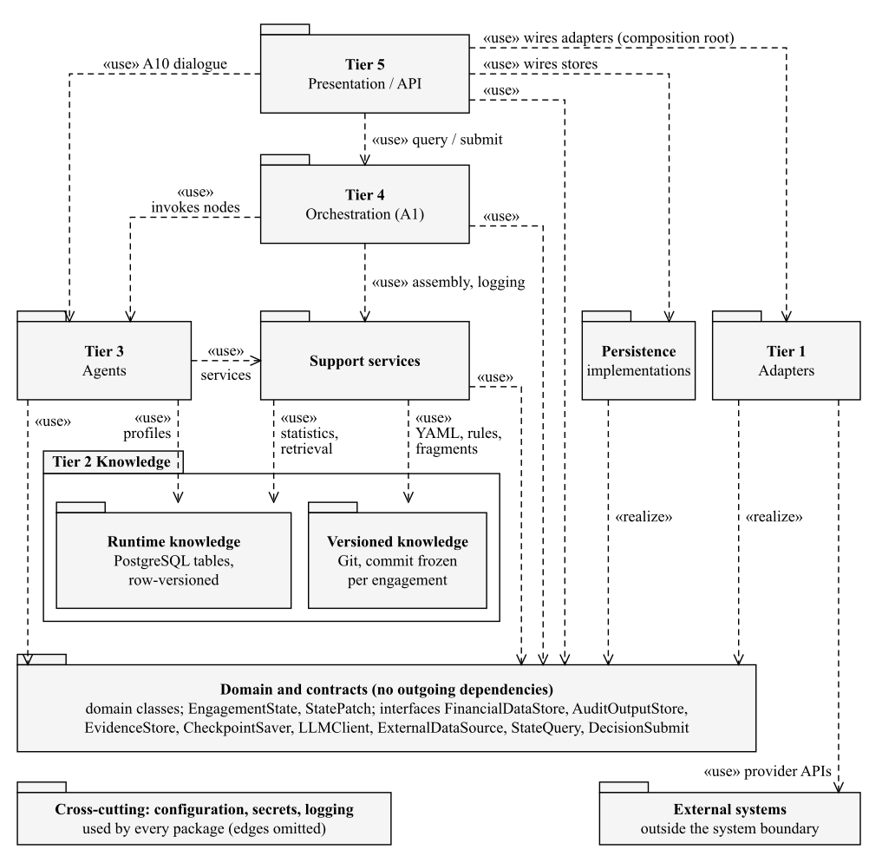

4.2 Agents and support components
Agents are divided by output type rather than audit area (Table 4.1).
Table 4.1. Ten roles; procedure ownership is not decision authority
Agent | Responsibility | LLM use / owned procedures
A1 Orchestrator | State machine, gates, assembly, schedule, merge and archive control | Deterministic; no owned audit procedure
A2 ClientIntel | Acceptance, client profile, independence and continuance | Rule / LLM / hybrid / manual; 11
A3 IngestAgent | API and event-driven offline ingestion; classify, extract, link and reconcile | Rule / LLM / hybrid; 12
A4 RiskAssessor | Baseline objectives, risk proposals, materiality, plan and reassessment | Rule / LLM / hybrid / manual; 20
A5 EvidenceAgent | Confirmations, monitoring, enquiries, representations and authorised lodgement | Deterministic service and manual support; 9
A6 FieldworkAgent | Transaction, balance and estimate procedures; bounded evidence retries | Rule / LLM / hybrid / manual; 80; configurable instances, default maximum 4
A7 ReviewAgent | Evidence-first independent judgment, then comparison | Independent critic LLM; 1
A8 WorkpaperAgent | Misstatements, corrections, communications, workpapers and sealing | Rule / LLM / hybrid / manual; 6
A9 QCAgent | Completeness, accumulation, reconciliation and candidate opinion route | Deterministic checks with human decisions; 7
A10 ConciergeAgent | Single entry, verbatim decisions, enquiry and report revision | LLM interaction with deterministic decision contracts; 15
Ownership totals 161 procedures; the RCA decides the reserved gates.
Table 4.2. Support components
Component | Responsibility
JudgmentEngine | Builds judgments with reasoning, confidence and counterargument; never writes a store.
OutputValidator | Checks syntax, structure, references and semantics before merge.
RuleEngine | Runs deterministic SQL rules over financial data; no LLM.
ProcedureLibrary | Versioned procedure configurations and dependency closure.
ReviewQueue | Ranks tasks, separates disputes, schedules blind samples, tracks agreement.
EvidenceStore | Keeps originals, resolves evidence pointers, hashes and seals records.
AuditTrail | Append-only log of model calls, human actions and transitions.
FinancialDataStore, AuditOutputStore | Relational client data; versioned audit outputs as JSONB.
VectorIndex (optional) | Locates passages in long contracts; hits are never evidence.

4.3 Role of LLMs
LLMs are used only where the work requires reading unstructured evidence or forming a reasoned judgment that fixed rules cannot express. Table 4.3 maps their contribution and the deterministic control retained around each use.
Table 4.3. LLM contribution and retained deterministic controls
Capability | Representative work | Control retained
Perception | Contract extraction; document classification and OCR (A3, A6) | Original document, location, transcription confidence and manual fallback
Decision-making | Risk reasoning (A4); exception attribution and revenue cut-off (A6) | Rule-generated objectives, structured schema, evidence checks and human authority
Independent review | Evidence-first critic (A7) | Separate client and model; eligibility rule; dispute adjudication
Interaction | Enquiry, decision presentation and report drafting (A10); workpaper narrative (A8) | Scoped state reads, verbatim commands, fact-to-judgment links and version checks
Context belongs to the procedure, not to the agent. Each LLM call executes one procedure with a context assembled from four declared layers: the system role and output schema; the cited standards fragments; the task prompt, parameters and covered objectives; and only the declared input rows and evidence elements. Agents keep no memory across procedures, judgments from other audit cycles are excluded, and A10’s conversation memory never enters a judgment. Fact steps carry evidence pointers; steps that cite a standard must reference an ID-bearing fragment in the versioned knowledge base, never a clause number recalled by the model; inference steps cite earlier steps. Unsupported steps stay visible and send the judgment to review.
Table 4.4. Default autonomy allocation and runtime reductions
Mode | Default count | Human authority and runtime reductions
L1 Advisory | 32 | The RCA decides; never upgraded (26 reserved by the standards or the Corporations Act, 6 by design).
L2 Judgment + Review | 41 | The RCA reviews each judgment, individually or by confirming a batch that the RCA selects.
L3 Exception-based | 40 | Ordinary eligible items can close automatically; exceptions require review.
L4 Autonomous | 31 | Eligible work runs autonomously with monitoring and sampling.
Manual engine | 17 | Physical, interpersonal or externally performed work is assigned, evidenced and logged.
Assembly reduction | Per procedure | Significant risk −2; high risk −1; historical agreement <80% −1; first-year client −1; related financial-report risk −1.
Judgment reduction | Per judgment, after A7 | Confidence <0.7 −1.
Direct human routing | Overrides scoring | An amount above performance materiality or a fraud indicator forces L1; critic disagreement, missing or stale evidence goes directly to human review.
Reductions accumulate to an L1 floor; reaching it through reductions enables blind mode. An upgrade requires over 95% human–AI agreement for the same procedure in three consecutive engagements, at least 30 blind samples from at least two client types, and RCA approval. Confidence combines evidence coverage, rule agreement, model self-report and critic agreement; it ranks review priority and is not a calibrated probability. The RCA may initiate batch confirmation of high-confidence, low-amount items, and the system imposes no spot check. Direct-routing items and reserved gate decisions are never batched, and a separate 5% blind sample of eligible items is drawn for calibration.
Table 4.5. Three feedback scopes
Scope | Trigger and allowed work | Exit and traceability
Loop 1: procedure | The generator or critic finds evidence insufficient; only further internal data may be sought. | At most three shared rounds, each a new ProcedureRun; unresolved disagreement becomes a dispute for RCA arbitration.
Loop 2: cycle | The RCA requests additional evidence or procedures without revising the risk assessment. | A1 assigns the work to A5 or A6, retains the request and recomputes settlement.
Loop 3: project | Blocking: fraud indicators, significant NOCLAR, undisclosed related parties, major subsequent events, uncorrected misstatements above 70% of overall materiality, confirmed management bias or a new fraud risk found in final review. Other triggers are advisory. | Blocking triggers stop dispatch at safe points. GATE-R approval revises risks and reassembles the plan (UC-05); rejection resumes the recorded phase; withdrawal seals work.
Independent review (procedure GEN-09) applies to LLM judgments that would close automatically at the procedure’s runtime level, L3 or L4, that is, the level after the assembly reductions in Table 4.4; internal-copy-only evidence, unsupported reasoning steps, recently changed procedures, low agreement and a 5% random sample also trigger it. A7 runs before the confidence reduction and the amount and fraud routing, uses a separate client and model, and derives its own conclusion from the evidence before comparing it with the candidate.

4.4 Key design decisions
Table 4.6. Rationale and rejected alternatives
Selected design | Alternative rejected | Reason / consequence
Bounded autonomy: a fixed phase state machine with agent-level feedback loops | A free-planning autonomous agent, or a one-pass workflow without feedback | ASA 230 requires reproducible workpapers, and ASA 315 requires the risk assessment to be revised as evidence arrives.
Ten agents divided by output type | One general LLM for all work, or one agent per procedure | One model cannot attribute judgments or run in parallel; 161 agents could not be verified.
Deterministic A1, A5 and A9 | LLM control of workflow, confirmations or completeness | The same inputs give the same path, and coverage can be verified.
SQL full-population rules | LLM scan of all entries | Enumerated rules are explainable and fast; only selected exceptions enter an LLM context.
Rule-based objective baseline with assembly per objective | LLM-defined objectives, or one procedure pack chosen from the engagement’s highest risk | Missing objectives cannot make coverage appear complete; nature, extent and timing follow each objective’s risk (ASA 330).
Selective evidence-first critic (A7) | No critic, or a critic on every judgment | A second review covers judgments no human would examine; the RCA already decides L1 and L2 judgments.

4.5 Extension points
The relationships between components keep common changes local (Table 4.7).
Table 4.7. Extension paths
Change | Path | Scope of impact
New audit procedure | Register a configuration entry in the procedure library | No code within existing engines and output contracts; a new engine or output type follows change assessment (Section 8.1).
New agent | Subclass ProcedureAgent, declare its output type and register its procedures | One orchestrator node and one ownership entry (Figure 5.6b).
Standards update | Update the Tier 2 knowledge fragments | Tiers 3 and 4 are unaffected.
New document type | Add a classification value and an extraction schema | The rest of the ingestion pipeline is unchanged.
New data source or model provider | Implement ExternalDataSource or LLMClient | Agents are unchanged (Figure 5.8).
State evolution | Add optional fields; version breaking changes | Old engagements replay with their recorded versions.

5. Elementary structure modelling
Table 5.1 shows where each kind of relationship is used. Classes drawn with a dashed border are defined in another figure. Money stores AUD integer minor units; every domain record carries id : String and, where it is versioned, version : Integer. HumanCommand is either a ReviewRecord or a GateDecision; VersionRef binds an ID to a version.
Table 5.1. UML relationships used in the class diagrams
Relationship | Where it is used
Generalisation | ProcedureAgent ← A2–A10 (Figure 5.6b).
Interface realisation | LLM adapters realise LLMClient (Figure 5.8).
Dependency («use») | RuleEngine → ProcedureLibrary and FinancialDataStore (Figure 5.7).
Composition | Judgment ◆ ReasoningStep and EvidencePointer (Figure 5.3).
Aggregation | AuditPlan ◇ its configured procedures (Figure 5.1).
Association, navigability and multiplicity | Engagement 1 — 0..* AuditPlan with a navigable currentPlan 0..1 (Figure 5.1).
Enumerations | AutonomyLevel (Figure 5.2).

5.1 Domain model
Figure 5.1. Planning, objectives and versioned risks
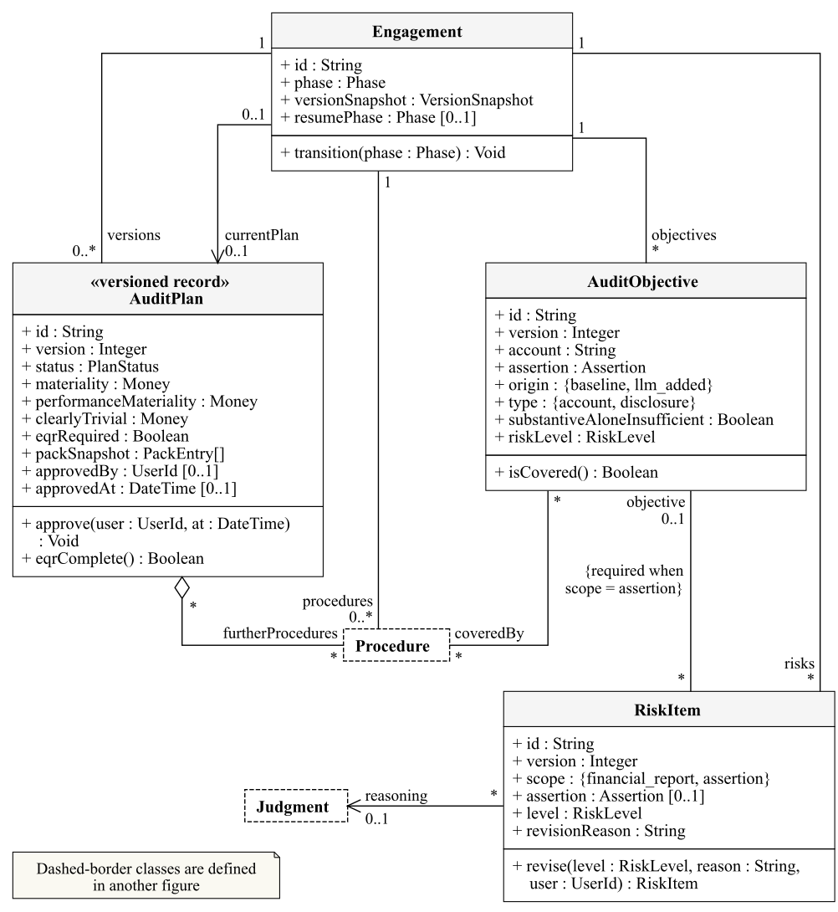
Only the current approved plan version authorises execution.
Figure 5.2. Templates, configured procedures and execution runs
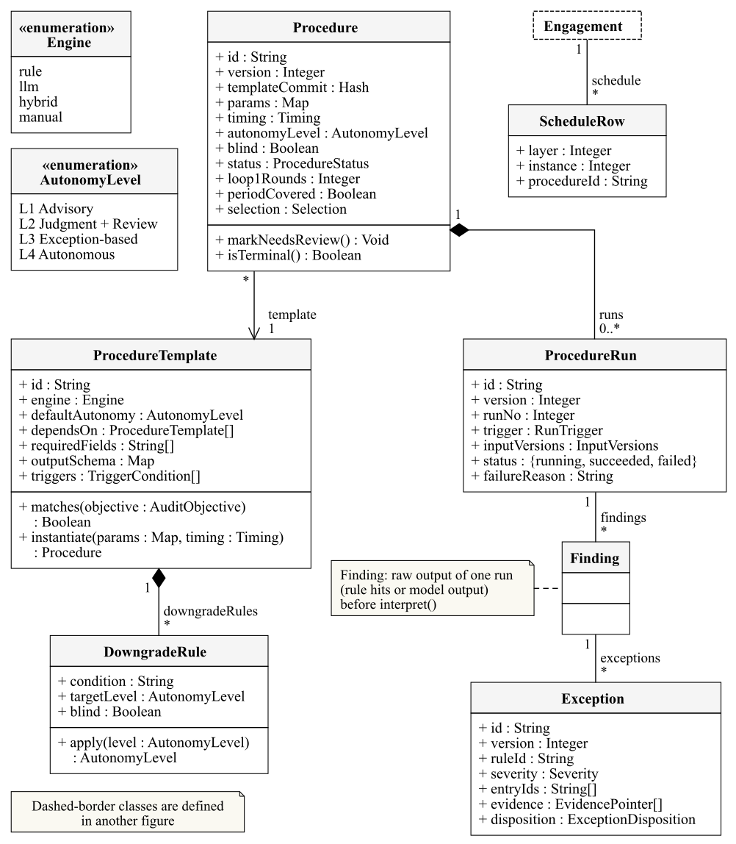
ProcedureTemplate is reusable configuration; Procedure is its engagement-specific instance.
Figure 5.3. Judgments, evidence, reasoning and workpapers
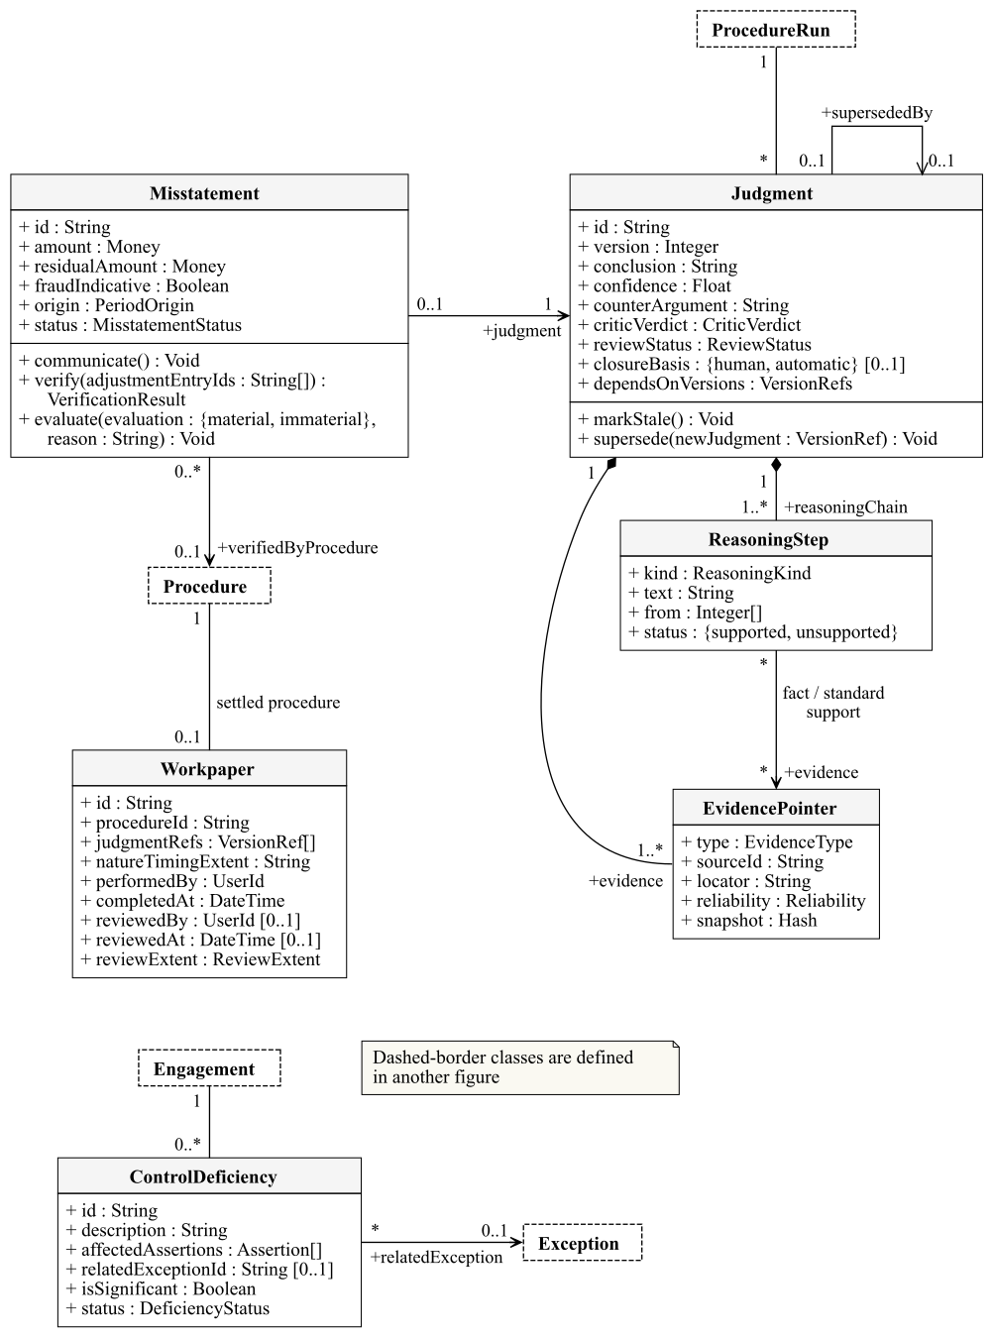
The supersededBy link keeps replacement history instead of overwriting a judgment.
Figure 5.4. Human decisions and report versions
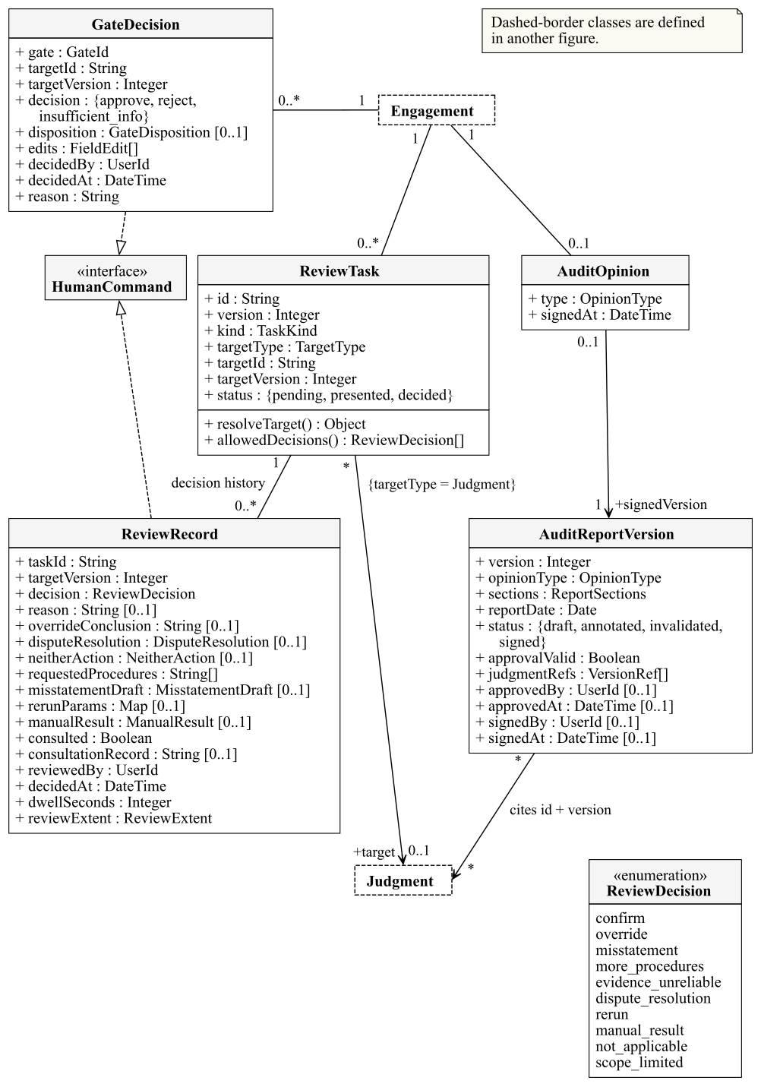
ReviewTask and ReviewRecord bind the target type (Judgment, Exception, ProcedureRun or Procedure), ID and version.
Figure 5.5. Signature, notification and original-evidence records
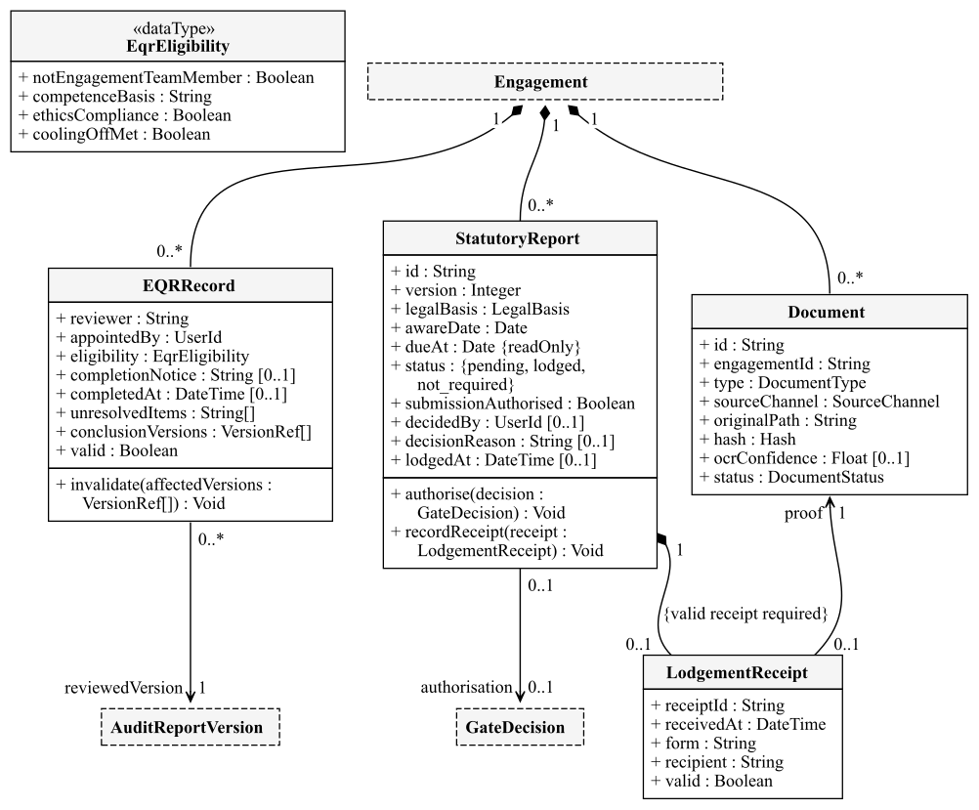

5.2 Agents, services and interfaces
Figure 5.6a. Agent generalisation and orchestrator parts
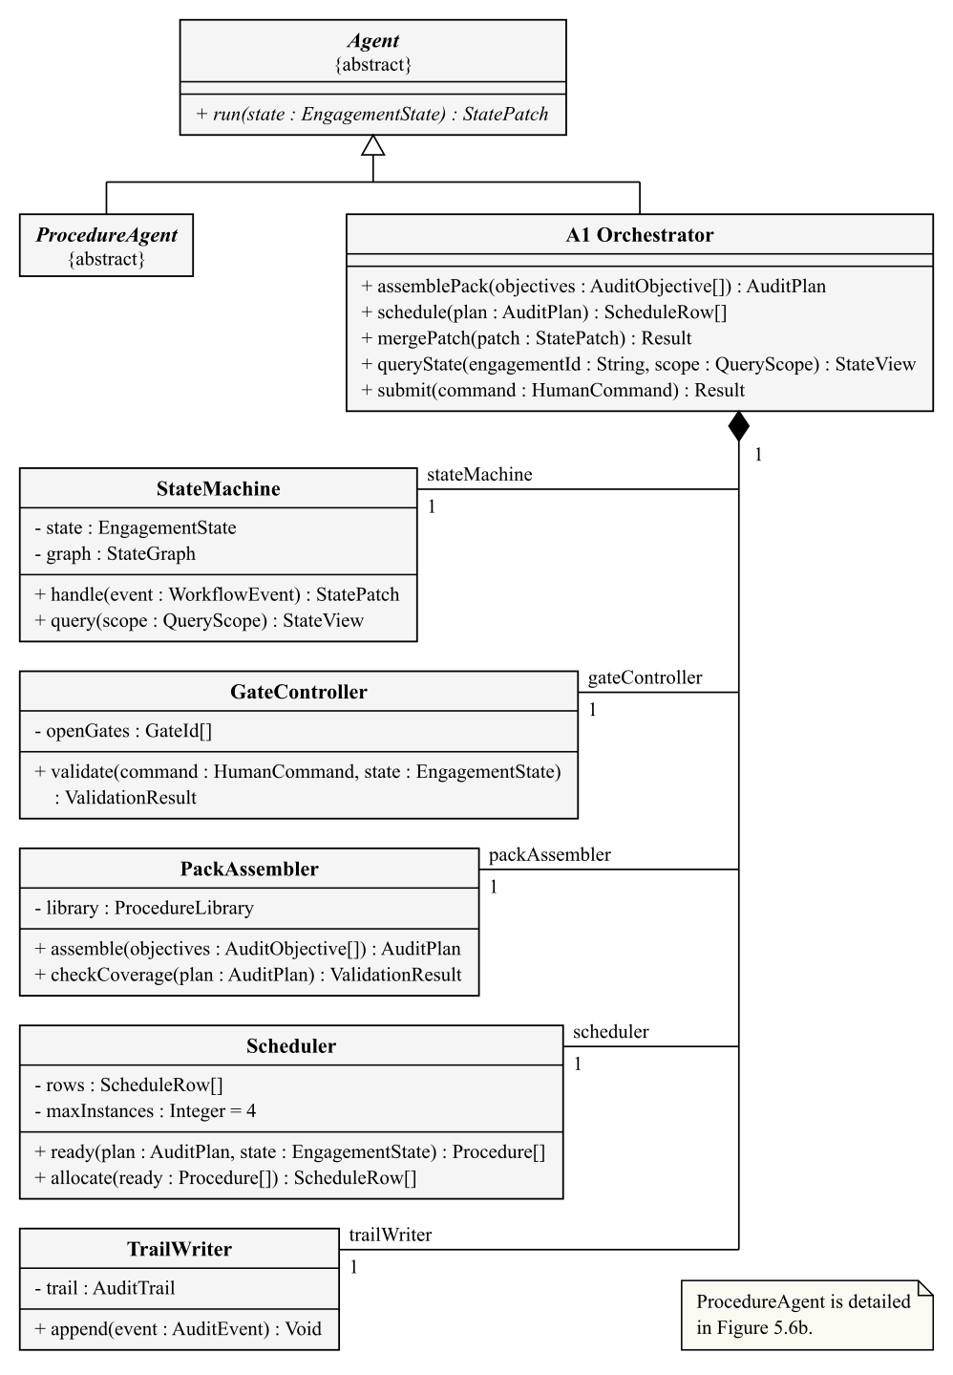
Figure 5.6b. ProcedureAgent specialisations and their operations
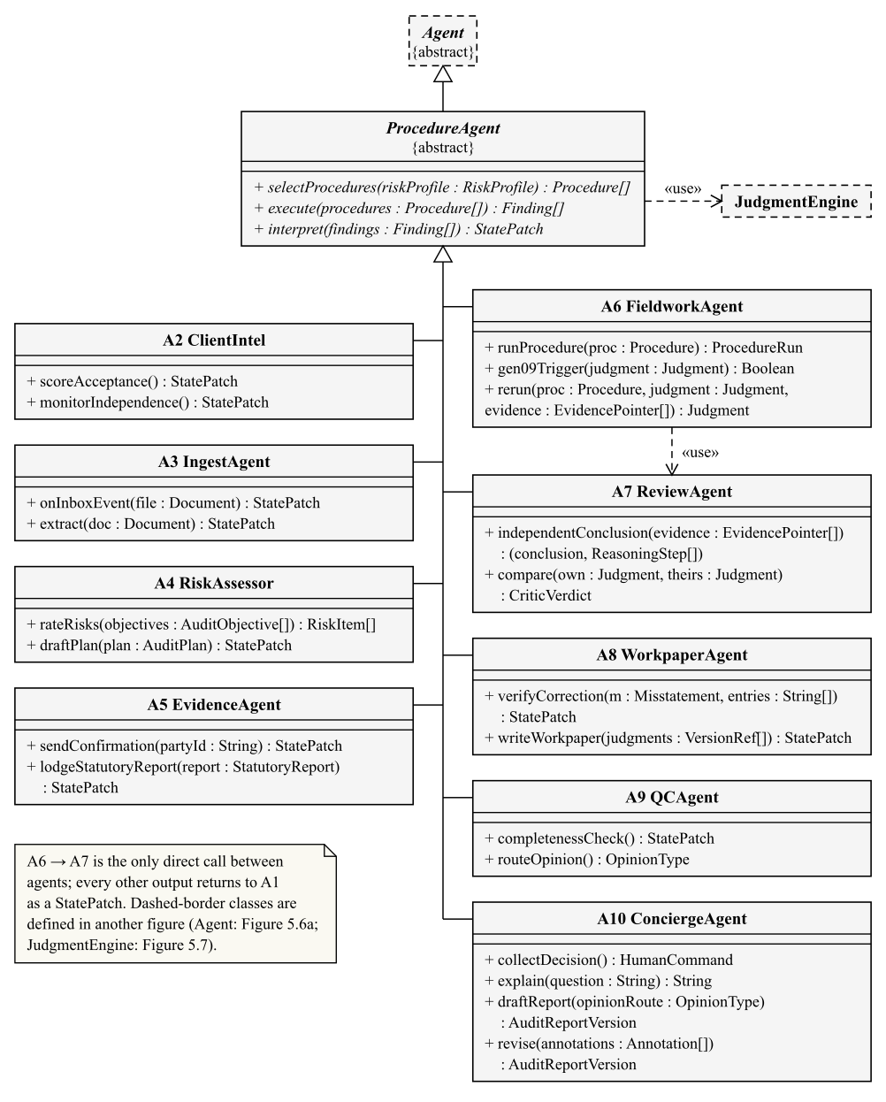
A1 inherits Agent directly and is composed of five parts; A2–A10 inherit ProcedureAgent, whose execute and interpret steps turn procedures into findings and findings into a state patch.
Figure 5.7. Support services and store contracts
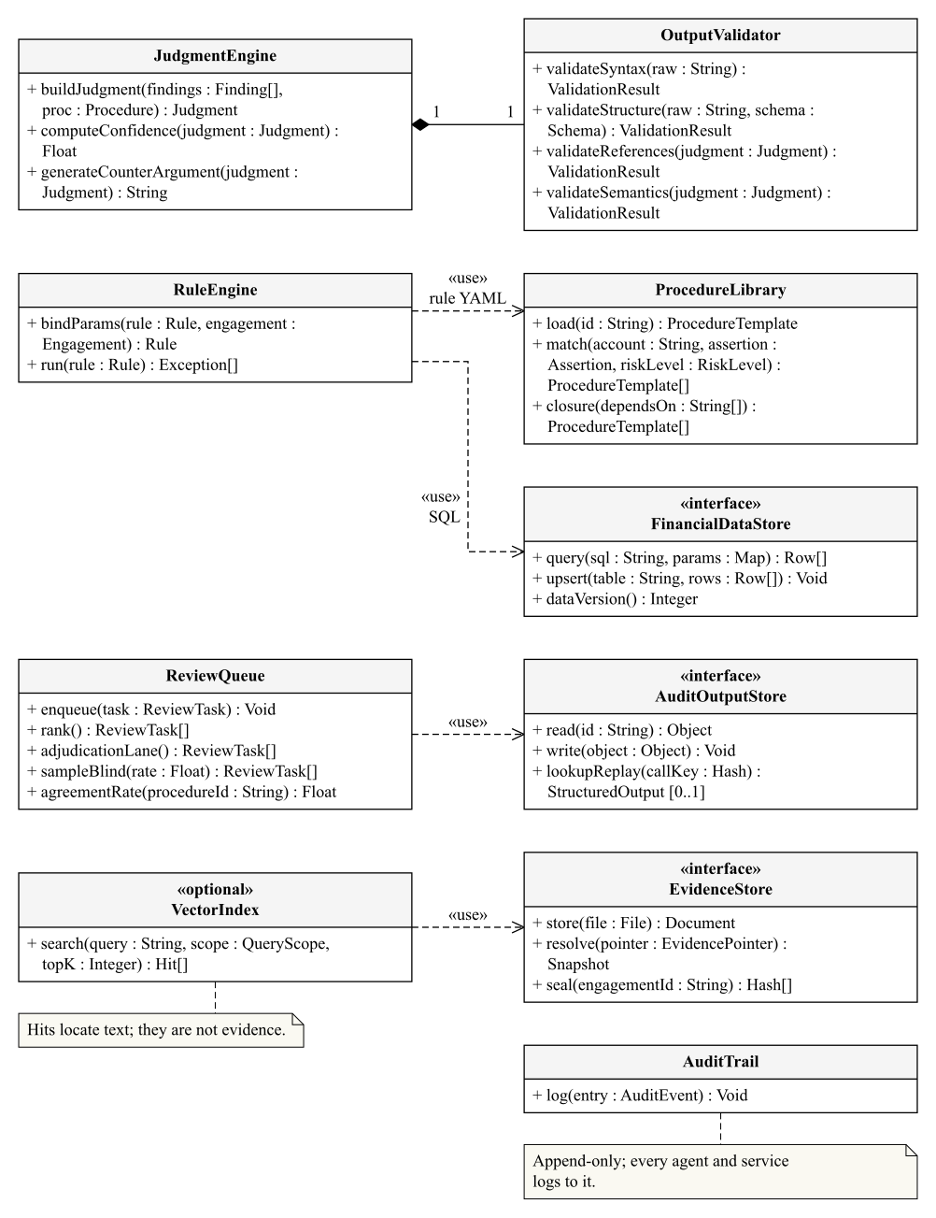
Figure 5.8. Provided and required interfaces with their realisations
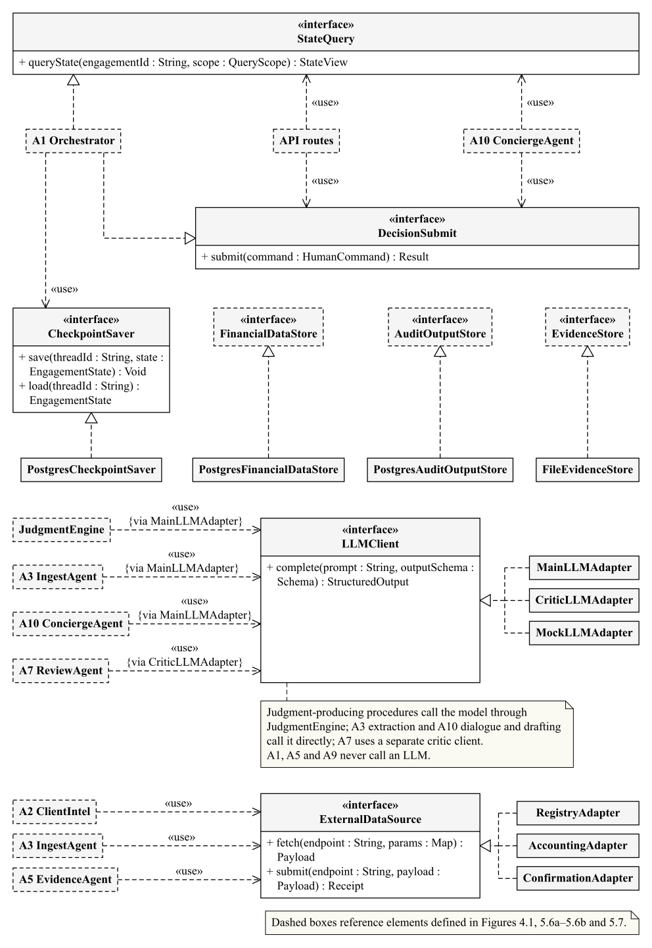

6. Complex structure modelling
The runtime models instantiate the classes of Section 5.

6.1 Orchestrator structured class
Figure 6.1. Orchestrator structured class: parts, ports and connectors
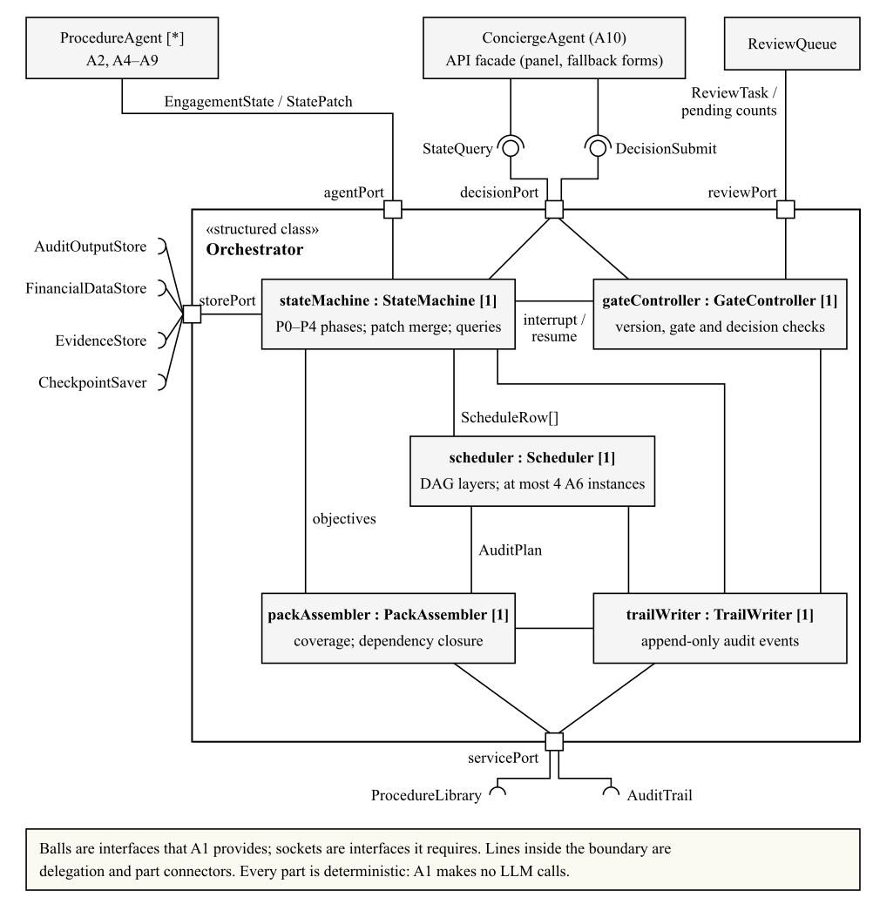
The parts of Figure 6.1 are typed by the five classes that Orchestrator composes in Figure 5.6a; decisionPort provides StateQuery and DecisionSubmit to A10 and the API.

6.2 Runtime object snapshot
Figure 6.2. Runtime object snapshot at a human-review boundary
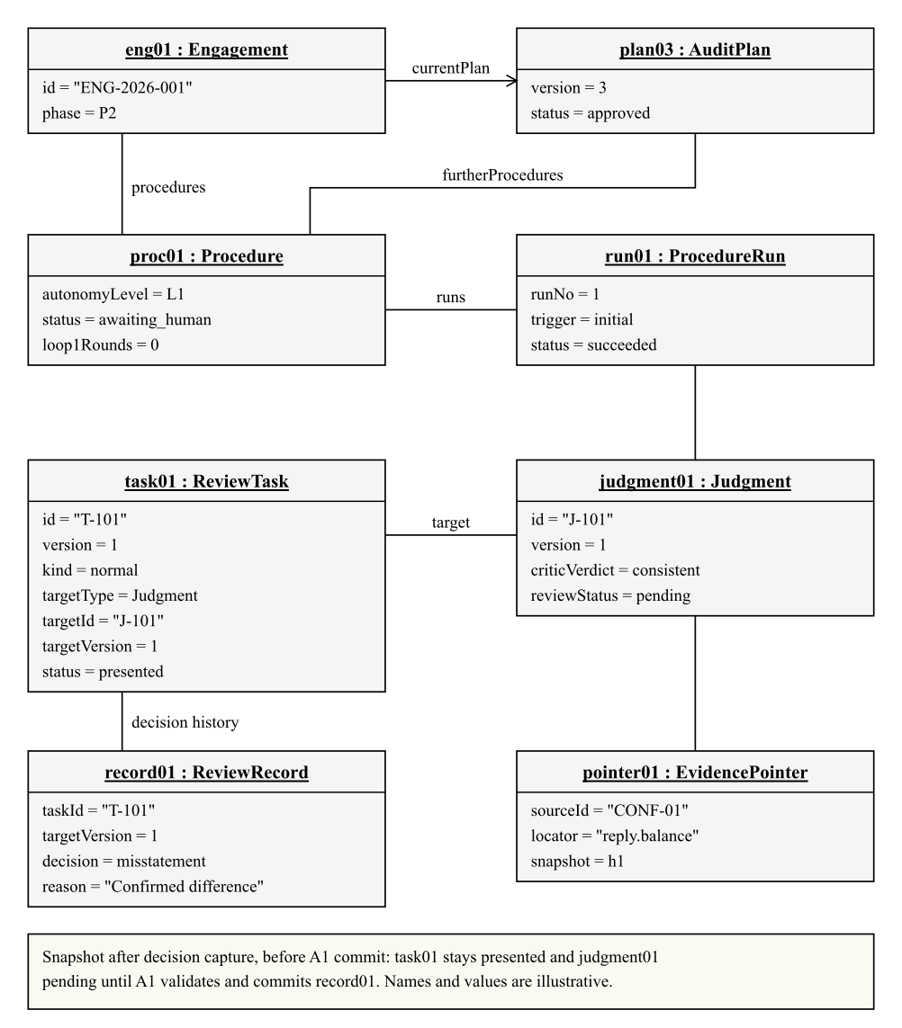
Slot values and links in Figure 6.2 instantiate the classes and associations of Figures 5.1–5.4; ReviewTask and ReviewRecord target the same judgment version.

6.3 Communication and collaboration
Figure 6.3. Communication diagram: one exception review (CSH-02)
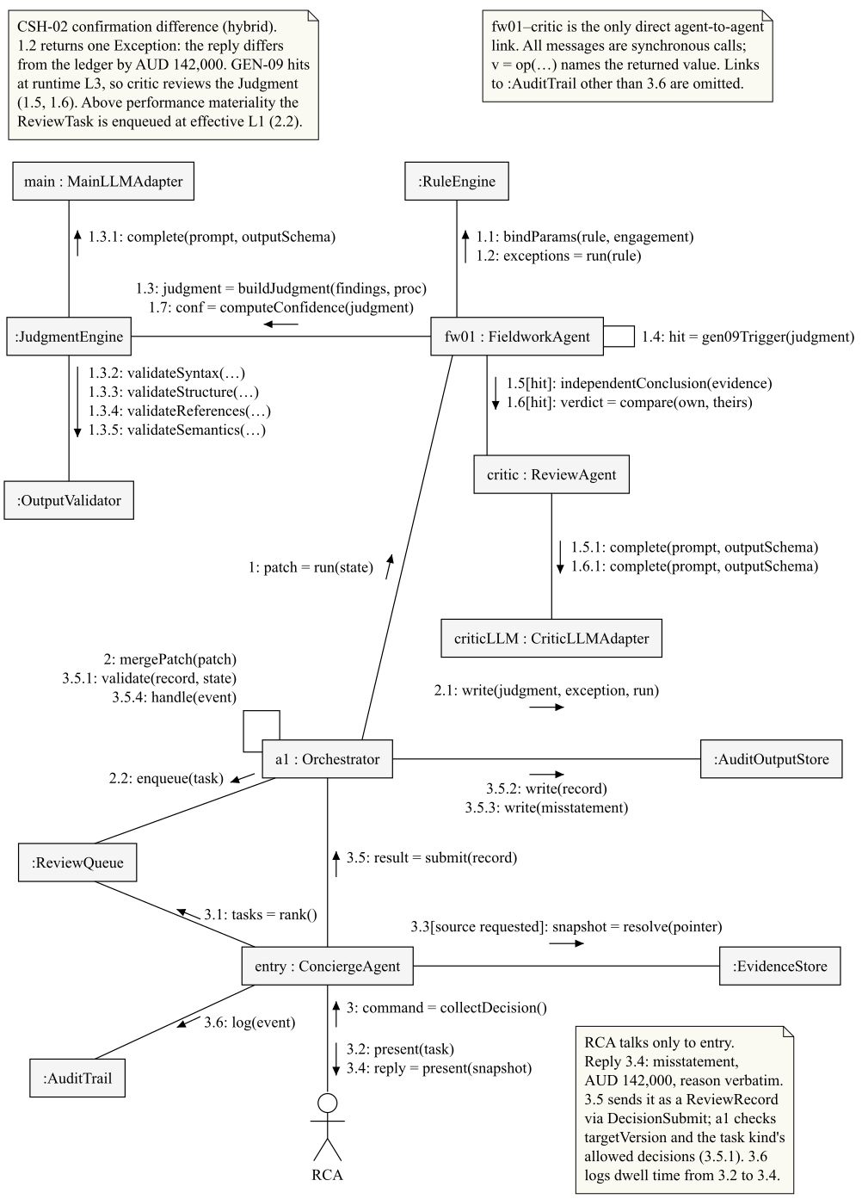
For CSH-02 (Figure 6.3), A6 runs the rule, builds a judgment through the LLM and obtains A7’s independent conclusion before returning its patch; because the amount exceeds performance materiality, the judgment is routed to L1, and A10 transfers the RCA’s decision, which A1 validates and commits.
Figure 6.4. IndependentReview collaboration and role bindings
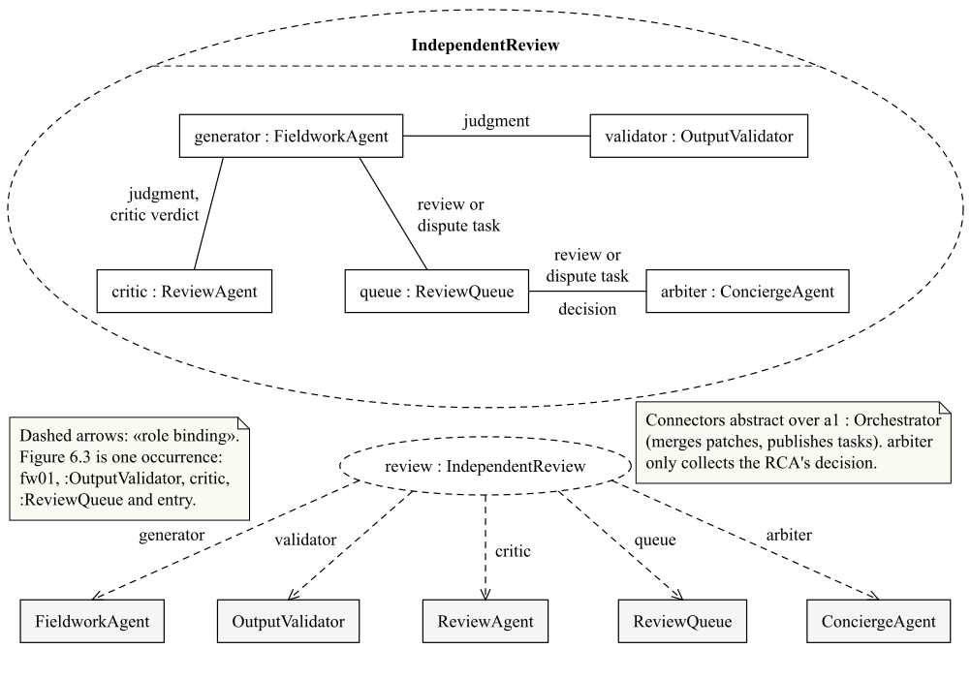
IndependentReview (Figure 6.4) names the roles that recur whenever a judgment needs a second opinion.

7. Behaviour modelling
Section 7.1 gives the group lifecycle; Sections 7.2–7.4 give each member’s models, based on that member’s ad hoc requirement and use cases (Table 8.3).

7.1 Engagement lifecycle
Figure 7.1 gives every phase transition; Table 7.1 expands the two exit conditions the figure abbreviates.
Table 7.1. P2 settlement and P4 signature conditions
Phase | Work and progression condition
P2 Execution | Dependency-layer fan-out, typed fan-in, review and confirmation events. The pack is settled only when its procedures and non-applicability tasks are disposed, disputes and confirmation dependencies are resolved, and no risk reassessment remains open.
P4 Reporting | Versioned draft and annotations; external EQR where required; signature prerequisites (ethics and independence confirmation, valid written representations and dates or a confirmed FIN-18 disclaimer, financial-statement reconciliation, the s307C independence declaration, governance communication, a complete ASA 402, 620 and 720 register, required EQR and no pending notification); then RPT-01. Refused or unreliable written representations permit only a disclaimer report (ASA 580). New conclusion-affecting evidence returns to P3.
Figure 7.1. Engagement lifecycle and controlled re-entry
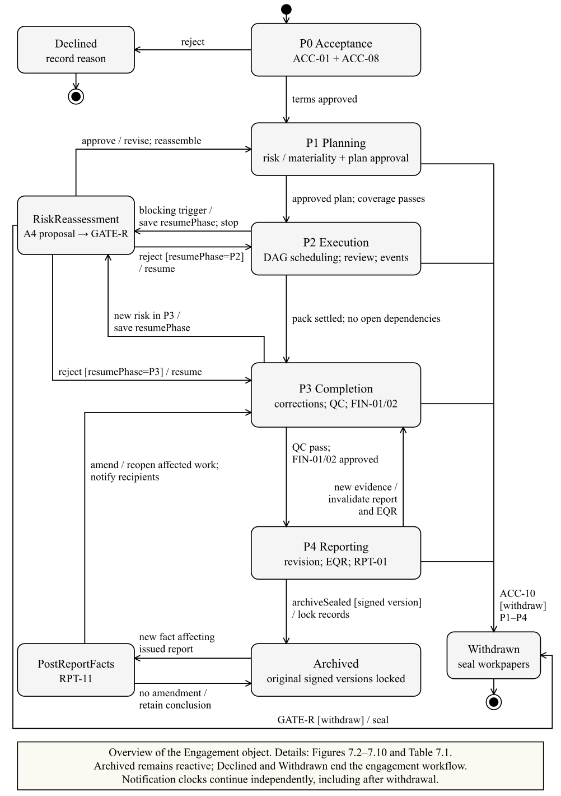

7.2 Activity diagrams

Chen Li — AH-A, UC-02
Figure 7.2. Plan approval activity — Chen Li / AH-A / UC-02
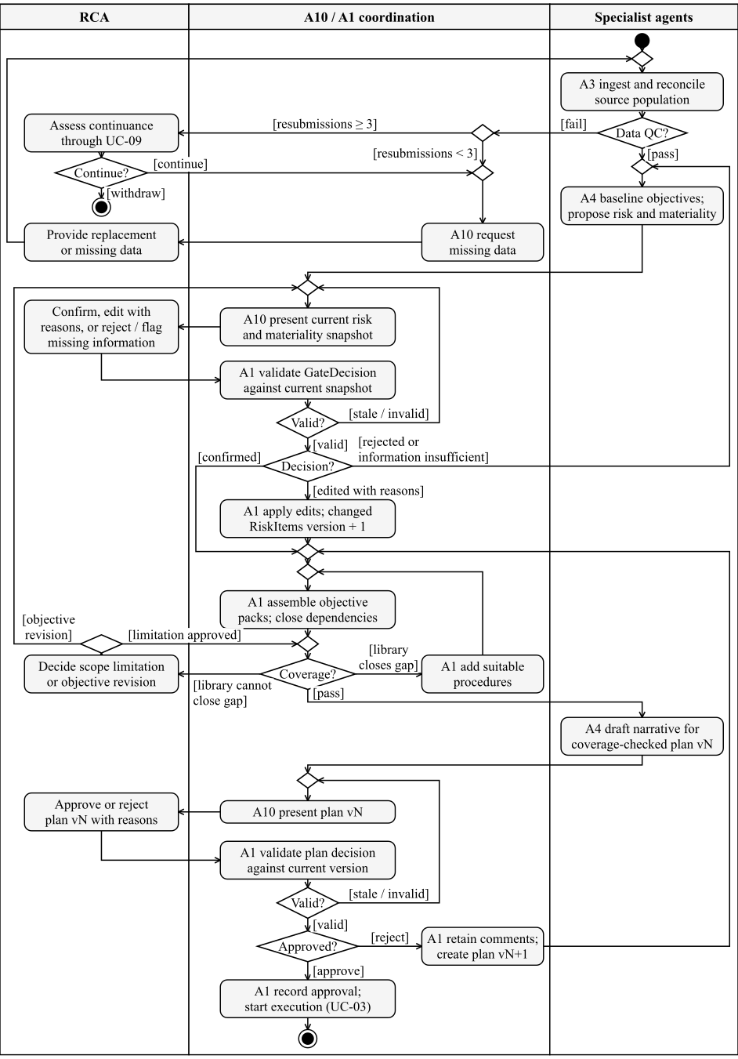

Yunpeng Tao — AH-B, UC-03 and UC-04
Figure 7.3. Procedure execution activity — Yunpeng Tao / AH-B / UC-03 and UC-04
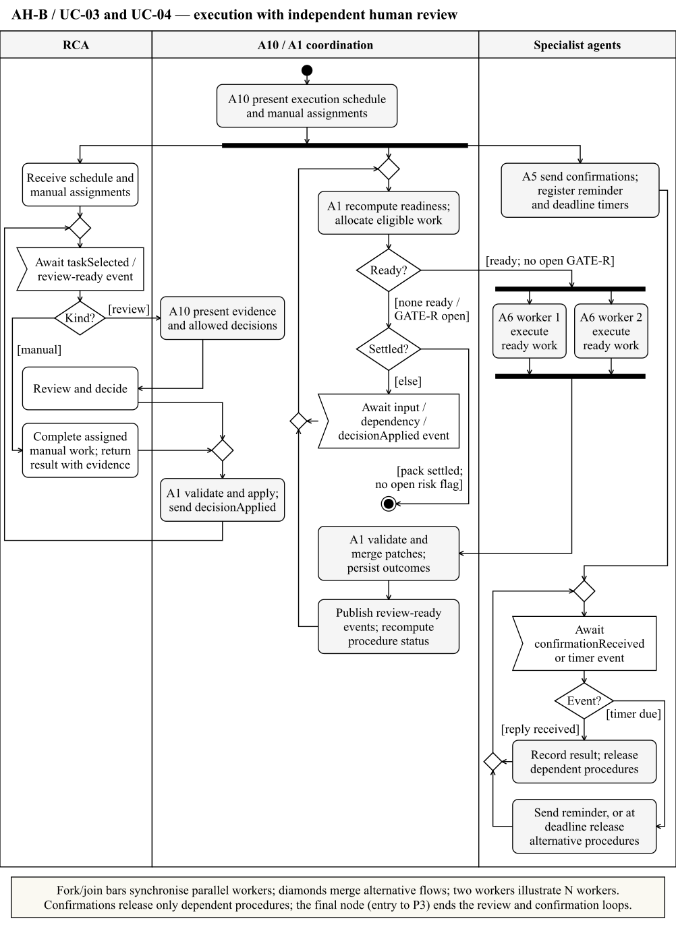

Yuanhao Wang — AH-C, UC-06
Figure 7.4a. Completion and report activity, part 1 — Yuanhao Wang / AH-C / UC-06
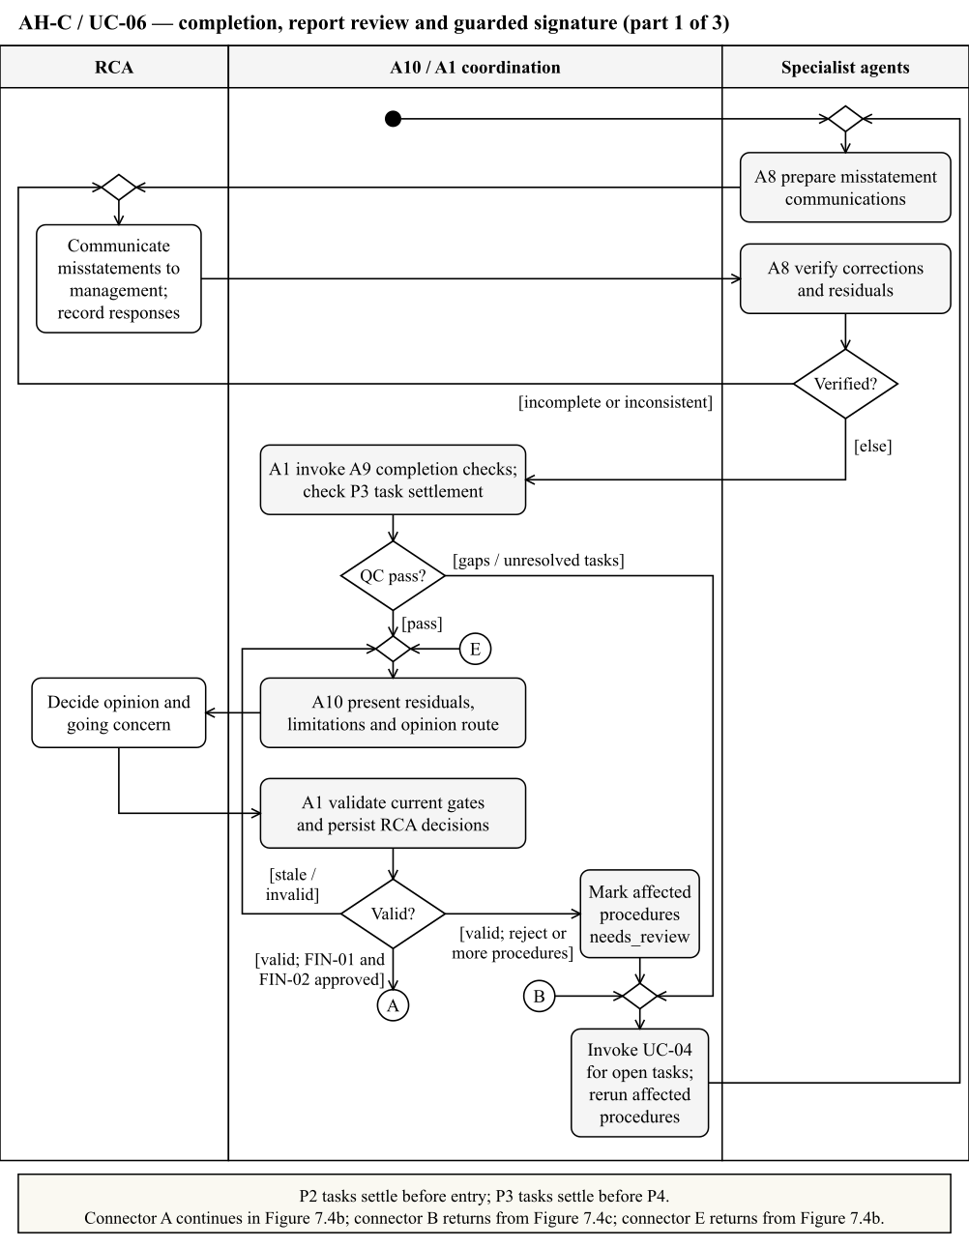
Figure 7.4b. Completion and report activity, part 2 — Yuanhao Wang / AH-C / UC-06
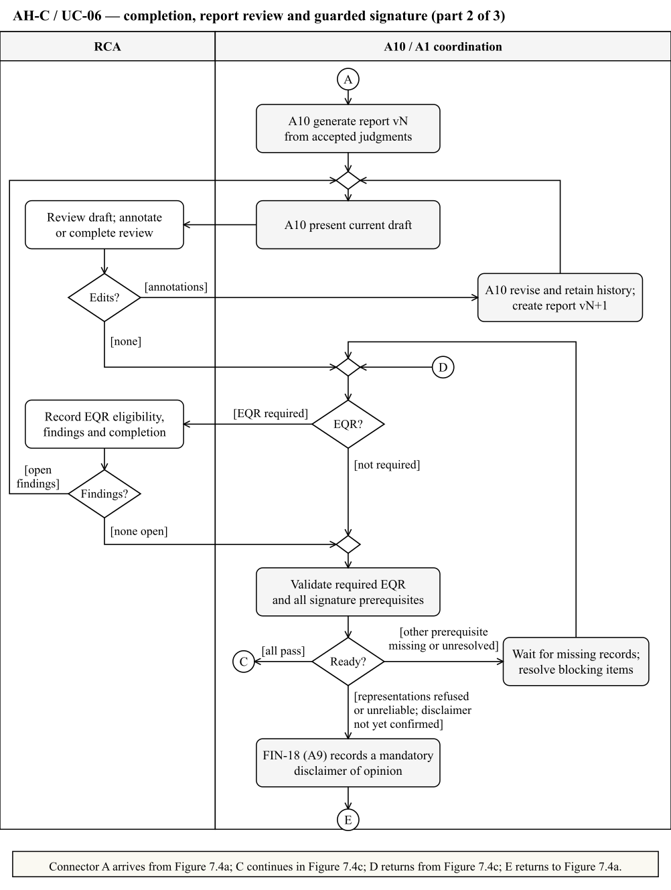
Figure 7.4c. Completion and report activity, part 3 — Yuanhao Wang / AH-C / UC-06
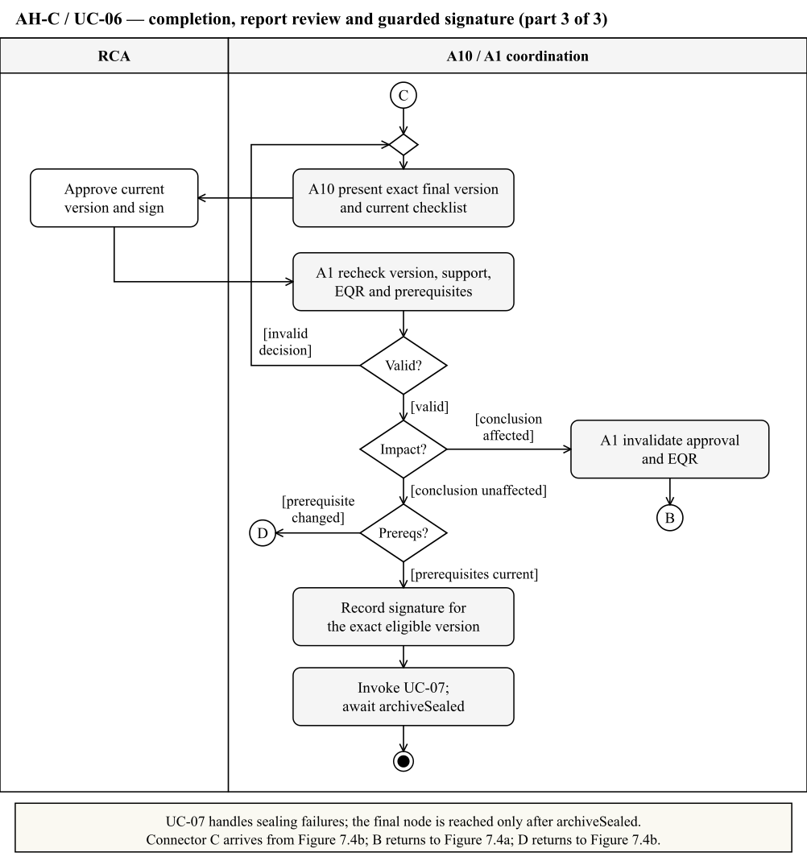

7.3 Interaction diagrams

Chen Li — AH-A, UC-02
Figure 7.5. Risk reasoning interaction — Chen Li / AH-A / UC-02
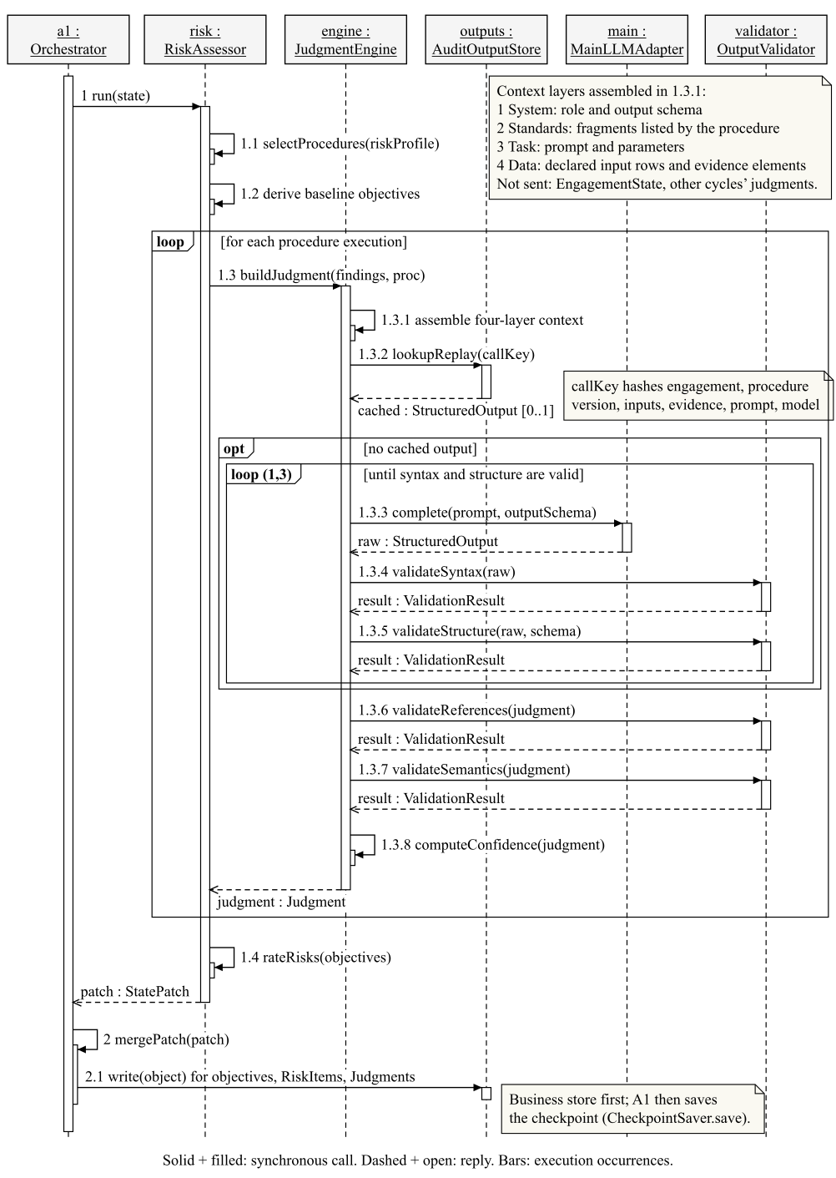

Yunpeng Tao — AH-B, UC-03 and UC-04
Figure 7.6a. Engine failure interaction — Yunpeng Tao / AH-B / UC-03 and UC-04
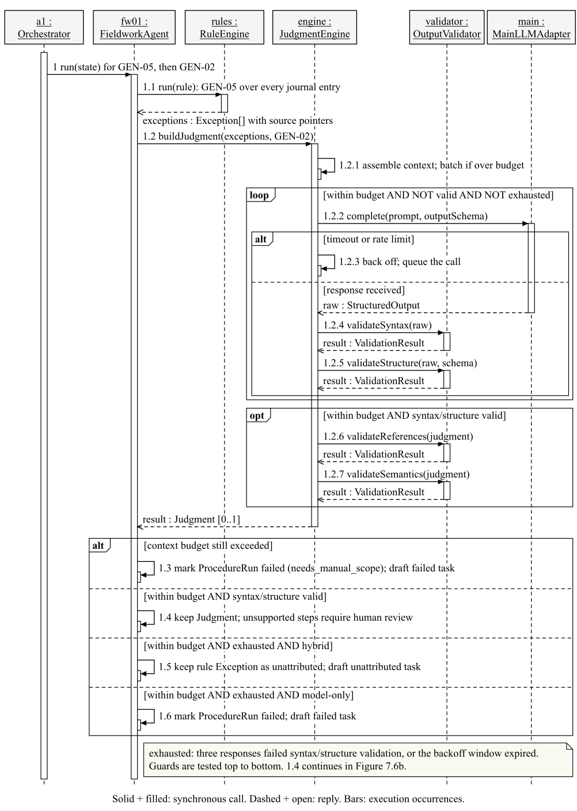
Figure 7.6b. Critic review interaction — Yunpeng Tao / AH-B / UC-03 and UC-04
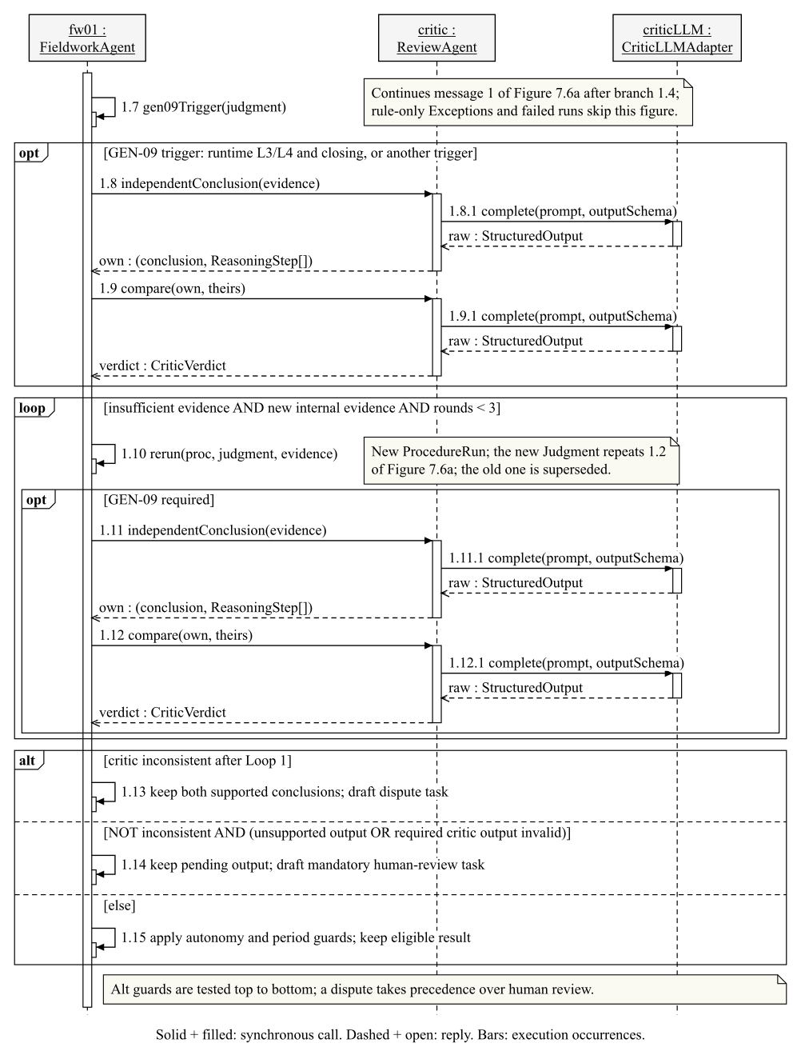

Yuanhao Wang — AH-C, UC-06
After GateController validates the RCA’s FIN-01 and FIN-02 decisions, A1 calls draftReport.
Figure 7.7. Report revision interaction: drafting and annotation — Yuanhao Wang / AH-C / UC-06
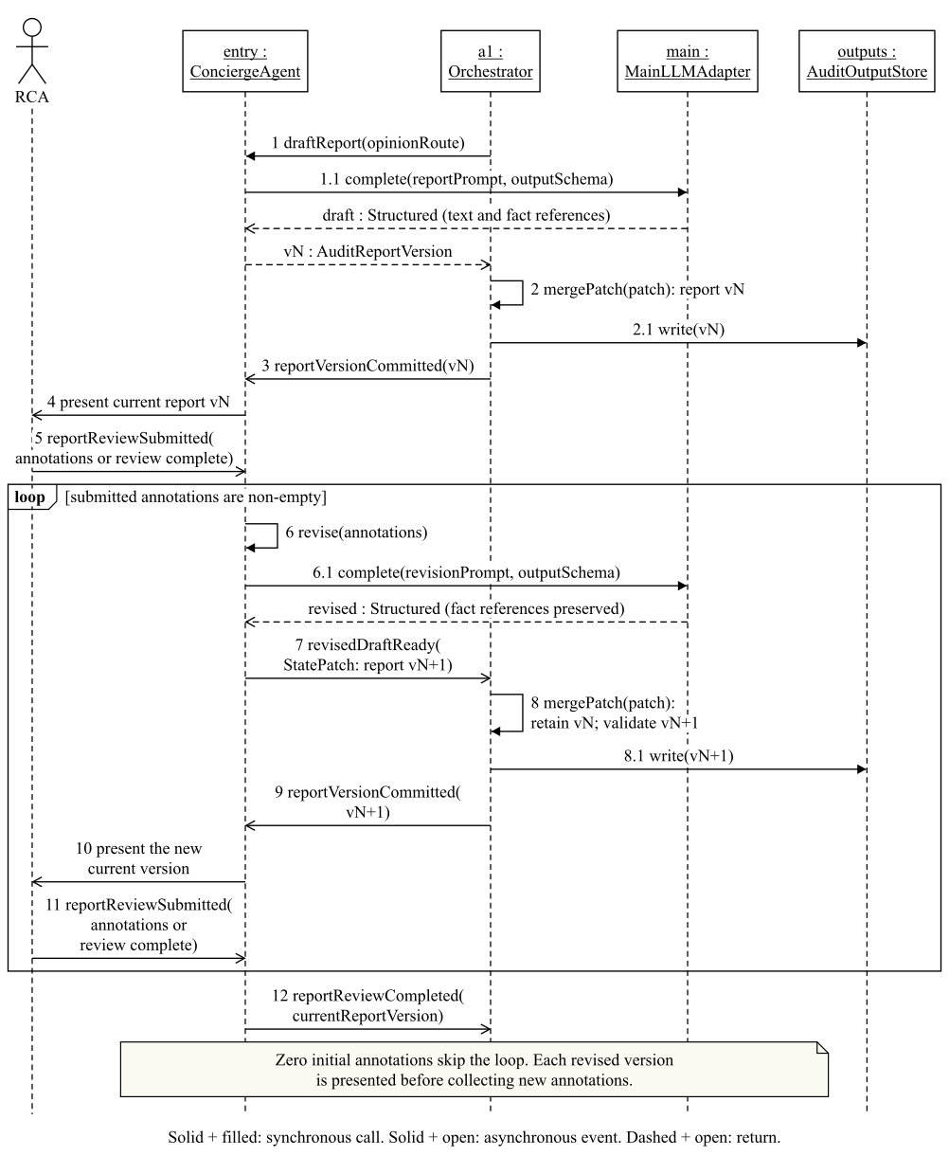

7.4 State machine diagrams

Chen Li — AH-A, UC-02 and UC-05
Figure 7.8. Planning lifecycle and AuditPlan versions — Chen Li / AH-A / UC-02 and UC-05
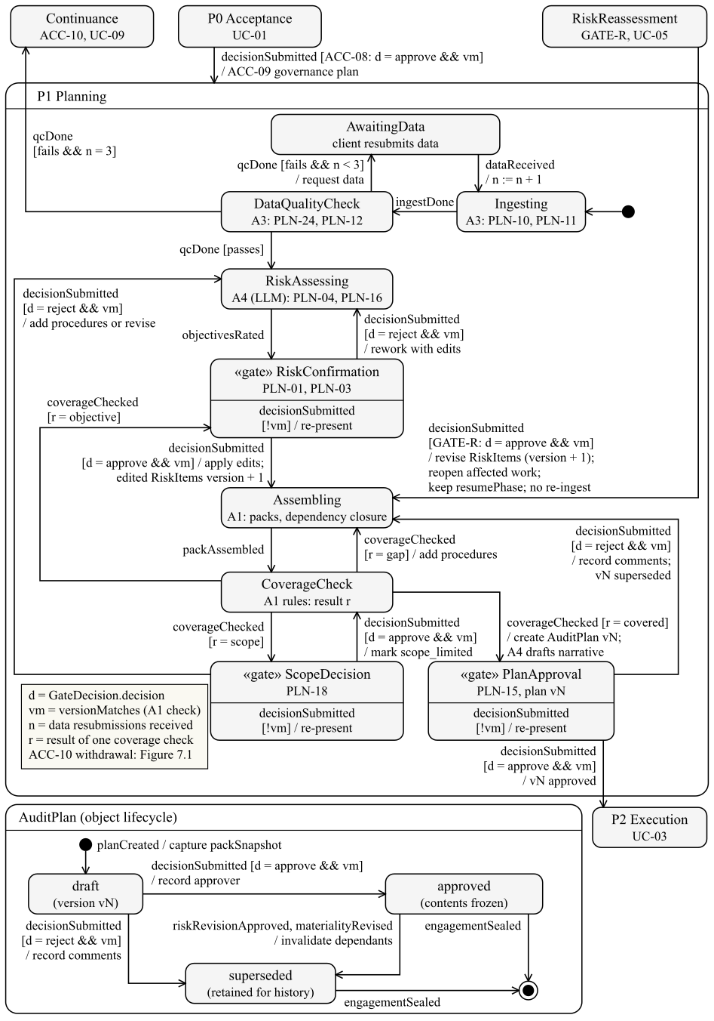
The state machine refines P1 of Figure 7.1 for UC-02 and UC-05. A4’s LLM risk reasoning is confirmed or reworked at the RiskConfirmation gate. The lower region shows the AuditPlan object: each version is created as a draft, frozen on approval and superseded, never overwritten.

Yunpeng Tao — AH-B, UC-03 and UC-04
Figure 7.9. Procedure lifecycle — Yunpeng Tao / AH-B / UC-03 and UC-04
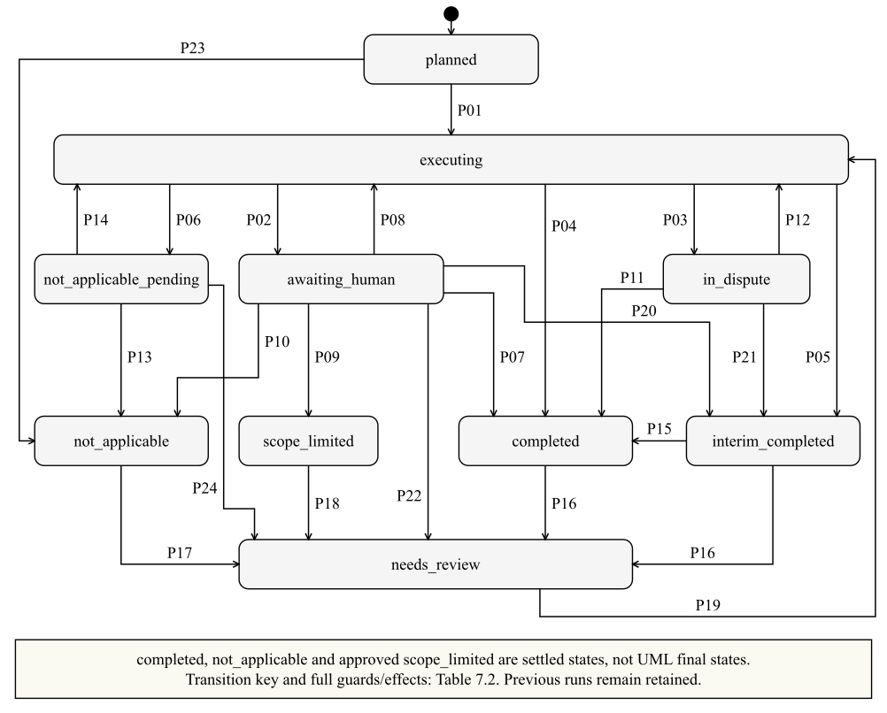
Table 7.2 defines the transition conditions. The reviewSettled guard means that all tasks are decided, no dispute or follow-up is open, and a current, valid, supported result exists. Human review and disputes take precedence over interim closure, and a year-end extension (GEN-24) can complete an interim procedure.
Table 7.2. Full transition semantics for Figure 7.9
Key | Source → target | Event [guard] / effect
P01 | planned → executing | scheduled [dependencies ready] / create a new ProcedureRun
P02 | executing → awaiting_human | resultReady [execution failed OR (human review required AND no unresolved dispute)]
P03 | executing → in_dispute | criticInconsistent [not resolved by Loop 1]
P04 | executing → completed | resultReady [autoCloseAllowed AND reviewSettled AND (NOT interim OR periodCovered)]
P05 | executing → interim_completed | resultReady [interim AND NOT periodCovered AND autoCloseAllowed AND reviewSettled]
P06 | executing → not_applicable_pending | ruleSuggestsNotApplicable / request confirmation
P07 | awaiting_human → completed | decisionSubmitted [reviewSettled AND (NOT interim OR periodCovered)]
P08 | awaiting_human → executing | decisionSubmitted [rerun OR more_procedures] / new run
P09 | awaiting_human → scope_limited | decisionSubmitted [scope_limited AND approval recorded]
P10 | awaiting_human → not_applicable | decisionSubmitted [not_applicable permitted by task kind]
P11 | in_dispute → completed | disputeResolved [reviewSettled AND (NOT interim OR periodCovered)]
P12 | in_dispute → executing | disputeResolved [neither + more_procedures] / new run
P13 | not_applicable_pending → not_applicable | decisionSubmitted [confirm rule non-applicability]
P14 | not_applicable_pending → executing | decisionSubmitted [rerun] / new run
P15 | interim_completed → completed | GEN24Completed [reviewSettled AND valid extension result] / set periodCovered
P16 | completed or interim_completed → needs_review | dependencyChanged OR additionalWorkRequested / invalidate affected result
P17 | not_applicable → needs_review | applicabilityChanged / reopen procedure
P18 | scope_limited → needs_review | newEvidenceReceived / reopen affected work
P19 | needs_review → executing | scheduled [new inputs and dependencies ready] / new run
P20 | awaiting_human → interim_completed | decisionSubmitted [interim AND reviewSettled AND NOT periodCovered]
P21 | in_dispute → interim_completed | disputeResolved [interim AND reviewSettled AND NOT periodCovered]
P22 | awaiting_human → needs_review | decisionSubmitted [evidence_unreliable] / mark dependent judgments stale; propagate invalidation
P23 | planned → not_applicable | decisionSubmitted [RCA judges not applicable] / record reason
P24 | not_applicable_pending → needs_review | applicabilityChanged / reopen procedure

Yuanhao Wang — AH-C, UC-06 and UC-07
Figure 7.10. Report version lifecycle — Yuanhao Wang / AH-C / UC-06 and UC-07
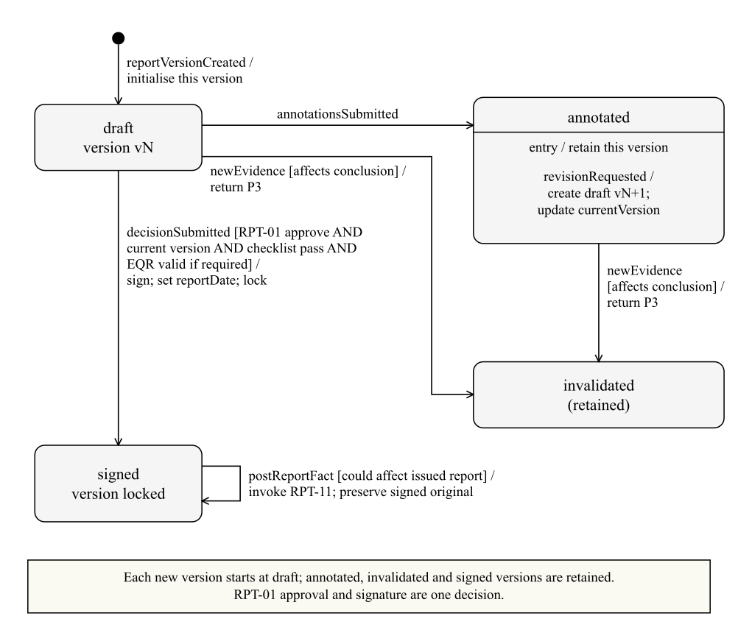

8. Traceability and contributions

8.1 Traceability and change assessment
Each mandatory requirement has a testable acceptance criterion, maintained with the design specification and used for Stage 2 acceptance. A change request is traced through Table 8.1 to the affected models, procedure configurations, prompts, schemas and acceptance criteria; its assessment records whether a mandatory requirement is affected and whether the change is accepted, rejected or deferred. Four signals raise a change request automatically: persistently high validation failure for a procedure, a high dispute rate, an abnormally high agreement rate between A7 and the generator, and confidence weights that blind-sample calibration shows need adjusting.
Table 8.1. Requirement traceability
Requirement · Feature | Components | Models
M-01 · F-JE | A6, RuleEngine | Figures 5.2, 7.3, 7.6a
M-02 · F-EVID | JudgmentEngine, EvidenceStore | Figures 5.3, 6.2, 6.3
M-03 · F-GATE | A1 GateController, A10 | Figures 5.4, 6.1, 7.1, 7.2, 7.8
M-04 · F-QC | A9, PackAssembler | Figures 7.2, 7.4a, 7.8
M-05 · F-CHAIN | JudgmentEngine | Figures 5.3, 7.5, 7.6a
M-06 · F-OVERRIDE | ReviewQueue, A10 | Figure 5.4
M-07 · F-TRAIL | AuditTrail | Figures 5.7, 6.3
M-08 · F-LOOP | A1, A4 | Figures 7.1, 7.8, 7.9
M-09 · F-ACC | A2 | Figures 3.1, 7.1
M-10 · F-APLAN | A1, A4 | Figures 5.1, 7.2, 7.8
M-11 · F-CONCIERGE | A10, StateQuery, DecisionSubmit | Figures 5.8, 6.1, 6.3
M-12 · F-STAT | A1, A5, A6 | Figure 5.5
M-13 · F-STAT | A9, A10 | Figures 5.5, 7.4c
M-14 · F-EXIT | A1, A2 | Figure 7.1
O-01 · F-MULTI | A1, ReviewQueue | Figures 2.2, 3.1
O-02 · F-EXT | A2, A5 | Figure 5.8
O-03 · F-MOBILE | Presentation tier | Figure 4.1
O-04 · F-I18N | A10 | Figures 5.6b, 7.7
O-05 · F-PROFILE | Tier 2 knowledge | Figure 4.1
O-06 · F-FEEDBACK | ReviewQueue, knowledge | Figure 5.7

8.2 Contributions
Every member took part in every group task (Table 8.2); Table 8.3 lists each member’s individual tasks.
Table 8.2. Group task contributions
Group task | Chen Li · 33.3% | Yunpeng Tao · 33.3% | Yuanhao Wang · 33.3%
Requirements and feature model (Figures 2.1–2.2) | Acceptance, planning, risk and profile features | Execution, evidence, review and interaction features | Completion, reporting, statutory and exit features
Use case overall diagram (Figure 3.1) | UC-01, UC-02, UC-05 | UC-03, UC-04, UC-08 | UC-06, UC-07, UC-09
Architecture and packages (Figure 4.1) | Orchestration, knowledge and plan interfaces | Execution, engines, output and queue contracts | Presentation, sign-off, archive and external-review boundary
Elementary structure (Figures 5.1–5.8) | Plans, objectives, risks and agent hierarchy | Templates, runs, judgments, evidence and services | Review and report, signature, statutory and document records
Complex structure (Figures 6.1–6.4) | A1 parts and ports; plan and state instances | Execution and review objects; numbered communication | Versioned decisions, review-record instances and store ports
Lifecycle and traceability (Figure 7.1; Table 8.1) | P0/P1 and UC-05; M-08–M-10 mapping | P2, recovery and human review; evidence and trail mapping | P3/P4, notifications and exit; signature mapping

Table 8.3. Individual tasks
Member | Ad hoc requirement | Use case specifications | Activity | Interaction | State machine
Chen Li | AH-A (§2.3) | UC-01, UC-02, UC-05 | Figure 7.2 | Figure 7.5 | Figure 7.8
Yunpeng Tao | AH-B (§2.3) | UC-03, UC-04 | Figure 7.3 | Figures 7.6a–7.6b | Figure 7.9
Yuanhao Wang | AH-C (§2.3) | UC-06, UC-07, UC-09 | Figures 7.4a–7.4c | Figure 7.7 | Figure 7.10

References
Accounting Professional and Ethical Standards Board. (2025). APES 110 Code of Ethics for Professional Accountants (including Independence Standards) (compiled July 2025).
Auditing and Assurance Standards Board. Australian Auditing Standards ASA 230, 315, 330, 402, 580, 600, 620 and 720, and ASQM 2 (compiled versions in force at September 2026).
Australian Securities and Investments Commission. (2024). Regulatory Guide 26: Resignation, removal and replacement of auditors.
Corporations Act 2001 (Cth), Compilation No. 148, 27 August 2026, ss 307C, 311, 324CA, 329 and 990K.
Privacy Act 1988 (Cth), Schedule 1, Australian Privacy Principle 8.

