LLM-Based Multi-Agent Audit Support System
ELEC5620 — Stage 1 Design Report

Member | SID | Contribution
Chen Li |  | 33.3%
Yunpeng Tao | 540998342 | 33.3%
Yuanhao Wang | 540356287 | 33.3%

Abstract and reading guide
This report designs an audit support system for a one-person practice operated by a Registered Company Auditor (RCA). Ten agents support acceptance, planning, fieldwork, completion and reporting. The library contains 161 procedures: 97 fixed or event-triggered and 64 risk-assembled. The RCA retains statutory decision and signature authority.
A deterministic workflow combines four human decision gates with four autonomy levels. Risk and evidence conditions can reduce autonomy. An independent critic reviews eligible judgments from evidence before comparing conclusions; three feedback loops support additional evidence, testing and approved risk revision.
Requirements are linked to use cases, structural and behavioural models, and acceptance criteria. Version-bound decisions and retained evidence support reconstruction.
AG/M/O identify agreements, mandatory requirements and optional extensions; AH identifies individual requirements; UC identifies use cases. A1–A10 identify agents and P0–P4 identify project phases. Numbered figures and tables link to their definitions.

Terminology
JE: journal entry; EQR: engagement quality review; NOCLAR: non-compliance with laws and regulations; ITGC: information technology general controls.

Contents
Abstract and reading guide 1
Contents 1
1. Introduction and scope 3
1.1 Business problem 3
1.2 Stakeholders and boundary 3
1.3 Assumptions and exclusions 3
2. Requirements specification 3
2.1 Optional and non-functional requirements 4
2.2 Feature decomposition and constraints 7
2.3 Individual informal requirements 8
3. Use cases and individual ownership 8
UC-01. Accept engagement 9
UC-02. Plan audit and assess risks 10
UC-03. Execute procedures and test journals 11
UC-04. Review exceptions and judgments 12
UC-05. Reassess audit risks 12
UC-06. Complete audit and approve report 13
UC-07. Archive and switch engagements 14
UC-08. Enquire about progress and evidence 15
UC-09. Handle notifications and withdrawal 15
4. Architecture and design rationale 16
4.1 Model of computation 17
4.2 Agent roles and execution boundaries 19
4.3 LLM enhancement 20
4.4 Design decisions and alternatives 20
5. Design-time and runtime structure 21
5.1 Relationship semantics 21
5.2 Cross-view invariants and persistence 29
6. Behaviour and lifecycle 34
6.1 Planning and risk assessment 37
6.2 Procedure execution and review 41
6.3 Completion and reporting 47
6.4 Autonomy, judgment and review controls 53
6.5 Feedback and failure routing 55
6.6 Version invalidation and opinion routing 55
7. Verification, validation and acceptance 56
7.1 Metrics 56
7.2 Requirement-to-model acceptance matrix 57
7.3 Boundary tests and change assessment 58
8. Development plan and contributions 59
8.1 Contribution record 59
8.2 Open validation items and production extensions 60

1. Introduction and scope

1.1 Business problem
A sole practitioner must collect evidence, assess risks, perform procedures and document conclusions while retaining responsibility for the engagement. The proposed One-Person AI Company assigns support work to specialised agents; the RCA approves reserved decisions, resolves disputes and signs the report.

1.2 Stakeholders and boundary
Table 1.1. Stakeholder responsibilities
Stakeholder | Interaction and responsibility
RCA | Primary operator; decides acceptance, risks, materiality, review outcomes, opinion, notifications and signature.
Client: management and governance | Supplies accounting records, documents and responses; receives communications; prepares corrections and representations.
External data source | Provides registry, accounting, banking and confirmation information through adapters; receives authorised submissions where supported.
External EQR reviewer | Performs review outside the system; findings and completion are recorded for the signature gate.

1.3 Assumptions and exclusions
The scope is an Australian SME statutory financial statement audit by a registered RCA. Listed entities, IPOs and consolidated group audits are excluded. Accounting access requires client authorisation and available source fields; demonstration data are synthetic.
The system supports human decisions and cannot issue an autonomous audit opinion or perform a fully automatic audit. Inventory observation, management interviews and substantive EQR work are performed externally; required records must be complete before progression. The prototype excludes human-readable workpaper export, write-once-read-many (WORM) storage and client-document semantic retrieval. Export, WORM retention, recovery and controlled archive amendments are production extensions; semantic retrieval remains optional.
Agreements define stakeholder premises and boundaries. Unresolved provider fields, submission forms and standards fragments are listed in Table 8.5.

2. Requirements specification
Sections 1–3 form the project requirements specification submitted as part of Stage 1.
Agreements define premises and responsibility boundaries (Table 2.1); mandatory requirements define required capabilities (Table 2.2); optional requirements define extensions (Table 2.3). Section 2.1 adds quality targets; Section 2.2 organises capabilities into features and constraints; Section 2.3 expresses individual user needs. These views lead to the use cases in Section 3 and their acceptance tests.
Table 2.1. Agreements
ID | Premise or boundary
AG-01 | Audit support; the RCA makes and owns statutory judgments.
AG-02 | Australian framework: ASA, Corporations Act and APES 110.
AG-03 | Registered RCA; independent external EQR before signature when required.
AG-04 | Authorised accounting API access; synthetic demonstration data.
AG-05 | SME entities within the stated statutory audit scope.
AG-06 | Human opinion and signature; physical procedures performed externally.
Table 2.2. Mandatory requirements
ID | Group | Required capability
M-01 | Execution and evidence | Scan the complete journal population; do not replace this scan with sampling.
M-02 | Execution and evidence | Every judgment adopted in an audit conclusion is traceable through valid evidence pointers to original evidence.
M-03 | Human judgment | Reserved decision points require explicit human confirmation before progression.
M-04 | Quality and audit trail | Block reporting if objective coverage is incomplete or a required procedure is unsettled.
M-05 | Execution and evidence | Present an inspectable reasoning record for every AI judgment.
M-06 | Human judgment | A human override requires the replacement conclusion and a recorded reason.
M-07 | Quality and audit trail | Log model calls, prompts, inputs, parameters, human actions, transitions, rules, external actions, failures and retries.
M-08 | Quality and audit trail | An approved risk revision reopens affected completed procedures.
M-09 | Statutory deadlines and prerequisites | Acceptance includes ASIC registration and ABN validity checks.
M-10 | Human judgment | Execution requires an approved audit plan; revisions retain versions and reasons.
M-11 | Human judgment | One human entry; transfer decisions verbatim; provide equivalent fallback forms.
M-12 | Statutory deadlines and prerequisites | Persist notification deadlines from awareness dates; escalate unresolved items and block signature.
M-13 | Statutory deadlines and prerequisites | Enforce independence, representations, reconciliation and all pre-signature prerequisites.
M-14 | Statutory deadlines and prerequisites | Permit human-authorised withdrawal at any phase and seal the engagement records.

2.1 Optional and non-functional requirements
Table 2.3. Optional requirements
ID | Capability
O-01 | Multiple concurrent engagements
O-02 | Additional external sources, including litigation and adverse media
O-03 | Mobile review interface
O-04 | Multilingual reports
O-05 | Cross-year client profile reuse
O-06 | Rule improvement proposals derived from human overrides
Table 2.4. Non-functional requirements and evaluation conditions
Quality | Design target and planned evidence
Performance | 100,000 journal entries scanned in <30 s; 3,000 in <3 s. A single LLM judgment target is <10 s. Record scale, hardware, concurrency and latency percentiles.
Traceability | 100% of adopted judgments resolve to original evidence. All generated outputs undergo reference checks; invalid outputs remain visible as failures.
Reconstruction | Recompute deterministic rules, assembly, scheduling and confidence. Replay cached LLM results using versioned inputs; temperature zero alone is insufficient.
Isolation and privacy | Server-side project authorisation; engagement-scoped data access; encrypted storage and access logging; minimum de-identified data sent to approved providers. External-call controls are defined below.
Availability | Interrupt and resume a single engagement without losing decisions or duplicating external actions. A10 failure switches to forms within 30 s.
Extensibility | Register a new procedure through configuration when existing engines and output contracts suffice; otherwise apply change assessment.
Archive integrity | Prototype: hashes and enforced read-only records. Production: retention, WORM, recovery and controlled amendments.
Review quality | Monitor blind agreement, review dwell time, overrides, critic disputes, costs and human effort; do not infer labour savings from procedure counts.
The privacy design addresses the Privacy Act 1988, including APP 8 for cross-border disclosure. External LLM calls send only procedure-declared fields and required document pages. Names, TFNs and bank accounts use placeholders whose mapping remains local. Providers require a data-processing agreement, no training use and an approved processing region. Uploaded documents and returned content are treated as untrusted data: embedded instructions cannot alter tools or permissions. Logs retain field lists and de-identification markers rather than raw outbound text.
Figure 2.1 classifies requirements; Figure 2.2 shows 26 primary features with planning, execution and review decomposed into child capabilities. F-VECTOR is an optional architectural extension, not a seventh optional user requirement. Table 2.5 expands the other parents and separates feature dependencies from runtime constraints.
Figure 2.1. Requirement classification and derivation
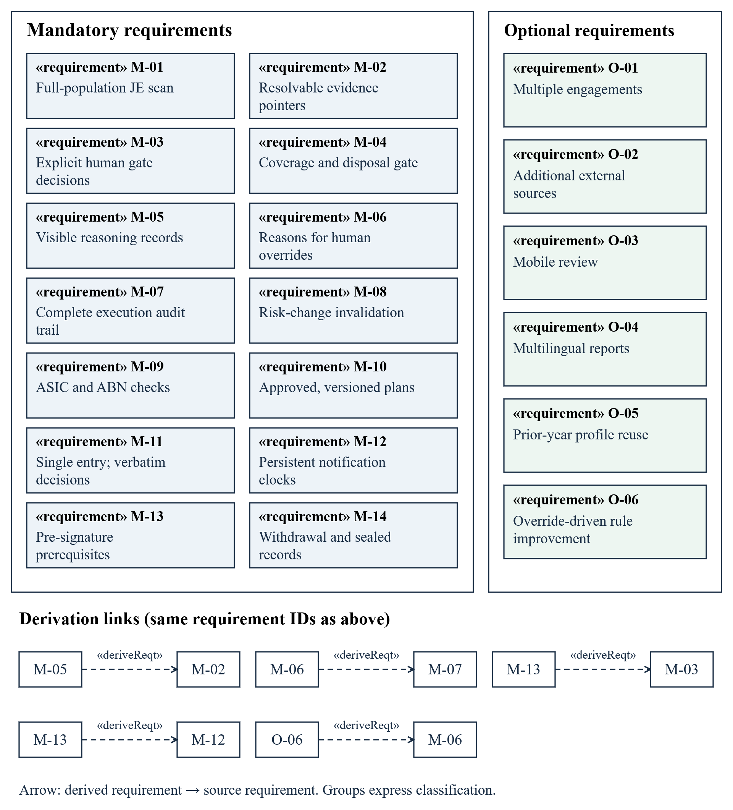
The dashed «deriveReqt» arrow points from the derived requirement to its source. Repeated IDs in the inset show these links without crossing the requirement groups.
Figure 2.2. Complete feature model
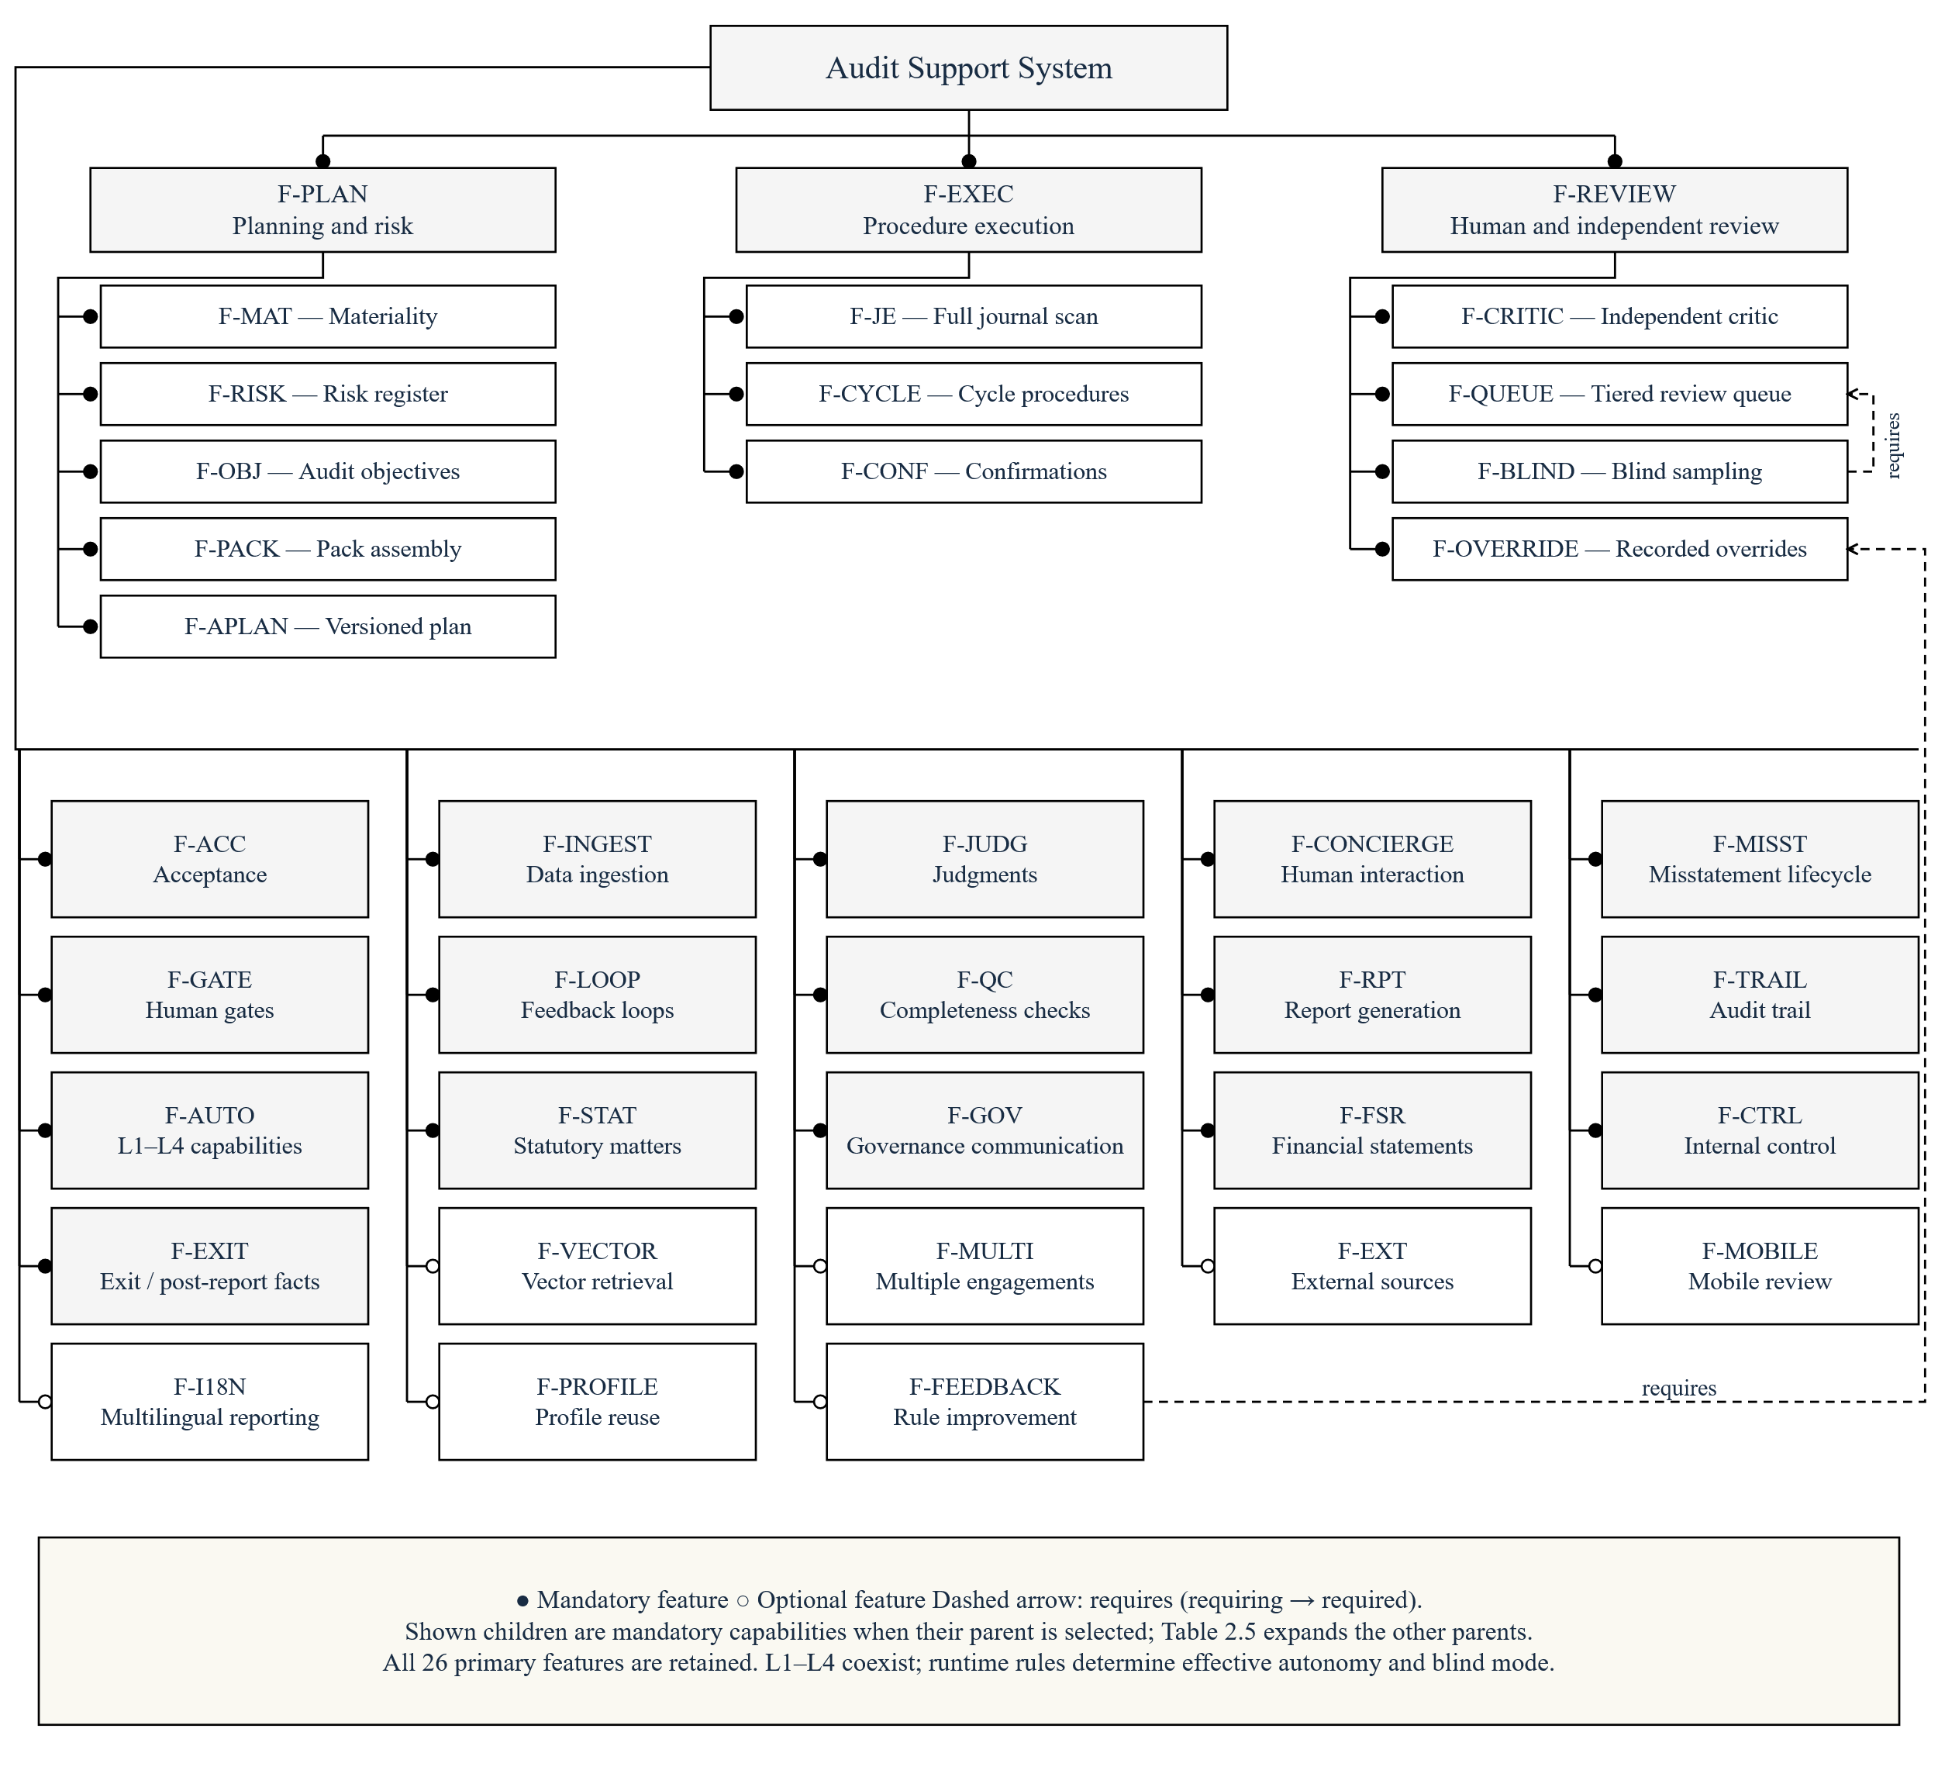
Filled circles mark mandatory branches; open circles mark optional branches. Shown child capabilities are mandatory when their parent is selected; dashed requires arrows point to the required feature. L1–L4 are available capabilities, with each procedure’s effective level determined at runtime.
Performance applies to data ingestion and full-population execution; traceability applies to judgments, evidence and audit trails; isolation and privacy apply to engagement access and external calls. Table 2.4 defines their evaluation conditions.

2.2 Feature decomposition and constraints
Table 2.5. Feature children and cross-feature constraints
Feature / correspondence in Figure 2.2 | Capabilities and constraints
Audit planning (F-PLAN) | Materiality; risk register; audit objectives; procedure-pack assembly; versioned audit plan.
Data ingestion (F-INGEST) | Accounting API feed; offline classification, OCR, extraction and linking.
Procedure execution (F-EXEC) | Full journal scan; transaction, balance and estimate procedures; confirmations.
Judgment records (F-JUDG) | Evidence pointers; reasoning records; counterarguments.
Review (F-REVIEW) | Independent critic; tiered review queue; blind sampling; human override records.
Human interaction (F-CONCIERGE) | Presentation and verbatim decision transfer; structured queue; enquiries; detail views; fallback forms.
Misstatements and reporting (F-MISST / F-RPT) | Misstatement communication and correction verification; annotation-driven report revision.
Statutory matters (F-STAT) | Non-compliance response and notification clocks; independence monitoring and declaration; statutory checks and sign-off.
Governance (F-GOV) | Governance identification; corroborated management enquiries; retained communications.
Financial statements (F-FSR) | Reconciliation; disclosure checks; going-concern evaluation.
Feature dependencies | Blind sampling requires the review queue. Rule-improvement proposals require human override records.
Runtime constraints | Reserved decisions remain L1. Accumulated downgrades reaching L1 enable blind mode; a human decision gate cannot run at L4.

2.3 Individual informal requirements
AH-A — Chen Li. I need acceptance checks and a complete risk-based plan, with explicit approval of risks, materiality and the exact plan version. New facts must produce an impact list and a revised plan while retaining previous assessments. Requirements: M-03, M-04, M-08–M-10.
AH-B — Yunpeng Tao. I need every journal entry tested and every exception linked to evidence and reasons. I must be able to inspect provenance, review failed or disputed work, and submit my decision and original reason through one reliable entry. Requirements: M-01, M-02, M-05–M-07, M-11.
AH-C — Yuanhao Wang. I need corrected and uncorrected matters evaluated, versioned report drafts for annotation, and signature blocked until all prerequisites and required EQR pass. Withdrawal must preserve reporting deadlines and sealed records. Requirements: M-03, M-04, M-12–M-14.

3. Use cases and individual ownership
These requirements lead to the nine stakeholder goals in Figure 3.1. UC-03 starts after plan approval; the RCA participates in manual work and supervision. Human decisions use the concierge interface or equivalent fallback forms. Table 3.1 links each member’s requirement, use cases and behaviour models.
Table 3.1. Individual requirement and model correspondence
Member / requirement | Use case specifications | Individual activity / interaction / state model
Chen Li / AH-A | UC-01, UC-02, UC-05 | Plan approval activity (Fig. 6.2); risk assessment interaction (Fig. 6.3a–6.3b); AuditPlan lifecycle (Fig. 6.4).
Yunpeng Tao / AH-B | UC-03, UC-04, UC-08 | Execution activity (Fig. 6.5); failure interaction (Fig. 6.6a–6.6b); Procedure lifecycle (Fig. 6.7).
Yuanhao Wang / AH-C | UC-06, UC-07, UC-09 | Completion activity (Fig. 6.8); reporting interaction (Fig. 6.9a–6.9b); report lifecycle (Fig. 6.10) and notification lifecycle (Fig. 6.11).
Table 3.2. Conditional use case extensions in Figure 3.1
Extension | Base / condition / extension point
UC-05 → UC-04 (a) | At result disposition: uncorrected misstatements exceed 70% of overall materiality, or a specified reassessment trigger occurs.
UC-09 → UC-02 (b) | At data-wait continuance assessment: retries exhausted and a withdrawal route is considered.
UC-09 → UC-04 (c) | At result disposition: NOCLAR or refused management-imposed scope relief.
UC-09 → UC-05 (d) | At the risk-reassessment gate (GATE-R): withdrawal is selected.
UC-09 → UC-06 (e) | At completion prerequisites: unreliable representations or an independence breach.
An «extend» arrow points to its base use case; Table 3.2 gives the conditions and extension points, and Figure 6.1 specifies phase progression.
Figure 3.1. System boundary, external actors and nine use cases
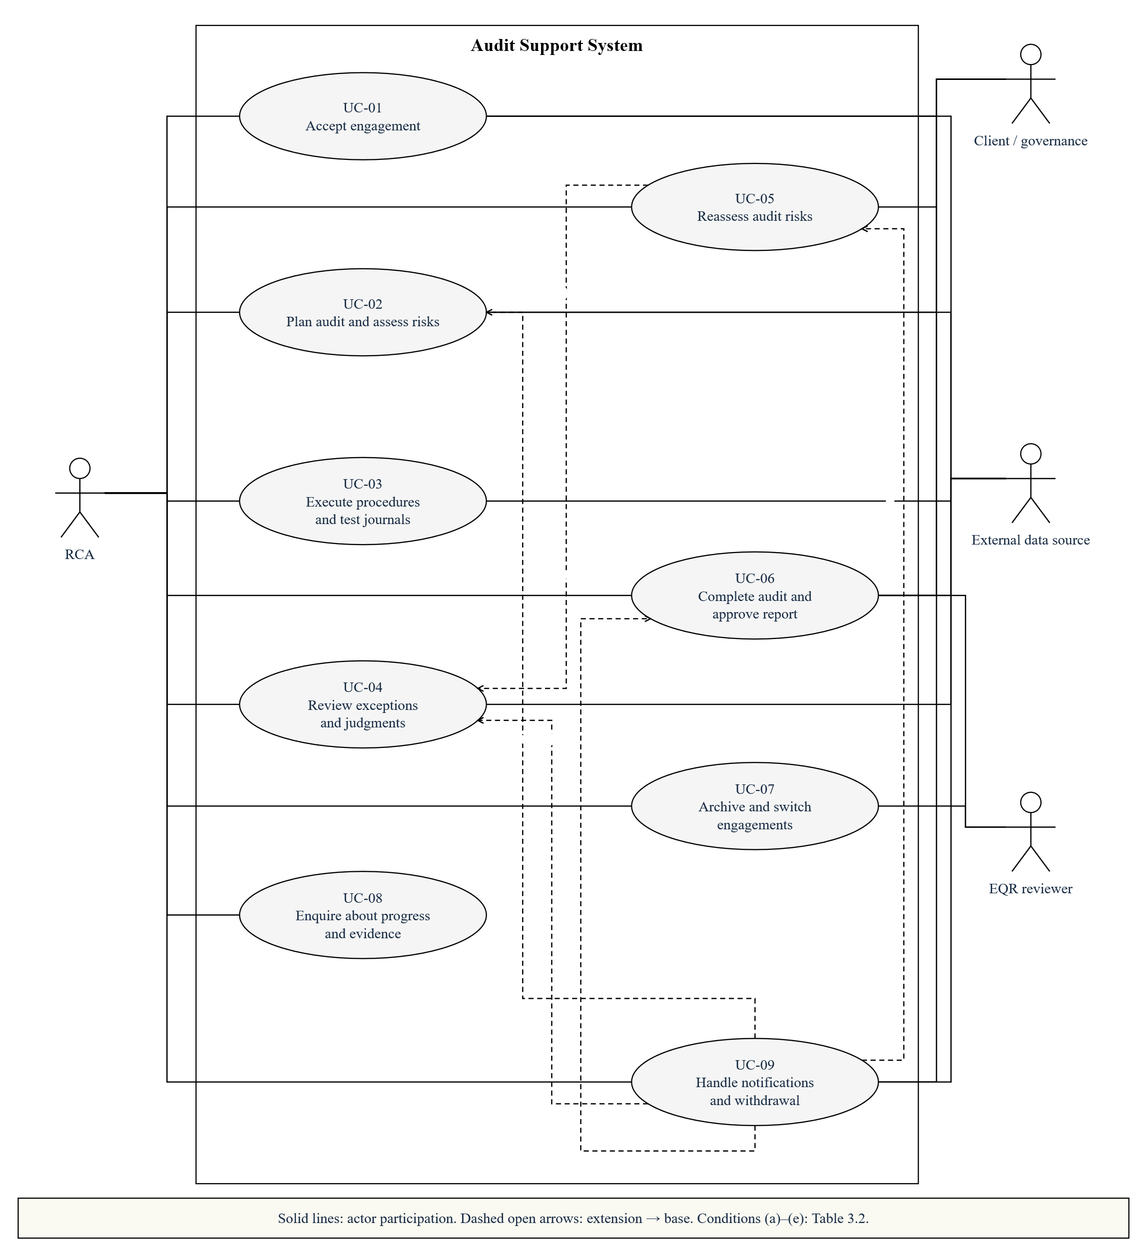
Actors are external to the system. Solid associations show participation; dashed extensions refer to Table 3.2. Internal agents are defined in Sections 4–6.

UC-01. Accept engagement
Responsible member: Chen Li. Primary actor: RCA. Supporting actors: Client management / governance; registry sources. Phase: P0. Related requirements: M-03, M-09; AG-01–AG-06.
Name | Goal | Level | Precondition | Success Condition | Failure Condition | Trigger
Accept engagement | Decide whether to accept an eligible client and establish the engagement. | User goal | The RCA is authenticated and the client is within scope. | Acceptance, terms and appointment are confirmed; planning may begin. | The engagement remains blocked or is declined with its reason. | The RCA creates an engagement and supplies client identifiers.

Main Success Scenario
- The RCA enters the client name and ABN and requests acceptance assessment.
- The system checks registration, ABN validity, background and independence, and presents the findings with evidence.
- The RCA reviews the findings and decides whether to accept the engagement.
- The system presents the engagement terms, responsibilities, access commitments and appointment evidence.
- The RCA confirms the terms and appointment prerequisites.
- The system records the decisions and governance recipients and opens planning.

Extension Scenarios
- 2.a {Predecessor communication is required} The RCA completes the communication or records permitted non-applicability; the assessment then resumes at step 2.
- 3.a {Information is insufficient} The system requests supplementary information and returns to step 2; acceptance remains unapproved.
- 3.b {The RCA rejects acceptance} The system records the reason and ends the use case with the engagement declined.
- 5.a {Terms, appointment or the presented version are invalid} The system blocks progression, presents current material and returns to step 4.

UC-02. Plan audit and assess risks
Responsible member: Chen Li. Primary actor: RCA. Supporting actors: Client; accounting and document sources. Phase: P1. Related requirements: M-03, M-04, M-10; O-05.
Name | Goal | Level | Precondition | Success Condition | Failure Condition | Trigger
Plan audit and assess risks | Approve a complete plan based on current risks and materiality. | User goal | Acceptance is approved and data access is authorised. | The current plan is approved and passes coverage checks; execution may begin. | Missing data, coverage gaps or absent approval keep execution blocked. | The RCA opens planning for the accepted engagement.

Main Success Scenario
- The RCA requests planning and supplies access to accounting records, statements and documents.
- The system reconciles the journal population, checks data quality, identifies material objectives and proposes risk ratings with reasons.
- The RCA reviews and confirms materiality, objectives and risks, recording reasons for any changes.
- The system assembles procedures and dependencies for every objective and checks substantive, significant-risk, remainder and year-end coverage.
- The system presents the resulting plan version and explanatory narrative.
- The RCA approves the displayed version; the system records approval and starts execution.

Extension Scenarios
- 2.a {Data reconciliation or quality checks fail} The system requests replacement or missing data and returns to step 2. After three unsuccessful resubmissions, the RCA assesses continuance through UC-09.
- 4.a {Coverage is incomplete} The system adds suitable procedures and repeats step 4; objective changes first return to step 3. A scope limitation needs an explicit RCA decision before rechecking.
- 6.a {The RCA rejects the plan} The system retains comments, revises the plan and returns to step 4 for coverage checks.
- 6.b {The submitted approval targets an outdated version} The system rejects it and returns to step 5 with the current version.

UC-03. Execute procedures and test journals
Responsible member: Yunpeng Tao. Primary actor: RCA. Supporting actors: Accounting and confirmation sources. Phase: P2. Related requirements: M-01, M-02, M-05, M-07.
Name | Goal | Level | Precondition | Success Condition | Failure Condition | Trigger
Execute procedures and test journals | Execute approved work and retain traceable results for review. | User goal | The current plan is approved; required inputs and dependencies are available. | Results are retained; eligible work is settled and outstanding review tasks are visible. | Failed, unsupported or disputed work remains unresolved and visible. | Approval recorded in UC-02 releases the current plan for execution.

Main Success Scenario
- The RCA receives the execution schedule and manual assignments for the approved plan.
- The system runs ready independent procedures in parallel and initiates required external confirmations.
- The system tests every supplied journal entry and retains exceptions linked to the original entries.
- The system explains selected exceptions using evidence, validates the results and obtains independent review where required.
- The RCA completes assigned manual work and returns the results with evidence; the system presents matters requiring human review through UC-04.
- The system retains outcomes and updates procedure status while continuing unrelated ready work.

Extension Scenarios
- 3.a {Required source fields are missing} The system marks the affected test unavailable and requests an alternate source or manual work; it cannot count the test as passed.
- 4.a {Output syntax or structure is invalid} The system retries at most twice. Exhaustion retains rule exceptions without attribution, or a failed model-only run, for UC-04.
- 4.b {Evidence is insufficient or the independent reviewer disagrees} Additional available internal evidence permits at most three shared retry rounds. Unresolved disagreement goes to human arbitration through UC-04.
- 6.a {A result cannot be safely merged} The system retries once, then retains a failed task for human action. Worker failure redistributes unfinished work and preserves completed results.

UC-04. Review exceptions and judgments
Responsible member: Yunpeng Tao. Primary actor: RCA. Supporting actors: External evidence sources. Phase: P2 and other phases with pending tasks. Related requirements: M-02, M-05–M-07, M-11; O-03, O-06.
Name | Goal | Level | Precondition | Success Condition | Failure Condition | Trigger
Review exceptions and judgments | Record a valid disposition of an exception, judgment or failed task. | User goal | The current task exists and the RCA is authorised for the engagement. | The decision and original reason are retained and applied to the current target. | Invalid or incomplete decisions leave the task unresolved. | The RCA selects a pending review task.

Main Success Scenario
- The RCA selects a task or an eligible batch from the review queue.
- The system presents the task type, allowed decisions, original evidence and, for ordinary review, the AI reasoning and critic result.
- The RCA selects a decision and supplies the required conclusion, reason or requested additional work.
- The system validates the task version and decision, records the original input and applies the outcome.
- The system recomputes outstanding work and period coverage, then displays the updated status and next available task.

Extension Scenarios
- 2.a {Blind review is required} The system presents only data and original evidence, withholding the AI conclusion, reasoning, counterargument and critic result. After the RCA records an independent judgment, it reveals the AI material for comparison.
- 2.b {The task is disputed} The system presents both supported conclusions and asks the RCA to uphold one or provide a human conclusion or additional work.
- 2.c {The conversation interface is unavailable} The system provides equivalent forms and resumes the same review steps and validation.
- 3.a {Required decision information is missing or the decision is not permitted} The system explains the missing fields and returns to step 3. Failed or unattributed work cannot be closed by acknowledgement alone.
- 4.a {The target has changed} The system rejects the stale decision and returns to step 2 with the current version.
- 4.b {Evidence is unreliable or more work is required} The system invalidates affected results or schedules requested work. A blocking risk trigger invokes UC-05.

UC-05. Reassess audit risks
Responsible member: Chen Li. Primary actor: RCA. Supporting actors: Client governance when communication is required. Phase: P2 or P3; approved revision returns to P1 assembly. Related requirements: M-03, M-08, M-10, M-14.
Name | Goal | Level | Precondition | Success Condition | Failure Condition | Trigger
Reassess audit risks | Approve or reject a risk revision without losing prior work. | User goal | An existing risk assessment and plan are identifiable. | An approved revision creates a new plan; rejection restores the suspended phase. | Unapproved revisions cannot replace risks or restart blocked work. | The RCA opens a blocking reassessment request or accepts an advisory proposal.

Main Success Scenario
- The system records the suspended phase and, for a blocking trigger, stops dispatch at safe points while retaining completed work.
- The system presents proposed risk changes, evidence, reasons and affected procedures.
- The RCA approves the proposed revision.
- The system versions the changed assessment and reopens affected completed work while preserving unrelated results.
- The system reassembles the plan without re-ingesting data and invokes UC-02 steps 4–6 for approval.
- The system executes the approved affected work and returns it to completion review when settled.

Extension Scenarios
- 1.a {The trigger is advisory} Work continues until the RCA chooses reassessment; the system then follows step 2.
- 3.a {The RCA rejects reassessment} The system records the reason, clears the flag and resumes the recorded phase, P2 or P3, without revising the assessment.
- 3.b {The RCA chooses withdrawal} UC-09 seals the engagement; statutory notification timers remain active.
- 4.a {The approved revision concerns fraud or another reportable matter} The RCA completes the required governance discussion and notification assessment; any reporting clock continues independently.

UC-06. Complete audit and approve report
Responsible member: Yuanhao Wang. Primary actor: RCA. Supporting actors: Client management / governance; accounting source; external EQR reviewer. Phase: P3–P4. Related requirements: M-03, M-04, M-12, M-13; O-04.
Name | Goal | Level | Precondition | Success Condition | Failure Condition | Trigger
Complete audit and approve report | Evaluate completed work and sign an eligible report version. | User goal | P2 procedures, including their non-applicability tasks, are settled; confirmation dependencies are resolved. | The RCA signs the eligible current report; UC-07 performs archiving. | Unsettled completion work or missing signature prerequisites blocks progression. | The RCA begins completion review when P2 work is settled.

Main Success Scenario
- The system presents misstatements; the RCA communicates them to management and records responses.
- The system ingests corrections, tests new entries, verifies residual amounts and repeats affected work.
- The system reassesses materiality and performs completion checks; the RCA resolves any new P3 review or non-applicability tasks.
- The RCA reviews residual amounts, scope limitations and going concern and decides the opinion and completion conclusions.
- The system records required communications and representations and drafts the report from current accepted judgments.
- The RCA annotates the report; the system retains each prior version and presents a new draft until review is complete.
- Where required, the external reviewer completes EQR and the RCA records eligibility, findings and completion.
- The system rechecks the current version and signature prerequisites. The RCA approves and signs it; the system invokes UC-07.

Extension Scenarios
- 2.a {Corrections are incomplete or inconsistent} The system retains residual amounts and returns affected matters to step 1; a refusal or stop-wait decision records them as uncorrected.
- 3.a {Completion checks create unresolved tasks or coverage gaps} The RCA resolves the tasks and the system repeats only affected work before returning to step 3. Pending P2 tasks must be resolved before this use case starts.
- 6.a {New evidence affects a conclusion} The system invalidates affected approval and EQR, returns to P3 checks and creates a new draft after the revised conclusions are accepted.
- 8.a {A prerequisite is missing, EQR remains unresolved or the version changed} The system blocks signing, displays the reason and returns to the relevant earlier step.

UC-07. Archive and switch engagements
Responsible member: Yuanhao Wang. Primary actor: RCA. Supporting actors: External EQR reviewer with authorised read-only access. Phase: P4–Archived. Related requirements: M-07, M-14; O-01, O-05.
Name | Goal | Level | Precondition | Success Condition | Failure Condition | Trigger
Archive and switch engagements | Seal signed records and allow authorised engagement switching. | User goal | A valid signed report and its supporting records exist. | Signed records are sealed and read only; an archive manifest is available. | Sealing failure leaves archiving incomplete; signed history remains preserved. | The RCA signs the report in UC-06.

Main Success Scenario
- The system hashes the signed report, supporting records and original evidence and records an archive manifest.
- The system applies read-only access and marks the engagement archived.
- The RCA views the manifest and authorised records.
- The system updates the permitted client profile summary; the RCA returns to the engagement list.

Extension Scenarios
- 1.a {Hashing or sealing fails} The system records the failure and retries safely; it does not claim that archiving succeeded.
- 2.a {A workpaper amendment is required} The production extension records the editor, reviewer, time and reason while preserving the signed original.
- 3.a {A new fact could have changed the issued report} The RCA assesses amendment and notifications. Required changes reopen affected work through UC-06 and create a replacement report; the original remains locked.
- 4.a {The RCA requests another engagement} With concurrent engagements enabled, the system checks authorisation and isolation before loading it; another project's rows, evidence and decisions remain inaccessible.

UC-08. Enquire about progress and evidence
Responsible member: Yunpeng Tao. Primary actor: RCA. Supporting actors: None. Phase: Any phase. Related requirements: M-02, M-05, M-07, M-11.
Name | Goal | Level | Precondition | Success Condition | Failure Condition | Trigger
Enquire about progress and evidence | Understand current progress and the evidence behind a result. | User goal | The RCA is authenticated and authorised for the selected engagement. | The RCA receives a scoped explanation and resolvable supporting links. | Unavailable or unauthorised information is identified without changing audit state. | The RCA asks about progress, a result or its evidence.

Main Success Scenario
- The RCA asks where work stands or where a result came from.
- The system retrieves the authorised current status and relevant judgment or evidence records.
- The system explains the result with supporting evidence, reasoning and independent-review information where applicable.
- The RCA opens original evidence or the audit trail and returns to the conversation.
- The system records the enquiry without treating it as an approval.

Extension Scenarios
- 2.a {A source is unavailable or a pointer cannot be resolved} The system identifies the gap and withholds unsupported claims; the RCA may request additional evidence.
- 3.a {The conversation interface is unavailable} The RCA uses the dashboard and equivalent forms to access the same authorised records.
- 5.a {The RCA wishes to make a decision} The system opens the relevant use case and requires an explicit decision for the presented version; an informal acknowledgement is insufficient.

UC-09. Handle notifications and withdrawal
Responsible member: Yuanhao Wang. Primary actor: RCA. Supporting actors: Client management / governance; authorised submission source. Phase: Any phase; notification timers outlive the engagement workflow. Related requirements: M-03, M-12–M-14.
Name | Goal | Level | Precondition | Success Condition | Failure Condition | Trigger
Handle notifications and withdrawal | Dispose of reporting obligations and any decision to withdraw. | User goal | The relevant facts and awareness date can be retained. | Notification is resolved, or authorised withdrawal seals records and preserves outstanding timers. | Unresolved notifications remain pending, escalate and block signature. | The RCA opens a reporting or continuance assessment, or requests withdrawal.

Main Success Scenario
- The system records the facts, awareness date, discussions and affected audit matters.
- The system presents the applicable reporting assessment and its fixed deadline.
- The RCA authorises lodgement and records the reason.
- The system uses the authorised route and retains the form, recipients and valid receipt.
- The RCA reviews any continuance concerns and decides to continue the engagement.
- The system records the reporting disposition and continuance decision and returns to the active phase.
Notification and withdrawal are separate outcomes. Lodgement does not imply withdrawal; an authorised exit follows extension 5.a and preserves outstanding reporting clocks. For resignation, the system records the entity-specific route under Corporations Act s329 and ASIC RG 26, including whether ASIC consent is required and its status.

Extension Scenarios
- 1.a {Only withdrawal is requested} The system retains the withdrawal grounds and proceeds to step 5; existing notification clocks continue.
- 3.a {The RCA decides that notification is not required} The system records the RCA and reason and closes that reporting matter. It proceeds to step 5 for continuance concerns, otherwise the use case ends.
- 3.b {The decision is incomplete or outdated} The system rejects it and returns to step 2; the reporting matter remains pending.
- 4.a {Submission fails or no valid receipt arrives} The matter remains pending, escalates and blocks signature. A separate withdrawal assessment may continue at step 5.
- 5.a {The RCA decides to withdraw} The system records the RCA, time and reason and distinguishes withdrawal from formal resignation. It records and completes the required exit steps before sealing workpapers. Pending notification timers remain active; the engagement workflow ends.
- 5.b {Management refuses scope relief} The RCA's prior request and management response must be retained before the exit decision.
- 5.c {The RCA decides to modify the opinion while continuing} The system records the decision and invokes UC-06 for the opinion and report change; any reporting matter continues independently.

4. Architecture and design rationale
These use cases require deterministic coordination around bounded LLM judgments. A1 controls state, assembly, scheduling and decisions; specialist agents return typed state patches. Shared services execute rules, validate outputs and manage queues and evidence. Figures 4.1–4.2 show the tiers and dependencies.
Table 4.1. Selected model viewpoints
Viewpoint / question | Model and design decision
Requirements: what must be supported? | Requirements, feature tree and traceability identify mandatory, optional and agreed boundaries.
Scenario: what does the stakeholder achieve? | Nine use cases with explicit normal, failure and human-authority paths.
Logical / design time: what types collaborate? | Domain, agent, service and interface class views in Section 5.
Runtime structure: what is instantiated? | Object snapshot, A1 parts and ports, and review collaboration.
Process / behaviour: what happens over time? | Phase lifecycle, individual activities, interactions and object states in Section 6.
Development: where are module boundaries? | Five tiers, shared contracts, persistence implementations and external adapters.

4.1 Model of computation
An event-driven state machine persists human interruptions. In P2, ready procedures run in dependency layers: independent fieldwork groups fan out, then return patches at fan-in. A6's configurable instance limit defaults to four. Grouping is deterministic; the same pack, dependencies and limit produce the same schedule. Confirmation replies and uploads arrive asynchronously; only dependent work waits for them.
A1 coordinates agents through shared versioned state. A6’s independent-review call to A7 is the sole direct agent-to-agent exception. StateQuery and DecisionSubmit carry human interactions; A1 validates the current target version before writing business state.
FastAPI exposes authenticated enquiry, upload and decision endpoints. The LangGraph main StateGraph coordinates P0–P4, with static human interruptions mapped to interrupt_before and parallel fieldwork mapped to Send. Ingestion (A3) and the concierge (A10) use independent graphs so uploads and enquiries can proceed while the main workflow waits. They submit events or commands through the same authorised contracts; the concierge cannot bypass a decision gate. Checkpoints retain resumable workflow state; the separate audit trail retains business history.
Figure 4.1. Overall software design: five-tier architecture and cross-cutting services
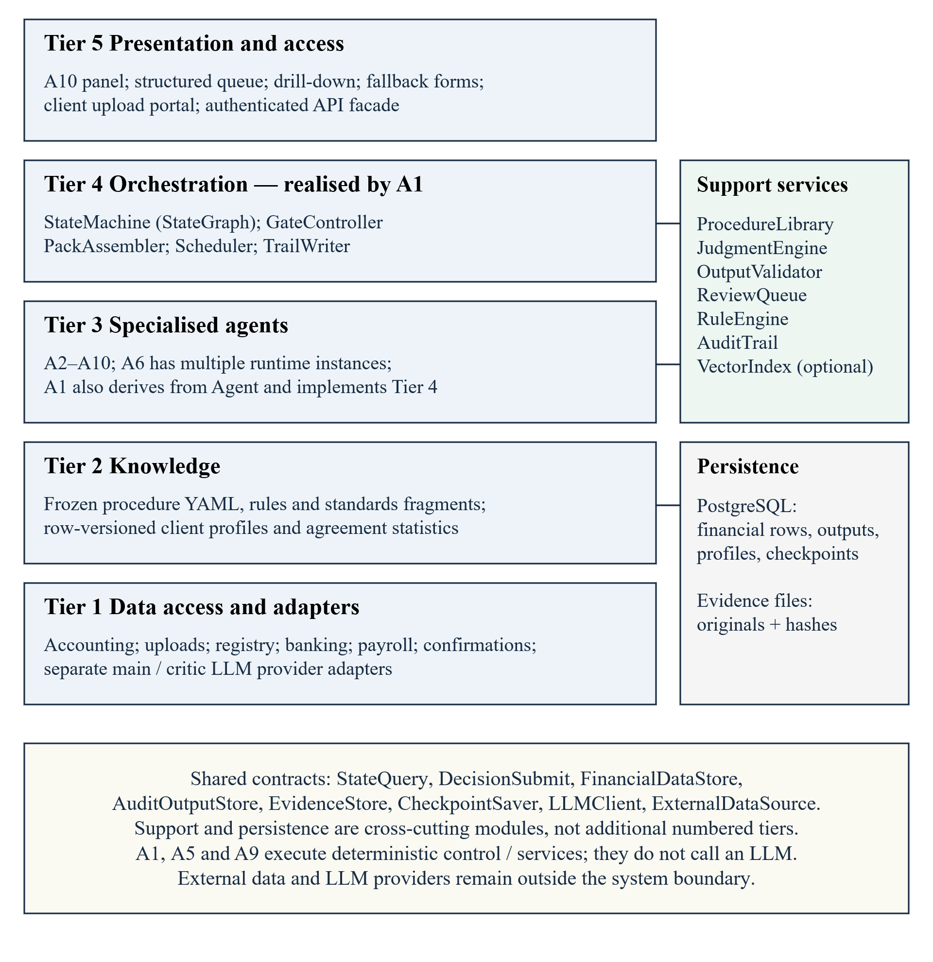
A1 implements Tier 4 and inherits the common agent contract. Services, persistence and contracts span the tiers; dependency directions are shown in Figure 4.2.
Figure 4.2. Package dependencies and interface realisation
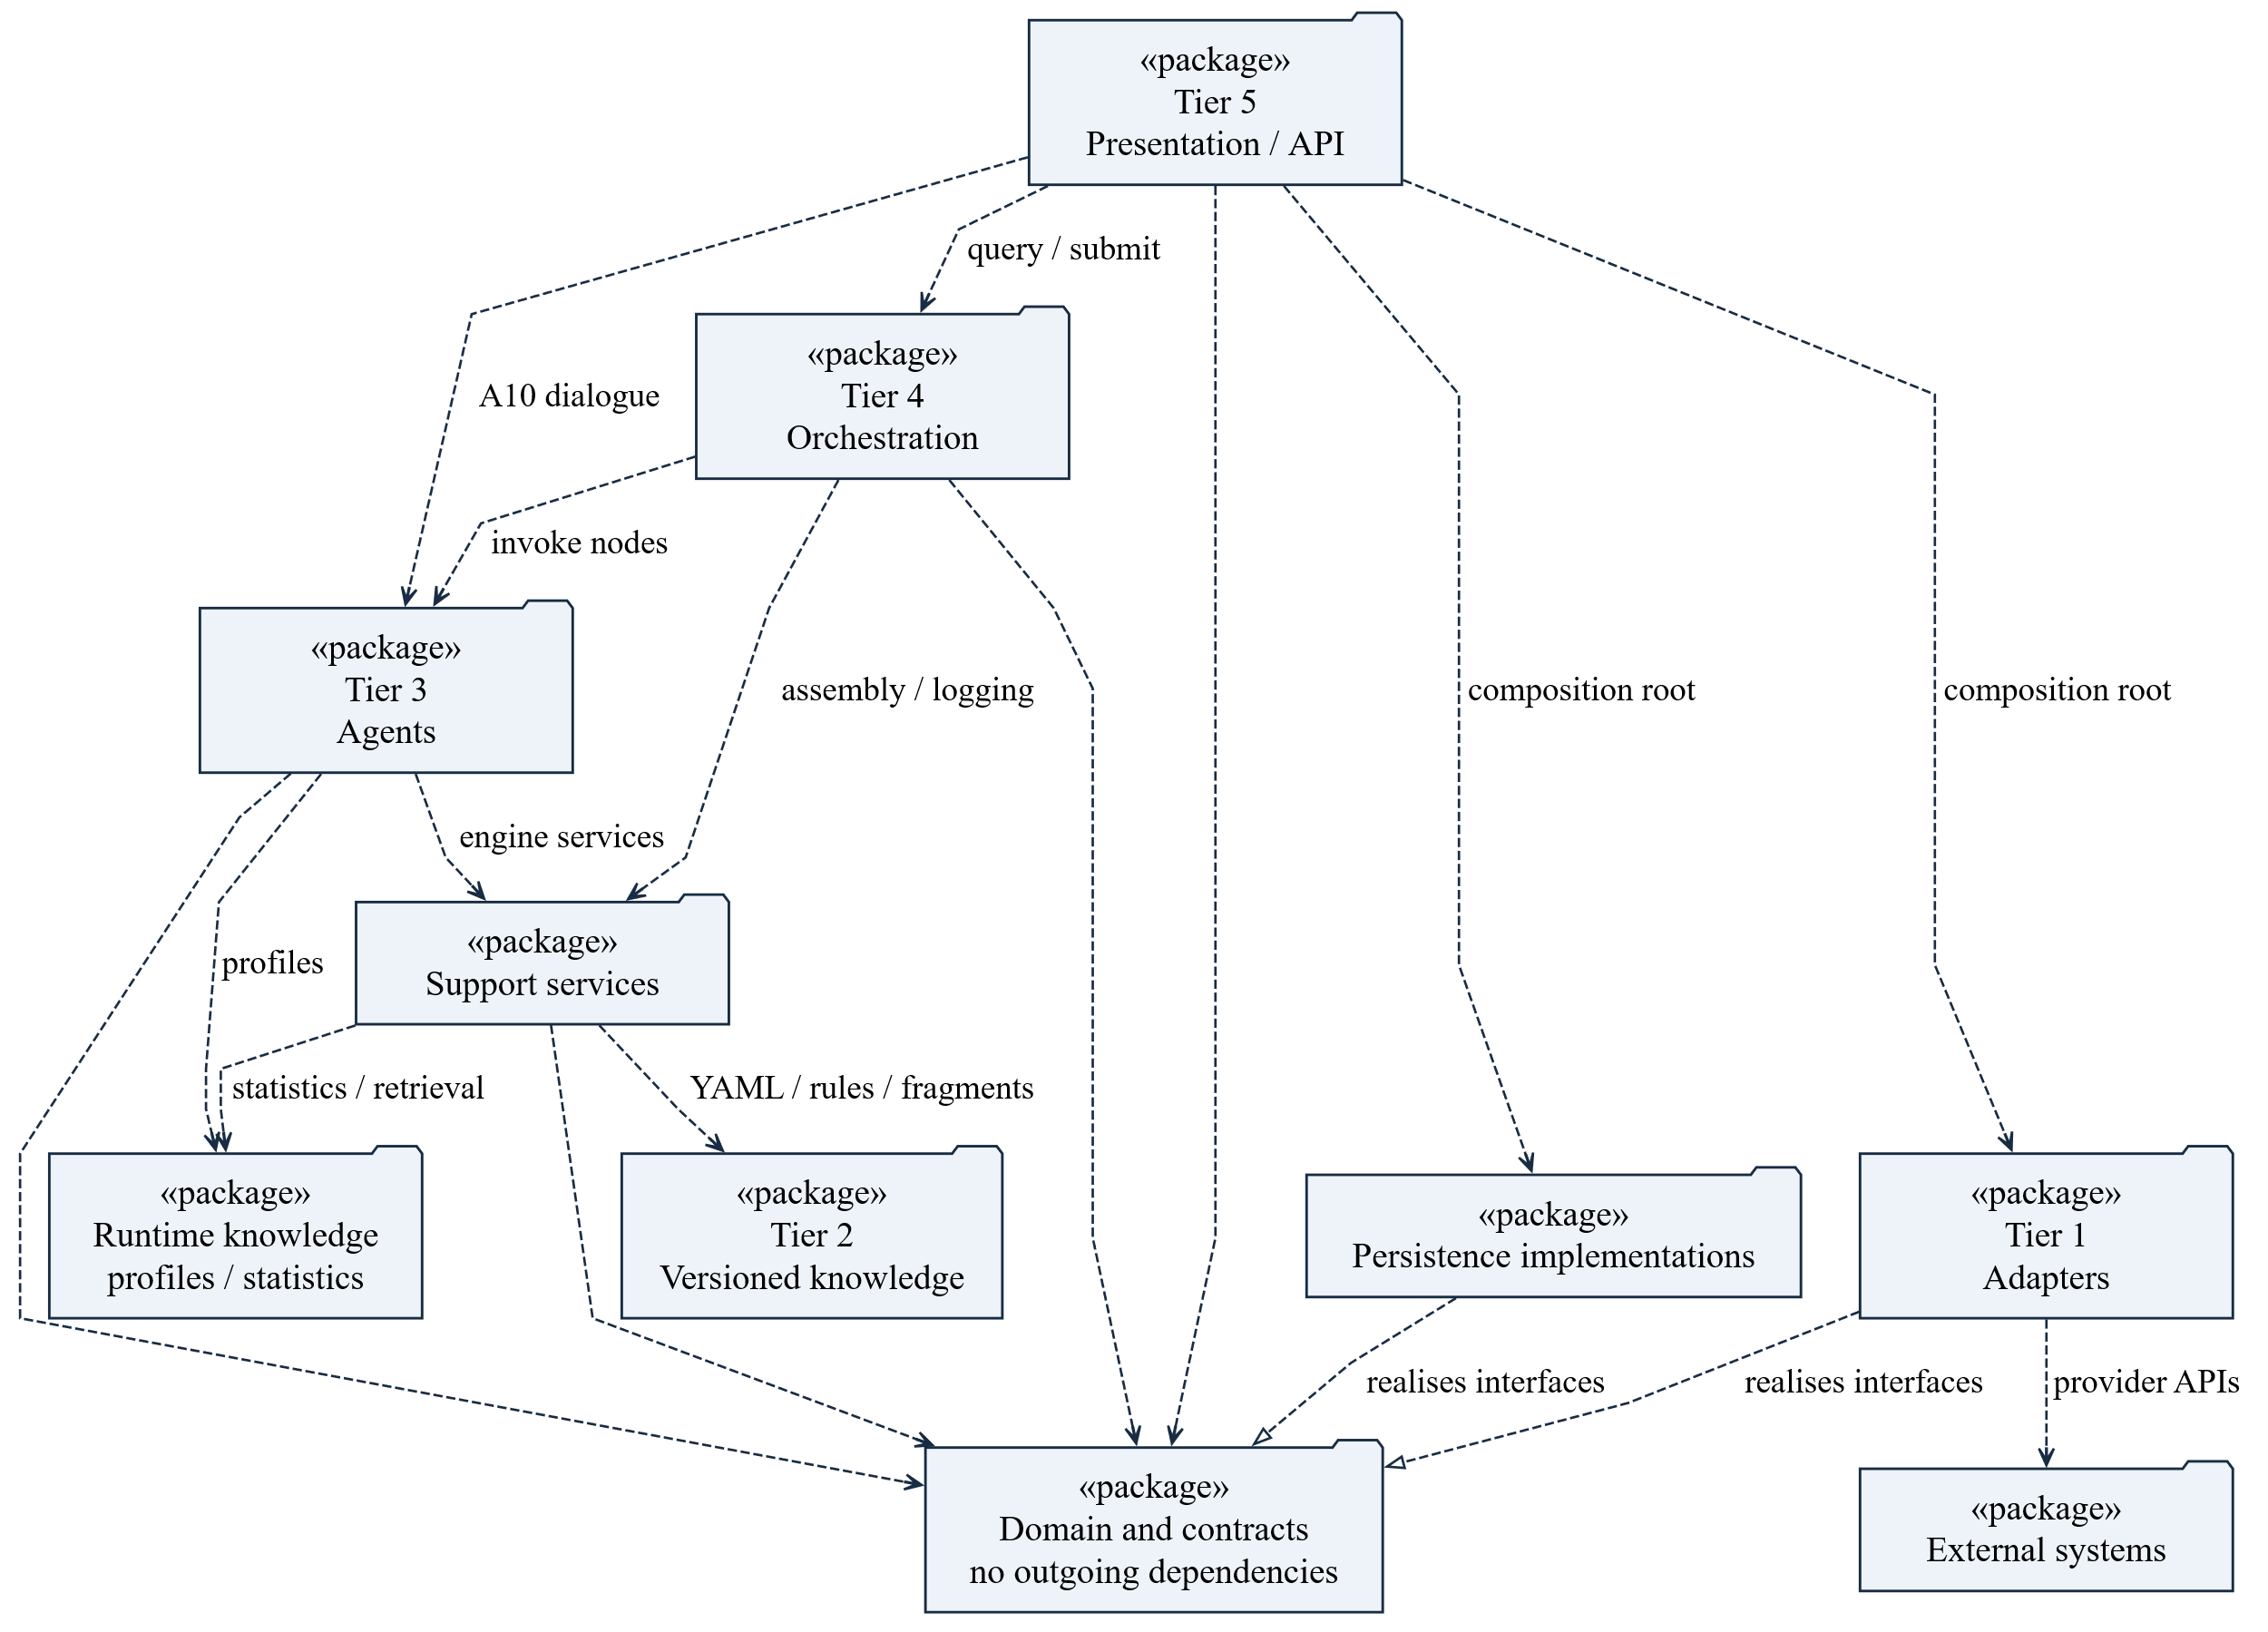
Dashed open arrows indicate client-to-supplier dependencies; hollow triangles indicate interface realisation. Domain contracts have no outgoing application dependencies. The composition root injects stores and adapters.

4.2 Agent roles and execution boundaries
Each procedure configuration declares its owner, engine, dependencies, inputs and output schema. Table 4.2 assigns the agent roles.
Table 4.2. Ten roles; procedure ownership is not decision authority
Agent | Responsibility | LLM use / owned procedures
A1 Orchestrator | State machine, gates, assembly, schedule, merge and archive control | Deterministic; no owned audit procedure
A2 ClientIntel | Acceptance, client profile, independence and continuance | Rule / LLM / hybrid / manual; 11
A3 IngestAgent | API and event-driven offline ingestion; classify, extract, link and reconcile | Rule / LLM / hybrid; 12
A4 RiskAssessor | Baseline objectives, risk proposals, materiality, plan and reassessment | Rule / LLM / hybrid / manual; 20
A5 EvidenceAgent | Confirmations, monitoring, enquiries, representations and authorised lodgement | Deterministic service and manual support; 9
A6 FieldworkAgent | Transaction, balance and estimate procedures; bounded evidence retries | Rule / LLM / hybrid / manual; 80; configurable instances, default maximum 4
A7 ReviewAgent | Evidence-first independent judgment, then comparison | Independent critic LLM; 1
A8 WorkpaperAgent | Misstatements, corrections, communications, workpapers and sealing | Rule / LLM / hybrid / manual; 6
A9 QCAgent | Completeness, accumulation, reconciliation and candidate opinion route | Deterministic checks with human decisions; 7
A10 ConciergeAgent | Single entry, verbatim decisions, enquiry and report revision | LLM interaction with deterministic decision contracts; 15
Procedure ownership totals 161 and concerns preparation or execution, not human decision authority. The RCA decides reserved opinion and signature gates. A1, A5 and A9 do not call an LLM.
Substantive analytical work counts towards material-objective coverage only when its suitability, source-data reliability, expectation precision and acceptable difference are recorded and pass. Otherwise the pack needs detail tests; significant-risk objectives cannot rely solely on analytics.

4.3 LLM enhancement
Table 4.3. LLM contribution and retained deterministic controls
Capability | Representative work | Control retained
Perception | Contract extraction; classification and OCR | Original document, location, transcription confidence and manual fallback
Decision-making | Risk reasoning; exception attribution; revenue cutoff | Rule-generated objectives, structured schema, evidence checks and human authority
Independent review | Evidence-first critic | Separate client/model; eligibility rule; dispute adjudication
Interaction | Enquiry; decision presentation; report drafting | Scoped state reads, verbatim commands, fact-to-judgment links and version checks

4.4 Design decisions and alternatives
Table 4.4. Rationale and rejected alternatives
Selected design | Alternative rejected | Reason / consequence
Deterministic A1 and rule-based QC | LLM control of workflow or completeness | Stable routing and verifiable coverage; LLM judgment is bounded by typed contracts.
Dependency-based scheduling | LLM chooses instance counts and assignments | Reproducible layers and groups respect dependencies and the configured instance limit.
Phase state machine with feedback | A one-pass DAG without reassessment | New evidence can require risk revision, plan versions and reopening completed work.
One configurable procedure library | One agent per procedure | 161 procedures remain enumerable; new compatible procedures need configuration rather than a new agent topology.
One A6 type with multiple instances | Separate transaction / balance / estimate agents | Same execution contract; cycle-specific context is in procedure configuration; parallelism follows actual dependencies.
SQL full-population rules | LLM scan of all entries | Enumerated rules are explainable and efficient; only selected exceptions enter LLM context.
Rule-based objective baseline | LLM defines the complete objective denominator | Missing generated objectives must not make 100% coverage appear valid.
Assembly for each audit objective | One pack chosen from the engagement's highest risk | Objective-specific nature, extent and timing avoid diluted high-risk coverage and unnecessary low-risk work.
Configurable autonomy with reserved gates | Hard-coded review points for every procedure | Risk can strengthen review without changing workflow topology; reserved human decisions remain fixed.
Structured extraction; optional retrieval for full-text contracts | Semantic indexing of every document | Tables and invoices use extracted fields; original locators remain authoritative. Full-text retrieval is an optional extension.
Selective evidence-first A7 review | No critic or critic on every judgment | Automatically closing L3/L4 judgments need a second review; L1/L2 already receive individual human decisions.
PostgreSQL rows and JSONB outputs | JSON-only files or a second document database | Filtered financial queries and consistent stores; adapters keep persistence replaceable.
A10 single entry with forms fallback | Independent decision interfaces with inconsistent rules | One version-checked submission path; original human intent and reasons are preserved.
Versioned knowledge and replay cache | Unversioned prompts or claimed identical live LLM reruns | Input reconstruction and cached replay support evidence review; deterministic code remains recomputable.
L3/L4 account for 71/161 procedures, approximately 44%. This proportion does not measure time saved: runtime downgrades and manual work determine actual human effort.

5. Design-time and runtime structure
The architecture is realised by domain types, agents and service contracts. Figures 5.1–5.7 define the core classes; grey classes reference another view. Figures 5.8–5.10 show their runtime parts, instances and communication. Supporting document and governance types are defined in Table 5.3, following the engagement ownership and versioning rules in Section 5.2.
Named types abbreviate domain enums or records. Money stores AUD integer minor units; UserId identifies an authenticated human; Void denotes no return value. HumanCommand is ReviewRecord or GateDecision. QueryScope selects authorised fields; Result and ValidationResult carry success and errors; VerificationResult records matching entries and the residual amount. VersionRef binds an ID and version. Public operation parameters and results are typed; adapter boxes omit repeated interface signatures.

5.1 Relationship semantics
Associations express retained relationships and multiplicities; navigation indicates direction. Composition gives exclusive ownership, while aggregation represents weaker grouping. Hollow triangles indicate generalisation or dashed interface realisation; dashed open arrows indicate use dependencies.
ReviewTask→Judgment and ControlDeficiency→Exception are persistent associations in Figures 5.4 and 5.3. A ReviewTask resolves one target selected by targetType; targetId encodes that domain ID as a string. Table 5.1 gives the cross-view invariants.
Figure 5.1. Planning, objectives and versioned risks
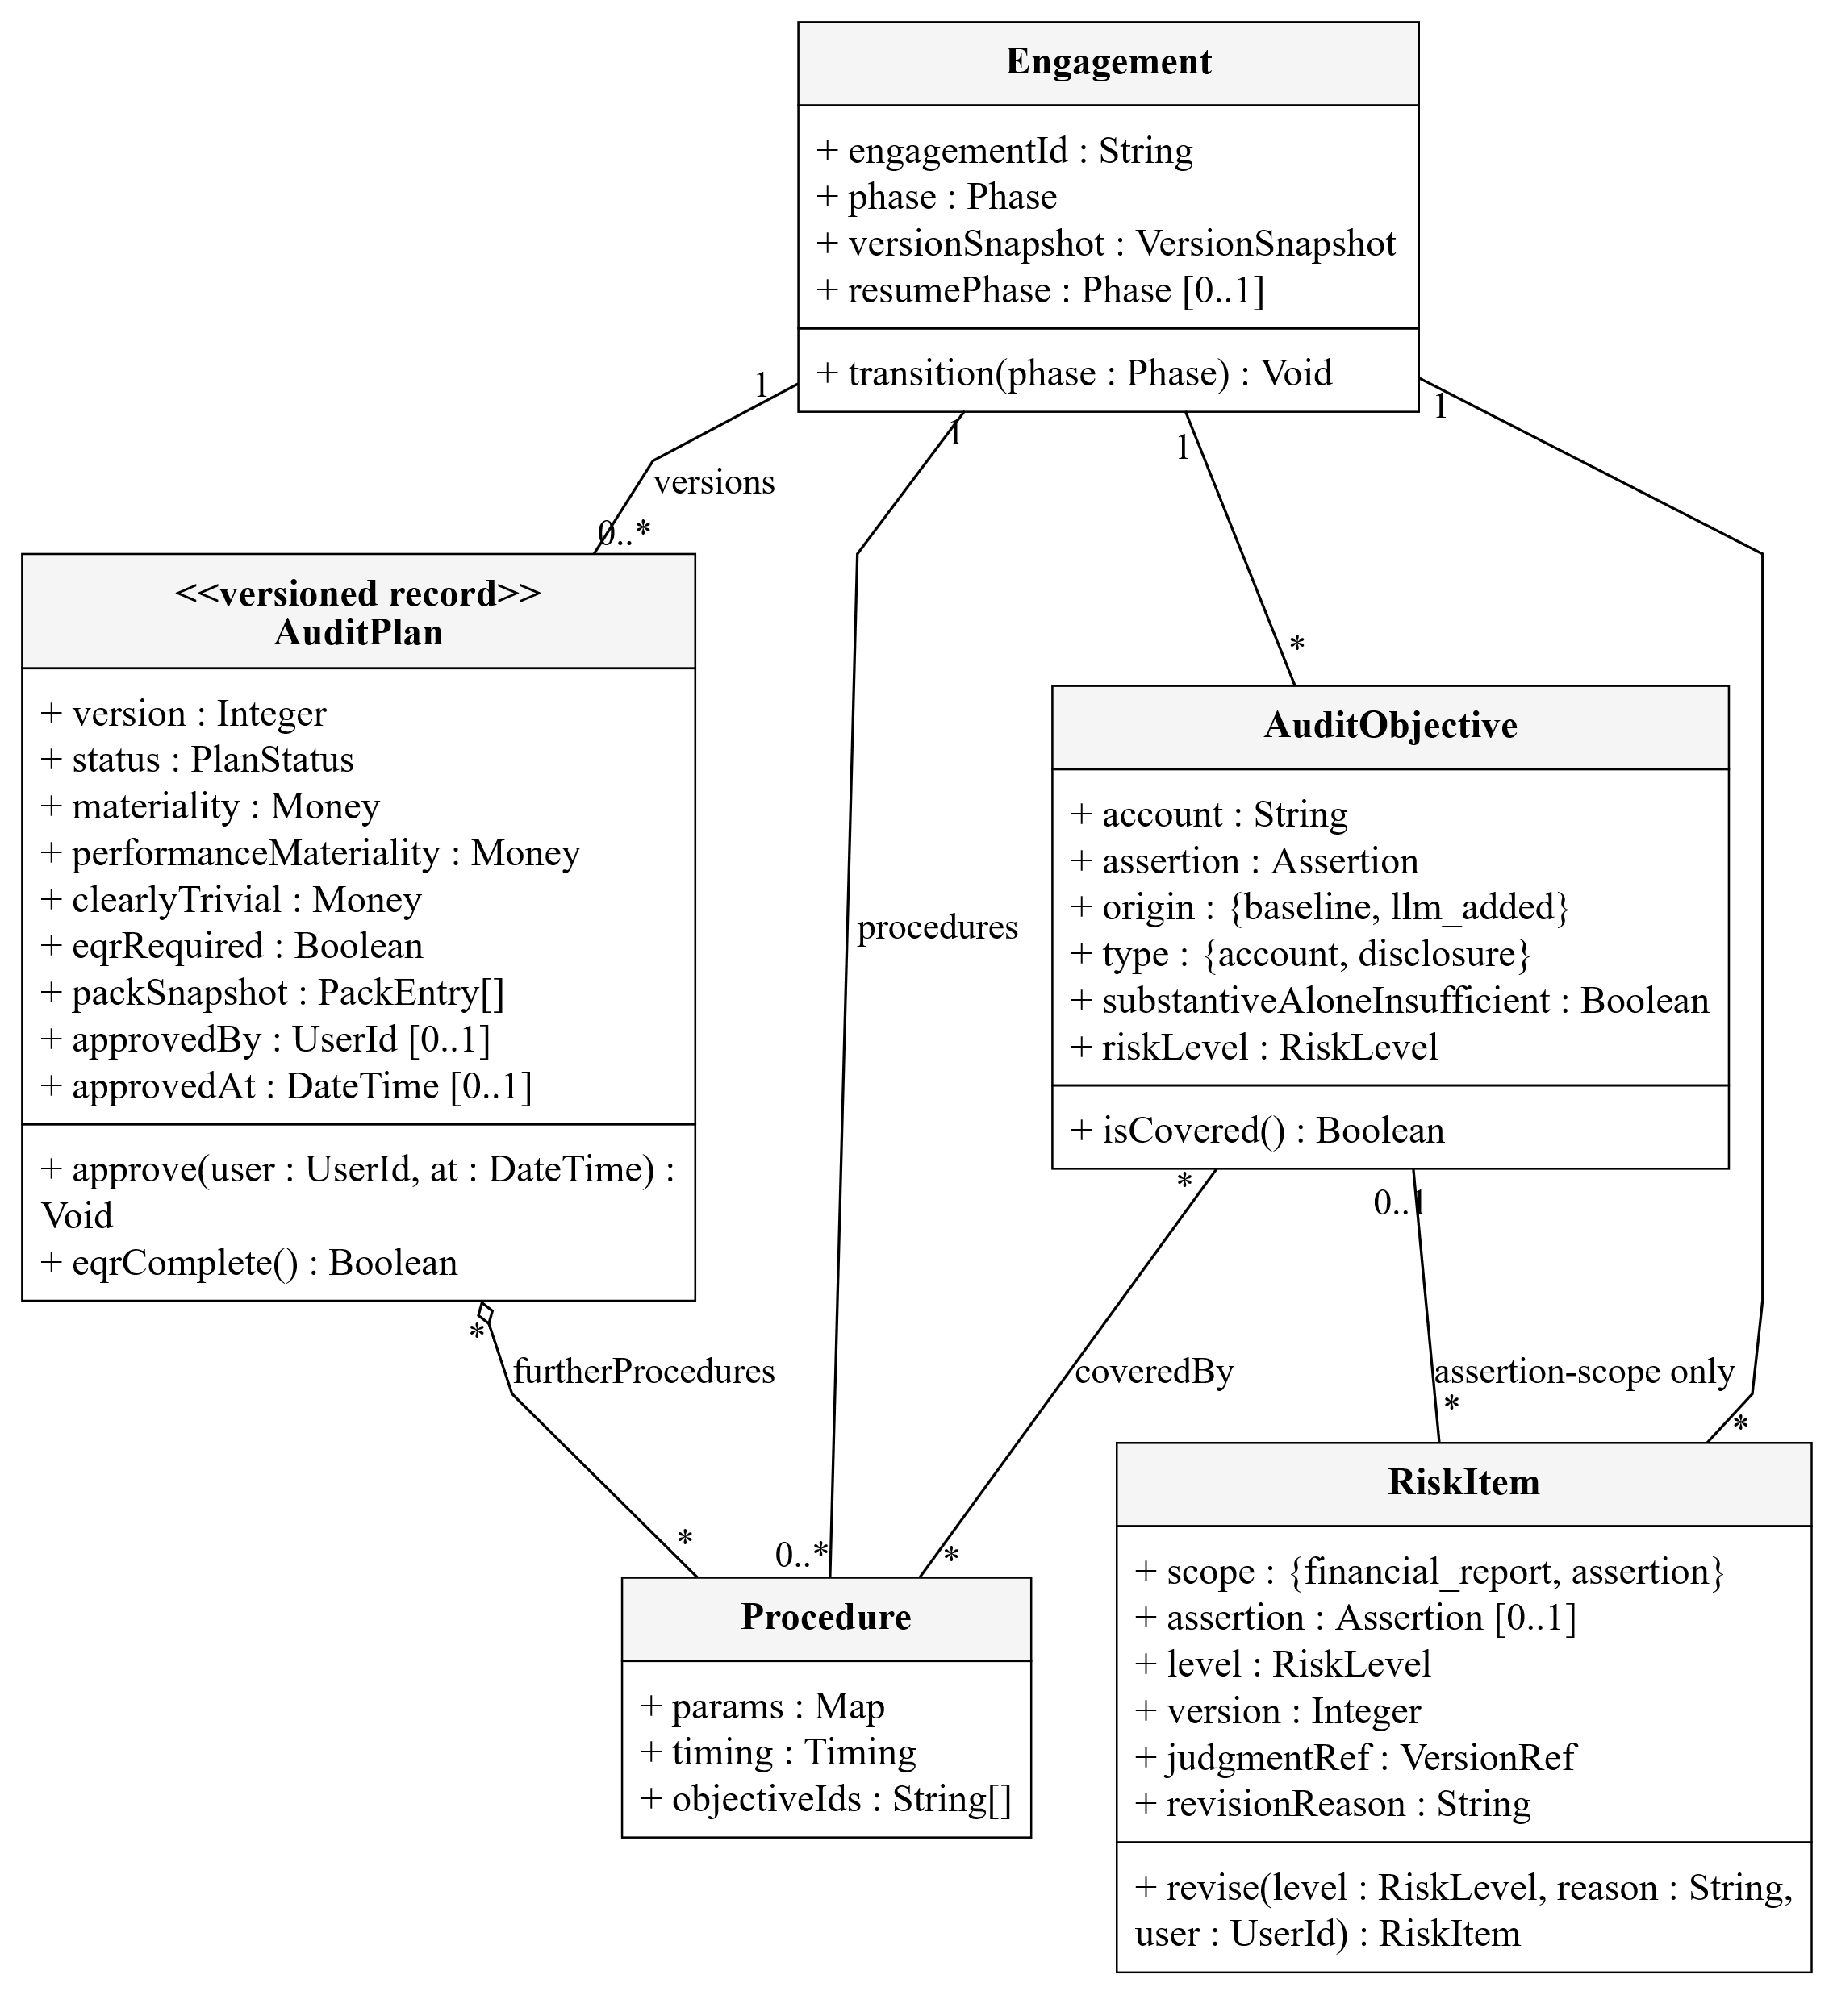
AuditPlan aggregates configured procedures and freezes their parameters in packSnapshot. Engagement separately references the current plan. Financial-report risks may lack an AuditObjective; assertion-level risks require one.
Figure 5.2. Templates, configured procedures and execution runs
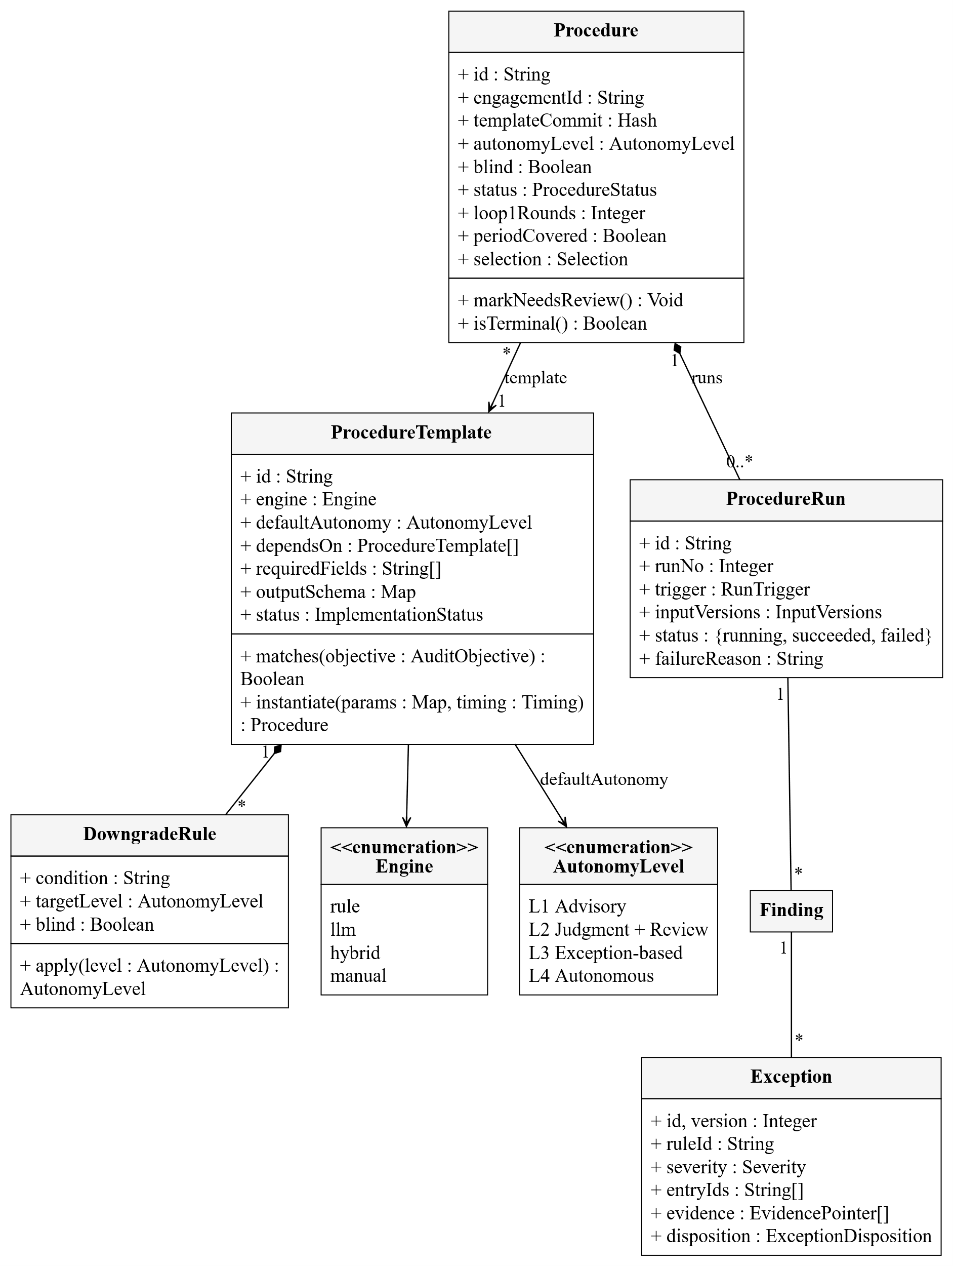
ProcedureTemplate is reusable configuration, Procedure is its engagement-specific instance, and ProcedureRun records an attempt with input versions. Retries create new runs. Manual execution is an engine boundary, not an autonomy level.
Figure 5.3. Judgments, evidence, reasoning and workpapers
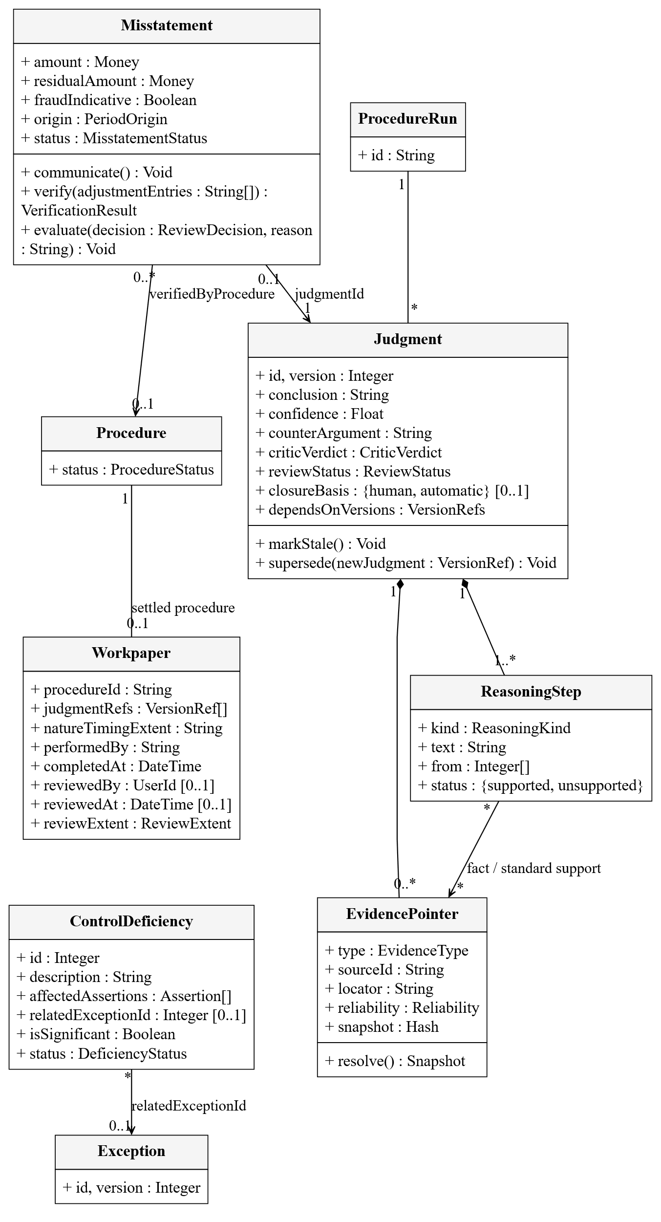
Judgment owns reasoning and pointer descriptors; adoption requires at least one valid pointer; multiple judgments may reference the same evidence file. supersededBy retains version history. Misstatement records original and residual amounts. ControlDeficiency records the affected assertions and significance and may reference the originating Exception.
Figure 5.4. Human decisions and report versions
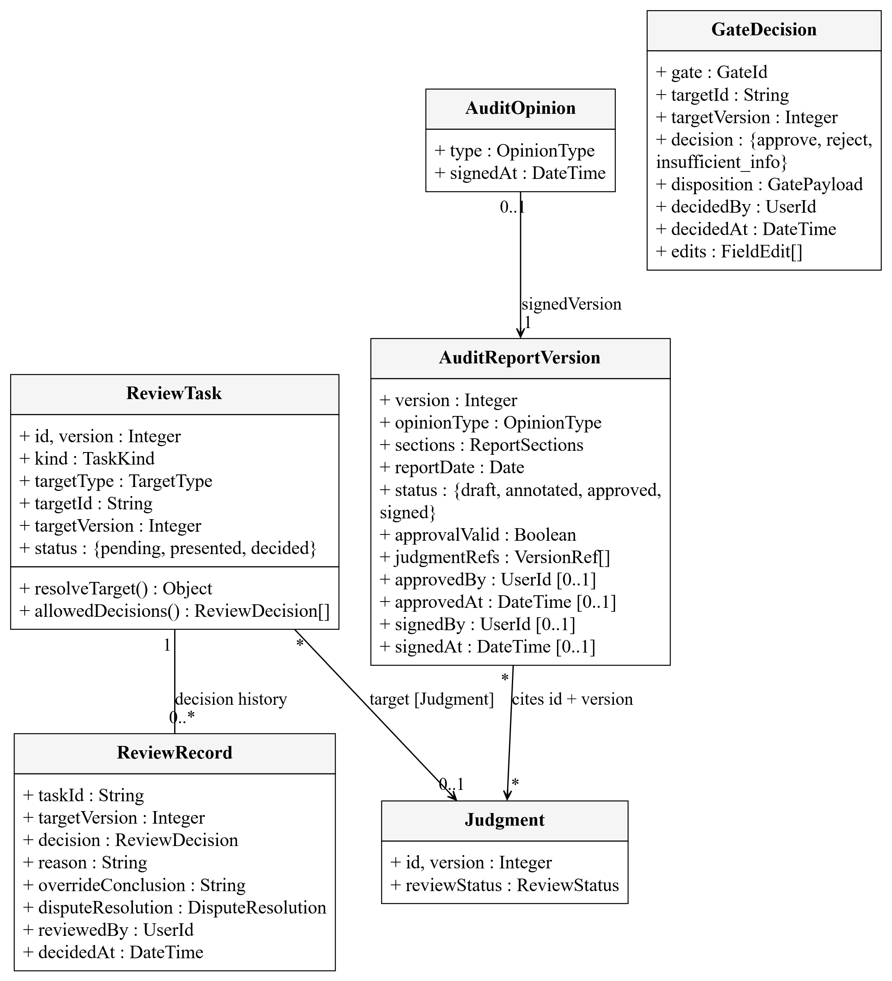
ReviewTask and ReviewRecord bind the target type, ID and version. GateDecision controls reserved gates. AuditReportVersion cites judgment versions; AuditOpinion references the signed report version.
Figure 5.4a. Signature, notification and original-evidence records
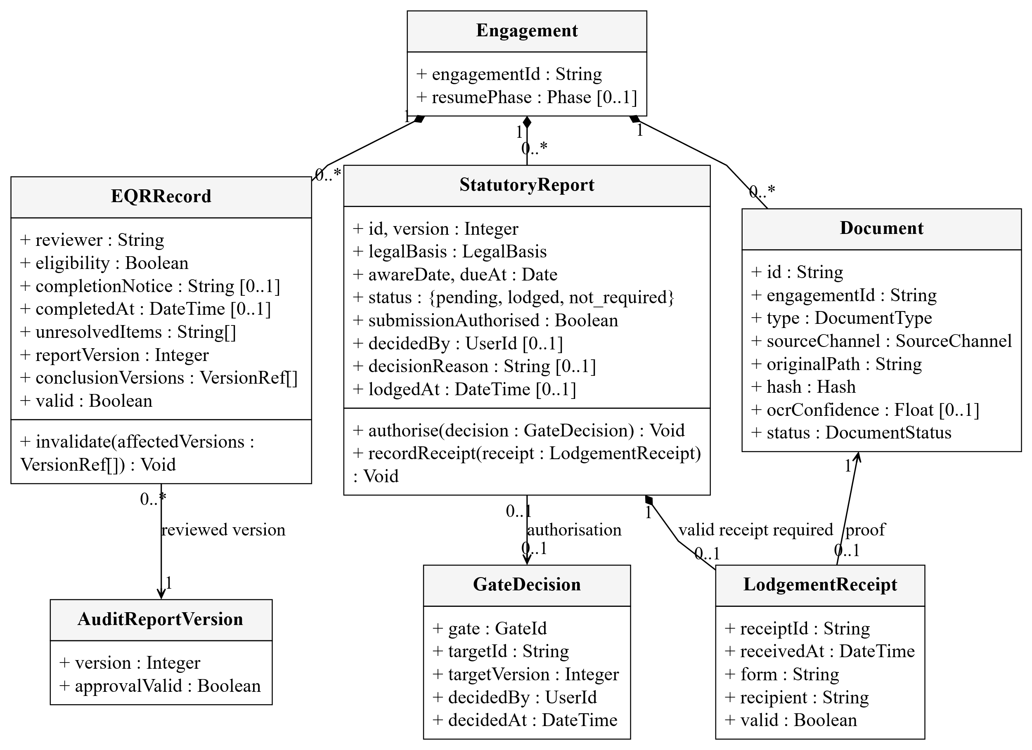
StatutoryReport retains the awareness date, legal basis, immutable deadline, human authorisation and lodgement receipt. EQRRecord binds the reviewed report and conclusion versions; invalidation removes its eligibility for signature. Document retains the original file location and hash. These types support UC-06, UC-09 and Figures 6.10–6.11.
Figure 5.5. Agent generalisation and specialised operations
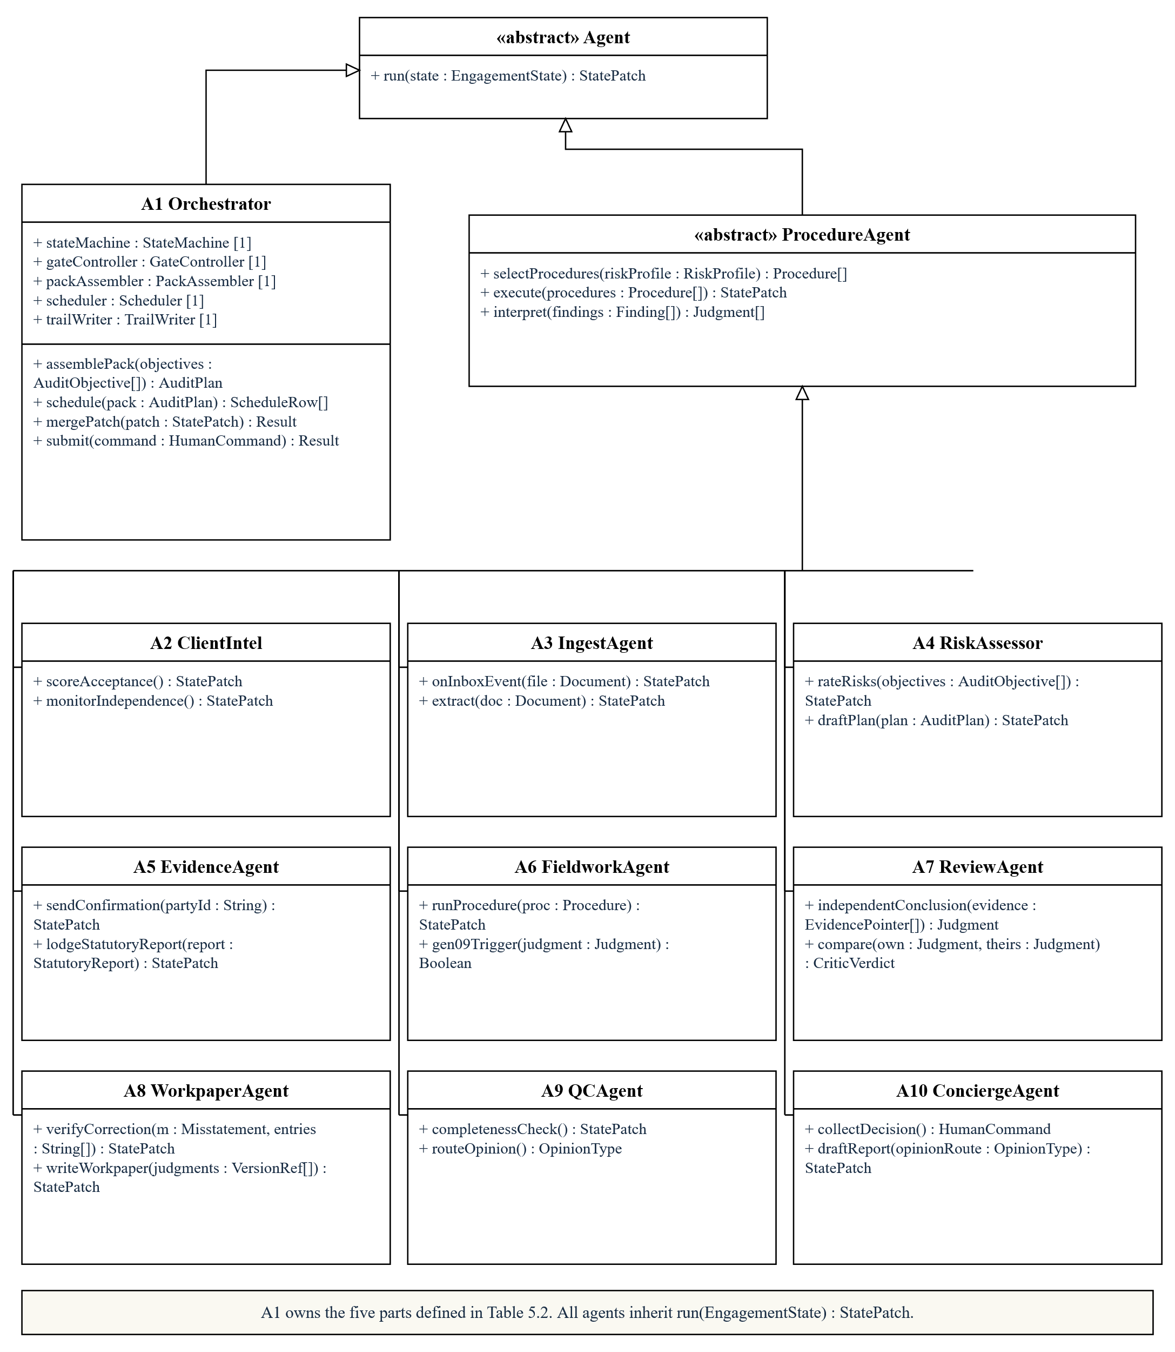
A1 inherits Agent and owns the five typed parts defined in Table 5.2; A2–A10 inherit ProcedureAgent, which also inherits Agent. All return state patches, but their engines differ. Multiple FieldworkAgent instances execute one A6 role.
Figure 5.6. Support services and store contracts
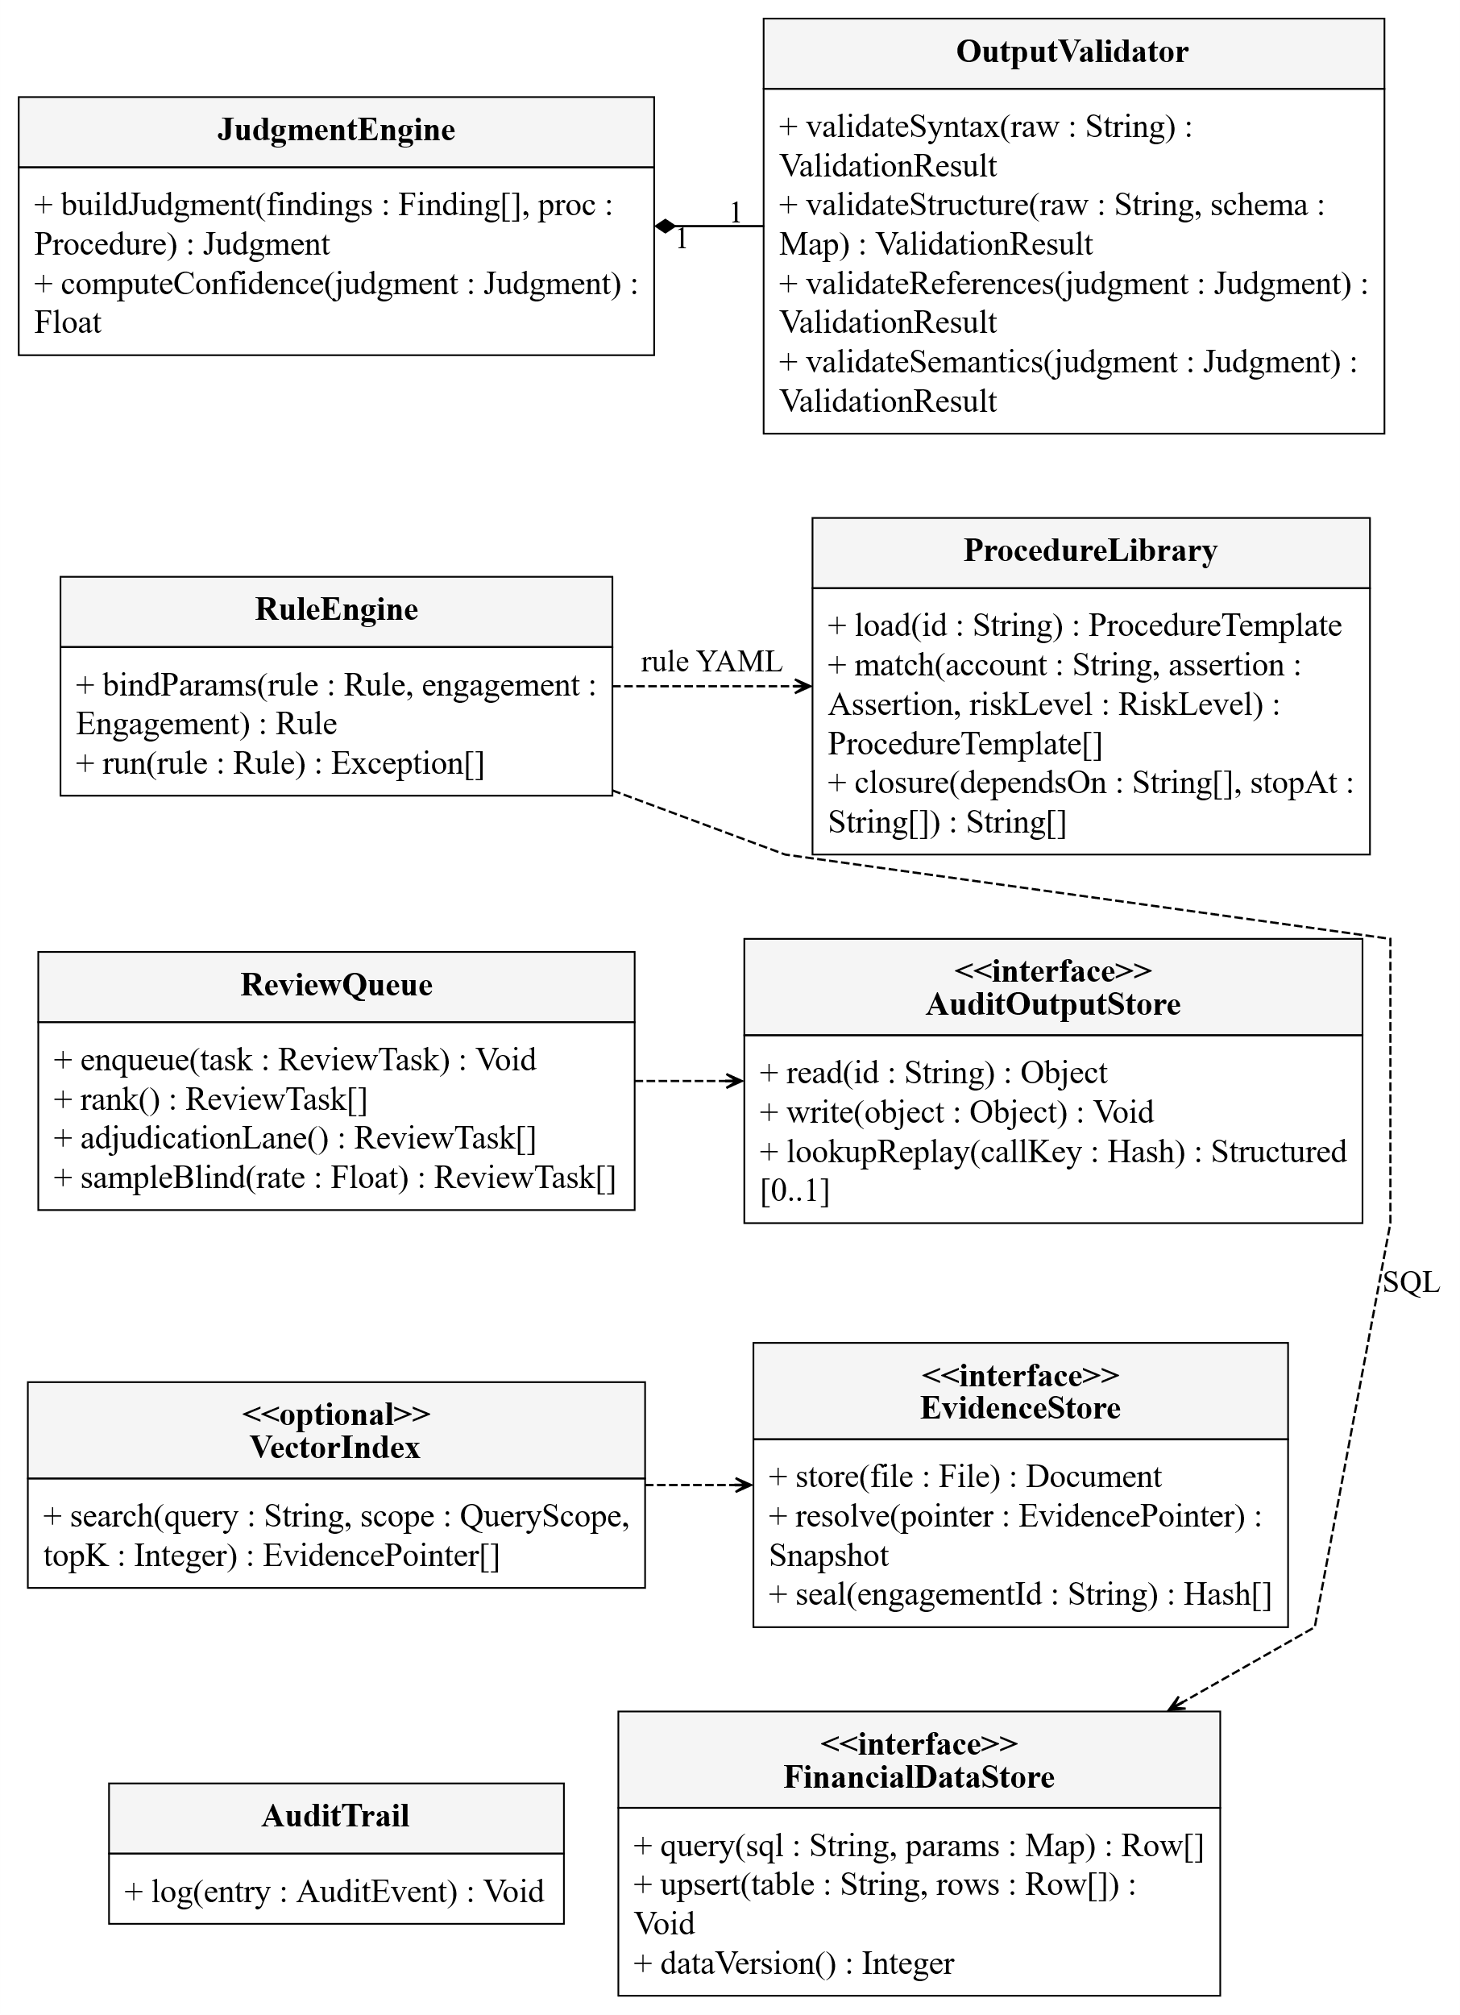
JudgmentEngine owns OutputValidator. RuleEngine uses ProcedureLibrary and FinancialDataStore; ReviewQueue reads persisted outcomes. VectorIndex is optional. All agents and services log to AuditTrail.
Figure 5.7. Query, decision and provider interface realisation
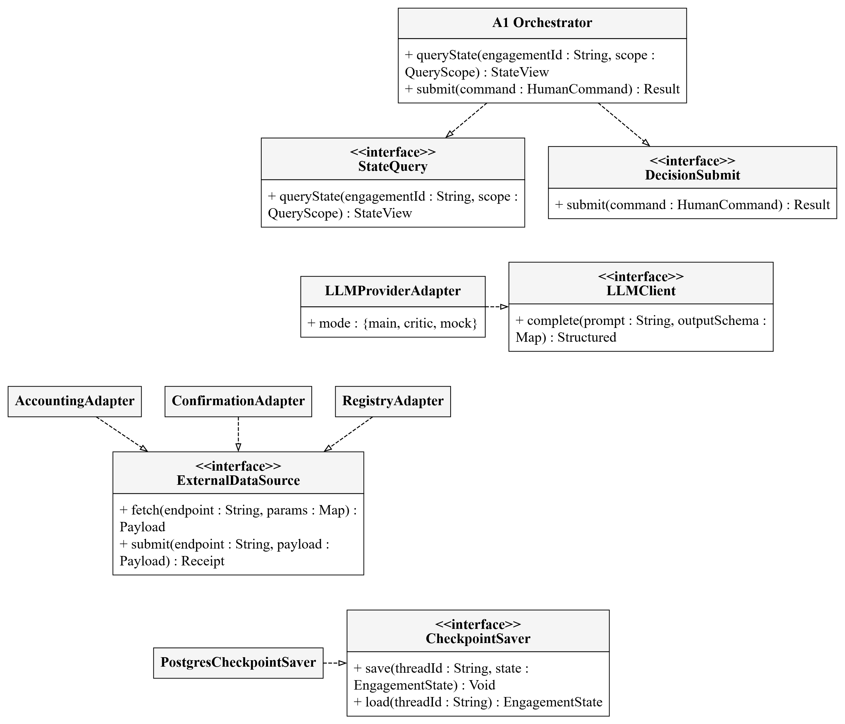
A1 provides StateQuery and DecisionSubmit. Main, critic and mock adapters realise LLMClient; external adapters realise ExternalDataSource. Concrete stores realise storage contracts and are injected at composition.

5.2 Cross-view invariants and persistence
Table 5.1. Relations and invariants spanning class views
Relation / invariant | Meaning
Engagement 1 — 0..* AuditPlan; currentPlan 0..1 | Historical plan versions are retained; only a current approved version authorises execution.
Engagement 1 — 0..* Procedure | Each procedure belongs to one engagement via engagementId. This association is the eng01—proc01 link in Figure 5.9; AuditPlan separately groups its configured procedures.
Engagement 1 — * ScheduleRow | Deterministic layer, instance and procedure allocation is recorded.
RiskItem * — 0..1 Judgment | Risk ratings may reference a reasoned judgment version.
Judgment 0..1 → 0..1 Judgment | supersededBy preserves replacement history; an old judgment is not overwritten to hide its basis.
ReviewTask target type | Judgment, Exception, ProcedureRun or Procedure; targetVersion must match the chosen object.
Engagement owns project context | resumePhase retains the phase suspended for reassessment. Domain records carry engagement identity; governance, documents, statutory matters and external-work records support the same lifecycle.
StatePatch merge contract | Authorised field owner; matching types; unique IDs; valid foreign keys. New IDs append; higher versions replace current views; equal-version conflicts require resolution.
Document evidence | A document pointer resolves sourceId to Document.id; its snapshot hash must match the retained original.
Engagement 1 — 0..* ControlDeficiency | Deficiencies remain in the engagement's record; Figure 5.3 shows the optional relatedExceptionId association.
Persistence interfaces | PostgresFinancialDataStore, PostgresAuditOutputStore, FileEvidenceStore and PostgresCheckpointSaver realise the corresponding store contracts.
Write authority | A3 ingests financial rows and evidence. Business outputs merge through A1; A10 submits human command objects through DecisionSubmit.
Review completion | One decided task does not complete a procedure. All tasks, disputes, follow-up work and period coverage must satisfy its completion condition.
Table 5.2. Class contracts for A1's owned parts
Type / owned role | Principal attributes | Public operations
StateMachine / stateMachine | state: EngagementState; graph: StateGraph | handle(event: WorkflowEvent): StatePatch; query(scope: QueryScope): StateView
GateController / gateController | openGates: GateId[] | validate(command: HumanCommand, state: EngagementState): ValidationResult
PackAssembler / packAssembler | library: ProcedureLibrary | assemble(objectives: AuditObjective[]): AuditPlan; checkCoverage(plan: AuditPlan): ValidationResult
Scheduler / scheduler | rows: ScheduleRow[]; maxInstances: Integer = 4 | ready(plan: AuditPlan, state: EngagementState): Procedure[]; allocate(ready: Procedure[]): ScheduleRow[]
TrailWriter / trailWriter | trail: AuditTrail | append(event: AuditEvent): Void
Each part has multiplicity 1 and the Orchestrator's lifetime. StateMachine is the application workflow type; its graph uses the LangGraph StateGraph framework type for P0–P4, interruptions and resume. The StateGraph label in Figure 4.1 denotes this same framework component. GateController, PackAssembler, Scheduler and TrailWriter are application classes. WorkflowEvent and AuditEvent record a typed payload, engagement identity and time; the former drives transitions and the latter preserves history.
Table 5.3. Supporting document and governance types
Type | Principal fields / operation | Associations and purpose
Contract | counterparty: String; amount: Money; effectiveTerms(): ContractTerm[] | Owns 1..* ContractVersion objects; returns effective terms while retaining superseded terms.
ContractVersion | version: Integer; signDate: Date; documentId: String | Belongs to one Contract, references one Document and owns 0..* ContractTerm objects.
ContractTerm | termType: TermType; text: String; locator: String; supersedesTermId: String [0..1] | Belongs to one version; locates the original clause and identifies any replaced term.
Confirmation | sentAt: DateTime [0..1]; repliedAt: DateTime [0..1]; result: ConfirmationResult | Belongs to one Engagement; references 0..1 reply Document. An outstanding reply blocks dependent work.
GovernanceCommunication | matter: String; kind: CommunicationKind; recipients: String[]; communicatedAt: DateTime [0..1] | Engagement 1—0..* communications; records planned and completed discussions, document references and responses.
ManagementEnquiry | responseText: String [0..1]; corroboratingEvidence: EvidencePointer[]; corroborationVerdict: CorroborationVerdict | Engagement 1—0..* enquiries; an unsupported response cannot establish procedure completion.
WrittenRepresentationLetter | status: LetterStatus; signedBy: String[]; datedAt: Date [0..1]; inconsistencies: String[] | Engagement 1—0..1 letter; references 0..1 UncorrectedMisstatementSchedule. Missing or unreliable required representations block signature.
UncorrectedMisstatementSchedule | items: ScheduleItem[]; rollover: Money; ironCurtain: Money | Each item identifies a Misstatement and its amount, origin and evaluation; snapshots support completion decisions and the representation letter.
FinancialStatements | version: Integer; preparedAt: DateTime | Engagement 1—0..1 current statement set; retained versions support reconciliation and report-date checks.
These supporting records carry id: String and engagementId: String. Named field types represent domain enumerations or records; their values follow procedure configuration. A Document retains its original path, hash and processing status in Figure 5.4a. Contract clauses and confirmation replies resolve through the same EvidencePointer contract as judgments. Required communication and representation records feed the signature checks in Section 6.4.
Versioned audit outputs use JSONB; original evidence retains IDs, paths and hashes. Each engagement freezes a library commit; client profiles and agreement statistics remain row-versioned runtime knowledge. Checkpoints save execution state, while the append-only trail records history.
Queries, evidence resolution and file access require engagement authorisation. Stable contracts allow provider replacement and compatible procedure additions; new output types require the change assessment in Section 7.
Figure 5.8. A1 internal parts, ports and delegation connectors
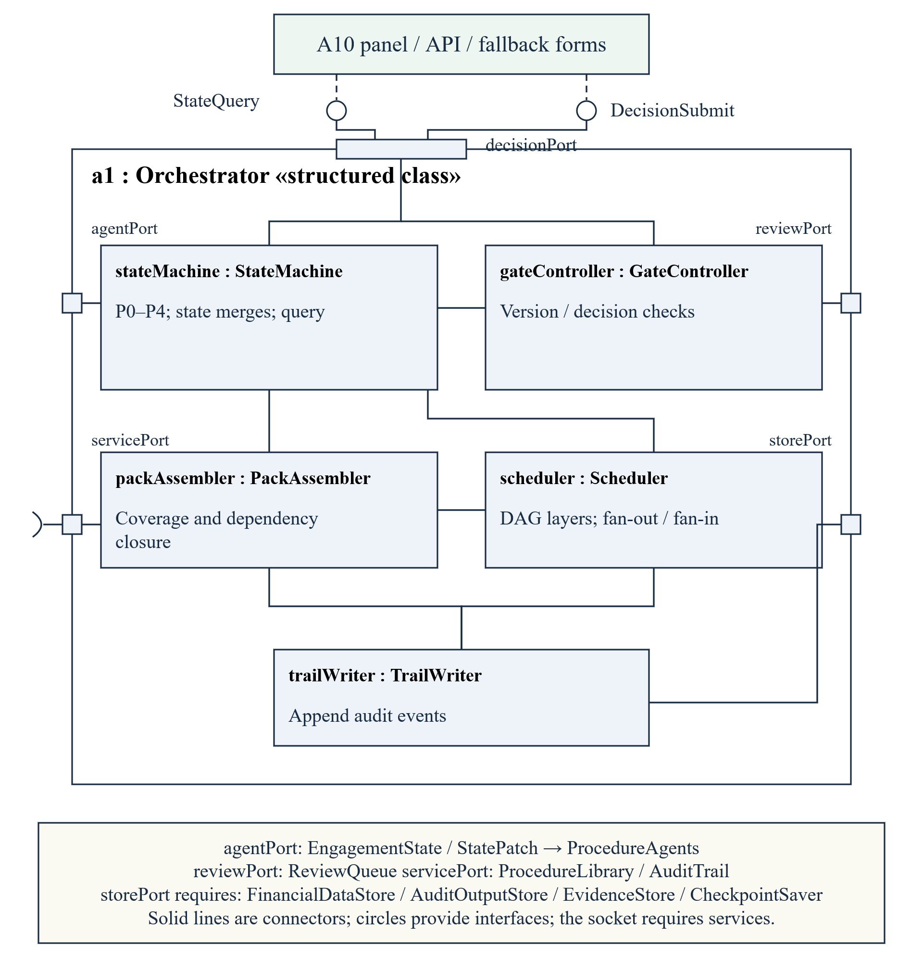
The role:Type parts instantiate Orchestrator's owned attributes in Figure 5.5, with class contracts in Table 5.2. decisionPort provides StateQuery and DecisionSubmit; the other ports connect agents, review, services and stores. Connectors show structure; Section 6 defines message order.
Figure 5.9. Runtime object snapshot at a human-review boundary
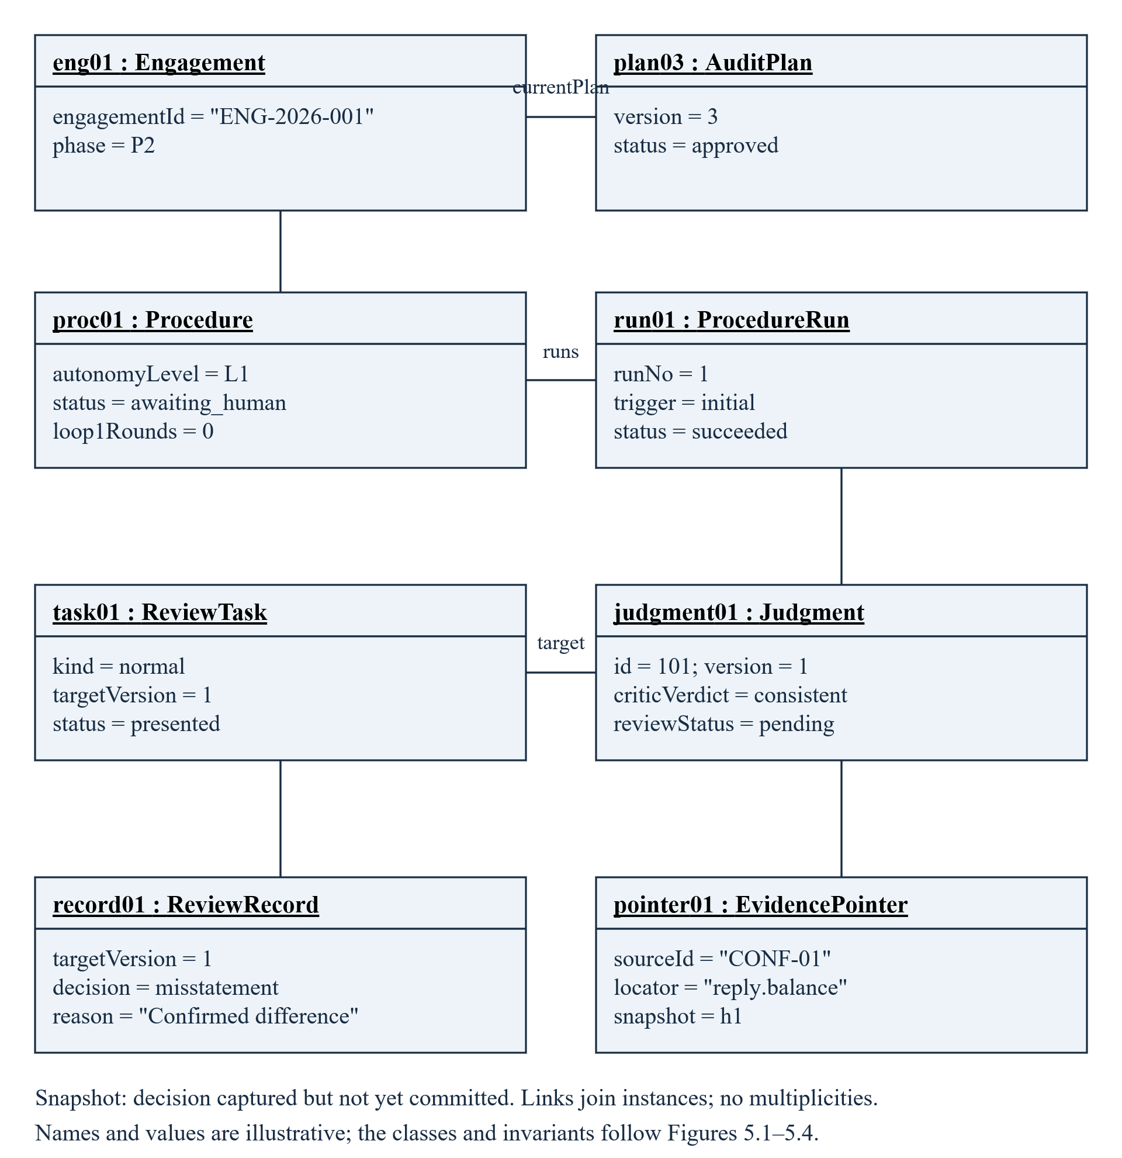
The snapshot follows decision capture but precedes A1's commit. Underlined instance names, current slot values and solid links instantiate the class associations in Figures 5.1–5.4 and Table 5.1. ReviewTask and ReviewRecord both target Judgment 101 version 1.
Figure 5.10. Runtime communication during exception review
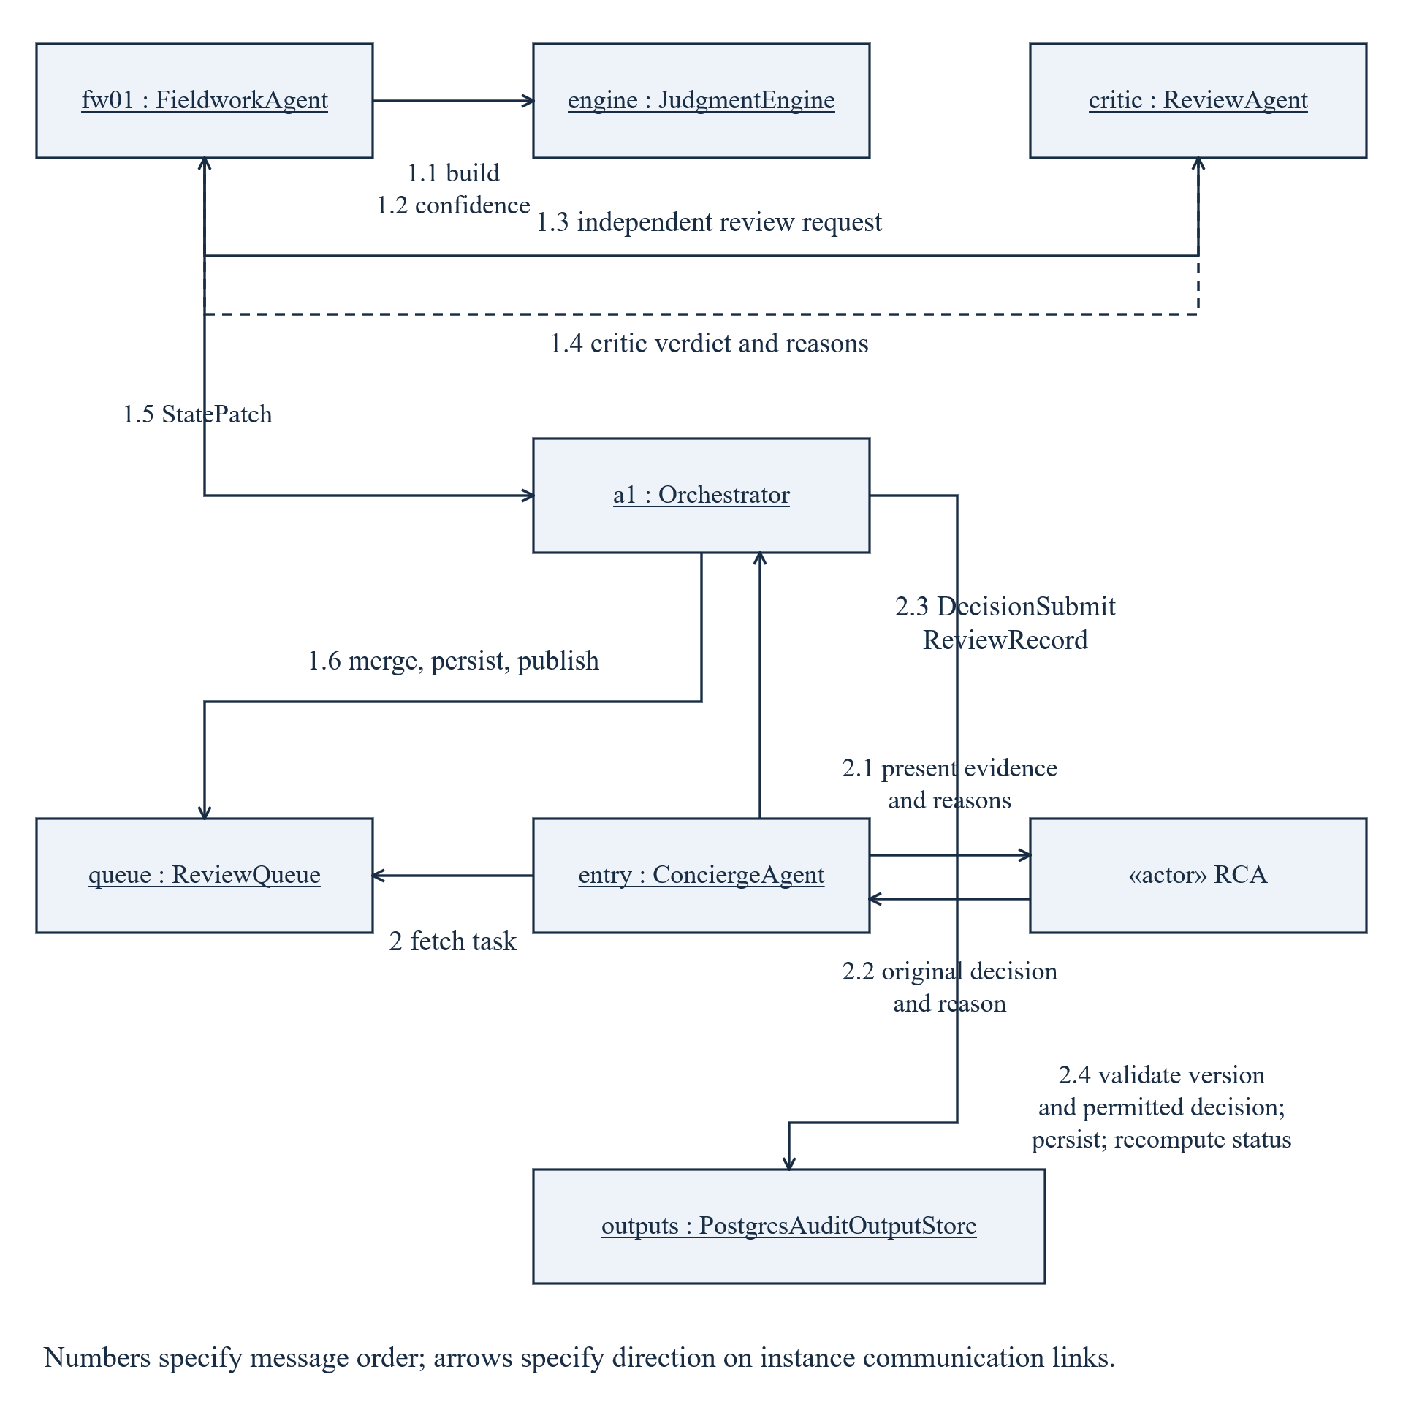
A6 constructs and reviews a judgment, then returns a patch. A1 validates, persists and publishes the task. A10 transfers the human decision; A1 applies it and recomputes status. Numbered messages give the order on instance links.

6. Behaviour and lifecycle
The runtime objects in Section 5 evolve through guarded phase transitions, human decisions and versioned feedback. Table 6.1 summarises progression; the individual suites show planning, execution and reporting in detail.
Activity diamonds merge mutually exclusive paths or select a guarded branch; bars fork and join parallel work. Actions receive one control input. In interactions, solid filled arrows are synchronous calls, solid open arrows are asynchronous events, and dashed open arrows are returns. Underlined role:Type headers identify object lifelines; RCA and the external EQR reviewer are actors.
Table 6.1. Project phases and human decision boundaries
Phase | Work and progression condition
P0 Acceptance | Registry and independence assessment → ACC-01 decision → ACC-08 terms / appointment confirmation → governance plan. Rejection records Declined; information insufficiency returns for queries.
P1 Planning | Population reconciliation, data quality and risk reasoning → risk / materiality confirmation → objective pack and coverage check → PLN-15 exact plan approval. Scope candidates may invoke PLN-18.
P2 Execution | DAG-layer fan-out, typed fan-in, review and confirmation events. The P2 execution pack is settled only when its procedures and non-applicability tasks are disposed, disputes and confirmation dependencies resolved, and no risk reassessment remains open.
P3 Completion | Misstatement communication and correction; incremental scan; materiality reassessment; completeness and final review; FIN-01 and FIN-02 human decisions. New P3 tasks must be settled before P4; gaps reopen only affected work.
P4 Reporting | Versioned draft and annotations; external EQR where required; signature prerequisites and RPT-01. New conclusion-affecting evidence returns to P3.
Archived / post-report facts | Signed version remains locked. RPT-11 can reopen affected work and produce a replacement version; the original remains preserved.
Withdrawal | ACC-10 can terminate an active phase after the RCA decision. Workpapers are sealed; unresolved reporting obligations retain independent timers.
Four business gates are realised as six static interruptions: two in acceptance, two in planning, one for completion opinion and going-concern decisions (FIN-01/FIN-02), and one for report approval and signature (RPT-01). Dynamic gates handle risk reassessment (GATE-R), scope decisions (PLN-18), continuance/exit (ACC-10) and notifications (GEN-14).
GateDecision carries approve, reject or insufficient_info and a gate-specific payload. A1 validates the version, gate state and payload. insufficient_info keeps the gate open, except an information-insufficient acceptance decision returns to background queries. Approval never transfers to a replacement version.
Figure 6.1. Engagement lifecycle and controlled re-entry
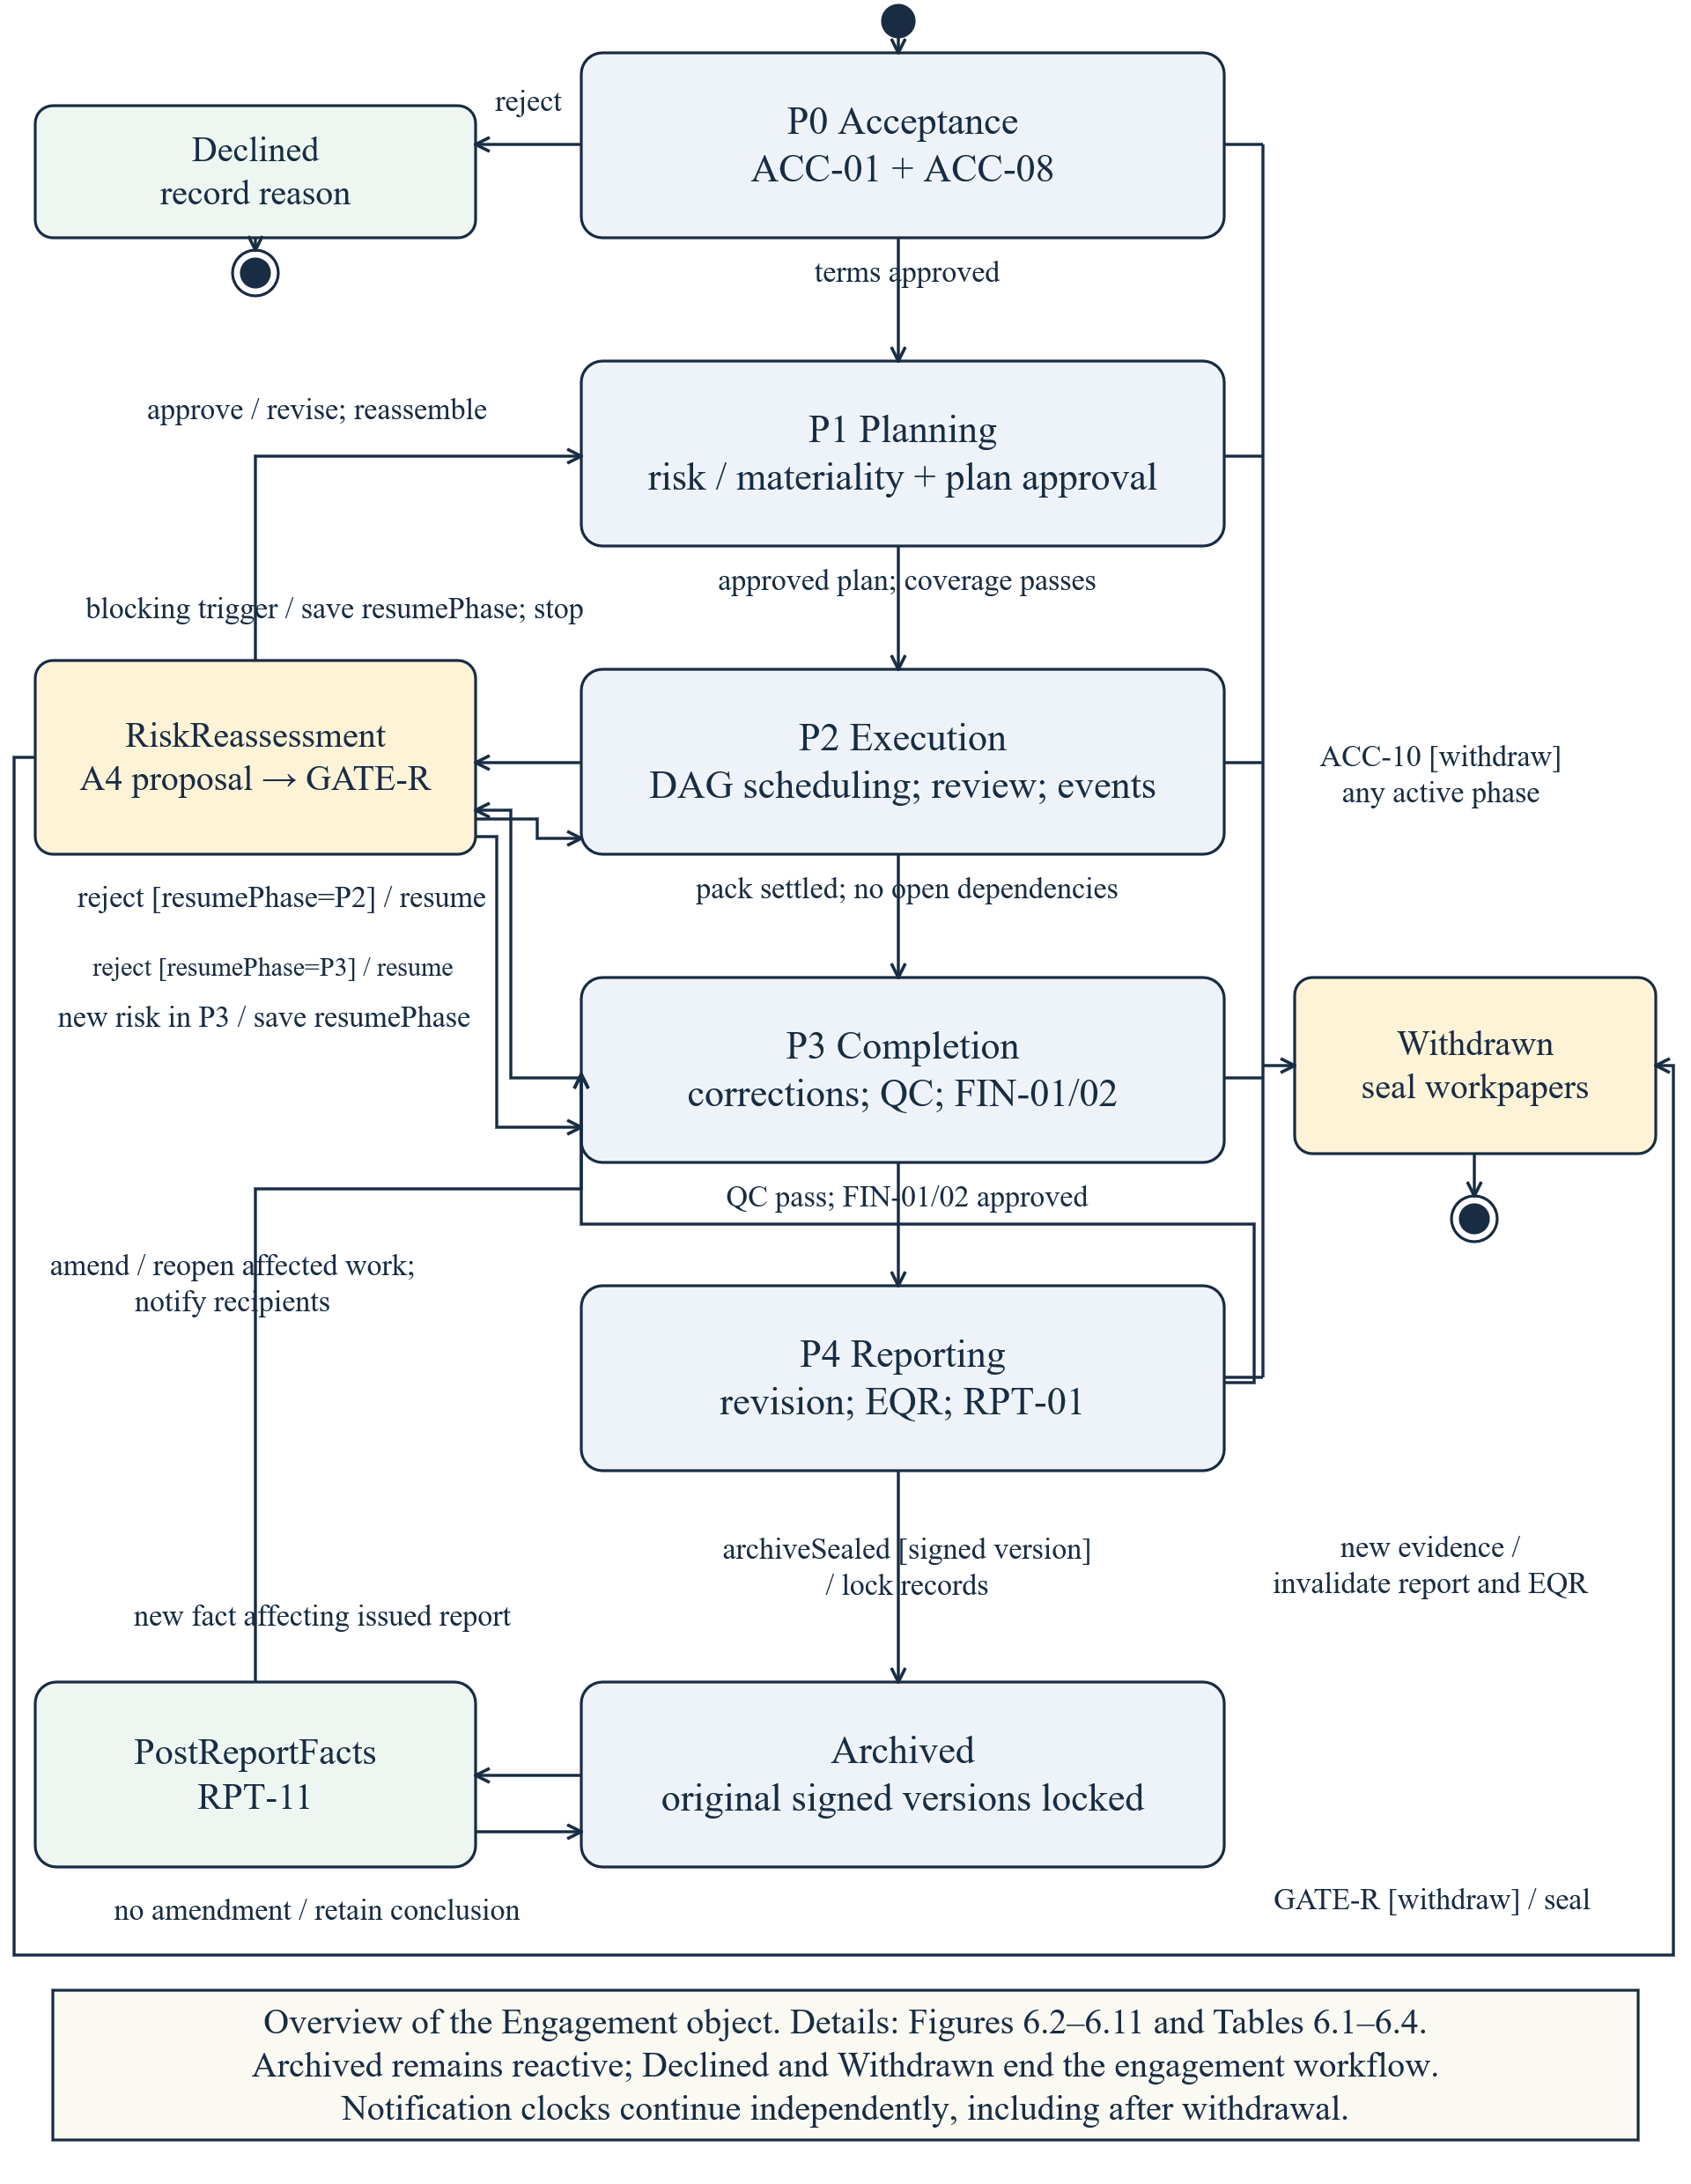
Reassessment records resumePhase. Approval returns to assembly without re-ingestion; rejection restores P2 or P3 as recorded. Post-report facts reopen affected work and create replacement reports while the signed original stays locked.

6.1 Planning and risk assessment
Figure 6.2. Plan approval activity — Chen Li / AH-A / UC-02
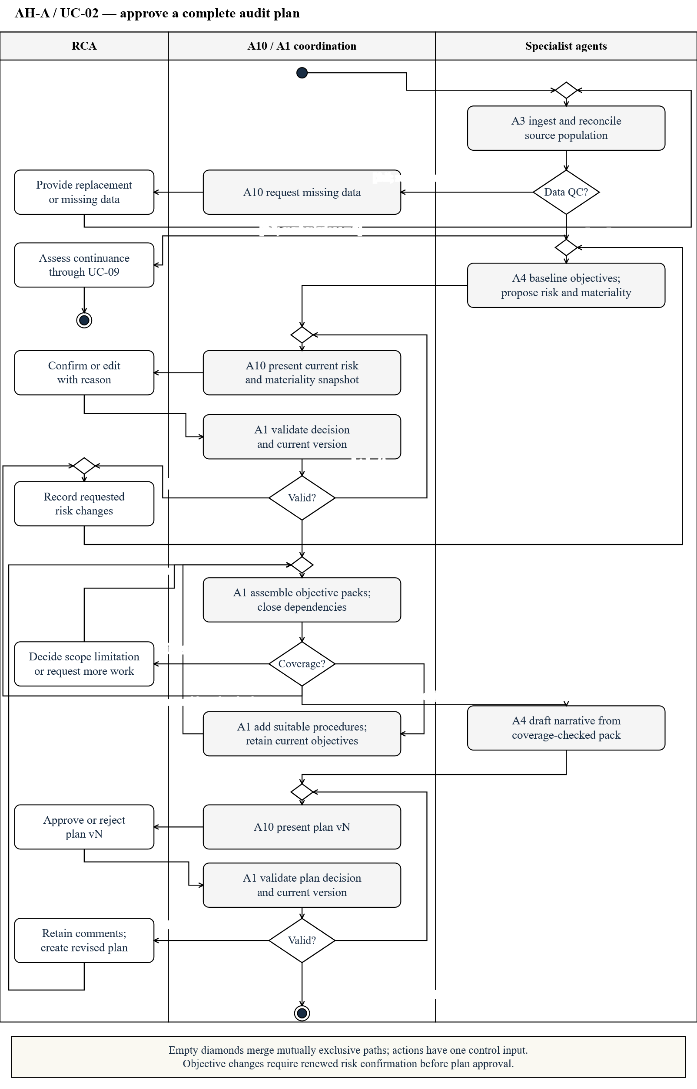
Data quality precedes risk reasoning. The RCA confirms risk and materiality; the system checks pack coverage before exact-version plan approval. Coverage failures select one remediation route: additional work, objective revision or a scope decision. Objective changes return to risk confirmation. A rejected plan returns to assembly and coverage, matching UC-02 step 4. Stale decisions return to presentation.
Figure 6.3a. Risk reasoning interaction — Chen Li / AH-A / UC-02
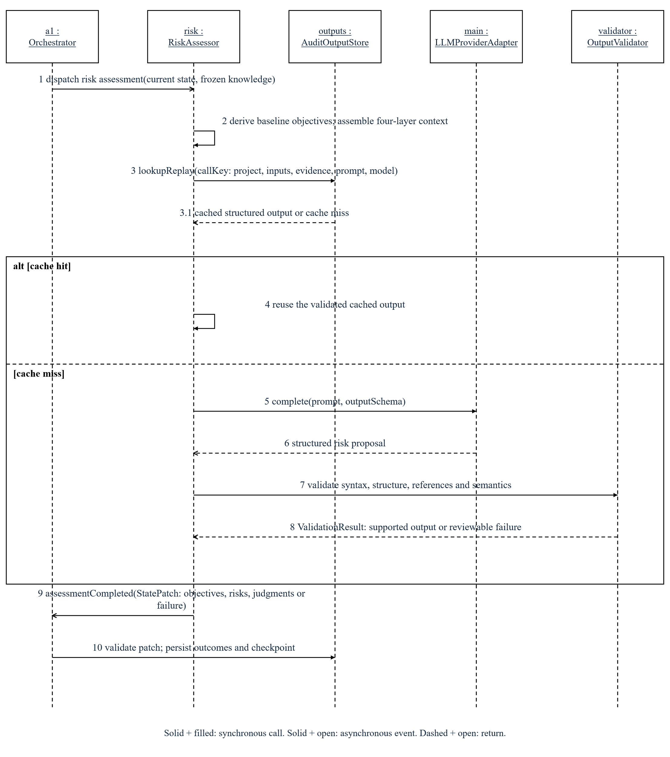
A4 uses scoped, versioned context and validated cached or live LLM output. It returns a StatePatch; A1 validates and persists it. Figure 6.3b continues with human confirmation.
Figure 6.3b. Risk confirmation interaction — Chen Li / AH-A / UC-02
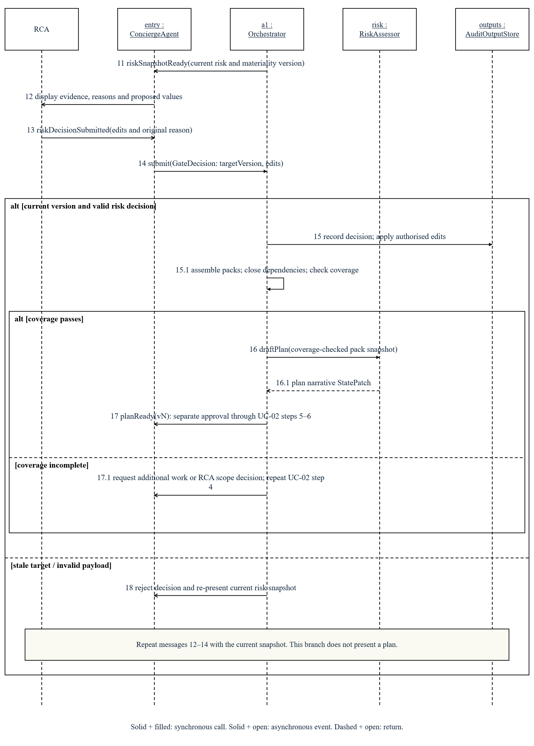
A10 transfers the decision for the presented snapshot. A1 rejects stale targets or invalid payloads. UC-02 then covers pack assembly, coverage and separate plan approval.
Figure 6.4. AuditPlan version lifecycle — Chen Li / AH-A / UC-02 and UC-05
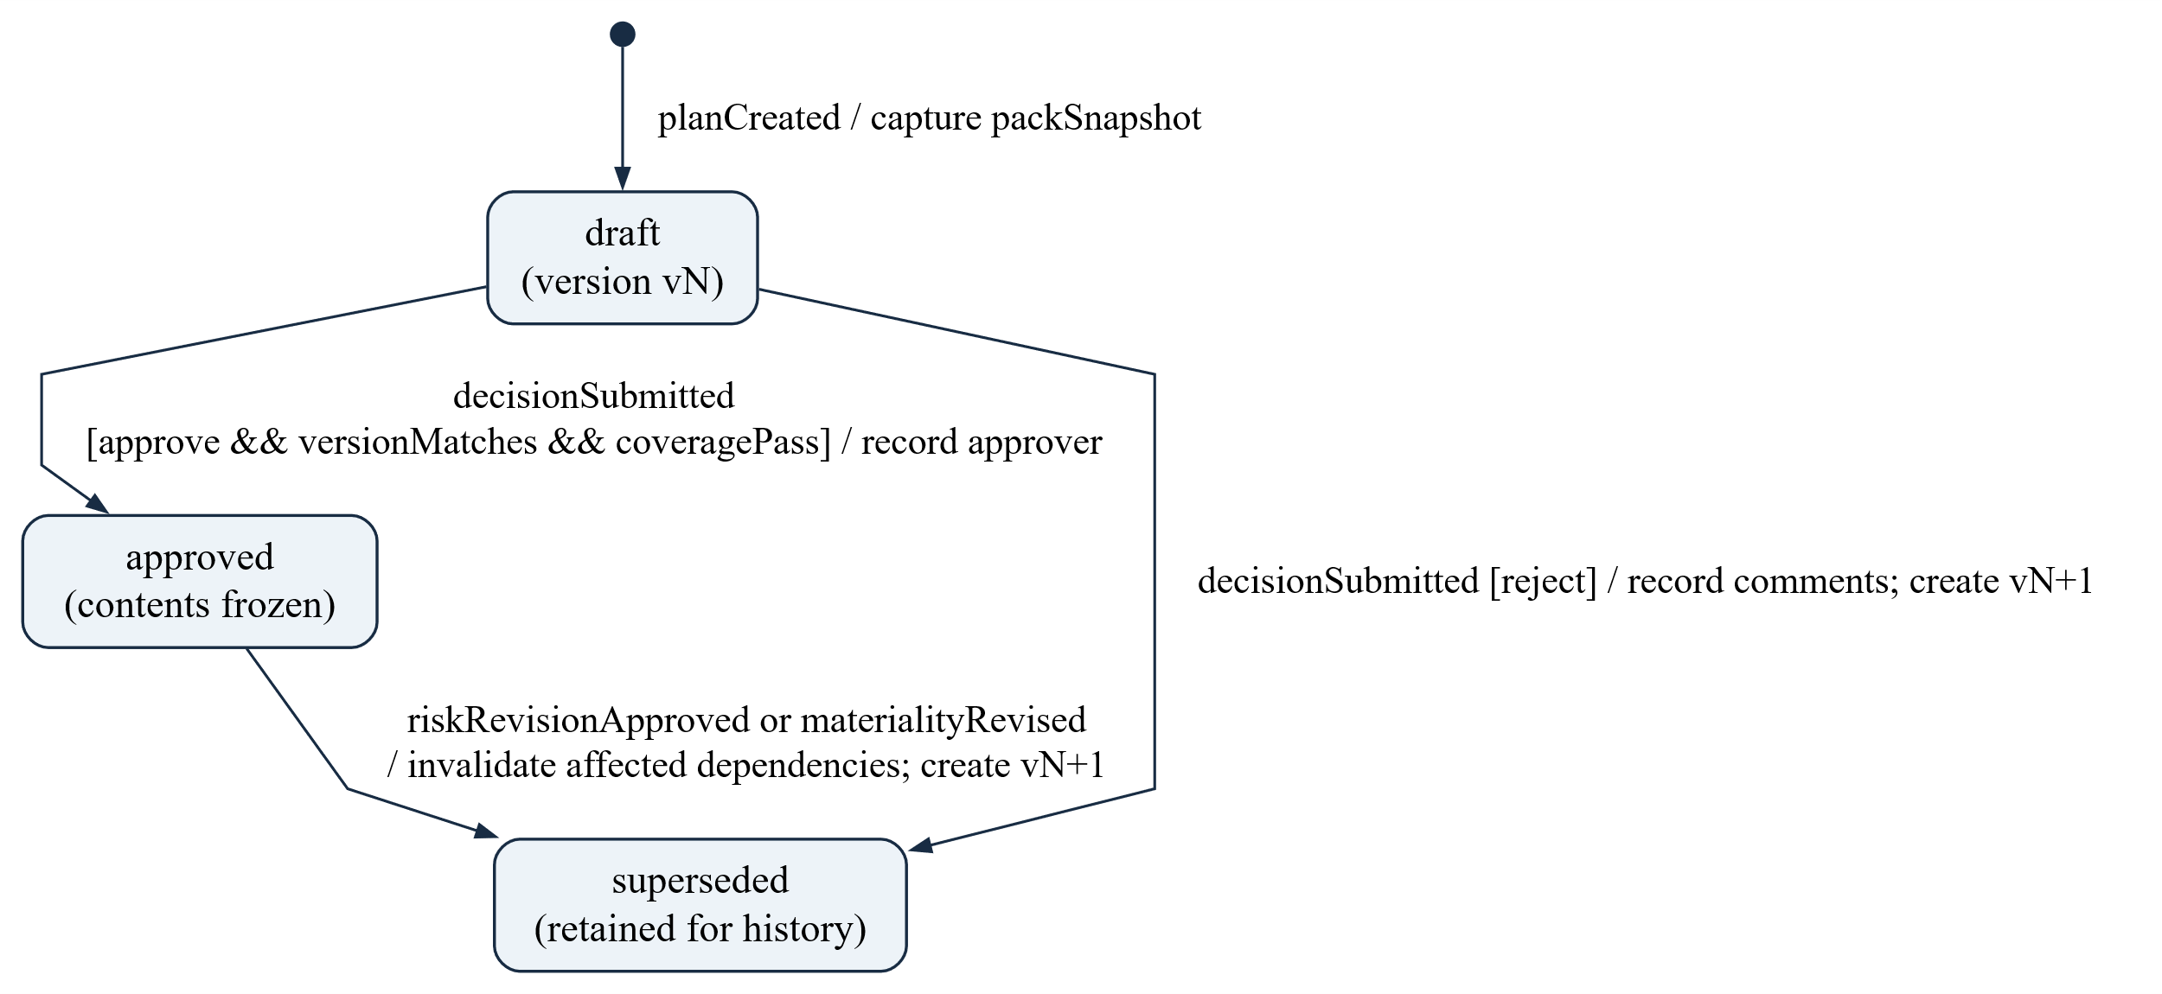
Approval freezes the current plan after coverage passes. Rejection, approved risk revision or changed materiality supersedes that version and creates a new draft; history is retained.

6.2 Procedure execution and review
Figure 6.5. Procedure execution activity — Yunpeng Tao / AH-B / UC-03
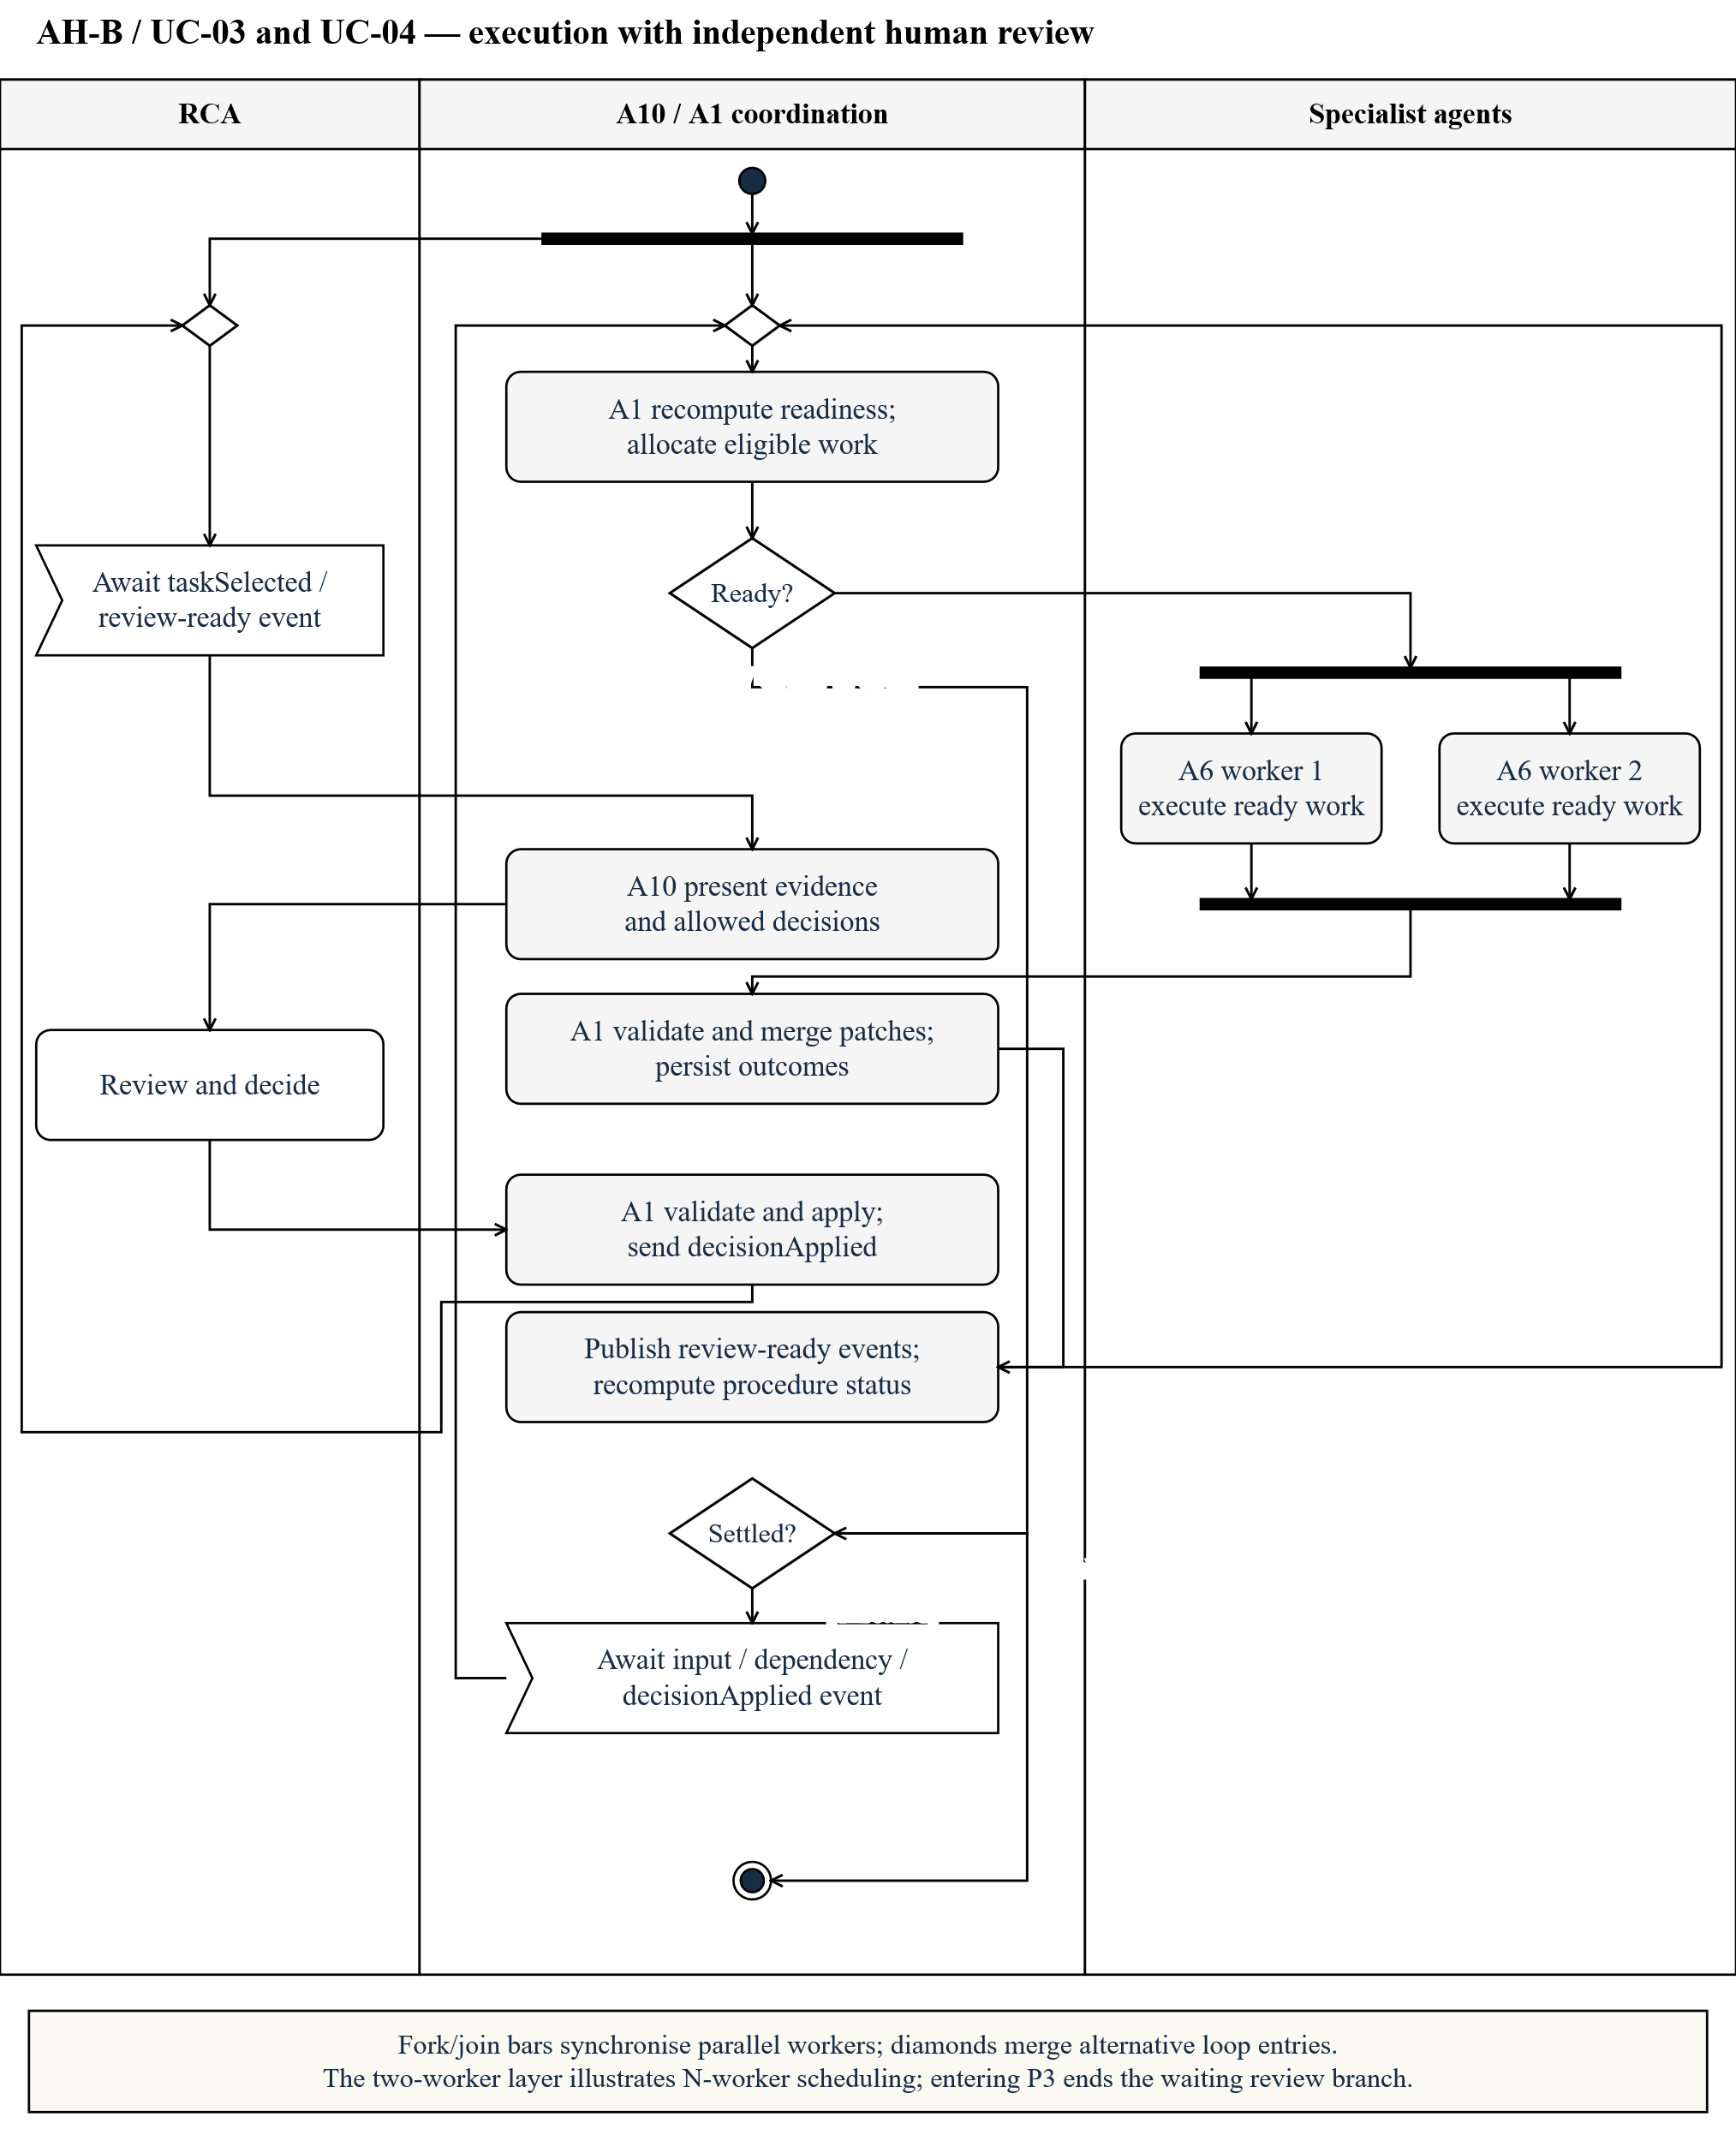
Fork/join synchronises ready A6 workers within the configured instance limit, default four. Confirmations arrive independently; only dependent procedures wait. A1 merges results before publishing tasks. Other ready procedures continue while review tasks remain pending. Exit to P3 requires the entire pack settled.
Figure 6.6a. Engine failure interaction — Yunpeng Tao / AH-B / UC-03 and UC-04
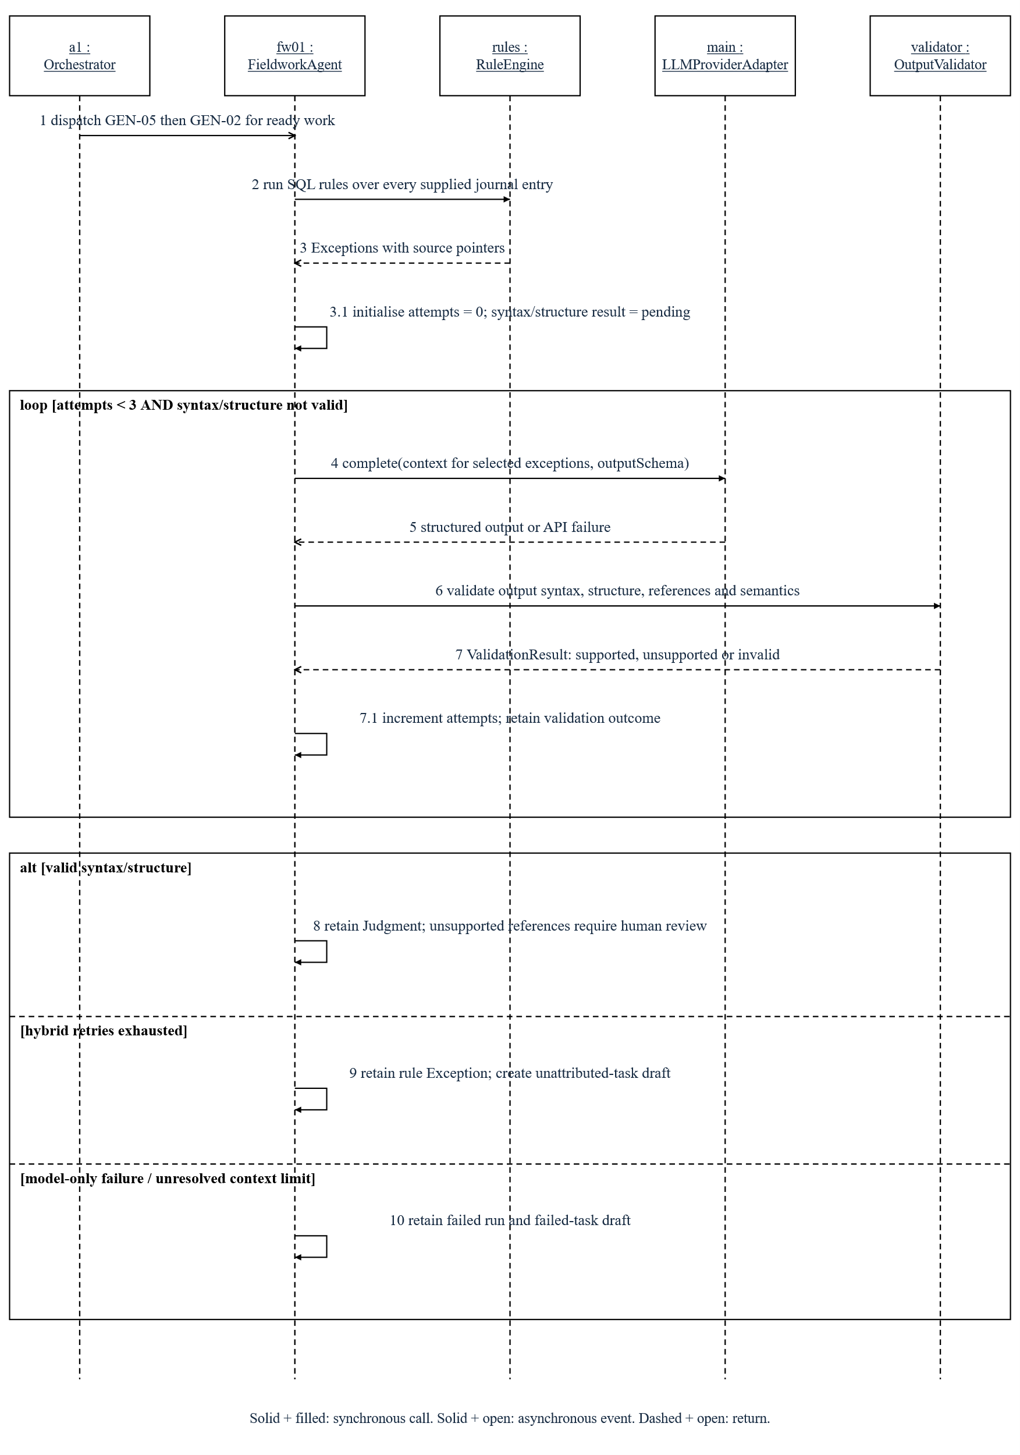
Syntax/structure validation permits an initial attempt and two retries. Outcomes are a validated Judgment, an unattributed hybrid Exception or a failed LLM-only run. Figure 6.6b handles review and merge.
Figure 6.6b. Critic and merge interaction — Yunpeng Tao / AH-B / UC-03 and UC-04
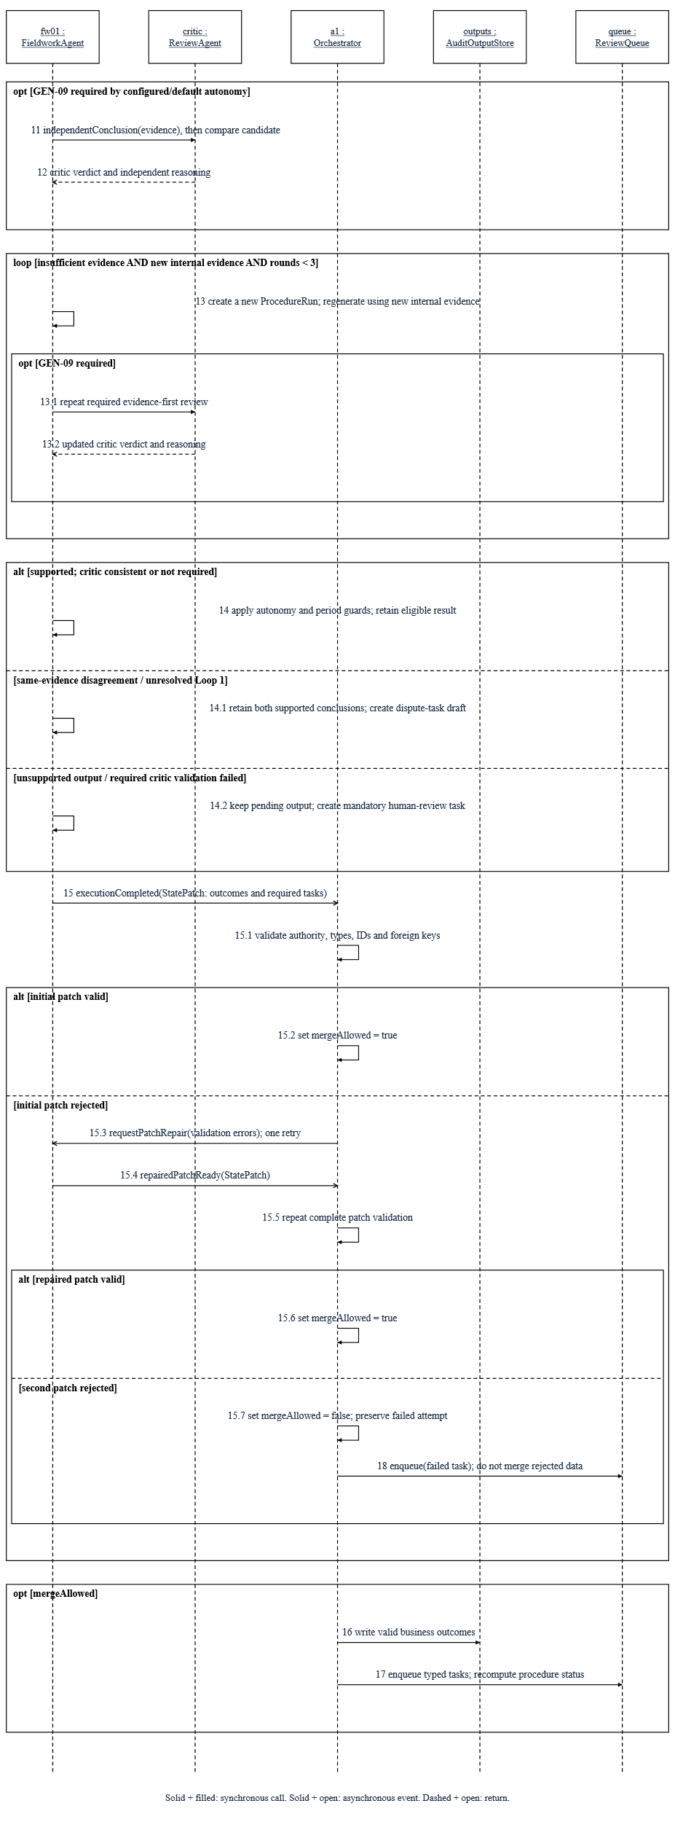
Eligible judgments receive independent critic review. New internal evidence can trigger up to three shared Loop 1 rounds; unresolved disagreement becomes a dispute. A1 validates patch authority, types, IDs and references before persistence and task publication. A second patch rejection requires human work.
Figure 6.7. Procedure lifecycle — Yunpeng Tao / AH-B / UC-03 and UC-04
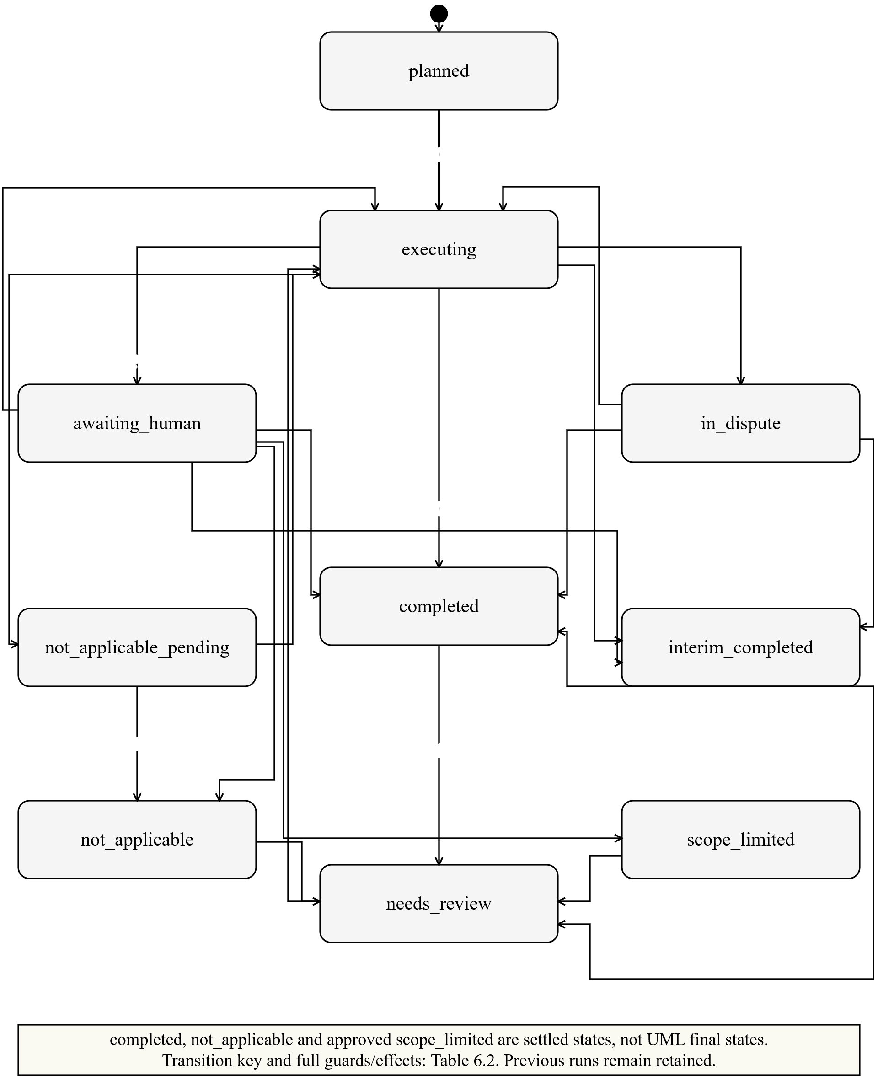
Settled states remain reopenable; rerun and more_procedures create new attempts. Tables 6.2 and 6.3 define transition conditions and permitted decisions.
Table 6.2. Full transition semantics for Figure 6.7
Key | Source → target | Event [guard] / effect
P01 | planned → executing | scheduled [dependencies ready] / create a new ProcedureRun
P02 | executing → awaiting_human | resultReady [execution failed OR (human review required AND no unresolved dispute)]
P03 | executing → in_dispute | criticInconsistent [not resolved by Loop 1]
P04 | executing → completed | resultReady [autoCloseAllowed AND reviewSettled AND periodCovered]
P05 | executing → interim_completed | resultReady [interim AND NOT periodCovered AND autoCloseAllowed AND reviewSettled]
P06 | executing → not_applicable_pending | ruleSuggestsNotApplicable / request confirmation
P07 | awaiting_human → completed | decisionSubmitted [reviewSettled AND periodCovered]
P08 | awaiting_human → executing | decisionSubmitted [rerun OR more_procedures] / new run
P09 | awaiting_human → scope_limited | decisionSubmitted [scope_limited AND approval recorded]
P10 | awaiting_human → not_applicable | decisionSubmitted [not_applicable permitted by task kind]
P11 | in_dispute → completed | disputeResolved [reviewSettled AND periodCovered]
P12 | in_dispute → executing | disputeResolved [neither + more_procedures] / new run
P13 | not_applicable_pending → not_applicable | decisionSubmitted [confirm rule non-applicability]
P14 | not_applicable_pending → executing | decisionSubmitted [rerun] / new run
P15 | interim_completed → completed | GEN24Completed [reviewSettled AND valid extension result] / set periodCovered
P16 | completed or interim_completed → needs_review | dependencyChanged OR additionalWorkRequested / invalidate affected result
P17 | not_applicable → needs_review | applicabilityChanged / reopen procedure
P18 | scope_limited → needs_review | newEvidenceReceived / reopen affected work
P19 | needs_review → executing | scheduled [new inputs and dependencies ready] / new run
P20 | awaiting_human → interim_completed | decisionSubmitted [interim AND reviewSettled AND NOT periodCovered]
P21 | in_dispute → interim_completed | disputeResolved [interim AND reviewSettled AND NOT periodCovered]
Instantiation enters planned. Table 6.2 expands Figure 6.7’s numbered transitions; all guards are evaluated against the current versions.
Table 6.3. Task kind × permitted decision matrix
Task kind | Permitted decisions / required payload
normal / blind | confirm; override with replacement conclusion and reason; misstatement with draft fields; more_procedures with requested IDs; evidence_unreliable with a recorded basis.
dispute | dispute_resolution only: a6_upheld, a7_upheld or neither. neither requires human_conclusion or more_procedures. a7_upheld is unavailable if the critic reasoning failed validation.
unattributed | override / human attribution, misstatement, more_procedures or evidence_unreliable. confirm is not a valid attribution.
failed | rerun with parameters; manual_result with conclusion and evidence; not_applicable with reason; approved scope_limited. Acknowledging failure cannot complete work.
scope_limited | Approve the limitation, rerun or request additional procedures. Management-imposed limits require a recorded request to lift the restriction and management response first.
na_pending | confirm to not_applicable, or rerun. An unconfirmed rule suggestion cannot satisfy completion.

Procedure settlement
A1 recomputes status after each decision. reviewSettled means all tasks decided, no open dispute or follow-up, and a current, valid supported result. Human review and disputes take precedence over interim closure. A year-end extension can complete an interim procedure only when reviewSettled remains true and the extension result is valid. Approved scope limitations and confirmed non-applicability remain reopenable with recorded reasons.
Review eligibility and sampling are defined in Section 6.4.

6.3 Completion and reporting
Figure 6.8. Completion and report activity — Yuanhao Wang / AH-C / UC-06
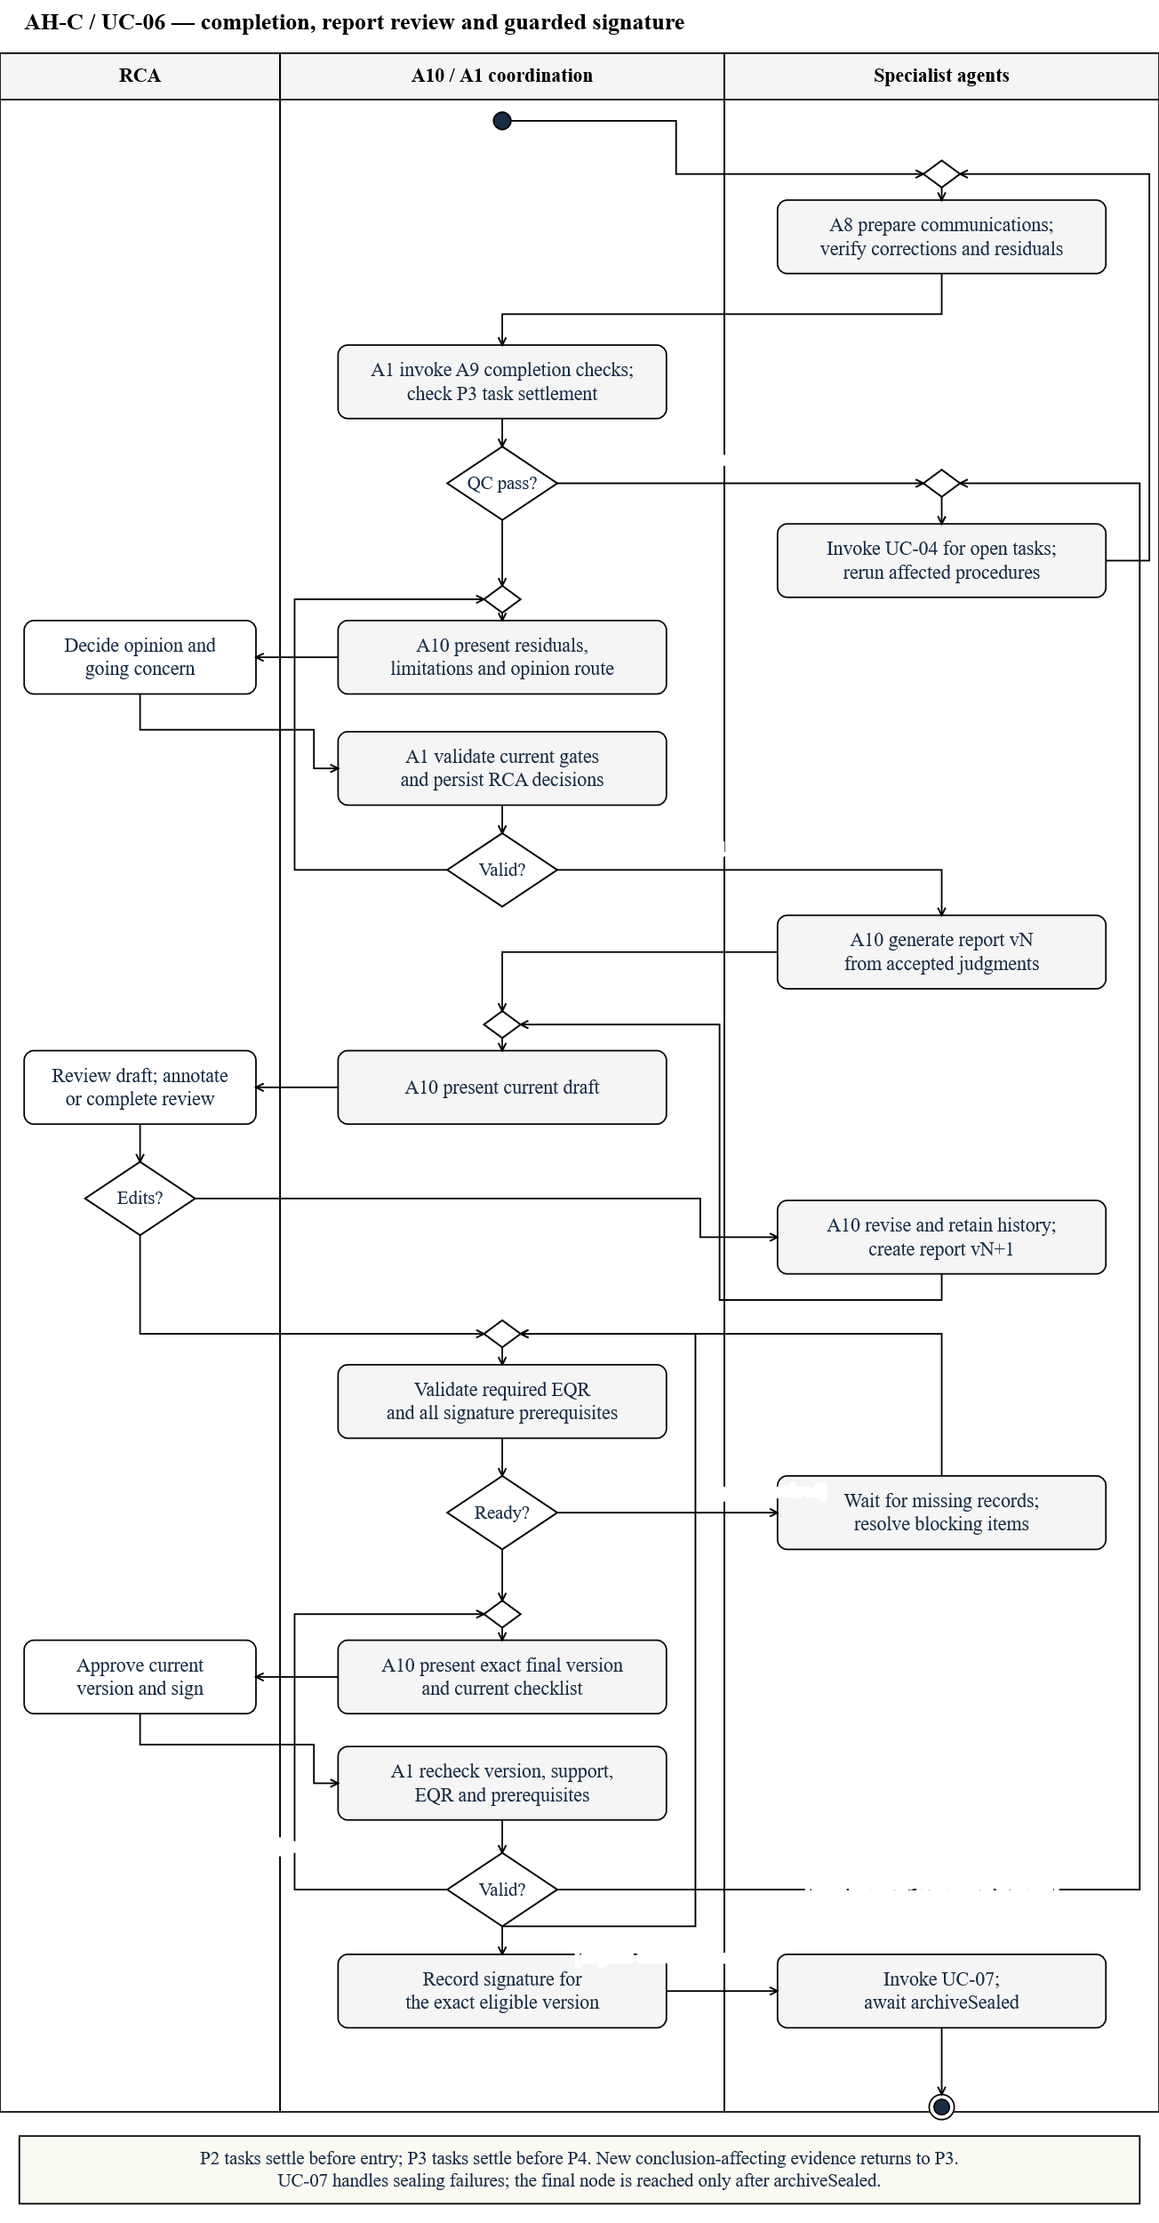
Corrections and reruns precede completeness checks. The RCA decides the opinion and going-concern outcome. Versioned revisions, required EQR and signature prerequisites must pass before signing.
Figure 6.9a. Report revision interaction — Yuanhao Wang / AH-C / UC-06
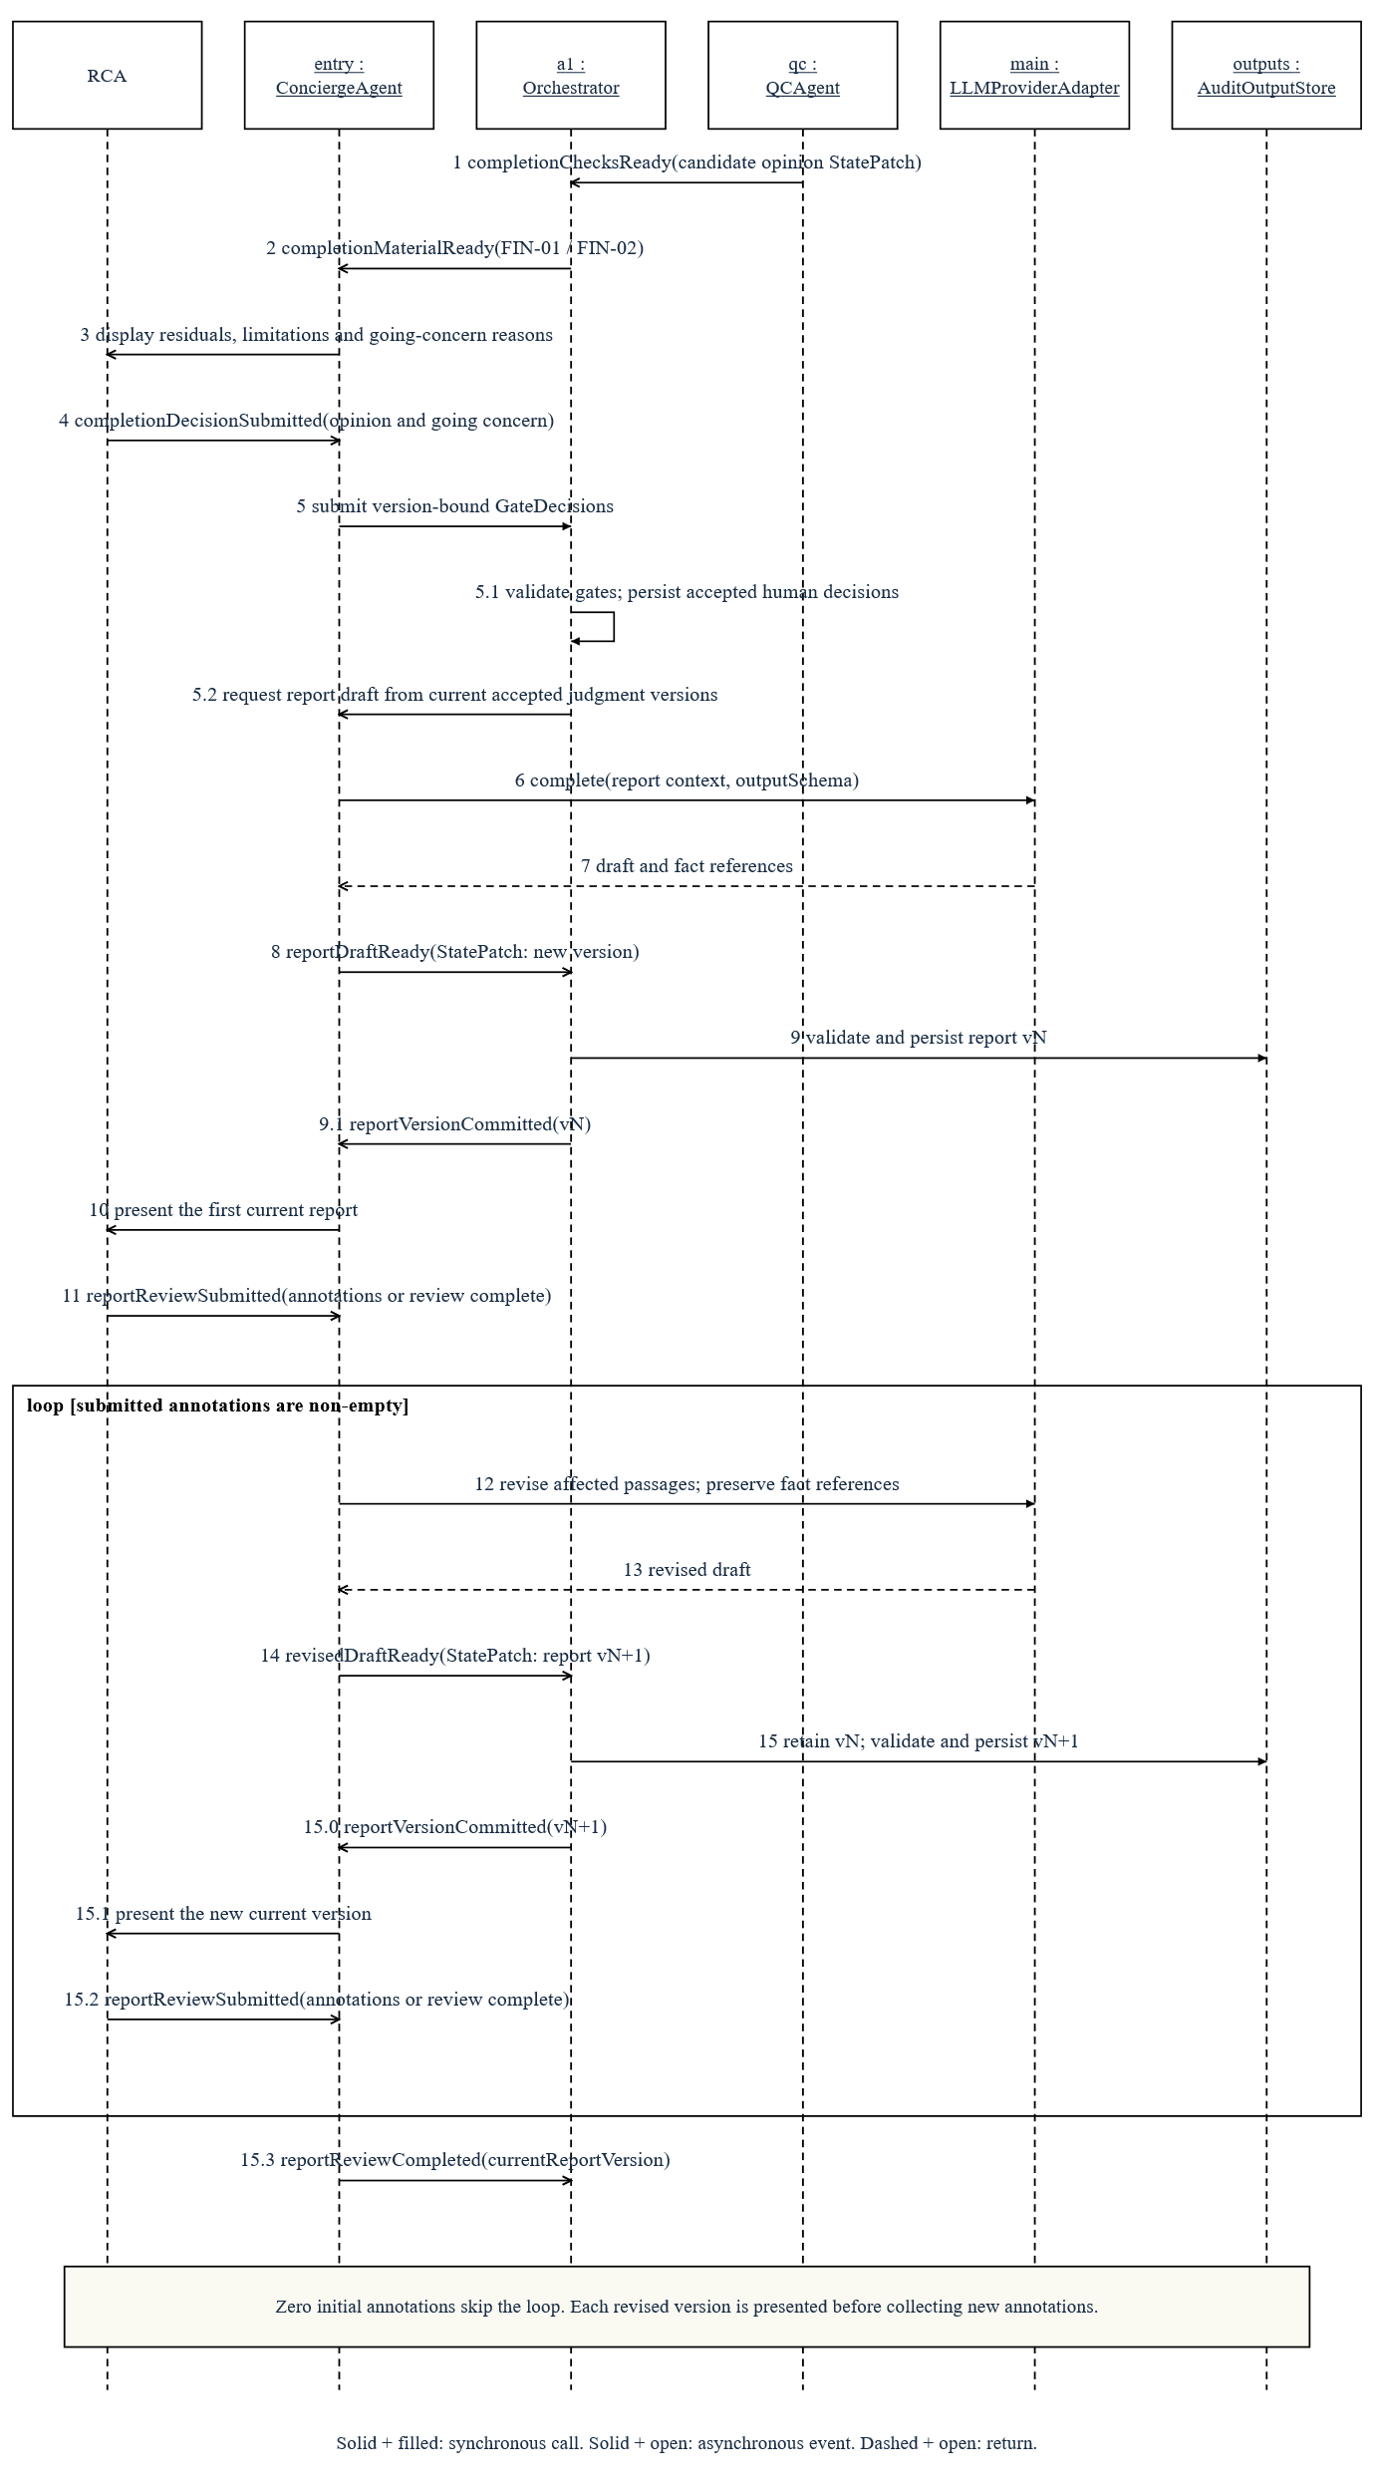
A10 drafts from accepted judgment versions and presents the first persisted report before collecting annotations. An empty response skips revision; each revised version is committed and presented before the next review. A1 retains the preceding annotated version.
Figure 6.9b. EQR and signature interaction — Yuanhao Wang / AH-C / UC-06
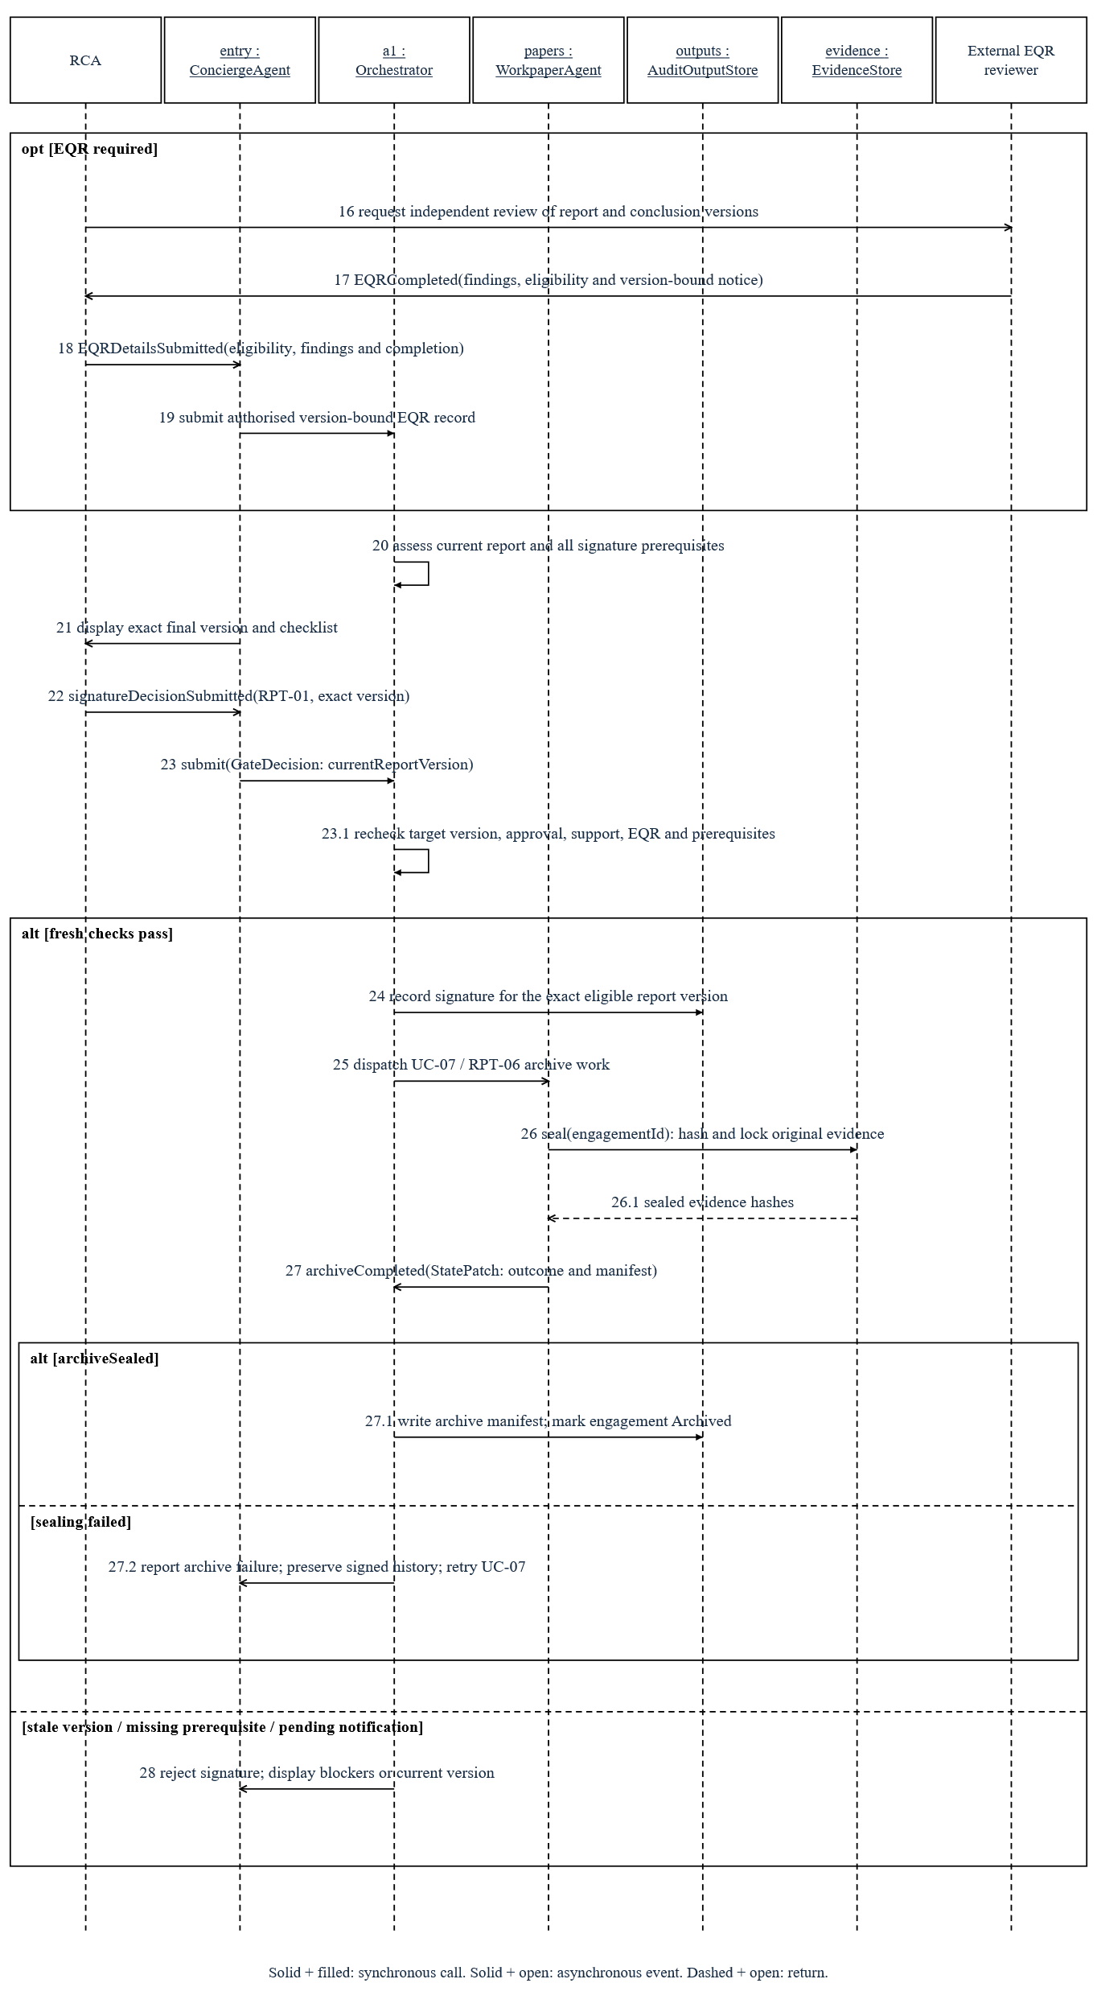
External EQR completion is recorded when required. After the RCA submits the signature decision, A1 repeats the current-version and prerequisite checks before signature. A8 seals evidence through EvidenceStore and returns the archive outcome; A1 persists the manifest only on success. Failed signing or sealing checks retain the unresolved state.
Figure 6.10. Report version lifecycle — Yuanhao Wang / AH-C / UC-06 and UC-07
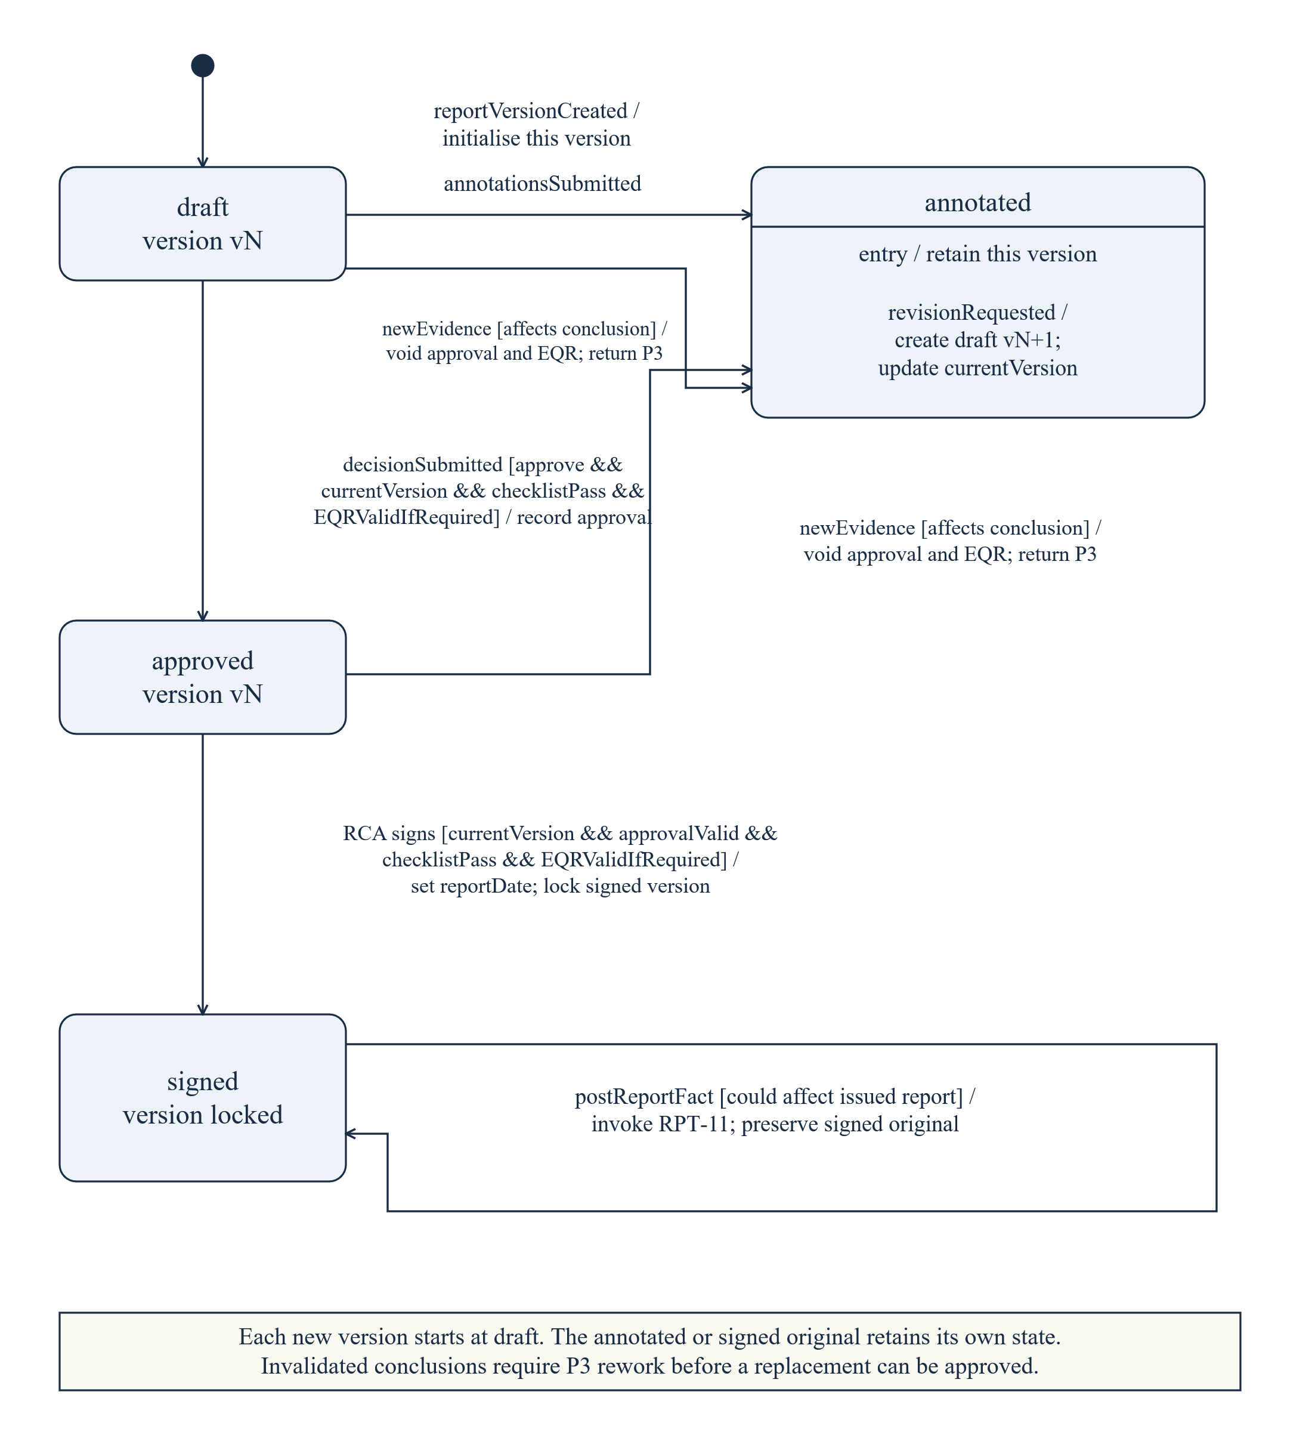
Each revision creates a separate version. Signature binds the approved current version; signed originals stay locked. Conclusion-affecting evidence invalidates approval and applicable EQR and returns the engagement to P3. A replacement version starts its own draft lifecycle; the annotated old version remains retained.
Figure 6.11. Persistent notification lifecycle — Yuanhao Wang / AH-C / UC-09
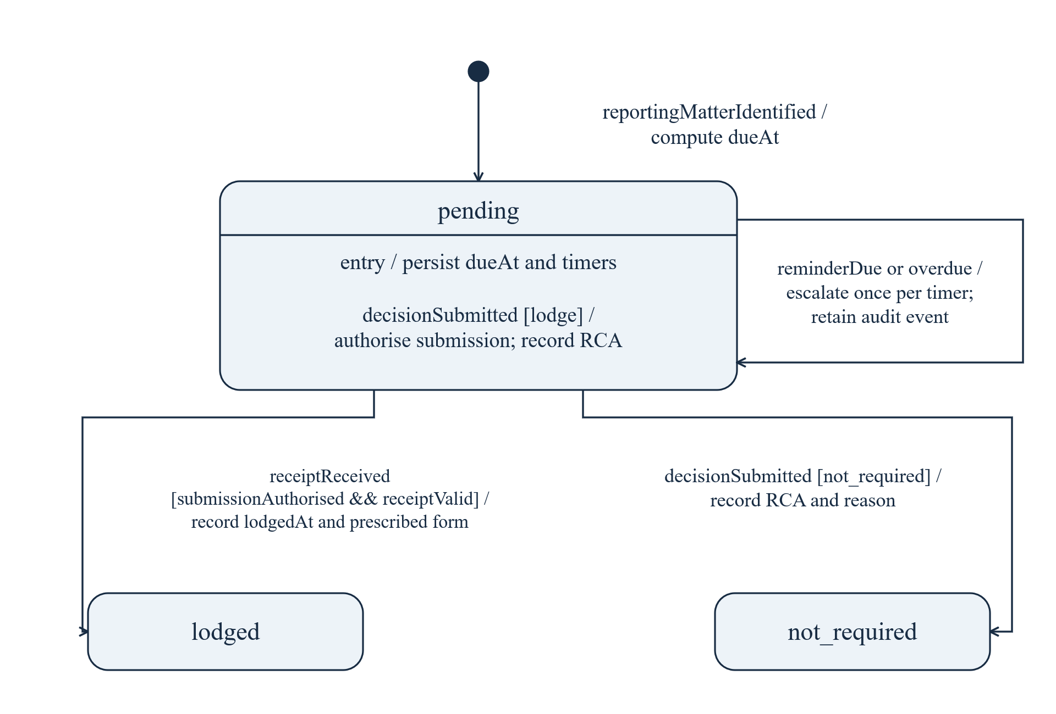
The design computes immutable dueAt from awareDate: 28 days for s311, seven for s990K and s324CA, subject to RCA-recorded applicability. Real forms and submission routes remain validation items.
Persisted reminders fire once three days before dueAt and once on overdue status. Lodgement requires human authorisation and a valid submission receipt. Pending notifications block signature; rejected reassessment, phase changes and withdrawal preserve the clocks.

6.4 Autonomy, judgment and review controls
Table 6.4. Default allocation and runtime autonomy
Mode | Default count | Human authority and runtime reductions
L1 Advisory | 32 | The system proposes; the RCA decides. These 32 reserved procedures never upgrade.
L2 Judgment + Review | 41 | The RCA reviews each judgment.
L3 Exception-based | 40 | Ordinary eligible items can close automatically; exceptions require review.
L4 Autonomous | 31 | Eligible work runs autonomously with monitoring and sampling.
Manual engine | 17 | Physical, interpersonal or externally performed work is assigned, evidenced and logged.
Runtime reduction | Applied per procedure | Significant risk: −2; high risk: −1; confidence <0.7: −1; historical agreement <80%: −1; first client: −1; related financial-report risk: −1.
Direct human routing | Overrides weighted scoring | Amount above performance materiality or fraud indicator forces L1. Inconsistent critic, missing required evidence or stale evidence goes directly to human review.
Downgrades accumulate to an L1 floor; reaching it through reductions enables blind mode. An upgrade requires the same procedure to exceed 95% human–AI agreement in three consecutive projects, with at least 30 blind samples covering at least two client types, and explicit RCA approval. Reserved L1 procedures cannot upgrade.

Inspectable judgment record
A judgment may support the report only if it is current, supported and accepted either by a valid human decision or by eligible automatic closure after required critic checks. Both use reviewStatus = confirmed; closureBasis records human or automatic acceptance. Missing or stale evidence, unsupported reasoning and unresolved disputes prevent adoption. Retained invalid outputs are pending audit records, not report inputs.
Judgments retain conclusions, evidence, reasoning, counterarguments, proposed actions, autonomy, critic results, review status and dependency versions. Facts and standards cite sources; inferences cite earlier steps. Unsupported facts remain reviewable. This record explains the result without claiming access to internal model reasoning.
Confidence weights are evidence coverage 0.3, hybrid rule agreement 0.3, LLM self-report 0.2 and eligible critic agreement 0.2. Inapplicable terms have zero weight; remaining weights are renormalised. Mandatory review overrides the score, which ranks review priority rather than calibrated correctness.
Table 6.4a. Review tiers and threshold boundaries
Condition | Required review
Confidence >0.9 and low amount | RCA-initiated batch confirmation with a 10% check.
Confidence 0.7–0.9 inclusive and medium amount | Individual reading of reasoning and counterargument.
Confidence <0.7 | Mandatory original-evidence inspection.
Amount above performance materiality | Full individual review; batch confirmation is unavailable.
Critic disagreement, missing/stale required evidence or fraud indicator | Full review or arbitration, regardless of confidence.
Amount bands are procedure-configured; the design does not assign a universal low/medium cutoff. A task that does not meet the batch condition receives individual review; low confidence or a mandatory trigger strengthens it. Exactly 0.7 and 0.9 belong to the individual-review band.
The 5% blind sample is separate from the batch check in Table 6.4a. Blind review presents only data and original evidence until the RCA records an independent judgment; it also withholds AI reasoning, counterargument and critic output. Arbitration presents both supported conclusions. Dwell time supports warnings about rushed review. Only the RCA initiates batch confirmation within the selected scope.
For example, a synthetic revenue-cutoff judgment links delivery note WB88213 (signed 3 January 2026), contract SC-113 (page 3, clause 4.2) and the retained AASB 15 paragraph 38 fragment. It proposes deferring AUD 142,000 with confidence 0.87 and records the possibility of a supplementary agreement as its counterargument. This score calls for individual review, with full review if the amount exceeds performance materiality. If the RCA confirms the misstatement, the system retains the decision and evidence, creates the misstatement record and tracks correction or residual evaluation.

Signature prerequisites
The signature gate checks independence, representations and dates, financial statement reconciliation, independence declaration, governance communication, other-information registration, required EQR, pending notifications and report-date prerequisites. A draft may exist before these pass, but cannot be signed.

6.5 Feedback and failure routing
Table 6.5. Three feedback scopes
Scope | Trigger and allowed work | Exit and traceability
Loop 1: procedure | Insufficient evidence from the generator or critic; seek only additional available internal data. | At most three shared rounds; each creates a new ProcedureRun. No new evidence exits early. Same-evidence disagreement or unresolved retries becomes human arbitration.
Loop 2: cycle | The RCA requests additional evidence or procedures without revising the project risk assessment. | A1 assigns the requested work to A5/A6, retains the request and rerun trigger and recomputes settlement.
Loop 3: project | Fraud, significant NOCLAR, undisclosed related parties, major events or uncorrected amounts above 70% of overall materiality; other triggers can be advisory. | Blocking triggers stop dispatch at safe points. GATE-R approval revises risks, reassembles and reapproves the plan; rejection resumes history; withdrawal seals work.
The independent-review procedure (GEN-09) uses configured/default autonomy before downgrades. Automatically closing L3/L4 LLM judgments need review; L1/L2 normally skip it unless an additional trigger applies. A7 uses an independent client/model, derives a conclusion from evidence, then compares the candidate. Rule-only Exceptions do not receive judgment review.
Arbitration records a6_upheld, a7_upheld, or neither with a human conclusion or additional procedures. Consultation supports this recorded decision.
Table 6.6. Important failure outcomes
Group / failure | Required visible outcome
LLM — timeout or rate limit | Bounded backoff and queuing; exhausted hybrid work retains an unattributed task, while LLM-only work becomes a failed task.
LLM — invalid output | Syntax/structure errors allow at most two retries. Unsupported references or reasoning remain visible and require human review; no unsupported result is adopted.
LLM — context budget exceeded | Batch rows or segment documents while retaining locators. If still over budget, create a failed task for a human scope decision; never truncate essential evidence.
Runtime — unauthorised or invalid patch | Reject the merge and request one repair. A second rejection creates a failed task for human action.
Runtime — fieldwork instance failure | Redistribute unfinished work within the configured instance limit; retain completed results and log the revised schedule.
Runtime — concierge unavailable | Switch to equivalent forms within 30 s, preserving the same decision validation. A transfer mismatch suspends the interface for assessment.
Review — unresolved critic disagreement | Retain a disputed task for RCA arbitration; it cannot count as settled or close automatically.
Review — abnormally high dual-model agreement | Investigate ineffective independence; change the model or prompt through change assessment and validate the revised critic.
Compliance — unresolved overdue notification | Issue pre-due and overdue escalation once each, retain the overdue event and block signature until disposition.
Missing, stale or unavailable external data are explicitly labelled and routed to replacement evidence or manual work through the relevant use case; they are not accepted as clean results.

6.6 Version invalidation and opinion routing
A1 follows evidence hashes and risk/plan versions to invalidate affected conclusions after evidence, risk, materiality, balances or reliability change. Related procedures become needs_review; approvals and report passages require review. Unrelated work is retained; supersededBy links replacement judgments.
Risk revision requires GATE-R and plan reapproval; corrections reopen affected balances without necessarily changing risk. Conclusion-affecting evidence in P4 returns to P3 and invalidates approval and applicable EQR. Material revisions require renewed EQR and affected written representations.
Table 6.7. Candidate opinion route: the RCA makes the final decision
Issue | Not material | Material, not pervasive | Material and pervasive
Confirmed uncorrected misstatement | Unqualified | Qualified | Adverse
Insufficient appropriate evidence | Unqualified | Qualified | Disclaimer
A9 proposes an opinion route from unresolved amounts and approved limitations. At the completion opinion decision, the RCA evaluates materiality, disclosure and pervasiveness, also considering going concern, core representations, prior-period matters and presentation.

7. Verification, validation and acceptance
The lifecycle guards now become testable acceptance conditions. Verification checks contracts and constraints; validation checks representative audit workflows. Tables 7.2a–7.2c connect every requirement to models and planned tests.
Table 7.1. Evaluation design
Evidence set | Purpose and reporting method
Synthetic demonstration set | Approximately 3,000 journal entries, a trial balance and supporting contracts, statements, delivery records, spreadsheet data, expense images and minutes.
Seven prototype anomaly types | Five full-population journal rules, a revenue cutoff issue and a return-clause issue. Report entry-level flags separately from judgment-level confirmed misstatements.
Three full-system anomaly types | Related-party transactions, leavers on payroll and long-outstanding balances without sufficient allowance. Retain these full-design tests even where the prototype omits the procedures.
Independent evaluation set | Use a different generation seed. Include suspicious-but-normal, missing, contradictory and supplementary evidence, missing source fields and interruption recovery.
Critic evaluation | A consistent L3 closure, a same-evidence disagreement requiring arbitration and an L2 judgment that should be skipped. Report findings, incorrect blocks and review rate by autonomy.
Performance scale | Measure 3,000 and 100,000 entries, hardware, model/provider configuration, concurrency, p50/p95 latency, tokens and cost. Report cold calls separately from cached replay.
Human workflow | Exercise gate rejection, stale version, explicit override, blind review, fallback forms, correction and sign-off blocking. Compare measured human effort with a defined no-system baseline.

7.1 Metrics
Recall = detected seeded anomalies / all seeded anomalies; precision = true positives / reported exceptions. FDR = FP / (TP + FP); FPR = FP / (FP + TN). Report false exceptions and human tasks per 1,000 entries. Measure reference-validation failure across all generated outputs; evidence resolution must be 100% for adopted judgments. Seeded recall covers only the represented anomaly types.
Objective coverage = objectives with assigned procedures / approved objective denominator. The denominator combines the rule baseline and approved additions. Report account/disclosure coverage separately, alongside evidence resolution, extraction accuracy, blind agreement, overrides, rework, critic outcomes, notification timeliness and external registrations.

7.2 Requirement-to-model acceptance matrix
Table 7.2a. Mandatory requirements
Requirement / feature | Component and model | Test / acceptance condition
M-01; Journal scan | A6 / RuleEngine; UC-03; Figs. 5.2, 6.5, 6.6a–6.6b | T01 — Scan every supplied entry; 3,000 entries <3 s; detect all seeded JE anomalies for the configured types.
M-02; Evidence traceability | JudgmentEngine / EvidenceStore; UC-04, UC-08; Figs. 5.3, 5.9 | T02 — Every adopted judgment has ≥1 valid pointer, with every required pointer resolving to the correct original source and locator. Invalid generated outputs remain counted as failures and cannot enter reports or auto-close.
M-03; Human gates | A1 / A10; UC-01, UC-02, UC-06; Fig. 6.1 | T03 — Each of four business gates / six static interruptions and GATE-R rejects unauthorised progression; decisions retain RCA and time.
M-04; Completeness checks | A1 / A9; UC-02, UC-06; Figs. 6.2, 6.8 | T04 — Any uncovered objective, unsettled procedure, unapproved limitation, pending NA, missing required standard/external-work record or required manual result blocks the relevant gate.
M-05; Reasoning records | JudgmentEngine; UC-04; Fig. 5.3 | T05 — Each LLM judgment has ≥1 reasoning step; fact/standard pointers and inference links are checked. Unsupported records remain visible and require review.
M-06; Human overrides | A10 / ReviewQueue; UC-04; Fig. 5.4 | T06 — Empty override reason or replacement conclusion is rejected; valid original text is preserved and the prior judgment retained.
M-07; Audit trail | AuditTrail; UC-03, UC-04, UC-08; Fig. 5.6 | T07 — Every call, human action, transition, rule, external action, failure and retry has an event; model/prompt/input/parameter snapshots can reconstruct the call.
Acceptance uses the complete design denominator. Substitutes and prototype_uncovered items are separately labelled and cannot establish full-system compliance.
Table 7.2b. Mandatory requirements
Requirement / feature | Component and model | Test / acceptance condition
M-08; Risk feedback | A1 / A4; UC-05; Figs. 5.1, 6.1, 6.4 | T08 — An approved revision marks 100% of affected completed procedures needs_review; unchanged dependencies remain retained.
M-09; Acceptance | A2; UC-01; Fig. 4.1 | T09 — The acceptance scorecard contains ASIC status and ABN validity; unavailable/stale results are labelled rather than accepted as a clean check.
M-10; Plan approval | A1 / A4; UC-02, UC-05; Figs. 6.2–6.4 | T10 — An unapproved or stale plan cannot start P2. Revised plans increment version and retain reason and approver.
M-11; Human interaction | A10 / API; UC-04, UC-08; Fig. 5.8 | T11 — Submitted decision and original payload match the RCA operation 100%; A10 failure reaches equivalent forms within 30 s; both routes reject stale targets.
M-12; Statutory controls | A1 / A5 / A6; UC-09; Figs. 5.4a, 6.11 | T12 — dueAt derives from awareDate and legal-basis rule and cannot be edited; pre-due and overdue events fire once; withdrawal does not cancel them; pending matters block signature.
M-13; Statutory controls | A9 / A10; UC-06; Figs. 5.4–5.4a, 6.9a–6.9b, 6.10 | T13 — Reject signature for missing ethics/independence confirmation (FIN-10), representation validation (FIN-18), financial reconciliation (FIN-12), independence declaration (RPT-08) or other prerequisites, invalid representation/report dates, required incomplete EQR or pending notifications.
M-14; Withdrawal | A1 / A2; UC-09; Fig. 6.1 | T14 — Human withdrawal is reachable from every active phase; record person/time/reason and any required resignation consent, then hash and seal workpapers; a management-imposed limitation needs the prior request and response.
Table 7.2c. Optional requirements
Requirement / feature | Component and model | Test / acceptance condition
O-01; Concurrent engagements | A1 / ReviewQueue; UC-07; §5.2 and Table 5.1 | T15 — Five engagements retain isolated states; project switching and cross-project queue ranking do not leak financial rows or evidence.
O-02; External sources | A2 / A5; UC-01; Fig. 5.7 | T16 — A configured litigation source contributes a labelled scorecard result through the replaceable interface.
O-03; Mobile review | Presentation; UC-04; Table 6.3 | T17 — A mobile layout supports confirm/override with the same payload and server-side validation.
O-04; Multilingual reports | A10; UC-06; Fig. 6.9a–6.9b | T18 — Generate English and Chinese versions from the same accepted judgment set without changing factual references or opinion selection.
O-05; Prior-year profiles | A2 / knowledge; UC-02, UC-07; Fig. 4.1 | T19 — Next-year loading identifies prior-year origin, version and differences; relevance is evaluated before reliance.
O-06; Rule-change proposals | ReviewQueue / knowledge; UC-04; Fig. 5.6 | T20 — Export overrides as traceable rule-change proposals; no automatic rule activation outside change assessment.

7.3 Boundary tests and change assessment
Table 7.3. Additional boundary and invariant tests
Case | Planned check
T21 · Round-amount journal rule boundaries | Normal one-sided entries, genuine round amounts, negative reversals, zeros and equality at the threshold. The zero side must not cause a false round-amount match.
T22 · Version race | Present v1, create v2, then submit a v1 decision. Reject it; show v2; retain the attempted action and prevent an implicit approval.
T23 · Correction path | Confirm cutoff misstatement, record client correction, increment data version, scan new entries, verify zero/positive residual or mismatch and recalculate accumulation.
T24 · Dependency closure and concurrency | Select an objective program whose predecessor is outside the initial selection. Close dependencies, reject cycles and retain the schedule. With default settings, no more than four A6 instances run at once; replaying identical inputs and limits produces the same grouping.
T25 · Context, references and review boundaries | Batch/segment excessive context without losing locators; route unknown pointers and exhausted work to review. Check scores just below, at and above 0.7/0.9; mandatory triggers always prohibit batch confirmation.
T26 · Resume / duplicate action | Interrupt near store write, external submission and checkpoint. Resume from recorded versions and idempotency keys; do not resend a confirmation or lose a decision.
T27 · Full coverage boundary | An interim result, unresolved dispute, unconfirmed NA, missing excluded-standard register or prototype-only gap must never be presented as complete full-system coverage.

Worked change: supplementary contract evidence
After a reviewed cutoff judgment, a supplementary agreement arrives. A3 records its hash/version; A1 marks dependent judgments stale, reopens affected procedures and rejects old-version decisions. A6 reruns affected work, retaining prior judgments. A risk change invokes UC-05; an evidence-only change follows normal invalidation.
Change assessment follows requirement → feature → component → model → acceptance impact. Record the decision and update affected diagrams, traceability, YAML, rules, prompts and schemas. Critic anomalies or repeated validation failures may trigger assessment. Compatible procedures need configuration; new engines/contracts need wider review.

8. Development plan and contributions
These acceptance criteria guide Stage 2. Its planned 26 implemented procedures, 42 substitutes and 93 registered-only procedures preserve the 161-item library. The prototype covers all phases and gates, four engine boundaries, perception, decisions, interaction, critic review and representative feedback.
Table 8.1. Prototype coverage
Slice | Planned procedures / behaviour
Acceptance | Registry/ABN check (ACC-04) and acceptance decision (ACC-01); appointment confirmation (ACC-08) retains its human interruption with substitute preparation.
Planning | Preliminary analytics (PLN-07), risk reasoning (PLN-04), materiality (PLN-01), risk confirmation (PLN-03) and plan approval (PLN-15).
Execution and perception | Journal scan and attribution (GEN-05, GEN-02); contract extraction (DOC-04); revenue contract, matching and cutoff work (REV-03, REV-08, REV-02).
Independent review | Subsequent-event monitoring and assessment (GEN-07, GEN-06) provide judgment scenarios for critic review (GEN-09); demonstrate consistent closure, arbitration and the normal L2 skip.
Completion | Misstatement communication and correction verification (FIN-08, FIN-09); accumulation and QC (FIN-04, FIN-05); human misstatement evaluation and going-concern decision (FIN-01, FIN-02).
Interaction and reporting | Enquiries and decision presentation (GEN-10, GEN-11); report drafting (RPT-03); guarded report approval and signature (RPT-01), including EQR/checklist and annotations.
Table 8.2. Three planned two-week iterations
Sprint | Increment and review evidence
1 · Skeleton | P0–P4, human gates, typed state, stores, merge checks, synthetic ingestion and rule/QC baseline. Demonstrate interruption and resume.
2 · Plan and judgment | Baseline objectives, risk proposals, dependency closure, plan narrative, document extraction, cutoff/attribution, structured output validation and review view.
3 · Review and closure | Independent critic, downgrades and feedback, correction lifecycle, EQR and sign-off, A10/fallback, blind review, independent evaluation and demonstration.

8.1 Contribution record
Table 3.1 identifies individual suites; Table 8.3 records the assigned report and model work.
Table 8.3. Assigned contribution record
Group task | Chen Li · 33.3% | Yunpeng Tao · 33.3% | Yuanhao Wang · 33.3%
Requirements / features | Acceptance, planning, risk and profile features | Execution, evidence, review and interaction features | Completion, reporting, statutory and exit features
Overall use case model | UC-01, UC-02, UC-05; actor/extension review | UC-03, UC-04, UC-08; actor/extension review | UC-06, UC-07, UC-09; actor/extension review
Architecture / package model | Orchestration, knowledge and plan interfaces | Execution, engines, output/queue contracts | Presentation, sign-off, archive and external-review boundary
Elementary structure | Plans, objectives, risks and Agent hierarchy | Templates, runs, judgments, evidence and services | Review/Report, governance, statutory and document consistency
Complex structure | A1 parts/ports; plan and state instances | Execution/review objects and numbered communication | Versioned decisions, sign-off instances and store realisation
Overall lifecycle / traceability | P0/P1 and UC-05; M-08–M-10 mapping | P2, recovery and human review; evidence/trail mapping | P3/P4, notifications and exit; signature mapping
Acceptance / report integration | Planning coverage, change assessment; design rationale | Rule boundaries, failure tests and model consistency | Correction/signature tests, document organisation and final readability
Table 8.4. Stage 2 feature responsibility
Member | Core features | Optional feature
Chen Li | Risk/objective planning and plan approval; controlled risk reassessment | O-05 prior-year profile reuse
Yunpeng Tao | Full-population execution; traceable judgment and review | O-06 override export and rule-change proposals
Yuanhao Wang | Correction/completion checks; report revision and guarded signature | O-04 multilingual reporting

8.2 Open validation items and production extensions
Table 8.5. Design assumptions requiring later validation
Item | Current treatment / completion evidence
Provider and interface fields | Verify authorisation, paging, entry population and created_by / approved_by availability. Missing fields need an alternate source or explicit manual route.
Standards and disclosure fragments | Maintain original text, IDs, provenance and versions. Complete the structured disclosure checklist and unresolved fragment locations before real use.
Prior-year relevance | Loading prior risks, misstatements and estimate outcomes requires current relevance assessment; a prior profile is not automatically valid current evidence.
Main and critic models | Select independent clients/models, permitted provider terms and acceptable external-data boundaries; validate critic performance and cost.
Notification forms, privacy and exit routing | Verify submission forms/routes, provider terms and APP 8 treatment, and entity-specific s329/RG 26 consent handling before live integration.
Production archive and operations | Human-readable export; WORM retention; controlled amendments; backup/recovery; deployment configuration, secrets and monitoring.
Optional knowledge services | Client-profile governance, rule-update approval and any embedding model / vector retrieval evaluation.

