**WISE WAYS**

**TO HEALTH©**



**Esther Johnson, RN, BSN, PHN**

**Holistic Nurse Consultant**

[**Ejohnsonholisticnurse@gmail.com**](mailto:Ejohnsonholisticnurse@gmail.com) **408-204-6885**

Copyright © 2016

All rights reserved, which includes the right to reproduce this e-book or portions thereof in any form whatsoever without permission.

For information, contact

Esther Johnson, RN, BSN, PHN

[Ejohnsonholisticnurse@gmail.com](mailto:Ejohnsonholisticnurse@gmail.com)

408-204-6885

The information provided to you and the products and services described are not intended to diagnose, treat, cure or prevent any disease. The statements regarding the products and services have not been evaluated by the Food and Drug Administration. The information provided is not intended as a substitute for the advice provided by your own physician or health care provider, and may not necessarily take your individual health situation into account. The author assumes no liability or responsibility for any actions you may take in response to the information received or use of the products or services described. Always consult with a licensed medical doctor prior to starting any diet, exercise or health improvement program.

Any inspirational testimonies and tips should not be considered medical advice and are not representative of results that may be obtained by everyone. This document contains tips, inspiration and motivation provided to you based solely on the personal results or opinions of the author.

**Wise Ways to Health©**

*Esther Johnson, RN, BSN, PHN, Holistic Nurse Consultant*

I am glad that you have requested my e-book Wise Ways to Health. As a registered nurse for over 35 years I have come to understand the importance of health and wellness and I am passionate about sharing that understanding with others.

This information has been complied over years of learning how to live healthier myself, as well as through reading, watching and learning from others about what exactly it takes to be a healthier and happier person.

It really is quite simple. So many times we are looking for what is easy or what will give us a quick fix. When in reality all it takes is common sense and a few techniques that anyone can implement easily and effortlessly, provided we are committed and conscious.

**WISE WAYS** is a Mnemonic to help remember each of the critical steps in achieving and maintaining the highest level of health and wellness.

**W = Water**

**I = Immune Function**

**S = Supplements**

**E = Eliminate Sugar & Processed Foods**

**W = Whole Food**

**A = Activity**

**Y = Your Commitment**

**S = Stress Management**

**W is for WATER**

Water: is perhaps the single most important thing we can do for our body. How much water do you drink each day? It is recommended to drink at least on half your body weight in ounces up to 100 ounces of water.

Water accounts for 60 – 70% of our body weight.

The brain is made up of 90- 95% water.

Blood is 82% water and the lungs 90%.

A drop of 2% in our body’s water can trigger dehydration. Dehydration is often the cause of feeling bloated, or experiencing an increase in fatigue.

When we do not get enough water, the body pulls it from other places, including the blood. This causes the small blood vessels to close, blood becomes thicker, we are more at risk for blood clots and it is harder for the cardiovascular system to pump the blood. This may result in causing high blood pressure, high cholesterol, and heart disease. Some studies have also linked the lack of water with headaches, arthritis and heartburn.

**Functions of water in the body**

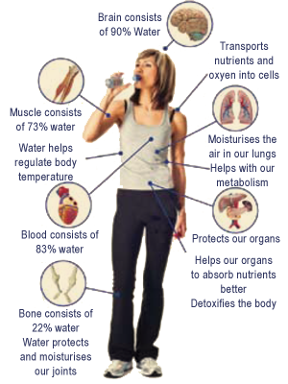

**Water hydrates and provides a vehicle for absorbing nutrients.**

***It lubricates our joints and cartilages*** and allows easier movement.

When we get dehydrated water is taken away from the joints resulting in more friction, more pain and is a common cause of arthritis.

***Water regulates our body temperature*** via perspiration and evaporation. The movement of water within our cells helps to transport plasma which plays a role in maintaining our body’s ph, circulating antibodies to support the immune system and regulating the osmotic balance within the cells.

***Water flushes toxins from the body*** via urination and perspiration. Water also helps relieve constipation and helps remove wastes quickly. Dehydration is a leading cause of constipation. Without proper hydration the intestinal tract can hold up to over 8 pounds of waste which can become poisonous to the body. Adequate fluid and fiber is the perfect combination, because the fluid pumps up the fiber and acts like a broom to keep your bowel functioning properly. Adequate water intake will also help the kidneys and liver function better further assisting in flushing out toxins and waste.

***Water Helps The Kidneys***. When adequate hydration is obtained the kidneys cleanse and remove toxins. Urine color should be light and free of odor. Urine that is concentrated or has an odor indicates dehydration. Chronic dehydration can lead to kidney stones.

***Water transports important nutrients*** within the body. Since our blood is 92% water it carries both oxygen and nutrients where they are needed. Water allows the nutrients to be carried through the small vessels of the intestinal tract to the blood and circulatory system.

***Water is a great appetite suppressant*** and will give a feeling of satiety when we are properly hydrated. We get water primarily three ways: from the fluids we drink, the food we eat and as a byproduct of metabolism.

***Water Helps Energize Muscles***. Cells that don't maintain their balance of fluids and electrolytes shrivel, which can result in muscle fatigue. Without enough fluid, muscles don’t work as well.

***Water Helps Keep Skin Looking Good***. Your skin contains water, and functions as a protective barrier to prevent excess fluid loss. Dehydration can cause the skin to look dry and wrinkled. Lock in moisture by using a moisturizer to create a physical barrier for hydrated skin.

***Water helps metabolize body fat***. Here is something I bet you did not know, being dehydrated causes an increase in body fat. This is because water helps to metabolize fat. When we lack water in the body extra glucose remains in the bloodstream and when it reaches the liver it gets stored as fat. One of the primary jobs of the liver is to metabolize fat into energy. If the body is dehydrated the kidneys cannot function properly to remove toxins and wastes and the liver must work harder to compensate. The body also removes water from inside body cells, including fat cells. This means that with less water in the fat cells the less the liver will be able to metabolize the fat and the fat cells will not be used for energy, instead they will just sit there, being FAT!!!

***Keep in mind that drinking too much water may lead to toxicity***. Excess water intake may be a risk to the kidneys and cardiovascular system.

**I is for IMMUNE FUNCTION**

80% of our immune function originates in our digestive system. A Healthy Gut will create a Healthy Body. A healthy immune system is the number one defense against ALL disease.

Here are the 4 R’s which are a key to a healthy gut:

* **Remove toxins**
* **Reduce fungus**
* **Replenish beneficial bacteria**
* **Regularity**

The immune system depends on essential nutrients being absorbed. When nutrients are scarce the body favors the brain. Eating a balanced, healthy diet is important. Anti-oxidants will enhance immune function. Vitamin D is now reported to help prevent disease though it’s effect on the immune system. Enzymes and Probiotics are also important for a properly functioning digestive system.

**Stress** will impair the body’s immune function, as will depression. Exercise is one of the simplest and easiest ways to deal with stress and depression, improve mood and rebuild the immune system.

**Food allergies** or sensitivities can cause damage to the digestive system or gut. As the body mounts an immune response to the suspected foods, holes develop in the digestive tract, nutrients are not absorbed, and as damage is increased. The allergies become more severe and trigger additional immune disorders to develop. This is known as “leaky gut”. The most common food allergies are wheat, gluten, corn, soy, dairy, eggs and nut/see allergies.

**Heavy metals** can cause toxicity, another factor that impairs the function of the digestive tract. Leaky gut is also caused by metal toxicity and frequently abdominal pain, dysbiosis (microbial imbalance) and a fungal overgrowth of Candida will be present, which all impair the immune system.

Poor diet or those who choose foods that lack tissue building proteins, fats and fat soluble nutrients add to the breakdown of intestinal function and impair the immune system. Many long term vegan diets may cause dysbiosis, colitis and an anabolic breakdown of the body’s tissues, which results in impaired immune function.

**S is for SUPPLEMENTS**

Supplements are important but should not be taken to replace whole food, which is the best source of nutrients. The most important supplements are Probiotics. So many health concerns are related to an imbalance in the good and bad bacteria of the intestinal tract. This is due in part to the overuse of antibiotics, chemicals and processed foods, toxins, high sugar intake and stress. The optimal balance should be 85% good bacteria and 15% bad bacteria. Choosing whole foods will shift the bacteria, but like a garden, we may need to fertilize for optimum function. Pre and Probiotics have been shown to repair a “leaky gut”, maintain a healthy gut and to help prevent chronic diseases of the bowel like IBD.

The friendly bacteria that reside in your gut have a number of very important functions.

***Carbohydrate digestion and absorption.*** Without good gut bacteria, the body is unable to absorb certain undigested starches, fiber, and sugars. The friendly bacteria in the intestinal tract convert these carbohydrates into energy and nutrients.

***Eliminate toxins, absorb minerals and produce vitamins.*** Probiotics aid in the breakdown and metabolism of toxins. Probiotics help to produce B vitamins and vitamin K and promote mineral absorption.

***Reduction of bad bacteria****.* Friendly bacteria in the gut compete with bad bacteria. Since the intestinal tract is more agreeable to the friendly bacteria they generally win most often for nutrition and attaching within the colon. However, when bad bacteria overgrowth occurs it is important to kill it off and eliminate it. The beneficial bacteria also help produce a substance that kills harmful bacteria while also signaling to the body how much nutrition is needed. Eating whole foods and a proper diet will help maintain this balance.

***Providing vital support to the immune system****.*Friendly bacteria have a powerful effect on your gut’s immune system and the overall systemic immune system. Beneficial bacteria protect and provide the development and operation of the mucosal immune system in the digestive tract. They also help to produce antibodies to harmful pathogens.

***Preventing allergies****.*Friendly bacteria train your immune system to recognize harmful pathogens and non-harmful antigens, and to respond appropriately. This is an important function which prevents the immune system from overreacting to non-harmful antigens, usually allergies.

***Anti-inflammatory effects***. Specific strains of Probiotics seem to have anti-inflammatory effects in healthy adults.  In addition to checking out which bacterial strains are included in the Probiotic it is also important to look for the following:

* Probiotics that need no refrigeration
* Probiotics with a long shelf life
* Probiotics that will survive stomach acid and reach the small intestine
* Probiotics that remain in the digestive tract long enough to be effective

Probiotics that contain *Lactobacillus, Propionibacterium, Bifidobacterium* and *Bacillus Coagulans* are the best.

Some studies have shown that the markers for inflammation in the body is lower in Lactobacillus and Propionibacterium groups which means they will be greater at acting as anti-inflammatories in the body systems. Other benefits are that these can better survive stomach acids and can withstand high temperatures, which means they will get to the small intestines where they do their work, and they do not need to be refrigerated.

**Sources of Natural Healthy Bacteria**

For centuries the use of fermented or cultured foods has been a way of keeping people healthy by maintaining beneficial bacteria in the gut. Foods such as yogurt, sauerkraut and some cheeses are excellent sources of healthy bacteria. Fermented foods such as Kim Chee, Kombucha or Kefir are affordable alternatives and provide the needed beneficial bacteria.

**Here is a list of popular fermented foods you might learn more about:**

1. **Kombucha** – a slightly fizzy and tangy beverage made by fermenting sweetened tea liquid with the kombucha mushroom culture. It has many different species of yeasts and bacteria’s, as well as amino acids, B vitamins, Vitamin C, and polyphenols. Kombucha contains something called glucuronic acid, a compound that can bind the toxins in the body and help remove them, which will aid in the detoxification process. And the antioxidants it contains, Vitamin C, epigallocatechin gallate, and organic acids of gluconic, lactic and acetic acids make it a wonderful immune booster.
2. **Sauerkraut or Kim Chee** – Cabbage has natural beneficial microbes on its leaves and by fermenting it in a brine solution or its own juice this fermented food is a wonderful natural probiotic.
3. **Tempeh** – this is a fermented bean cake that can be made from soybeans, black beans or garbanzo beans. When the beans are cooked and fermented they are easier to digest and will help with amino acid and protein absorption.
4. **Kefir** – a tart tasting drink, similar to yogurt. Kefir is made from fermenting milk (dairy, coconut or nut milks) using a Kefir starter. During the fermentation process the beneficial bacteria multiply and may provide the intestinal tract with probiotic properties that may boost immune function, eliminate harmful bacteria, and help rebuild the healthy gut flora. It is especially useful for those who frequently take antibiotics, as antibiotics kill off all bacteria in the intestinal tract. Kefir is best taken first thing in the morning when the stomach is empty.
5. **Miso** – is a fermented bean paste that is salty and is created by mashing beans, salt and the culture starter, “koji” which contains Aspergillus oryzae. Miso can be made with any type of legume.

**E is for ELIMINATE SUGAR & PROCESSED FOODS**

Elimination of sugar is one of the best things you can do for your health.

Do you read labels? Learning to read labels will provide you with a wealth of information. Since sugar is added to just about everything knowing the names of sugar will help. When reading labels, products are listed according to the amount of that ingredient present in the product. However, if many different forms of sugar are added to a product, when taken together, sugar could end up being the most plentiful ingredient in that product. Therefore it is helpful to know how to tell the difference between a foods inherent sugar, and what sugars are added.

Do you know all the names that sugar goes by? Here is a handy list:

* Agave
* All sugar substitutes
* barley malt
* beet sugar
* brown sugar
* buttered syrup
* cane-juice crystals
* cane sugar
* caramel
* carob syrup
* coconut sugar
* corn syrup
* corn syrup solids
* date sugar
* dextran
* dextrose
* diatase
* diastatic malt
* ethyl maltol
* evaporated cane juice
* fructose
* fruit juice
* fruit juice concentrate
* glucose
* glucose solids
* golden sugar
* golden syrup
* grape sugar
* high-fructose corn syrup
* honey
* invert sugar
* lactose
* malt syrup
* maltitol
* maltodextrin
* Malted …(anything malted)
* maltose
* mannitol
* maple syrup
* molasses
* raw sugar
* refiner's syrup
* sorbitol
* sorghum sugar
* sorghum syrup
* sucralose
* sucrose
* sugar
* turbinado sugar
* yellow sugar

Sugar creates an imbalance in your blood sugar and increases the demand on the body for insulin and can lead to metabolic syndrome, excess fat storage, and ultimately life threatening diseases. Metabolic disease is more problematic than obesity and may result in diabetes, fatty liver disease, heart disease, dementia or cancer.

**Tips for eliminating sugar and processed foods:**

1. Don’t shop when you are hungry
2. Shop the perimeter of the store which is where whole foods and fresh foods are placed
3. Read food labels, know how to identify sugars by its many names. Choose only those products with the lowest amounts of sugar.
4. Avoid anything that has “partially hydrogenated” on the label. This means it will last forever
5. Consider the food dessert, if sugar is listed as one of the first 3 items on the list
6. Replace beverages sweetened with sugar to those that are low calorie or sugar-free
7. Cut back on the amount of sugar you usually add to foods and drinks. Try substituting fruit for sugar on cereals and oatmeal. Or replace sugar in recipes using spices or natural flavoring extracts.
8. Remember milk has sugar, it is called lactose. Try substituting non GMO soy milk, almond milk or coconut milk instead.
9. Just because it says “whole grain” might not mean it is. However, if it does not say “whole grain: you can bet it is not.
10. Start your large meal of the day with a salad, using sugar free dressing. This allows your body to load up on high fiber foods which trigger the satiety center of the brain.
11. When eating breakfast, make real food, such as bacon and eggs, a fruit smoothie, cottage cheese or unsweetened yogurt as opposed to a “breakfast bar” or cereal.
12. Pack a lunch and make sure it is nutritious and contains foods you or your kids enjoy.
13. Like to snack? Try eating healthy snacks, like fresh veggies with hummus, slices of avocado, nuts or peanut butter. There is something to be said for healthy fats! They fill you up and when they are the right fats, and help your body and brain function better. When you feel full you will crave fewer sweets.
14. Remember, sugar is an addiction, so find out what triggers yours. Maybe you are bored, stressed or sad. Take up a new activity and engage in that instead of eating mindlessly. Try going for a walk, reading, being creative. Find a new habit to replace sugar cravings and over time you will have more energy, and feel better.

**Sugar Addiction**

Are you aware that sugar is addicting? Studies have shown that when given a choice of sugar or any other addictive substance, research animals will always choose sugar, hands down.

Watch this TED video to see how sugar tricks the brain:

<https://www.youtube.com/watch?v=lEXBxijQREo>

Sugar works to trick your brain by stimulating the “reward” center of the brain that causes dopamine to be released, one of our feel good chemicals. Too much dopamine production however is the basis of addiction.

Some sugars, such as glucose, fructose and lactose, occur naturally in fruits, vegetables and other foods. You body more easily recognizes and utilizes these sugars for energy. But many of the foods we eat contain "added" sugars, which are generally artificial or chemically constructed ingredients added to enhance the flavor. When the body is not able to easily recognize these substances it will “store” them as fat for use later since it does not know what to do with them.

**The most common sources of added sugars include soft drinks, cookies, cakes, pies, chocolate, fruit drinks and desserts. On can of cola can contain up to 7 teaspoons of added sugar, and an average-sized chocolate bar can contain up to 6 teaspoons.**

It is pretty near impossible to cut ALL sugar out of the diet since fruits, vegetables, milk and dairy products, alcohol, nuts and even eggs contain sugar. And eating a diet of only meat and fats is not healthy either.

**What about artificial sweeteners?**

While a large number of people have chosen to use artificial sweeteners, these may be no healthier than good old fashioned sugar. Artificial sweeteners may still cause the development of diabetes or obesity. Why? Because artificial sweeteners, which include sucralose, aspartame and saccharin, all interfere with the healthy bacteria in the gut. Some studies have shown that long term use of artificial sweeteners is associated with an increase in weight, increased abdominal fat, higher blood sugar levels and increased glycosylated hemoglobin levels, the marker that indicates the development of diabetes. So while artificial sweeteners were created to reduce sugar and lead to more healthy bodies, they actually may have had the exact opposite results. And remember, they are chemicals, and the body does not recognize and utilize artificial chemicals easily.

**Processed Foods**

Processed foods are the reason so many people are overweight and unhealthy. Let’s first look at the word “processed”. We know that most all the food we eat is processed in some manner. Avocados are cut from trees, ground meat has been ground up by a machine, and butter is nothing more than cream that has separated the milk from the churn. These are all mechanical processing and since there are no added chemicals that have been added, this is all still Whole Food.

The difference comes from chemical processing. When we refer to “*Processed Foods*” we mean food that has been chemically processed and made from artificial substances and refined ingredients. Here are the facts about processed foods.

1. **Processed foods generally are loaded with added sugar**. Remember that list?
2. **Processed foods contain multiple kinds of artificial ingredients.** How many times do you look at a food label and find you cannot even pronounce the ingredients? Most processed food is compiled of artificial chemicals and not real food. Even foods that are marketed as “healthy” or “natural” are processed. These artificial chemicals are generally added to prevent food from rotting, or used to give foods a special texture, color or taste. Be aware that not all chemicals are listed either. When a label lists “artificial flavor” there may be up to 10 more additional chemicals that make up that flavor.
3. **Processed foods often contain refined carbohydrates**. Carbohydrates are an important part of good nutrition, but they must come from whole foods. Processed foods contain simple carbohydrates that are broken down quickly resulting in a spike in blood sugar levels, and the demand for more insulin. This creates a pattern of highs and lows which result in cravings for more carbohydrates a few hours later.
4. **Processed foods trick our taste buds and brain** and as a result we tend to over consume them. Nature gave us taste buds to help us identify sweet, salty and fat tastes, because these are the foods we need for survival, energy and brain health. When manufacturers process food they make it so appealing to the complex mechanism in our bodies and brain that we get confused and choose unhealthy foods over those that regulate our energy balance. This is known as the “food reward hypothesis of obesity”.
5. **Processed foods are addicting**. You have already read about the addictive components of sugar, add in chemicals and it becomes even more problematic. Like sugar, artificial chemicals also trick the brain and cause the release of more dopamine. When the biochemistry of the brain is changed it can result in losing one’s will power to avoid unhealthy foods.
6. **Processed foods are generally lower in nutrients.**  When foods are processed they lose the valuable vitamins and minerals we need to maintain our bodies. Eating real, whole foods are the best way to get the recommended daily allowances of all the vitamins, minerals, antioxidants, trace nutrients and enzymes we need for proper body function.
7. **Processed foods are low in fiber.** Our bodies need soluble, fermentable fiber to function optimally. When foods are processed fiber is removed during that process. Fiber slows down the absorption of carbohydrates, helps us to feel full longer which allows us to eat less food. Soluble fiber is also an important part of daily regularity. Many people who eat processed foods are constipated. Were you aware that the gut can hold up to 8 pounds of decaying waste? Fiber also acts as a Pre-biotic and helps to feed the friendly bacteria that our intestinal tract needs.
8. **Processed foods require less time and less energy during digestion.** Processed foods are made to be easily consumed, easy to chew, swallow and have a very long shelf life. Processing foods renders them totally different from the foods they were created to resemble. As a result these foods are consumed more quickly and require little to no energy to metabolize. As a result we take in more calories and expend fewer calories. Studies have shown that when we eat whole foods we can burn up to twice as many calories and get the important nutrients our body needs. This is based on the “thermic effect of food (TEF)”, which is a measurement of the amount of energy it takes to metabolize a food.
9. **Processed foods contain high levels of trans fats or processed vegetable oils.** Trans fats are the unhealthy fats that result from refined and hydrogenated seed or vegetable oils. Generally they are cheaper to produce, and often contain higher than normal amounts of omega’s that may increase oxidation and inflammation in the body. Trans fats put people at higher risk for heart disease. The best alternatives to trans fats and hydrogenated oils is to choose real fats like butter, coconut oil ad olive oil instead.

The best way to improve gut health and prevent disease is to eat Whole Foods.

**W is for WHOLE FOODS**

Eating whole foods is the best way to get the nutrients, vitamins and minerals we need. But due to our current lifestyles and demand for food being easily available we have gotten away from eating whole foods.

When we eat whole foods our body recognizes the basic components of the food and processes it, using it for energy and metabolizing it completely. When we eat processed foods the chemicals and additives are not recognized by the body and so are not utilized but rather stored as fat, since the body does not know what to do with them.

So when shopping, choose REAL whole foods, fresh fruits, vegetables, whole grains, and choice lean cuts of meat.

Again, avoiding processed foods whenever possible will give you a healthier advantage.

**What is a Whole Food?**

Whole foods are those that are in their most natural state. They may be grown locally, in your own garden, organic or pesticide free, but they don’t have to be all of these things. When we eat whole foods, we get all of the vitamins, minerals and other nutrients that are in that food, which will help keep the immune system strong and functioning optimally.

Studies show that choosing whole foods may contribute to reduced risk of heart disease, diabetes or some types of cancer. In addition to vitamins and minerals, whole foods contain phytochemicals, which are the plants natural compounds that help our body. Some of these phytochemicals include antioxidants like lycopene in tomatoes, flavonoids in chocolate or carotenoids in carrots.

Eating whole foods is also much less expensive than eating processed foods, since processing increases the cost. And who doesn’t love the taste of a fresh ripe tomato right out of the garden. Growing your own fruits and vegetables can be a fun and healthy way to live better.

**A is for ACTIVITY**

We all know that exercise is “good for us”. But do you really understand the importance of daily activity. Physical activity will give you more energy, boost your spirits, improve your sex life and provide overall health and wellness and may well lead to living a longer life. Doing some type of physical activity every day is necessary for our physical as well as mental and emotional health.

Research has shown that exercise is the best way to reduce stress, relieve anxiety and process mental challenges.

Many people don’t feel they have time to exercise or still more don’t even like exercise. So where can we start and how do we get in the activity that we need to be healthier?

* Take the steps instead of the elevator
* Park at the far end of the parking lot and walk a longer distance
* Get up from your desk every 90 minutes and take a 5 minute walk. Did you know that even short spurts of exercise when added together are as beneficial as a 30 minute workout?
* Take a walk during your lunch break.
* Find an activity that you really enjoy and do it, consistently.

Benefits of regular physical activity include:

1. **Boosts Energy**. Regular physical activity delivers nutrients and oxygen to the body which will improve muscle strength and help improve your ability to do more, or increase endurance. It also helps the heart and cardiovascular system function more efficiently.
2. **Improves Mental Health and Mood**. Physical activity activates the chemicals in the brain and stimulates the feel good chemicals like endorphins and dopamine. Getting exercise when feeling stressed, depressed or tired can give you the physical and emotional boost you need. When you feel better your self esteem and confidence improve too. Regular physical activity keeps us thinking clearly, helps enhance the learning process and keeps our judgment intact.
3. **Strengthen bones and muscles**. Regular physical activity will keep the bones, muscles and joints limber. We may be able to slow the progression of arthritis by continuing to move. Muscle strengthening activities will increase or maintain muscle mass and strength. As we age we begin to develop holes in the matrix of our bones. Older adults are at higher risk for falls and possibly hip fracture. Studies have shown that engaging in muscle strengthening; aerobic exercise can slow the loss of bone density. This is especially important for post menopausal women.
4. **Weight Control**. Physical activity burns calories. The more intense the activity the greater the number of calories will be burned. And this calorie burn continues for up to several hours after a workout. So physical exercise can help with weight loss or maintaining a stable healthy weight. Even something as simple as taking the stairs, doing household chores or walking around the block with raise the metabolism of the body and burn more calories.
5. **Improve Sleep**. When we engage in regular physical activity we are more easily able to fall asleep at bedtime, stay asleep and engage in the deep REM sleep needed for rest and rejuvenation. However, try to avoid exercise right before bedtime as it may increase energy which may interfere with falling asleep.
6. **Supports a healthy body prevents development of chronic conditions or disease.**  Physical activity can help to manage all sorts of health concerns or problems. Metabolic disease, which is a condition that presents with a high level of fat around the waist, high blood pressure, high blood sugar levels, low levels of High Density Lipoproteins (HDL) and high triglycerides.Engaging in daily physical activity gets the body’s blood moving which may reduce blood sugar levels, lower blood pressure, and increase the amount of High Density Lipoproteins (HDL) in the body needed to keep cholesterol at healthy levels. It will also help to lower unhealthy low density lipoproteins (LDL) and triglycerides. Studies have shown that engaging in regular physical activity may help with improving balance to reduce risk of falls, reduce pain due to arthritis, correct metabolic syndrome, or prevent the development of stroke, depression, certain types of cancer and diabetes.
7. **Reduce risk of some cancers.** Research has demonstrated that regular physical activity lowers the risk of both breast and colon cancer. While more research is needed on other cancers that may be prevented by an active lifestyle, it has been shown that for those who are cancer survivors, regular physical exercise does improve both physical fitness and quality of life.
8. **Energize your sex life.** Studies have shown that regular physical activity can lead to fewer problems with erectile dysfunction for men and more arousal for women. When we exercise regularly we feel more energized and feel better which may have a positive effect on our sex life.

**Y is for YOUR COMMITMENT**

What are you willing to do to be healthier? This is a very big question that deserves some real contemplation. Too many times we want the quick fix, the easy way out. The magic bullet. Well the only way to be healthy and to stay healthy is to be committed and stay committed.

Health is a commitment to lifestyle changes. It is learning to let go of harmful habits and substitute healthy habits instead and this takes time and dedication.

Consider that the state of your health is a direct result of the choices and habits you have engaged in for a number of years. Changing these habits and making new choices will create a healthier you but it is going to take time.

Are you overweight? How long did it take to get to the place you are now? Do you have a chronic medical condition like diabetes or heart disease? How long has your body been fighting before it finally broke down and succumbed to the chronic condition. Yes, Type 2 diabetes and heart disease CAN be reversed and repaired, but it will take time and commitment. So what are you willing to do?

Making a commitment can be challenging so enlist the help of family or friends, have an accountability buddy, make a contract with yourself, or schedule time in your date book or planner to do what you need to do daily to make it all happen.

**S is for STRESS MANAGEMENT**

Aside from eliminating sugar and processed foods, the next best thing we can do to maintain our health is to manage our stress. How do you address your stress? Do you even know you are stressed?

Studies have shown stress is responsible for 80% of illness or disease. So knowing how stress affects our body, mind and spirit is extremely important in understanding how to manage it effectively.

**What is stress?**

Stress is a normal physiologic and psychological function that affects all of us. There are both good and bad stressors in our daily lives.

Our brains are hard wired to help protect us in times of crisis. When we perceive a threat, the brain signals the body to release chemicals to help in survival. This is called the “flight or fight” response. Once the threat is eliminated, the body returns to a state of balance. This was very helpful during the days we were cave men and women and needed to fuel our muscles to run fast, sharpen our vision to see better or fuel our brain to think quickly. But in the current hustle and bustle of daily life our flight or fight response gets triggered multiple times daily which results in higher levels of the stress hormone, cortisol, flowing through our body. This means our alarm system rarely returns to normal. Too much cortisol for too long a period of time can cause illness or disease.

Learning to address our stress is very important. Practicing stress management techniques will provide us with tools to reset and rebalance the body systems.

Knowing when we are stressed, and knowing our stress triggers will be helpful in identifying when stress management tools need to be used. It is important to monitor your stress level daily. Some stressors are easy to identify; that jerk in traffic, pressure on the job, financial problems or relationship issues. Other factors can also contribute to stress such as over committing oneself, not being able to say “no” or even the positive events in life such as starting a new job, getting married or buying your dream home.

Follow this link: <http://www.stress.org/holmes-rahe-stress-inventory/> to see the Holmes Rahe Stress Inventory and find out your current level of stress.

**The Science behind Stress**

When stress occurs the brain undergoes both chemical and physical changes that affect its function. When stress levels are high, chemicals in the brains, called neurotransmitters, such as epinephrine, norepinephrine or dopamine start rising, triggering other chemicals in the flight or fight response such as adrenaline which are released by the adrenal glands. The release of these chemicals cause physiologic changes such as an increase in blood pressure, a faster heart rate and lowering of the immune response.

Often our body tries to manage stress on its own and prolonged stress may accumulate slowly and we may not even notice it as our body tries to adapt. However, our nervous system is still dealing with the overload of stress which manifests by muscle tensing, digestive disruption and these things can lead to common complaints such as headaches, pain, nausea, reflux and elimination issues. In addition to the physical effects of stress, the psychological effects may manifest as irritability, increased anger or frustration, anxiety, depression and an overall sense of decreased well being.

Research has shown that people with heart disease and mental illness are the most at risk for health complications due to stress. Mental stress increases the demand on the body for oxygen, which raises blood pressure and heart rate. When an individual is already predisposed to heart disease this may further increase the risk of stroke, heart attack or death. Sometimes stress will trigger a heart attack or stroke in individuals not previously diagnosed with heart problems. This may occur due to stress causing a rupture of plaque in the blood vessels. Those who suffer from mental illness, such as anxiety or depression are also at risk for worsening symptoms when stressed.

Stress may also affect the nervous system which in turn controls the glands of the body, the skin, the digestive system, the cardiovascular system and the respiratory system. This can mean that anyone who suffers from conditions such as chronic pain, Irritable Bowel Syndrome (IBS), digestive disorders even headaches can have a worsening of these conditions when under stress.

**Warning signs of stress (Stress Overload)**

1. Changes in appetite or diet
2. Change in mood, loss of optimism, or feeling of being overwhelmed
3. Increase in feelings of irritability or anger
4. Inability to sleep and wake up feeling refreshed
5. Inability to see the big picture or to put stress in a long term perspective

If you recognize any of these symptoms in yourself it is important to reach out to family and friends. See a doctor if your symptoms continue, or seek out advice from a mental health professional trained to deal with these issues.

There are therapies to help people deal with the effects of stress. These usually target altering factors in the environment that are causing the stress or changing how one perceives and respond to stress.

**How to manage stress**

Once you know your stress triggers you can begin to identify how to manage stress in your life. Don’t feel like you have to figure it all out yourself either. Ask for support from family, friends or a professional skilled in stress management. Find out what helpful stress relievers others are using.

Some techniques that are easy to learn and practice include.

* Relaxation techniques
* Breathing exercises
* Biofeedback
* Passive or Active muscle relaxation techniques
* Yoga, Tai Chi or Pilates
* Massage therapy or regular body work such as acupuncture, acupressure, or Acutonics®
* Guided Imagery, meditation or self hypnosis
* Being out in nature
* Listening to music
* Immersing oneself in a creative process such as painting, playing an instrument, knitting or needlework.

It doesn't matter which technique you choose. What matters is that you select something that works for you and that you are willing to engage in on a regular basis.

Stress in our lives is inevitable, and learning how to manage it will be an ongoing process that will take commitment and practice. But the better able we are to manage our stress the better able we will be to cope with life’s challenges.

**More tips for relieving stress and keeping life in balance**

1. Make every effort to maintain a normal routine. A schedule can help you feel more in control even when the circumstances around you are chaotic.
2. Maintain a strong social support system. Interacting with family, friends, and your spiritual community will act as a buffer against stress.
3. Make time for things you enjoy. Reading a book, listening to music, playing with kids or pets. Whatever makes you happy and fulfilled will reduce the stress level.
4. Give yourself permission to take a break and stay away from things amplify your stress. Limit contact with people or things that you know will cause stress.
5. Volunteer. Helping others when they need help can be very empowering to us.
6. Take care of yourself. Avoid letting stress interfere with your schedule, your diet, your exercise regimen or sleep patterns.

 So there you have the WISE WAYS TO HEALTH. It really is pretty simple isn’t it?  

**Want to Maintain Health? Need Help Managing Stress?**

Here are some of the services that I offer in my Holistic Nurse Consultant private practice. If you or someone you know are interested in learning more about these methods of stress management, please contact me by calling or texting 408-204-6885. I can also be reached by email at [Ejohnsonholisticnurse@gmail.com](mailto:Ejohnsonholisticnurse@gmail.com)

### Relaxation Skills

I teach how to use breathing exercises, passive and active muscle relaxation skills, Emotional Freedom Techniques (tapping sequences) and positive affirmations for health and wellness.

### Acutonics & Sound Healing

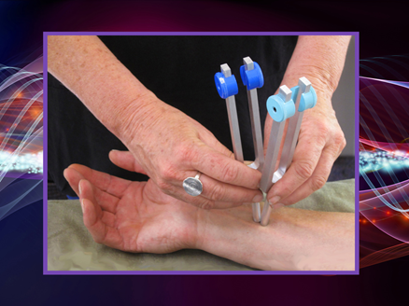

An energy based non-invasive treatment similar to acupuncture. Precision calibrated tuning forks are applied to specific acupressure points to access the body’s energy systems. Energy flows along specific pathways in the human body. Each pathway is associated with a particular internal organ & physiological system. Disease disrupts the energy flow with the body. The vibrations of the tuning forks connect with & support the body’s natural frequencies to align with & heal. The treatments are relaxing and help with issues related to pain, chronic conditions or emotional blocks.

### Integrative Imagery

Sometimes described as “directed daydreaming”, integrative imagery is the use of relaxation & the senses of visualization, hearing, smell, taste and touch. Through relaxation, the “guide” assists the individual to create a special place that is comfortable and safe. One of the biggest benefits of using imagery is its availability. Imagery can be used anywhere, anytime. Once this skill is learned the technique may be useful for relieving anxiety, managing pain, providing symptom relief, or accessing the unconscious mind to utilize insights and find solutions to promote health and wellness or direct one’s own physical, mental or spiritual healing process.

### Aromatherapy

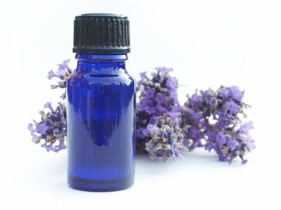

The use of herbal medicines dates back thousands of years, and almost every part of the world has some history of the use of aromatics in its health care system.

Aromatherapy is the use of essential oils for therapeutic or medical purposes. Aromatherapy is defined as a natural treatment which uses the concentrated herbal energies in essential oils from plants in association with massage, friction, inhalation, compresses or baths. Aesthetic Aromatherapy is about providing you pleasure and comfort. Holistic Aromatherapy involves supporting you wherever you are – in mind, body and spirit. I will be happy to make a blend that is specific for whatever you need for healing of mind, body or spirit.

### Benefits of Integrative Therapies

* + Balance and realign the flow of energy in the body
  + Alleviate pain and discomfort
  + Facilitate relaxation or rest
  + Reduce anxiety or agitation
  + Increase energy
  + Alleviate depression
  + Deepen inner balance
  + Identify memories and emotions in order to express them
  + Reset negative cellular patterns
  + Create a sense of well-being

**My Personal Testimony in my Journey to Health & Wellness**

I’d like to share with you some products I found that helped me in my health and wellness journey. There are many great products in the market place and there is no particular reason to choose one over another. The most important thing is that you do your own research and find products that you feel are high quality, work for you and fit your budget. As a nurse I did a lot of research on a wide variety of products and found that Plexus offered what I was searching for and they worked. For me, Plexus Products have literally changed my life!!

**Plexus Products**

These are all natural, plant based health and wellness products that are developed and manufactured in the US. Products that are gluten free, vegetarian, GMO free, and contain no artificial ingredients, chemicals or artificial stimulants. When used consistently and as directed I was able to achieve the results you see in my testimony below.

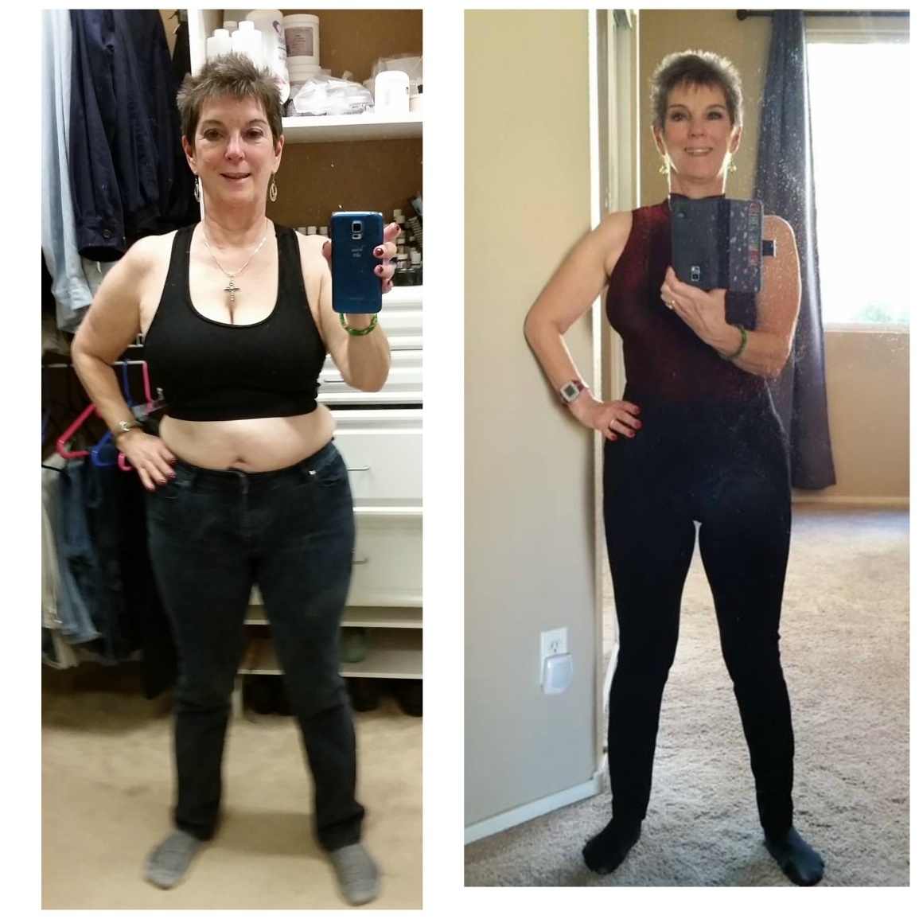

**Before Plexus** **1 Year Later**

Total Cholesterol 223 Total Cholesterol 201

HDL 88 HDL 96

LDL 116 LDL 93

Triglycerides 147 Triglycerides 62

Weight 154 pounds Weight 124 pounds

Percent body fat 34% Percent body fat 24%

**How did I achieve my success?**

I followed the ***Wise Ways to Health!!***

I drank ***Plexus Slim*** (The Pink Drink) EVERY DAY. Commitment!!

Focus on gut health and getting my immune function back in balance.

Taking ***Triplex*** (Plexus Slim, ProBio5 and Bio Cleanse) EVERY day.

Taking ***X Factor*** Vitamin & ***Mega X*** Omega supplements.

Taking ***Block*** (our carbohydrate blocker and fat burner) before a large meal daily.

Drinking at least 1/2 my body weight in ounces of ***Water*** EVERY day.

***Exercise*** and ***Eating Smart***!!

Over a period of 1 year I was able to lower my cholesterol and triglyceride levels, get off all my prescription medication, my energy levels increased, I was able to sleep through the night for the first time in 15 years and wake up refreshed and I lost 30# and 10% body fat. And the best part is that the episodes of fast and irregular heartbeats I was experiencing stopped. Plexus has truly given me my life back.

**Plexus offers 4 different types of products:**

* Breast care products
* Healthy Body Detox products
* Pain Management products
* Weight Management products



**Breast Care Products**

Plexus Worldwide started as a breast care company and the **Breast Chek Kit** is a unique way to increase tactile sensitivity when performing breast self examination. **Plexus Body Cream** was originally created to reduce the formation of breast cysts. The breast cream has been improved and is now offered as a body cream which is amazing for skin care, reducing fine lines, overall moisturizing and elimination of wrinkles and saggy skin.

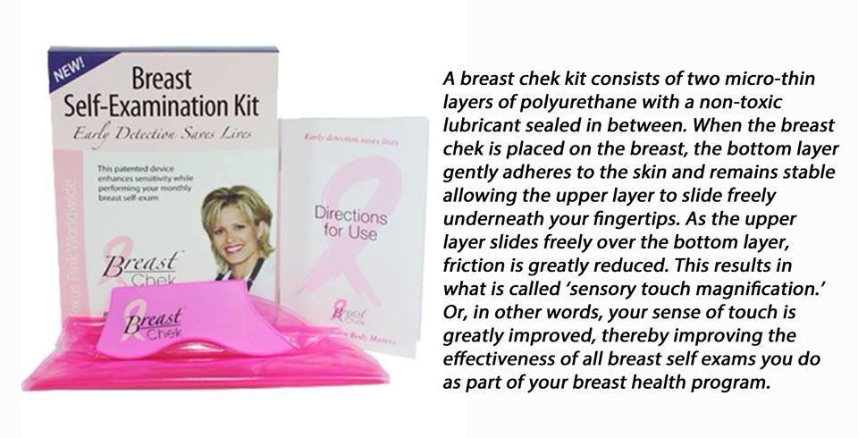

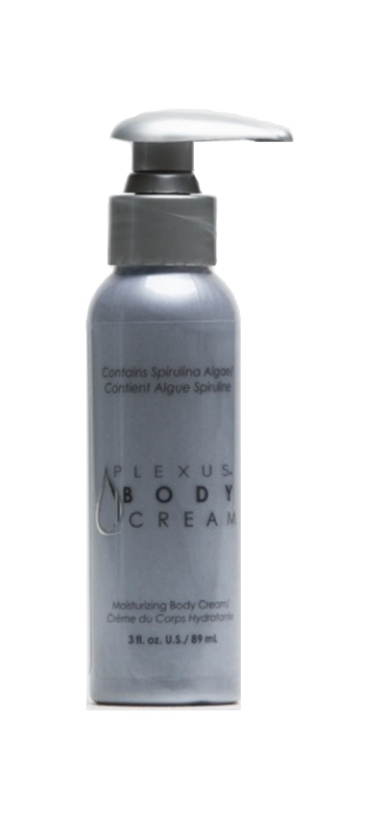

**Plexus Body Cream** is a unique skin renewing cream with Spirulina Algae and Activated Charcoal! Initial reports say that Plexus Body Cream has been found to revitalize the skin over the entire body of both men and women.

The effective detoxifying action is promoted by Spirulina Algae, plus the new addition of Activated Charcoal, to remove age-advancing toxins and impurities from the skin. These ingredients are carried into the skin's layers on a Rich Blend of Aloe Barbadensis (Aloe Vera Gel), Sweet Almond Oil, Grape Seed Oil, Evening Primrose Oil, Lavender Oil and Rosaceae Oil.

Plexus Body Cream brings new life and vibrancy to your skin!*

**Pain Management products**

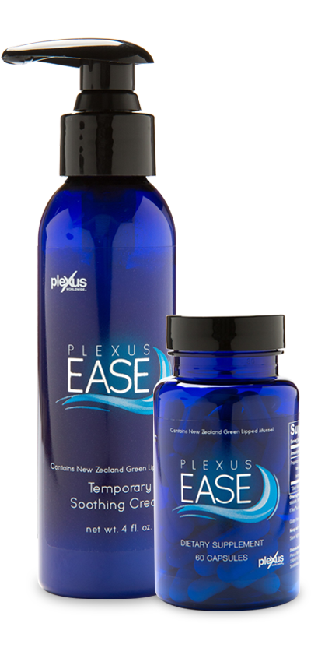

Over 76 million Americans struggle with discomfort each day. Struggling with discomfort-back problems, muscle tension, joint soreness, and so forth-you may be wondering how to find a healthy solution to help you with maintenance of discomfort!

Plexus has developed **Plexus Ease**, a cutting-edge product system with a proprietary ingredient blend that can help you live happier, healthier, and reduce discomfort.

Plexus Ease Capsules may help with discomfort due to an active lifestyle. Day after day, you may notice your discomfort becoming less and less.

Contains:

* ETArol - New Zealand Green Lipped Muscle powder
* Bromelain
* Serrapeptase
* Turmeric extract

Plexus Ease Cream **For External Use Only**

Provides synergistic "inside-outside" relief with the Plexus Ease Capsules* Non-greasy and with pleasant scent.

Plexus Ease capsules or Ease topical cream to relieve minor discomfort from an active lifestyle.

**Plexus Nerve**

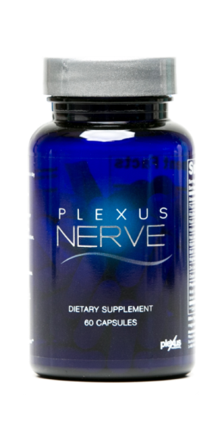

**Plexus Nerve** a formulation of vitamins, minerals, herbs and amino acids that help support healthy nerve cells and the nervous system. Nerve may reduce the symptoms of nerve discomfort that is the result of an underlying disease or condition

**Weight Management & Healthy Body Detox products**

**TRIPLEX**

Here is our number one selling combo Triplex which is 3 products in one. Gut health products **Pro Bio 5** and **Bio Cleanse** along with cornerstone product **Plexus Slim** often referred to as “the Pink Drink”

Safe & effective weight control

Helps maintain

* healthy blood sugars
* healthy blood pressure
* healthy cholesterol & lipid levels

Ingredients: Alpha Lipoic Acid, Chlorogenic Acid, Garcinia Cambogia

No Meal Replacements

No Shakes

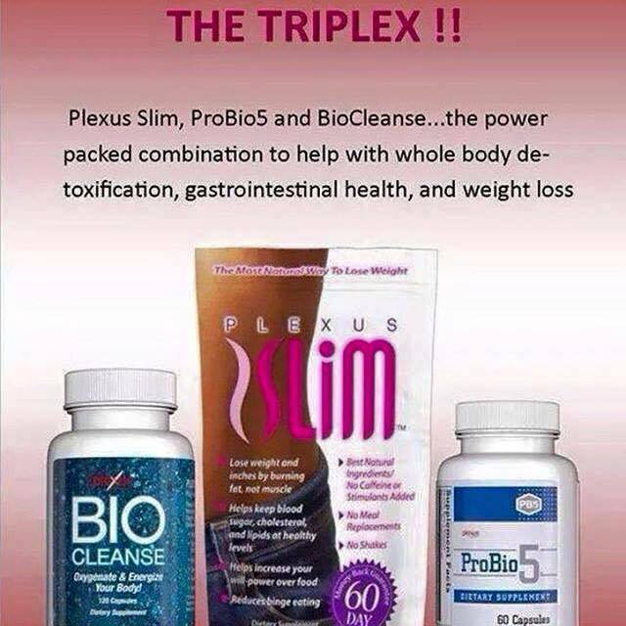

**Plexus Slim**

**Our Best Seller will help you look good and feel great.**

You’ve got goals – Plexus Slim can help. Finally there is a great way to help manage your weight. When combined with a healthy diet and exercise, Slim can help you feel better than ever.

Simply pour into a bottle of water 30 minutes before a meal, drink and experience the results you’ve been dreaming of.

## Features & Benefits

* Includes Alpha Lipoic Acid, Chlorogenic Acid, and Garcinia Cambogia
* 10 Calories
* Natural Berry Flavor
* Fast and easy
* Just add water, and go
* No meal replacements or shakes
* Gluten Free
* 100% Vegetarian

**Pro Bio 5**

Despite our efforts to make healthy lifestyle choices, it is impossible to avoid the environment around us. Processed foods and the chemicals we are exposed to disrupt the delicate balance of microorganisms in our bodies. Almost 70% of our immune system cells are located in the gut, and optimal health starts with a healthy digestive system. Probiotics are essential to supporting a healthy digestive and immune system, and ProBio 5 is one of the best things you can do to maintain a healthy balance of microflora to help promote optimal health.

**Features & Benefits** Promotes digestive health. Promotes a healthy immune system. Provides 5 strains of probiotic bacteria to help support and maintain intestinal flora. Contains enzymes to aid in the breakdown of proteins and fibrous foods during digestion. Helps reduce free radical damage in the body. Gluten Free

**Bio Cleanse**

Feeling Sluggish – BioCleanse can help. As a result of modern, busy lifestyle, it may be tough to get the exercise you need, or eat a balanced diet rich in fiber. This can leave you feeling bloated and uncomfortable. Our specially formulated BioCleanse provides a Magnesium source to help you manage those days when your digestive system feels out of balance.

**Features & Benefits:** Help cleanse the gastro-intestinal tract, Help energize the body. Vitamin C provides antioxidant support. Relieves occasional constipation (that is not associated with chronic constipation, which may be a symptom of a serious disease) Gluten Free 100% Vegetarian

**Block**

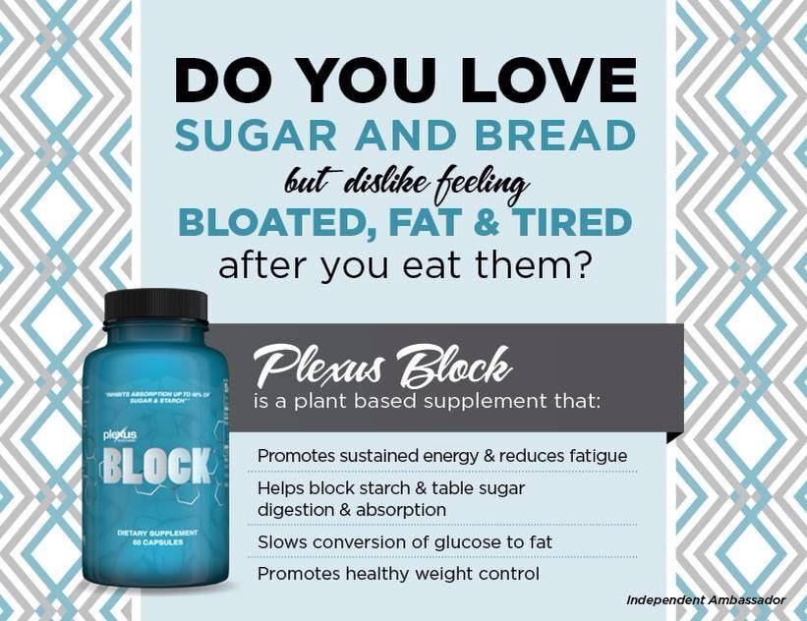

Experts typically point to the overconsumption of simple carbohydrates, sugars and starches as a primary culprit in our declining state of health. The problem with these foods is that they are quickly converted to glucose in the body, But there’s good news! Plexus Block does just what its name suggests— it helps block the absorption of starches and sugars up to 48%, thereby helping to maintain blood sugar levels already within the normal range and contributing to an enhanced state of overall wellness

**Features & Benefits** Helps you manage your weight, when taken in conjunction with a healthy diet and exercise* Helps block up to 48% of the absorption of starches and sugars from your diet* Helps reduce the glycemic index of carbohydrates and sugars* Helps maintain blood sugar levels already in the normal range* Beneficially modulates starch and table sugar digestion/absorption. Gluten Free

**Ingredients:** InSea2® Brown Seaweed blend: In a clinical study, the brown seaweed blend in Plexus Block inhibits the absorption of enzymes alpha amylase and alpha glucosides that convert table sugar and carbohydrates in to glucose

**Plexus 96**

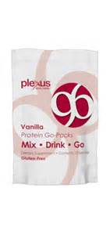

P 96, comes in vanilla or chocolate and is a single serving protein supplement that is a great snack or for use before or after a work out

Nutrient rich with more than 20 vitamins and minerals and provides 15 grams of whey protein to build lean muscle and fuel the body.

Helps curb cravings and hunger

Not a meal replacement

**X Factor Vitamins**

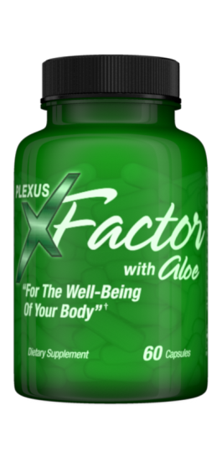

Contains B vitamins, Vitamins D, C, and E

We call this a turbocharged vitamin because of the unique ingredients of Aloe Vera and New Zealand Black Currant.

Aloe Vera helps to increase the absorb ion of all vitamins, minerals and nutrients in the body by up to 300%.

You know how when you take most vitamins and you go to the bathroom your urine is a bright yellow? That is because the vitamins have not been absorbed but are rather passing through. Not with X Factor

New Zealand Black Currant is a berry that is one of the best antioxidants on the planet and contains minerals that help the body absorb iron better. In fact during WWII when the troops ran out of Vitamin C to help the soldiers stay healthy, Black Currant was the supplement that was substituted because it worked better than Vitamin C.

**X** **Factor Family Chewables**

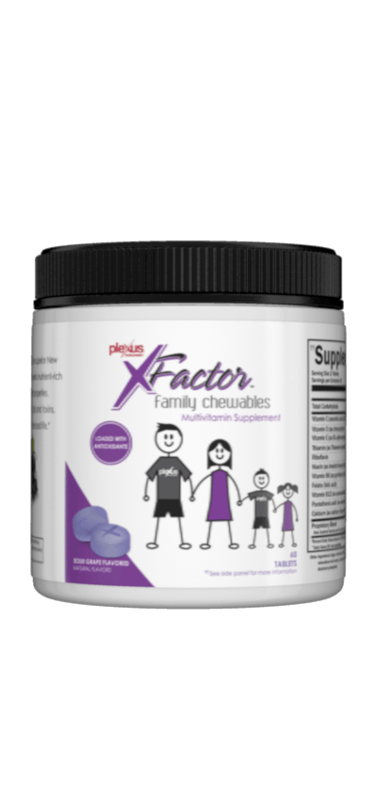

X Factor Family Chewables offer the same great ingredients but without the Aloe and are easy to take, chewable and safe for the entire family.

Taste like a sweet tart.

**Mega X**

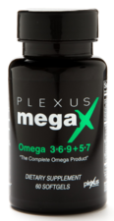

Our bodies don’t create the essential fatty acids we need and most people have been told to take an Omega 3. However, those often have a fishy aftertaste.

Mega X is an all plant based omega that contains not only omega 3 but also omega 6,9, 5 & 7 which addresses both heart health and brain health.

Research shows omega 3’s may contribute to lower triglyceride levels

Mega X helps maintain normal lipid levels, normal cholesterol levels and will maintain blood pressure at a healthy level

Some research suggests that omega 3’s may have a positive effect on gradual memory loss linked to aging

Mega X helps with everyday stress management and relaxation

Studies show that omega 3 fatty acids may be essential for optimal visual development.

**Plexus Accelerator**

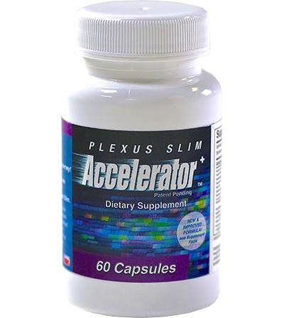

Works in conjunction with Plexus Slim to accelerate weight loss

Suppresses appetite

Boosts metabolism

Increases energy

Contains natural plant based stimulants Yerba Matte, higamine and hordinine

**Plexus Boost**

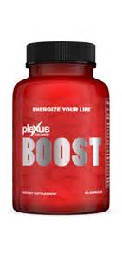

Is a thermogenic so it increases the body temperature to boost metabolism and energy

Contains Caralluma Fimbriata, an edible cactus used by tribal east Indians to suppress hunger and increase energy

Also contains natural plant based stimulant Yerba Matte

 I would love to help you or someone you know live healthier and happier. If you have any additional questions about the Wise Ways to Health, Plexus products, or any of the services I offer please contact me.

If you would like additional information about the ingredients and the science behind how the Plexus products work please contact me and I will be happy to send that information to you.

Contact me at: [Ejohnsonholisticnurse@gmail.com](mailto:Ejohnsonholisticnurse@gmail.com)

Cell phone: 408-204-6885

To purchase Plexus Products or learn more about them please visit my website:

[www.Plexusesther.com](http://www.Plexusesther.com)

Thank you for the opportunity to educate you about health and wellness.

Be Well!!

Esther Johnson, RN, BSN, PHN