Preprocessing : Before starting, you must put all your video of interest together, and if possible remove all the video belonging to other experiments elsewhere. The videos must be organized as follow :

* Top_folder (contains all the videos that will be monitored. Take irrelevant videos away)
  + Day of experiment in the following format ”yyyy-mm-d”
    - Experiment folder in the following format “experiment_#”
      * Your Videos (Labview format is “yyMMdd_hh_mm_ss VidRec”

Each labview video folder is expected be as follow

* Your Videos (Labview format is “yyMMdd_hh_mm_ss VidRec”

Timestamp_file per camera

* + “yyMMdd_hh_mm_ss VidRec” subfolder

XXXCam-1.avi

XXXCam-relative times.txt

YYYCam-1.avi

YYYCam-relative times.txt

Behaviour Toolbox

1. Start the process

```Behaviour_analysis```

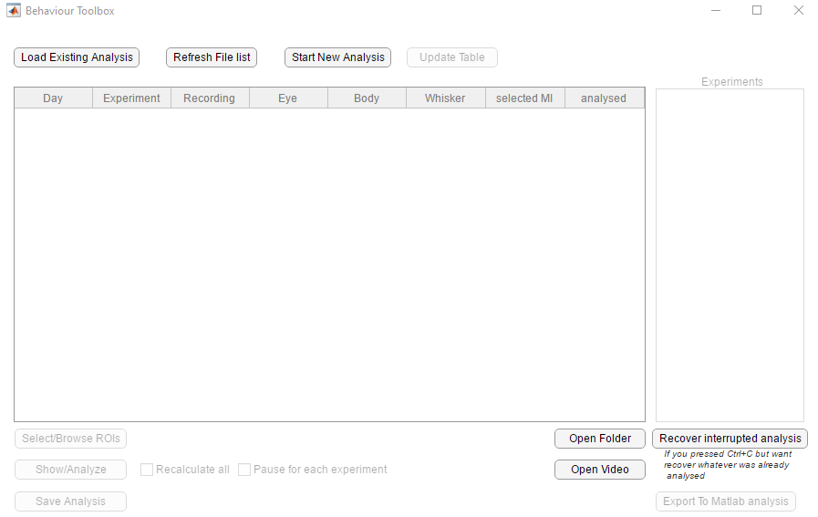

Start a new analysis :

Select the folder where all your videos are.

This may take some time, in particular if the videos are on a remote server.

Please keep an eye at the messages printed, as they could indicate problematic videos. The toolbox does not support split videos (yet)

Once finished, you should see an updated GUI. As this step can be very long, it is recommended to save your data base at this stage