**CSS**

**Selectors**

CSS selectors are used to "find" (or select) the HTML elements you want to style.

We can divide CSS selectors into five categories:

* Simple selectors (select elements based on name, id, class)
* [Combinator selectors](https://www.w3schools.com/css/css_combinators.asp) (select elements based on a specific relationship between them)
* [Pseudo-class selectors](https://www.w3schools.com/css/css_pseudo_classes.asp) (select elements based on a certain state)
* [Pseudo-elements selectors](https://www.w3schools.com/css/css_pseudo_elements.asp) (select and style a part of an element)
* [Attribute selectors](https://www.w3schools.com/css/css_attribute_selectors.asp) (select elements based on an attribute or attribute value)

The **HTML/element selector** selects HTML elements based on the element name.

p {  
  text-align: center;  
  color: red;  
}

The **id selector** uses the id attribute of an HTML element to select a specific element.

The id of an element is unique within a page, so the id selector is used to select one unique element!

To select an element with a specific id, write a hash (#) character, followed by the id of the element.

#para1 {  
  text-align: center;  
  color: red;  
}

<body>

<p id=”para”>This is para</p>

</body>

We can use same id for different tags but by convention it is not allowed as id identify each tag uniquely so we should never use same id for different elements.

**The below example will have two identifiers of name p1 and h1 and whenever we give this to id than we can give this identifier to any tag.**

#p1,#h1 {  
  text-align: center;  
  color: red;  
}

**ALLOWED**

<body>

<p id=”**p1**”>This is para</p>

<h1 id=”**h1**”>This is a heading</h1>

</body>

**NOT ALLOWED**

<body>

<p id=”**p1**”>This is para</p>

<h1 id=”**p1**”>This is a heading</h1>

</body>

**Note:** An id name cannot start with a number!

The **class selector** selects HTML elements with a specific class attribute.

**Class is used whenever we want to style multiple elements with same styling.**

To select elements with a specific class, write a period (.) character, followed by the class name.

.center {  
  text-align: center;  
  color: red;  
}

You can also specify that only specific HTML elements should be affected by a class.

In this example only <p> elements with class="center" will be center-aligned:

p.center {  
  text-align: center;  
  color: red;  
}

The below code won’t effect the <h1> but only all the <p> tag

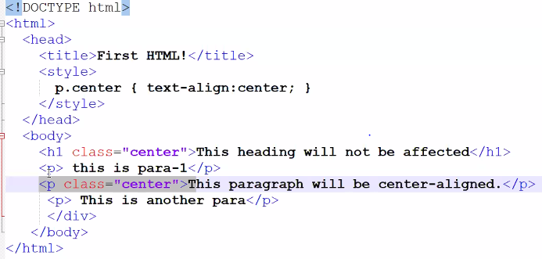

HTML elements can also refer to more than one class.

In this example the <p> element will be styled according to class="center" and to class="large"

<p class="center large">This paragraph refers to two classes.</p>

**Note:** A class name cannot start with a number!

**ID VS CLASS**

**HTML id Attribute:** The id attribute is a unique identifier which is used to specify the document. It is used by CSS and JavaScript to perform a certain task for a unique element. In CSS, the id attribute is written using # symbol followed by id.

**HTML class Attribute:** The class attribute is used to specify one or more class names for an HTML element. The class attribute can be used on any HTML element. The class name can be used by CSS and JavaScript to perform certain tasks for elements with the specified class name. The class name in CSS stylesheet using **“.”** symbol.

| **Sr. No.** | **Key** | **Id** | **Class** |
| --- | --- | --- | --- |
| 1 | Syntax | In Html for an element ID name starts with the “#” symbol followed by a unique name assigned to it. | On the other hand class assigned to an element has its name starts with “.” followed by class name. |
| 2 | Selector | Only one ID selector can be attached to an element. | Multiple class selectors can be attached to an element. |
| 3 | Uniqueness | Id is unique in a page and can only apply to at most one element | The class can be applied to multiple elements so it could be multiple times on a single page. |

* Each element can have only one ID
* Each page can have only one element with that ID
* You can use the same class on multiple elements.
* You can use multiple classes on the same element.

The **universal selector (*)** selects all HTML elements on the page.

The CSS rule below will affect every HTML element on the page:

* {  
  text-align: center;  
  color: blue;  
}

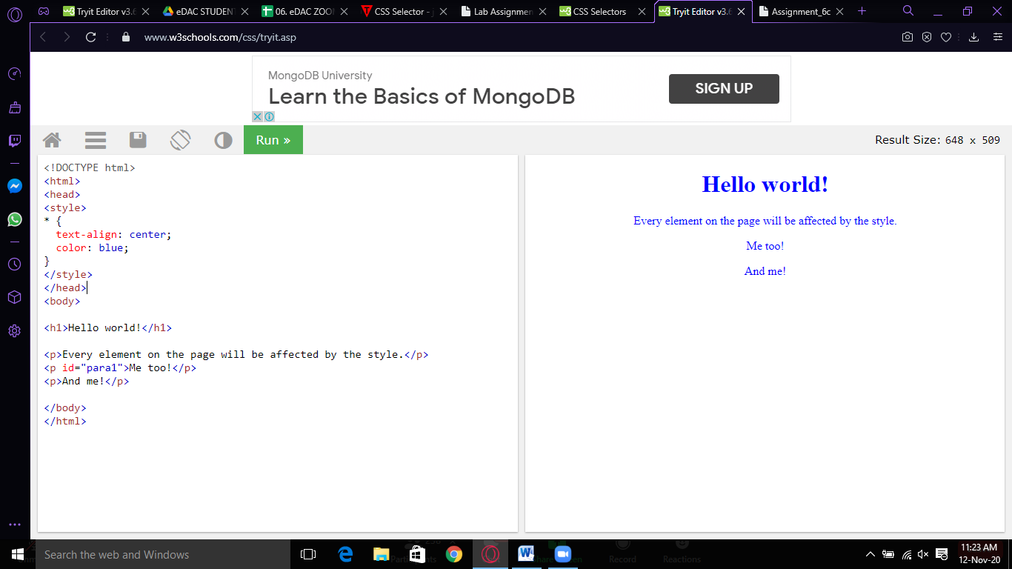

The **grouping selector** is used to select all the elements with the same style definitions.

Grouping selector is used to minimize the code. Commas are used to separate each selector in grouping.

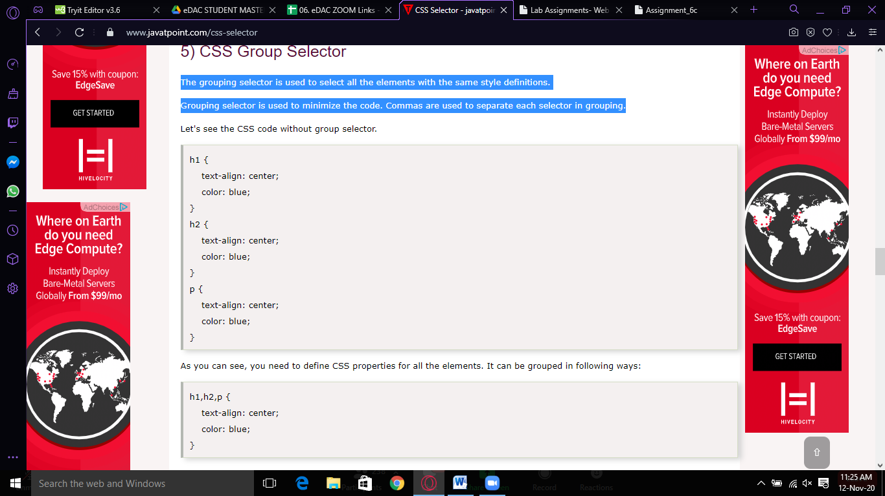

**CSS PropertiesOrder by Category**

The following section contains a complete list of standard properties belonging to the latest CSS3 specifications. All the properties are listed alphabetically.

<https://www.tutorialrepublic.com/css-reference/css3-properties.php>

| **Property** | **Description** |
| --- | --- |
| [align-content](https://www.tutorialrepublic.com/css-reference/css3-align-content-property.php) | Specifies the alignment of flexible container's items within the flex container. |
| [align-items](https://www.tutorialrepublic.com/css-reference/css3-align-items-property.php) | Specifies the default alignment for items within the flex container. |
| [align-self](https://www.tutorialrepublic.com/css-reference/css3-align-self-property.php) | Specifies the alignment for selected items within the flex container. |
| [animation](https://www.tutorialrepublic.com/css-reference/css3-animation-property.php) | Specifies the keyframe-based animations. |
| [animation-delay](https://www.tutorialrepublic.com/css-reference/css3-animation-delay-property.php) | Specifies when the animation will start. |
| [animation-direction](https://www.tutorialrepublic.com/css-reference/css3-animation-direction-property.php) | Specifies whether the animation should play in reverse on alternate cycles or not. |
| [animation-duration](https://www.tutorialrepublic.com/css-reference/css3-animation-duration-property.php) | Specifies the number of seconds or milliseconds an animation should take to complete one cycle. |
| [animation-fill-mode](https://www.tutorialrepublic.com/css-reference/css3-animation-fill-mode-property.php) | Specifies how a CSS animation should apply styles to its target before and after it is executing. |
| [animation-iteration-count](https://www.tutorialrepublic.com/css-reference/css3-animation-iteration-count-property.php) | Specifies the number of times an animation cycle should be played before stopping. |
| [animation-name](https://www.tutorialrepublic.com/css-reference/css3-animation-name-property.php) | Specifies the name of [@keyframes](https://www.tutorialrepublic.com/css-reference/css3-keyframes-rule.php) defined animations that should be applied to the selected element. |
| [animation-play-state](https://www.tutorialrepublic.com/css-reference/css3-animation-play-state-property.php) | Specifies whether the animation is running or paused. |
| [animation-timing-function](https://www.tutorialrepublic.com/css-reference/css3-animation-timing-function-property.php) | Specifies how a CSS animation should progress over the duration of each cycle. |
| [backface-visibility](https://www.tutorialrepublic.com/css-reference/css3-backface-visibility-property.php) | Specifies whether or not the "back" side of a transformed element is visible when facing the user. |
| [background](https://www.tutorialrepublic.com/css-reference/css-background-property.php) | Defines a variety of background properties within one declaration. |
| [background-attachment](https://www.tutorialrepublic.com/css-reference/css-background-attachment-property.php) | Specify whether the background image is fixed in the viewport or scrolls. |
| [background-clip](https://www.tutorialrepublic.com/css-reference/css3-background-clip-property.php) | Specifies the painting area of the background. |
| [background-color](https://www.tutorialrepublic.com/css-reference/css-background-color-property.php) | Defines an element's background color. |
| [background-image](https://www.tutorialrepublic.com/css-reference/css-background-image-property.php) | Defines an element's background image. |
| [background-origin](https://www.tutorialrepublic.com/css-reference/css3-background-origin-property.php) | Specifies the positioning area of the background images. |
| [background-position](https://www.tutorialrepublic.com/css-reference/css-background-position-property.php) | Defines the origin of a background image. |
| [background-repeat](https://www.tutorialrepublic.com/css-reference/css-background-repeat-property.php) | Specify whether/how the background image is tiled. |
| [background-size](https://www.tutorialrepublic.com/css-reference/css3-background-size-property.php) | Specifies the size of the background images. |
| [border](https://www.tutorialrepublic.com/css-reference/css-border-property.php) | Sets the width, style, and color for all four sides of an element's border. |
| [border-bottom](https://www.tutorialrepublic.com/css-reference/css-border-bottom-property.php) | Sets the width, style, and color of the bottom border of an element. |
| [border-bottom-color](https://www.tutorialrepublic.com/css-reference/css-border-bottom-color-property.php) | Sets the color of the bottom border of an element. |
| [border-bottom-left-radius](https://www.tutorialrepublic.com/css-reference/css3-border-bottom-left-radius-property.php) | Defines the shape of the bottom-left border corner of an element. |
| [border-bottom-right-radius](https://www.tutorialrepublic.com/css-reference/css3-border-bottom-right-radius-property.php) | Defines the shape of the bottom-right border corner of an element. |
| [border-bottom-style](https://www.tutorialrepublic.com/css-reference/css-border-bottom-style-property.php) | Sets the style of the bottom border of an element. |
| [border-bottom-width](https://www.tutorialrepublic.com/css-reference/css-border-bottom-width-property.php) | Sets the width of the bottom border of an element. |
| [border-collapse](https://www.tutorialrepublic.com/css-reference/css-border-collapse-property.php) | Specifies whether table cell borders are connected or separated. |
| [border-color](https://www.tutorialrepublic.com/css-reference/css-border-color-property.php) | Sets the color of the border on all the four sides of an element. |
| [border-image](https://www.tutorialrepublic.com/css-reference/css3-border-image-property.php) | Specifies how an image is to be used in place of the border styles. |
| [border-image-outset](https://www.tutorialrepublic.com/css-reference/css3-border-image-outset-property.php) | Specifies the amount by which the border image area extends beyond the border box. |
| [border-image-repeat](https://www.tutorialrepublic.com/css-reference/css3-border-image-repeat-property.php) | Specifies whether the image-border should be repeated, rounded or stretched. |
| [border-image-slice](https://www.tutorialrepublic.com/css-reference/css3-border-image-slice-property.php) | Specifies the inward offsets of the image-border. |
| [border-image-source](https://www.tutorialrepublic.com/css-reference/css3-border-image-source-property.php) | Specifies the location of the image to be used as a border. |
| [border-image-width](https://www.tutorialrepublic.com/css-reference/css3-border-image-width-property.php) | Specifies the width of the image-border. |
| [border-left](https://www.tutorialrepublic.com/css-reference/css-border-left-property.php) | Sets the width, style, and color of the left border of an element. |
| [border-left-color](https://www.tutorialrepublic.com/css-reference/css-border-left-color-property.php) | Sets the color of the left border of an element. |
| [border-left-style](https://www.tutorialrepublic.com/css-reference/css-border-left-style-property.php) | Sets the style of the left border of an element. |
| [border-left-width](https://www.tutorialrepublic.com/css-reference/css-border-left-width-property.php) | Sets the width of the left border of an element. |
| [border-radius](https://www.tutorialrepublic.com/css-reference/css3-border-radius-property.php) | Defines the shape of the border corners of an element. |
| [border-right](https://www.tutorialrepublic.com/css-reference/css-border-right-property.php) | Sets the width, style, and color of the right border of an element. |
| [border-right-color](https://www.tutorialrepublic.com/css-reference/css-border-right-color-property.php) | Sets the color of the right border of an element. |
| [border-right-style](https://www.tutorialrepublic.com/css-reference/css-border-right-style-property.php) | Sets the style of the right border of an element. |
| [border-right-width](https://www.tutorialrepublic.com/css-reference/css-border-right-width-property.php) | Sets the width of the right border of an element. |
| [border-spacing](https://www.tutorialrepublic.com/css-reference/css-border-spacing-property.php) | Sets the spacing between the borders of adjacent table cells. |
| [border-style](https://www.tutorialrepublic.com/css-reference/css-border-style-property.php) | Sets the style of the border on all the four sides of an element. |
| [border-top](https://www.tutorialrepublic.com/css-reference/css-border-top-property.php) | Sets the width, style, and color of the top border of an element. |
| [border-top-color](https://www.tutorialrepublic.com/css-reference/css-border-top-color-property.php) | Sets the color of the top border of an element. |
| [border-top-left-radius](https://www.tutorialrepublic.com/css-reference/css3-border-top-left-radius-property.php) | Defines the shape of the top-left border corner of an element. |
| [border-top-right-radius](https://www.tutorialrepublic.com/css-reference/css3-border-top-right-radius-property.php) | Defines the shape of the top-right border corner of an element. |
| [border-top-style](https://www.tutorialrepublic.com/css-reference/css-border-top-style-property.php) | Sets the style of the top border of an element. |
| [border-top-width](https://www.tutorialrepublic.com/css-reference/css-border-top-width-property.php) | Sets the width of the top border of an element. |
| [border-width](https://www.tutorialrepublic.com/css-reference/css-border-width-property.php) | Sets the width of the border on all the four sides of an element. |
| [bottom](https://www.tutorialrepublic.com/css-reference/css-bottom-property.php) | Specify the location of the bottom edge of the positioned element. |
| [box-shadow](https://www.tutorialrepublic.com/css-reference/css3-box-shadow-property.php) | Applies one or more drop-shadows to the element's box. |
| [box-sizing](https://www.tutorialrepublic.com/css-reference/css3-box-sizing-property.php) | Alter the default CSS box model. |
| [caption-side](https://www.tutorialrepublic.com/css-reference/css-caption-side-property.php) | Specify the position of table's caption. |
| [clear](https://www.tutorialrepublic.com/css-reference/css-clear-property.php) | Specifies the placement of an element in relation to floating elements. |
| [clip](https://www.tutorialrepublic.com/css-reference/css-clip-property.php) | Defines the clipping region. |
| [color](https://www.tutorialrepublic.com/css-reference/css-color-property.php) | Specify the color of the text of an element. |
| [column-count](https://www.tutorialrepublic.com/css-reference/css3-column-count-property.php) | Specifies the number of columns in a multi-column element. |
| [column-fill](https://www.tutorialrepublic.com/css-reference/css3-column-fill-property.php) | Specifies how columns will be filled. |
| [column-gap](https://www.tutorialrepublic.com/css-reference/css3-column-gap-property.php) | Specifies the gap between the columns in a multi-column element. |
| [column-rule](https://www.tutorialrepublic.com/css-reference/css3-column-rule-property.php) | Specifies a straight line, or "rule", to be drawn between each column in a multi-column element. |
| [column-rule-color](https://www.tutorialrepublic.com/css-reference/css3-column-rule-color-property.php) | Specifies the color of the rules drawn between columns in a multi-column layout. |
| [column-rule-style](https://www.tutorialrepublic.com/css-reference/css3-column-rule-style-property.php) | Specifies the style of the rule drawn between the columns in a multi-column layout. |
| [column-rule-width](https://www.tutorialrepublic.com/css-reference/css3-column-rule-width-property.php) | Specifies the width of the rule drawn between the columns in a multi-column layout. |
| [column-span](https://www.tutorialrepublic.com/css-reference/css3-column-span-property.php) | Specifies how many columns an element spans across in a multi-column layout. |
| [column-width](https://www.tutorialrepublic.com/css-reference/css3-column-width-property.php) | Specifies the optimal width of the columns in a multi-column element. |
| [columns](https://www.tutorialrepublic.com/css-reference/css3-columns-property.php) | A shorthand property for setting [column-width](https://www.tutorialrepublic.com/css-reference/css3-column-width-property.php) and [column-count](https://www.tutorialrepublic.com/css-reference/css3-column-count-property.php) properties. |
| [content](https://www.tutorialrepublic.com/css-reference/css-content-property.php) | Inserts generated content. |
| [counter-increment](https://www.tutorialrepublic.com/css-reference/css-counter-increment-property.php) | Increments one or more counter values. |
| [counter-reset](https://www.tutorialrepublic.com/css-reference/css-counter-reset-property.php) | Creates or resets one or more counters. |
| [cursor](https://www.tutorialrepublic.com/css-reference/css-cursor-property.php) | Specify the type of cursor. |
| [direction](https://www.tutorialrepublic.com/css-reference/css-direction-property.php) | Define the text direction/writing direction. |
| [display](https://www.tutorialrepublic.com/css-reference/css-display-property.php) | Specifies how an element is displayed onscreen. |
| [empty-cells](https://www.tutorialrepublic.com/css-reference/css-empty-cells-property.php) | Show or hide borders and backgrounds of empty table cells. |
| [flex](https://www.tutorialrepublic.com/css-reference/css3-flex-property.php) | Specifies the components of a flexible length. |
| [flex-basis](https://www.tutorialrepublic.com/css-reference/css3-flex-basis-property.php) | Specifies the initial main size of the flex item. |
| [flex-direction](https://www.tutorialrepublic.com/css-reference/css3-flex-direction-property.php) | Specifies the direction of the flexible items. |
| [flex-flow](https://www.tutorialrepublic.com/css-reference/css3-flex-flow-property.php) | A shorthand property for the [flex-direction](https://www.tutorialrepublic.com/css-reference/css3-flex-direction-property.php) and the [flex-wrap](https://www.tutorialrepublic.com/css-reference/css3-flex-wrap-property.php) properties. |
| [flex-grow](https://www.tutorialrepublic.com/css-reference/css3-flex-grow-property.php) | Specifies how the flex item will grow relative to the other items inside the flex container. |
| [flex-shrink](https://www.tutorialrepublic.com/css-reference/css3-flex-shrink-property.php) | Specifies how the flex item will shrink relative to the other items inside the flex container. |
| [flex-wrap](https://www.tutorialrepublic.com/css-reference/css3-flex-wrap-property.php) | Specifies whether the flexible items should wrap or not. |
| [float](https://www.tutorialrepublic.com/css-reference/css-float-property.php) | Specifies whether or not a box should float. |
| [font](https://www.tutorialrepublic.com/css-reference/css-font-property.php) | Defines a variety of font properties within one declaration. |
| [font-family](https://www.tutorialrepublic.com/css-reference/css-font-family-property.php) | Defines a list of fonts for element. |
| [font-size](https://www.tutorialrepublic.com/css-reference/css-font-size-property.php) | Defines the font size for the text. |
| [font-size-adjust](https://www.tutorialrepublic.com/css-reference/css3-font-size-adjust-property.php) | Preserves the readability of text when font fallback occurs. |
| [font-stretch](https://www.tutorialrepublic.com/css-reference/css3-font-stretch-property.php) | Selects a normal, condensed, or expanded face from a font. |
| [font-style](https://www.tutorialrepublic.com/css-reference/css-font-style-property.php) | Defines the font style for the text. |
| [font-variant](https://www.tutorialrepublic.com/css-reference/css-font-variant-property.php) | Specify the font variant. |
| [font-weight](https://www.tutorialrepublic.com/css-reference/css-font-weight-property.php) | Specify the font weight of the text. |
| [height](https://www.tutorialrepublic.com/css-reference/css-height-property.php) | Specify the height of an element. |
| [justify-content](https://www.tutorialrepublic.com/css-reference/css3-justify-content-property.php) | Specifies how flex items are aligned along the main axis of the flex container after any flexible lengths and auto margins have been resolved. |
| [left](https://www.tutorialrepublic.com/css-reference/css-left-property.php) | Specify the location of the left edge of the positioned element. |
| [letter-spacing](https://www.tutorialrepublic.com/css-reference/css-letter-spacing-property.php) | Sets the extra spacing between letters. |
| [line-height](https://www.tutorialrepublic.com/css-reference/css-line-height-property.php) | Sets the height between lines of text. |
| [list-style](https://www.tutorialrepublic.com/css-reference/css-list-style-property.php) | Defines the display style for a list and list elements. |
| [list-style-image](https://www.tutorialrepublic.com/css-reference/css-list-style-image-property.php) | Specifies the image to be used as a list-item marker. |
| [list-style-position](https://www.tutorialrepublic.com/css-reference/css-list-style-position-property.php) | Specifies the position of the list-item marker. |
| [list-style-type](https://www.tutorialrepublic.com/css-reference/css-list-style-type-property.php) | Specifies the marker style for a list-item. |
| [margin](https://www.tutorialrepublic.com/css-reference/css-margin-property.php) | Sets the margin on all four sides of the element. |
| [margin-bottom](https://www.tutorialrepublic.com/css-reference/css-margin-bottom-property.php) | Sets the bottom margin of the element. |
| [margin-left](https://www.tutorialrepublic.com/css-reference/css-margin-left-property.php) | Sets the left margin of the element. |
| [margin-right](https://www.tutorialrepublic.com/css-reference/css-margin-right-property.php) | Sets the right margin of the element. |
| [margin-top](https://www.tutorialrepublic.com/css-reference/css-margin-top-property.php) | Sets the top margin of the element. |
| [max-height](https://www.tutorialrepublic.com/css-reference/css-max-height-property.php) | Specify the maximum height of an element. |
| [max-width](https://www.tutorialrepublic.com/css-reference/css-max-width-property.php) | Specify the maximum width of an element. |
| [min-height](https://www.tutorialrepublic.com/css-reference/css-min-height-property.php) | Specify the minimum height of an element. |
| [min-width](https://www.tutorialrepublic.com/css-reference/css-min-width-property.php) | Specify the minimum width of an element. |
| [opacity](https://www.tutorialrepublic.com/css-reference/css3-opacity-property.php) | Specifies the transparency of an element. |
| [order](https://www.tutorialrepublic.com/css-reference/css3-order-property.php) | Specifies the order in which a flex items are displayed and laid out within a flex container. |
| [outline](https://www.tutorialrepublic.com/css-reference/css-outline-property.php) | Sets the width, style, and color for all four sides of an element's outline. |
| [outline-color](https://www.tutorialrepublic.com/css-reference/css-outline-color-property.php) | Sets the color of the outline. |
| [outline-offset](https://www.tutorialrepublic.com/css-reference/css3-outline-offset-property.php) | Set the space between an outline and the border edge of an element. |
| [outline-style](https://www.tutorialrepublic.com/css-reference/css-outline-style-property.php) | Sets a style for an outline. |
| [outline-width](https://www.tutorialrepublic.com/css-reference/css-outline-width-property.php) | Sets the width of the outline. |
| [overflow](https://www.tutorialrepublic.com/css-reference/css-overflow-property.php) | Specifies the treatment of content that overflows the element's box. |
| [overflow-x](https://www.tutorialrepublic.com/css-reference/css3-overflow-x-property.php) | Specifies the treatment of content that overflows the element's box horizontally. |
| [overflow-y](https://www.tutorialrepublic.com/css-reference/css3-overflow-y-property.php) | Specifies the treatment of content that overflows the element's box vertically. |
| [padding](https://www.tutorialrepublic.com/css-reference/css-padding-property.php) | Sets the padding on all four sides of the element. |
| [padding-bottom](https://www.tutorialrepublic.com/css-reference/css-padding-bottom-property.php) | Sets the padding to the bottom side of an element. |
| [padding-left](https://www.tutorialrepublic.com/css-reference/css-padding-left-property.php) | Sets the padding to the left side of an element. |
| [padding-right](https://www.tutorialrepublic.com/css-reference/css-padding-right-property.php) | Sets the padding to the right side of an element. |
| [padding-top](https://www.tutorialrepublic.com/css-reference/css-padding-top-property.php) | Sets the padding to the top side of an element. |
| [page-break-after](https://www.tutorialrepublic.com/css-reference/css-page-break-after-property.php) | Insert a page breaks after an element. |
| [page-break-before](https://www.tutorialrepublic.com/css-reference/css-page-break-before-property.php) | Insert a page breaks before an element. |
| [page-break-inside](https://www.tutorialrepublic.com/css-reference/css-page-break-inside-property.php) | Insert a page breaks inside an element. |
| [perspective](https://www.tutorialrepublic.com/css-reference/css3-perspective-property.php) | Defines the perspective from which all child elements of the object are viewed. |
| [perspective-origin](https://www.tutorialrepublic.com/css-reference/css3-perspective-origin-property.php) | Defines the origin (the vanishing point for the 3D space) for the perspective property. |
| [position](https://www.tutorialrepublic.com/css-reference/css-position-property.php) | Specifies how an element is positioned. |
| [quotes](https://www.tutorialrepublic.com/css-reference/css-quotes-property.php) | Specifies quotation marks for embedded quotations. |
| [resize](https://www.tutorialrepublic.com/css-reference/css3-resize-property.php) | Specifies whether or not an element is resizable by the user. |
| [right](https://www.tutorialrepublic.com/css-reference/css-right-property.php) | Specify the location of the right edge of the positioned element. |
| [tab-size](https://www.tutorialrepublic.com/css-reference/css3-tab-size-property.php) | Specifies the length of the tab character. |
| [table-layout](https://www.tutorialrepublic.com/css-reference/css-table-layout-property.php) | Specifies a table layout algorithm. |
| [text-align](https://www.tutorialrepublic.com/css-reference/css-text-align-property.php) | Sets the horizontal alignment of inline content. |
| [text-align-last](https://www.tutorialrepublic.com/css-reference/css3-text-align-last-property.php) | Specifies how the last line of a block or a line right before a forced line break is aligned when [text-align](https://www.tutorialrepublic.com/css-reference/css-text-align-property.php) is justify. |
| [text-decoration](https://www.tutorialrepublic.com/css-reference/css-text-decoration-property.php) | Specifies the decoration added to text. |
| [text-decoration-color](https://www.tutorialrepublic.com/css-reference/css3-text-decoration-color-property.php) | Specifies the color of the [text-decoration-line](https://www.tutorialrepublic.com/css-reference/css3-text-decoration-line-property.php). |
| [text-decoration-line](https://www.tutorialrepublic.com/css-reference/css3-text-decoration-line-property.php) | Specifies what kind of line decorations are added to the element. |
| [text-decoration-style](https://www.tutorialrepublic.com/css-reference/css3-text-decoration-style-property.php) | Specifies the style of the lines specified by the [text-decoration-line](https://www.tutorialrepublic.com/css-reference/css3-text-decoration-line-property.php) property |
| [text-indent](https://www.tutorialrepublic.com/css-reference/css-text-indent-property.php) | Indent the first line of text. |
| [text-justify](https://www.tutorialrepublic.com/css-reference/css3-text-justify-property.php) | Specifies the justification method to use when the [text-align](https://www.tutorialrepublic.com/css-reference/css-text-align-property.php) property is set to justify. |
| [text-overflow](https://www.tutorialrepublic.com/css-reference/css3-text-overflow-property.php) | Specifies how the text content will be displayed, when it overflows the block containers. |
| [text-shadow](https://www.tutorialrepublic.com/css-reference/css3-text-shadow-property.php) | Applies one or more shadows to the text content of an element. |
| [text-transform](https://www.tutorialrepublic.com/css-reference/css-text-transform-property.php) | Transforms the case of the text. |
| [top](https://www.tutorialrepublic.com/css-reference/css-top-property.php) | Specify the location of the top edge of the positioned element. |
| [transform](https://www.tutorialrepublic.com/css-reference/css3-transform-property.php) | Applies a 2D or 3D transformation to an element. |
| [transform-origin](https://www.tutorialrepublic.com/css-reference/css3-transform-origin-property.php) | Defines the origin of transformation for an element. |
| [transform-style](https://www.tutorialrepublic.com/css-reference/css3-transform-style-property.php) | Specifies how nested elements are rendered in 3D space. |
| [transition](https://www.tutorialrepublic.com/css-reference/css3-transition-property.php) | Defines the transition between two states of an element. |
| [transition-delay](https://www.tutorialrepublic.com/css-reference/css3-transition-delay-property.php) | Specifies when the transition effect will start. |
| [transition-duration](https://www.tutorialrepublic.com/css-reference/css3-transition-duration-property.php) | Specifies the number of seconds or milliseconds a transition effect should take to complete. |
| [transition-property](https://www.tutorialrepublic.com/css-reference/css3-transition-property-property.php) | Specifies the names of the CSS properties to which a transition effect should be applied. |
| [transition-timing-function](https://www.tutorialrepublic.com/css-reference/css3-transition-timing-function-property.php) | Specifies the speed curve of the transition effect. |
| [vertical-align](https://www.tutorialrepublic.com/css-reference/css-vertical-align-property.php) | Sets the vertical positioning of an element relative to the current text baseline. |
| [visibility](https://www.tutorialrepublic.com/css-reference/css-visibility-property.php) | Specifies whether or not an element is visible. |
| [white-space](https://www.tutorialrepublic.com/css-reference/css-white-space-property.php) | Specifies how white space inside the element is handled. |
| [width](https://www.tutorialrepublic.com/css-reference/css-width-property.php) | Specify the width of an element. |
| [word-break](https://www.tutorialrepublic.com/css-reference/css3-word-break-property.php) | Specifies how to break lines within words. |
| [word-spacing](https://www.tutorialrepublic.com/css-reference/css-word-spacing-property.php) | Sets the spacing between words. |
| [word-wrap](https://www.tutorialrepublic.com/css-reference/css3-word-wrap-property.php) | Specifies whether to break words when the content overflows the boundaries of its container. |
| [z-index](https://www.tutorialrepublic.com/css-reference/css-z-index-property.php) | Specifies a layering or stacking order for positioned elements. |

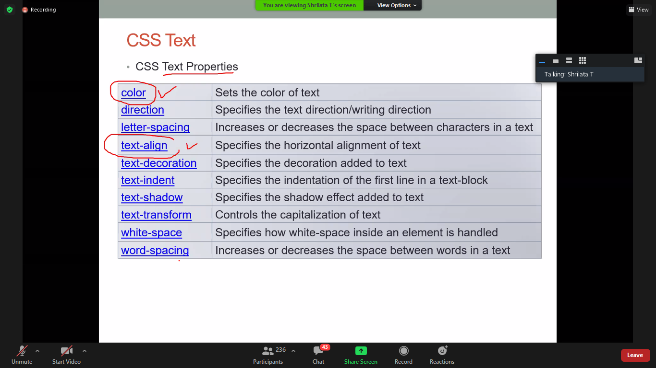

<style>

#t1{background-color:yellow;}

</style>

<body>

Name:<input type=”text” name=”name” id=”t1”>

</body>

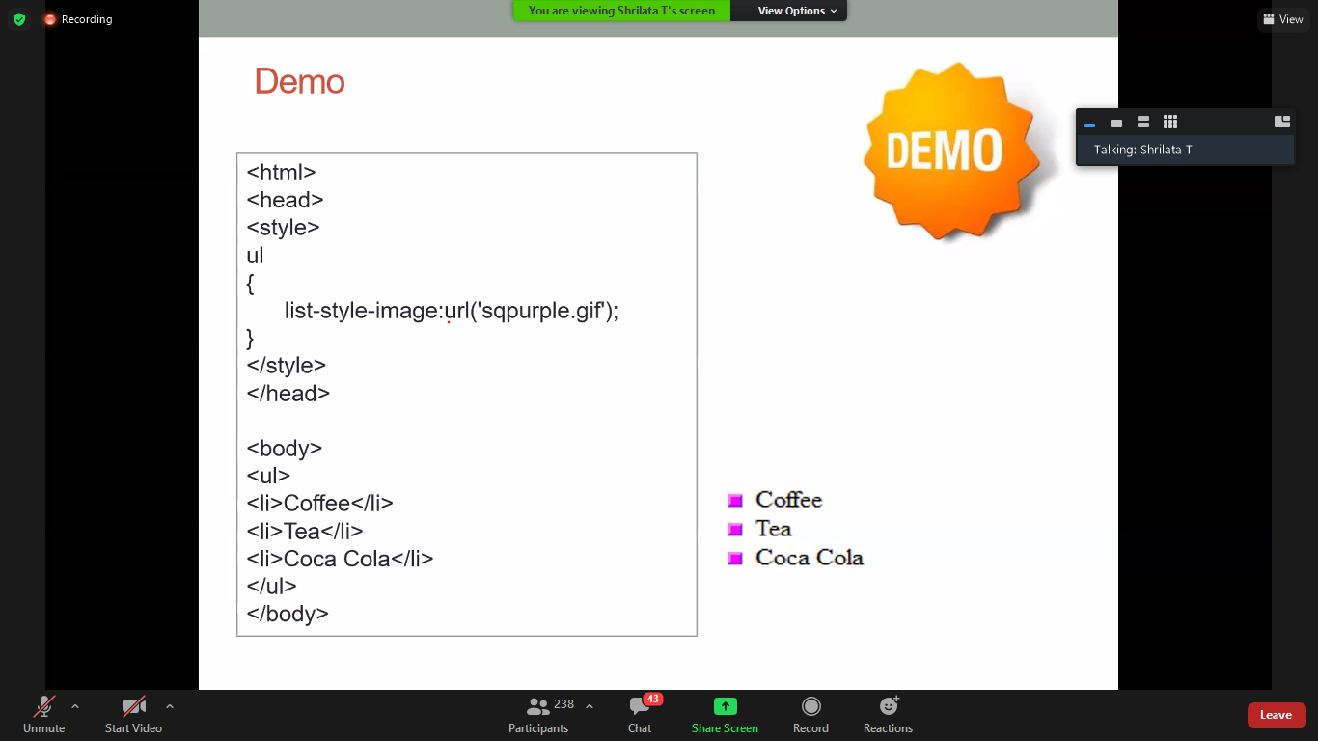

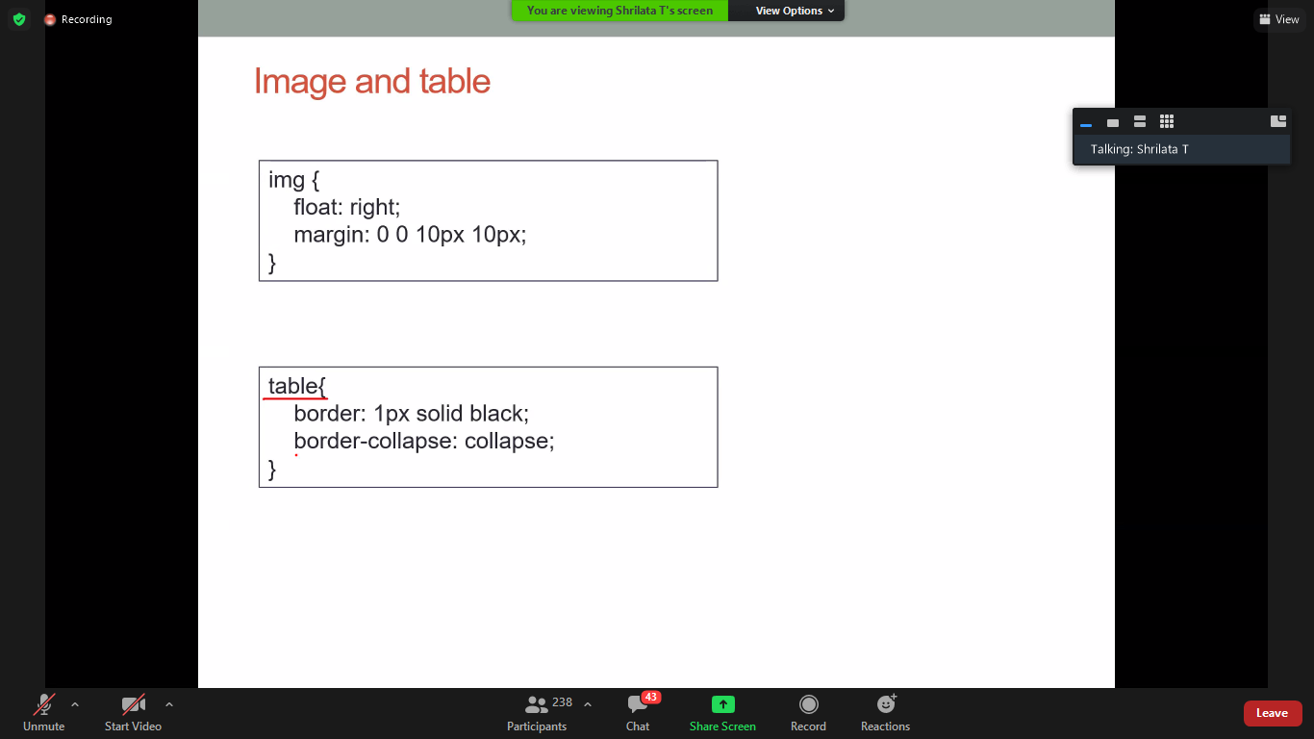

<table>

<tr><td>1</td><td>2</td></tr>

<tr><td>1</td><td>2</td></tr>

</table>



**THE CSS BOX MODEL**

All HTML elements can be considered as boxes. In CSS, the term "box model" is used when talking about design and layout.

It consists of: margins, borders, padding, and the actual content. The image below illustrates the box model:

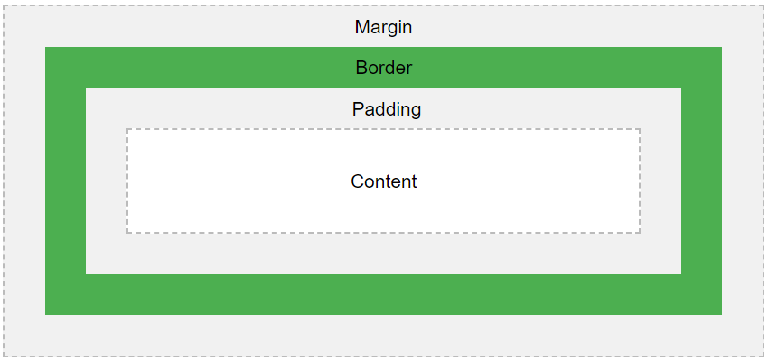

Explanation of the different parts:

* **Content** - The content of the box, where text and images appear
* **Padding** - Clears an area around the content. The padding is transparent
* **Border** - A border that goes around the padding and content
* **Margin** - Clears an area outside the border. The margin is transparent

Example:

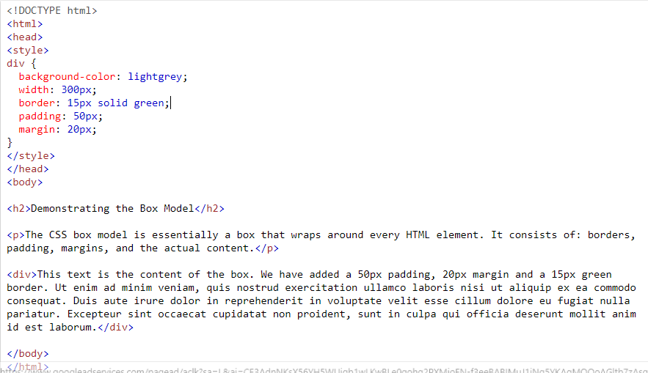

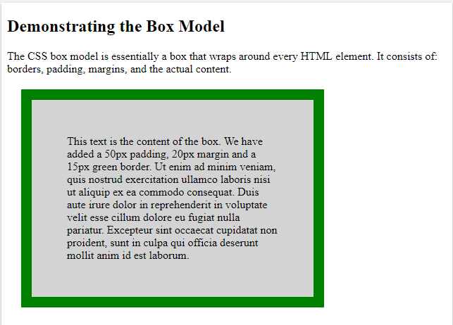

**Important:** When you set the width and height properties of an element with CSS, you just set the width and height of the **content area**. To calculate the full size of an element, you must also add padding, borders and margins.

div {  
  width: 320px;  
  padding: 10px;  
  border: 5px solid gray;  
  margin: 0;  
}

Here is the calculation:

320px (width)  
+ 20px (left + right padding)(10+10)  
+ 10px (left + right border)(5+5)  
+ 0px (left + right margin)  
**= 350px**

The total width of an element should be calculated like this:

Total element width = width + left padding + right padding + left border + right border + left margin + right margin

The total height of an element should be calculated like this:

Total element height = height + top padding + bottom padding + top border + bottom border + top margin + bottom margin

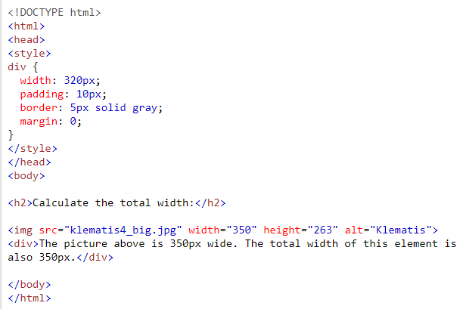

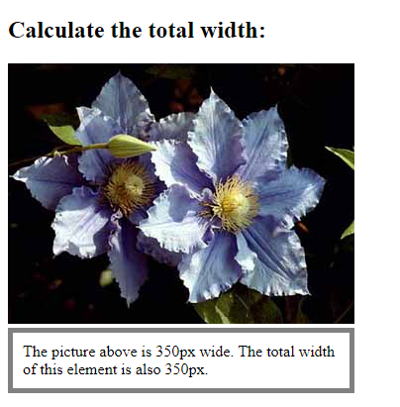

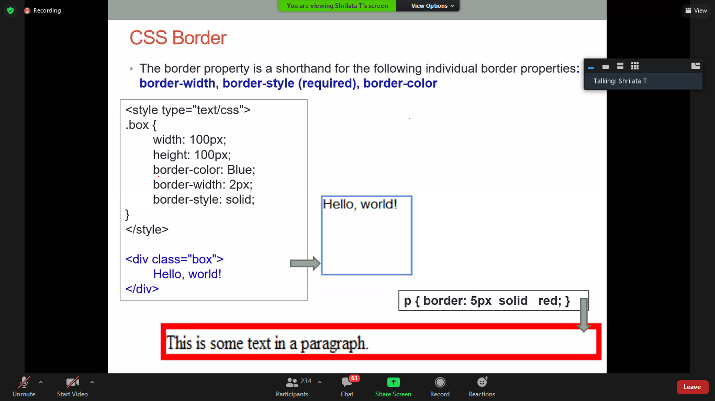

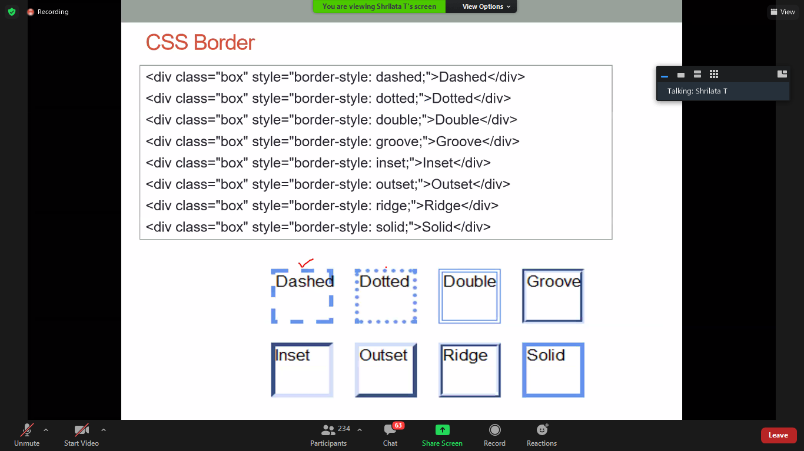

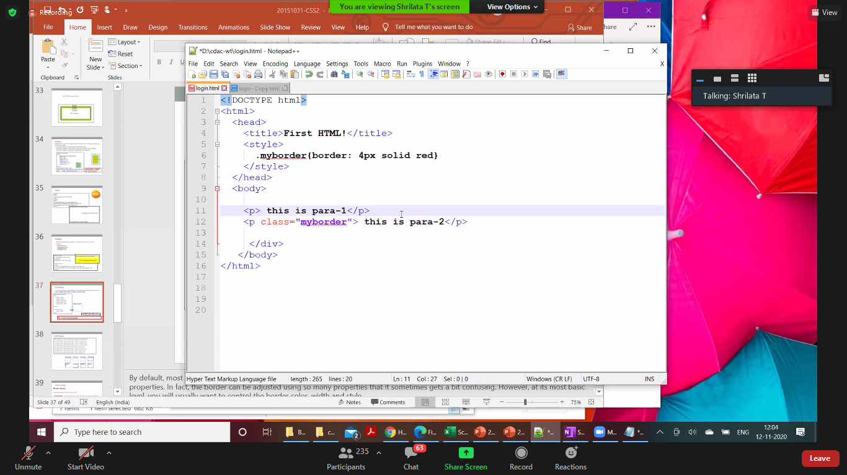

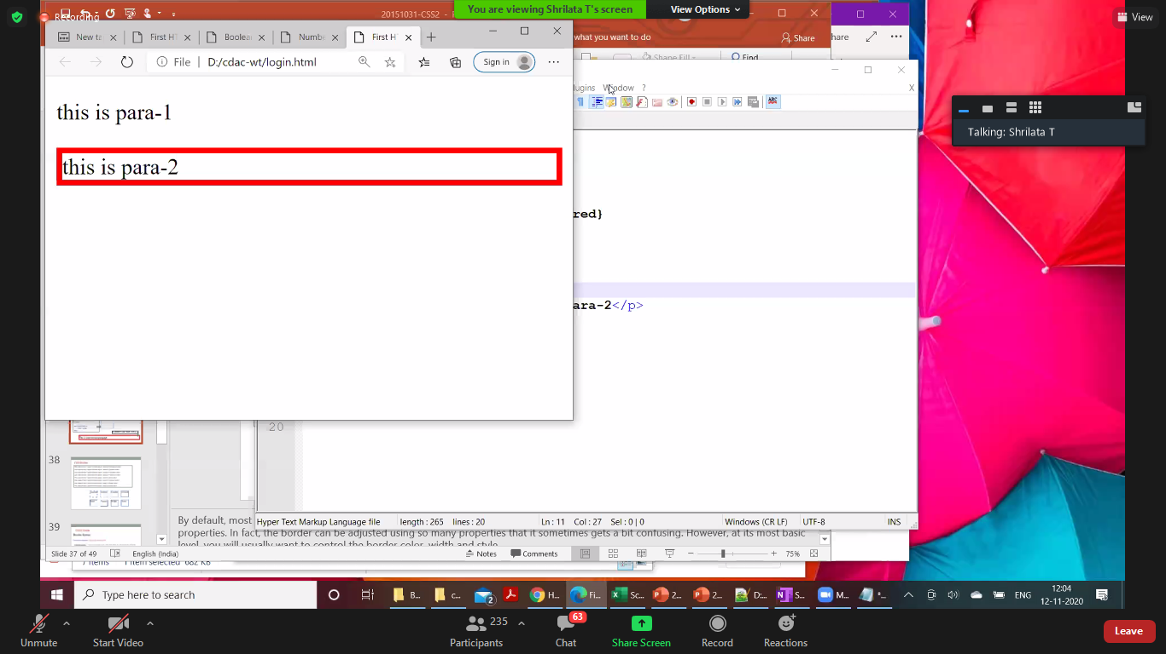

**JAVASCRIPT**

JavaScript and [Java](https://www.w3schools.com/java/default.asp) are completely different languages, both in concept and design.

JavaScript was invented by Brendan Eich in 1995, and became an ECMA standard in 1997.

ECMA-262 is the official name of the standard. ECMAScript is the official name of the language.

JavaScript is ***an object-based scripting language(as it doesnot supportcomplete object oriented)*** which is lightweight and cross-platform.

JavaScript is not a compiled language, but it is a translated language. The JavaScript Translator (embedded in the browser) is responsible for translating the JavaScript code for the web browser.

It is an interpreted, full-fledged programming language that enables dynamic interactivity on websites when applied to an HTML document.

With JavaScript, users can build modern web applications to interact directly without reloading the page every time. The traditional website uses javascript to provide several forms of interactivity and simplicity.

JavaScript was first known as **LiveScript,** but Netscape changed its name to JavaScript, possibly because of the excitement being generated by Java. JavaScript made its first appearance in Netscape 2.0 in 1995 with the name **LiveScript**. The general-purpose core of the language has been embedded in Netscape, Internet Explorer, and other web browsers.

There are following features of JavaScript:

1. All popular web browsers support JavaScript as they provide built-in execution environments.
2. JavaScript follows the syntax and structure of the C programming language. Thus, it is a structured programming language.
3. **Less server interaction** − You can validate user input before sending the page off to the server. This saves server traffic, which means less load on your server
4. **Immediate feedback to the visitors** − They don't have to wait for a page reload to see if they have forgotten to enter something
5. **Increased interactivity**
6. **Richer interfaces**
7. JavaScript is a weakly typed language, where certain types are implicitly cast (depending on the operation).
8. It is a light-weighted and interpreted language.
9. **It is a case-sensitive language.**
10. JavaScript is supportable in several operating systems including, Windows, macOS, etc.
11. It provides good control to the users over the web browsers.

## Limitations of JavaScript

* Client-side JavaScript does not allow the reading or writing of files.
* JavaScript cannot be used for networking applications because there is no such support available
* JavaScript doesn't have any multi-threading or multiprocessor capabilities

Application of javascript:

* Client-side validation,
* Dynamic drop-down menus,
* Displaying date and time,
* Displaying pop-up windows and dialog boxes (like an alert dialog box, confirm dialog box and prompt dialog box),
* Displaying clocks etc.
* React to events like clicking something

**Every browser comes with an HTML interpreter and JS engine like Mozilla has SpiderMonkey, Google comes with V8, Safari has JavascriptCore, IE has Chakra.**

**What is scripting language?**

* All scripting languages are programming languages.
* The scripting language is basically a language where instructions are written for a run time environment.
* They do not require the compilation step and are rather interpreted.
* It brings new functions to applications and glue complex system together.
* A scripting language is a programming language designed for integrating and communicating with other programming languages.
* They cannot run standalone
* Ex: Python, Perl, Ruby, Hash, Node JS

**Javascript Example:**

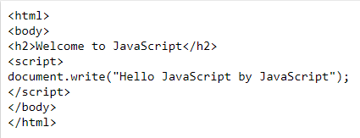

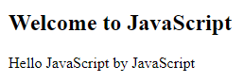

<https://www.w3schools.com/js/tryit.asp?filename=tryjs_intro_lightbulb>

JavaScript provides 3 places to put the JavaScript code:

1. within **body tag**,
2. within **head tag** and
3. external **JavaScript file(.js file).**

**<script** type="text/javascript"**>**

document.write("JavaScript is a simple language for javatpoint learners");

**</script>**

The **script** tag specifies that we are using JavaScript.

The **text/javascript** is the content type that provides information to the browser about the data.

The **document.write()** function is used to display dynamic content through JavaScript.

1. JS code between body tag

**Try the below code:

<html>

<body>

<script type="text/javascript">

alert("Hello Javatpoint");

</script>

</body>

</html>

<https://www.javatpoint.com/oprweb/test.jsp?filename=example2js>

1. JS code between head tag

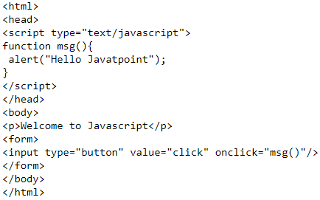

1. External JS file

* It provides **code re usability** because single JavaScript file can be used in several html pages.
* It is time-efficient as web browsers cache the external js files, which further reduces the page loading time
* The length of the code reduces as only we need to specify the location of the js file

MyJS.js file

var name="Rinkesh";

document.write("Hell"+name);

Myjs.html file

<!DOCTYPE html>

<html>

<head>

<title>Page Title</title>

</head>

<body>

**<script src="./MYJS.js"></script>**

</body>

</html>

Javascript is a Weakly typed language

<!DOCTYPE html>

<html>

<head>

<title>Page Title</title>

</head>

<body>

<script>

var i=10;

document.write("i ="+i);

i="Rinkesh";

document.write("i ="+i);

i=true;

document.write("i ="+i);

</script>

</body>

</html>

**Javascript Conditional stmt**

The **JavaScript if-else statement** is used *to execute the code whether condition is true or false*. There are three forms of if statement in JavaScript.

1. If Statement
2. If else statement
3. if else if statement

**<script>**

var a=20;

if(a%2==0){

document.write("a is even number");

}

else{

document.write("a is odd number");

}

**</script>**

