|  |
| --- |
| Software design |
| Cafe Register System |
| Version 1.0 |
| Prepared by class SE1407 Group 4  Nguyen Quang Vinh  Nguyen Vinh Quang  Nguyen Duy Trong  Tran Gia Viet Anh  July 30, 2020 |

Contents

Revision history

1. Document description

2. SRS overview

2.1. List of system users

2.2. List of use cases

2.3. Use case diagram

2.3.1. Preliminary use case diagram

2.3.2. Use case detail diagrams

2.4. Activity diagrams of use case scenarios

2.4.1. Activity diagram for use case “Order”

3. Data model

3.1. Entity Relationship Diagram

3.2. Table details

3.2.1. Table name: Orders

3.2.2. Table name: Order_details

3.2.3. Table name: Login

3.2.4. Table name: Items

3.2.5. Table name: Category

4. Class diagram

4.1. List of classes in the Layers

4.2. Modeling the Class Behaviors - sequence diagrams

4.2.1. Sequence diagram for use case “Order”

5. User Interface Model Design

5.1. User interface model design

5.1.1. Screen “Login”

5.1.2. Screen “Table”

5.1.3. Screen “Order”

5.1.4. Screen “Pay”

5.1.5. Screen “Manager”

5.1.6. Screen “Edit menu”

5.1.7. Screen “Add item”

5.1.8. Screen “Edit Item”

5.1.9. Screen “History”

5.1.10. Screen “History Detail”

5.1.11. Screen “Create Account”

5.2. Interface Flow Diagrams

# Revision history

|  |  |  |  |
| --- | --- | --- | --- |
| **Date** | **Authors** | **Modifications** | **Version** |
|  |  |  |  |
|  |  |  |  |
|  |  |  |  |
|  |  |  |  |
|  |  |  |  |

# Document description

This document describes solution version 1.0 for Cafe Register system. It is divided into the following sections:

* In the section 2 an overview of the Cafe Register system’s requirements will be provided, including list of system users, use cases, use case diagram, and activity diagrams that describes the most important use case scenarios.
* In the section 3 an E-R diagram and all tables of the Cafe Register system in detail will be presented.
* In the section 4 all classes organized in the layers and their behaviors (sequence diagrams) for the most important use cases will be presented.
* In the section 5 the most screen prototypes will be presented.

# SRS overview

## 2.1. List of system users

1. Employee: The person working the Register

2. Manager: The person managing the Register activity

## 2.2. List of use cases

1. Login

2. Create Account

3. Make order(s) for table(s)

4. Add and Edit the item in the cafe’s menu

5. View history and detail of order

## 2.3. Use case diagram

### 2.3.1. Preliminary use case diagram

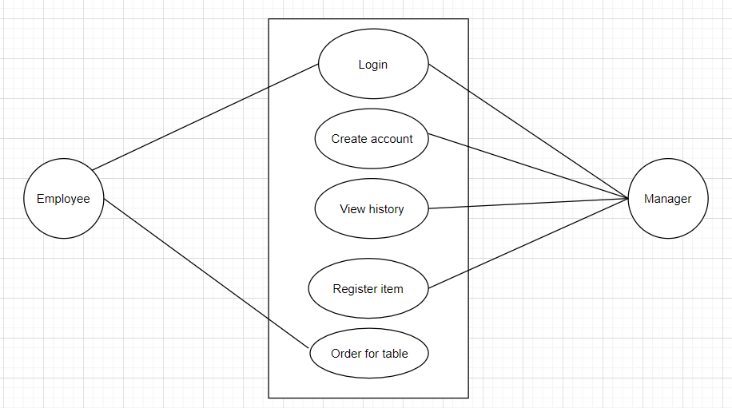

### 2.3.2. Use case detail diagrams

#### 2.3.2.1. Use case “Order for table”

## usecase1

## 2.4. Activity diagrams of use case scenarios

### 2.4.1. Activity diagram for use case “Order”

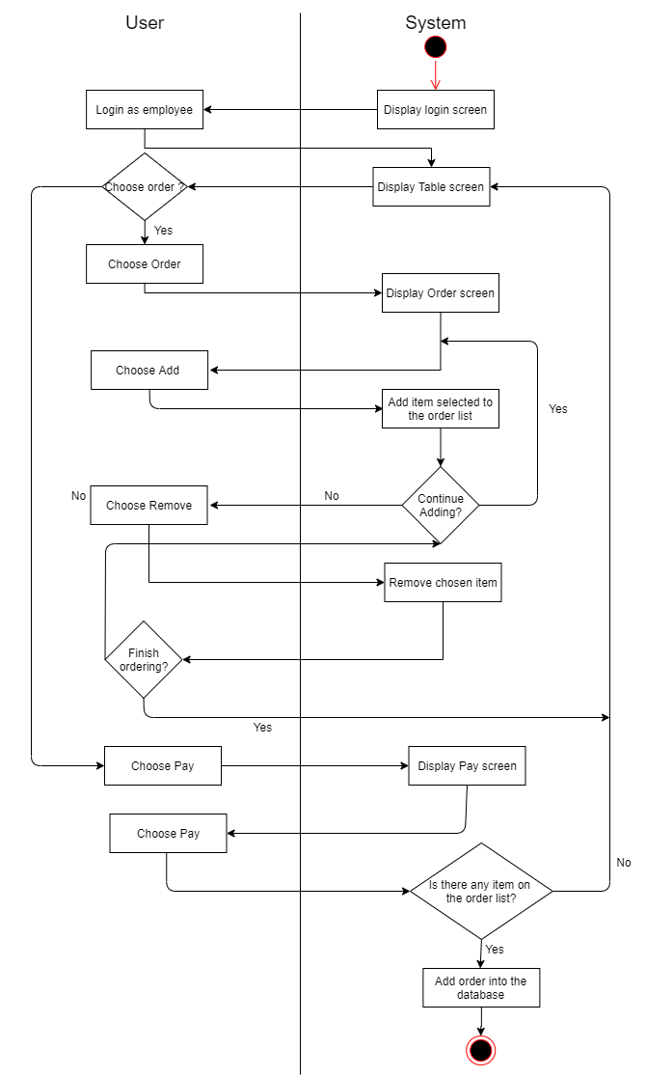

# Data model

## Entity Relationship Diagram

## 

## Table details

Note: Attribute with underline is Primary key

### Table name: Orders

|  |  |  |
| --- | --- | --- |
| **Field name** | **Type** | **Note** |
| order_id | Int | Primary key |
| tbl_id | Int | Not null |
| user_id | nvarchar(20) | Not null |
| created | Date | Not null |
| total | Int | Not null |

### Table name: Order_details

|  |  |  |
| --- | --- | --- |
| **Field name** | **Type** | **Note** |
| order_id | Int | Foreign key, refers to Orders table |
| item_id | Int | Foreign key, refers to Login table |
| quantity | Smallint | Not null |

### Table name: Login

|  |  |  |
| --- | --- | --- |
| **Field name** | **Type** | **Note** |
| user_id | String | Primary key |
| password | String | Not null |
| user_position | Bit | Not null |
| Display_name | String | Not null |

### Table name: Items

|  |  |  |
| --- | --- | --- |
| **Field name** | **Type** | **Note** |
| item_id | Int | Primary key |
| items | String | Not null |
| price | Int | Not null |
| short_description | String | Not null |
| category_id | Int | Foreign key, refers to Categories table |

### Table name: Category

|  |  |  |
| --- | --- | --- |
| **Field name** | **Type** | **Note** |
| category_id | Int | Primary key |
| category_name | String | Not null |

# Class diagram

## List of classes in the Layers

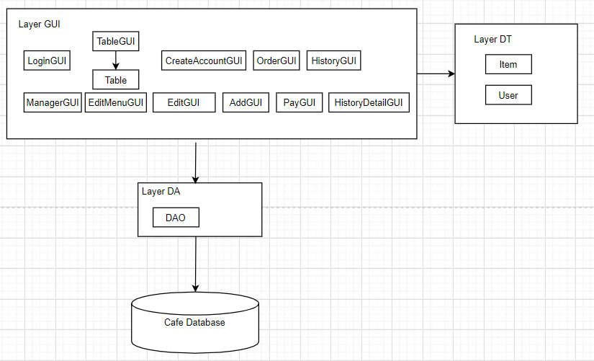

Note: Allow to use

BL: Business logic DT: Data transfer

DA: Data access

## Modeling the Class Behaviors - sequence diagrams

### Sequence diagram for use case “Order”

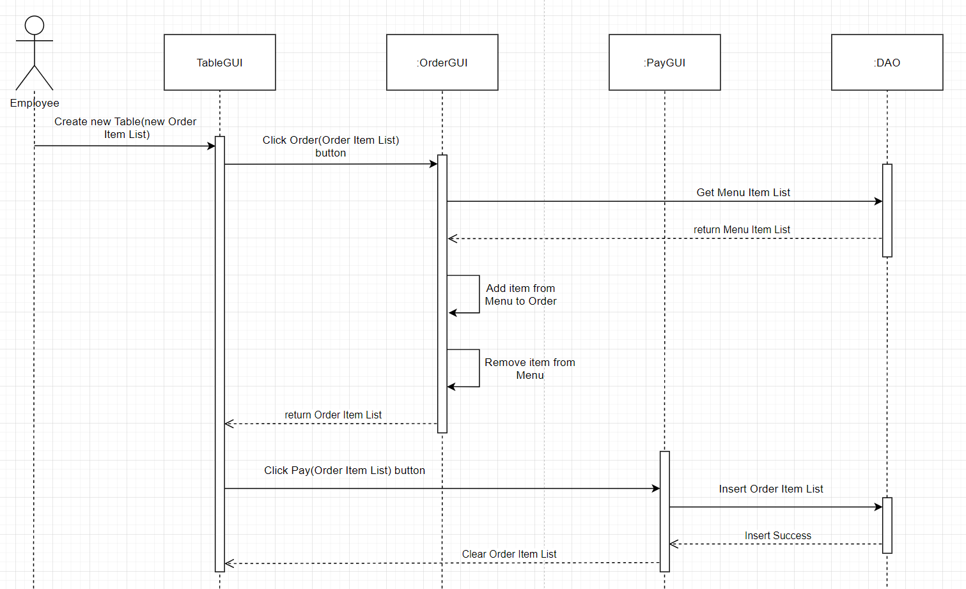

# User Interface Model Design

## User interface model design

### 5.1.1. Screen “Login”

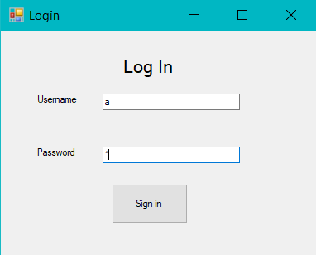

### 5.1.2. Screen “Table”

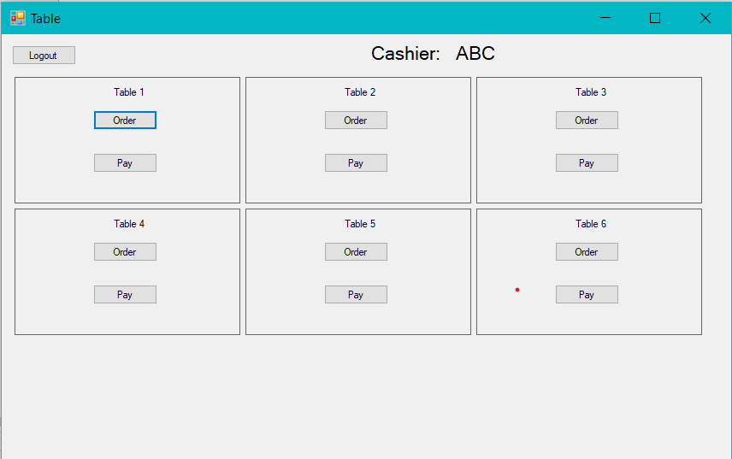

### 5.1.3. Screen “Order”

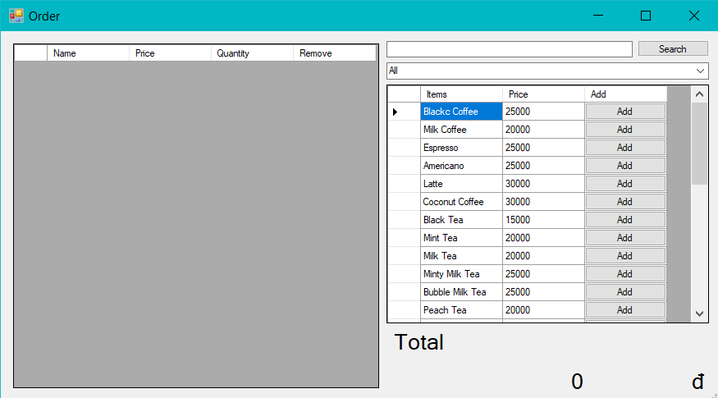

### 5.1.4. Screen “Pay”

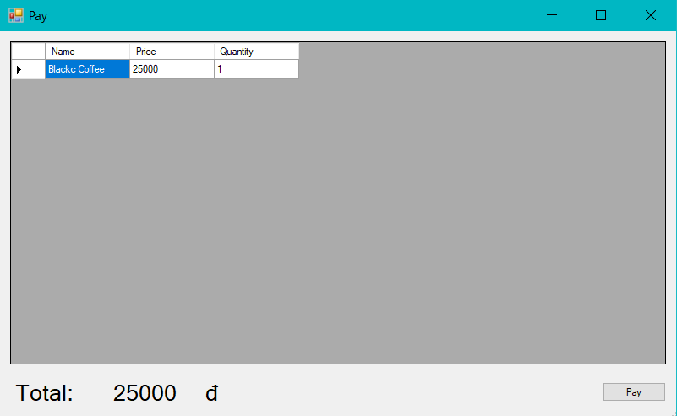

### 5.1.5. Screen “Manager”

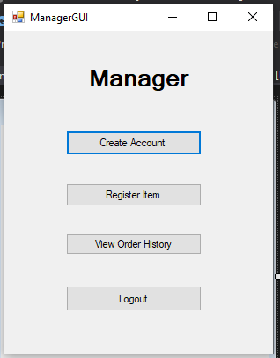

### 5.1.6. Screen “Register Item”

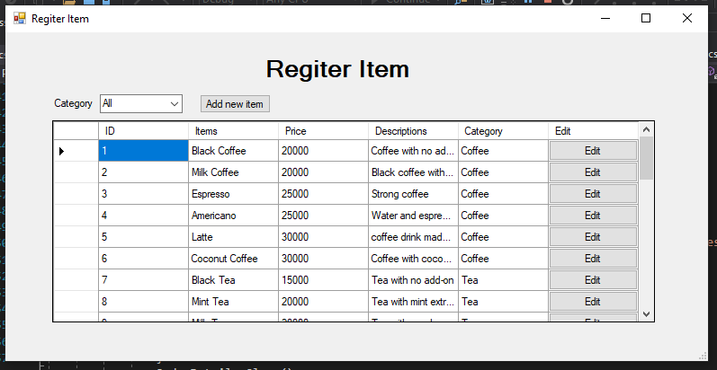

### 5.1.7. Screen “Add item”

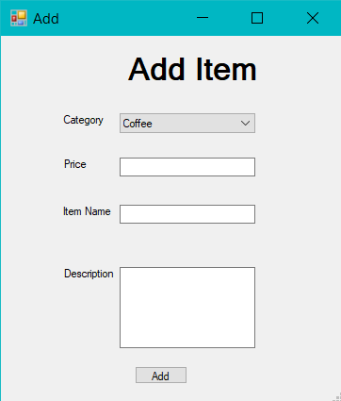

### 5.1.8. Screen “Edit Item”

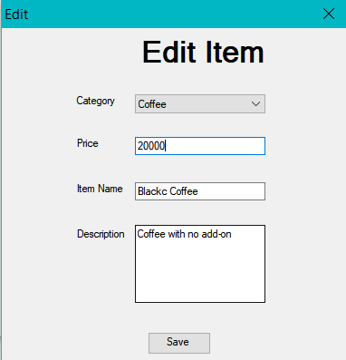

### 5.1.9. Screen “History”

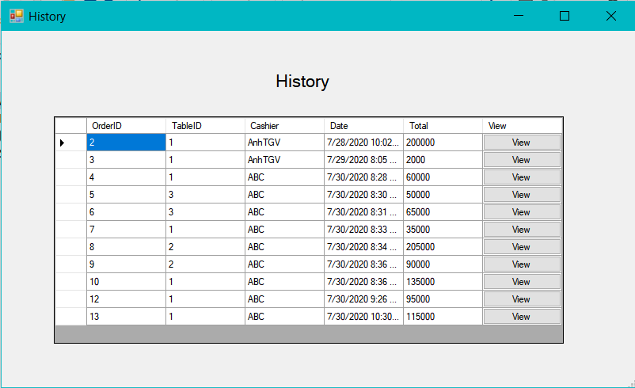

### 5.1.10. Screen “History Detail” historydetailsssss

### 5.1.11. Screen “Create Account”

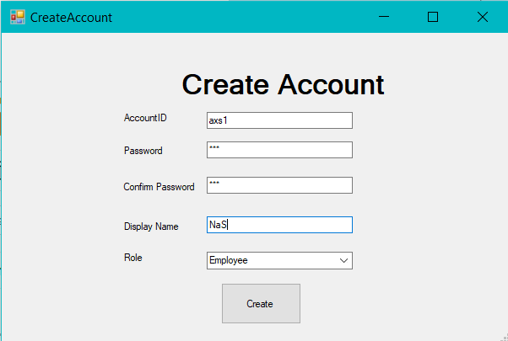

## Interface Flow Diagrams

