|  |
| --- |
| User Guide |
| Cafe Register System |
| Version 1.0 |
| Prepared by class SE1407 Group 4  Nguyen Quang Vinh  Nguyen Vinh Quang  Nguyen Duy Trong  Tran Gia Viet Anh  July 30, 2020 |

Document Revisions

|  |  |  |  |
| --- | --- | --- | --- |
| **Date** | **Authors** | **Modifications** | **Version** |
|  |  |  |  |
|  |  |  |  |
|  |  |  |  |
|  |  |  |  |
|  |  |  |  |

Table of Contents

1. Introduction 4

1.1 Scope and Purpose 4

1.2 Process Overview 4

2. Functions 5

2.1 Log in 5

2.2 Function Order 8

2.2.1 Order 8

2.2.1.1 Search 8

2.2.1.2 Add 9

2.2.1.3 Remove 9

2.2.2 Pay 9

2.3 Function Create Account 9

2.4 Function Register Item 10

2.4.1 Edit Item 10

2.4.2 Add Item 11

2.5 Function View Order History 12

3. System requirement 14

# Introduction

## Scope and Purpose

This document describes user guide for Cafe Register system.

## Process Overview

Cafe Register System is divided into 2 section: 1 for the manager and 1 for employees and user have to log in with manager account or employee account to access them

-For Employees: Create orders for tables

-For Managers:

1. Create Account
2. Register items into menu
3. View history of orders

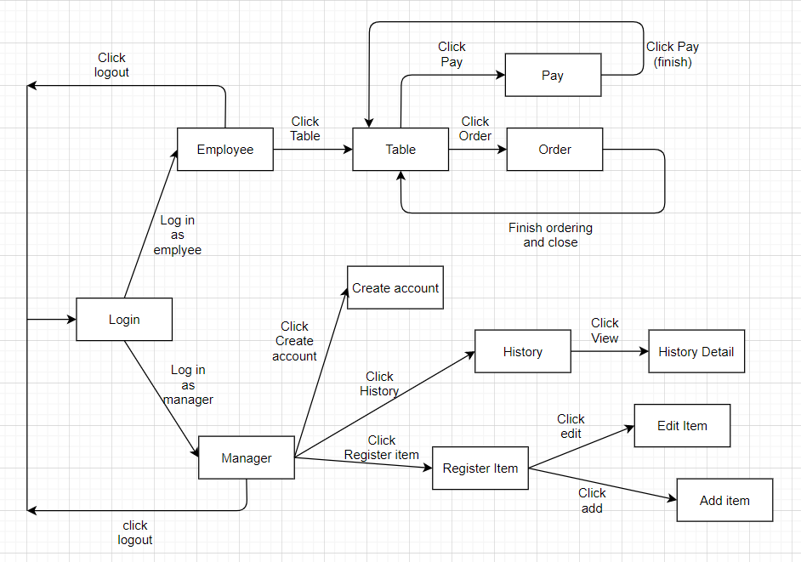

# Functions

## 2.1 Log in

User have to log in to use any feature of the program

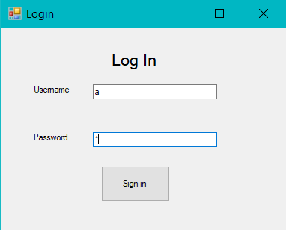

1. Enter some text into User Name field
2. Enter some text into Password field
3. Click “Sign in” to log into the program.
4. If user log into an employee account, the program will display the Table screen
5. 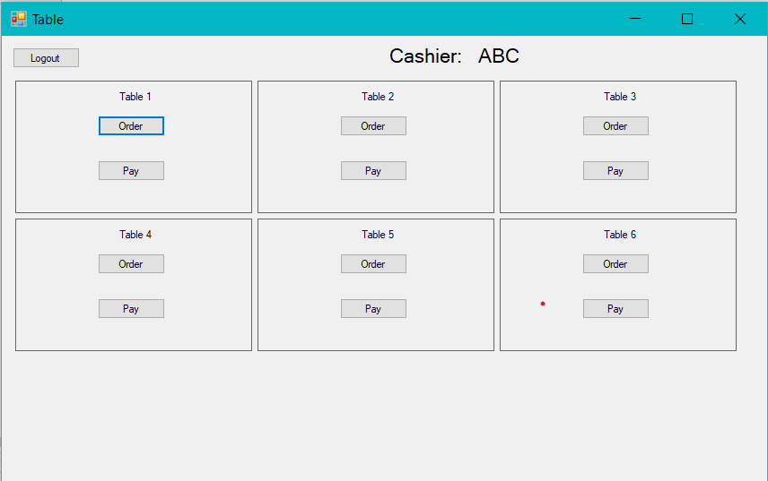

If user log into a manager account, the program will display the Manager menu screen

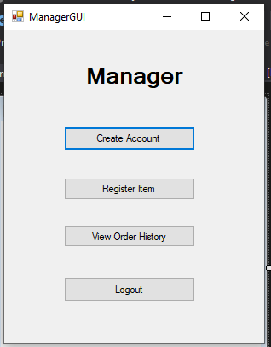

NOTE: User name and password have to be correct to log in, all fields have to be filled

## 2.2 Function Order



### 2.2.1 Order

-Click on Order button on the Table screen

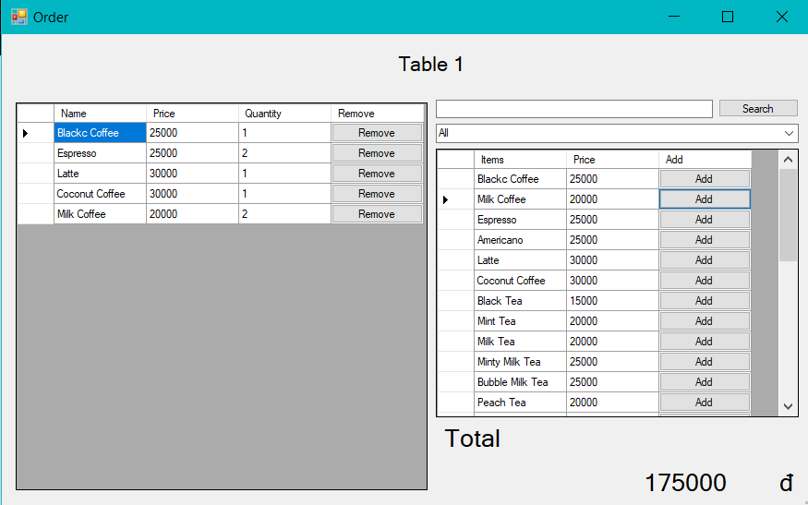

### 2.2.1.1 Search

1. Enter some text into the search field

2. Click Search to find items whose names contain the text you entered

### 2.2.1.2 Add

- Click on “Add” button next to any item on the menu to add it to the order

### 2.2.1.3 Remove

- Click on “Remove” button next to any item on the order list to remove it from the order

### 2.2.2 Pay

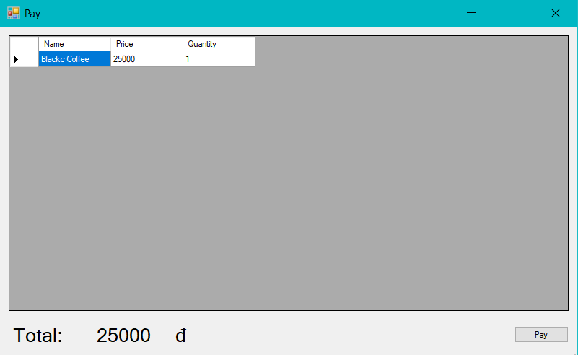

1. Click on “Pay” button on the Table screen

2. Click on “Pay” button on the Pay screen

NOTE: There have to be at least 1 item in a table’s order in order to pay

## 2.3 Function Create Account

- User click on “Create Account” in Manager menu screen

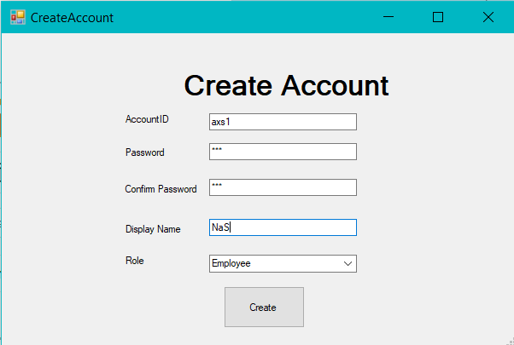

1. Enter some text into all text field
2. Choose role in the combobox
3. Click on “Create” to create a new account

NOTE: Password field and Confirm Password field must be identical, all fields have to be filled

## 2.4 Function Register Item

- User click on “Register Item” in Manager menu screen

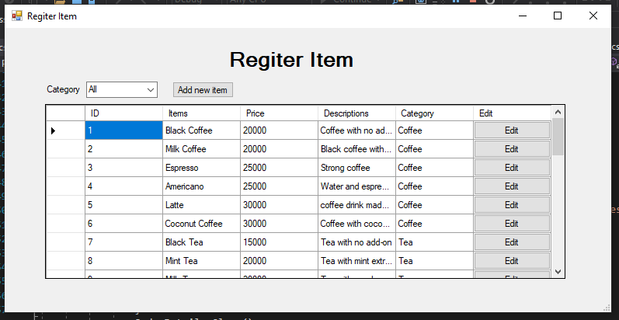

### 2.4.1 Edit Item

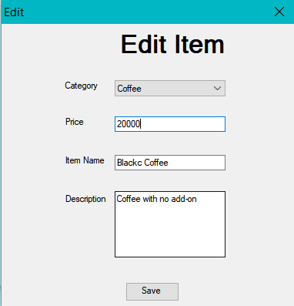

1. Click on “Edit” button next to any item in the list

2. Choose Category int the combobox

3. Enter some text in all text field

4. Click on “Save” button to finish editing the item

NOTE: All fields have to be filled

### 2.4.2 Add Item

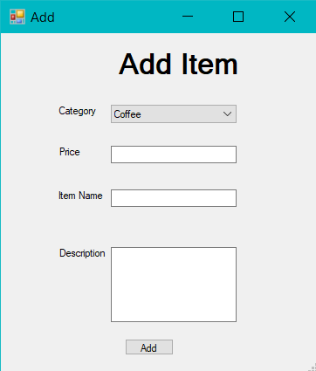

1. Click on “Add”

2. Choose Category int the combobox

3. Enter some text in all text field

4. Click on “Add” button to add the item into menu

NOTE: All fields have to be filled

## 2.5 Function View Order History

1. User click on “View Order History” in Manager menu screen

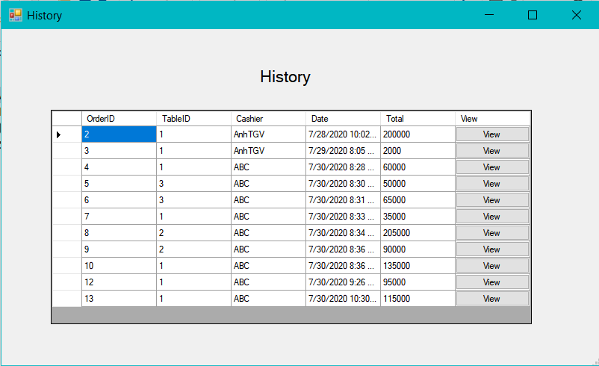

2.Click on “View button” next to any item on the list to show it’s details

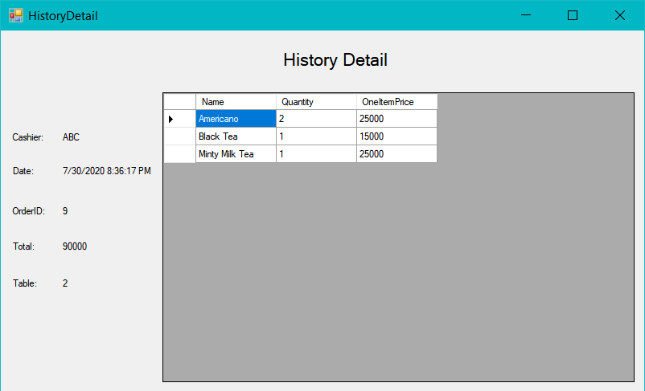

# System requirement

- Operating system: Window 10

- Supporting software: Visual Studio 2019

If you encounter issues not addressed by this user guide, please contact your account manager for additional support.