Small letter

Capital letter

Take out

Period

Add

Proofreadin Mark

Copyright © by William H. Sadlier, Inc. Permission to duplicate classroom quantities granted to users of Grammar Workshop.

Name | rammar
Name | GWorkshop
 | , Level Blue


Unit 4 Adjectives, Adverbs, Conjunctions, and Prepositions

Proofreading (Lessons 29–39, pp. 132–175)

Read the paragraphs below. There are mistakes in the use of adjectives and negatives and in the use of adjectives and adverbs that compare. There are also mistakes in the use of conjunctions.

Find the 14 mistakes, and use the proofreading marks to correct them.
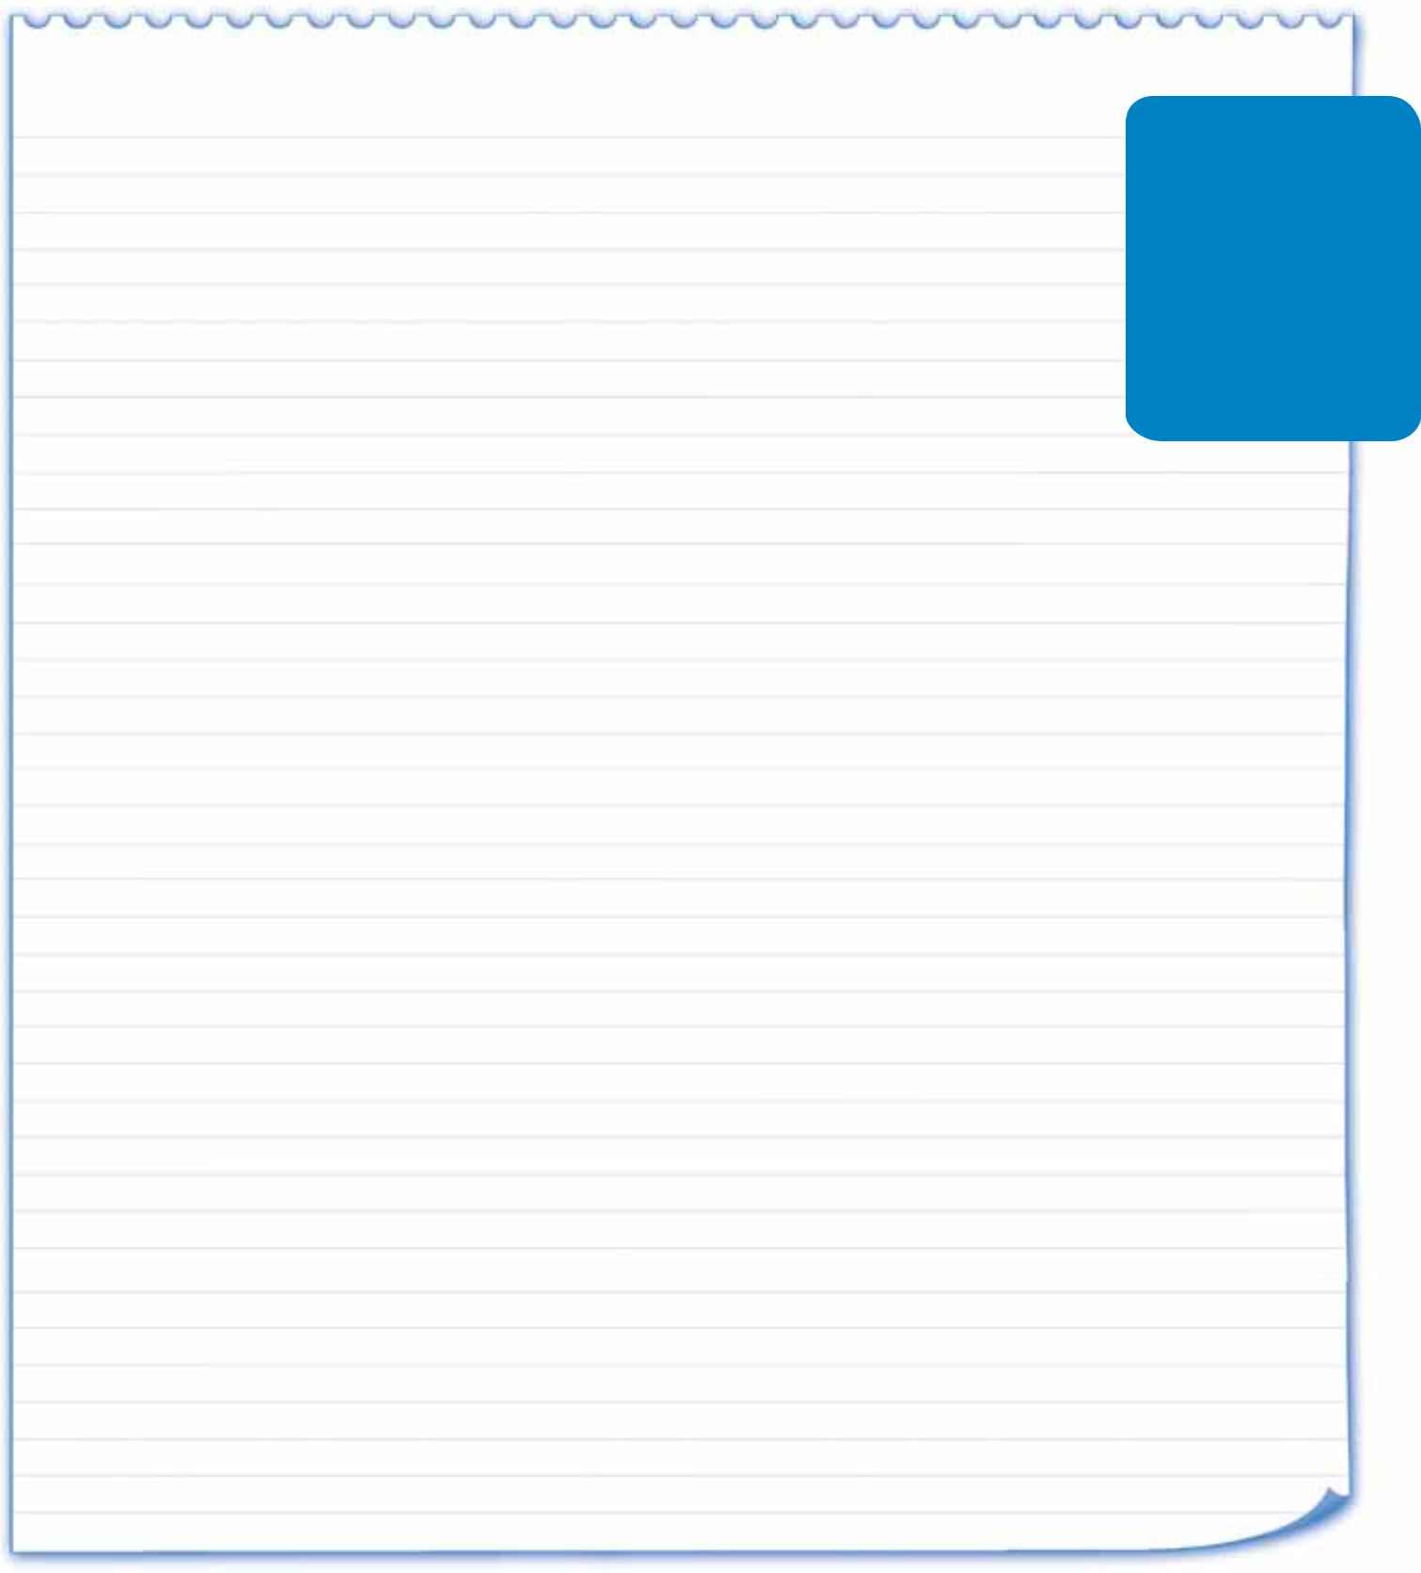

Things weren’t going good at the Johnson house Saturday morning. “Where’s my tennis racket?” shouted
Anita. She had an important tennis match.

“Where’s my saxophone?” shouted her brother Spike. Spike shouted more louder than Anita. He was late for band practice, and he was in a worser mood than she was.
“My work boots are missing!” shouted Mr. Johnson. His shout was the most loudest of all.

Mrs. Johnson gave everyone a real big smile. “I can’t help none of you,” she said, “until we clean the hall closet.”

“There isn’t no time to clean,” Anita groaned. “Today is our busiest day.” Mrs. Johnson opened the closet anyway. Out fell an basketball,

kneepads, and Anita’s tennis racket. “Take this things to your room, Anita.” Spike looked more deeper into the closet. He gathered up not only

notebooks and a umbrella, and some games. Under that things was his saxophone!

After Mr. Johnson looked in the closet, his face got reder than usual. His work boots were right there, too.

Mrs. Johnson smiled. “Thanks for cleaning the closet,” she said.

