**III Semester B. Tech - Computer and Communication Engineering**

**19CCE201 Microcontroller and Interfacing Techniques**

**Term Project**

***Room Occupancy and Security with LPC2148***

**Prepared by:**

|  |  |  |
| --- | --- | --- |
| **S .NO** | **NAME** | **ROLL NO** |
| 01 | Anna R Riya Abbhishree | CB.EN.U4CCE22013 |
| 02 | Rayhan Muhammed R | CB.EN.U4CCE22038 |
| 03 | Aravind B | CB.EN.U4CCE22057 |
| 04 | Amrish Seenu R | CB.EN.U4CCE22061 |

**Department of Electronics and Communication Engineering**

**Amrita School of Engineering, Coimbatore - 641112**

**2022 – 2023 (odd)**

**MOTIVATION / PROBLEM STATEMENT:**

Context:

We need to develop a real-time room occupancy system for a room with two doors (entry and exit) to monitor occupancy and detect intrusion during nighttime hours.

Desired Functionalities:

Occupancy Tracking:

Two IR sensors strategically placed to count individuals entering and exiting the room.

LCD display to showcase the current room occupancy count in real-time.

Nighttime Intrusion Detection:

Real-time clock module to differentiate between daytime (5 AM - 5 PM) and nighttime (5 PM - 5 AM).

During nighttime, any increase in the entry count, without a corresponding increase in the exit count, triggers an intrusion alert.

LCD display shows an alert message ("Somebody is in the room") alongside the current occupancy count.

Buzzer alarm activates to provide an audible indication of the intrusion.

Challenges:

Ensuring accurate occupancy count despite potential simultaneous entry and exit events.

Mitigating false alarms caused by factors like pets or moving objects.

Balancing power efficiency with real-time data display and alarm functionality.

Target Users:

Building managers or security personnel responsible for the room's safety and security.

Occupants of the room who may desire awareness of real-time occupancy and potential nighttime intrusions.

Expected Benefits:

Enhanced security and intrusion detection during vulnerable nighttime hours.

Improved awareness of room occupancy for efficient space utilization and resource allocation.

Potential reduction in security patrols and response costs.

**THEORY:**

1. Sensor and Signal Processing:

Infrared (IR) Sensors: Emit and detect infrared radiation to sense body heat, triggering a signal when someone enters or exits the room through either door.

Signal Conditioning: Prepares the IR sensor signals for processing by filtering noise and amplifying them to ensure accurate detection.

Logic Unit: Receives and interprets the conditioned signals from each door sensor, differentiating between entry and exit events based on direction and timing.

2. Real-Time Data Processing and Display:

Microcontroller: Processes the logic unit's output in real-time, maintaining an accurate occupancy count and updating the LCD display with the current number of occupants.

Real-Time Clock (RTC): Tracks the system's time to differentiate between daytime and nighttime operation.

LCD Display: Provides a visual interface for displaying the occupancy count and alert messages during nighttime intrusions.

3. Time-Based Intrusion Detection and Alarm System:

Time-Based Decision Making: The system employs the RTC to distinguish between daytime and nighttime periods. During nighttime (5 PM - 5 AM), any increase in the occupancy count triggered by an entry event, without a corresponding increase from the exit, activates the intrusion detection protocol.

Alert Mechanism:

LCD Display: Displays a clear and concise count indicating Somebody is in the room.

Buzzer(in the form of led): Generates an visible light to notify designated personnel or deter potential intruders.

Additional Considerations:

False Alarm Mitigation: Implementing algorithms to account for potential false triggers from pets, moving objects, or environmental factors like temperature fluctuations.

Power Efficiency: Utilizing low-power electronics and sleep modes to extend system operation without frequent battery replacements.

Scalability and Integration: Designing the system with modularity and communication protocols in mind to allow for future expansion or integration with broader security systems.

**BLOCK DIAGRAM:**

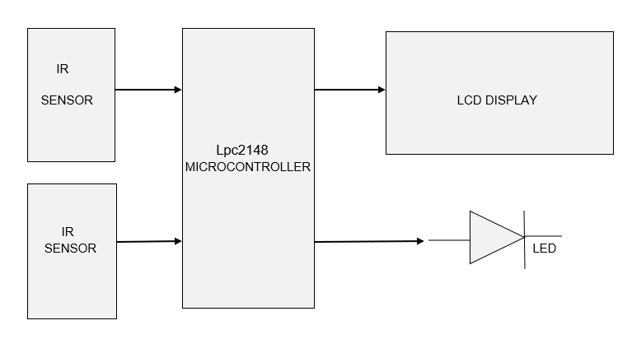

**DESIGN:**

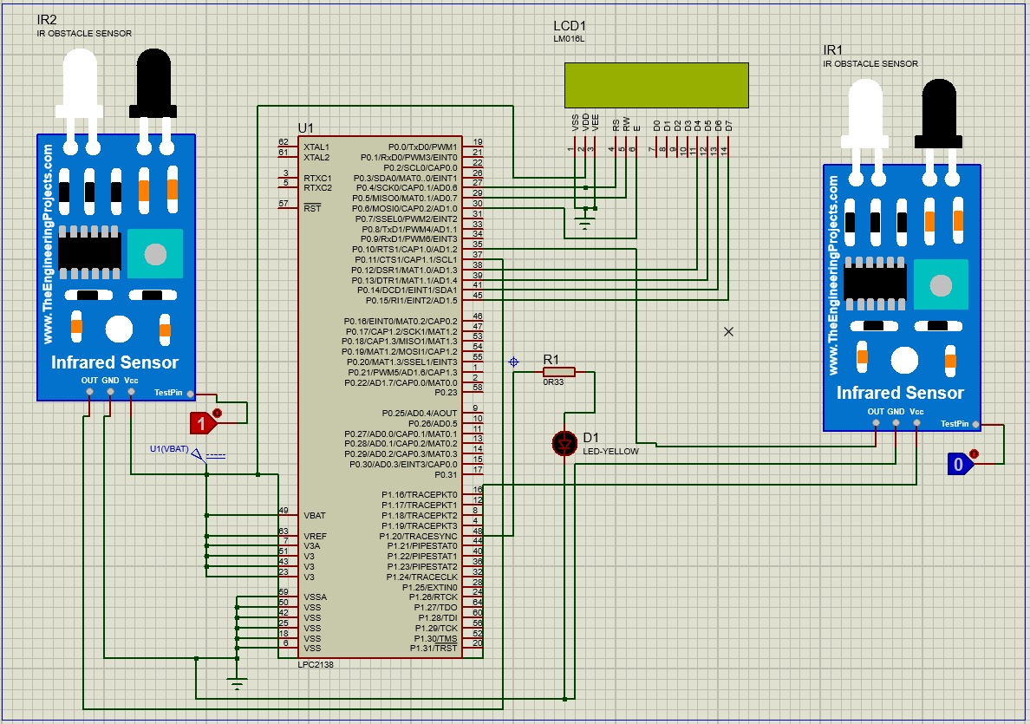

**OUTPUT:**

INTRUSION DETECTION:

Day time:

The lcd displays the count of people entering the room.

Night time:

The led glows to notifies that there is an intruder inside the room after the allowed time ensuring safety.

**INFERENCE:**

Overall, the system infers real-time occupancy status and automatically detects intrusions during vulnerable nighttime hours providing an additional layer of security and awareness. The buzzer alarm and error message is generated when intrusion is detected. During the day time the system remains in monitoring mode keeping track of movements.