Project 1 Report

Course: CMPT371

Liwei Jin ID: 301239902
Di Fu ID: 301239912
Date: Oct.1st, 2013

- Solution:
By using nslookup command and combining with known information, we figured out the answers:
WEB -Address: 142.58.102.68 (ipv4), 2607:f8f0:670:2::5(ipv6)
-Name: www.sfu.ca
DNS -Address: 206.12.16.14
-Name: ns3.sfu.ca
SSH -Address: 142.58.101.25
-Name: fraser.sfu.ca
SMTP -Address: 142.58.101.3
-Name: rm-rstar1.sfu.ca
-Aliases: smtp.sfu.ca
IMAP -Address: 142.58.101.9
-Name: connect.sfu.ca
-Aliases: imap.sfu.ca
POP -Address: 142.58.101.9
-Name: connect.sfu.ca
-Aliases: pop.sfu.ca

- ChordDHT Solution:
Code:
- import java.io.*;
- import java.nio.*;
- import java.nio.channels.FileChannel;
- import java.util.*;

- public class ChordDHT {

- private static ChordDHT my_chord = null;
- private int s; // hash space size==s+1
- private int n; // number of nodes
- private int m; // number of keys
- private Map<Integer, dht_node> nodesMap = new HashMap<Integer, dht_node>();

- private StringBuilder sb = new StringBuilder();

- private class dht_node {
- private int id;
- public Set<Integer> si = new HashSet<Integer>();

- Map<Integer, dht_node> key_map = new HashMap<Integer, dht_node>();

- dht_node(int a) {
- id = a;
- }

- public void addFile(int i) {
- si.add(i);
- }

- public int getId() {
- return id;
- }

- public void updateMap() {
- int finger = 1;
- int flag;
- SortedSet<Integer> keys = new TreeSet<Integer>(nodesMap.keySet());
- while (finger < (s + 1)) {
- flag = 0;
- for (Integer key : keys) {
- if (key >= ((id + finger) % (s + 1))) { // if the node is
- // just >= than the
- // key
- key_map.put((id + finger) % (s + 1), nodesMap.get(key));
- flag = 1;
- break;
- }
- }
- if (flag == 0)
- key_map.put((id + finger) % (s + 1),
- nodesMap.get(keys.first())); // the key is store in
- // the first node
- finger *= 2;
- }
- }

- public void queryDHT(Integer key_to_find) throws IOException {
- if (si.contains(key_to_find)) {
- writeFile(id, 1);
- return;
- }
- SortedSet<Integer> keys = new TreeSet<Integer>(key_map.keySet());
- writeFile(id, 0);
- if (key_to_find < keys.first())
- key_map.get(keys.last()).queryDHT(key_to_find); //if the //key is less than the least node key go to the largest one
- else {
- key_map.get(keys.subSet(0, key_to_find + 1).last()).queryDHT(
- key_to_find); // left inclusive, right exclusive, so + 1
- }
- }

- public void printTable() { // for unit test
- Iterator it = key_map.entrySet().iterator();
- System.out.println("id is" + id + this);
- while (it.hasNext()) {
- System.out.println(it.next());
- }
- System.out.println("\n");
- }
- }

- /* end of dht_node class */

- public void queryDHT(int key, dht_node node) throws IOException {
- node.queryDHT(key);
- }

- public void writeFile(Integer id, int signal) throws IOException {
- sb.append(id + " ");
- if (signal == 1) {
- sb.append("\n");
- FileChannel fc = new FileOutputStream("./src/dht.out").getChannel();
- fc.write(ByteBuffer.wrap(sb.toString().getBytes()));
- fc.close();
- }
- }

- public void readFile() throws IOException {
- String tmp;
- String[] entity;
- int count = 0;
- @SuppressWarnings("resource")
- BufferedReader in = new BufferedReader(new FileReader("./src/dht.in"));
- tmp = in.readLine();
- while (tmp != null) {
- entity = tmp.split(","); //get rid of comma
- for (String str : entity) {
- switch (count) {
- case 0:
- s = Integer.valueOf(str);
- break;
- case 1:
- n = Integer.valueOf(str);
- break;
- case 2:
- m = Integer.valueOf(str);
- break;
- case 3:
- int id = Integer.valueOf(str);
- dht_node d = new dht_node(id);
- nodesMap.put(id, d);
- SortedSet<Integer> keys = new TreeSet<Integer>(
- nodesMap.keySet());
- for (Integer key : keys) {
- nodesMap.get(key).updateMap();
- }
- break;
- case 4:
- int k = Integer.valueOf(str);
- SortedSet<Integer> keys2 = new TreeSet<Integer>(
- nodesMap.keySet());
- if (k > keys2.last()) {
- nodesMap.get(keys2.first()).addFile(k);
- } else
- nodesMap.get(keys2.tailSet(k).first()).addFile(k);
- queryDHT(k, nodesMap.get(1)); // always start from nodeas
- // required
- break;
- }
- }
- count++;
- tmp = in.readLine();
- }
- }

- public static ChordDHT getInstance() {
- if (my_chord == null) {
- my_chord = new ChordDHT();
- }
- return my_chord;
- }

- private ChordDHT() {
- };

- public static void main(String[] args) throws IOException {
- ChordDHT cd = ChordDHT.getInstance();
- cd.readFile();
- }
- }

Sample input, query from host 1:
7
4
2
1,2,0,6
7,6,5,4,3,2,1,0

where the last lines number are the files, they joined one by one and queried one by one.

Sample output:
1 6 0
1 6
1 6
1 6
1 6
1 2
1
1 6 0

Also worth mentioning here, by changing code in line 121 “queryDHT(k, nodesMap.get(N))” , where N is a constant less than or equal to S, this program can start querying from any hosts N. And change the input to buildup a larger hash space:

Sample input, query from host 3:
63
4
2
1,3,6,8,10,17,21,33,36,41,56,61
13,21,23,28,27,33,37,36,45,48,49,57,60,0

Sample output:
3 17
3 21
3 21 33
3 21 33
3 21 33
3 21 33
3 36 41
3 36
3 36 56
3 36 56
3 36 56
3 36 56 61
3 36 56 61
3 36 56 1

3. Base64 Encoder Solution:
Code:
- import java.io.*;
- import java.nio.*;
- import java.nio.channels.FileChannel;

- public class Base64Encoder {
- private static final int BSIZE = 3;
- private static final int LINECUT = 76;
- private static final char[] indexTable = { 'A', 'B', 'C', 'D', 'E', 'F',
- 'G', 'H', 'I', 'J', 'K', 'L', 'M', 'N', 'O', 'P', 'Q', 'R', 'S',
- 'T', 'U', 'V', 'W', 'X', 'Y', 'Z', 'a', 'b', 'c', 'd', 'e', 'f',
- 'g', 'h', 'i', 'j', 'k', 'l', 'm', 'n', 'o', 'p', 'q', 'r', 's',
- 't', 'u', 'v', 'w', 'x', 'y', 'z', '0', '1', '2', '3', '4', '5',
- '6', '7', '8', '9', '+', '/' };

- @SuppressWarnings("resource")
- public static void encode() throws IOException {
- FileChannel fc = new FileInputStream("data.in").getChannel();
- ByteBuffer bb = ByteBuffer.allocate(BSIZE);
- StringBuilder sb = new StringBuilder();
- short s_fake = 0;
- int count = 0;
- while (fc.read(bb) != -1) {
- if (bb.position() == 3) { //when 24 bits as a block
- if (count % LINECUT == 0 && count != 0)
- sb.append("\n");
- bb.flip();
- s_fake = bb.getShort(); // used to get 2 bytes
- sb.append(indexTable[s_fake >> 10 & 0x3f]);
- sb.append(indexTable[(short) (s_fake << 6) >> 10 & 0x3f]);
- bb.rewind();
- s_fake = bb.getShort(1);
- sb.append(indexTable[(short) (s_fake << 4) >> 10 & 0x3f]);
- bb.rewind();
- sb.append(indexTable[bb.get(2) & 0x3f]);
- count += 4;
- }

- else if (bb.position() == 2) { //if 16 bits in this block(tail)
- if (count % LINECUT == 0 && count != 0)
- sb.append("\n");
- bb.put((byte) 0x00);
- bb.flip();
- s_fake = bb.getShort(); // used to get 2 bytes
- sb.append(indexTable[s_fake >> 10 & 0x3f]);
- sb.append(indexTable[(short) (s_fake << 6) >> 10 & 0x3f]);
- bb.rewind();
- s_fake = bb.getShort(1);
- sb.append(indexTable[(short) (s_fake << 4) >> 10 & 0x3f]);
- sb.append("=");
- }

- else if (bb.position() == 1) { //if 8 bits in this block(tail)
- if (count % LINECUT == 0 && count != 0)
- sb.append("\n");
- bb.put((byte) 0x00);
- bb.put((byte) 0x00);
- bb.flip();
- s_fake = bb.getShort(); // used to get 2 bytes
- sb.append(indexTable[s_fake >> 10 & 0x3f]);
- sb.append(indexTable[(short) (s_fake << 6) >> 10 & 0x3f]);
- sb.append("==");
- }

- }

- fc = new FileOutputStream("data.out").getChannel();
- fc.write(ByteBuffer.wrap(sb.toString().getBytes()));
- fc.close();
- }

- public static void main(String[] args) throws IOException {
- encode();
- }
- }

Given the sample input:

CMPT 371 Data Communications and Networking Project 1.

The output given by the program is:

Q01QVCAzNzEgRGF0YSBDb21tdW5pY2F0aW9ucyBhbmQgTmV0d29ya2luZyBQcm9qZWN0IDEu

Add more characters to the sample input:

CMPT 371 Data Communications and Networking Project 1, nailed.

And the output becomes:

Q01QVCAzNzEgRGF0YSBDb21tdW5pY2F0aW9ucyBhbmQgTmV0d29ya2luZyBQcm9qZWN0IDEsIG5h
aWxlZC4=

Notice that there is a \n in between the output sequence, which is due to the requirements in most of bas64 encoding that a ‘\n’ should be inserted every 76 characters.

4. Wireshark Solution:
A. Packet sniffer:
1.
Screenshot:
TCP HTTP ARP

2.
It takes 27.139501-27.028939=110.562msec.

3.
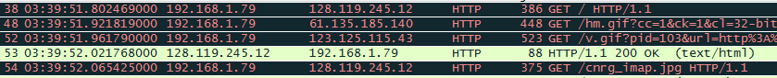
The address of the gaia.cs.umass.edu is 128.119.245.12.
And my computer’s address is 192.168.1.79.

4.
No. Time Source Destination Protocol Length Info
22 03:43:23.456825000 192.168.1.79 128.119.245.12 HTTP 513 GET /wireshark-labs/INTRO-wireshark-file1.html HTTP/1.1

Frame 22: 513 bytes on wire (4104 bits), 513 bytes captured (4104 bits) on interface 0
Ethernet II, Src: Hewlett-_e7:83:ea (2c:27:d7:e7:83:ea), Dst: ZyxelCom_6e:04:cf (c8:6c:87:6e:04:cf)
Internet Protocol Version 4, Src: 192.168.1.79 (192.168.1.79), Dst: 128.119.245.12 (128.119.245.12)
Transmission Control Protocol, Src Port: 65323 (65323), Dst Port: http (80), Seq: 1, Ack: 1, Len: 459
Hypertext Transfer Protocol
GET /wireshark-labs/INTRO-wireshark-file1.html HTTP/1.1\r\n
Host: gaia.cs.umass.edu\r\n
Connection: keep-alive\r\n
Accept: text/html,application/xhtml+xml,application/xml;q=0.9,*/*;q=0.8\r\n
User-Agent: Mozilla/5.0 (Windows NT 6.1; WOW64) AppleWebKit/537.36 (KHTML, like Gecko) Chrome/27.0.1453.110 Safari/537.36\r\n
Accept-Encoding: gzip,deflate,sdch\r\n
Accept-Language: en-US,en;q=0.8\r\n
If-None-Match: "8734b-51-ad85ca40"\r\n
If-Modified-Since: Sun, 20 Oct 2013 10:32:01 GMT\r\n
\r\n
[Full request URI: http://gaia.cs.umass.edu/wireshark-labs/INTRO-wireshark-file1.html]
[HTTP request 1/2]
[Response in frame: 24]
[Next request in frame: 27]

No. Time Source Destination Protocol Length Info
24 03:43:23.569634000 128.119.245.12 192.168.1.79 HTTP 434 HTTP/1.1 200 OK (text/html)

Frame 24: 434 bytes on wire (3472 bits), 434 bytes captured (3472 bits) on interface 0
Ethernet II, Src: ZyxelCom_6e:04:cf (c8:6c:87:6e:04:cf), Dst: Hewlett-_e7:83:ea (2c:27:d7:e7:83:ea)
Internet Protocol Version 4, Src: 128.119.245.12 (128.119.245.12), Dst: 192.168.1.79 (192.168.1.79)
Transmission Control Protocol, Src Port: http (80), Dst Port: 65323 (65323), Seq: 1, Ack: 460, Len: 380
Hypertext Transfer Protocol
HTTP/1.1 200 OK\r\n
Date: Sun, 20 Oct 2013 10:43:23 GMT\r\n
Server: Apache/2.2.3 (CentOS)\r\n
Last-Modified: Sun, 20 Oct 2013 10:43:01 GMT\r\n
ETag: "8734b-51-d4dc9740"\r\n
Accept-Ranges: bytes\r\n
Content-Length: 81\r\n
Keep-Alive: timeout=10, max=100\r\n
Connection: Keep-Alive\r\n
Content-Type: text/html; charset=UTF-8\r\n
\r\n
[HTTP response 1/2]
[Time since request: 0.112809000 seconds]
[Request in frame: 22]
[Next request in frame: 27]
[Next response in frame: 28]
Line-based text data: text/html

HTTP:
Part 1.
GET and response messages:
No. Time Source Destination Protocol Length Info
103 03:54:12.564883000 192.168.1.79 128.119.245.12 HTTP 426 GET /wireshark-labs/HTTP-wireshark-file1.html HTTP/1.1 (Indicates the browser supports HTTP version 1.1)

Frame 103: 426 bytes on wire (3408 bits), 426 bytes captured (3408 bits) on interface 0
Ethernet II, Src: Hewlett-_e7:83:ea (2c:27:d7:e7:83:ea), Dst: ZyxelCom_6e:04:cf (c8:6c:87:6e:04:cf)
Internet Protocol Version 4, Src: 192.168.1.79 (It’s the address of my computer) (192.168.1.79), Dst: 128.119.245.12 (It’s the address of the server) (128.119.245.12)
Transmission Control Protocol, Src Port: 65336 (65336), Dst Port: http (80), Seq: 1, Ack: 1, Len: 372
Hypertext Transfer Protocol
GET /wireshark-labs/HTTP-wireshark-file1.html HTTP/1.1\r\n
Host: gaia.cs.umass.edu\r\n
Connection: keep-alive\r\n
Accept: text/html,application/xhtml+xml,application/xml;q=0.9,*/*;q=0.8\r\n
User-Agent: Mozilla/5.0 (Windows NT 6.1; WOW64) AppleWebKit/537.36 (KHTML, like Gecko) Chrome/27.0.1453.110 Safari/537.36\r\n
Accept-Encoding: gzip,deflate,sdch\r\n
Accept-Language: en-US,en;q=0.8\r\n
\r\n (Browser supports two languages: en-US and en.)
[Full request URI: http://gaia.cs.umass.edu/wireshark-labs/HTTP-wireshark-file1.html]
[HTTP request 1/2]
[Response in frame: 109]
[Next request in frame: 118]

No. Time Source Destination Protocol Length Info
109 03:54:12.675089000 128.119.245.12 192.168.1.79 HTTP 482 HTTP/1.1 (Indicates the server is running HTTP version 1.1
) 200 OK (the status code returned) (text/html)

Frame 109: 482 bytes on wire (3856 bits), 482 bytes captured (3856 bits) on interface 0
Ethernet II, Src: ZyxelCom_6e:04:cf (c8:6c:87:6e:04:cf), Dst: Hewlett-_e7:83:ea (2c:27:d7:e7:83:ea)
Internet Protocol Version 4, Src: 128.119.245.12 (128.119.245.12), Dst: 192.168.1.79 (192.168.1.79)
Transmission Control Protocol, Src Port: http (80), Dst Port: 65336 (65336), Seq: 1, Ack: 373, Len: 428
Hypertext Transfer Protocol
HTTP/1.1 200 OK\r\n
Date: Sun, 20 Oct 2013 10:54:12 GMT\r\n
Server: Apache/2.2.3 (CentOS)\r\n
Last-Modified: Sun, 20 Oct 2013 10:54:01 GMT\r\n
(The HTML file was last modified at 20 Oct 2013 10:54:01 GMT)
ETag: "8734d-80-fc336440"\r\n
Accept-Ranges: bytes\r\n
Content-Length: 128\r\n
(The content length is 128 bytes)
Keep-Alive: timeout=10, max=100\r\n
Connection: Keep-Alive\r\n
Content-Type: text/html; charset=UTF-8\r\n
\r\n
[HTTP response 1/2]
[Time since request: 0.110206000 seconds]
[Request in frame: 103]
[Next request in frame: 118]
[Next response in frame: 119]
Line-based text data: text/html
There are some headers not displayed in the packet-listing window like Content-Type and Keep-Alive.

Part 2.
8. No.
9. Yes. The status code return is “200 OK” not “304 Not Modified”, so the server has to send the whole HTML file to the client. On the other hand, the cache of browser is entirely deleted, so the browser has to get the html object from server.
10.Yes. The content of “IF-MODIFIED-SINCE:” header is “If-Modified-Since: Sun, 20 Oct 2013 11:22:01 GMT”.
11. The second status code returned is “304 Not Modified” and server didn’t return the content explicitly. That’s because the browser knows the cache is up-to-date from this status code and doesn’t need to ask the server to resend the html object.

Part 3.
12. Two. Packet No.58 contains the GET message for the Bill of Rights.
13. Packet No.64.
14. 200 OK.
15. Four.
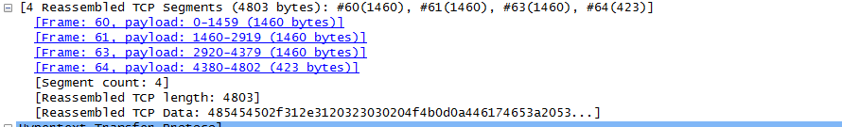

Part 4.
16. Four. The address is 128.119.245.12, 128.119.240.90 and 165.193.140.14 respectively.
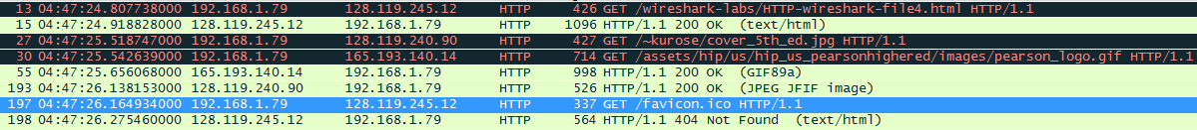
17. In parallel. Because the browser sends the second request before receiving the first response.

Part 5.
18. 401 Authorization Required
19.A new header called “Authorization” is included.

DNS
Part 3.
Packet content:
No. Time Source Destination Protocol Length Info
1 05:03:01.194590000 192.168.1.79 192.168.1.254 DNS 72 Standard query 0x8155 A www.ietf.org

Frame 1: 72 bytes on wire (576 bits), 72 bytes captured (576 bits) on interface 0
Ethernet II, Src: Hewlett-_e7:83:ea (2c:27:d7:e7:83:ea), Dst: ZyxelCom_6e:04:cf (c8:6c:87:6e:04:cf)
Internet Protocol Version 4, Src: 192.168.1.79 (192.168.1.79), Dst: 192.168.1.254 (192.168.1.254)
User Datagram Protocol, Src Port: 59065 (59065), Dst Port: domain (53)
Domain Name System (query)

No. Time Source Destination Protocol Length Info
2 05:03:01.246772000 192.168.1.254 192.168.1.79 DNS 88 Standard query response 0x8155 A 12.22.58.30

Frame 2: 88 bytes on wire (704 bits), 88 bytes captured (704 bits) on interface 0
Ethernet II, Src: ZyxelCom_6e:04:cf (c8:6c:87:6e:04:cf), Dst: Hewlett-_e7:83:ea (2c:27:d7:e7:83:ea)
Internet Protocol Version 4, Src: 192.168.1.254 (192.168.1.254), Dst: 192.168.1.79 (192.168.1.79)
User Datagram Protocol, Src Port: domain (53), Dst Port: 59065 (59065)
Domain Name System (response)
4. UDP.
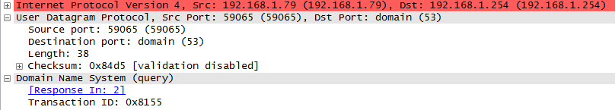
5. The destination port is 53 and the source port is also 53.
6. 192.168.1.254. They are the same.
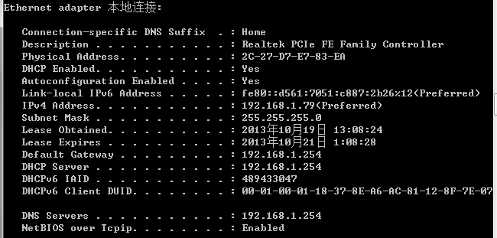
7. It’s a type A Standard Query and it doesn’t contain any answers.
8. There were 1 answers provided. The content is listed:
www.ietf.org: type A, class IN, addr 12.22.58.30
Name: www.ietf.org
Type: A (Host address)
Class: IN (0x0001)
Time to live: 30 minutes
Data length: 4
Addr: 12.22.58.30 (12.22.58.30)
9. The destination IP of SYN packet was just the IP address provided in the first DNS response message.
10. No.
11. The destination port for the DNS query message is 53. And the source port of DNS response message is also 53.
12. The DNS query message is sent to 192.168.1.254 which is the same IP address as my local DNS server.
13. It’s a type A Standard Query and it doesn’t contain any answers.
14.It provided 3 answers.
www.mit.edu: type CNAME, class IN, cname www.mit.edu.edgekey.net
Name: www.mit.edu
Type: CNAME (Canonical name for an alias)
Class: IN (0x0001)
Time to live: 26 minutes, 21 seconds
Data length: 25
Primaryname: www.mit.edu.edgekey.net
www.mit.edu.edgekey.net: type CNAME, class IN, cname e7086.b.akamaiedge.net
Name: www.mit.edu.edgekey.net
Type: CNAME (Canonical name for an alias)
Class: IN (0x0001)
Time to live: 4 minutes, 22 seconds
Data length: 21
Primaryname: e7086.b.akamaiedge.net
e7086.b.akamaiedge.net: type A, class IN, addr 23.6.166.151
Name: e7086.b.akamaiedge.net
Type: A (Host address)
Class: IN (0x0001)
Time to live: 15 seconds
Data length: 4
Addr: 23.6.166.151 (23.6.166.151)
15.
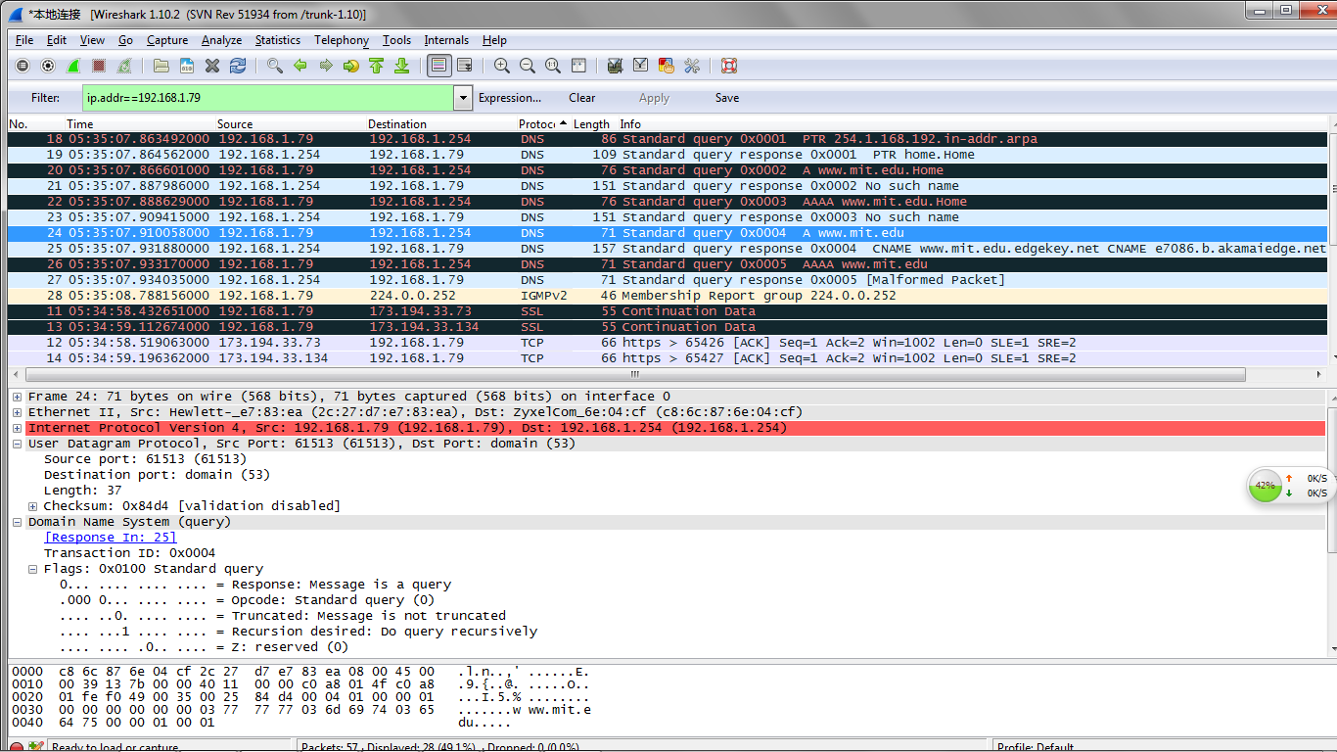
16. The DNS query message is sent to 192.168.1.254 which is my local DNS server.
17. It’s a type NS Standard query and doesn’t contain any answers.
18. Name servers of MIT are usw2.akam.net, asia2.akam.net, asia1.akam.net, use5.akam.net, eur5.akam.net, ns1-173.akam.net, use2.akam.net, ns1-37.akam.net. It didn’t provide the IP addresses of the name servers.
19.
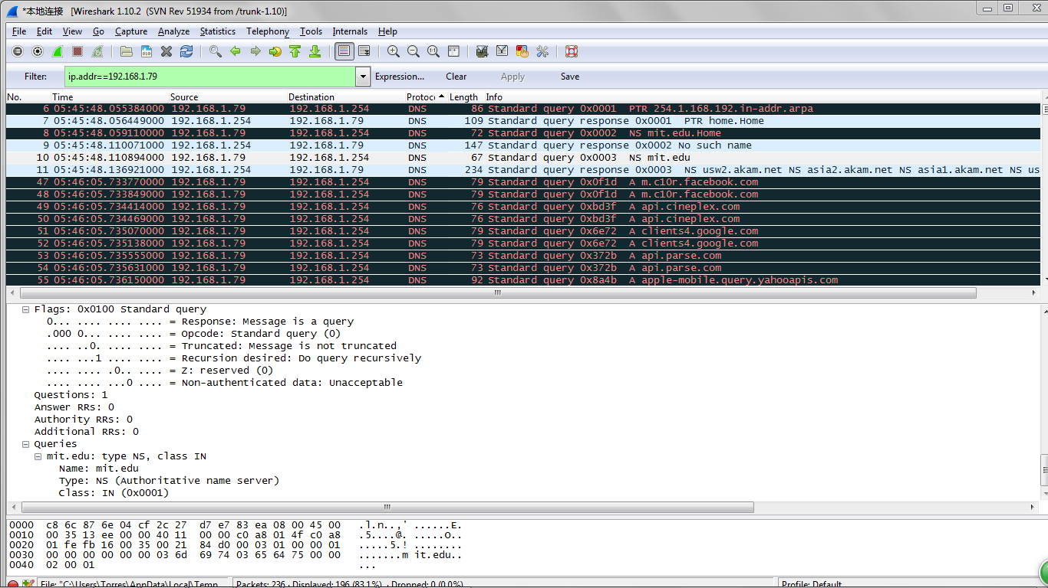
20-23. It returns timeout notification.

- Python Socket Server Solution:
The following codes are the Python socket server:
- #import socket module
- from socket import *
- PORT=80
- MAXMSGLEN=1024
- serverSocket = socket(AF_INET, SOCK_STREAM)
- #Prepare a sever socket
- ipaddress=gethostbyname(gethostname())
- serverSocket.bind((gethostbyname(gethostname()),PORT))
- serverSocket.listen(5)
- while True:
- #Establish the connection
- print ipaddress+' Ready to serve...'
- connectionSocket, addr = serverSocket.accept()
- try:
- message = connectionSocket.recv(MAXMSGLEN)
- filename = message.split()[1]
- f = open("./serverRoot"+filename)
- outputdata = f.readlines();
- f.close()
- #Send one HTTP header line into socket
- connectionSocket.send("HTTP/1.1 200 OK \nConnection close\nContent-Type: text/html\n\n")
- #Send the content of the requested file to the client
- for i in range(0, len(outputdata)):
- connectionSocket.send(outputdata[i])
- except IOError:
- #Send response message for file not found
- connectionSocket.send("HTTP/1.1 404 Not Found \nConnection close\n\n")
- #Close client socket
- if not connectionSocket is None:
- connectionSocket.close()

