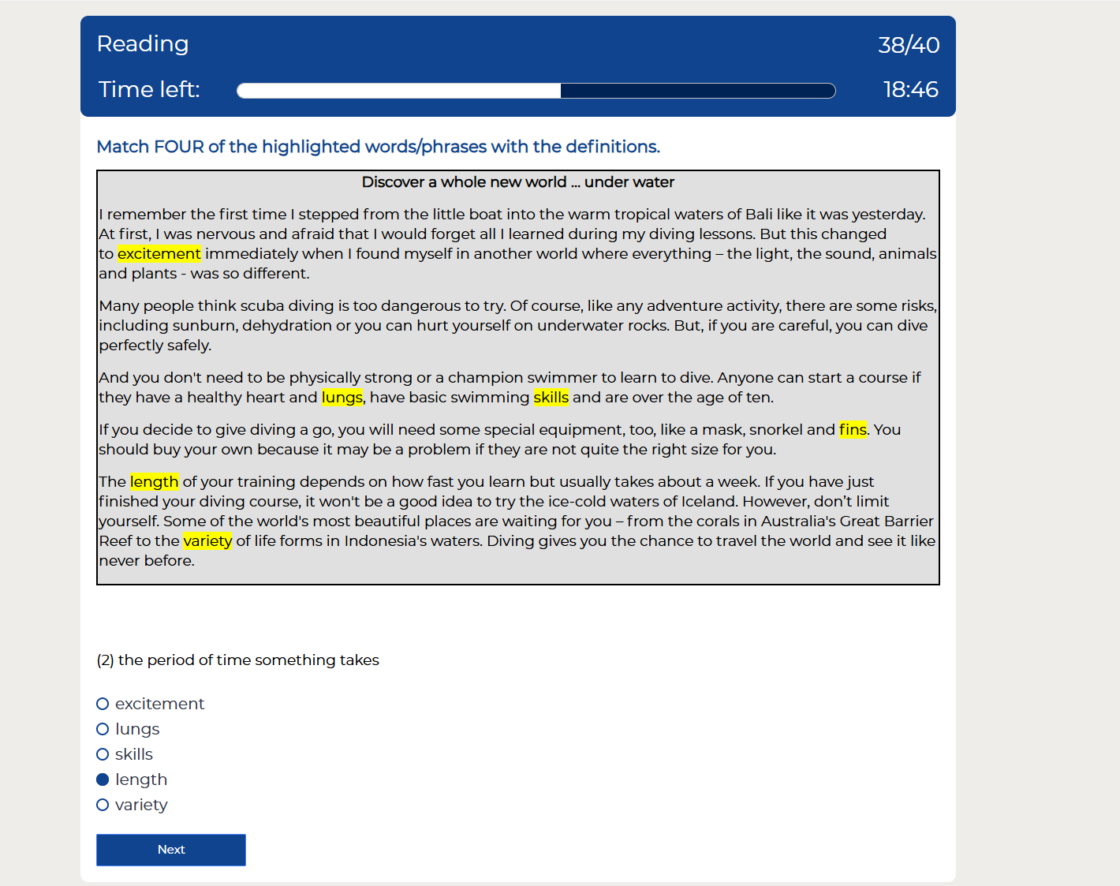
Variety
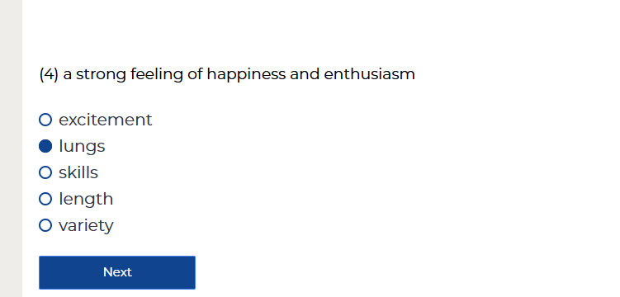
pedestrian zone
blunt
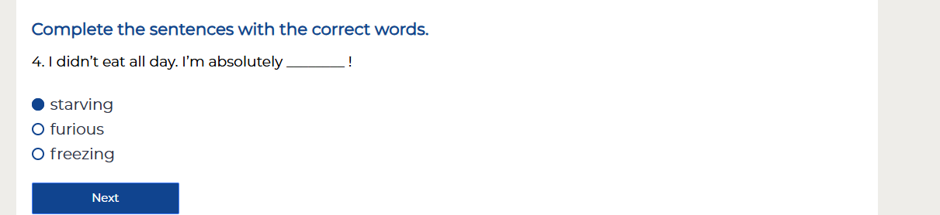
Complete the sentences with the correct words.
5. My colleagues were very ________ of me, because I was promoted.
jealous
ambitious
moody
embarrassed
confused
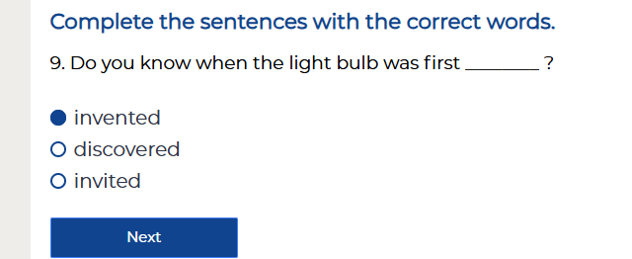
11. I really expected them to win the match and felt very ________ when they lost.
fascinated
pleased
disappointed

Complete the sentences with the correct words.
14. The local guide ________ us of the dangers of walking the streets at night.
explained
spoke
warned

Don't ________ with him. He won't change his mind.
trust
argue
accept
. The policeman asked him ___________________ .
what was his name
what is his name
if his name was
what his name was
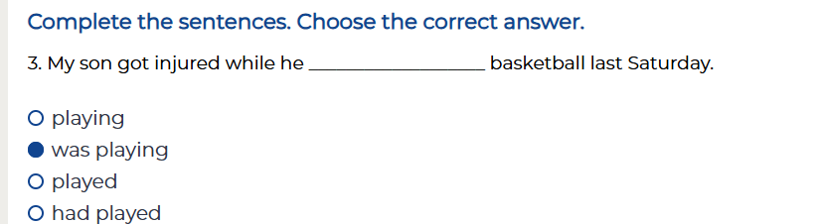
4. I can't go out now. I ___________________ .
haven't finish my homework yet
haven't finished my homework already
didn't finish my homework yet
haven't finished my homework yet
6. We ___________________ at 10:00 o'clock tomorrow in Jack's office. We arranged it weeks ago.
will meet
meet
are meeting
are going to meeting

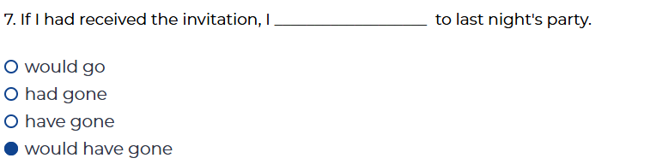
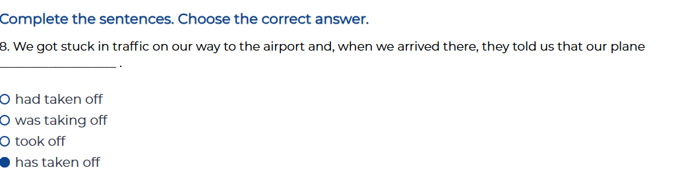
9. Unfortunately, I’m ___________________ I used to be when I first started working in this job.
less excited that
least excited than
not so excited that
not as excited as
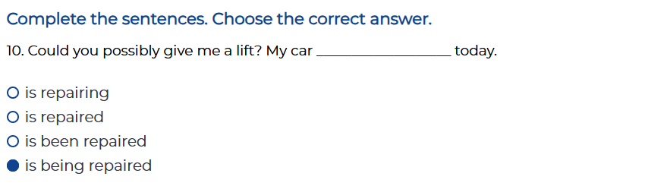
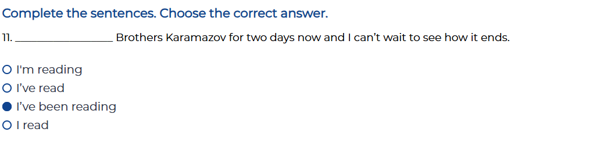
Complete the sentences. Choose the correct answer.
13. That girl took your handbag, __________________ ?
did she
didn't she
does she
wasn't she
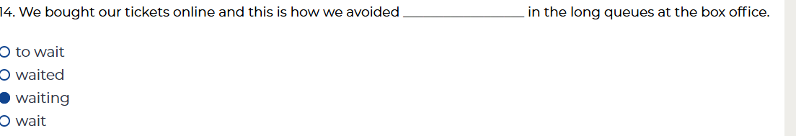
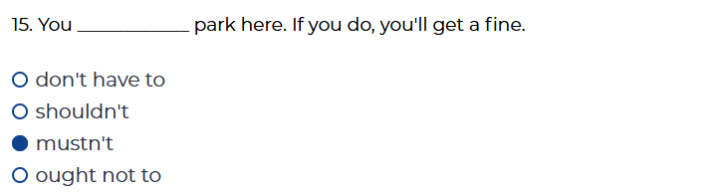
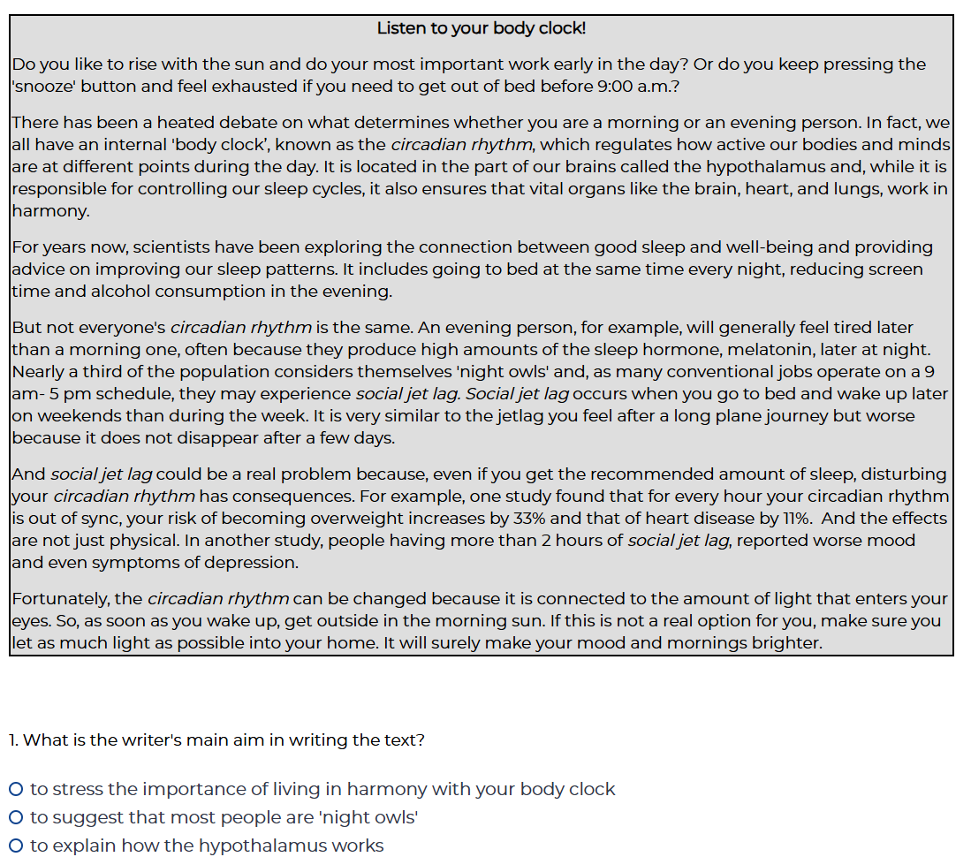
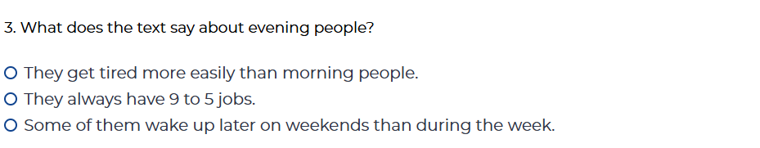

4. What does the text say about social jet lag?
Its effects are as serious as those after a long plane journey.
It is only experienced by people who travel.
It increases people's risks of ill health.

5. What does the text suggest about changing your circadian rhythm?
It is possible to change your circadian rhythm only if you wake up early every morning.
It depends on how much light there is around you.
It is possible to change your circadian rhythm only if you get outside in the morning sun.

