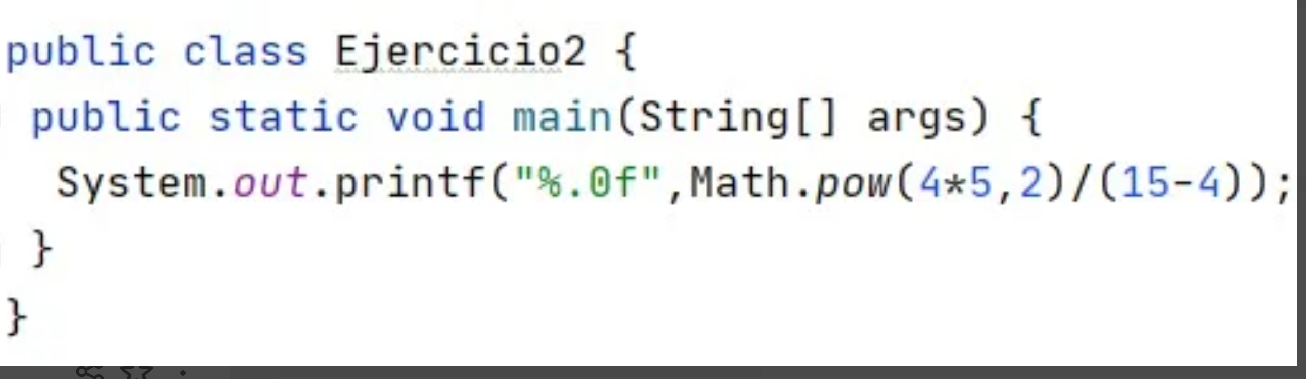

}

Mayor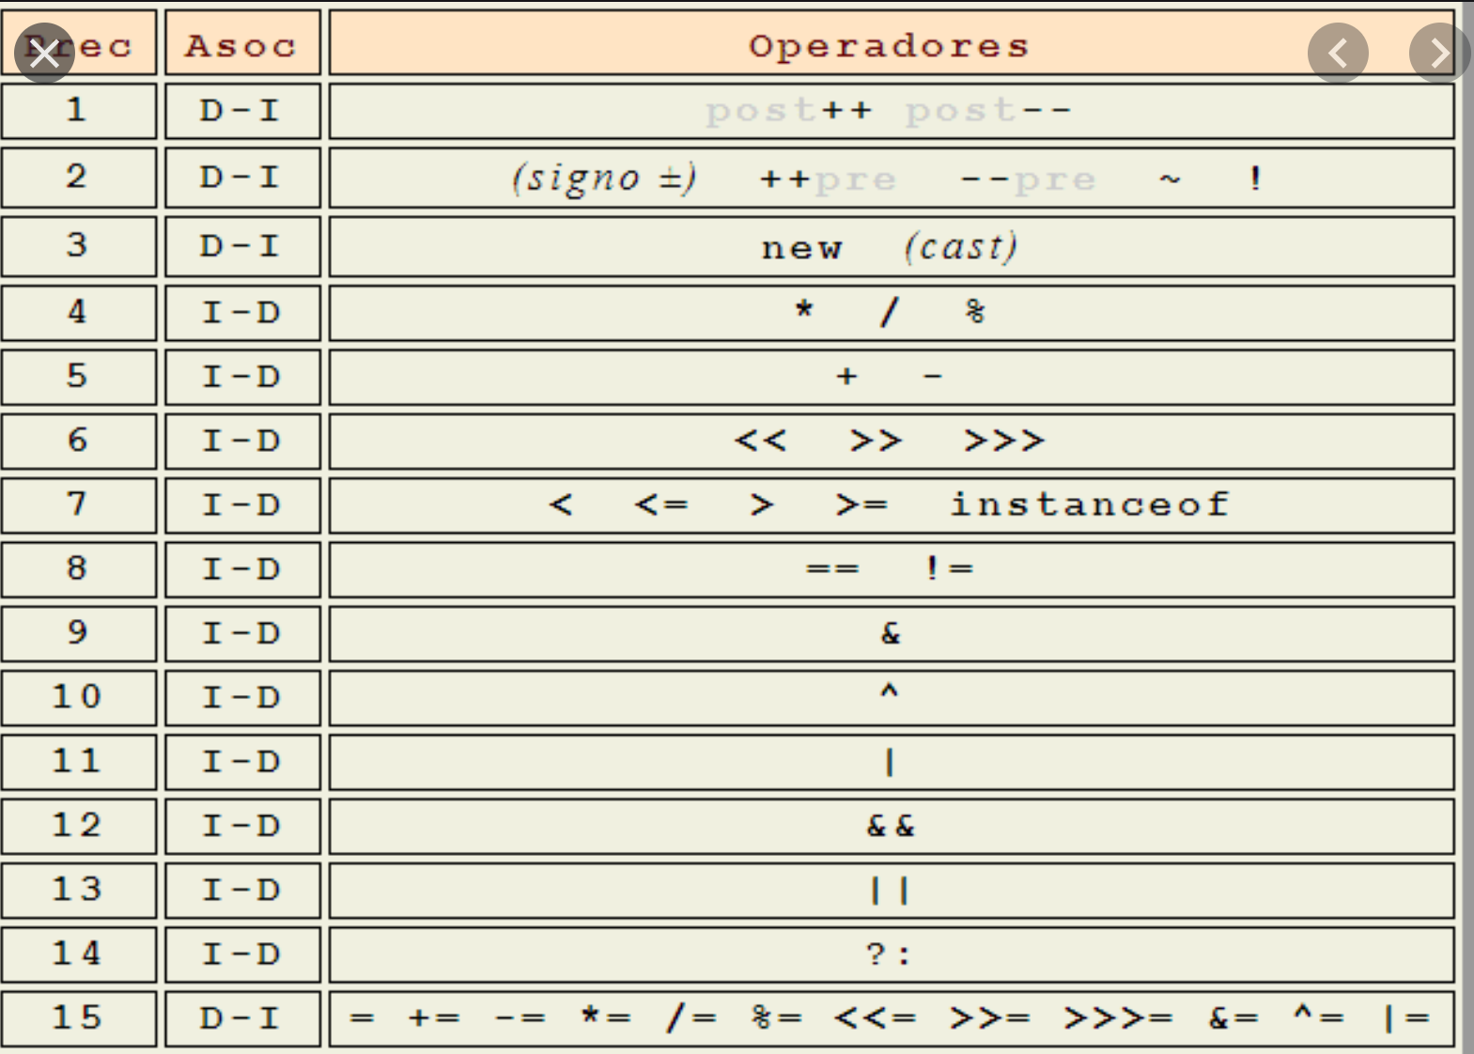

Menor

2/2\*3 🡺3

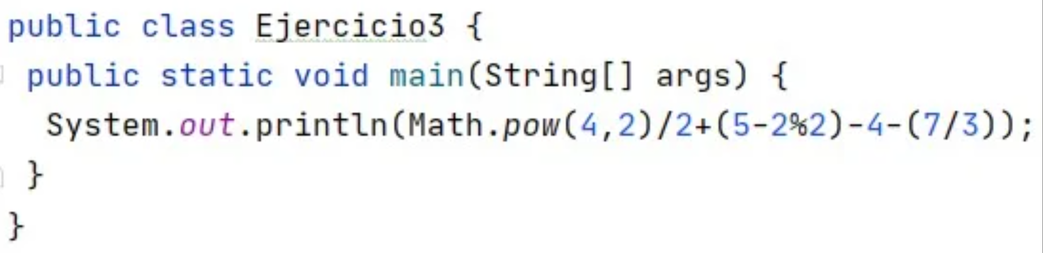

16 / 2 = 84 , 5 -0-4-2 = -1 => 7