Adafruit NeoPixel WS2811
https://wp.josh.com/2014/05/13/ws2812-neopixels-are-not-so-finicky-once-you-get-to-know-them/

Datasheet timing constraints for driving a NeoPixel
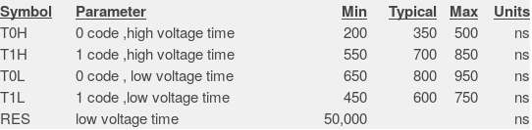
Here is the canonical WS2812 timing diagram from the datasheet…
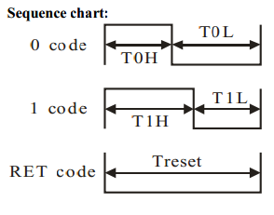

Simplified timing constraints for driving a NeoPixel
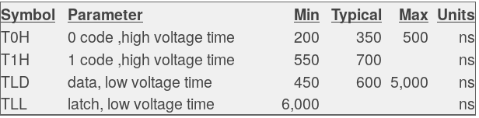
TLD – межбитовый разрыв.
TLL – reset latch

There is a minimum width of a 0-bit pulse (T0H) to ensure it is detected
- There is a maximum width of a 0-bit pulse (T0H) to ensure that it does not become a 1-bit
- There is a minimum width of a 1-bit pulse (T1H) since it must be long enough to not be a 0-bit pulse.
- There is a minimum time the level must stay low between consecutive bits (TxL), which ensures that the chip sees separate bits rather than one long bit.
- There is a maximum time the level can stay low (TxL) before a reset is triggered and any loaded data is latched and displayed on the LED.
ermal_zone
