ORANGE PI DEBIAN HOWTO

1) Запись на SD-карту
2) Настройка подключения сети
3) Автозапуск SSH
4) Подключение по SSH
5) Установка утилиты и библиотеки WiringOP-Zero
6) Работа с GPIO в bash
7) Компиляция программы с помощью gcc

1) Запись на SD-карту

http://www.orangepi.org/Docs/SDcardinstallation.html

Вставьте microSD карту >=4Gb и как можно высшего класса скорости.
- Format the TF card.
  - Check the TF card node.
sudo fdisk -l
  - Delete all partition of TFcard.
Use d command to delete all partition of TF card and use n command to add one new partition and use w command to save change.
sudo fdisk /dev/sdx
  - Format all the partition of TF card as FAT32.
sudo mkfs.vfat /dev/sdxx
(x should be replaced according to your TF card node)
You can also jump this step under Linux, because write image command dd under Linux will format the TF card automatically.
- Download the OS image from the Downloads webpage.
http://www.orangepi.org/downloadresources/
- Unzip the download file to get the OS image.
unzip [path]/[downloaded filename]
If the filename extension is .tgz, run the following command.
tar -zxvf [path]/[downloaded filename]
Ensure that neither the file name of the image you're using or the path contain any spaces (or other odd characters, for that matter).
- Write the image file to the TF card.
  - Check the TF card node.
sudo fdisk -l
  - Verify if the hash key of the zip file is the same as shown on the downloads page (optional).
sha1sum [path]/[imagename]
This will print out a long hex number which should match the "SHA-1" line for the TF image you have downloaded.
  - Unmount all the partition of the the TF card
umount /dev/sdxx
  - Write image file to TF card.
sudo dd bs=4M if=[path]/[imagename] of=/dev/sdx
Wait patiently to successfully complete writing. Please note that block size set to 4M will work most of the time, if not, please try 1M, although 1M will take considerably longer.You can use the command below to check progress.
sudo pkill -USR1 -n -x dd

2) Настройка подключения сети

root@localhost:[/home/silvia]# ip a

Файл sdcard/etc/interfaces:

# interfaces(5) file used by ifup(8) and ifdown(8)
# Include files from /etc/network/interfaces.d:
source-directory /etc/network/interfaces.d
allow-hotplug wlan3
auto wlan3
iface wlan3 inet dhcp
wpa-ssid Ssid
wpa-psk Password

Файл sdcard/etc/wpa_supplication.conf:

network={
ssid="Ssid"
psk="Password"
priority=1
}

Поменять на данные точки wifi

3) Автозапуск SSH

Добавить в systemd сервис ssh

root@localhost: ln -s /lib/systemd/system/ssh@.service etc/systemd/system
root@localhost: ln -s /lib/systemd/system/sshd.service etc/systemd/system

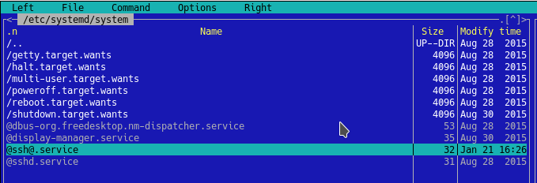
https://wiki.archlinux.org/index.php/Systemd_(%D0%A0%D1%83%D1%81%D1%81%D0%BA%D0%B8%D0%B9)#.D0.98.D1.81.D0.BF.D0.BE.D0.BB.D1.8C.D0.B7.D0.BE.D0.B2.D0.B0.D0.BD.D0.B8.D0.B5_.D1.8E.D0.BD.D0.B8.D1.82.D0.BE.D0.B2
4) Подключение по SSH

Откройте терминал.

Утилита для мониторинга сети
root@localhost:[/home/silvia]# apt-get install arp-scan
Reading package lists... Done
Building dependency tree
Reading state information... Done
...
The following NEW packages will be installed:
arp-scan
0 upgraded, 1 newly installed, 0 to remove and 3 not upgraded.
Need to get 262 kB of archives.
...
Preparing to unpack .../arp-scan_1.9-1_amd64.deb ...
Unpacking arp-scan (1.9-1) ...
Setting up arp-scan (1.9-1) ...
Processing triggers for man-db (2.7.6.1-2) ...
root@localhost:[/home/silvia]# sudo watch -n 10 -d arp-scan --interface=wlo1 --localnet
Interface: wlo1, datalink type: EN10MB (Ethernet)
Starting arp-scan 1.9 with 256 hosts (http://www.nta-monitor.com/tools/arp-scan/)
192.168.1.1 94:0c:6d:ab:4a:dc TP-LINK Technologies Co.,Ltd.
192.168.1.100 b4:74:43:af:ba:79 (Unknown)
192.168.1.103 3c:70:b1:d4:35:da (Unknown)
3 packets received by filter, 0 packets dropped by kernel
Ending arp-scan 1.9: 256 hosts scanned in 2.278 seconds (112.38 hosts/sec). 3 responded
Ваш сетевой интерфейс. Команда “ip a”

Подключение к Orange Pi
root@localhost:[/usr/src/kernels/linux-sunxi]# ssh -X root@192.168.1.103
The authenticity of host '192.168.1.103 (192.168.1.103)' can't be established.
ECDSA key fingerprint is SHA256:gDNkggHKbdJqvb+awBWhHBTvknDKOhyxbKReGwCYwyg.
Are you sure you want to continue connecting (yes/no)? yes
Warning: Permanently added '192.168.1.103' (ECDSA) to the list of known hosts.
root@192.168.1.103's password:
****************************************
WARNING: TO RESIZE FILESYSTEM RUN:
sudo fs_resize

to remove this message run:

sudo rm /usr/local/bin/fs_resize_warning
****************************************
05:06:34 root@OrangePizero: [~]#

Установка часового пояса
https://www.cyberciti.biz/faq/howto-set-date-time-from-linux-command-prompt/

To see list all available time zones, enter:
$ timedatectl list-timezones
$ timedatectl list-timezones | more
$ timedatectl list-timezones | grep -i asia
$ timedatectl list-timezones | grep America/New
To set the time zone to ‘Asia/Kolkata’, enter:
# timedatectl set-timezone 'Asia/Kolkata'
Verify it:
# timedatectl
Local time: Mon 2015-11-23 08:17:04 IST
Universal time: Mon 2015-11-23 02:47:04 UTC
RTC time: Mon 2015-11-23 13:16:09
Time zone: Asia/Kolkata (IST, +0530)
NTP enabled: no
NTP synchronized: no
RTC in local TZ: no
DST active: n/a

Файловый менеджер - apt-get install mc
( https://uk.wikipedia.org/wiki/Midnight_Commander )

5) Установка утилиты и библиотеки WiringOP-Zero

https://pcminipro.ru/orangepi/wiringop-wiringpi-na-orange-pi/

Для работы с GPIO, необходимо установить WiringOP на Orange Pi.
WiringPi загружена на GIT. Для того, что бы загрузить WiringOP из github необходимо чтобы был установлен пакет git-core:
apt-get install git-core

Скачать WiringOP для Zero (для других Orange pi – перейдите по ссылке выше)
git clone https://github.com/xpertsavenue/WiringOP-Zero.git

Установка WiringOP
cd WiringOP
chmod +x ./build
sudo ./build

Проверка:

# gpio readall

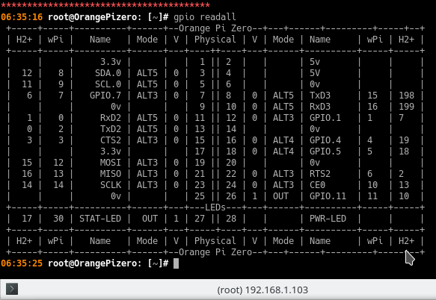

7) Компиляция программы с помощью gcc

Тест мигание светодиодом.
Создание файла: touch blink.c
#include <wiringPi.h>
int main (void) {
wiringPiSetup();
pinMode (30, OUTPUT) ;
for (;;) {
digitalWrite(30, HIGH);
delay (500) ;
digitalWrite(30, LOW);
delay(500);
}
return 0;
}
//Номер ножки по колонке Wpi

Компиляция и запуск:
# gcc blink.c -o blink -lwiringPi -lpthread
# ./blink

