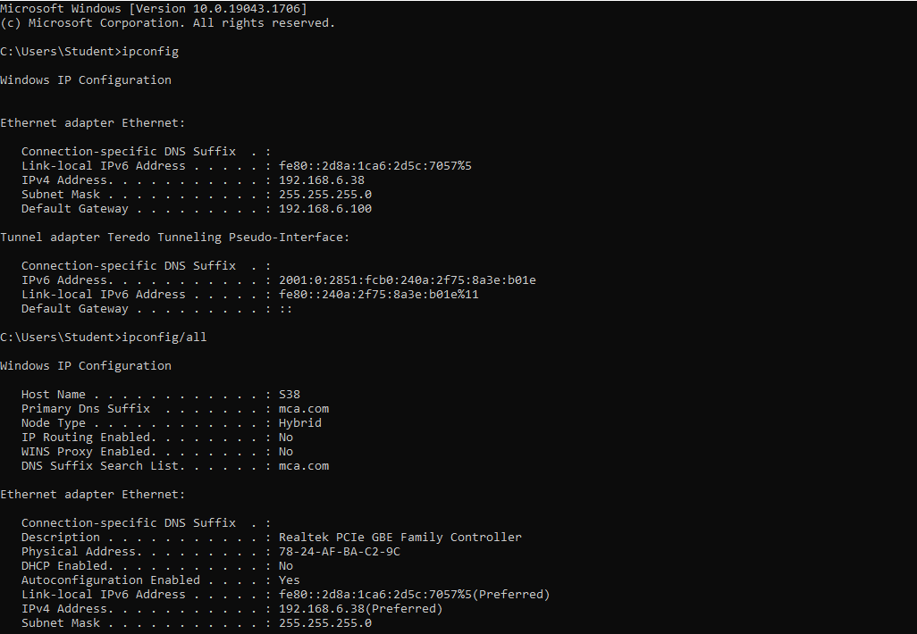

Microsoft Windows [Version 10.0.19043.1706] (c) Microsoft Corporation. All rights reserved.

C:\Users\Student>ipconfig Windows IP Configuration

Ethernet adapter Ethernet:

Connection-specific DNS Suffix . : Link-local IPv6 Address . ....: fe80::2d8a:1ca6:2d5c:7057%5 IPv4 Address. . . . . . . . . . . : 192.168.6.38 Subnet Mask . . . . . . . . . . . : 255.255.255.0 Default Gateway .........: 192.168.6.100

Tunnel adapter Teredo Tunneling Pseudo-Interface:

Connection-specific DNS Suffix . : IPV6 Address...........: 2001:0:2851: fcbo: 240a:2f75:8a3e: bole Link-local IPv6 Address .....: fe80::240a:2f75:8a3e: b01e 11 Default Gateway .........:::

C:\Users\Student>ipconfig/all

Windows IP Configuration

Host Name . . . . . . . . . . . . : 538 Primary Dns Suffix ... .: mca.com Node Type ............: Hybrid IP Routing Enabled..

: No WINS Proxy Enabled... .: No DNS Suffix Search List. .....: mca.com

Ethernet adapter Ethernet:

Connection-specific DNS Suffix Description ...........: Realtek PCIe GBE Family Controller Physical Address. ........: 78-24-AF-BA-C2-96 DHCP Enabled. ....

: No Autoconfiguration Enabled ....: Yes Link-local IPv6 Address .....: fe80::2d8a:1ca6:2d5c:7057%5(Preferred) IPv4 Address. ..........: 192.168.6.38 (Preferred) Subnet Mask ...........: 255.255.255.0