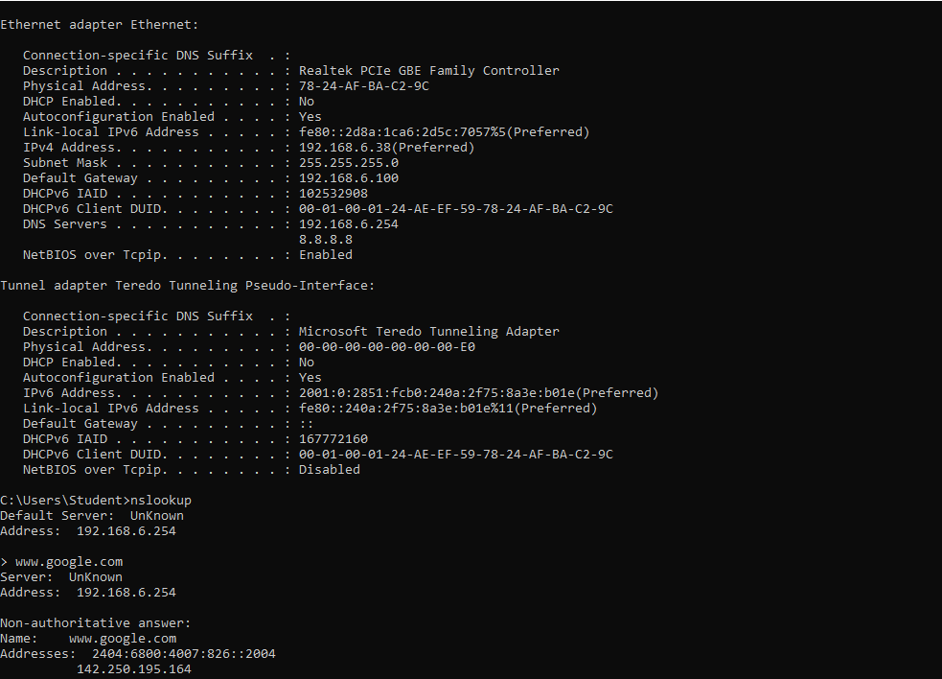

Ethernet adapter Ethernet:

Connection-specific DNS Suffix Description ...........: Realtek PCIe GBE Family Controller Physical Address. ........: 78-24-AF-BA-C2-96 DHCP Enabled. ....

: No Autoconfiguration Enabled ....: Yes Link-local IPv6 Address .....: fe80::2d8a:1ca6:2d5c:7057%5(Preferred) IPv4 Address. . . . . . . . . . . : 192.168.6.38 (Preferred Subnet Mask . . . . . . . . . . . : 255.255.255.0 Default Gateway . . . . . . . . . : 192.168.6.100 DHCPv6 IAID . . . . . . . . . : 102532908 DHCPv6 Client DUID. .......: 00-01-08-01-24-AE-EF-59-78-24-AF-BA-C2-9C DNS Servers ...........: 192.168.6.254

8.8.8.8 NetBios over Tcpip. ....: Enabled

Tunnel adapter Teredo Tunneling Pseudo-Interface:

Connection-specific DNS Suffix . : Description ...........: Microsoft Teredo Tunneling Adapter Physical Address. ........: 00-00-00-00-00-00-00-EO DHCP Enabled. . . . . . . . . . : NO Autoconfiguration Enabled ....: Yes IPV6 Address. . . . . . . . . . . .

.....: 2001:0:2851:fcbe:240a:2f75:8a3e: bole (Preferred) Link-local IPv6 Address ..... : fe80::240a:2f75:8a3e: b01e%11(Preferred) Default Gateway .........::: DHCPV6 IAID . . . . . . . . . . . : 167772160 DHCPv6 Client DUID. .......: 00-01-08-01-24-AE-EF-59-78-24-AF-BA-C2-9C NetBIOS over Tcpip. . ....: Disabled

C:\Users\Student>nslookup Default Server: Unknown Address: 192.168.6.254

> www.google.com Server: Unknown Address: 192.168.6.254

Non-authoritative answer: Name: www.google.com Addresses: 2484:6800:4007:826::2004

142.250.195.164