AIM: Familiarization of Linux Commands

PROCEDURE

1. pwd

The [pwd](https://www.javatpoint.com/linux-pwd) command is used to display the location of the current working directory.

Syntax:



Output:



1. mkdir

The [mkdir](https://www.javatpoint.com/linux-mkdir) command is used to create a new directory under any directory.

Syntax:

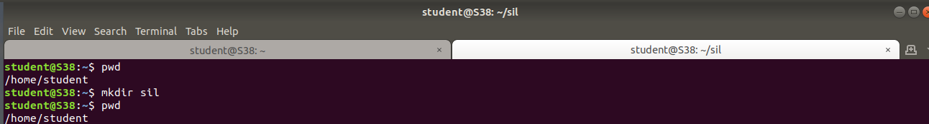

Output:



1. ls

The [ls](https://www.javatpoint.com/linux-ls) command is used to display a list of content of a directory.

Syntax: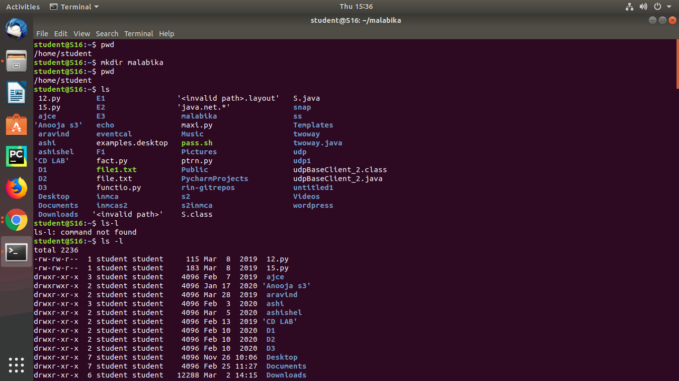

Output:



* ls –l

Syntax: 

Output:



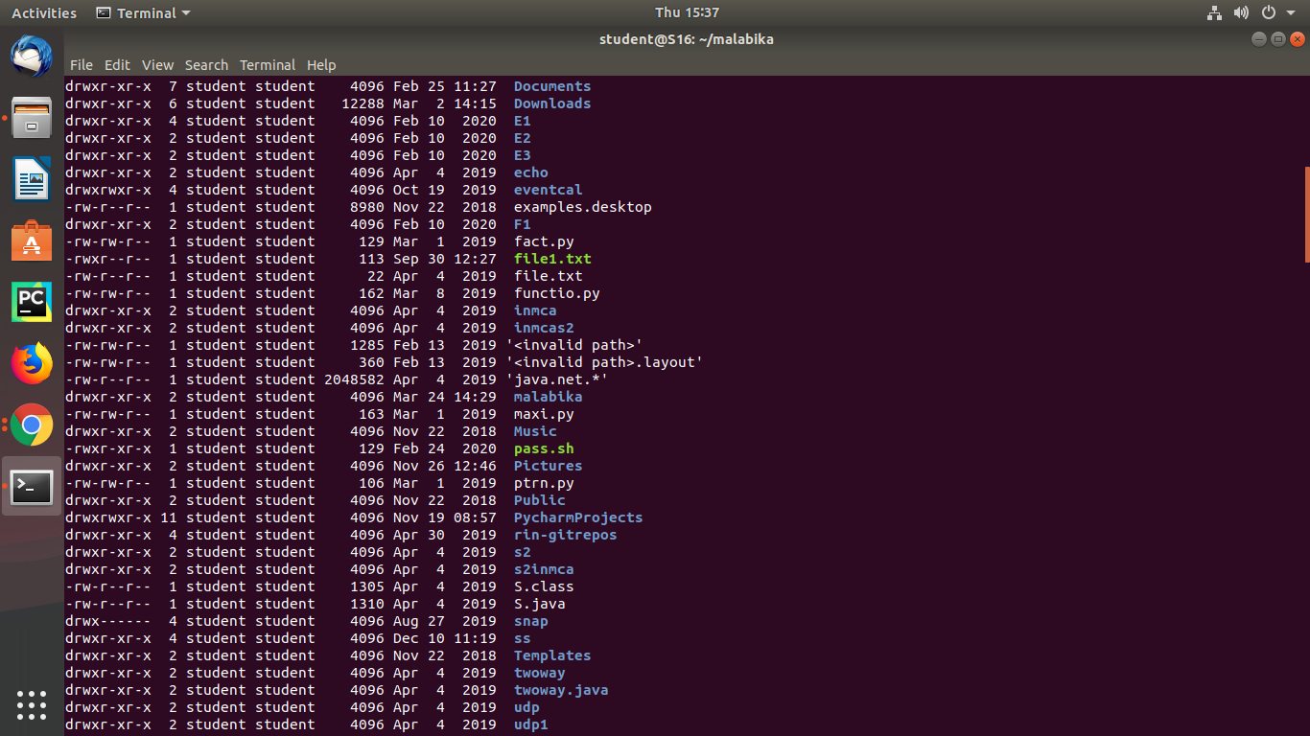

* ls –a

Syntax:

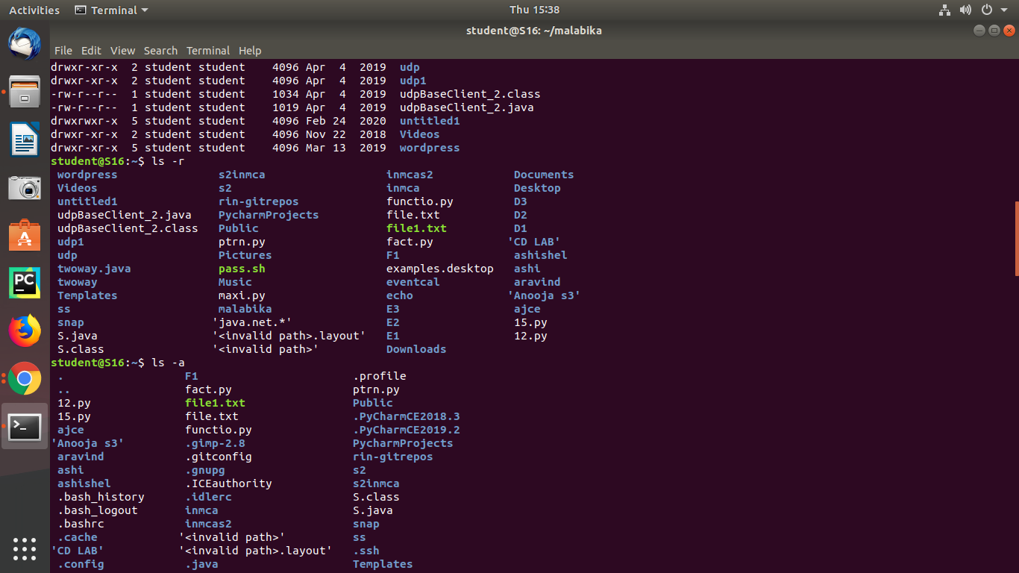

Output:



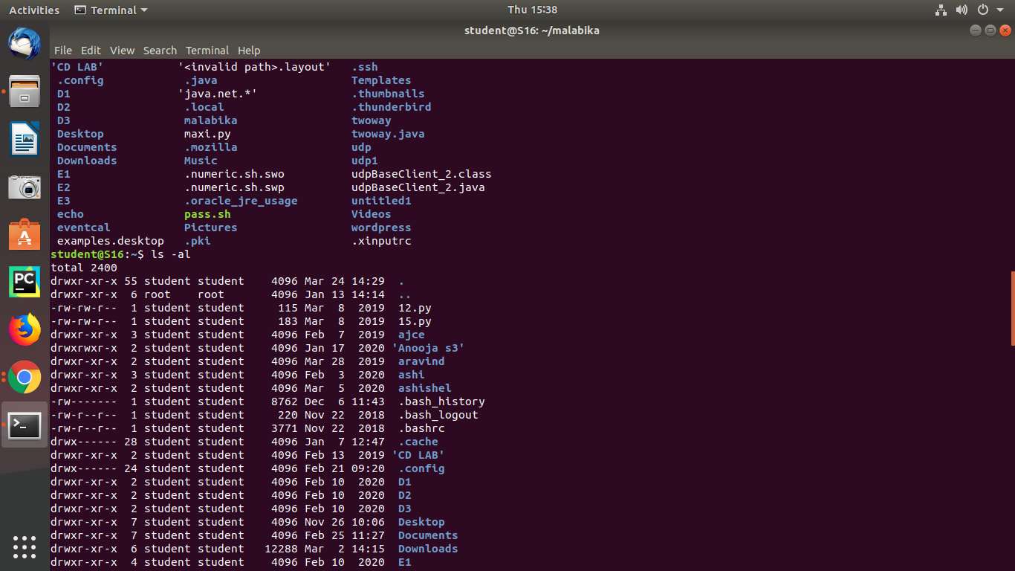

* ls –r

Syntax:



Output:



* ls –al

Syntax:



Output:



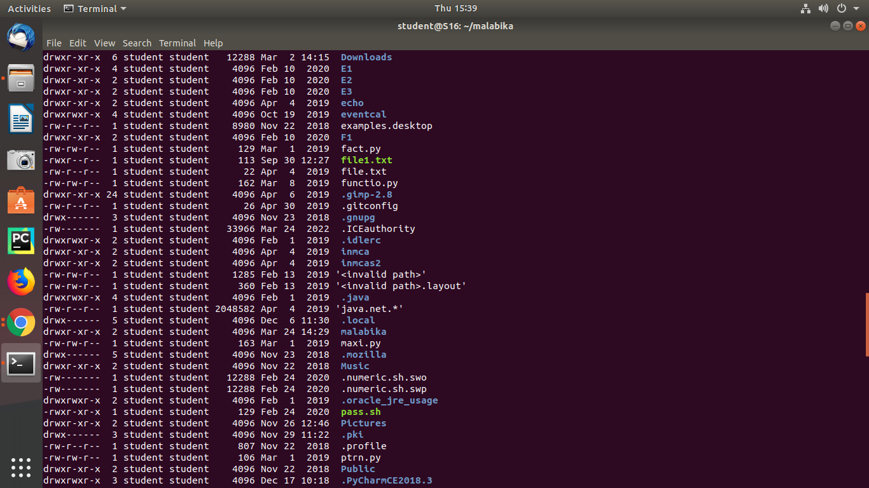

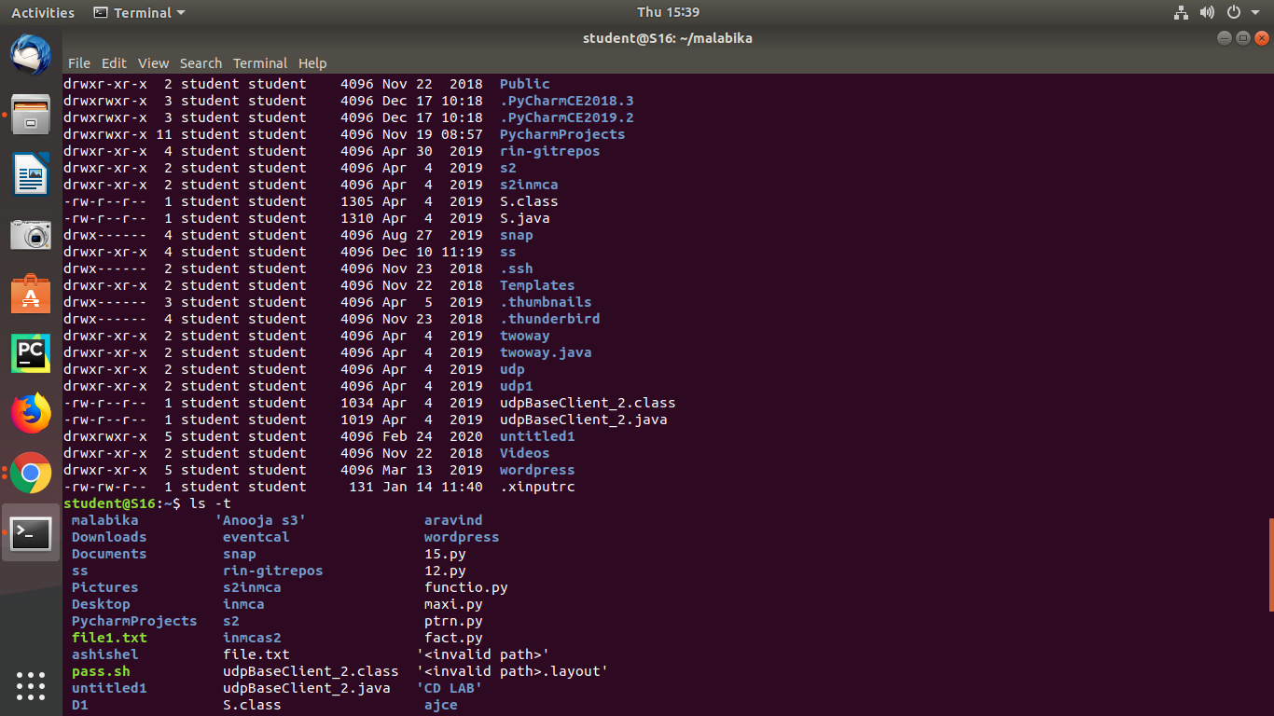

* ls –t

Syntax:



Output:



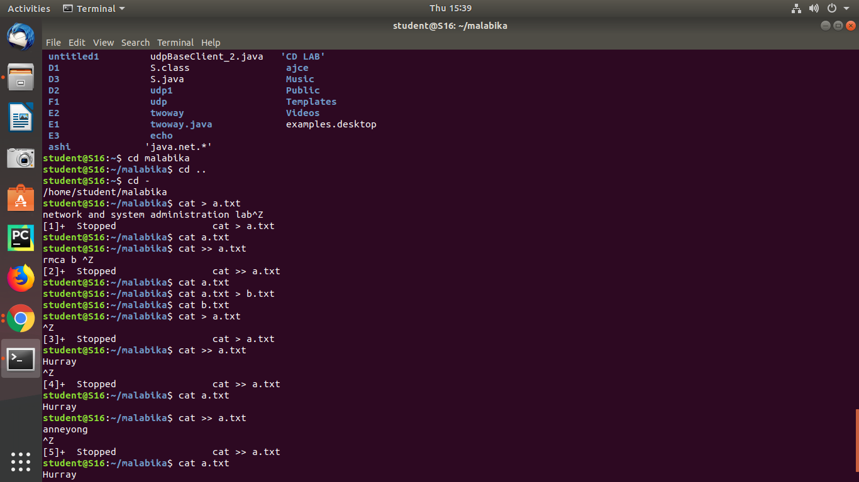

1. cd

The [cd](https://www.javatpoint.com/linux-cd) command is used to change the current directory.

Syntax:



Output:



1. cat

The [cat](https://www.javatpoint.com/linux-cat) command is a multi-purpose utility in the Linux system. It can be used to create a file, display content of the file, copy the content of one file to another file, and more.

Syntax:

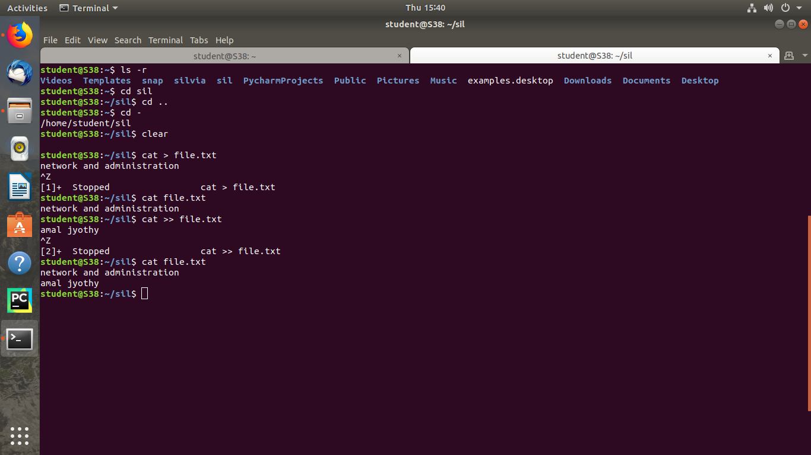





Output:





