Silvia Curelariu

Karl Morris

CIS 3238 Software Design

November 1st 2017

UML Diagram Patterns

Pattern 1:

Identify: Singleton Pattern

Reason: There should only be one-character Wonder Woman in the game at one time

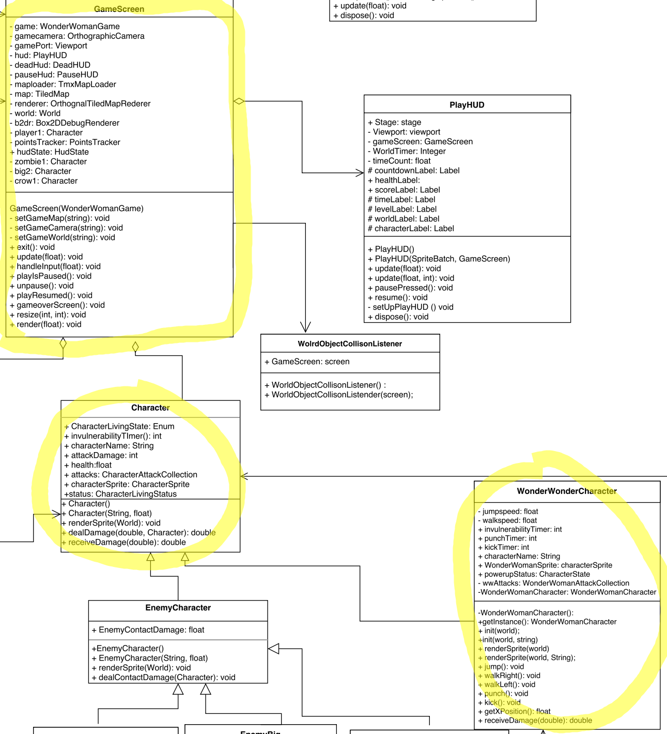

Pattern 2:

Identify: State Pattern

Reason: So the characters powerups can change the characters attacks

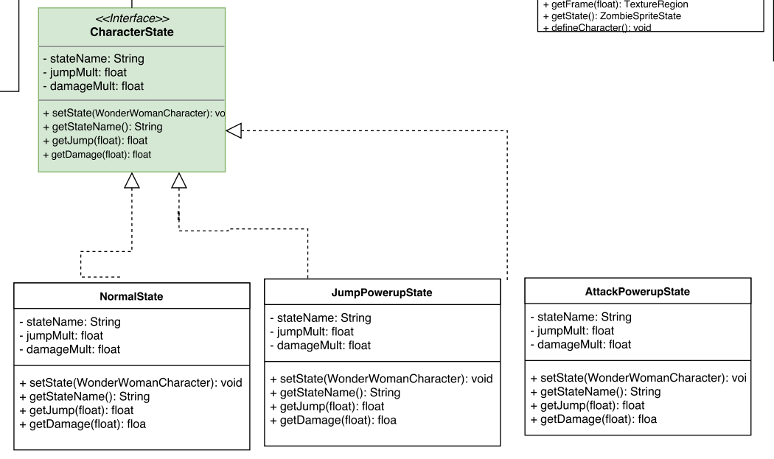

Pattern 3:

Identify: Builder Pattern

Reason: To making building the world easier and not have to worry about implementing the resources each time a new map/world is created.

