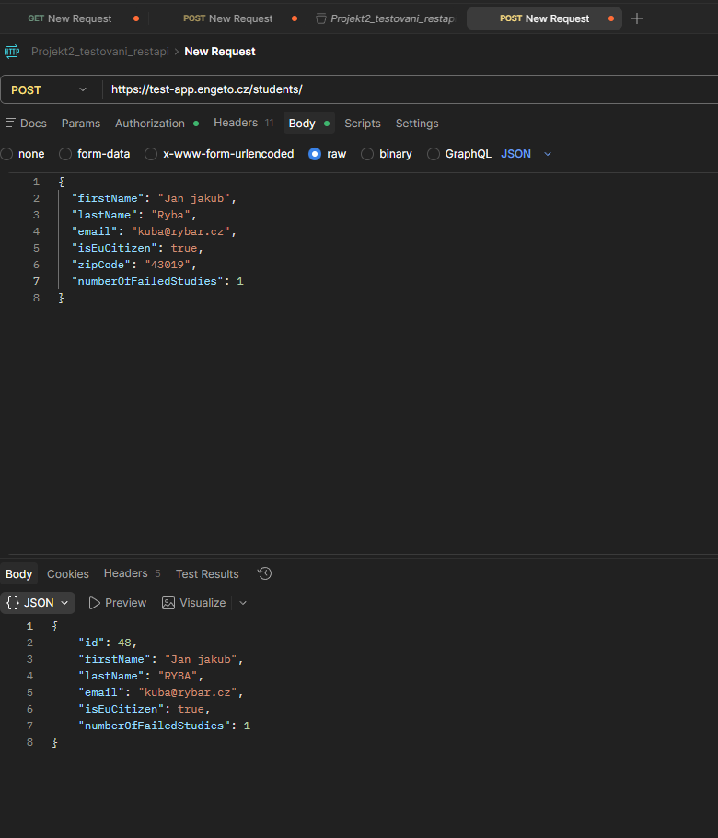
{
"firstName": "Jan jakub",
"lastName": "Ryba",
"email": "kuba@rybar.cz",
"isEuCitizen": true,
"zipCode": "43019",
"numberOfFailedStudies": 1
}

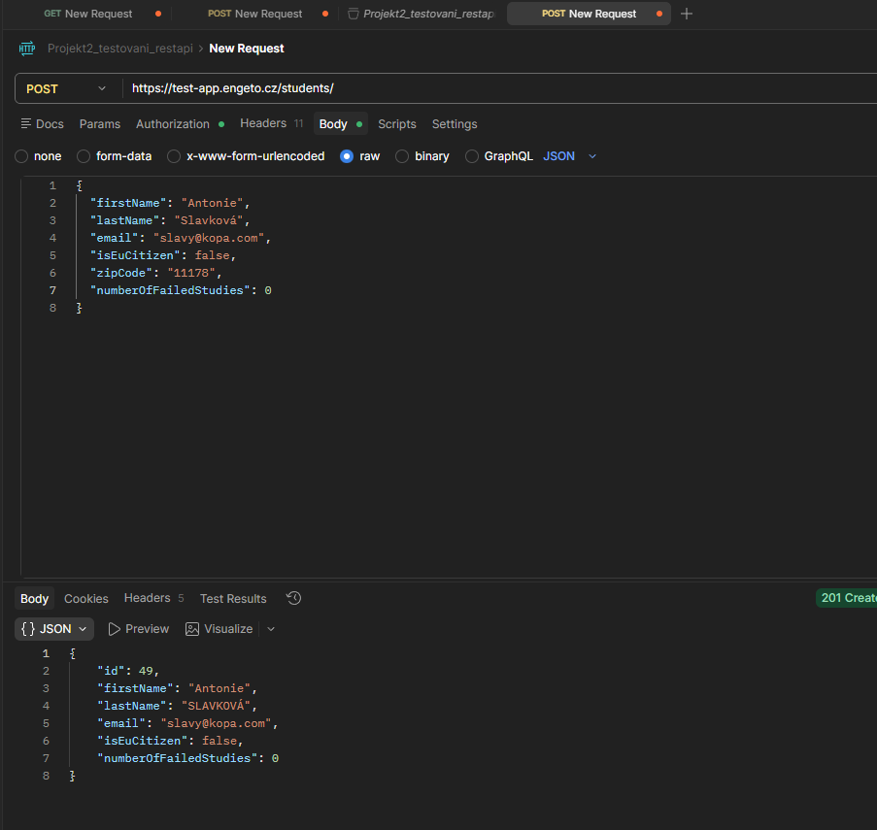
{
"firstName": "Antonie",
"lastName": "Slavková",
"email": "slavy@kopa.com",
"isEuCitizen": false,
"zipCode": "11178",
"numberOfFailedStudies": 0
}

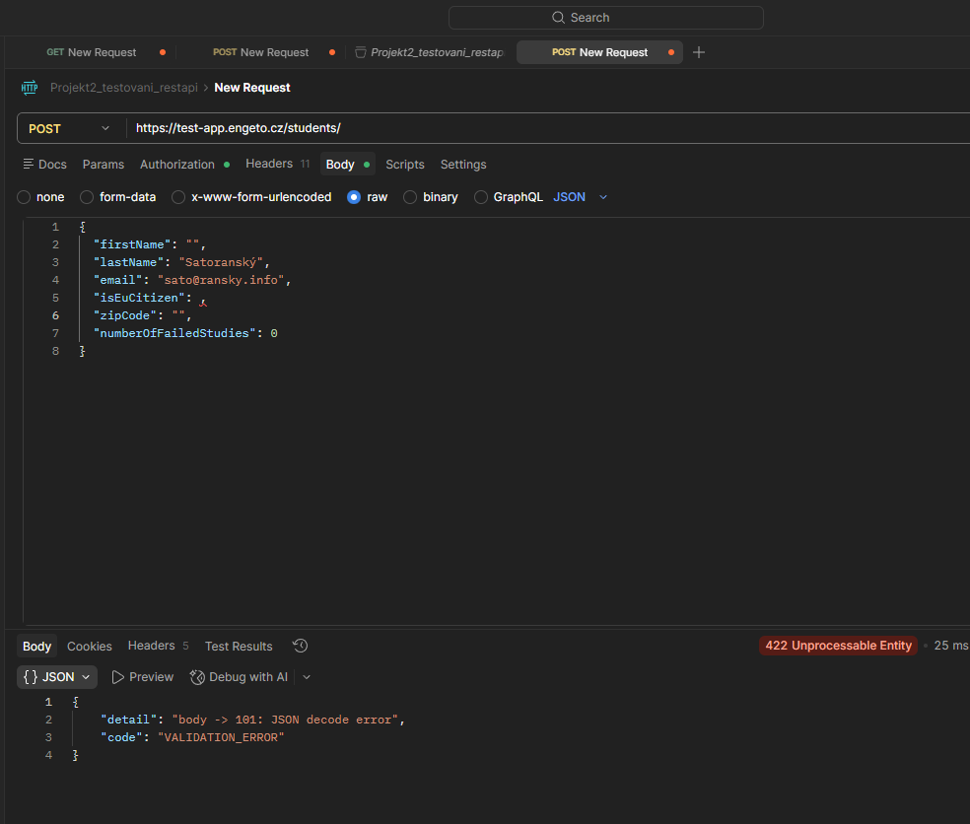
{
"firstName": "",
"lastName": "Satoranský",
"email": "sato@ransky.info",
"isEuCitizen": ,
"zipCode": "",
"numberOfFailedStudies": 0
}

