Bellabeat SQL Case Study
Insights & Product Strategy

An end‑to‑end SQL Server analysis with actionable marketing and product recommendations

Prepared by: Silvio Serafin
25 October 2025

Contents
Executive Summary 3
1. Business Task 3
2. Data & Tools 3
2.1. Dataset: 3
2.2. Tools and Environment: 3
Data Source and Structure: 4
2.3. Disclaimer: 4
3. Data Preparation 4
4. Key Findings 4
4.1. Summary Statistics Table 5
4.1.1. Interpretation 5
5. Product Recommendations 6
5.1. Bellabeat Smart Scale (for holistic body tracking) 6
5.2. Bellabeat BlueShield Glasses (for late-night professionals) 6
5.3. Ecosystem Integration: Connected Wellness Platform 7
6. Limitations 7
7. Share: How Findings Were Visualised and Communicated 8
7.1. Dashboard Overview 8
7.2. Key Visual Insights 8
7.3. Visual References 9
8. Next Steps 9
8.1. Marketing Strategy 9
8.1.1. Target Audience 9
8.1.2. Positioning and Value Proposition 9
8.1.3. Core message: 10
8.1.4. Marketing Approach 10
8.1.5. Long-Term Goal 11
8.1.6. Appendix A — SQL Queries and Views 11

Executive Summary
This project analyses activity and sleep data from 33 Fitbit users to uncover behavioural patterns that can guide Bellabeat’s product strategy and marketing initiatives. Using SQL Server for data processing and Power BI for visualization, the analysis explored relationships between daily movement, sedentary time, and sleep behaviour to identify opportunities for software enhancement and user engagement growth.
The results revealed three clear behavioural segments — moderate, low, and high movers — and consistent activity patterns across weekdays and weekends, reflecting the continuous routines of women managing multiple responsibilities. These insights inspired two new product concepts: the Bellabeat Smart Scale, designed for body-composition tracking and hydration intelligence, and the Bellabeat BlueShield, eyewear promoting digital-wellness and better sleep quality.
Together, these ideas reinforce Bellabeat’s mission to create a connected, empathetic wellness ecosystem that supports women’s physical and emotional balance through intelligent design.

Business Task
Identify behaviour patterns from smartwatch usage that can inform Bellabeat’s marketing and product strategy for the Time smartwatch. Specifically: uncover weekday/seasonality patterns, sleep–activity relationships, and user movement segments to guide feature design, positioning, and targeted nudges.

Data & Tools

Dataset:
The analysis uses the FitBit Fitness Tracker Data (CC0: Public Domain) made available by Mobius on Kaggle. This dataset contains personal fitness tracker information from 33 consenting Fitbit users who recorded their activity, sleep, and weight data over approximately 33 days.

Tools and Environment:
- Microsoft SQL Server (T-SQL): used for data import, cleaning, transformation, and analytical modelling.
- Power BI: used to visualize trends and relationships derived from SQL outputs.
- Excel: used for minor data validation and final visual refinements.

Data Source and Structure:
The database includes five key tables reflecting user activity and lifestyle metrics:
- dailyActivity_merged2
- dailySteps_merged2
- dailyIntensities_merged2
- sleepDay_merged2
These tables were imported into SQL Server and linked by Id and Date to create unified analytical views for daily and user-level insights.

Disclaimer:
The dataset represents a limited sample (33 users) and may not fully reflect Bellabeat’s target audience demographics. Results should therefore be interpreted as exploratory behavioural patterns, not population-wide conclusions.

Data Preparation
Files were imported as tables into SQL Server. Initial profiling includes row counts, date ranges, distinct users, and duplicate checks by (Id, date). Where date columns are text, we cast them to DATE in views to ensure consistency.

Key Findings
Running the SQL queries revealed several clear behavioural patterns among Bellabeat users:
- Weekday Effect: Activity levels were slightly lower at the start of the week (Monday avg. 7,785 steps; Tuesday 7,993 steps) and peaked toward the weekend (Saturday 8,303 steps). However, Sunday consistently showed the lowest average steps (6,950) and highest sedentary time (990 min), suggesting reduced mobility and longer rest.
- Sleep Linkage: Average sleep duration remained below optimal levels across all weekdays, ranging from 401 to 453 minutes (≈6.7–7.5 hours), with 35–51 minutes of time wasted in bed. Days with shorter sleep tended to align with lower activity and higher sedentary time the following day.
- Active Intensity: High-intensity activity averaged 19–23 minutes per day, with Monday and Tuesday slightly higher possibly reflecting the start-of-week motivation effect.
- Movement Segments: Most users fell within the moderate-mover range (5,000–10,000 steps/day), representing Bellabeat’s most consistent and influenceable group for product engagement.
- Burnout Indicators: Repeated patterns of low activity and long sedentary periods were identified among a subset of users, highlighting opportunities for personalized interventions promoting recovery and balance.

Summary Statistics Table
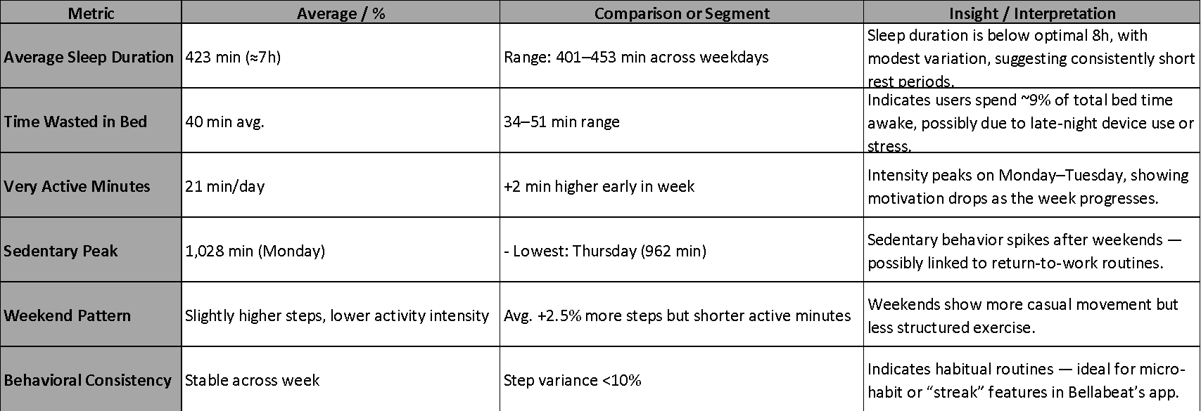

Interpretation
Unlike many general-population datasets, Bellabeat users maintain a steady rhythm throughout the week, averaging 7,608 steps on weekdays and 7,550 on weekends, a negligible 0.7% difference. Sedentary time also remained consistently high (996 vs. 977 minutes), suggesting that users remain equally engaged during both work and rest days.
This balance indicates that many Bellabeat users, primarily women, continue to juggle multiple responsibilities beyond work, staying active across domestic, caregiving, and family duties. This behavioural trend, often described as the “triple workload journey,” highlights the invisible labour that sustains constant activity but limits recovery.
Sleep metrics reinforce this narrative: users averaged 423 minutes of sleep per night (≈7 hours), with around 40 minutes spent awake in bed, reflecting limited rest efficiency. Those sleeping under six hours still averaged 8,484 daily steps, compared to 8,202 among longer sleepers suggesting persistence in activity despite fatigue. Monday marked the highest sedentary peak (1,028 minutes), likely linked to post-weekend workload adjustment.
Overall, activity consistency combined with short sleep and prolonged sedentary time points to a pattern of effort without restoration. These findings support Bellabeat’s mission to advance women’s holistic well-being and reveal opportunities for features that emphasize recovery, energy balance, and self-care ensuring users are not only active but truly well.

Product Recommendations
Based on the behavioural insights uncovered in the analysis including consistent daily activity, short sleep duration, and high sedentary time three innovation opportunities were identified to expand Bellabeat’s ecosystem and improve user well-being through personalized, data-driven solutions.

Bellabeat Smart Scale
Expand Bellabeat’s hardware ecosystem with a Smart Scale that measures body composition (fat, muscle, bone, and hydration) and syncs directly with the Bellabeat app.
The scale acts as a progress-tracking hub, helping users interpret changes beyond body weight such as water retention during menstruation or muscle gain offsetting fat loss.
Integration with the Spring smart bottle allows hydration reminders to adapt based on each user’s activity level, body composition, and menstrual phase. During this period, the app can also suggest comforting, hormone-supportive foods to promote recovery and emotional well-being.
By translating physiological data into personalized and cycle-aware insights, the Smart Scale strengthens Bellabeat’s position as a holistic, empathetic wellness brand.
Success metrics: engagement with body composition tracking, improved hydration adherence, and higher satisfaction scores related to cycle-aware recommendations.

Bellabeat BlueShield Glasses
Introduce BlueShield, a stylish, app-connected eyewear line designed to reduce blue-light exposure and enhance sleep quality and recovery. Bellabeat’s existing devices such as the Leaf and Time already monitor sleep stages (REM, light, and deep), providing valuable insight into users’ rest patterns.
While the Fitbit dataset used in this analysis did not include those specific sleep-stage metrics, Bellabeat’s proprietary data already captures them. By integrating BlueShield with the app, the system could correlate screen exposure and lighting habits with sleep-stage performance, helping users improve REM and deep sleep duration through consistent use.
Additionally, BlueShield can directly reduce the time spent awake in bed before falling asleep (averaging ~40 minutes in current data) by minimizing pre-sleep alertness caused by blue-light exposure. The app can prompt users to wear BlueShield during late-night device use and guide them through personalized wind-down protocols to restore natural melatonin rhythms and sleep onset.
Success metrics: increase in TotalMinutesAsleep, reduction in time awake in bed, improvement in REM/deep sleep percentages, and fewer short-sleep episodes.

Ecosystem Integration: Connected Wellness Platform
Unify all Bellabeat devices including the Leaf, Time, Spring, Smart Scale, and BlueShield through the Bellabeat app to create a fully connected, intelligent wellness ecosystem.
Cross-device synchronization enables adaptive, context-aware insights: hydration goals can adjust automatically after body composition updates, and late-night screen exposure detected by BlueShield can trigger relaxation routines or bedtime recommendations.
This seamless integration transforms Bellabeat from a device manufacturer into a data-driven wellness intelligence platform, offering users a personalized, science-backed experience that aligns physical, emotional, and digital well-being.
Success metrics: increase in multi-device adoption, higher app engagement frequency, and improved long-term user retention.

Limitations
- Sample size and timeframe are limited and may not fully represent Bellabeat’s target audience.
- The dataset may lack demographic details and contextual variables (occupation, caregiving load).
- Sleep and HR measures may be incomplete; some days lack matching sleep logs.

Share: How Findings Were Visualised and Communicated
To clearly communicate the analytical insights uncovered through SQL, a Power BI dashboard was developed to visualize relationships between daily activity, sedentary time, and sleep behaviour among Fitbit users. The dashboard transforms raw data into accessible, meaningful visuals that highlight women’s daily wellness patterns and provide evidence for Bellabeat’s strategic product decisions.

Dashboard Overview
The Power BI dashboard consists of four main visuals:
- Average Steps by Weekday — compares daily step counts across the week, revealing a stable activity pattern between weekdays and weekends (7,608 vs. 7,550 average steps).
- Sleep vs. Time in Bed — illustrates the efficiency of rest, showing that users spend an average of 40 minutes awake in bed each night.
- Sedentary Minutes vs. Active Time — highlights the proportion of inactive time per day, identifying potential burnout or recovery imbalance.
- Movement Segments Distribution — classifies users as low, moderate, or high movers, helping to target specific behaviour groups for personalized wellness recommendations.
These visuals were created from SQL summary views and aggregated tables (e.g., v_daily_activity, v_dim_date, and v_user_segments).
Data was modelled and cleaned in SQL Server, exported as CSVs, and then loaded into Power BI for dynamic visualization.

Key Visual Insights
The dashboard shows a consistent rhythm of activity across all days of the week, supporting the “triple workload journey” hypothesis women maintain moderate activity even on weekends due to overlapping work, caregiving, and household responsibilities.
Sleep averages remain below optimal levels, suggesting opportunities for new features and product interventions, such as recovery tracking and digital-wellness tools.
Together, these visuals bridge the technical analysis and strategic outcomes, forming the basis for Bellabeat’s new wellness concepts the Smart Scale and BlueShield Glasses both aimed at improving hydration, recovery, and sleep quality through a connected, data-driven ecosystem.

Visual References
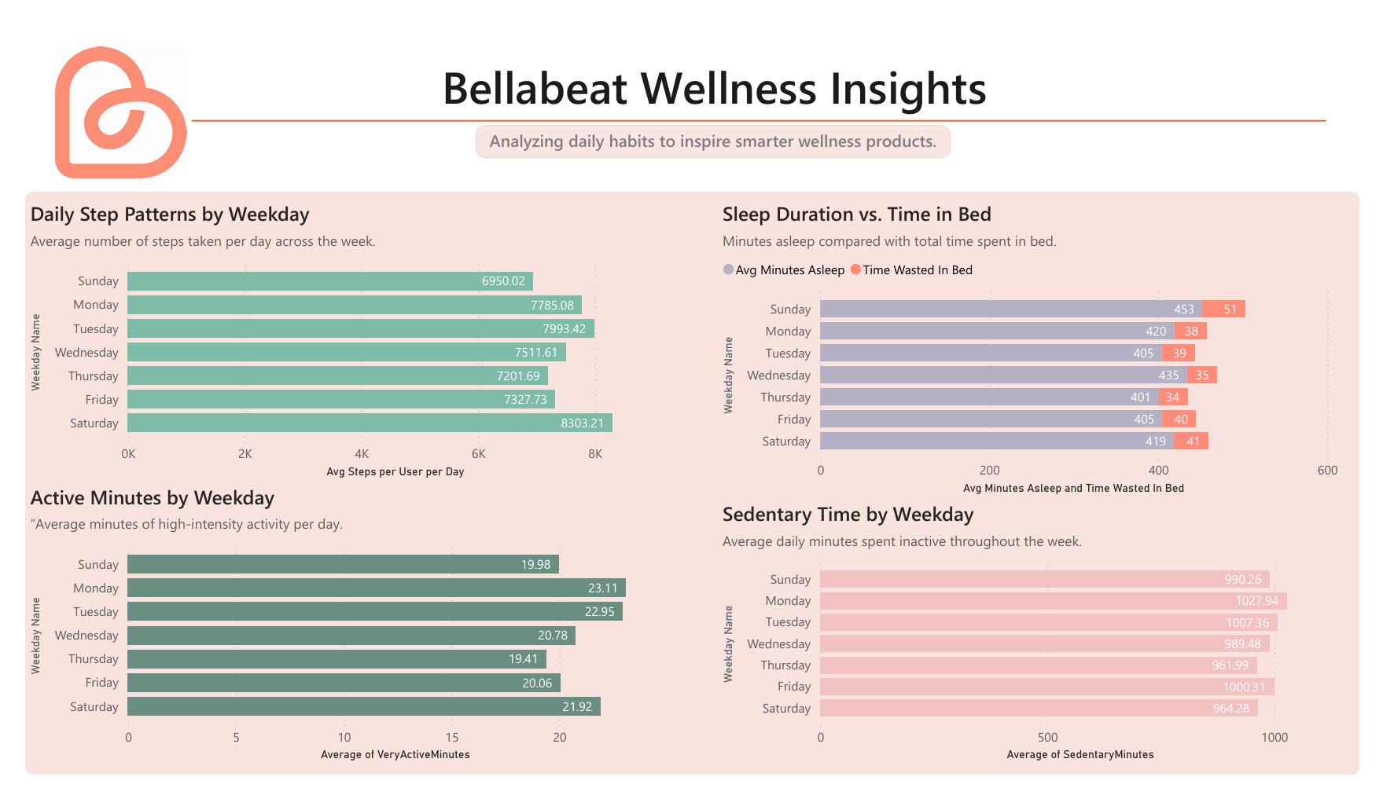

Next Steps

Marketing Strategy

Target Audience
The insights reveal that Bellabeat’s core audience consists of women aged 25–45 who maintain moderate daily activity (5k–10k steps) while balancing professional, domestic, and caregiving responsibilities the “triple workload” demographic.
These women are health-conscious, already use wellness technology, and value efficiency, personalization, and science-based insights that fit seamlessly into their busy lives.
They are the ideal audience for the Smart Scale and BlueShield Glasses, as both products address the key challenges observed in the data: hydration, sleep quality, and recovery.

Positioning and Value Proposition
Bellabeat should be positioned as a holistic wellness ecosystem that empowers women through intelligent, connected design.
- The Smart Scale becomes a “wellness mirror” enabling women to see progress beyond weight, by understanding hydration, body composition, and hormonal balance.
- The BlueShield Glasses act as a “digital lifestyle ally” combining fashion and function to improve sleep, recovery, and focus.

Core message:
“Bellabeat helps women understand their bodies, balance their energy, and live well every day.”

Marketing Approach
- Personalized Digital Campaigns
Use Bellabeat app data to segment users by sleep habits, hydration consistency, and movement patterns. Target in-app recommendations and social ads toward users showing high sedentary time, short sleep, or irregular hydration.
- Content Strategy
Develop educational campaigns around “Why weight doesn’t tell the full story,” “How light affects your sleep,” and “Smart ways to recover from daily overload.” Use short-form videos, carousel posts, and infographics optimized for Instagram, TikTok, and YouTube Shorts.
- Influencer & Community Partnerships
Collaborate with female wellness coaches, nutritionists, and lifestyle creators who represent the triple-workload demographic. Show real-life examples of how the Smart Scale and BlueShield Glasses fit naturally into daily routines.
- In-App Engagement Loops
Launch goal-based challenges (e.g., “Sleep Better in 14 Days” or “Hydrate Smarter Week”) linked to new device data, rewarding participation with badges, membership credits, or product discounts.
- Performance Metrics
  - Conversion rate of Smart Scale and BlueShield sales among active app users
  - Growth in daily app sessions and feature usage
  - Increase in premium membership subscriptions
  - 28-day retention rate and user satisfaction scores

Long-Term Goal
Establish Bellabeat as a data-driven, empathetic wellness brand one that not only tracks activity, but also helps women achieve energy balance, mental clarity, and recovery through smart, interconnected design.

Appendix A — SQL Queries and Views
The following SQL scripts summarize each step of the data-analysis process, from initial checks to BI output preparation.
This appendix documents the SQL used for profiling, cleaning, analysis, and Power BI outputs.
Each query includes a short explanation so the results and visuals in the report are fully reproducible.
- A.0 Reproducibility Note
Database Management System: Microsoft SQL Server (T-SQL)
Schema: BellaBeat.dbo
Source tables: dailyActivity_merged2, dailySteps_merged2, dailyIntensities_merged2, sleepDay_merged2, weightLogInfo_merged2
All outputs were exported to Power BI via SQL views described below.

- A.1 Data Profiling
Purpose: Validate row counts and user coverage per table.
Row counts and distinct users by table:
SELECT 'dailyActivity_merged2' AS tbl, COUNT(*) AS rows, COUNT(DISTINCT Id) AS users FROM BellaBeat.dbo.dailyActivity_merged2
UNION ALL SELECT 'dailySteps_merged2', COUNT(*), COUNT(DISTINCT Id) FROM BellaBeat.dbo.dailySteps_merged2
UNION ALL SELECT 'dailyIntensities_merged2', COUNT(*), COUNT(DISTINCT Id) FROM BellaBeat.dbo.dailyIntensities_merged2
UNION ALL SELECT 'sleepDay_merged2', COUNT(*), COUNT(DISTINCT Id) FROM BellaBeat.dbo.sleepDay_merged2
UNION ALL SELECT 'weightLogInfo_merged2', COUNT(*), COUNT(DISTINCT Id) FROM BellaBeat.dbo.weightLogInfo_merged2;
This query validates the integrity of the dataset.

- A.2 Date Range Validation
Purpose: Confirm consistent time coverage across tables.
SELECT MIN(ActivityDate) AS min_date, MAX(ActivityDate) AS max_date FROM BellaBeat.dbo.dailyActivity_merged2;
SELECT MIN(ActivityDay) AS min_date, MAX(ActivityDay) AS max_date FROM BellaBeat.dbo.dailySteps_merged2;
SELECT MIN(SleepDay) AS min_date, MAX(SleepDay) AS max_date FROM BellaBeat.dbo.sleepDay_merged2;
These checks ensure consistent temporal coverage before analysis.

- A.3 Duplicate Checks (User + Date)
Purpose: Detect duplicates that could bias averages.
-- Activity duplicates
SELECT Id, ActivityDate, COUNT(*) AS dupes
FROM BellaBeat.dbo.dailyActivity_merged2
GROUP BY Id, ActivityDate
HAVING COUNT(*) > 1;
-- Sleep duplicates
SELECT Id, SleepDay, COUNT(*) AS dupes
FROM BellaBeat.dbo.sleepDay_merged2
GROUP BY Id, SleepDay
HAVING COUNT(*) > 1;
-- Steps duplicates
SELECT Id, ActivityDay, COUNT(*) AS dupes
FROM BellaBeat.dbo.dailySteps_merged2
GROUP BY Id, ActivityDay
HAVING COUNT(*) > 1;
This query validates that each user-date pair is unique, ensuring analytical accuracy.

- A.4 Cleaning and Base Views
Purpose: Remove duplicates, cast dates, and create unified daily tables.
Clean daily activity (dedupe + date cast):
CREATE OR ALTER VIEW dbo.v_daily_activity AS
SELECT Id, CAST(ActivityDate AS date) AS activity_date,
TotalSteps, TotalDistance, VeryActiveMinutes, FairlyActiveMinutes,
LightlyActiveMinutes, SedentaryMinutes, Calories
FROM (
SELECT *, ROW_NUMBER() OVER (PARTITION BY Id, ActivityDate ORDER BY (SELECT NULL)) AS rn
FROM dbo.dailyActivity_merged2
) d
WHERE rn = 1;
Clean daily steps:
CREATE OR ALTER VIEW dbo.v_daily_steps AS
SELECT Id, CAST(ActivityDay AS date) AS activity_date, StepTotal AS Steps
FROM (
SELECT *, ROW_NUMBER() OVER (PARTITION BY Id, ActivityDay ORDER BY (SELECT NULL)) AS rn
FROM dbo.dailySteps_merged2
) x
WHERE rn = 1;
Clean sleep view:
CREATE OR ALTER VIEW dbo.v_sleep AS
SELECT Id, CAST(SleepDay AS date) AS sleep_date,
TotalSleepRecords, TotalMinutesAsleep, TotalTimeInBed
FROM (
SELECT *, ROW_NUMBER() OVER (PARTITION BY Id, SleepDay ORDER BY (SELECT NULL)) AS rn
FROM dbo.sleepDay_merged2
) s
WHERE rn = 1;
These base views ensure all tables are deduplicated and properly formatted for analysis.

- A.5 Date Dimension
Purpose: Provide weekday and month context for trend analysis.
CREATE OR ALTER VIEW dbo.v_dim_date AS
WITH bounds AS (
SELECT MIN(activity_date) AS dmin, MAX(activity_date) AS dmax FROM dbo.v_daily_activity
),
cal AS (
SELECT dmin AS d FROM bounds
UNION ALL
SELECT DATEADD(DAY, 1, c.d) FROM cal c CROSS JOIN bounds b WHERE c.d < b.dmax
)
SELECT d, DATENAME(WEEKDAY, d) AS weekday_name, DATEPART(WEEKDAY, d) AS weekday_num, DATEPART(MONTH, d) AS month_num
FROM cal;
This date view enables aggregation by weekday and month for Power BI visuals.

- A.6 Analytical Queries (for Charts and Insights)
Daily trends – steps vs calories:
SELECT a.activity_date,
AVG(CAST(a.TotalSteps AS float)) AS avg_steps,
AVG(CAST(a.Calories AS float)) AS avg_calories
FROM dbo.v_daily_activity a
GROUP BY a.activity_date
ORDER BY a.activity_date;
Weekday patterns – steps, sedentary, calories:
SELECT d.weekday_name,
AVG(CAST(a.TotalSteps AS float)) AS avg_steps,
AVG(CAST(a.SedentaryMinutes AS float)) AS avg_sedentary_min,
AVG(CAST(a.Calories AS float)) AS avg_cal
FROM dbo.v_daily_activity a
JOIN dbo.v_dim_date d ON a.activity_date = d.d
GROUP BY d.weekday_name, d.weekday_num
ORDER BY d.weekday_num;
Movement segments – user classification:
WITH user_days AS (
SELECT Id, AVG(CAST(TotalSteps AS float)) AS avg_steps
FROM dbo.v_daily_activity
GROUP BY Id
)
SELECT CASE
WHEN avg_steps >= 10000 THEN 'High movers (10k+)'
WHEN avg_steps BETWEEN 5000 AND 9999 THEN 'Moderate movers (5k–10k)'
ELSE 'Low movers (<5k)' END AS segment,
COUNT(*) AS users
FROM user_days
GROUP BY CASE
WHEN avg_steps >= 10000 THEN 'High movers (10k+)'
WHEN avg_steps BETWEEN 5000 AND 9999 THEN 'Moderate movers (5k–10k)'
ELSE 'Low movers (<5k)' END
ORDER BY users DESC;
Sleep vs Activity relationship:
WITH ds AS (
SELECT a.Id, a.activity_date, a.TotalSteps, a.Calories, s.TotalMinutesAsleep, s.TotalTimeInBed
FROM dbo.v_daily_activity a
LEFT JOIN dbo.v_sleep s ON a.Id = s.Id AND a.activity_date = s.sleep_date
)
SELECT CONVERT(decimal(10,1), AVG(CAST(TotalMinutesAsleep AS float)) / 60.0) AS avg_sleep_hours,
CONVERT(decimal(10,1), AVG(CAST(TotalTimeInBed AS float)) / 60.0) AS avg_time_in_bed_hours,
CONVERT(decimal(10,1), AVG(CAST(TotalSteps AS float))) AS avg_steps,
CONVERT(decimal(10,1), AVG(CAST(Calories AS float))) AS avg_cal
FROM ds;
These queries power the main Power BI visuals in the report.

- A.7 KPI Queries (Used in Report and Dashboard)
Weekday vs Weekend average steps (7,608 vs 7,550):
WITH wk AS (
SELECT CASE WHEN DATEPART(WEEKDAY, a.activity_date) IN (1,7) THEN 'Weekend' ELSE 'Weekday' END AS day_type,
CAST(a.TotalSteps AS float) AS steps
FROM dbo.v_daily_activity a
)
SELECT day_type, CONVERT(decimal(10,0), AVG(steps)) AS avg_steps
FROM wk
GROUP BY day_type;
Sleep efficiency and minutes awake (~40 minutes):
WITH ds AS (
SELECT a.activity_date, s.TotalMinutesAsleep, s.TotalTimeInBed
FROM dbo.v_daily_activity a
LEFT JOIN dbo.v_sleep s ON a.Id = s.Id AND a.activity_date = s.sleep_date
)
SELECT CONVERT(decimal(4,2), AVG(CAST(TotalMinutesAsleep AS float)) / NULLIF(AVG(CAST(TotalTimeInBed AS float)),0)) AS avg_sleep_efficiency,
CONVERT(decimal(10,1), AVG(CAST(TotalTimeInBed AS float) - CAST(TotalMinutesAsleep AS float))) AS avg_minutes_awake_in_bed
FROM ds;
Low-movement day rate (22.9%):
WITH flags AS (
SELECT a.activity_date,
CASE WHEN a.TotalSteps < 5000 AND a.SedentaryMinutes > 900 THEN 1 ELSE 0 END AS low_move_flag
FROM dbo.v_daily_activity a
)
SELECT CONVERT(decimal(5,1), 100.0 * SUM(low_move_flag) / NULLIF(COUNT(*),0)) AS pct_low_movement_days
FROM flags;
These KPI queries directly correspond to the metrics presented in the Executive Summary and Key Findings.

- A.8 Output Views for Power BI
Consolidated daily view (main Power BI source):
CREATE OR ALTER VIEW dbo.v_fact_daily AS
SELECT a.Id, a.activity_date,DATEPART(WEEKDAY, a.activity_date) AS weekday_num,
DATENAME(WEEKDAY, a.activity_date) AS weekday_name,
CASE WHEN DATEPART(WEEKDAY, a.activity_date) IN (1,7) THEN 'Weekend' ELSE 'Weekday' END AS day_type,
a.TotalSteps, a.SedentaryMinutes, a.VeryActiveMinutes, a.Calories,
s.TotalMinutesAsleep, s.TotalTimeInBed,
CASE WHEN s.TotalTimeInBed > 0 THEN 1.0 * s.TotalMinutesAsleep / s.TotalTimeInBed END AS sleep_efficiency
FROM dbo.v_daily_activity a
LEFT JOIN dbo.v_sleep s ON a.Id = s.Id AND a.activity_date = s.sleep_date;
Daily user summary (optional narrower dataset):
CREATE OR ALTER VIEW dbo.v_daily_user_summary AS
SELECT a.Id, a.activity_date, a.TotalSteps, a.SedentaryMinutes, a.VeryActiveMinutes, a.Calories,
s.TotalMinutesAsleep, s.TotalTimeInBed
FROM dbo.v_daily_activity a
LEFT JOIN dbo.v_sleep s ON a.Id = s.Id AND a.activity_date = s.sleep_date;
User segment classification:
CREATE OR ALTER VIEW dbo.v_user_segments AS
SELECT u.Id,
CASE WHEN u.avg_steps >= 10000 THEN 'High movers (10k+)'
WHEN u.avg_steps BETWEEN 5000 AND 9999 THEN 'Moderate movers (5k–10k)'
ELSE 'Low movers (<5k)' END AS movement_segment
FROM (
SELECT Id, AVG(CAST(TotalSteps AS float)) AS avg_steps
FROM dbo.v_daily_activity
GROUP BY Id
) AS u;

