Politehnica University of Timisoara

SMART KITCHEN SYSTEM

Students: Alexa Cristian & Manzur Silviu
Course: Microprocessor Systems
Assistant Teacher: Groza Claudiu

Content

- Repository
- User Requirements
- System Overview
- Circuit Design
- Software Design
- Results and further work
- References

Repository

- Following git repository contains the source code for API, UI and Raspberry PI, schematics and diagrams.

Repo: https://github.com/SilviuMSR/SmartKitchen-MS

User Requirements

This project will try to automate a restaurant kitchen where humidity and temperature is always a problem and also automation of light will increase the profit.

- User will have to select its kitchen name (board initialization).
- In this moment, use will have two options, to start or to stop the application.
- The application will provide following features:
  - → Temperature measurement
  - → Humidity measurement
  - → Based on humidity and temperature received informations a step motor will start and it will be stopped by pressing a button.
  - → Step motor can also be controlled by pressing a button on user need, without measuring the temperature or humidity.
  - → Light control. Switching between on and off and chancing light intensity based on current time or from button.
  - → Provide history for all executed commands.

System overview

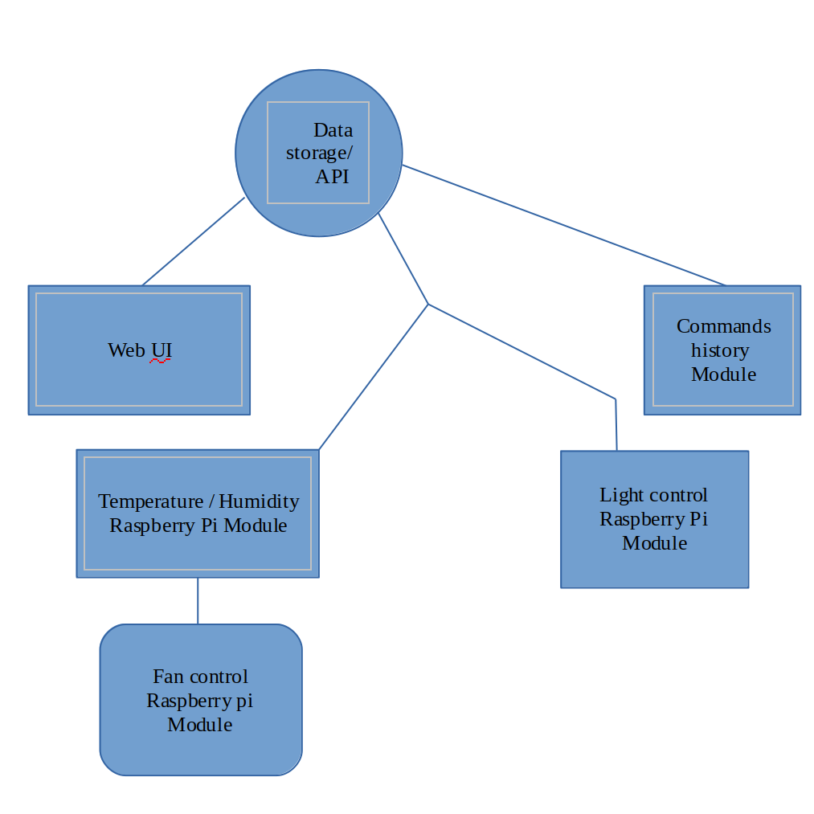
The overview of the system is presented in the following picture.

System overview information.

- Data storage / API will be the part where our Raspberry PI together with the user will make different requests and from where history module will take all executed commands.

- Web UI will provide provide user options, here user can initialize, start and stop the application.

- Raspberry PI module is the module where temperature, humidity, light and fan will be controlled and where sensors will be.

- Temperature and humidity module will receive informations from sensors and will send them to API using http requests and based on that values Fan control module will be called.

- Light control is the module where light will be managed based on current time.

Circuit Design

Circuit design is presented in the following picture.

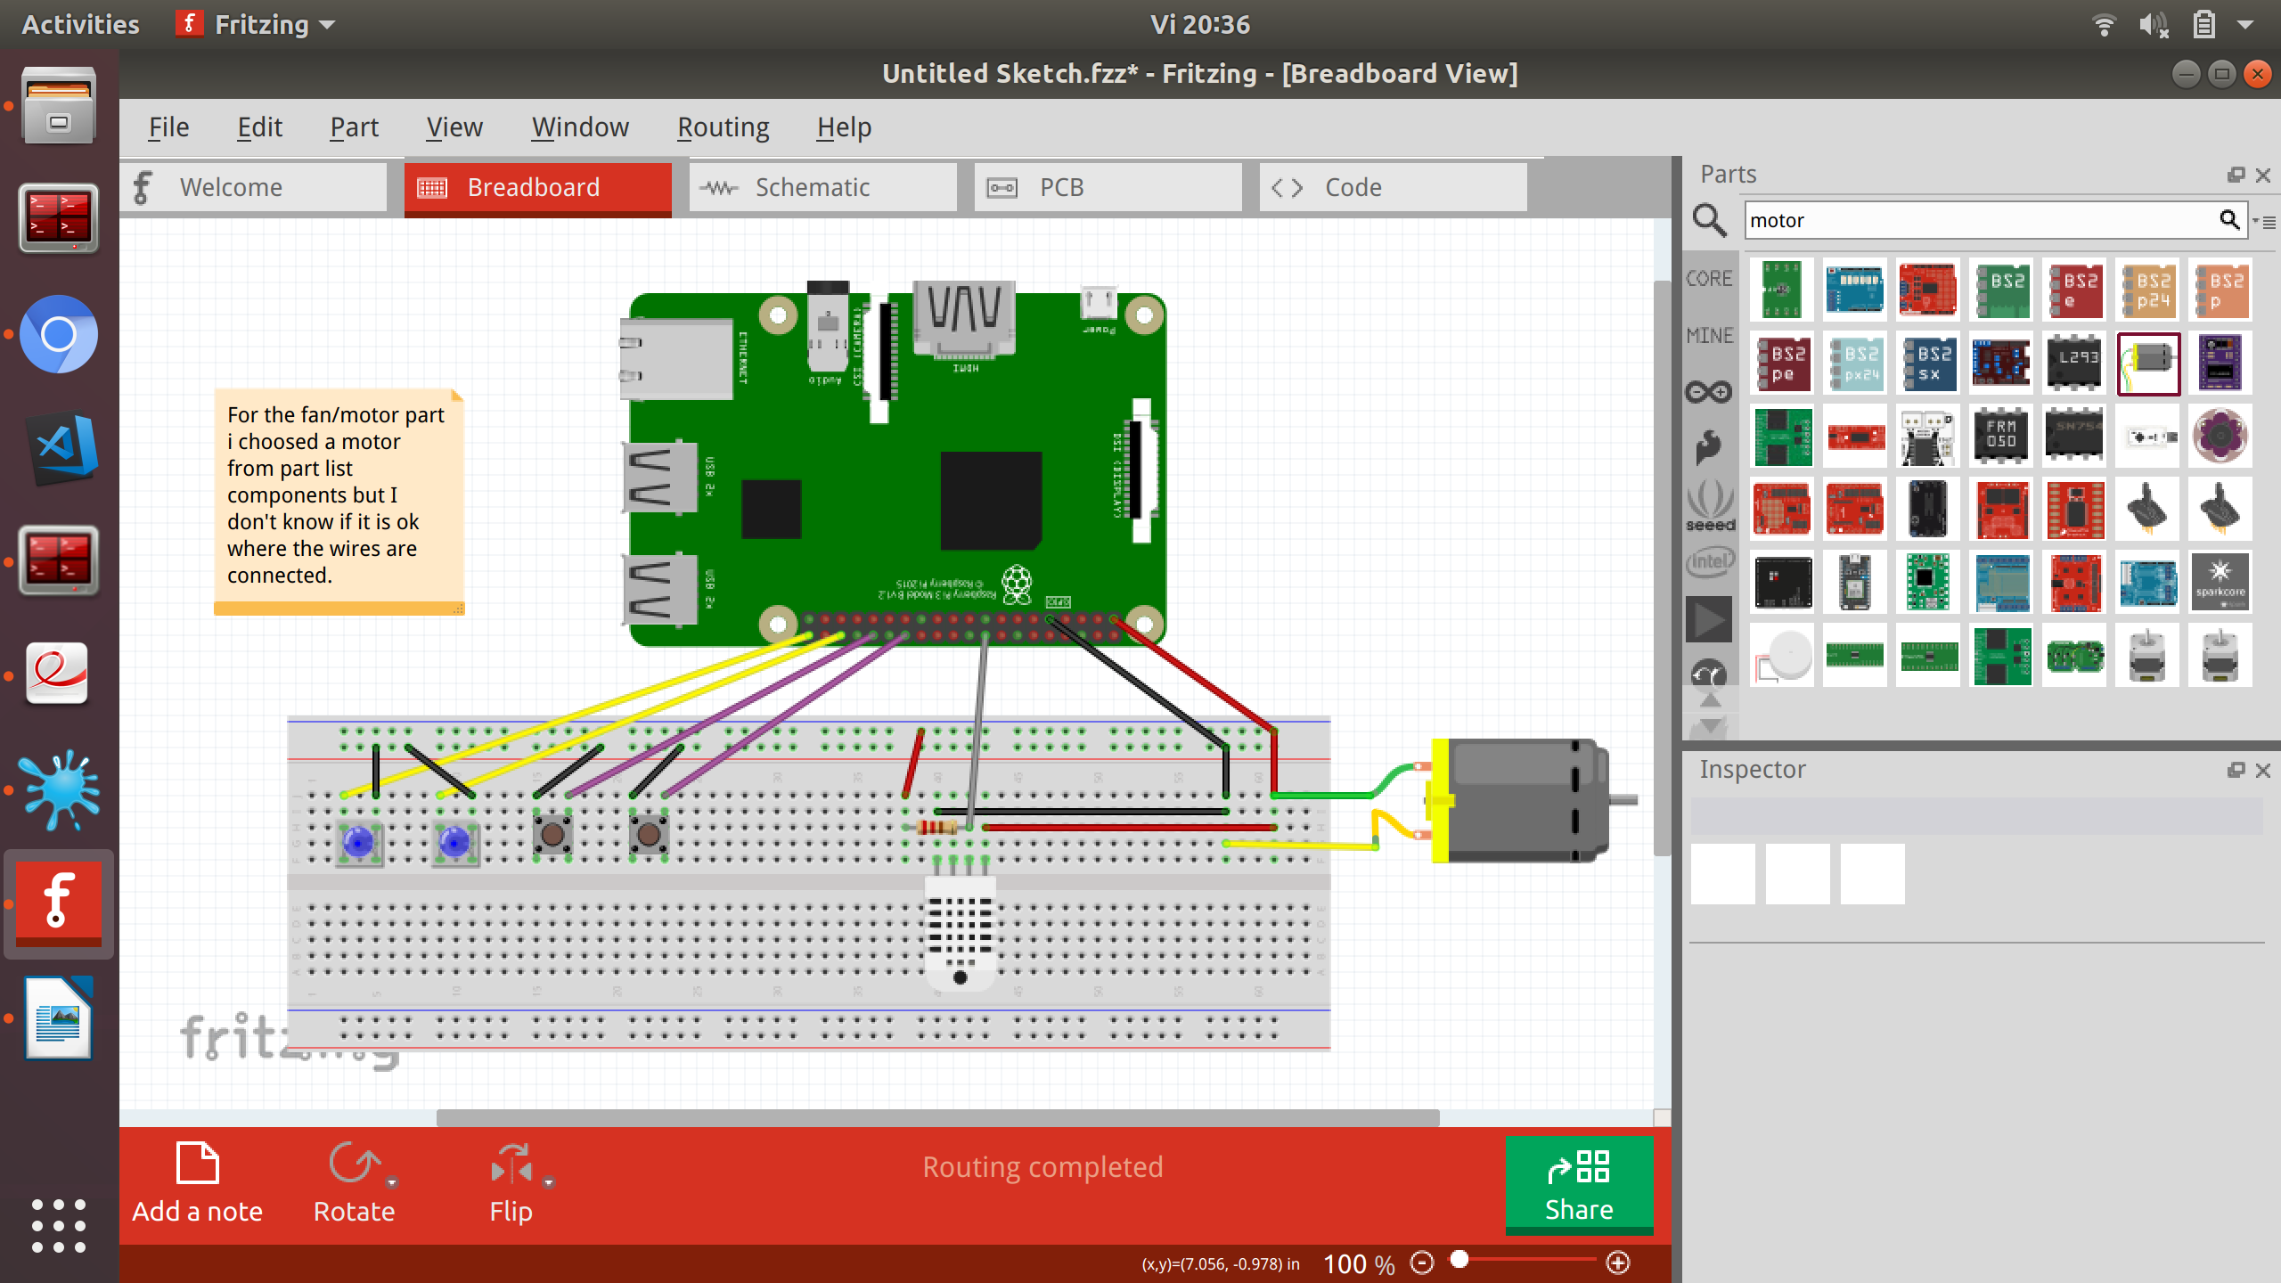
Components used for this project are.
- Raspberry Pi board.
- Simple buttons.
- Simple LED.
- DHT-22 Humidity and Temperature Sensor.
- Wires.
- Step Motor 28BYJ-48 5VDC.

Components description.
- Raspberry Pi is used because it has the ability to interact with the outside world, and because provide support for quick prototyping.
- DHT-22 Humidity and Temperature Sensor is an one-wire sensor which give us current temperature and humidity values.
- Step Motor 28BYJ is used instead of a fan and it maintain temperature and humidity.

Software Design

Software design and data flow is presented in following picture.

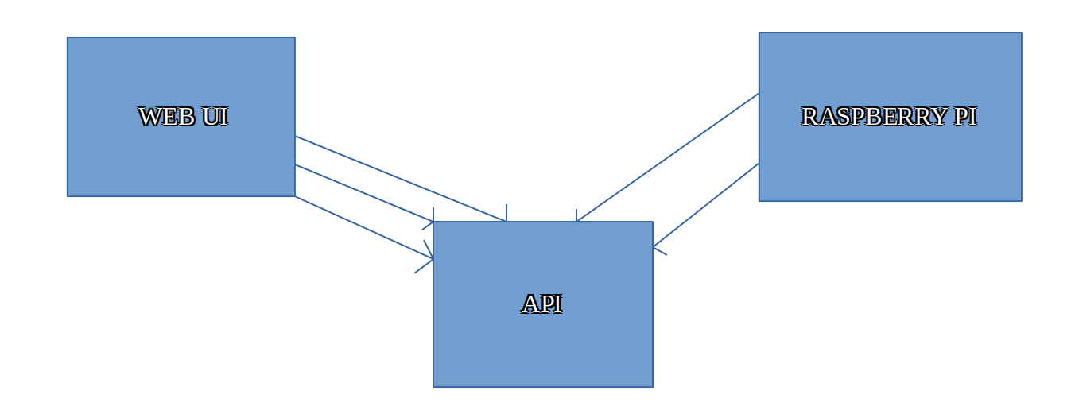

Software description.

→ Web UI is used to communicate with API sending requests requests. First of all will be POST Request when initializing the board and after that PUT Requests when executing actions. And also GET Request is called when customer want to see actions history.
For creating the Web UI we used React Js.

→ API is the backend of our application, here are stored informations.
Here are defined routes and logic for each action and also here are defined models for boards and requests. In order to store informations we used MongoDB and to write the API we used NodeJS.

→ Raspberry will communicate with API also with requests. It will use GET requests in order to know which commands to be executed.

When will receive informations about humidity and temperature it will send a PUT request to API in order to know that action was executed and to store measured data.
And also in Raspberry Pi we will write the logic to turn LED ON/OFF, to increase and decrease PWM of LED, to control button pressing events and also to control the step motor.

Results and further work

In this stage, the project support next functionalities:
- Communication with user with help of an user interface.
- Reading temperature and humidity values.
- Controlling kitchen light.
- Controlling kitchen fan.
- Access to all requests.

In case of extensions, following functionalities may be included:
- Extend application functionality for Android.
- Storing temperature and humidity values into database.
- Option to export values.

References

- Fritzing. http://fritzing.org
- Step motor. http://www.scraptopower.co.uk/Raspberry-Pi/how-to-connect-stepper-motors-a-raspberry-pi
- AdafruitDHT library.https://learn.adafruit.com/dht-humidity-sensing-on-raspberry-pi-with-gdocs-logging/software-install-updated
- DHT-22 Sensor.https://tutorials-raspberrypi.com/raspberry-pi-measure-humidity-temperature-dht11-dht22/

