Pentru simularea proiectului vom folosi aplicatia Proteus, unde putem incerca codul Arduino si observa starea senzorilor inainte de a realiza schema fizica.

Pentru acest proiect am ales urmatoarele componente:

1. Arduino UNO R3
2. Senzor de umiditate rezistiv
3. Senzor de calitatea aerului MQ-2
4. Senzor de presiune
5. Senzor de intensitate luminoasa
6. Ecran LCD
7. Alte componente necesare testarii circuitului pecum potentiometer si leduri

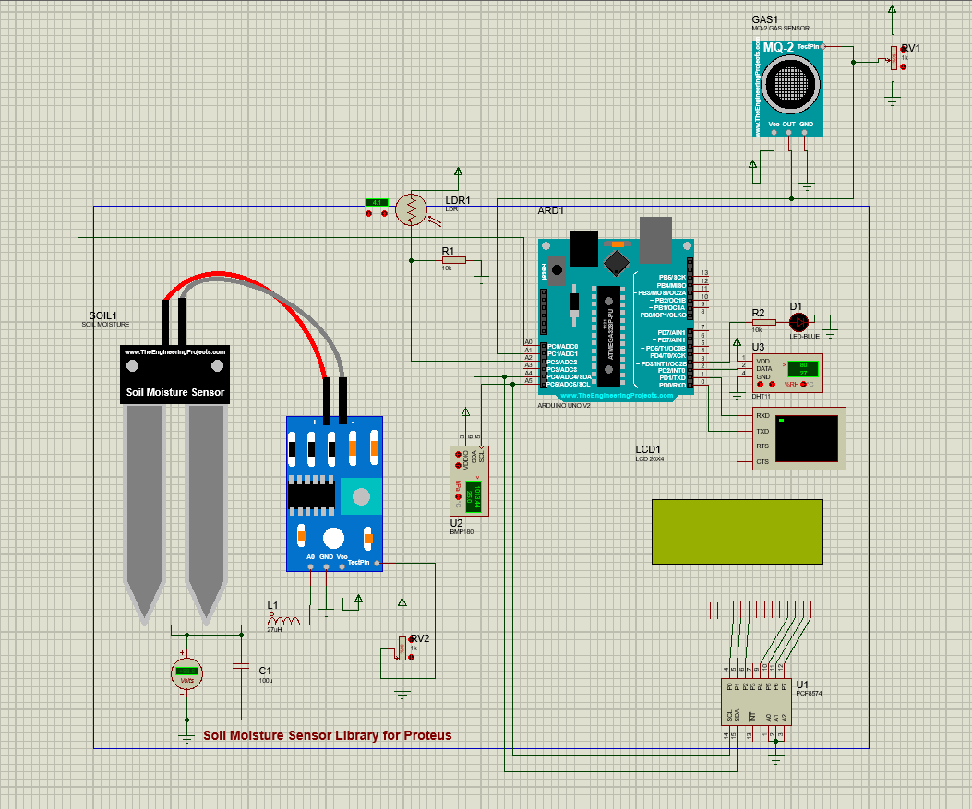

Putem observa starea senzorilor setati de noi cu ajutorul unor potentiometer.

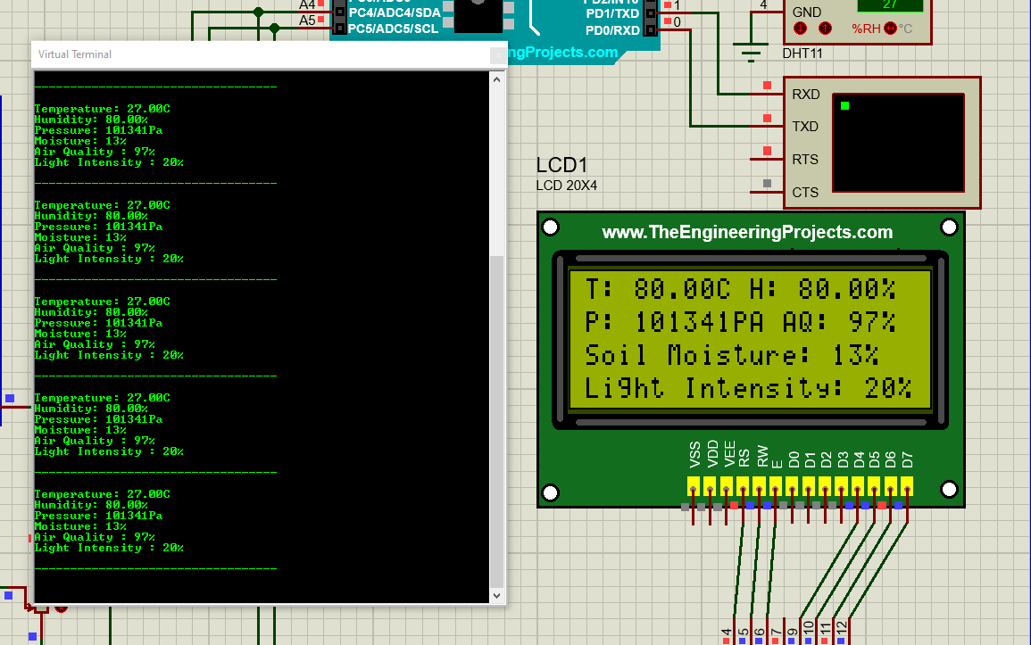

Am reusit sa obstinem aceste detalii cu ajutorul codului Arduino:

//Libraries

#include<Wire.h>

#include<Adafruit_Sensor.h>

#include<DHT.h>

#include<DHT_U.h>

#include<Adafruit_BMP085.h>

#include<LiquidCrystal_I2C.h>

//Pins declaration

#define DHTPIN 2

#define soil_pin A0

#define gas_pin A1

#define ldr_pin A2

#define valve 3

#define DHTTYPE DHT11

//Sensor object

DHT_Unified dht(DHTPIN, DHTTYPE);

Adafruit_BMP085 bmp;

LiquidCrystal_I2C lcd(0x20,20,4);

//Declare data variables

int soil_value;

int gas_value;

int ldr_value;

uint32_t dedlayMS;

int delayMS;

void setup(){

  Serial.begin(9600);

  Serial.println("Sistem inteligent de irigatii");

  pinMode(valve, OUTPUT);

  lcd.init();

  lcd.backlight();

  dht.begin();

  if(!bmp.begin()){

    Serial.println("Could not find a valid sensor");

    while(1){}

  }

  else{

    Serial.println(F("Pressure sensor initialized"));

  }

  Serial.println(F("DHT11 Begin"));

  Serial.println("");

  delayMS = sensor.min_delay / 1000;

  lcd.clear();

}

void loop(){

  delay(delayMS);

  //Get temperature

  sensors_event_t event;

  dht.temperature().getEvent(&event);

  if (isnan(event.temperature)){

    Serial.println(F("Error reading temperature"));

  }

  else{

    Serial.print(F("Temperature: "));

    Serial.print(event.temperature);

    Serial.println(F("C"));

  }

  //Get humidity

  dht.humidity().getEvent(&event);

  if (isnan(event.relative_humidity)){

    Serial.println(F("Error reading humidity"));

  }

  else{

    Serial.print(F("Humidity: "));

    Serial.print(event.relative_humidity);

    Serial.println(F("%"));

  }

  //Get pressure

   Serial.print(F("Pressure: "));

    Serial.print(bmp.readPressure());

    Serial.println(F("Pa"));

  //Get Soil Value

  soil_value = analogRead(soil_pin);

  soil_value = map(soil_value,0,1023,0,100);

  Serial.print("Moisture: ");

  Serial.print(soil_value);

  Serial.println("%");

  if(soil_value<25){

    digitalWrite(valve,HIGH);

  }

  else{

    digitalWrite(valve,LOW);

  }

  //Gas Sensor

  gas_value = analogRead(gas_pin);

  gas_value = map(gas_value,0,1023,100,0);

  Serial.print("Air Quality : ");

  Serial.print(gas_value);

  Serial.println("%");

  //LDR

  ldr_value = analogRead(ldr_pin);

  ldr_value = map(ldr_value, 0 ,1023, 0, 100);

  Serial.print("Light Intensity : ");

  Serial.print(ldr_value);

  Serial.println("%");

  Serial.println();

  Serial.println(F("----------------------------------"));

  Serial.println();

  //LCD display

  lcd.setCursor(0,0);

  lcd.print("T: ");

  lcd.print(event.temperature);

  lcd.print("C H: ");

  lcd.print(event.relative_humidity);

  lcd.print("%");

  lcd.setCursor(0,1);

  lcd.print("P: ");

  lcd.print(bmp.readPressure());

  lcd.print("PA AQ: ");

  lcd.print(gas_value);

  lcd.print("%");

  lcd.setCursor(0,2);

  lcd.print("Soil Moisture: ");

  lcd.print(soil_value);

  lcd.print("%");

  lcd.setCursor(0,3);

  lcd.print("Light Intensity: ");

  lcd.print(ldr_value);

  lcd.print("%");

}

Codul precedent este foarte simplu, momentan, doar luam valorile date de senzori si le printam pe ecranul lcd, urmand ca sa continuam prin face niste leduri sa se aprinda cand valoarea data de sensor nu este intr-o limita sanatoasa plantei, valorile minime si maxime ale senzorilor vor fi luate de catre un sistem intelligent de clasificare a plantelor, acesta le va clasifica si va lua valorile date de noi intr-o baza de date.

Camera reprezinta cea mai complexa parte a proiectului nostru, vom dori sa facem camera sa poata fi folosita real time cu un model programabil ESP32-CAM.

Pentru modelul de recunoastere a plantelor momentan vom folosi limbajul de programare Python,in care ne ajutam de librariile facute special pentru recunoasterea imaginilor: pyTorch si Tranformers,

Pentru functionalitatea acestora trebuie sa antrenam modelul cu imagini cu plante pana la recunoasterea acestora automata. Codul pe care il avem momentan contine 3 fisiere:

* Un processor de imagini care are rolul de a prelucra imaginile:

1. import os
2. from PIL import Image
3. def preprocess_images(base_path, plant_dataset, size):
4. for category, data_types in plant_dataset.items():
5. for data_type, file_list in data_types.items():
6. input_dir = os.path.join(base_path, category, data_type)
7. output_dir = os.path.join(base_path, category, f'preprocessed_{data_type}')
8. if not os.path.exists(output_dir):
9. os.makedirs(output_dir)
10. for file in file_list:
11. img_path = next((os.path.join(input_dir, filename) for filename in os.listdir(input_dir) if filename.lower() == file.lower()), None)
12. if img_path is None:
13. print(f"Image not found: {file}")
14. continue
15. print(f"Processing image: {img_path}")
16. img = Image.open(img_path)
17. img = img.resize(size)
18. img.save(os.path.join(output_dir, file), format='JPEG')
19. # Your Python dataset definition
20. plant_dataset = {
21. "tomato": {
22. "train": ["tomato_train_1.jpg", "tomato_train_2.jpg"],
23. "val": ["tomato_val_1.jpg"]
24. },
25. "dragon_fruit": {
26. "train": ["dragon_fruit_train_1.jpg", "dragon_fruit_train_2.jpg"],
27. "val": ["dragon_fruit_val_1.jpg"]
28. },
29. "cactus": {
30. "train": ["cactus_train_1.jpg", "cactus_train_2.jpg"],
31. "val": ["cactus_val_1.jpg"]
32. }
33. }
34. # Provide the base path to your plant photos
35. base_path = 'C:\\Users\\silvi\\Desktop\\ProiectSE\\Plante'
36. # Specify the size for resizing images
37. image_size = (224, 224)
38. # Preprocess images using the defined dataset
39. preprocess_images(base_path, plant_dataset, image_size)
40. print("Preprocessing complete.")

* Un fisier cu baza de date si dictionarul :

1. import os
2. from PIL import Image
3. from torchvision import transforms
4. from torch.utils.data import Dataset, DataLoader
5. class PlantDataset(Dataset):
6. def __init__(self, root_dir, dataset_dict, transform=None):
7. self.root_dir = root_dir
8. self.dataset_dict = dataset_dict
9. self.transform = transform
10. self.data = []
11. self.labels = []
12. self.load_data()
13. def load_data(self):
14. for category, splits in self.dataset_dict.items():
15. for split, file_list in splits.items():
16. for file_name in file_list:
17. img_path = os.path.join(self.root_dir, category, split, file_name)
18. label = category  # You might need to convert categories to numeric labels
19. self.data.append(img_path)
20. self.labels.append(label)
21. def __len__(self):
22. return len(self.data)
23. def __getitem__(self, idx):
24. img_path = self.data[idx]
25. label = self.labels[idx]
26. img = Image.open(img_path).convert("RGB")
27. if self.transform:
28. img = self.transform(img)
29. return img, label
30. # Example usage:
31. root_dir = 'C:\\Users\\silvi\\Desktop\\ProiectSE\\Plante'
32. plant_dataset_dict = {
33. 'tomato': {
34. 'train': ["tomato_train_1.jpg", "tomato_train_2.jpg"],
35. 'val': ["tomato_val_1.jpg"]
36. },
37. 'dragon_fruit': {
38. 'train': ["dragon_fruit_train_1.jpg", "dragon_fruit_train_2.jpg"],
39. 'val': ["dragon_fruit_val_1.jpg"]
40. },
41. 'cactus': {
42. 'train': ["cactus_train_1.jpg", "cactus_train_2.jpg"],
43. 'val': ["cactus_val_1.jpg"]
44. }
45. }
46. transform = transforms.Compose([
47. transforms.Resize((224, 224)),
48. transforms.ToTensor(),
49. ])
50. plant_dataset = PlantDataset(root_dir, plant_dataset_dict, transform=transform)
51. # Create DataLoader
52. batch_size = 32
53. data_loader = DataLoader(plant_dataset, batch_size=batch_size, shuffle=True)
54. # Example of how to iterate through the data loader
55. for inputs, labels in data_loader:
56. # Your training loop goes here
57. print(f"Batch Size: {len(labels)}")

* Si un fisier pentru antrenarea modelului:

1. import os
2. import torch
3. import torch.nn as nn
4. import torch.optim as optim
5. from torch.utils.data import DataLoader
6. from torchvision import transforms
7. from torchvision.models import resnet18
8. from PIL import Image
9. # Custom dataset class
10. class PlantDataset(torch.utils.data.Dataset):
11. def __init__(self, root_dir, transform=None):
12. self.root_dir = root_dira
13. self.transform = transform
14. self.data = self.load_data()
15. def load_data(self):
16. # Implement your logic to load dataset paths here
17. # Example: return a list of (image_path, label) tuples
18. data = [
19. (os.path.join(self.root_dir, 'tomato', 'train', 'tomato_train_1.jpg'), 0),
20. (os.path.join(self.root_dir, 'dragon_fruit', 'train', 'dragon_fruit_train_1.jpg'), 1),
21. (os.path.join(self.root_dir, 'cactus', 'train', 'cactus_train_1.jpg'), 2)
22. ]
23. return data
24. def __len__(self):
25. return len(self.data)
26. def __getitem__(self, idx):
27. img_path, label = self.data[idx]
28. img = Image.open(img_path).convert("RGB")
29. if self.transform:
30. img = self.transform(img)
31. return img, label
32. # Define transformations
33. transform = transforms.Compose([
34. transforms.Resize((224, 224)),
35. transforms.ToTensor(),
36. ])
37. # Set paths
38. root_dir = 'C:\\Users\\silvi\\Desktop\\ProiectSE\\Plante'
39. # Create dataset and dataloader
40. train_dataset = PlantDataset(root_dir, transform=transform)
41. train_loader = DataLoader(train_dataset, batch_size=32, shuffle=True)
42. # Define a simple neural network model
43. model = resnet18(pretrained=False, num_classes=3)  # Adjust num_classes based on your dataset
44. # Define loss function and optimizer
45. criterion = nn.CrossEntropyLoss()
46. optimizer = optim.Adam(model.parameters(), lr=0.001)
47. # Training loop
48. num_epochs = 5
49. for epoch in range(num_epochs):
50. for inputs, labels in train_loader:
51. optimizer.zero_grad()
52. outputs = model(inputs)
53. loss = criterion(outputs, labels)
54. loss.backward()
55. optimizer.step()
56. print(f'Epoch {epoch+1}/{num_epochs}, Loss: {loss.item()}')
57. # Debugging prints
58. for img_path, label in train_dataset.data:
59. print(f"Image Path: {img_path}, Label: {label}")
60. print('Training complete.')

Pentru aceste modele, momentan, folosim doar 3 imagini pentru 3 tipuri de plante.