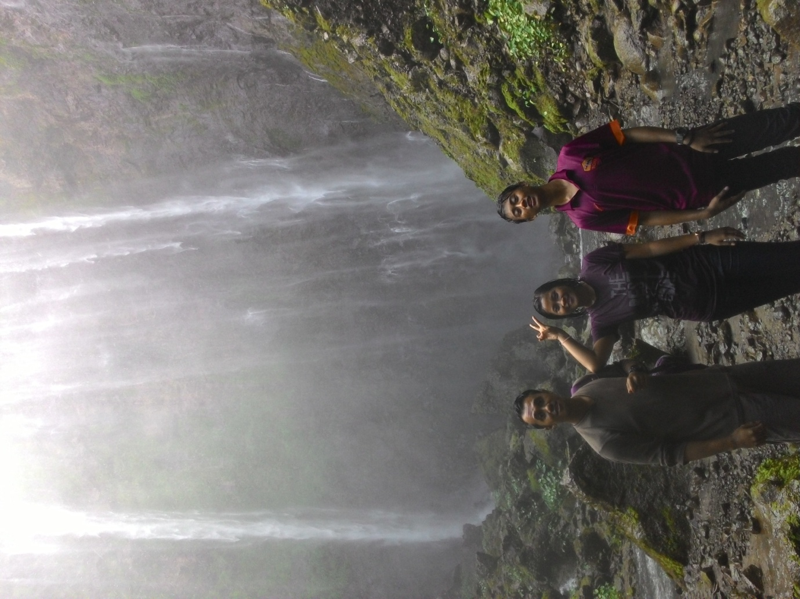

I remember this photo was taken by my brother, i spent my holiday in my hometown, this photo was taken at Coban Sewu. I took a picture with my cousin. on my left side there are my older brother and on my right side there are my younger brother. I visited many beautiful and interesting place at malang. I came there by private car with all my cousin. We passed a lot of rocks to get down the ravine. But we were very happy. Because the view very beautiful and we were satified.

**Silvy Dharma Febryana**

**D4 Teknik Informatika 1-D**