16. Mendel’s first law of inheritance are :-
Law of dominance : The first law of inheritance is law of dominance means which suppressed the receive then get dominant over it and expressed own character.
for example Tall plant (TT) cross over short plant (tt)
Image: image1.wmf

In f1 phase all plants are tall.

(ii)
Image: image2.png
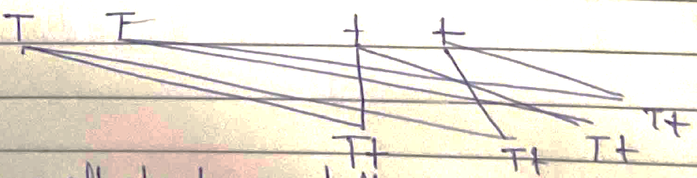
(ii)
The DNA (Double helical model) of four nitrogenous product adenine, Thymine, Guenine and Cytosine.
Whereas Adenine made double hydrogen bond with Thymine (T) then, Guenine made thriple hydrogen bond with cytosine.
A = T

(iii) (a) The meaning of destarched plants is plant leaves without starch. It can destarched by the iodine solution.
(b) (i) Take a plants leaves without the presence of starch.
(ii) Then, cover a half part of the leaf the help of black strip.
(iii) leave the plants at the light place.
(iv) Then, use iodine solution where doesn’t not present starch it converted into Brown in colour.

(iv) (a) Mitosis : Mitosis is equational division and it completes there stage in two phase (i) karyokinesis (ii) cytokinesis it is known as mitosis.
(b) Meiosis : Meiosis is reductional division and present in the reproductive part it is known as meiosis.
(c) Crossing over : crossing over means crossing a contrasting character and change the genotypes is known as crossing over.
(d) Karyokinesis : Karyokinesis is division of nucleus and present in mitosis.
(e) Interphase : Interphase are resting phase of mitosis and involve three steps G, S and G2 this known as interphase.

