18. (i) Prophase

(ii) Centromere, (2) chromatids, (3) spindle fibre

(iii)
Image: image3.png
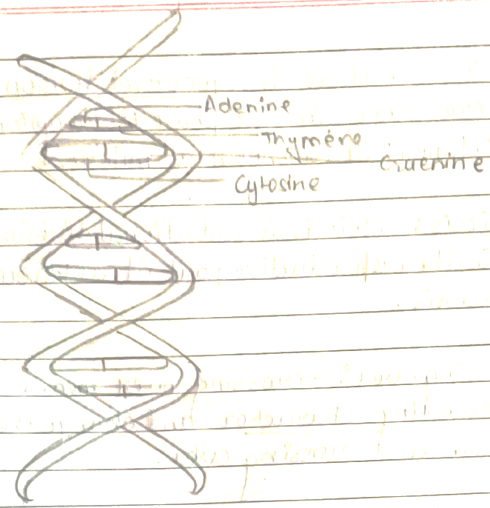
(iii)
nuclear membrane appear

(iv) (a) mitosis division
(b) meiosis division

Mitosis | Meiosis
* 2 daughter cell produced | * 4 daughter cell produced
* equcational division | * reductional division
*It present somatic ang vegetative part | *It present on reproductive part.
*It is diplode | *It is haploid
(v)

