10. (a) Role of Hydrochloride acid in stomach :
(1) It kills the germs in the stomach.
(2) It creates an acidic medium for enzyme pepsin to actron protein activate.

(b)
Image: image1.png
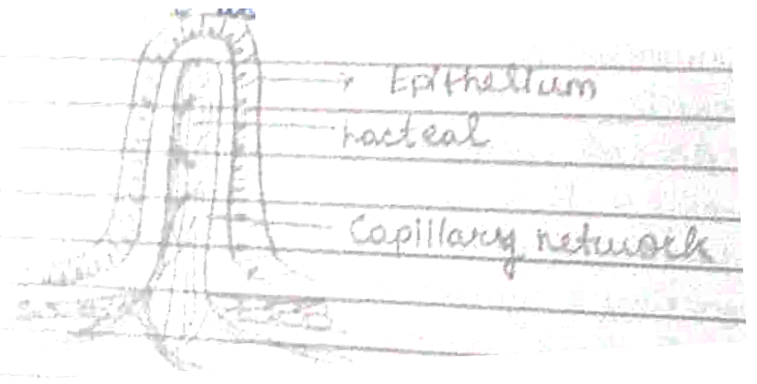
(b)
Function of lacteal – During the process of digestion, the lacteals absorb large molecules of fats and lipids from the small intestine.

