17.(i)(a) Dendrites
(b) Axon

(ii)
Image: image1.png
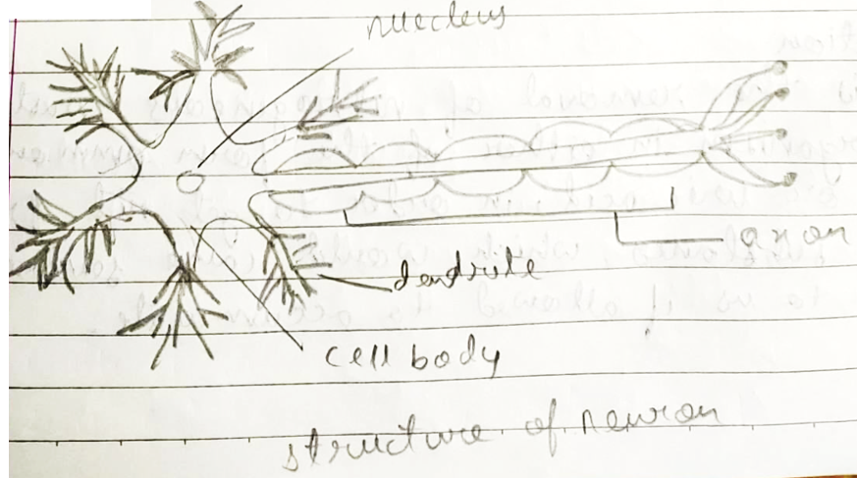
(ii)

(iii) (a)Photo trophism
(b) Thigmo trophism

(iv) (a) Population
It refers to the count of people living in a particular area and in a particular period of time. These is termed as population.
(b) Tubectomy
It is one of the mechanical method for reducing population. It is the surgical removal of a particular part of oviduct or fallopian tube of female.

(v) (a) Auxins
These are sprayed in order to make the plant to grow properly as it is responsible for apical dominance.
(b) Gibberlins
These are used for stem elongation of plants.
(c) Abscasic acid
It is used for artificial ripening of fruit.

