Human OCR | Gemini OCR | CER (Character Error Rate)
18. (i) Prophase  (ii) Centromere, (2) chromatids, (3) spindle fibre  (iii)  Image: image3.png  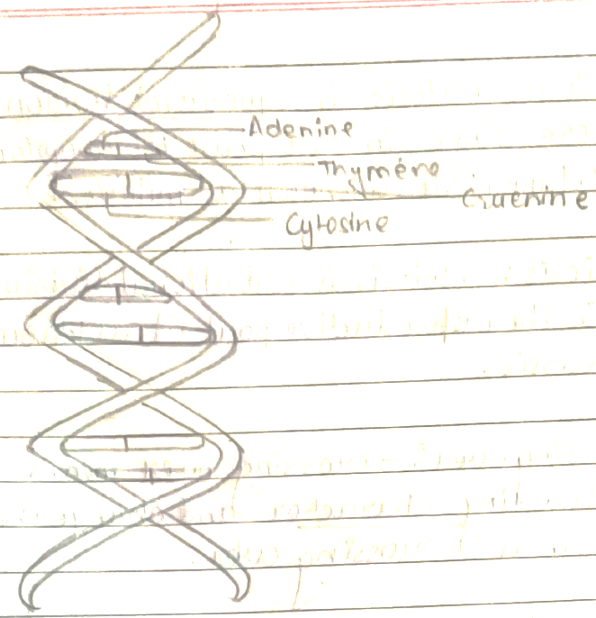  (iii)  nuclear membrane appear  (iv) (a) mitosis division  (b) meiosis division  Mitosis Meiosis  * 2 daughter cell produced * 4 daughter cell produced  * equcational division * reductional division  *It present somatic ang vegetative part *It present on reproductive part.  *It is diplode *It is haploid  (v) | Q.18 (i) (1) Prophase (2) chromatids, (3) spindle fibre  (ii) centromere  (iv) (a) mitosis division  (b) meiosis division  (v) <diagram_1>  nuclear membrane appear  mitosis  2 daughter cell produced  equational division  It present somatic and vegetative part.  It is diplode  meiosis  4 daughter cell produced  reductional division  It present on reproductive part.  It is haploid | 152.0%

