Human OCR | Gemini OCR | CER (Character Error Rate)
10. (a) Role of Hydrochloride acid in stomach :  (1) It kills the germs in the stomach.  (2) It creates an acidic medium for enzyme pepsin to actron protein activate.  (b)  Image: image1.png  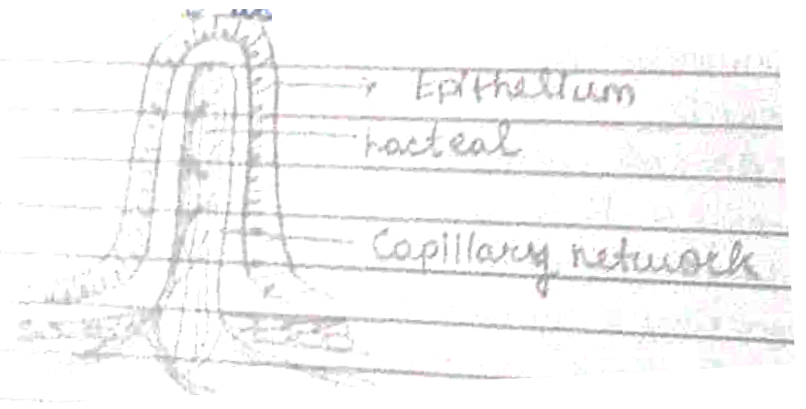  (b)  Function of lacteal – During the process of digestion, the lacteals absorb large molecules of fats and lipids from the small intestine. | a) Role of HCL Hydrochloride acid in stomach :-  1) It kills the germs in the stomach.  2) It creates an acidic medium for enzyme pepsin to act on proteins activate.  b) <diagram_1>  Function of lacteal - During the process of digestion, the lacteals absorb large molecules of fats and lipids from the small intestine.  b) Cartilaginous rings supports trachea and prevents it from collapsing. It also helps in the flexible movement of neck during breathing. | 53.9%

