Human OCR | Gemini OCR | CER (Character Error Rate)
17.(i)(a) Dendrites  (b) Axon  (ii)  Image: image1.png  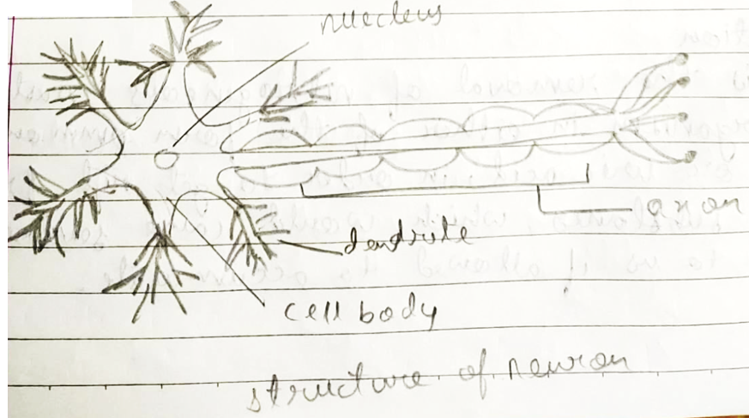  (ii)  (iii) (a)Photo trophism  (b) Thigmo trophism  (iv) (a) Population  It refers to the count of people living in a particular area and in a particular period of time. These is termed as population.  (b) Tubectomy  It is one of the mechanical method for reducing population. It is the surgical removal of a particular part of oviduct or fallopian tube of female.  (v) (a) Auxins  These are sprayed in order to make the plant to grow properly as it is responsible for apical dominance.  (b) Gibberlins  These are used for stem elongation of plants.  (c) Abscasic acid  It is used for artificial ripening of fruit. | 17. 1) a) Dendrites  b) Axon  ii) <diagram_1>  iii) a) Phototrophism  b) Thigmotrophism  iv) a) Population  It refers to the count of people living in a particular area and in a particular period of time. This is termed as population.  b) Tubectomy  It is one of the mechanical methods for reducing population It is the surgical removal of a particular part of oviduct or fallopian tubes of of female.  v) a) Auxins  These are sprayed in order to make the plant to grow properly as it is responsible for apical dominance  b) Gibberellins  These are used for stem elongation of plants  c) Abscisic acid  It is used for artificial ripening of fruit. | 8.1%

