Human OCR | Gemini OCR | CER (Character Error Rate)
18.(i) Exceretion  It is the removal of nitrogenous wastes by organism in either of the form ammonia, urea or uric acid, in order to get mid from tixic substances, which would cause severe harm to us if allowed to accumulate.  (ii) The substances that are selectively re absorbed are glucose, essantial salts like sodium chloride, or iodine, etc. This also includes absorbtion of water also.  (iii) (a) It is the not of different blood vessels that come to kidney for fill ration of blood and excreted harmful wastes.  (b) Bowman’s capsule is there for the process of ultrafiltration under high pressure. It is referred as ultrafiltration as it is three layer filtration  (iv) (a) PCT  It’s function is to absorb all essaintial substances like that of glucose, salt, like sodium chloride, sodium bicarbonate and iodine.  (b) Loop of henle  It is for re-absorbtion of water molecules and make the urine concentrated.  (v) Nephron is the structural functional unit of kidney.  Image: image2.png  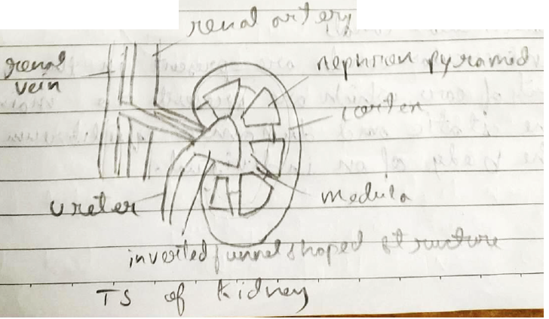 | 18. 1) Excretion  It is the removal of nitrogenerous wastes by organism in either of the form ammonia, urea or uric acid, in order to get rid from tonic substances, which would cause severe harm to us if allowed to accumulate.  ii) The substances that are selectively re-absorbed are glucose, essintial salts like sodium chloride, iodine, etc. This also includes absorbtion of water also.  iii) a) It is the knot of substance different blood vessels that came to kidney for filtration of blood and excrete harmful wastes.  b) Bowman's capsule is there for the process of ultrafiltration under high pressure. It is reffered as ultrafiltration as it is three layer filtration.  iv) a) PCT  Its function is to absorb all essintial substances like that of glucose, salt, like sodium chloride, sodium bicarbonate and iodine.  b) Loop of henle  It is for re-absorbtion of water molecules and make the wine concentrated.  v) Nephron is the structural functional unit of kidney.  <diagram_1> | 6.5%

