33. x–y+1 = 0
If x =2 if x = 0 if x =1
2–y + 1 = 0 0 – y + 1 = 0 1 – y + 1 = 0
3 = y 1 = y 2 = y

Image: image7.wmf

Image: image8.wmf

if x = 2 3x+2–12=0 If x = 4
12–+2y = 0
y =0

Image: image9.png
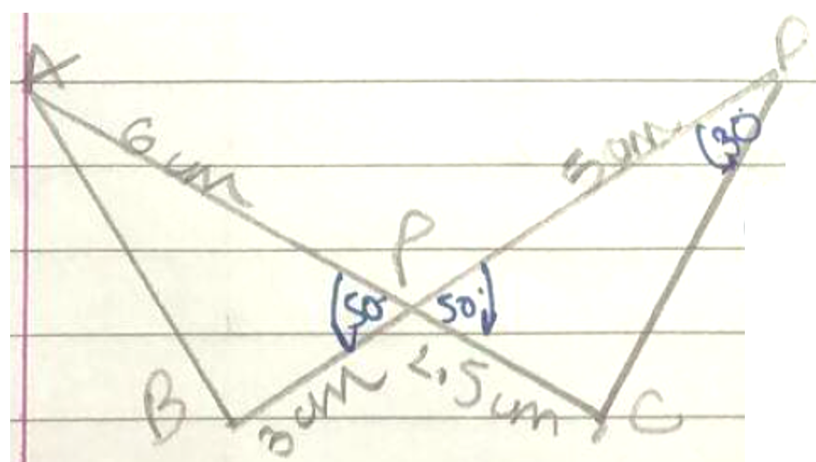

Virti us of
A – (2, 3)
B – (–1, 0)
C – (4, 0)
x1 = 2 y1 = 3
x2 = (–1) y2 = 0
x3 = 4 y3 = 0
area of

area of

