Image: image153.png
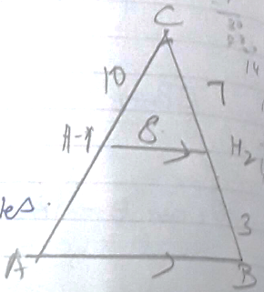
16. Given

To prove that

Statement | Reason
DE ̸ ̸ BC | Basic proportionality theorem  Common angle  By SAS similarity criteria.

