25. Section formula

Image: image10.png
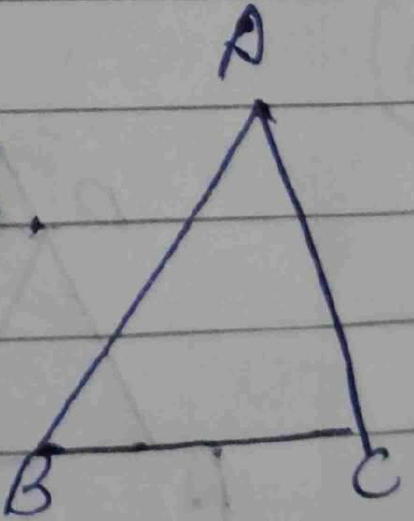

→
→ 1 (1) + x

