Image: image1.png
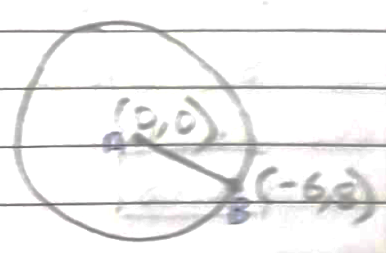
10. Given
PD||BC,

To prove,
PE||AC
Proof,
As AD||BC
[BPT] ……(i)
Also,
(given) ……(ii)
From equation (i) and (ii)

By converse of BPT,

Hence, proved.

